Github: https://github.com/Senthamil2003/DailyPracticePresidioIntern/tree/master/Day3/slnConsoleApp1

1.Simple Calculator

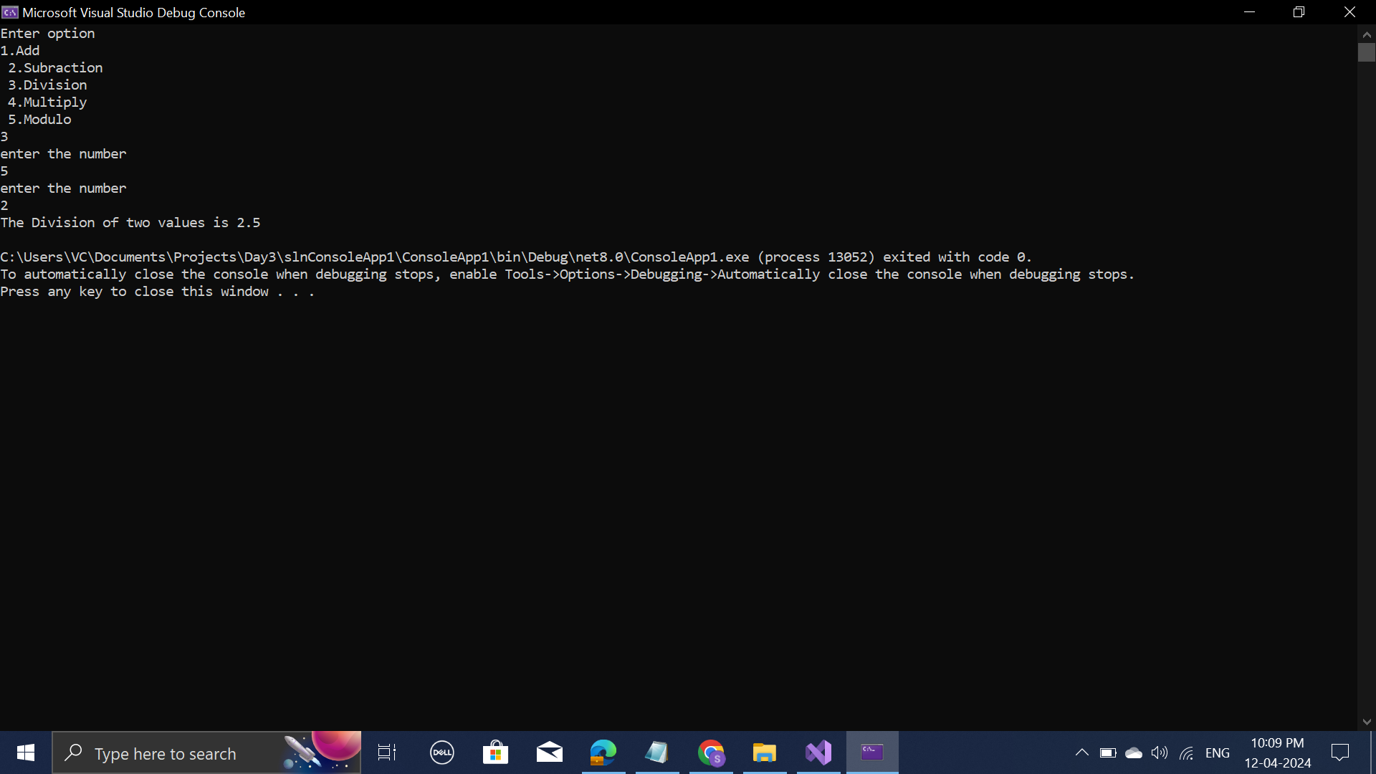

2.Find the grat number

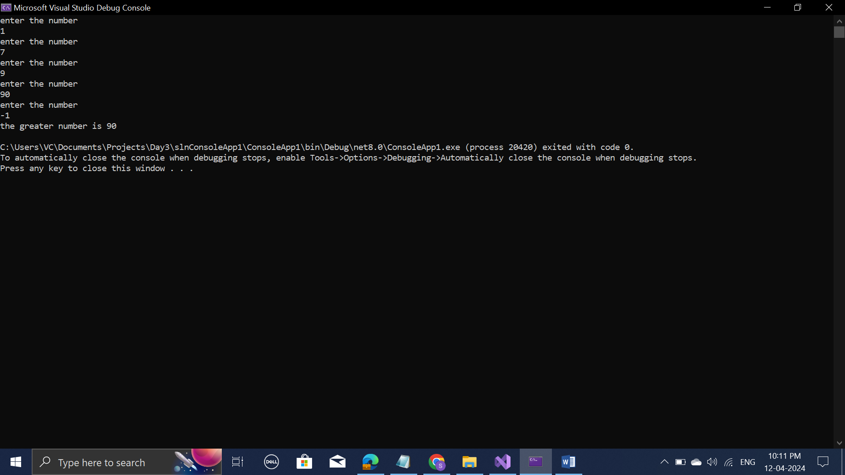

3.Average of the multiply of 7

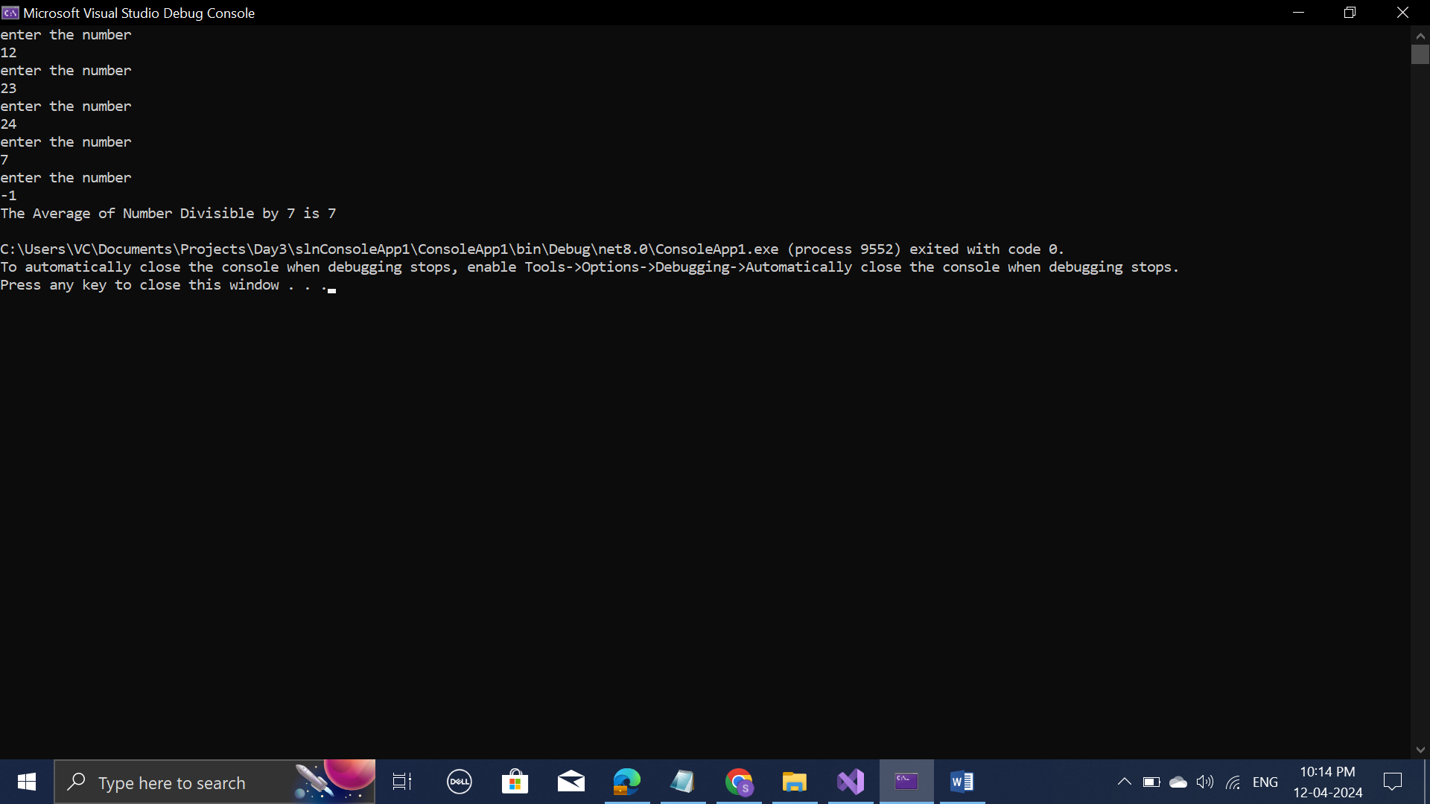

4.Username Length

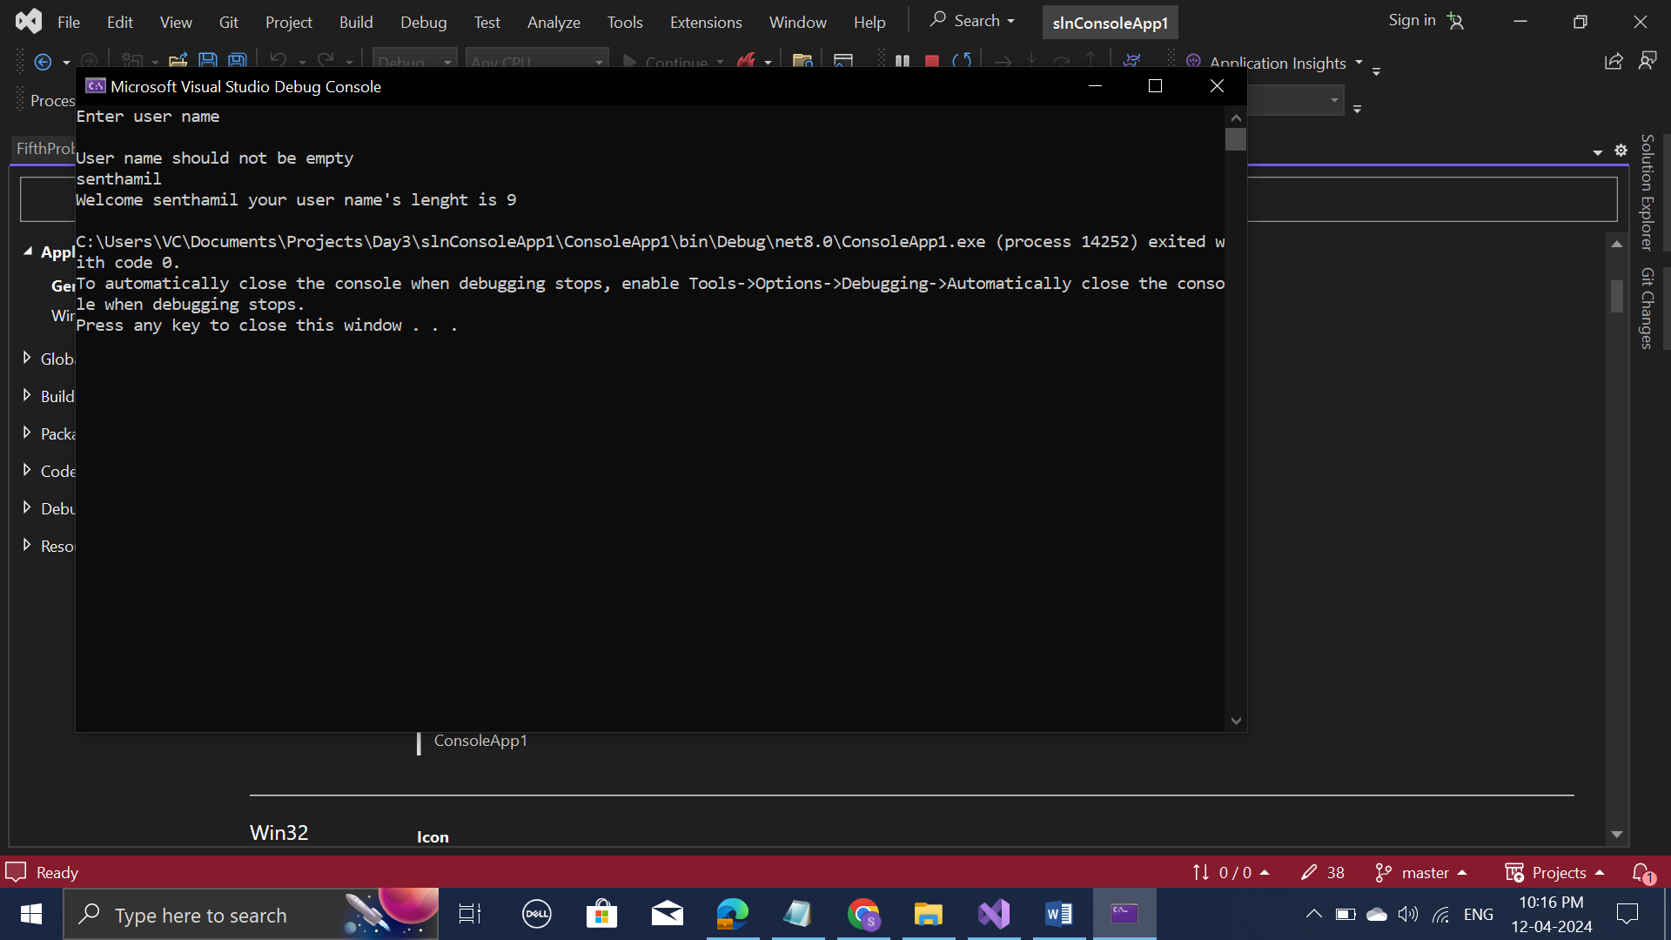

5.Login Check upto max of 3 attempt

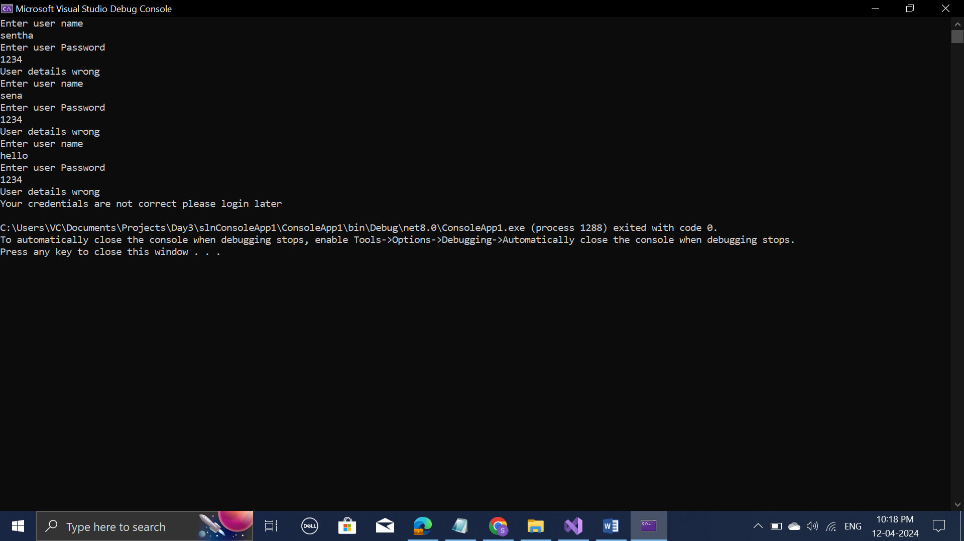

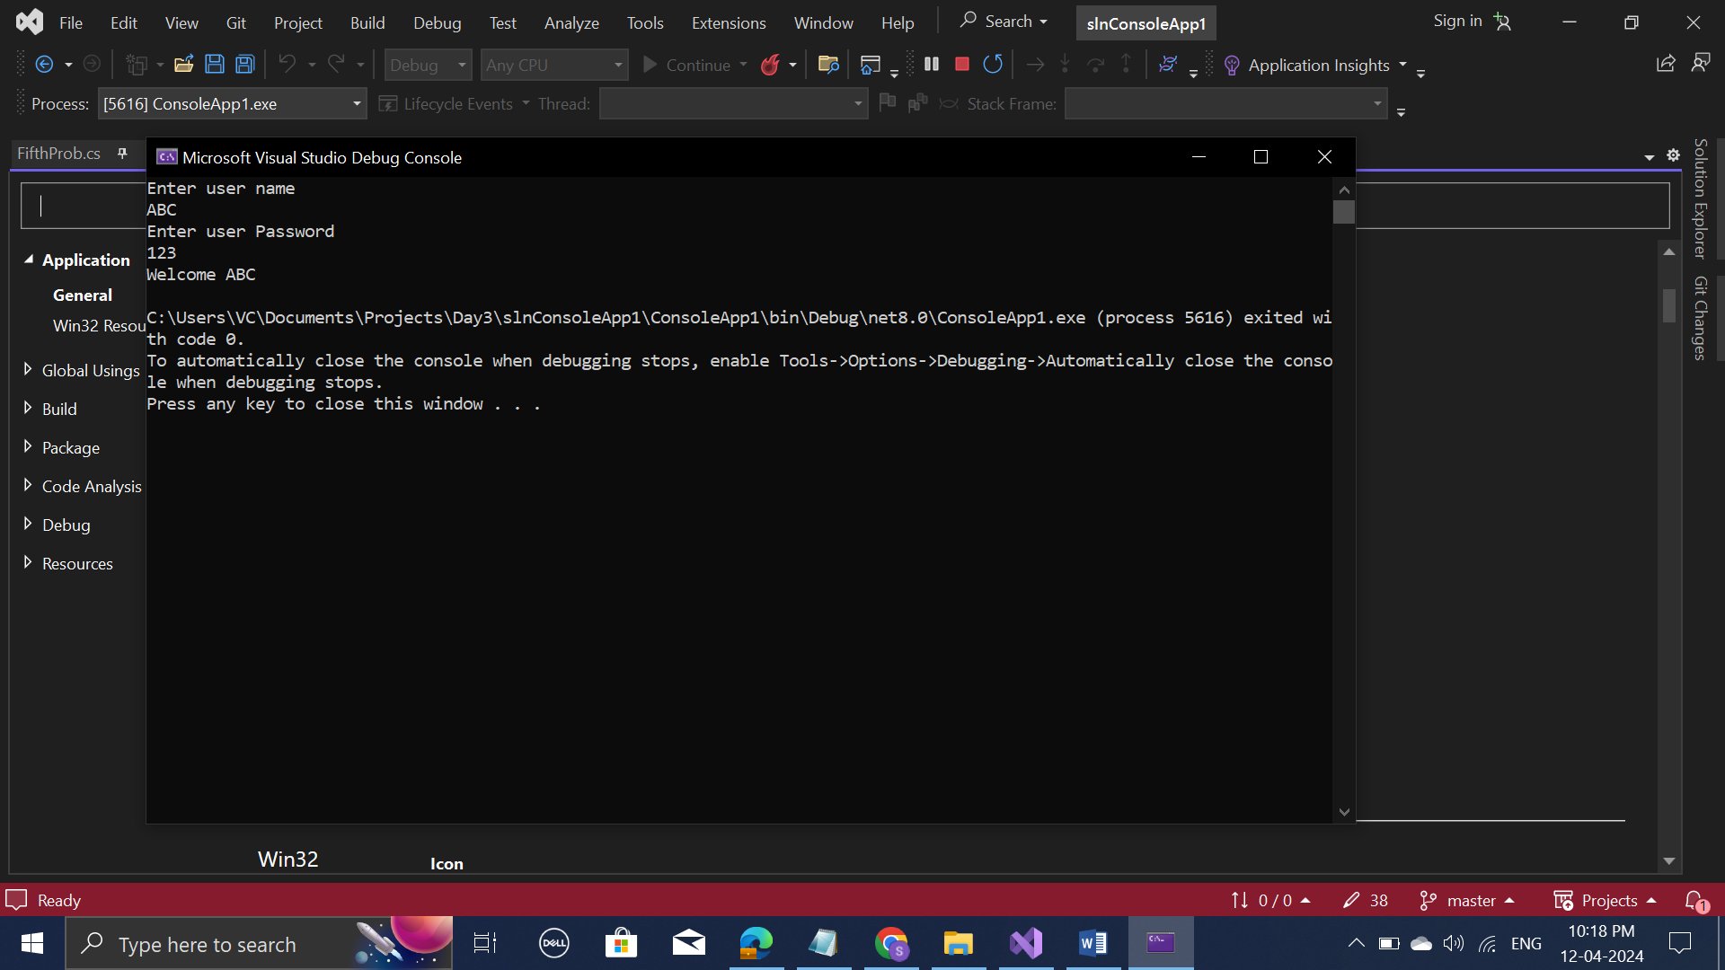

6.Word with minimum vowel count

