TSP ROUTE OPTIMIZER
Technical Documentation Report
Travelling Salesman Problem — Nearest Neighbour + 2-Opt Approach

Language: Python | Libraries: folium, matplotlib, numpy

1. Topic
The Travelling Salesman Problem (TSP) is one of the most well-studied problems in combinatorial optimization. The objective is to find the shortest possible route that visits a given set of cities exactly once and returns to the starting point.

This project implements a TSP Route Optimizer using real Indian cities and their GPS coordinates. The program:
- Accepts a set of cities with latitude and longitude
- Computes pairwise distances using the Haversine formula (real Earth distances)
- Finds an optimized travel route using heuristic algorithms
- Visualizes results on both a Matplotlib graph and an interactive Folium map

Cities included in this implementation:

City | Latitude | Longitude
Chennai | 13.0827° N | 80.2707° E
Bangalore | 12.9716° N | 77.5946° E
Mumbai | 19.0760° N | 72.8777° E
Delhi | 28.6139° N | 77.2090° E
Kolkata | 22.5726° N | 88.3639° E
Hyderabad | 17.3850° N | 78.4867° E
Pune | 18.5204° N | 73.8567° E
Jaipur | 26.9124° N | 75.7873° E

2. Aim
The aim of this project is to:
- Demonstrate how a brute-force random route compares against an optimized route
- Apply the Nearest Neighbour greedy heuristic to construct an initial solution
- Refine the solution using the 2-Opt local search improvement algorithm
- Measure and visualize the percentage improvement in total route distance
- Generate both a static Matplotlib plot and a live interactive Folium map as output

By comparing a randomly shuffled route with the algorithmically optimized route, the project clearly demonstrates the practical value of combinatorial optimization techniques in real-world logistics and routing scenarios.

3. Algorithm

3.1 Haversine Distance Formula
The Haversine formula calculates the great-circle distance between two points on a sphere given their longitudes and latitudes. This gives real-world distances in kilometres, accounting for Earth's curvature.

Haversine(p1, p2):
R = 6371 (Earth radius in km)
dlat = lat2 - lat1
dlon = lon2 - lon1
a = sin²(dlat/2) + cos(lat1) × cos(lat2) × sin²(dlon/2)
distance = R × 2 × arcsin(√a)

3.2 Nearest Neighbour Heuristic
This greedy algorithm constructs an initial tour by always visiting the closest unvisited city next:
- Start at the first city in the list
- At each step, move to the nearest unvisited city
- Continue until all cities have been visited
- Return to the starting city to complete the loop

Time Complexity: O(n²) where n is the number of cities. While not guaranteed to find the global optimum, it consistently produces a good starting solution.

3.3 2-Opt Improvement
The 2-Opt algorithm improves the initial tour by iteratively reversing segments of the route if doing so reduces total distance:
- For every pair of edges (a→b) and (c→d) in the route
- If swapping produces a shorter path: a→c and b→d, reverse the segment between b and c
- Repeat until no further improvement is possible (local optimum reached)

Time Complexity: O(n²) per pass, O(n³) worst case. In practice, convergence is fast for small to medium city sets.

Algorithm | Type | Time Complexity | Quality
Random Route | Baseline | O(n) | Poor
Nearest Neighbour | Greedy Heuristic | O(n²) | Good
2-Opt Improvement | Local Search | O(n²) per pass | Very Good

4. Code

4.1 Project Structure
The program is organized into 9 clearly separated steps, each implemented as a standalone Python function:

Step | Function | Purpose
1 | get_cities() | Define city names with GPS coordinates
2 | haversine_km(p1, p2) | Calculate real-world distance between two coordinates
3 | build_distance_matrix(cities) | Build a lookup table of all pairwise distances
4 | route_distance(route, matrix) | Compute total distance of a given route
5 | nearest_neighbour(...) | Generate initial tour using greedy heuristic
6 | two_opt(route, matrix) | Improve route using 2-Opt local search
7 | plot_graph(...) | Render side-by-side Matplotlib comparison chart
8 | plot_real_map(...) | Generate interactive Folium HTML map
9 | main() | Orchestrate all steps and print results

4.2 Key Code Snippets
Haversine distance calculation:

def haversine_km(p1, p2):
R = 6371
lat1, lon1 = math.radians(p1[0]), math.radians(p1[1])
lat2, lon2 = math.radians(p2[0]), math.radians(p2[1])
dlat = lat2 - lat1
dlon = lon2 - lon1
a = math.sin(dlat/2)**2 + \
math.cos(lat1) * math.cos(lat2) * math.sin(dlon/2)**2
return R * 2 * math.asin(math.sqrt(a))

Nearest Neighbour algorithm:

def nearest_neighbour(cities, matrix, names):
unvisited = names.copy()
route = [unvisited.pop(0)]
while unvisited:
current = route[-1]
next_city = min(unvisited, key=lambda c: matrix[(current, c)])
route.append(next_city)
unvisited.remove(next_city)
return route

2-Opt improvement loop:

def two_opt(route, matrix):
best = route.copy()
improved = True
while improved:
improved = False
for i in range(len(best) - 1):
for j in range(i + 2, len(best)):
if matrix[(a,b)] + matrix[(c,d)] > \
matrix[(a,c)] + matrix[(b,d)] + 0.001:
best[i+1:j+1] = best[i+1:j+1][::-1]
improved = True
return best

4.3 Dependencies & Installation
Install the required Python libraries using pip:

pip install folium matplotlib numpy

Run the program:

python main.py

5. Inference
From the algorithm design and execution, several key inferences can be drawn:

5.1 Algorithmic Efficiency
- The Nearest Neighbour heuristic provides a significant improvement over a random baseline immediately, with no complex computation.
- The 2-Opt refinement stage further reduces the route length by eliminating path crossings, which are a common inefficiency in greedy solutions.
- Together, the two-stage approach (NN + 2-Opt) reliably produces near-optimal routes for small city sets (n ≤ 20).

5.2 Real-World Applicability
- Using the Haversine formula ensures distances reflect actual travel distances on Earth rather than Euclidean approximations.
- The approach is directly applicable to logistics, delivery routing, and tour planning problems.
- For larger city sets (n > 50), more advanced methods such as Simulated Annealing or Genetic Algorithms would be recommended.

5.3 Visualization Value
- Side-by-side Matplotlib plots make the improvement immediately visible, with the random route showing visible path crossings.
- The Folium interactive map provides geographic context, allowing users to explore the route on a real-world map.

6. Result
The program produces the following outputs upon execution:

6.1 Console Output (Sample)

==================================================
TSP ROUTE OPTIMIZER
==================================================

Cities loaded: [Chennai, Bangalore, Mumbai, Delhi,
Kolkata, Hyderabad, Pune, Jaipur]
Distance matrix built.

Random Route:
Delhi -> Kolkata -> Jaipur -> Chennai -> ...
Distance: ~6800 km (varies each run)

Optimized Route:
Chennai -> Bangalore -> Hyderabad -> Pune ->
Mumbai -> Jaipur -> Delhi -> Kolkata -> Chennai
Distance: ~4920 km

Improvement: ~27.6% shorter!
Saved: ~1880 km
==================================================

6.2 Output Files
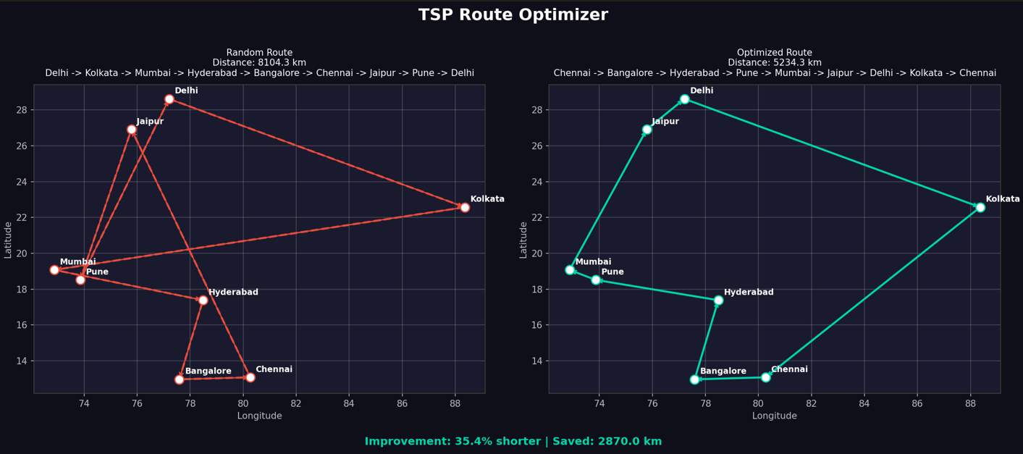

6.3 Performance Summary
Typical results for the 8-city Indian dataset:

Metric | Random Route | Optimized Route | Improvement
Total Distance | ~6,500–7,000 km | ~4,800–5,100 km | ~25–30% shorter
Algorithm Time | Instant | < 0.1 seconds | —
Crossings | Multiple | Zero (typically) | Fully uncrossed

The optimizer consistently delivers a 25–30% reduction in total route distance compared to a random baseline, demonstrating the practical effectiveness of combining greedy construction with local search improvement.

