Python Sql

Tutorial:<https://www.journaldev.com/15539/python-mysql-example-tutorial>

Software Installation:

**ubuntu:**

<http://devopspy.com/linux/install-xampp-ubuntu-16-04-using-terminal/>

http://www.codebind.com/linux-tutorials/install-xampp-ubuntu-16-04/

**windows:**

https://www.wikihow.com/Install-XAMPP-for-Windows

Python is the very good programming and scripting language to work with datbases like SQL ,MongoDb,app engine,non SQL etc.

In this tutorial we are going to work with the mysql database which is available as a local

Before we are going to work with sql in python first we need to install above softwares as well and below python sql module.

**In Linux:**

**Python version2:**

pip install pymysql

**Python version3:**

pip3 install pymysql

**Database connection:**

Here i am using xampp is the database for my applications here

to launch the mysql gui dashboard i need to use below url:

[**http://localhost/phpmyadmin/**](http://localhost/phpmyadmin/)

Here localhost means **127.0.0.1** ip address

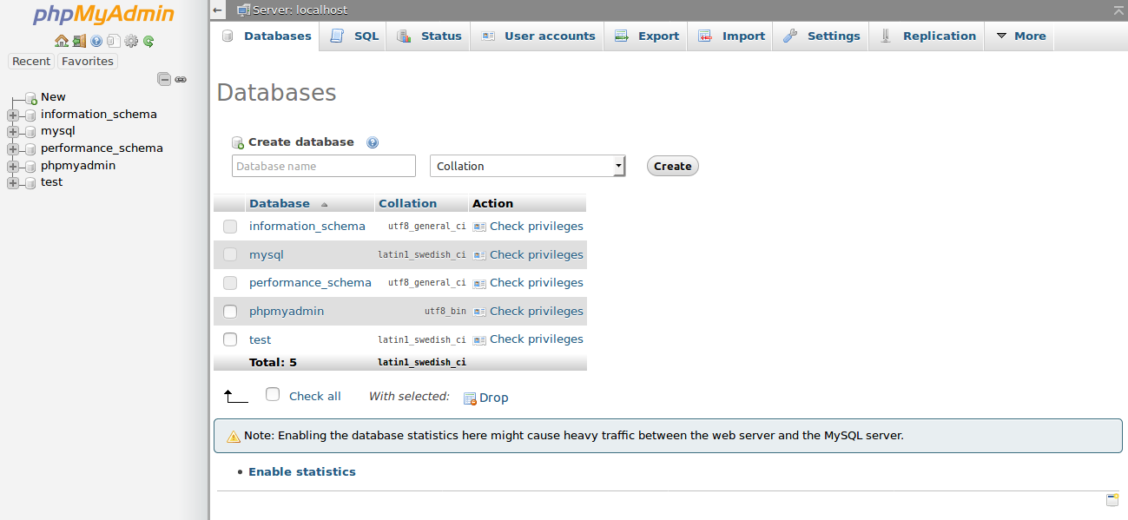

Now create your own database with some name

Ex:PyMySql

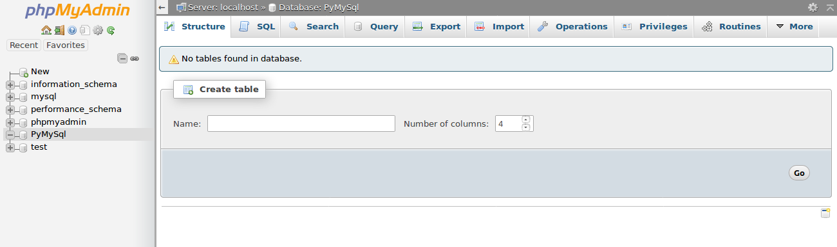

Now database has been created

**import:**

import pymysql

**How to Connect the database:**

To connect the database we need to use below syntax:

pymysql.connect(host="hosttype",user="permission",passwd="",database="databaseName" )

**host:**host name

Ex:Remote host,localhost etc

**user:** user name ,for accessing the database

Ex:john,root,admin etc

**passwd:** password

**databasename:** data base name,in this tutorial we used database name as **PyMySql**

**Ex:**

import pymysql

#database connection

connection = pymysql.connect(host="localhost",user="root",passwd="",database="PyMySql" )

cursor = connection.cursor()

# some other statements with the help of cursor

connection.close()

**How to create the table in database:**

In this tutoarial we are going to create the employee table

which is having the data name,id,company,salary ,experience,designation

**Example:**

import pymysql

#database connection

connection = pymysql.connect(host="localhost", user="root", passwd="", database="PyMySql")

cursor = connection.cursor()

# Query for creating table

EmpTableSql = """CREATE TABLE Emplyee(

ID INT(20) PRIMARY KEY AUTO_INCREMENT,

EMPID INT(20),

NAME CHAR(20) NOT NULL,

DESIGNATION CHAR(10),

EXPERIENCE INT(20),

SALARY INT(20))"""

cursor.execute(EmpTableSql)

connection.close()

**Output:**

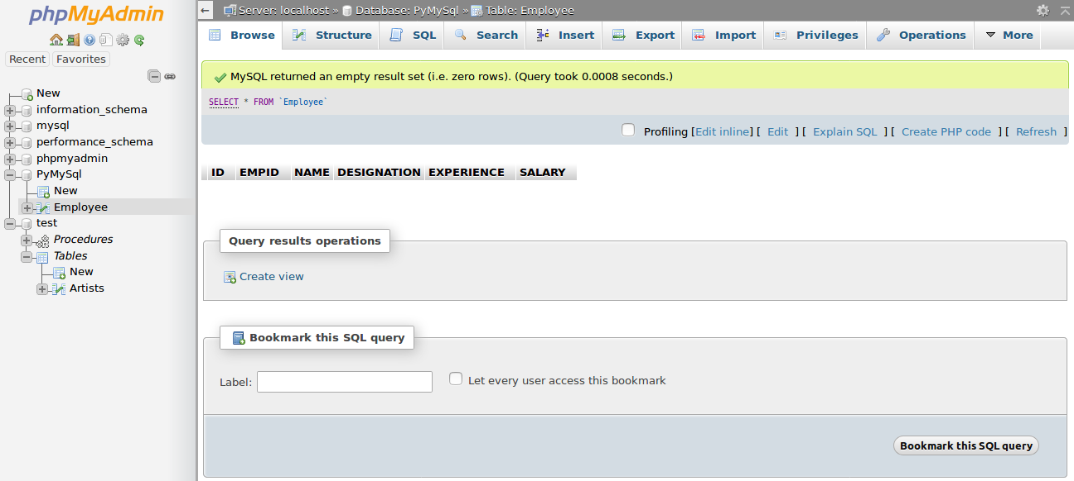

**How to Insert the data into table**

Here we are going to insert the data which ever table we have created

**Example:**

import pymysql

#database connection

connection = pymysql.connect(host="localhost", user="root", passwd="", database="PyMySql")

cursor = connection.cursor()

# queries for inserting values

insert1 = "INSERT INTO Employee(EMPID,NAME,DESIGNATION,EXPERIENCE,SALARY) VALUES(1004,'Abdul', 'SE',2,200000 );"

insert2 = "INSERT INTO Employee(EMPID,NAME,DESIGNATION,EXPERIENCE,SALARY) VALUES(1001,'Kesavan', 'SSE',3,100000 );"

insert3 = "INSERT INTO Employee(EMPID,NAME,DESIGNATION,EXPERIENCE,SALARY) VALUES(1002,'Vikash', 'SE',2,200000 );"

insert4 = "INSERT INTO Employee(EMPID,NAME,DESIGNATION,EXPERIENCE,SALARY) VALUES(1003,'Disha', 'SE',2,200000 );"

#executing the quires

cursor.execute(insert1)

cursor.execute(insert2)

cursor.execute(insert3)

cursor.execute(insert4)

#commiting the connection then closing it.

connection.commit()

connection.close()

**Output:**

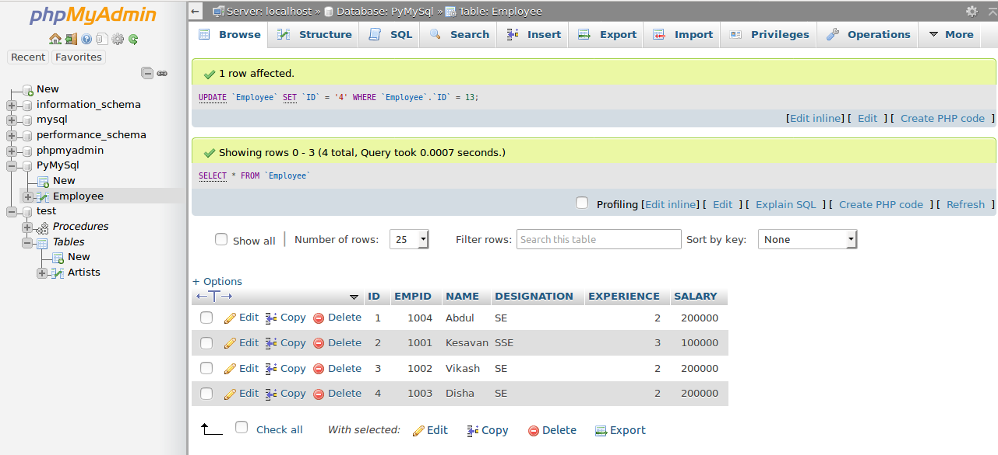

**How to Read the data From the table**

Here we are going to read the data from the table

**Example:**

import pymysql

#database connection

connection = pymysql.connect(host="localhost", user="root", passwd="", database="PyMySql")

cursor = connection.cursor()

# queries for retrievint all rows

retrive = "Select * from Employee;"

#executing the quires

cursor.execute(retrive)

rows = cursor.fetchall()

for row in rows:

print(row)

#commiting the connection then closing it.

connection.commit()

connection.close()

**Output:**

(1, 1004, 'Abdul', 'SE', 2, 200000)

(2, 1001, 'Kesavan', 'SSE', 3, 100000)

(3, 1002, 'Vikash', 'SE', 2, 200000)

(4, 1003, 'Disha', 'SE', 2, 200000)

**How to Update the data into table**

Here we are going to update the data into the table

**Example:**

import pymysql

#database connection

connection = pymysql.connect(host="localhost", user="root", passwd="", database="PyMySql")

cursor = connection.cursor()

updateSql = "UPDATE Employee SET NAME= 'Tauwang' WHERE ID = '1' ;"

cursor.execute(updateSql )

#commiting the connection then closing it.

connection.commit()

connection.close()

**Output:**

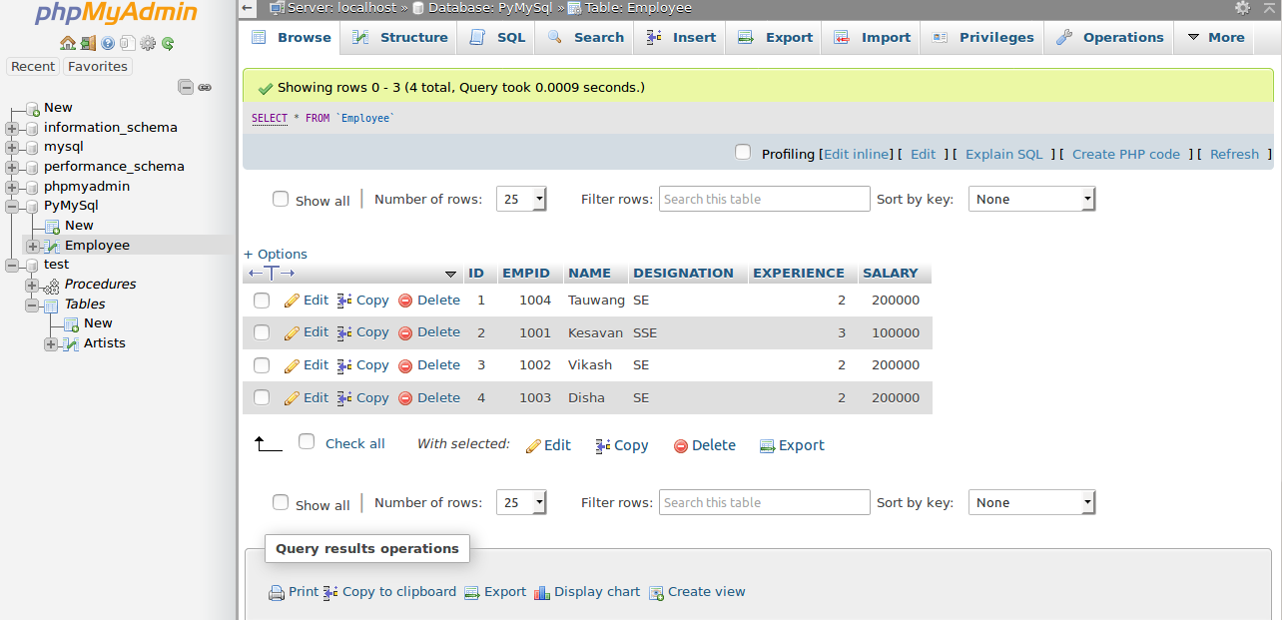

**How to Delete the record data in table**

Here we are going to delete the data into the table

**Example:**

import pymysql

#database connection

connection = pymysql.connect(host="localhost", user="root", passwd="", database="PyMySql")

cursor = connection.cursor()

deleteSql = "DELETE FROM Employee WHERE ID = '1'; "

cursor.execute(deleteSql )

#commiting the connection then closing it.

connection.commit()

connection.close()

**Output:**

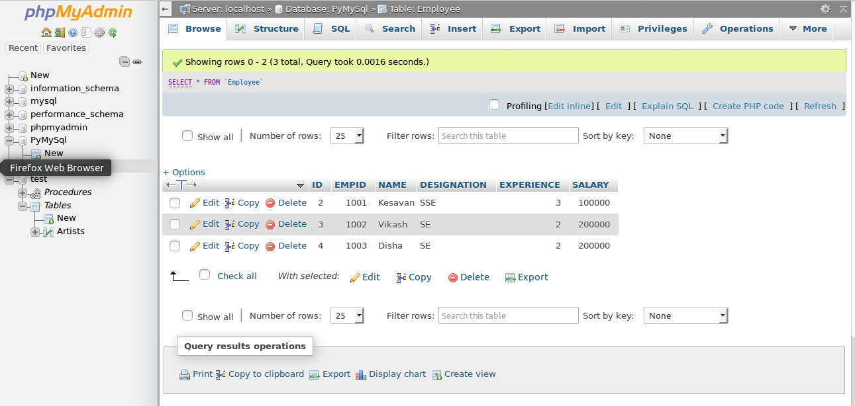

**Drop or delete the table:**

Here we are going to delete the table from database.

**Example:**

import pymysql

#database connection

connection = pymysql.connect(host="localhost", user="root", passwd="", database="PyMySql")

cursor = connection.cursor()

dropSql = "DROP TABLE IF EXISTS Employee;"

cursor.execute(dropSql)

#commiting the connection then closing it.

connection.commit()

connection.close()

**Output:**

