**MongoDB Task**

**MongoDB**

MongoDB is a popular, open-source NoSQL database management system known for its flexibility, scalability, and ease of use.

It is designed to handle large volumes of unstructured or semi-structured data, making it well-suited for a wide range of applications

**Key Concepts:**

* Document- Oriented - it stores data in JSON-like documents
* Collections- data into collections (tables)
* NoSQL- (Not Only SQL) database ,No fixed schemas/structure
* Scalability- handling large datasets.(load balance)

**1. Find all the information about each products**

**Answer:**

**db.products.find();**

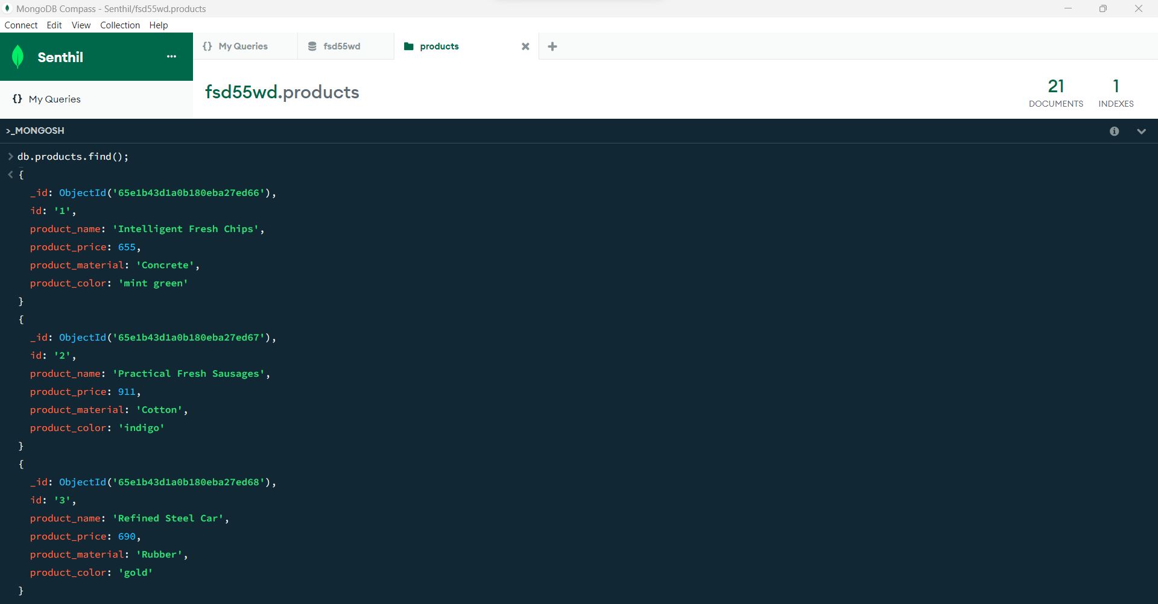

**.**

**.**

**.**

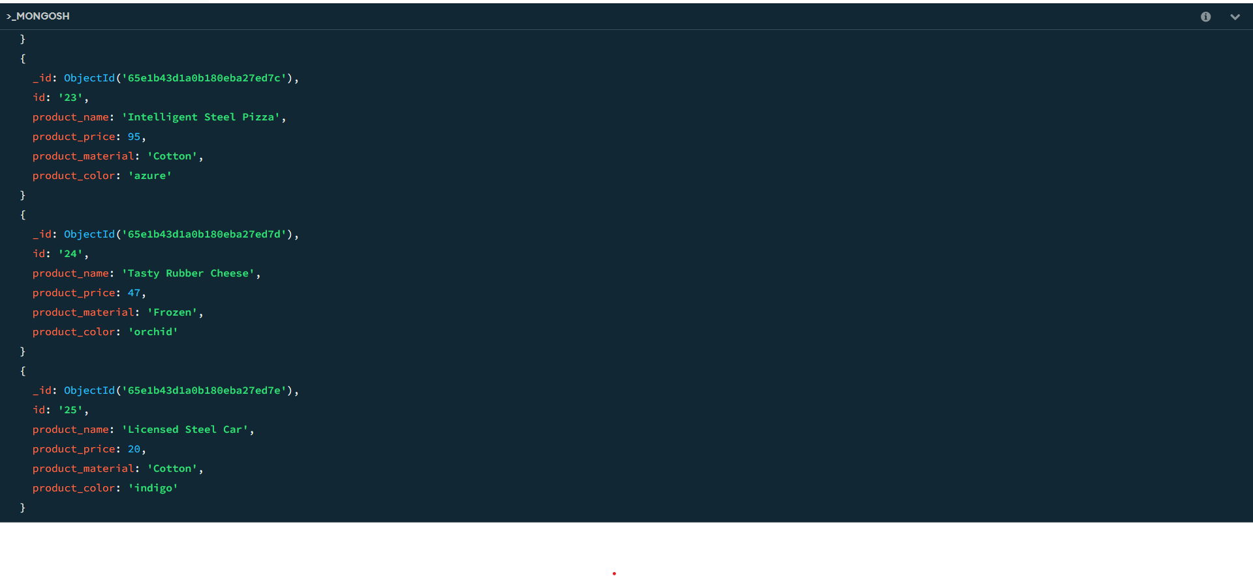

**2. Find the product price which are between 400 to 800**

**Answer:**

**db.products.find({product_price:{$gt:400,$lt:800}});**

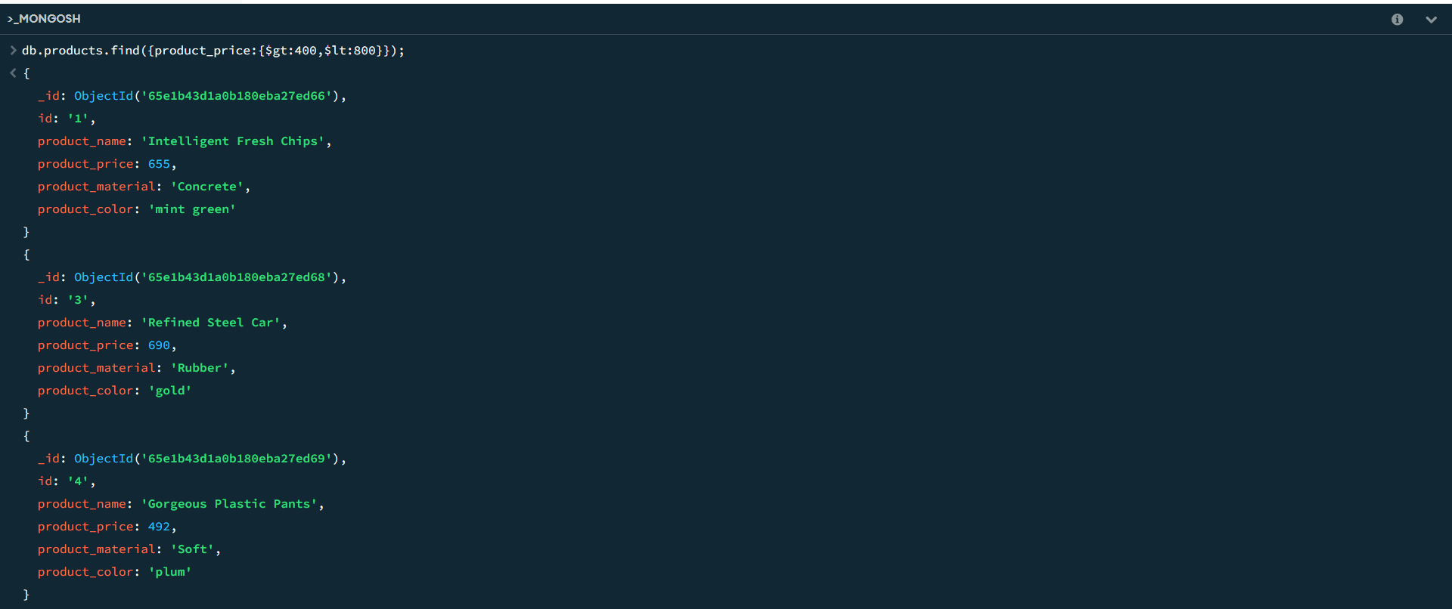

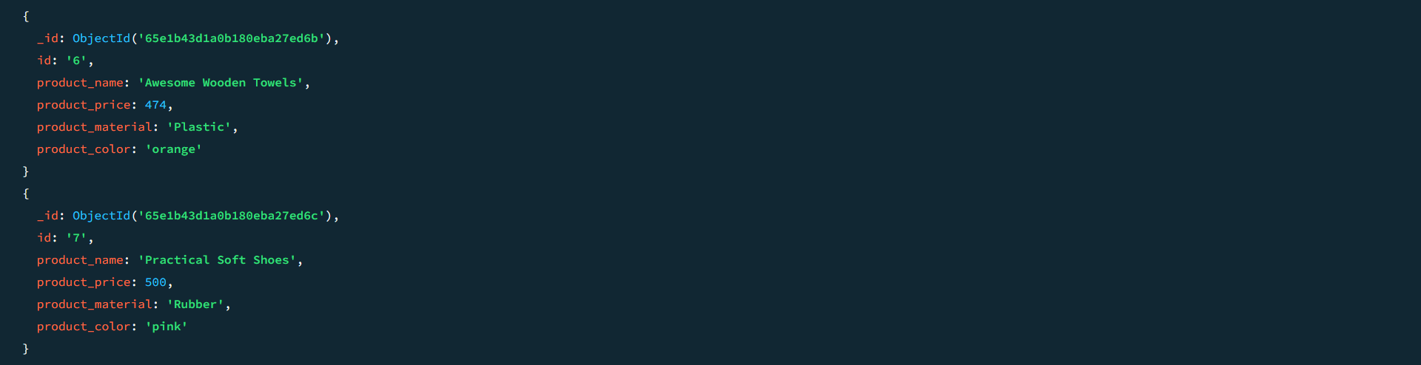

**3.Find the product price which are not between 400 to 600**

**Answer:**

**db.products.find({product_price:{$not:{$gte:400,$lte:600}}});**

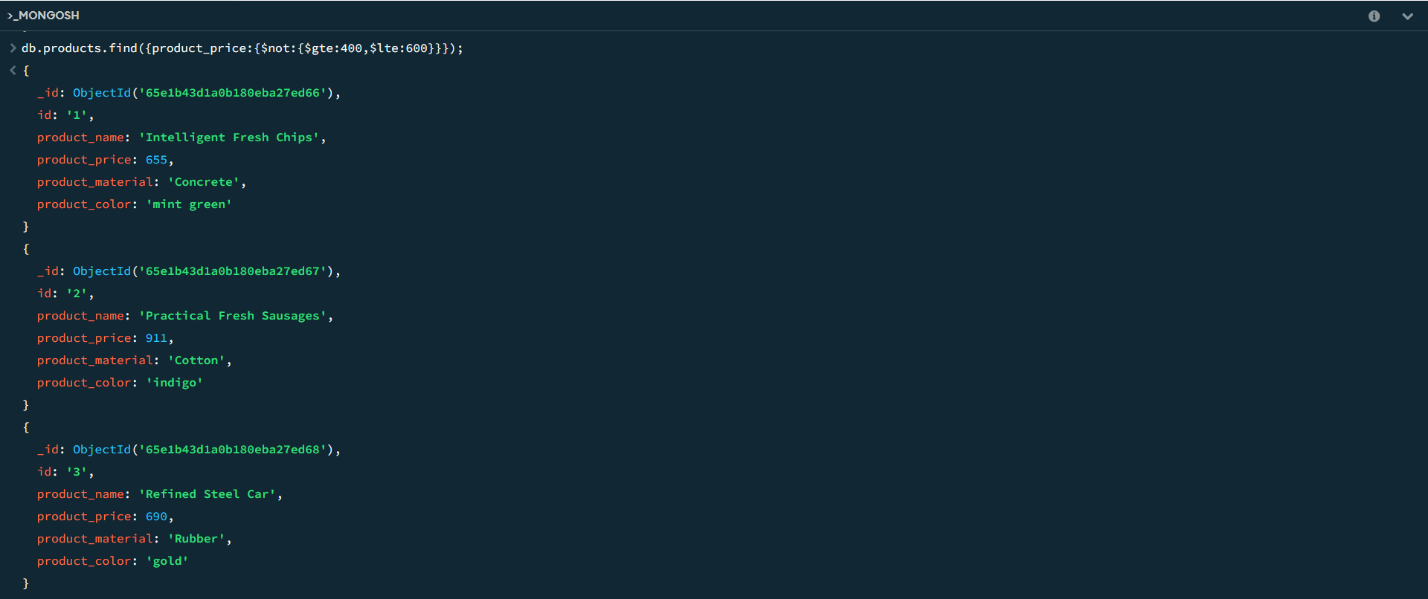

**.**

**.**

**.**

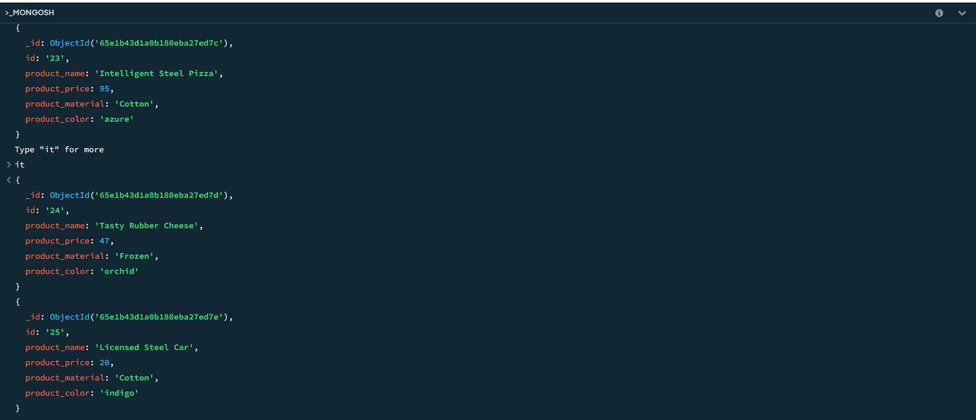

**4. List the four product which are greater than 500 in price**

**Answer:**

**db.products.find({product_price:{$gte:500}}).limit(4);**

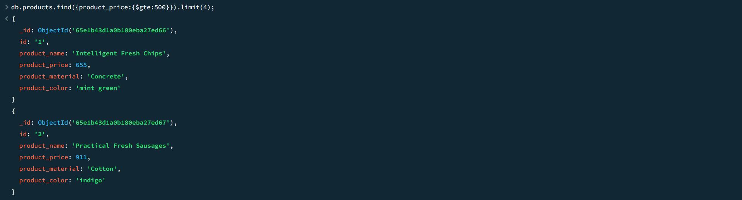

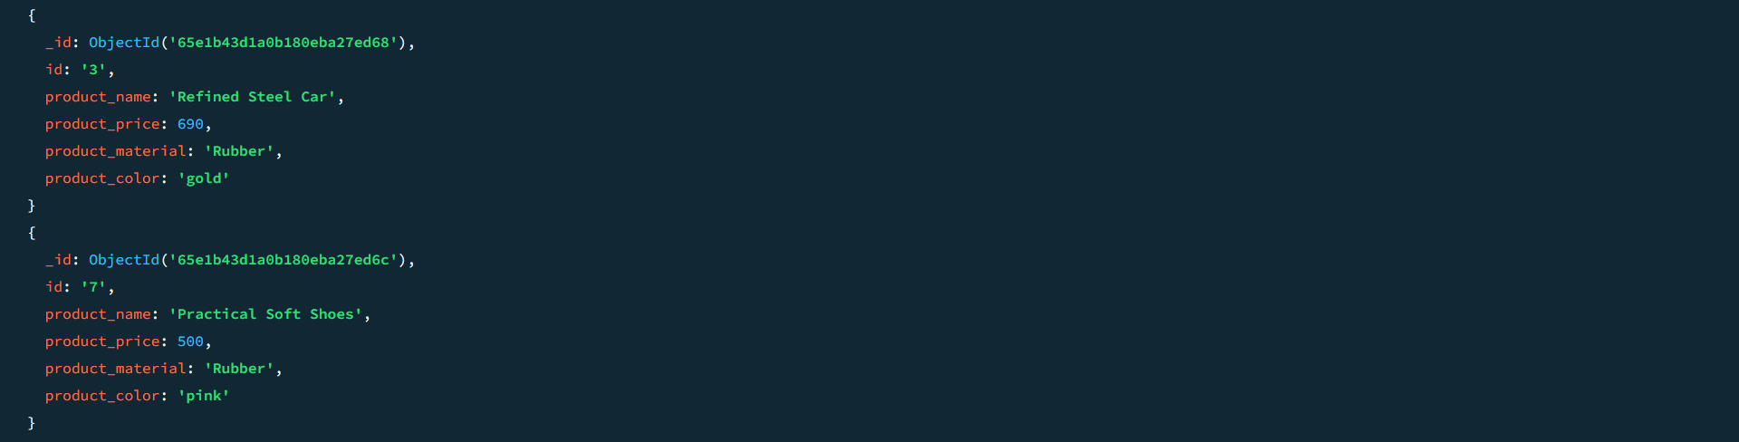

**5.Find the product name and product material of each products**

**Answer:**

**db.products.find({},{product_name:1,product_material:1});**

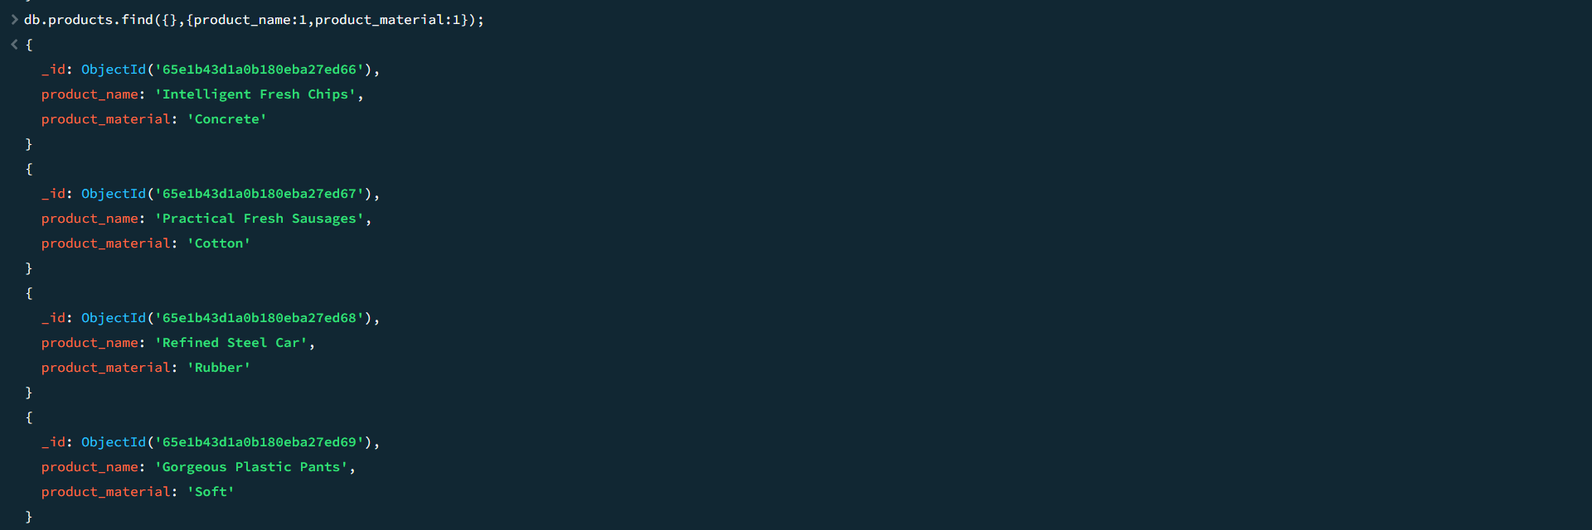

**.**

**.**

**.**

**.**

**.**

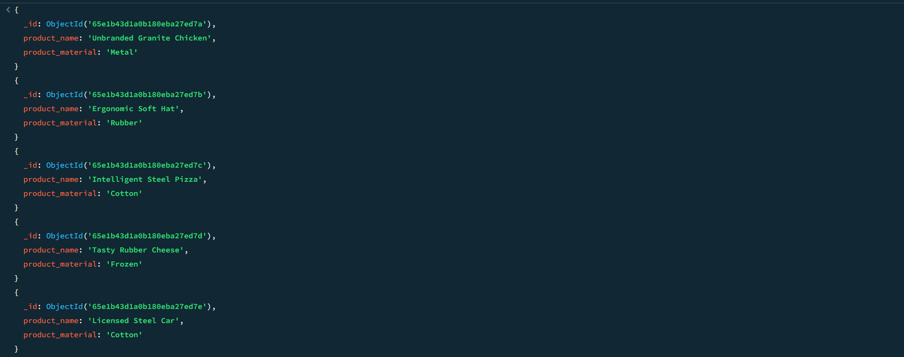

**6. Find the product with a row id of 10**

**Answer:**

**db.products.find({id:"10"});**

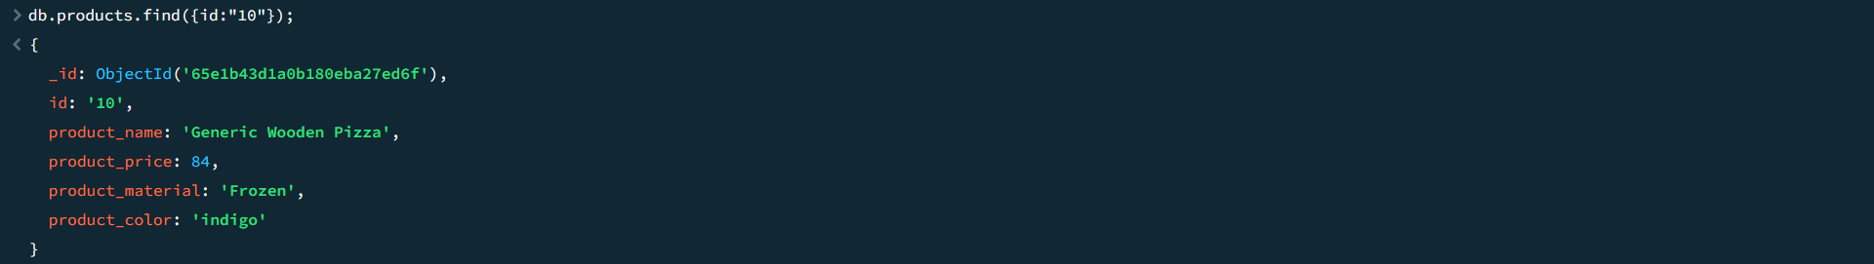

**7. Find only the product name and product material**

**Answer:**

**db.products.find({},{product_name:1,product_material:1,_id:0});**

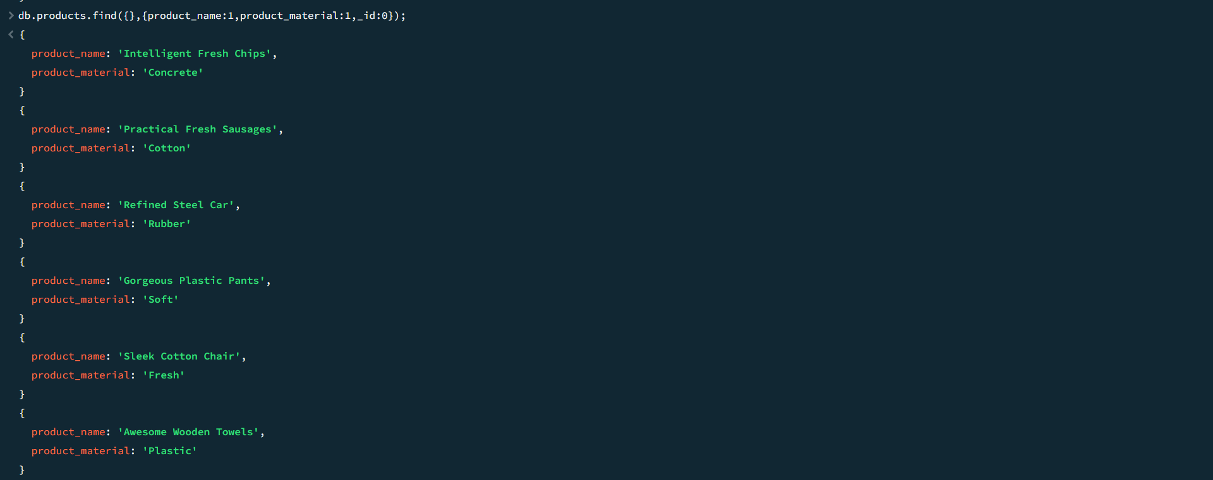

**.**

**.**

**.**

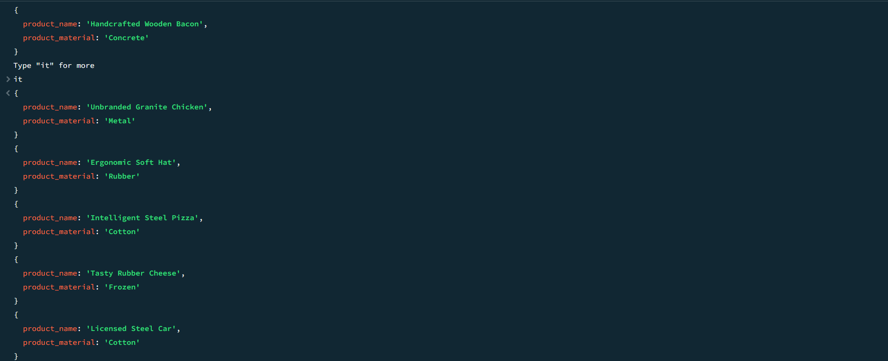

**8. Find all products which contain the value of soft in product material**

**Answer:**

**db.products.find({product_material:”soft”});**



**9. Find products which contain product color indigo and product price 492.00**

**Answer:**

**db.products.find({$or:[{product_color:'indigo'},{product_price:492}]});**

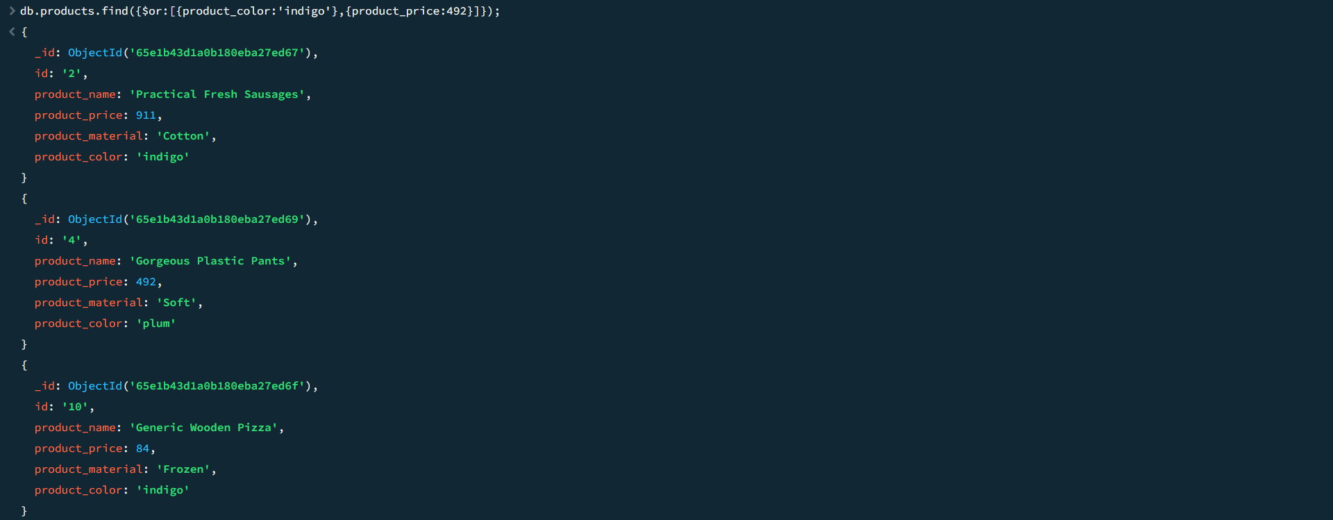

**.**

**.**

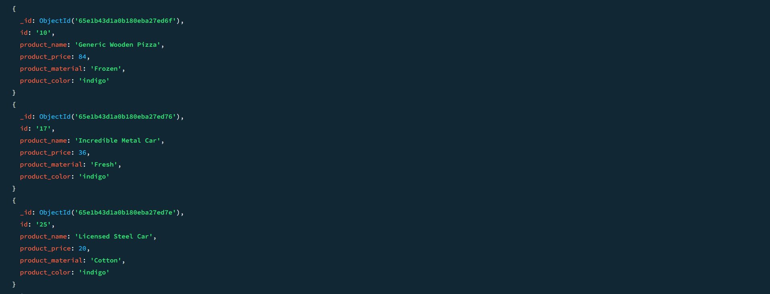

**10. Delete the products which product price value are same**

**Answer:**

**db.products.aggregate([{$group:{_id:'$product_price',count:{$sum:1}}},{$match:{count:{$gt:1}}}]).forEach((e)=>{db.products.deleteMany({product_price:e._id})});**

