**Design Database for Zen Class Programme**

**Create database**

use Zen-Class-Database;

**Create collection and insert data – “Users”**

db.createCollection("users");

db.users.insertMany([

{ user_id: 1, name: "senthil", email: "senthil@gmail.com" },

{ user_id: 2, name: "selva", email: "selva@gmail.com" },

{ user_id: 3, name: "muthu", email: "muthu@gmail.com" },

{ user_id: 4, name: "sanjeev", email: "sanjeev@gmail.com" },

{ user_id: 5, name: "mayura", email: "mayu@gmail.com" },

{ user_id: 6, name: "gokul", email: "gokul@gmail.com" },

{ user_id: 7, name: "vinoth", email: "vino@gmail.com" },

{ user_id: 8, name: "kathir", email: "kathir@gmail.com" }]);

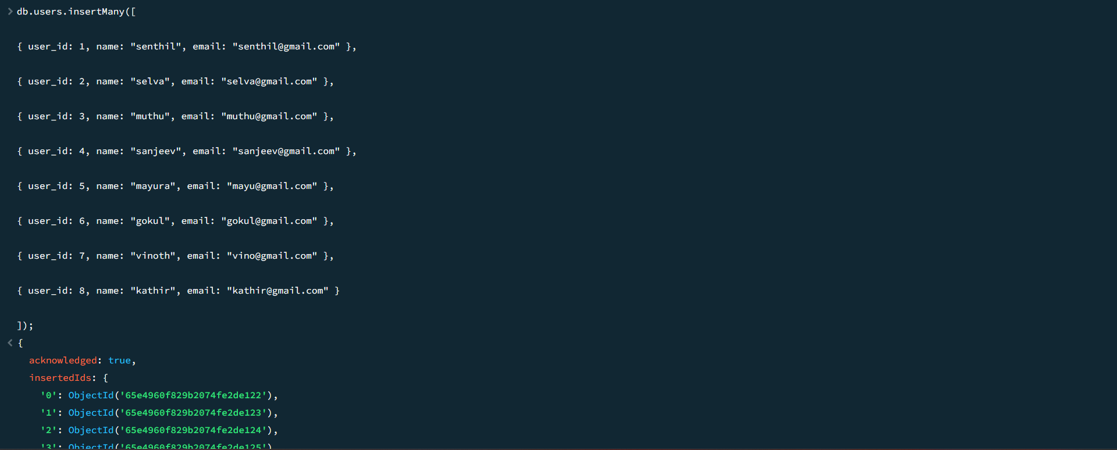

**Create collection and insert data – “Codekata”**

db.createCollection("codekata");

db.codekata.insertMany([

{ user_id: 1, problems: 50 },

{ user_id: 2, problems: 60 },

{ user_id: 3, problems: 90 },

{ user_id: 4, problems: 51 },

{ user_id: 5, problems: 61 },

{ user_id: 6, problems: 72 },

{ user_id: 7, problems: 83 },

{ user_id: 8, problems: 55 }]);

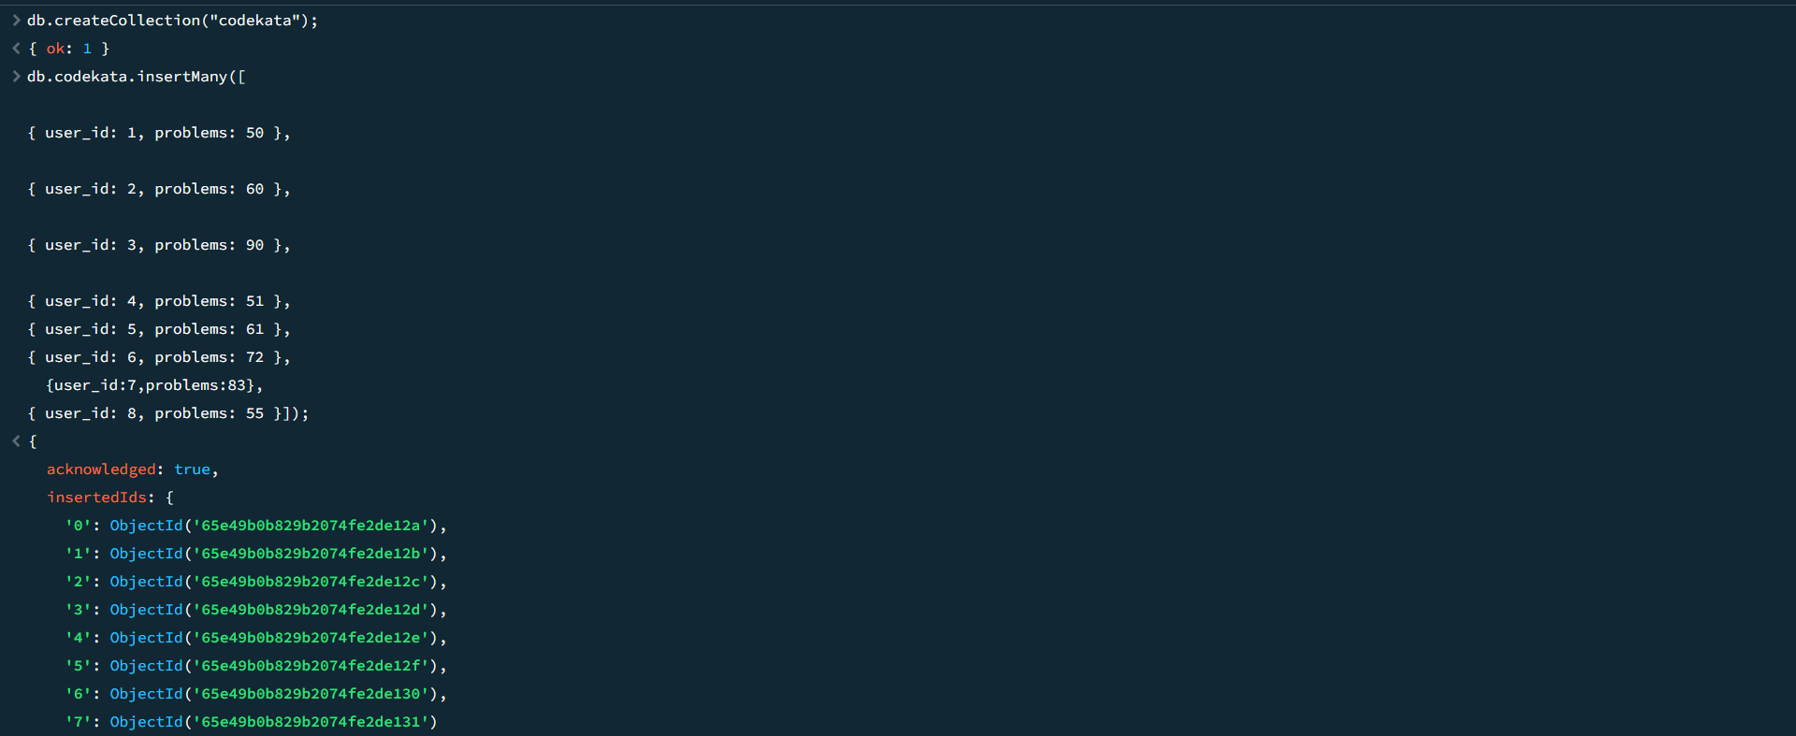

**Create collection and insert data – “Attendance”**

db.createCollection("attendance");

db.attendance.insertMany([

{ user_id: 1, topicid: 2, attended: true },

{ user_id: 2, topicid: 1, attended: true },

{ user_id: 3, topicid: 5, attended:false },

{ user_id: 4, topicid: 3, attended: true },

{ user_id: 5, topicid: 4, attended: false },

{user_id: 6, topicid: 8, attended: true },

{user_id: 7, topicid: 6, attended: false },

{user_id: 8, topicid: 7, attended: true }]);

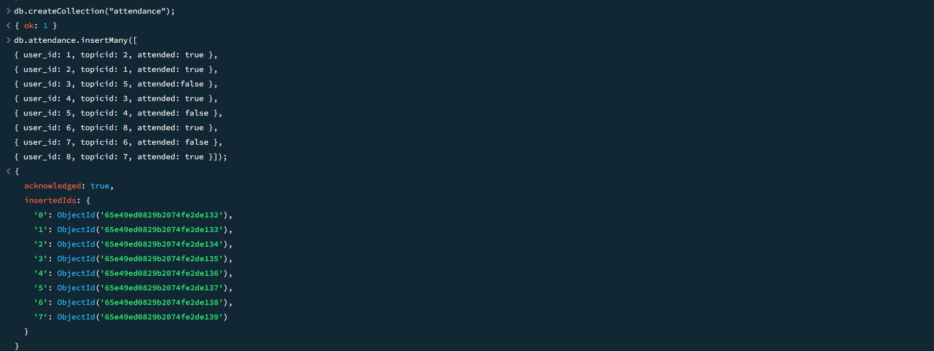

**Create collection and insert data – “Topics”**

db.createCollection("topics");

db.topics.insertMany([

{ topicid: 1, topic: "HTML", topic_date: new Date("18-Oct-2020") },

{ topicid: 2, topic: "CSS", topic_date: new Date("28-Oct-2020") },

{ topicid: 3, topic: "JavaScript", topic_date: new Date("05-Nov-2020") },

{ topicid: 4, topic: "ReactJS", topic_date: new Date("15-Nov-2020") },

{ topicid: 5, topic: "NodeJS", topic_date: new Date("19-Nov-2020") },

{ topicid: 6, topic: "Bootstrap", topic_date: new Date("15-Oct-2020") },

{ topicid: 7, topic: "ExpressJS", topic_date: new Date("20-Oct-2020") },

{ topicid: 8, topic: "VueJS", topic_date: new Date("25-Nov-2020") }]);

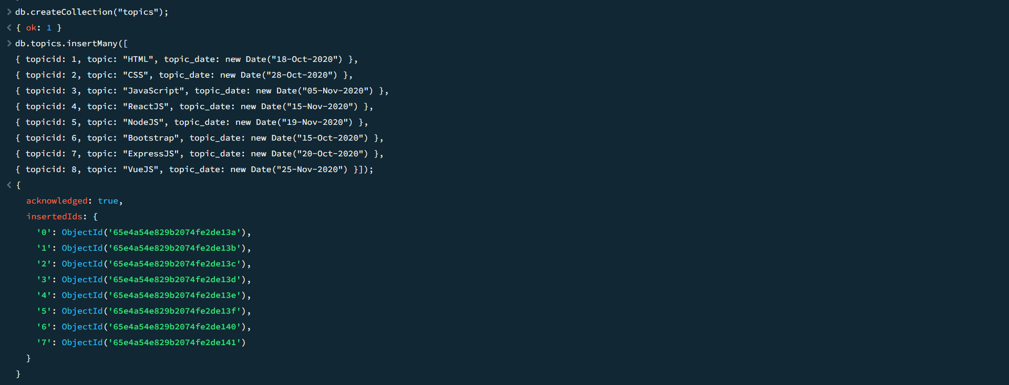

**Create collection and insert data – “Tasks”**

db.createCollection("tasks");

db.tasks.insertMany([

{ taskid: 1, topicid: 1, user_id: 1, task: "HTML Task", due_date: new Date("18-Oct-2020"), submitted: true },

{ taskid: 2, topicid: 2, user_id: 2, task: "CSS Task", due_date: new Date("28-Oct-2020"), submitted: false },

{ taskid: 3, topicid: 3, user_id: 3, task: "Javascript Task", due_date: new Date("05-Nov-2020"), submitted: true },

{ taskid: 4, topicid: 4, user_id: 4, task: "ReactJS Task", due_date: new Date("15-Nov-2020"), submitted: false },

{ taskid: 5, topicid: 5, user_id: 5, task: "NodeJS Task", due_date: new Date("19-Nov-2020"), submitted: true },

{ taskid: 6, topicid: 6, user_id: 6, task: "Bootstrap Task", due_date: new Date("15-Oct-2020"), submitted: false },

{ taskid: 7, topicid: 7, user_id: 7, task: "ExpressJS Task", due_date: new Date("20-Oct-2020"), submitted: true },

{ taskid: 8, topicid: 8, user_id: 8, task: "VueJS Task", due_date: new Date("25-Nov-2020"), submitted: false }]);

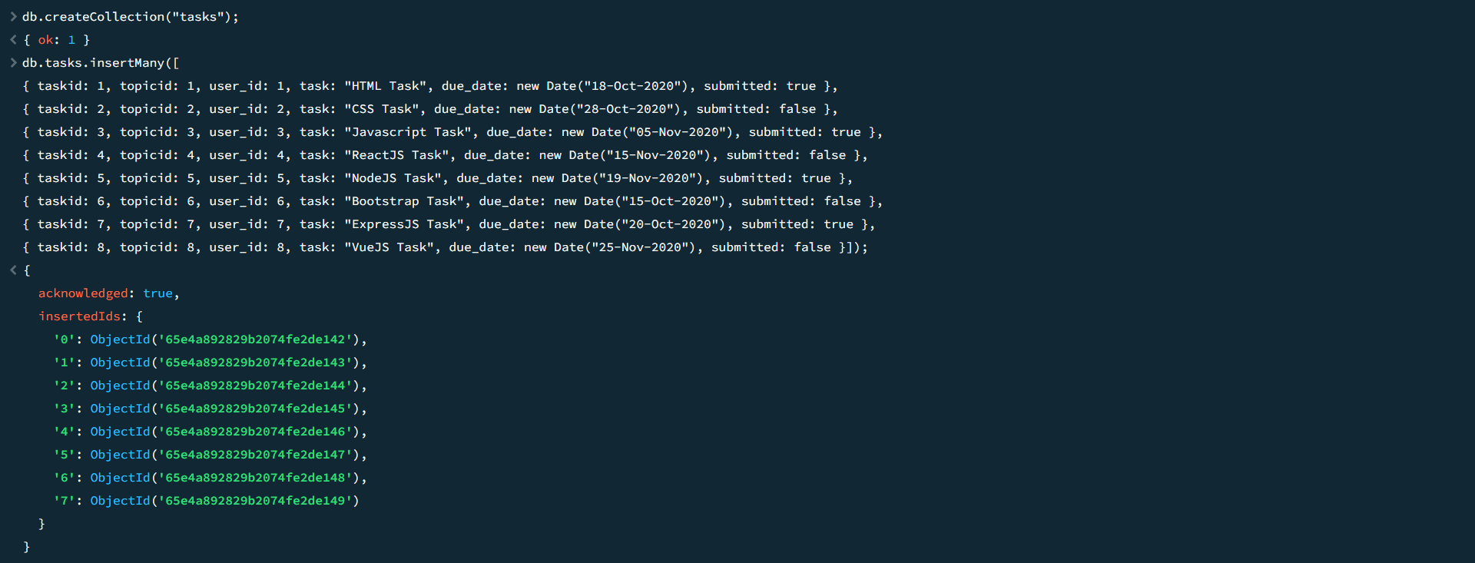

**Create collection and insert data – “Company Drivers”**

db.createCollection("companydrives");

db.companydrives.insertMany([

{ user_id: 1, drive_date: new Date("20-Oct-2020"), company: "Apple" },

{ user_id: 2, drive_date: new Date("22-Oct-2020"), company: "Amazon" },

{ user_id: 3, drive_date: new Date("25-Oct-2020"), company: "TCS" },

{ user_id: 4, drive_date: new Date("30-Oct-2020"), company: "CTS" },

{ user_id: 5, drive_date: new Date("28-Oct-2020"), company: "ZOHO" },

{ user_id: 6, drive_date: new Date("15-Nov-2020"), company: "Flipkart" },

{ user_id: 7, drive_date: new Date("05-Nov-2020"), company: "HCL" },

{ user_id: 8, drive_date: new Date("24-Oct-2020"), company: "SVT" }]);

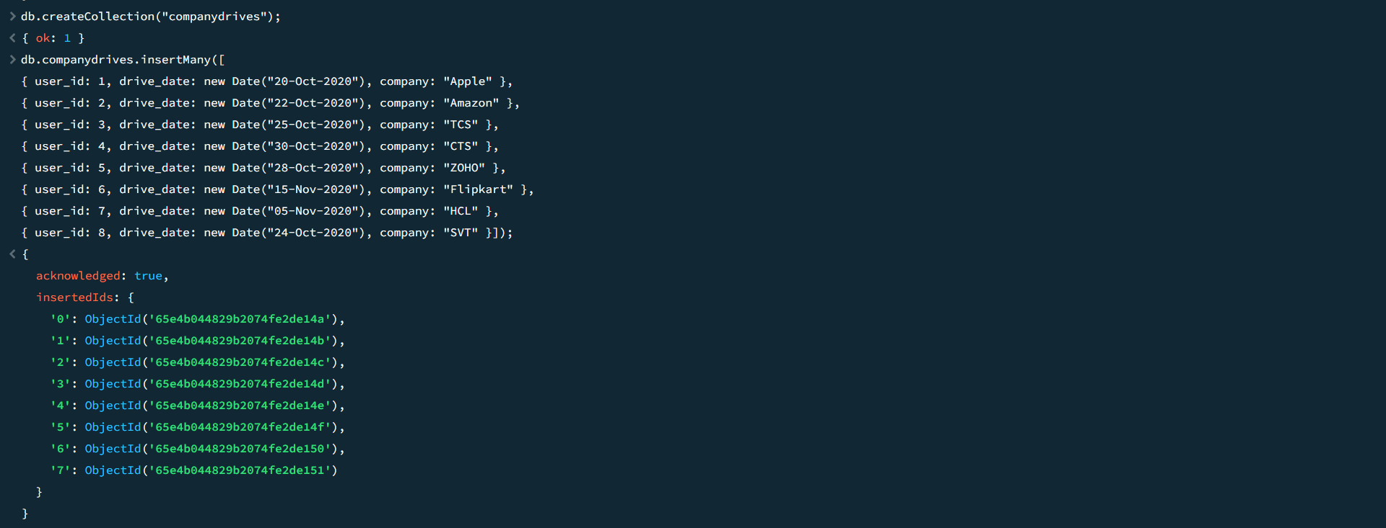

**Create collection and insert data – “Mentors”**

db.createCollection("mentors");

db.mentors.insertMany([

{ mentorid: 1, mentorname: "Rupan", mentor_email: "rupan@gmail.com", mentee_count: 20 },

{ mentorid: 2, mentorname: "Nagaraj", mentor_email: "nagaraj@gmail.com", mentee_count: 18 },

{ mentorid: 3, mentorname: "Krishna", mentor_email: "krishna@gmail.com", mentee_count: 30 },

{ mentorid: 4, mentorname: "Parthi", mentor_email: "parthi@gmail.com", mentee_count: 15 },

{ mentorid: 5, mentorname: "Sabhari", mentor_email: "sabhari@gmail.com", mentee_count: 17 },

{ mentorid: 6, mentorname: "Ganesh", mentor_email: "ganesh@gmail.com", mentee_count: 14 },

{ mentorid: 7, mentorname: "Manoj", mentor_email: "manoj@gmail.com", mentee_count: 20 },

{ mentorid: 8, mentorname: "Gowtham", mentor_email: "gowtham@gmail.com", mentee_count: 18 }]);

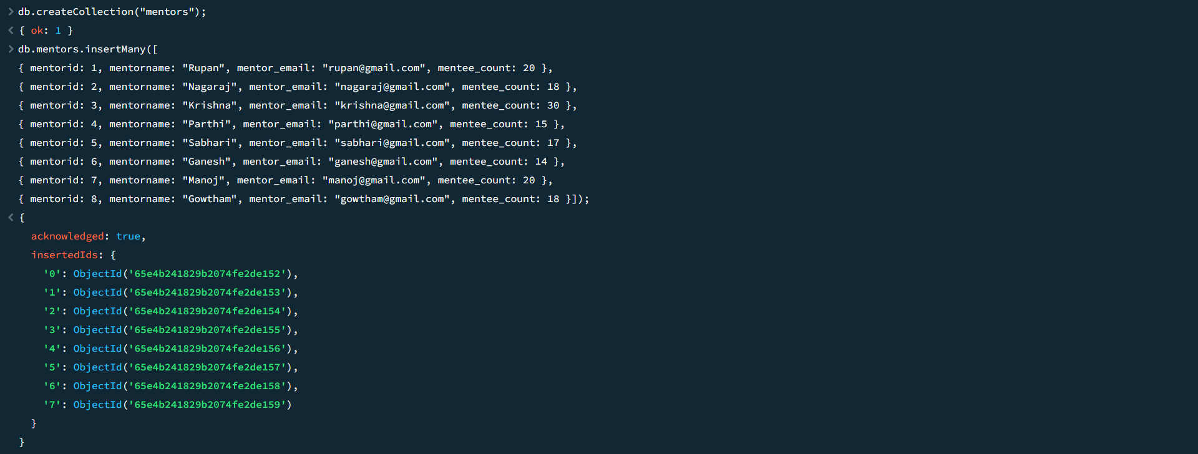

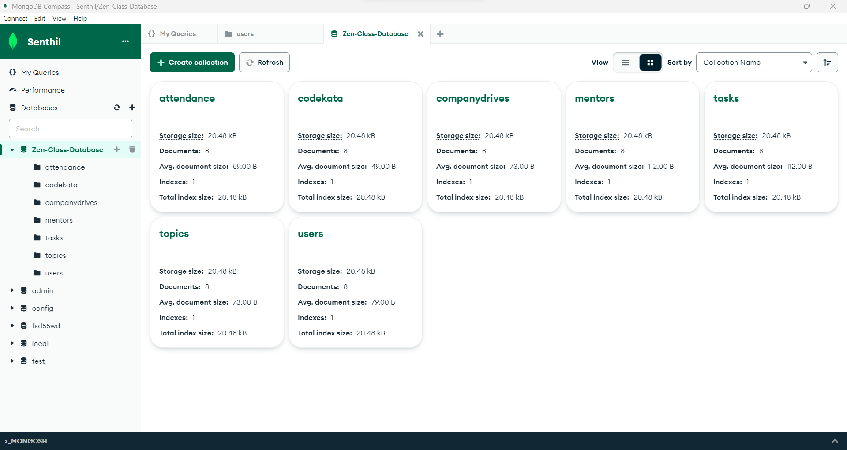

**1. Find all the topics and tasks which are thought in the month of October**

**Answer:**

**db.topics.aggregate([**

**{**

**$lookup: {**

**from: "tasks",**

**localField: "topicid",**

**foreignField: "topicid",**

**as: "taskinfo"**

**}},{**

**$match: {**

**$and: [**

**{ topic_date: { $gte: new Date("2020-10-01"), $lt: new Date("2020-11-01") } },**

**{**

**$or: [**

**{ "taskinfo.due_date": { $gte: new Date("2020-10-01"), $lt: new Date("2020-11-01") } },**

**{ "taskinfo.due_date": { $exists: false } }**

**]}]}**

**},{**

**$project: {**

**_id: 0,**

**topicid: 1,**

**topic: 1,**

**topic_date: 1,**

**tasks: "$taskinfo.task",**

**due_dates: "$taskinfo.due_date"**

**}**

**}]);**

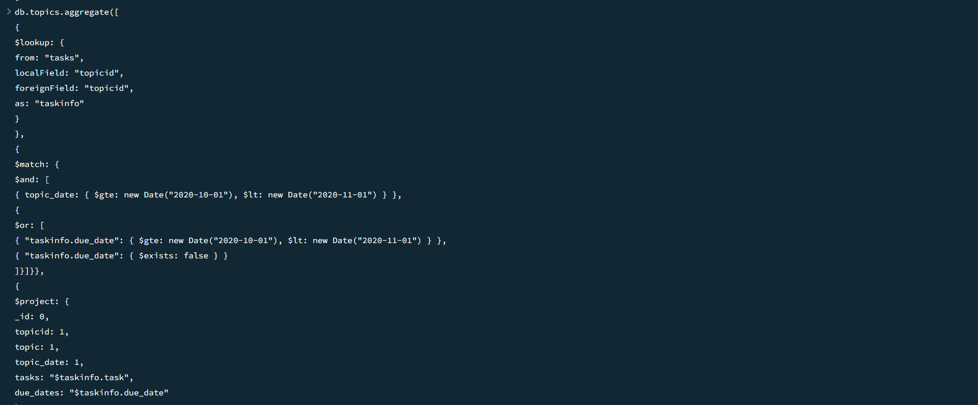

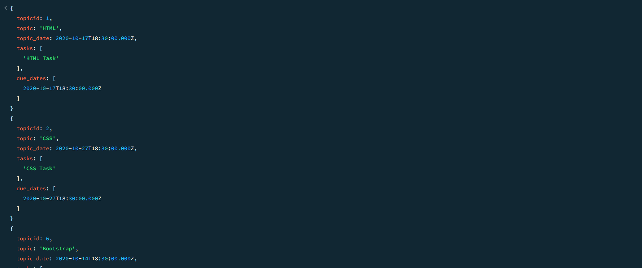

**2. Find all the company drives which appeared between 15 oct-2020 and 31-oct-2020**

**Answer:**

**db.companydrives.find({**

**$or: [**

**{ drive_date: { $gte: new Date("15-oct-2020") } },**

**{ drive_date: { $lte: new Date("31-oct-2020") } }**

**]});**

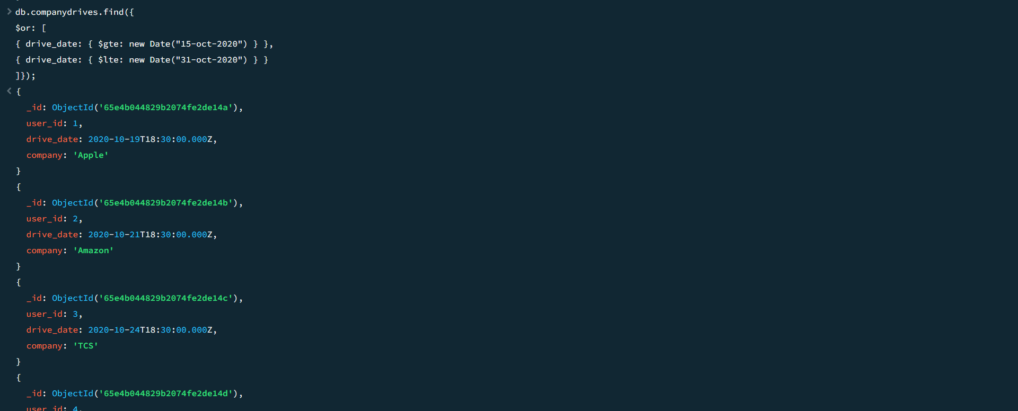

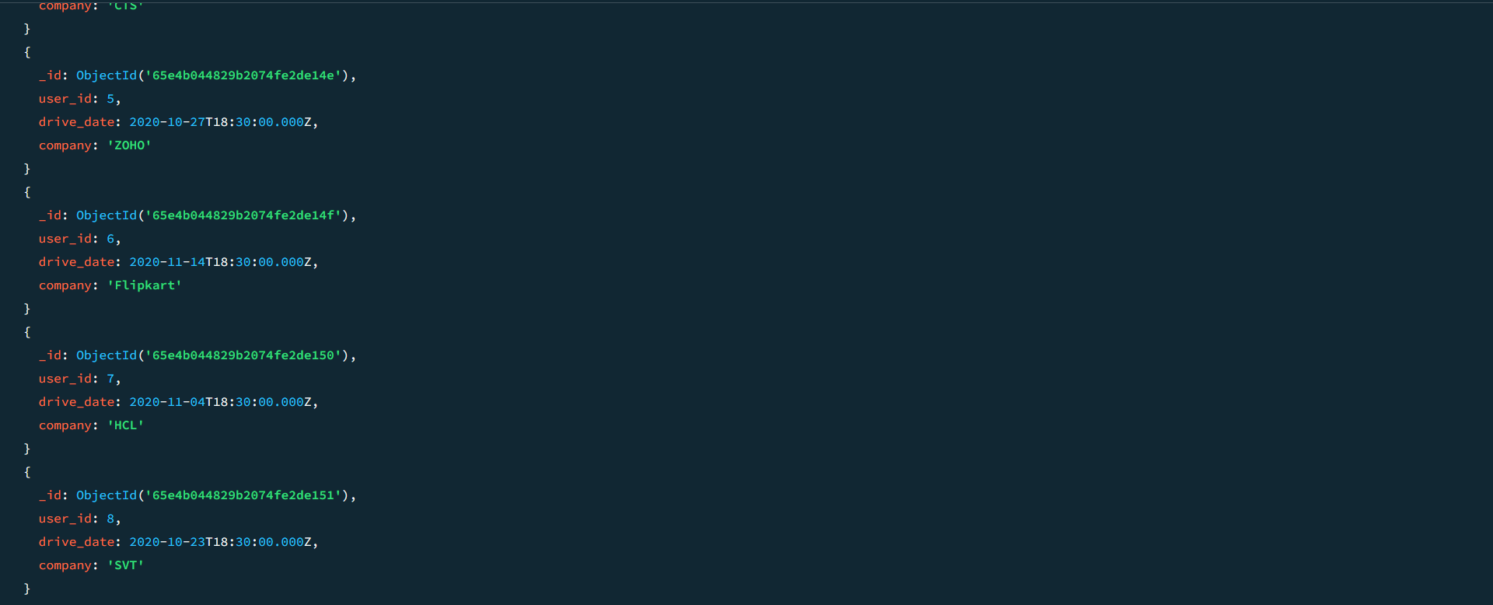

**3. Find all the company drives and students who are appeared for the placement :**

**Answer:**

**db.companydrives.aggregate([**

**{**

**$lookup: {**

**from: "users",**

**localField: "userid",**

**foreignField: "userid",**

**as: "userinfo"**

**}**

**},**

**{**

**$project: {**

**_id: 0,**

**company: 1,**

**drive_date: 1,**

**students: "$userinfo"**

**}} ]);**

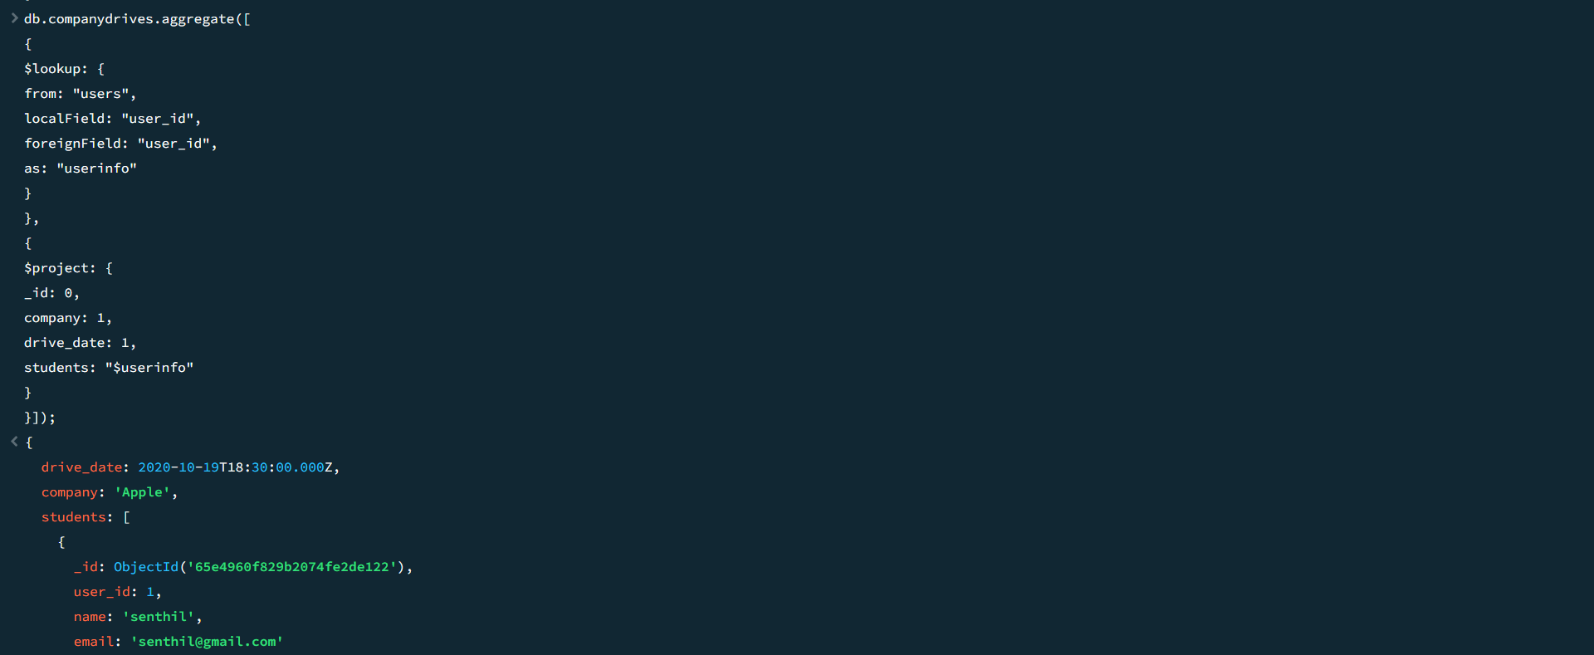

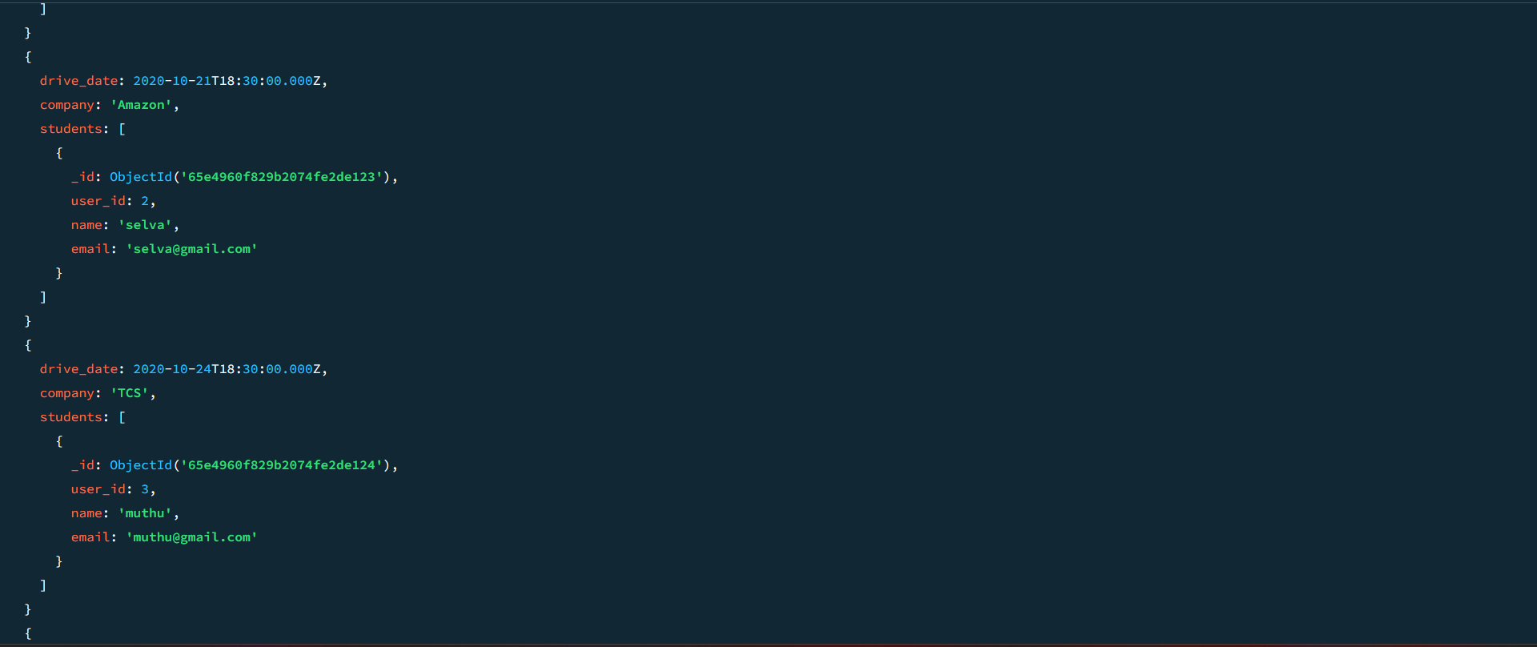

**4. Find the number of problems solved by the user in codekata**

**Answer:**

**db.codekata.aggregate([**

**{**

**$lookup: {**

**from: "users",**

**localField: "userid",**

**foreignField: "userid",**

**as: "userinfo"**

**}**

**},**

**{**

**$group: {**

**_id: {**

**username: "$userinfo.name"**

**},**

**total_problems_solved: { $sum: "$problems" }**

**}**

**},**

**{**

**$project: {**

**_id: 0,**

**userid: "$_id.userid",**

**username: "$_id.username",**

**total_problems_solved: 1**

**}**

**}**

**]);**

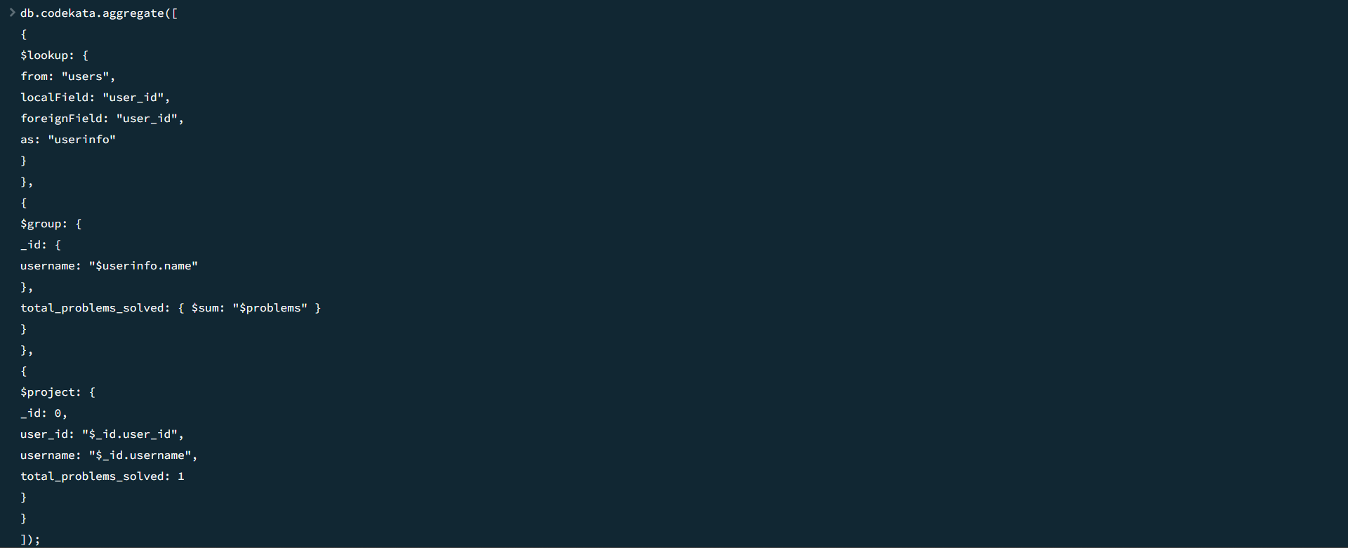

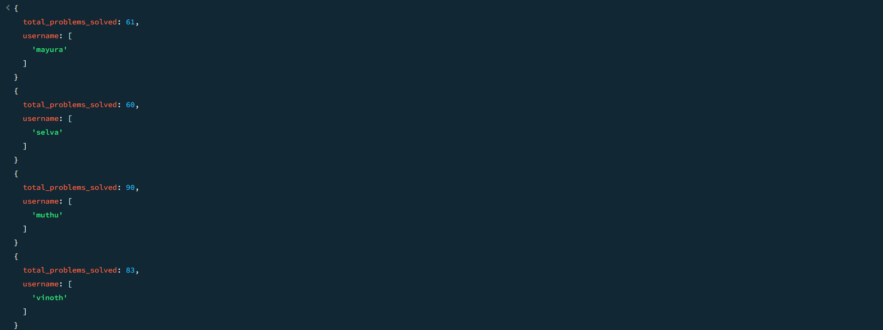

**5. Find all the mentors with who has the mentee's count more than 15**

**Answer:**

**db.users.aggregate([**

**{**

**$match: { mentorid: { $exists: true } }**

**},**

**{**

**$group: {**

**_id: "$mentorid",**

**mentorname: { $first: "$mentorname" },**

**mentee_count: { $sum: 1 }**

**}**

**},**

**{**

**$match: { mentee_count: { $gt: 15 } }**

**},**

**{**

**$project: {**

**_id: 0,**

**mentorid: "$_id",**

**mentorname: 1,**

**mentee_count: 1**

**}**

**}**

**]);**

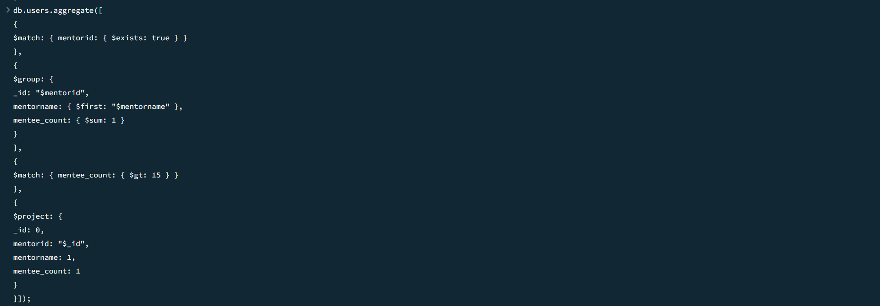

**6. Find the number of users who are absent and task is not submitted between 15 oct-2020 and 31-oct-2020**

**Answer:**

**db.attendance.aggregate([**

**{**

**$lookup: {**

**from: "topics",**

**localField: "topicid",**

**foreignField: "topicid",**

**as: "topics"**

**}**

**},**

**{**

**$lookup: {**

**from: "tasks",**

**localField: "topicid",**

**foreignField: "topicid",**

**as: "tasks"**

**}**

**},**

**{**

**$match: {**

**attended: false,**

**"tasks.submitted": false,**

**$and: [**

**{ "topics.topic_date": { $gte: new Date("15-oct-2020") } },**

**{ "topics.topic_date": { $lte: new Date("31-oct-2020") } },**

**{ "tasks.due_date": { $gte: new Date("15-oct-2020") } },**

**{ "tasks.due_date": { $lte: new Date("31-oct-2020") } }**

**]**

**}**

**},**

**{$count: "No_of_students_absent"}]);**

