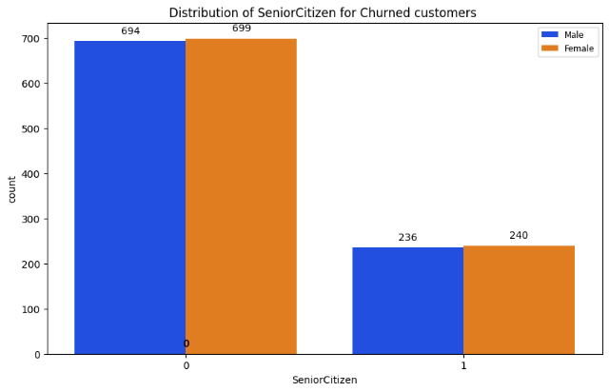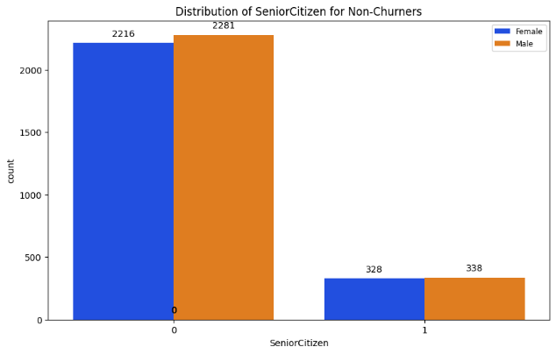

Male Senior citizen churner = 236

Male Senior citizen non-churner = 338

Male senior churn % = 236/(236+338) = 41%

Female Senior citizen churner = 240

Female Senior citizen non-churner = 328

Female senior churn % = 42

Male non-Senior citizen churner = 694

Male non-Senior citizen non-churner = 2281

Male non-senior churn % = 23

Female non-Senior citizen churner = 699

Female non-Senior citizen non-churner = 2216

Female non-senior churn % = 24

Conclusion :

* Female senior citizens have a high chance of churning with a churn % of 42
* Male non-senior citizens are least likely to churn with a churn % of 23

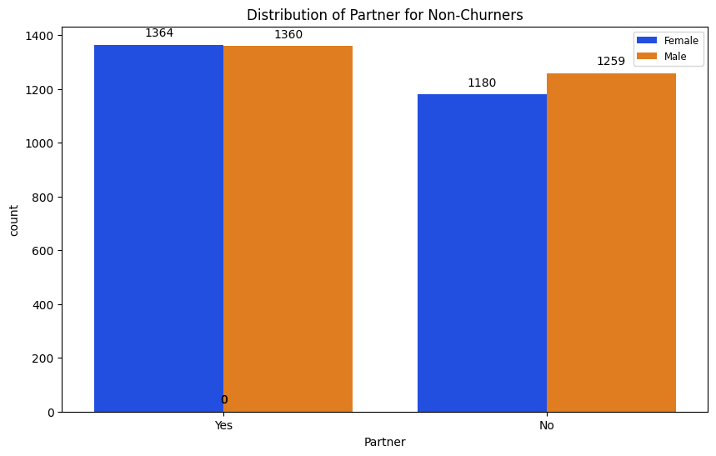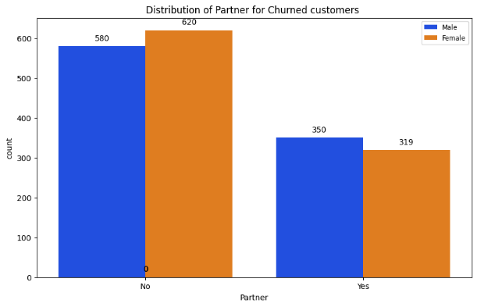

Male with partner churner = 350

Male with partner non-churner = 1360

Male with partner churn % = 20.45

Female with partner churner = 319

Female with partner non-churner = 1364

Female with partner churn % = 18.98

Male without partner churner = 580

Male without partner non-churner = 1259

Male without partner churn % = 31.58

Female without partner churner = 620

Female without partner non-churner = 1180

Female without partner churn % = 34.43

Conclusion:

* Female without partners have the highest churn percentage at 34.43%.
* Female with partners have the lowest churn percentage at 18.98%.

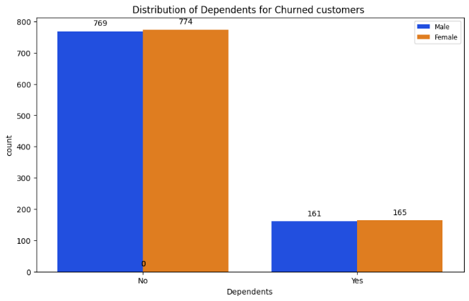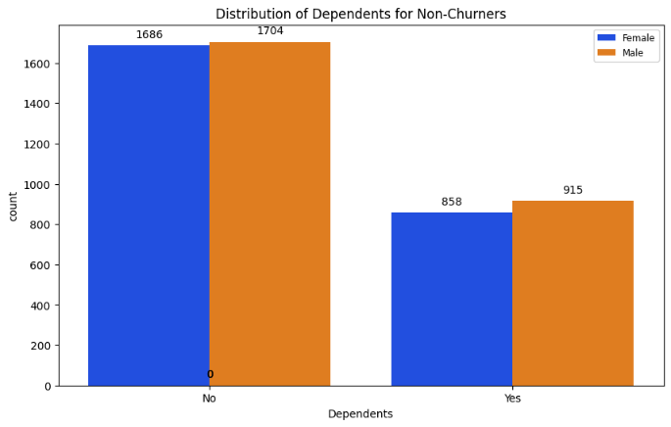

Male with dependents churner = 161

Male with dependents non-churner = 915

Male with dependents churn % = 14.97

Female with dependents churner = 165

Female with dependents non-churner = 858

Female with dependents churn % = 16.12

Male without dependents churner = 769

Male without dependents non-churner = 1704

Male without dependents churn % = 31.1

Female without dependents churner = 774

Female without dependents non-churner = 1686

Female without dependents churn % = 31.46

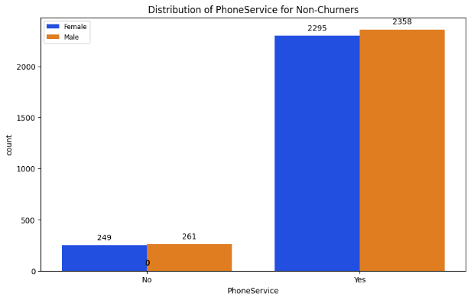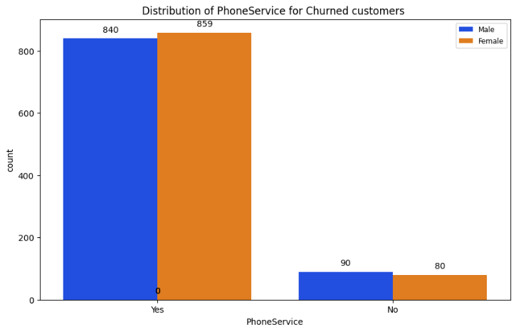

Male with phone service churner = 840

Male with phone service non-churner = 2358

Male with phone service churn % = 26.27

Female with phone service churner = 859

Female with phone service non-churner = 2295

Female with phone service churn % = 27.26

Male without phone service churner = 90

Male without phone service non-churner = 261

Male without phone service churn % = 25.64

Female without phone service churner = 80

Female without phone service non-churner = 249

Female without phone service churn % = 24.32

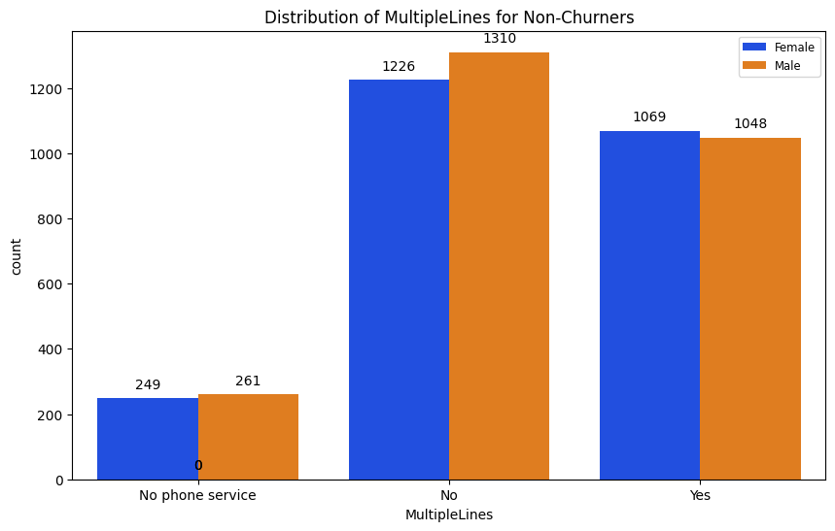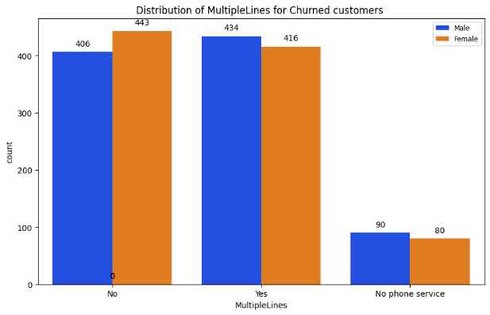

Male with multiple lines churner = 434

Male with multiple lines non-churner = 1048

Male with multiple lines churn % = 29.29

Female with multiple lines churner = 416

Female with multiple lines non-churner = 1069

Female with multiple lines churn % = 28.01

Male without multiple lines churner = 406

Male without multiple lines non-churner = 1310

Male without multiple lines churn % = 23.66

Female without multiple lines churner = 443

Female without multiple lines non-churner = 1226

Female without multiple lines churn % = 26.56

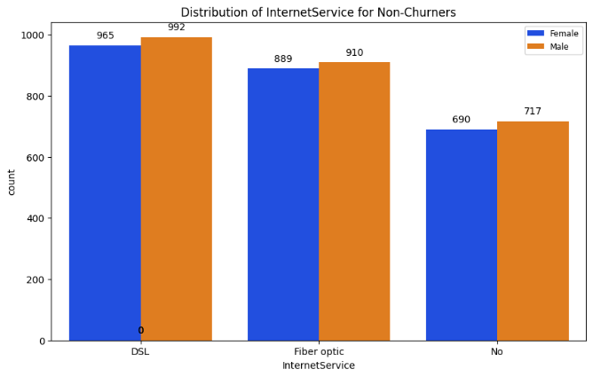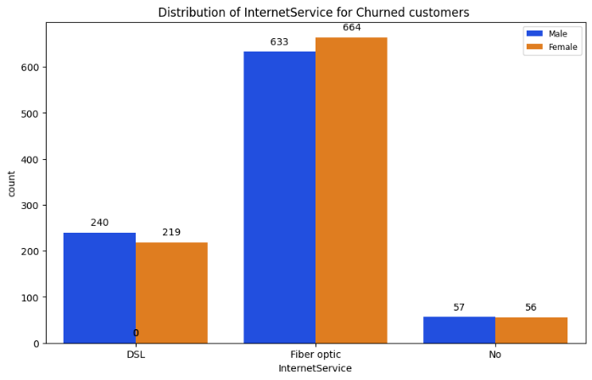

Male with fibre optics churner = 633

Male with fibre optics non-churner = 910

Male with fibre optics churn % = 41.07

Female with fibre optics churner = 664

Female with fibre optics non-churner = 889

Female with fibre optics churn % = 42.79

Male with DSL churner = 240

Male with DSL non-churner = 992

Male with DSL lines churn % = 19.48

Female with DSL churner = 219

Female with DSL non-churner = 965

Female with DSL churn % = 18.48

Conclusion:

* Female with fiber optics have the highest churn % with among the provided categories, indicating a significant churn risk.
* Male with DSL lines have the lowest churn % , indicating relatively lower churn risk.

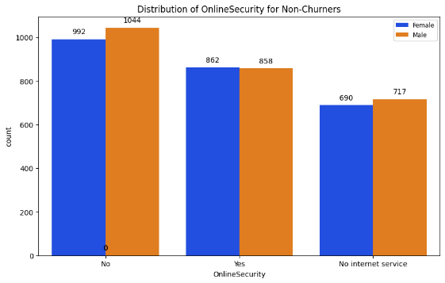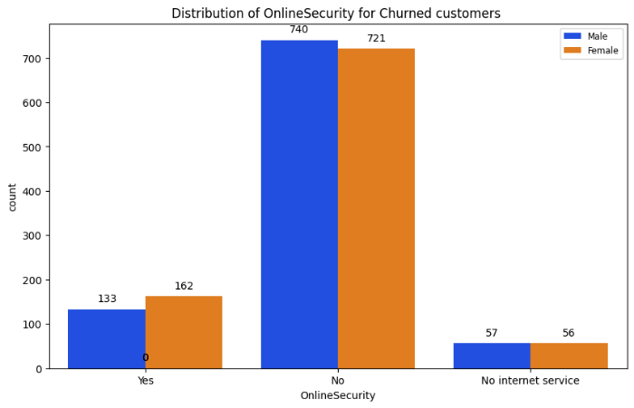

Male with online security churner = 133

Male with online security non-churner = 858

Male with online security churn % = 13.44

Female with online security churner = 162

Female with online security non-churner = 862

Female with online security churn % = 15.82

Male without online security churner = 740

Male without online security non-churner = 1044

Male without online security churn % = 41.48

Female without online security churner = 721

Female without online security non-churner = 992

Female without online security churn % = 42.09

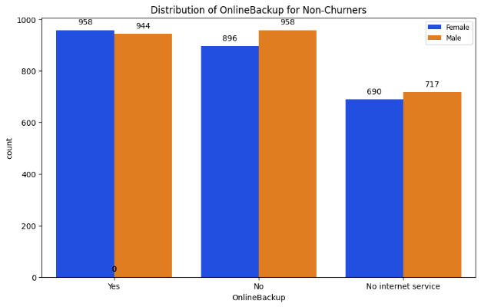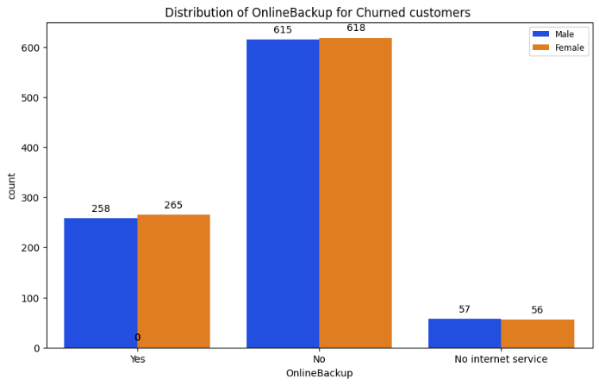

Male with online backup churner = 258

Male with online backup non-churner = 944

Male with online backup churn % = 21.47

Female with online backup churner = 265

Female with online backup non-churner = 958

Female with online backup churn % = 21.64

Male without online backup churner = 615

Male without online backup non-churner = 958

Male without online backup churn % = 39.06

Female without online backup churner = 618

Female without online backup non-churner = 896

Female without online backup churn % = 40.48

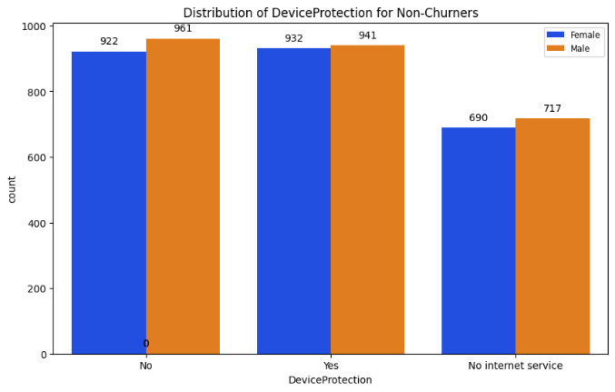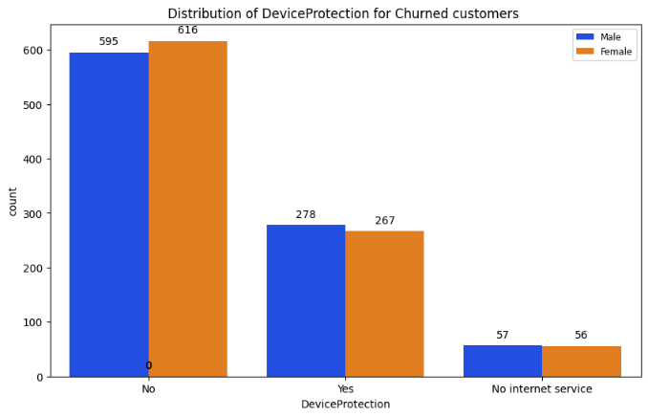

Male with device protection churner = 595

Male with device protection non-churner = 941

Male with device protection churn % = 38.73

Female with device protection churner = 616

Female with device protection non-churner = 932

Female with device protection churn % = 39.83

Male without device protection churner = 278

Male without device protection non-churner = 961

Male without device protection churn % = 22.42

Female without device protection churner = 267

Female without device protection non-churner = 922

Female without device protection churn % = 22.47

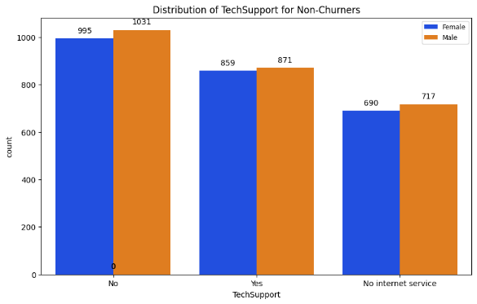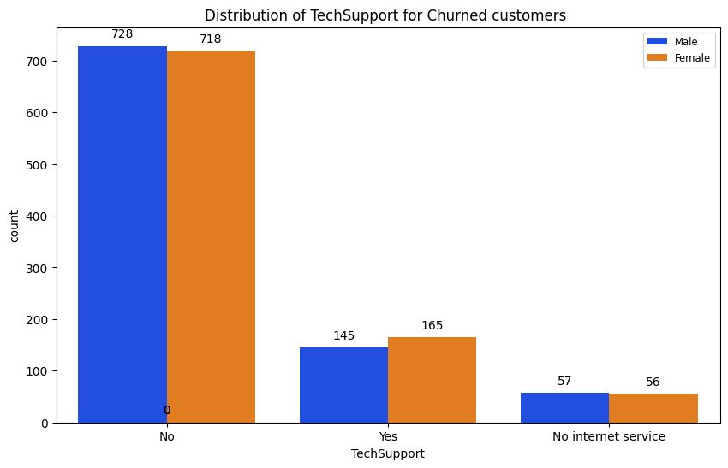

Male with tech support churner = 145

Male with tech support non-churner = 871

Male with tech support churn % = 14.27

Female with tech support churner = 165

Female with tech support non-churner = 859

Female with tech support churn % = 16.09

Male without tech support churner = 728

Male without tech support non-churner = 1031

Male without tech support churn % = 41.41

Female without tech support churner = 718

Female without tech support non-churner = 995

Female without tech support churn % = 41.91

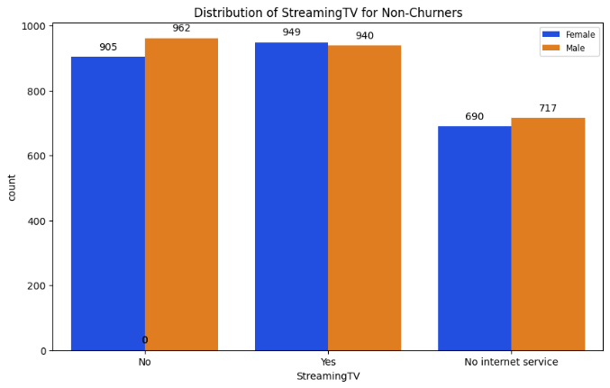 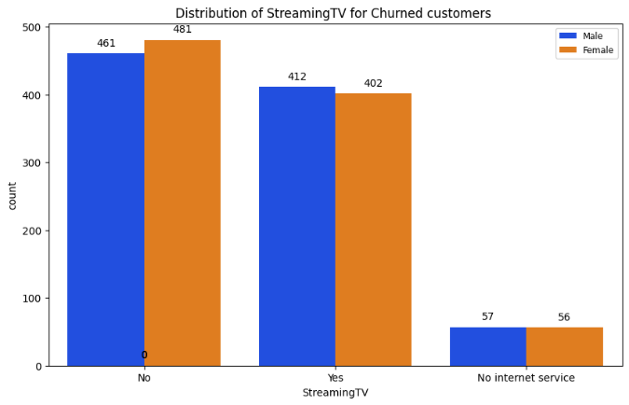

Male with Streaming TV churner = 412

Male with Streaming TV non-churner = 940

Male with Streaming TV churn % = 30.51

Female with Streaming TV churner = 402

Female with Streaming TV non-churner = 949

Female with Streaming TV churn % = 29.79

Male without Streaming TV churner = 461

Male without Streaming TV non-churner = 962

Male without Streaming TV churn % = 32.39

Female without Streaming TV churner = 481

Female without Streaming TV non-churner = 905

Female without Streaming TV churn % = 34.70

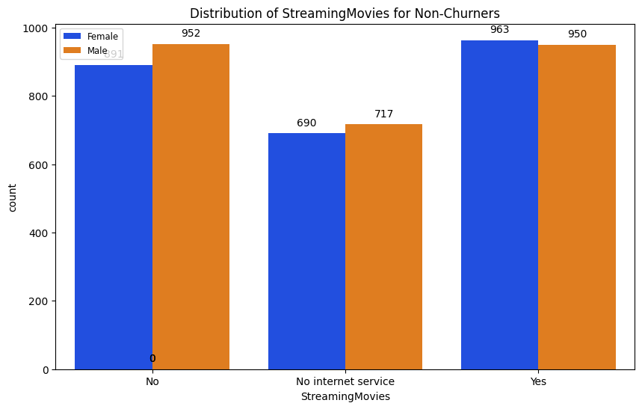 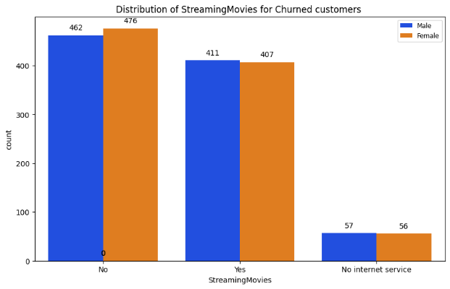

Male with Streaming movies service churner = 411

Male with Streaming movies service non-churner = 950

Male with Streaming movies service churn % = 30.19

Female with Streaming movies service churner = 407

Female with Streaming movies service non-churner = 963

Female with Streaming movies service churn % = 29.72

Male without Streaming movies service churner = 462

Male without Streaming movies service non-churner = 952

Male without Streaming movies service churn % = 32.67

Female without Streaming movies service churner = 476

Female without Streaming movies service non-churner = 891

Female without Streaming movies service churn % = 34.82

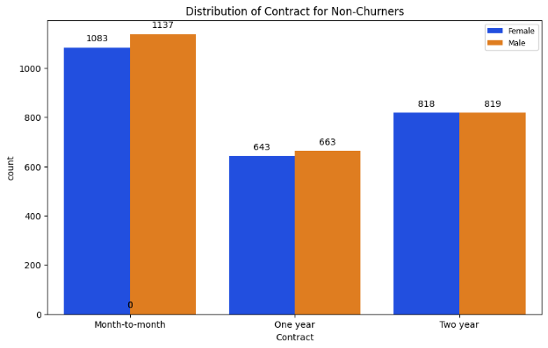 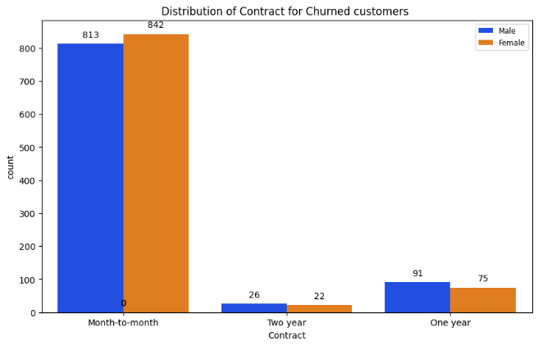

Male with month-to-month contract churner = 813

Male with month-to-month contract non-churner = 1137

Male with month-to-month contract churn % = 41.61

Female with month-to-month contract churner = 842

Female with month-to-month contract non-churner = 1083

Female with month-to-month contract churn % = 43.73

Male with one-year contract churner = 91

Male with one year contract non-churner = 663

Male with one-year contract service churn % = 12.07

Female with one-year contract churner = 75

Female with one-year contract non-churner = 643

Female with one-year contract churn % = 10.44

Male with two-year contract churner = 26

Male with two-year contract non-churner = 819

Male with two-year contract churn % = 3.08

Female with two-year contract churner = 22

Female with two-year contract non-churner = 818

Female with two-year contract churn % = 2.62

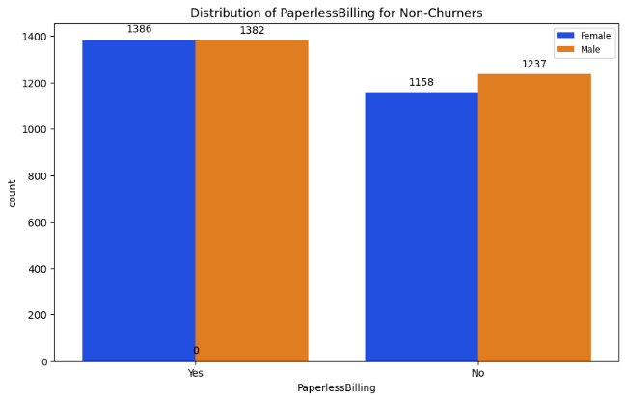 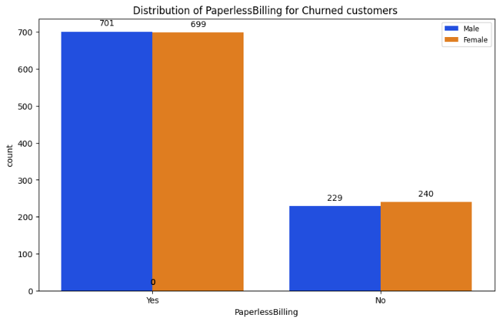

Male with paperless billing churner = 701

Male with paperless billing non-churner = 1382

Male with paperless billing churn % = 33.64

Female with paperless billing churner = 699

Female with paperless billing non-churner = 1386

Female with paperless billing churn % = 33.51

Male without paperless billing churner = 229

Male without paperless billing non-churner = 1237

Male without paperless billing churn % = 15.62

Female without paperless billing churner = 240

Female without paperless billing non-churner = 1158

Female without paperless billing churn % = 17.17

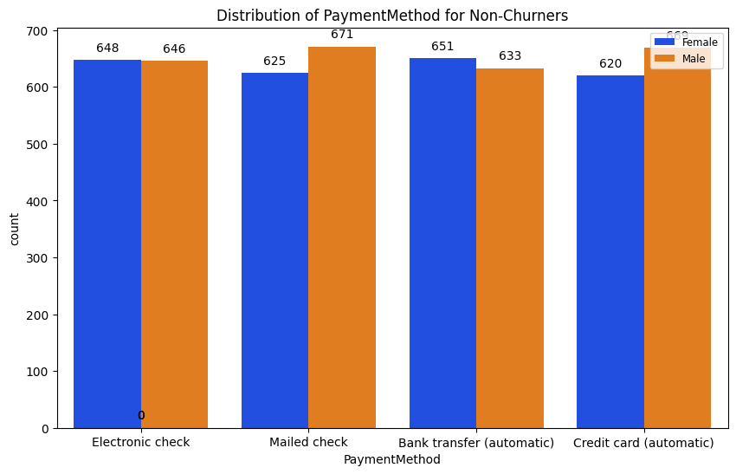 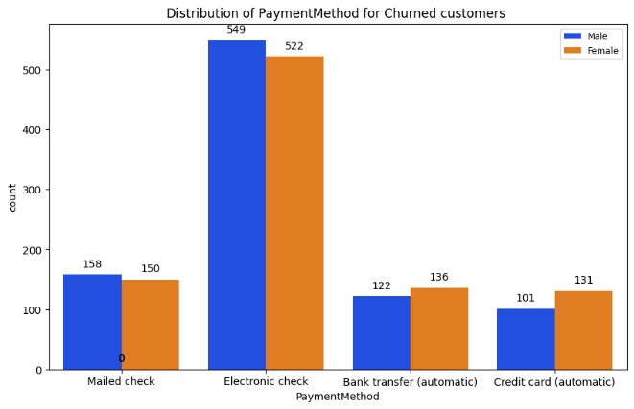

Male with electronic check payment method churner = 549

Male with electronic check payment method non-churner = 646

Male with electronic check payment method churn % = 45.94

Female with electronic check payment method churner = 522

Female with electronic check payment method non-churner = 648

Female with electronic check payment method churn % = 44.62

Male with mailed check payment method churner = 158

Male with mailed check payment method non-churner = 671

Male with mailed check payment method churn % = 19.08

Female with mailed check payment method churner = 150

Female with mailed check payment method non-churner = 625

Female with mailed check payment method churn % = 19.35

Male with bank transfer payment method churner = 122

Male with bank transfer payment method non-churner = 633

Male with bank transfer payment method churn % = 16.19

Female with bank transfer payment method churner = 136

Female with bank transfer payment method non-churner = 651

Female with bank transfer payment method churn % = 17.03

Male with credit transfer payment method churner = 101

Male with credit transfer payment method non-churner = 669

Male with credit transfer payment method churn % = 13.12

Female with credit transfer payment method churner = 131

Female with credit transfer payment method non-churner = 620

Female with credit transfer payment method churn % = 17.44

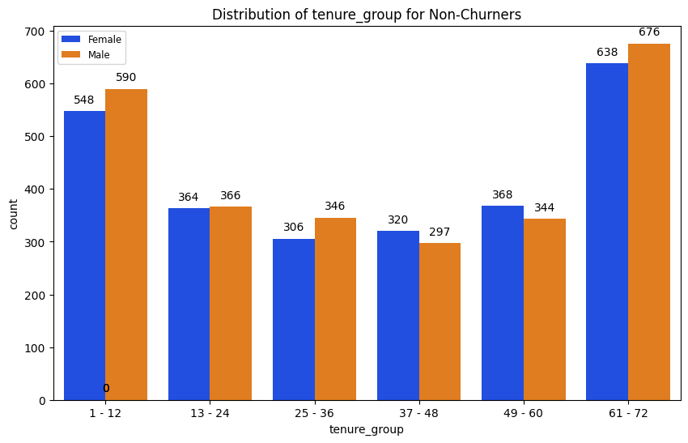 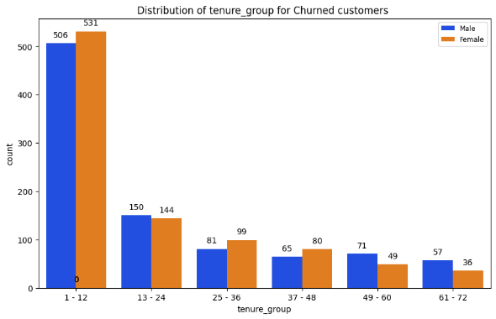

Male with 1-12 tenure group churner = 506

Male with 1-12 tenure group non-churner = 590

Male with 1-12 tenure group churn % = 46.18

Female with 1-12 tenure group churner = 531

Female with 1-12 tenure group non-churner = 548

Female with 1-12 tenure group churn % = 49.18

Male with 13-24 tenure group churner = 150

Male with 13-24 tenure group non-churner = 366

Male with 13-24 tenure group churn % = 29.09

Female with 13-24 tenure group churner = 144

Female with 13-24 tenure group non-churner = 364

Female with 13-24 tenure group churn % = 28.32

Male with 25-36 tenure group churner = 81

Male with 25-36 tenure group non-churner = 346

Male with 25-36 tenure group churn % = 18.99

Female with 25-36 tenure group churner = 99

Female with 25-36 tenure group non-churner = 306

Female with 25-36 tenure group churn % = 24.43

Male with 37-48 tenure group churner = 65

Male with 37-48 tenure group non-churner = 297

Male with 37-48 tenure group churn % = 17.94

Female with 37-48 tenure group churner = 80

Female with 37-48 tenure group non-churner = 320

Female with 37-48 tenure group churn % = 20.00

Male with 49-60 tenure group churner = 71

Male with 49-60 tenure group non-churner = 344

Male with 49-60 tenure group churn % = 17.11

Female with 49-60 tenure group churner = 49

Female with 49-60 tenure group non-churner = 368

Female with 49-60 tenure group churn % = 11.75

Male with 61-72 tenure group churner = 57

Male with 61-72 tenure group non-churner = 676

Male with 61-72 tenure group churn % = 7.78

Female with 61-72 tenure group churner = 36

Female with 61-72 tenure group non-churner = 638

Female with 61-72 tenure group churn % = 5.34