**1. Problem Statement**

This analysis aims to gain insights from the Sales data of ABC Company over the last three years (2017, 2018 & 2019). The dataset includes information on Sales transactions, Targets set for Salespersons, Customer details, Product information, and dates. Through this analysis, we aim to identify the sales trends, evaluate salesperson performance, understand customer behaviour, and assess the overall business performance.

**2. Data Modelling:**

**New Table**: Sales (all years) = Table.Combine({#"Sales 2017", #"Sales 2018", #"Sales 2019"})

**Target table**: Upivot function applied to all the other columns except Supervisor ID – this way there are multiple rows for the supervisors with the month name and target combination

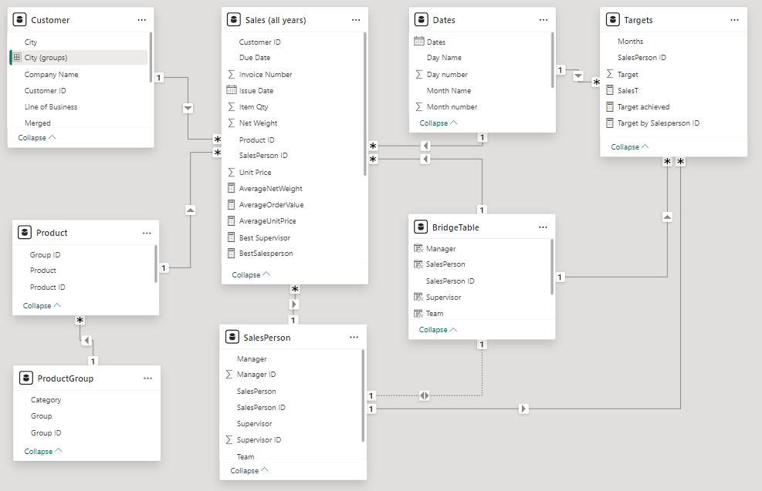

**3. Dashboard:**

**Page 1: Homepage and KPIs:**

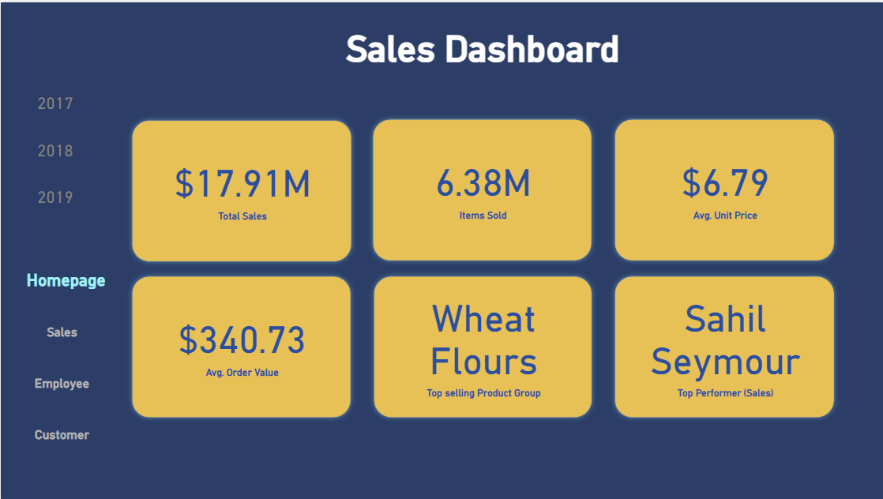

**KPIs:**

1. Total Sales
2. Number of Items sold
3. Average Unit price of the products
4. Average order value
5. Top-selling product group
6. Top performing employee – Sales

**Measures used :**  
**1. Total Sales** = SUMX('Sales (all years)', 'Sales (all years)'[Item Qty] * 'Sales (all years)'[Unit Price])

**2. TotalQuantitySold** = SUM('Sales (all years)'[Item Qty])

**3. TotalQuantitySold** = SUM('Sales (all years)'[Item Qty])

**4. AverageOrderValue** =

ROUND(

    DIVIDE(

        [Total Sales],

        DISTINCTCOUNT('Sales (all years)'[Invoice Number])

    ),

    2

)

**5. BestSellingProductGroup** =

SELECTCOLUMNS(

    TOPN(1, SUMMARIZE('Sales (all years)', 'ProductGroup'[Group], "TotalQty", SUM('Sales (all years)'[Item Qty])), [TotalQty], DESC),

    "BestSellingProductGroup",

    'ProductGroup'[Group]

)

**6. BestSalesperson** =

SELECTCOLUMNS(

    TOPN(1, SUMMARIZE('Sales (all years)', 'SalesPerson'[SalesPerson], "TotalSales", [Total Sales]), [TotalSales], DESC),

    "BestSalesperson",

    'SalesPerson'[SalesPerson]

)

**Page 2: Sales Data:**

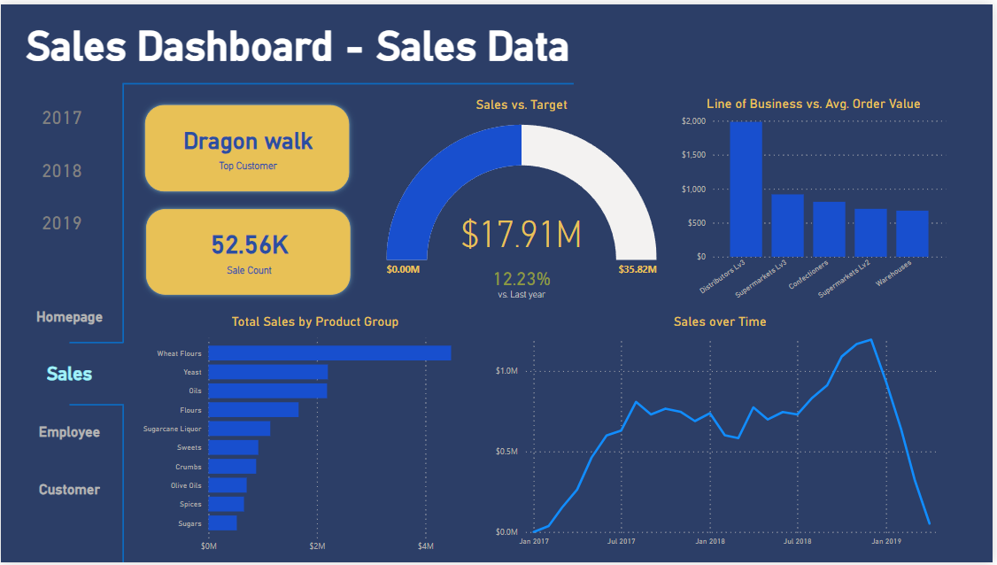

**Measures used :**

1. **TopCust** =

SELECTCOLUMNS(

    TOPN(1, SUMMARIZE('Sales (all years)', Customer[Company Name], "TopCust", SUM('Sales (all years)'[Item Qty])), [TopCust], DESC),

    "TopCust",

    Customer[Company Name]

)

1. **Count Sales** = DISTINCTCOUNT('Sales (all years)'[Invoice Number])
2. **SalesDifferencePercentage** =

VAR CurrentYearSales = [SalesT]

VAR PreviousYearSales = CALCULATE(

    [SalesT],

    SAMEPERIODLASTYEAR(Dates[Dates])

)

RETURN

DIVIDE(

    CurrentYearSales - PreviousYearSales,

    PreviousYearSales,

    0

)

1. **Average Order Value**
2. **Total Sales**

**Page 3: Employee Data:**

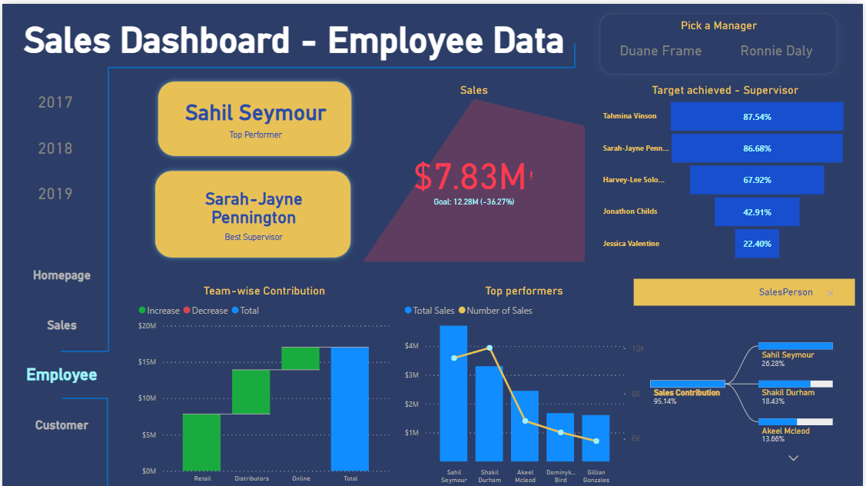

**Measures used :**

1. **BestSalesperson** =

SELECTCOLUMNS(

    TOPN(1, SUMMARIZE('Sales (all years)', 'SalesPerson'[SalesPerson], "TotalSales", [Total Sales]), [TotalSales], DESC),

    "BestSalesperson",

    'SalesPerson'[SalesPerson]

)

1. **Best Supervisor** = SELECTCOLUMNS(

    TOPN(1, SUMMARIZE('Sales (all years)', 'SalesPerson'[Supervisor], "TotalSales", [Total Sales]), [TotalSales], DESC),

    "BestSupervisor",

    'SalesPerson'[Supervisor]

)

1. **Target achieved** = DIVIDE([Total Sales], [TargetsMeasure], 0)
2. **Sales Contribution** = DIVIDE([Total sales], CALCULATE([SalesT], ALL(BridgeTable)))

**Page 4: Customer Data:**

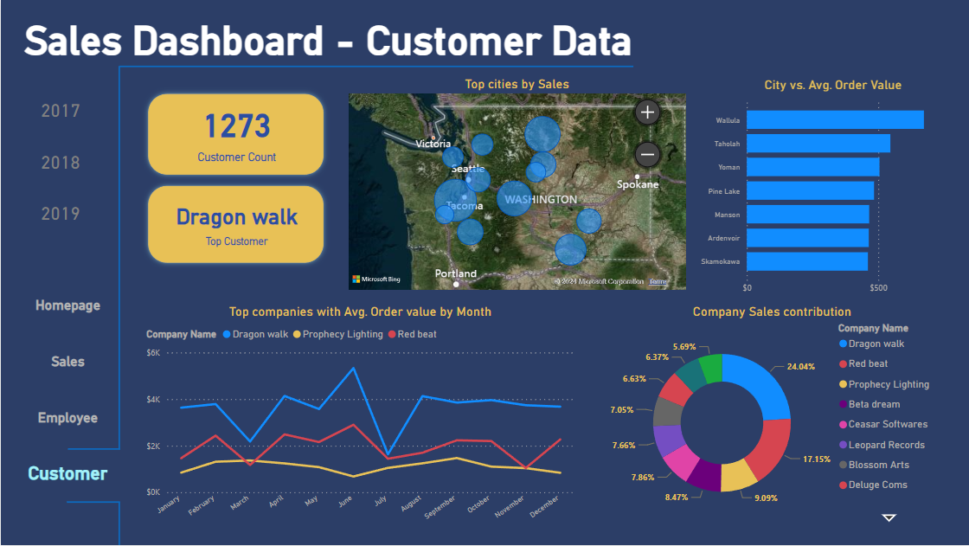

**Measures used :**

1. **TopCust** =

SELECTCOLUMNS(

    TOPN(1, SUMMARIZE('Sales (all years)', Customer[Company Name], "TopCust", SUM('Sales (all years)'[Item Qty])), [TopCust], DESC),

    "TopCust",

    Customer[Company Name]

)

1. **Count customers** = DISTINCTCOUNT('Sales (all years)'[Customer ID])
2. **Average Order Value**
3. **Total Sales**

**3. Future Improvements:**

* **Predictive Modeling**: Develop predictive models to forecast future sales or identify trends and patterns in customer behaviour. Machine learning algorithms such as regression, time series analysis, or clustering could be used.
* **Natural Language Processing (NLP**): Implement NLP techniques to analyze unstructured data such as customer reviews, feedback, or social media comments. Sentiment analysis and topic modelling could provide valuable insights into customer sentiment and preferences.
* **Integration with External Systems**: Integrate the Power BI dashboard with other business systems or platforms such as CRM software, ERP systems, or marketing automation tools to streamline data sharing and reporting across the organization.