Session Application – GDS Challenge – ReadMe
The Session Application allows users to participate in a restaurant voting session.
Users are loaded via Batch (CSV import), and a session can be initiated either via CLI or managed through REST APIs.
The application supports:
- User import using Spring Batch
- Session management (invite, vote, end session)
- Random restaurant selection
- REST APIs with Swagger documentation
- CLI-based interaction for session initiation.
How to Run the application
Command to Run the application - mvn spring-boot:run
On startup:
- The application prompts for a session initiator name via CLI.
- If authorized, a session starts and menu options are displayed.
- REST APIs are also available for session operations.
File name – resources/users.csv
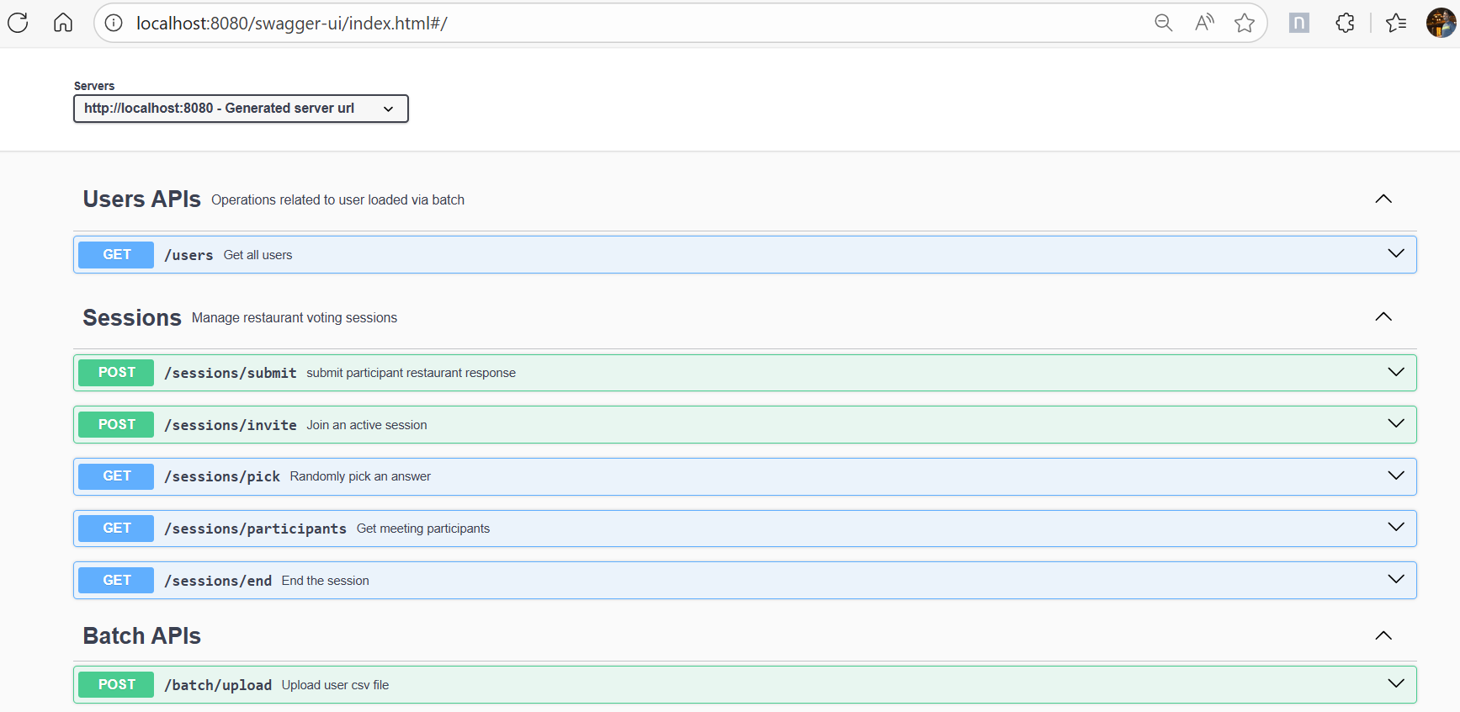
Rest API’s:
  - Batch Job upload
POST API /batch/upload
Which will update H2 Embedded Database table ‘users’
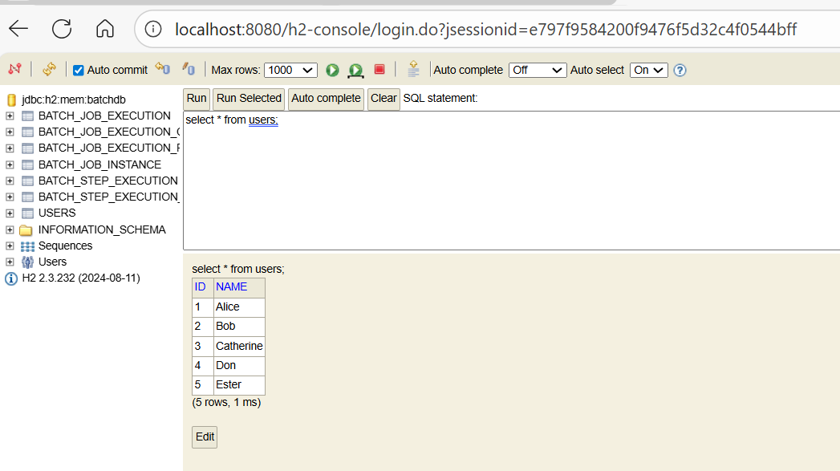

  - Get all users GET
API /users

  - Session Management Invite Participants
POST API /sessions/invite?participant=Ben

  - Session Management Submit Restaurant Choice
POST API /sessions/submit?participant=Bob&restaurant=ChickenRice

  - Session Management End Session
GET API /sessions/end?initiator=Amy

  - Session Management Randomly pick a restaurant
Get API /sessions/pick

  - Session Management view Participants & Choices
Get API /sessions/participants
Note: In my Local machine setup, Lombok package been included, but it’s not working as expected. So, I have included manually Getter and Setter.
CLI Session Menu:
    - Invite participant
    - Submit response
    - Choice of Restaurant made
    - End session
    - Randomly pick answer
    - Exit
Core Components
SessionManager
- CLI-based session handling
- Menu-driven user interaction
- Delegates business logic to SessionService
SessionService
- Maintains session state
- Handles participants, responses, and session lifecycle
- Randomly select restaurant after session ends
Spring Batch
- Reads users from CSV
- Converts UserDto → User
- Persists users to database
Testing:
- Pure unit tests for controllers and services
- Mockito-based mocking
- No Spring context required for controller unit tests
Project Links
- H2 Console - http://localhost:8080/h2-console/
- Swagger Documentation - http://localhost:8080/swagger-ui/index.html

