What are WebSockets and how do they work?
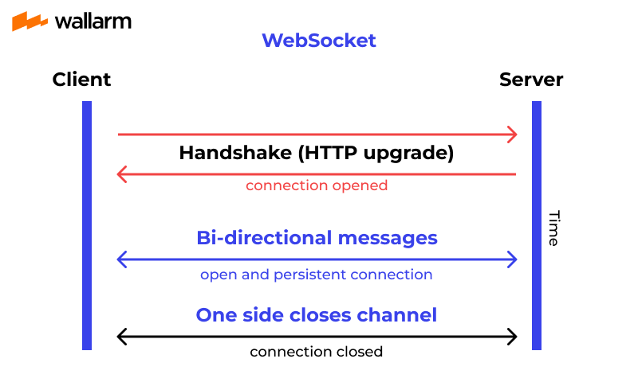
WebSockets are a protocol that allows for real-time, two-way communication between a client and a server over a single, long-lived connection. WebSockets have gained popularity in recent years due to their ability to provide low-latency, real-time communication in web applications. In this article, we’ll explore what WebSockets are, how they work, and some common use cases.

What are WebSockets?
WebSockets are a protocol for bi-directional, real-time communication between a client and a server over a single, long-lived connection. Unlike traditional HTTP requests, which are unidirectional and require a new connection for each request, WebSockets allow for continuous communication between the client and server.
WebSockets are part of the HTML5 specification and are supported by all modern web browsers. They are typically implemented using JavaScript on the client side and a server-side technology such as Node.js or Java on the server side.
How WebSockets Work
WebSockets work by establishing a persistent connection between the client and server over a single TCP socket. Once the connection is established, data can be sent and received in real-time between the client and server.
The WebSocket protocol consists of two parts: an initial HTTP handshake and the Web Socket protocol itself.

HTTP Handshake
The initial HTTP handshake is used to establish the WebSocket connection. The client sends an HTTP request to the server, specifying the WebSocket protocol in the Upgrade header. The server responds with an HTTP response that includes an Upgrade header indicating that it is switching to the WebSocket protocol.

The HTTP handshake is a process used to initiate a WebSocket connection between a client and a server. WebSockets provide a full-duplex communication channel over a single, long-lived connection, allowing for real-time data transfer between the client and the server.
Here's how the HTTP handshake works:
- Client Request:
  - The process begins with the client sending an HTTP request to the server. This request typically includes an HTTP header known as the Upgrade header, with a value of websocket, indicating that the client wishes to upgrade the connection to a WebSocket protocol.
  - Additionally, the request may include other headers, such as Sec-WebSocket-Key, which is a randomly generated key used for security purposes.
- Server Response:
  - Upon receiving the client's request, the server examines the Upgrade header. If the server supports WebSocket connections and agrees to upgrade the connection, it responds with an HTTP response.
  - The server's response includes an HTTP status code of 101 Switching Protocols, indicating that the protocol is being switched from HTTP to WebSocket.
  - The response also includes an Upgrade header with a value of websocket, confirming the protocol switch, and possibly other headers such as Sec-WebSocket-Accept, which is a response to the Sec-WebSocket-Key provided by the client. This ensures the security of the WebSocket connection.
- Establishment of WebSocket Connection:
  - Upon receiving the server's response, the client and server both recognize that the connection has been successfully upgraded to the WebSocket protocol.
  - From this point onwards, the connection operates using the WebSocket protocol, allowing for full-duplex communication between the client and the server.
  - Unlike traditional HTTP, which follows a request-response model, WebSocket allows for continuous bi-directional communication, enabling real-time data transfer without the overhead of repeated HTTP requests and responses.

WebSocket Protocol

The WebSocket protocol is a communication protocol that provides full-duplex communication channels over a single, long-lived TCP connection. It allows bidirectional communication between clients and servers in real-time. Unlike HTTP, which follows a request-response model, WebSocket enables persistent connections where both the client and server can send messages to each other asynchronously without the overhead of multiple HTTP connections.
Here's an overview of how the WebSocket protocol works:
- Handshake: The WebSocket protocol begins with a handshake over HTTP. The client sends a request to upgrade the connection to WebSocket by including certain headers like Upgrade: websocket and Connection: Upgrade. If the server supports WebSocket, it responds with a 101 status code indicating the switch to the WebSocket protocol. After this handshake, the TCP connection is upgraded, and subsequent communication follows the WebSocket protocol.
- Frame-based communication: Messages in WebSocket are sent as frames. Each frame consists of two parts: a header and a payload. The header contains metadata about the frame, such as its type (e.g., text or binary), whether it's the final frame in a message, and the payload length. The payload contains the actual data of the message.
- Bi-directional communication: Once the connection is established, both the client and server can send messages to each other at any time. This enables real-time, bidirectional communication. Messages can be text or binary data, allowing for versatile use cases ranging from chat applications to real-time data feeds.
- Ping/Pong mechanism: WebSocket includes a ping/pong mechanism for detecting connection failures or latency issues. Either the client or server can send a ping frame, and the other party responds with a pong frame. If a pong frame is not received within a certain timeframe, the connection may be considered lost.
- Security: WebSocket connections can be secured using TLS/SSL, providing encryption and data integrity. This ensures that communication over WebSocket remains secure, especially when sensitive information is being exchanged.
Overall, the WebSocket protocol provides a lightweight, efficient way to establish persistent, real-time communication channels between clients and servers, making it well-suited for applications that require low-latency, interactive experiences, such as online gaming, collaborative editing, and live data visualization.
One side Close Channel or Connection Close
In the context of WebSocket communication, the term "one side close" or "connection closed" refers to the scenario where one party (client or server) closes the WebSocket connection without receiving a corresponding closure message from the other party.
WebSocket connections can be closed intentionally or due to various reasons such as network issues, server errors, or client disconnects. When a WebSocket connection is closed, it can be initiated by either the client or the server.
Here's a breakdown of what happens in a "one side close" scenario:
- Client-initiated close: The client sends a close frame to the server indicating its intention to close the connection. This can happen when the client explicitly calls a close method or when it encounters an error or a situation where it decides to terminate the connection. Once the server receives the close frame, it acknowledges the closure and closes the connection on its end as well.
- Server-initiated close: Conversely, the server can also initiate the closure of the WebSocket connection by sending a close frame to the client. This might happen due to various reasons such as server errors, timeouts, or administrative actions. Upon receiving the close frame from the server, the client acknowledges the closure and closes the connection on its end.
In both cases, the party initiating the closure sends a close frame to the other party, indicating the reason for the closure (if applicable) and allowing the other party to gracefully handle the closure of the connection.
Handling connection closures gracefully is an essential aspect of WebSocket-based applications. Both clients and servers should be able to handle close events, clean up resources, and possibly inform the user or log relevant information for debugging purposes.
Overall, "one side close" or "connection closed" refers to the situation where one party closes the WebSocket connection without waiting for a corresponding closure message from the other party, thus ending the communication abruptly.

Use Cases for WebSockets
WebSockets are commonly used in a variety of real-time web applications. Here are some common examples:
Chat Applications
WebSockets are commonly used in chat applications to provide real-time messaging between users. With WebSockets, messages can be sent and received in real-time, providing a fast and responsive chat experience.
Online Gaming
WebSockets are also used in online gaming to provide real-time communication between players and the game server. With WebSockets, game events can be sent and received in real-time, allowing for a more immersive and interactive gaming experience.
Real-time Dashboards
WebSockets can also be used to create real-time dashboards that display real-time data updates. With WebSockets, data can be pushed to the dashboard in real-time, allowing users to see the latest updates as they happen.
Financial Trading
WebSockets are commonly used in financial trading applications to provide real-time updates on stock prices and other financial data. With WebSockets, data can be sent and received in real-time, allowing traders to make informed decisions based on the latest market information.
Conclusion
WebSockets are a powerful protocol for real-time communication between a client and server in web applications. They allow for low-latency, bi-directional communication over a single, long-lived connection, making them ideal for real-time applications such as chat, gaming, dashboards, and financial trading. With the widespread adoption of WebSockets in modern web browsers, they have become an essential tool for building real-time web applications.

