ProjectDocumentation

**ProjectTitle:Insight Stream: Navigate The News Landscape-(Duplicate)**

# Introduction :

Insight Stream is a personalized news platform that helps you navigate the complex world of news and information. With curated content, expert analysis, and tailored recommendations, Insight Stream empowers you to stay informed and up-to-date on the topics that matter most.

## ProjectTitle: Insight Stream: Navigate The News Landscape-(Duplicate)

* + **TeamID :NM2025TMid33840**
  + **TeamLeader:** SENTHIL KUMAR M senthilkumarmking1234@gmail.com

## TeamMembers:

* + - MOHAMED JAHID M[mohamedjahid21@gmail.com](C:\\Users\\admin\\Downloads\\mohamedjahid21@gmail.com)
    - YOGESHWARAN S<akashsakthivel002@gmail.com>
    - NAINA MOHAMED RAWOOTHER M<nainamohamed94873@gmail.com>

# ProjectOverview

* + **Purpose:**To empower users with a curated and personalized news experience, providing easy access to relevant information, diverse perspectives, and expert insights, ultimately helping them stay informed and navigate the complex news landscape.

## Features:

* + - Personalized News Feed
    - Topic-Based Filtering
    - Customizable Preferences
    - Expert Analysis

# Architecture

* + **Frontend:**React.jswithBootstrapandMaterialUI
  + **Backend:**Node.jsandExpress.jsmanagingserverlogicandAPIendpoints
  + **Database:**MongoDBstoresuserdata,projectinformation, applications, andchat messages

# SetupInstructions

* Node.js and npm: Node.js is a powerful JavaScript runtime environment that allows you to run JavaScript code on the local environment. It provides a scalable and efficient platform for building network applications.
  + Install Node.js and npm on your development machine, as they are required to run JavaScript on the server-side.
  + Download: <https://nodejs.org/en/download/>
  + Installation instructions: <https://nodejs.org/en/download/package-manager/>
* React.js: React.js is a popular JavaScript library for building user interfaces. It enables developers to create interactive and reusable UI components, making it easier to build dynamic and responsive web applications.

Install React.js, a JavaScript library for building user interfaces.

* Create a new React app:

npx create-react-app my-react-app

Replace my-react-app with your preferred project name.

* Navigate to the project directory:

**cd my-react-app**

* Running the React App:

With the React app created, you can now start the development server and see your React application in action.

* Start the development server:

**npm start**

This command launches the development server, and you can access your React app at http://localhost:3000 in your web browser.

* HTML, CSS, and JavaScript: Basic knowledge of HTML for creating the structure of your app, CSS for styling, and JavaScript for client-side interactivity is essential.
* Version Control: Use Git for version control, enabling collaboration and tracking changes throughout the development process. Platforms like GitHub or Bitbucket can host your repository.
  + Git: Download and installation instructions can be found at: <https://git-scm.com/downloads>
* Development Environment: Choose a code editor or Integrated Development Environment (IDE) that suits your preferences, such as Visual Studio Code, Sublime Text, or WebStorm.
  + Visual Studio Code: Download from <https://code.visualstudio.com/download>
  + Sublime Text: Download from <https://www.sublimetext.com/download>
  + WebStorm: Download from [https://www.jetbrains.com/webstorm/](https://www.sublimetext.com/download)

To clone and run the Application project from GitHub:

Follow below steps

* Install Dependencies:
  + Navigate into the cloned repository directory and install libraries:

**cd news**

**npm install**

* Start the Development Server:
  + To start the development server, execute the following command:

**npm start**

* Access the App: Open your web browser and navigate to http://localhost:3000.

You have successfully installed and set up the application on your local machine. You can now proceed with further customization, development, and testing as needed.

# FolderStructure

SB-Works/

|-- client/ #Reactfrontend

|components/ L pages/

| server/ #Node.jsbackend

|routes/

| models/

| controllers/

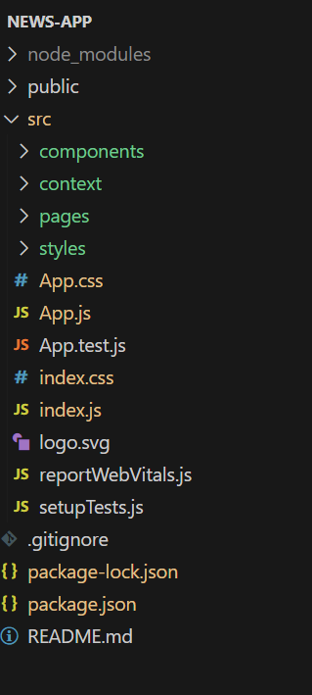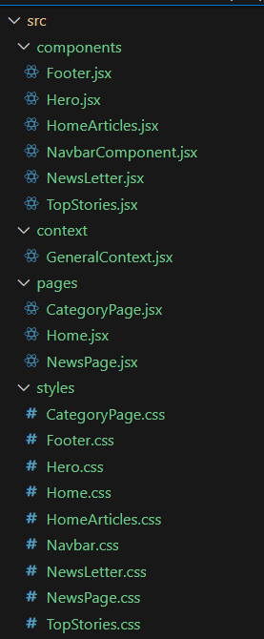

# RunningtheApplication

## Frontend:

cd client npm start

**backend**

cdservernpm start

* + **Access:**Visit[http://localhost:3000](http://localhost:3000/)

# APIDocumentation

## User:

* + - /api/user/register
    - /api/user/login

**Projects:**

/api/projects/create

/api/projects:id

Applications:/api/apply

# Authentication

* + Secure Login
  + Multi-Factor Authentication
  + Personalized Profile

# UserInterface

* + Responsive Design
  + Customizable Dashboard
  + Easy Navigation
  + Responsive Design

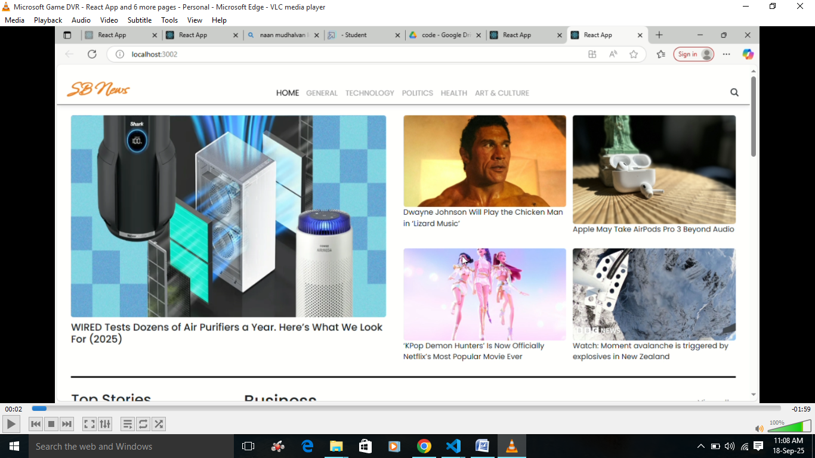

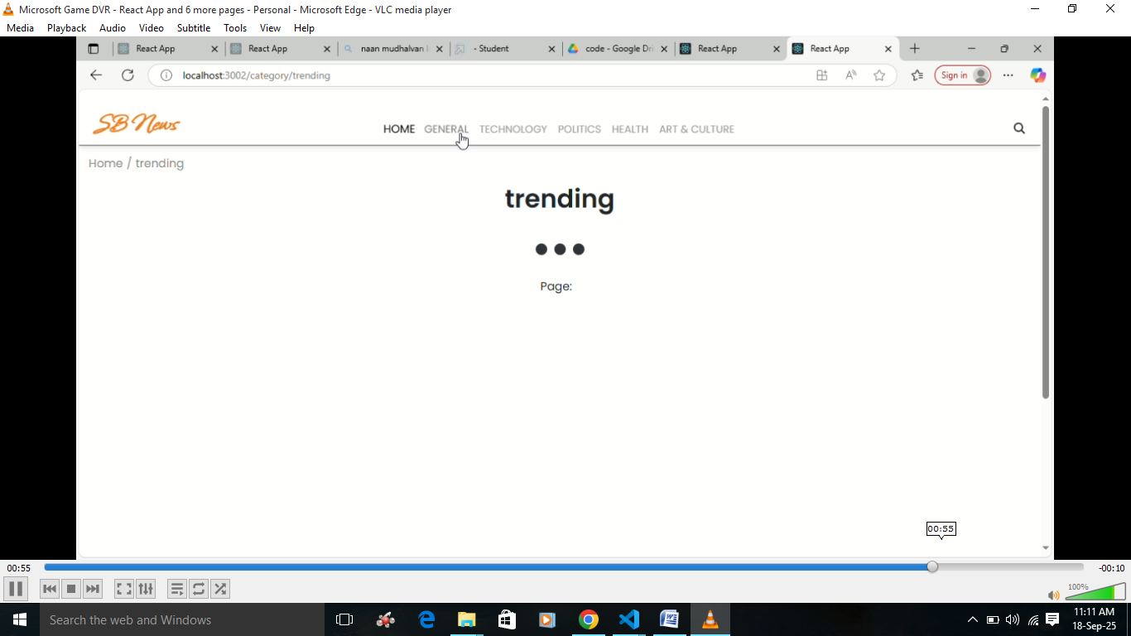

# Testing

* + News Aggregator:
  + Topic Tracker
  + Personalized Recommendations
  + Real-time Alerts
  + Functional Testing
  + Security Testing:
  + Performance Testing

1. **KnownIssues**

1. Occasional Feed Delays: News feed updates might be delayed due to server or network issues.

2. Inaccurate Sentiment Analysis: Sentiment analysis may not always accurately reflect the tone or intent of news articles.

3. Limited Source Diversity: News aggregation might not cover all relevant sources or perspectives.

4. Notification Overload: Real-time alerts might become overwhelming if not customized properly.

1. **FutureEnhancements**

1. AI-Driven Insights: Advanced AI analysis for deeper news understanding.

2. Personalized Summaries: Automated summaries tailored to user interests.

3. Multimedia Integration: Incorporating videos, podcasts, and infographics.

4. Social Sharing Features: Enhanced sharing capabilities.

5. Customizable Notifications: More granular control over notification preferences.