**Readme documentation on Placement app & Streamlit UI app**

The project has a directory called “guvi” from the root. Inside guvi, there are two directories called “placementapp” & “streamlitUI”.

guvi



[This Photo](https://freepngimg.com/png/7847-folder-png-image) by Unknown Author is licensed under [CC BY-NC](https://creativecommons.org/licenses/by-nc/3.0/)

placementapp



[This Photo](https://freepngimg.com/png/7847-folder-png-image) by Unknown Author is licensed under [CC BY-NC](https://creativecommons.org/licenses/by-nc/3.0/)

streamlitUI



[This Photo](https://freepngimg.com/png/7847-folder-png-image) by Unknown Author is licensed under [CC BY-NC](https://creativecommons.org/licenses/by-nc/3.0/)

**Placementapp** project involves in creating the database, and creates the necessary tables inside the database. And then creates the source files in csv format using faker library for all the four tables. And then reads the source csv files and populates the table accordingly. All the above mentioned operations happens in a single click.

**StreamlitUI** project involves in providing an interactive UI in Streamlit. It has two pages, Candidate Screening which has provision to provide varieties of criteria to filter the suitable candidates. And it also has Dashboard page which provides some key insights on the placements app.

**Following software’s are required as a prerequisite:**

* Python (3.12.1, latest version)
* Visual studio code
* MySQL(running instance)

**Follow the steps to execute placementapp project:**

1. Open Visual Studio code
2. File > Open Folder > point the **placementapp** folder to launch **placementapp** project
3. Navigate to **dboperation.py** file
4. In the __init__ method of **Dboperation** class, update **host, password & root** and save the file

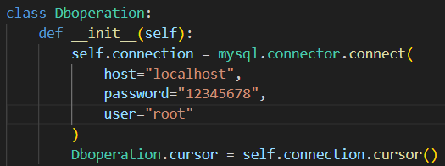

1. From VS Code terminal, navigate to main.py
2. Execute python.exe main.py

**Expected outcome:**

1. In MySql, the guvi database is created
2. Inside **guvi** database, the following tables are created:
   1. Students
   2. Placements
   3. Softskills
   4. Programming
3. Following source files are generated in the local:
   1. Students.csv
   2. Placements.csv
   3. Programming.csv
   4. Softskills.csv
4. Tables are populated with the source file generated accordingly

**Follow the steps to execute streamlitUI project:**

1. Open Visual Studio code
2. File > Open Folder > point the **streamlitUI** folder to launch **streamlitUI** project
3. Navigate to **db_connection.py** file
4. In the __init__ method of **DatabaseManager** class, update **user,** **password, host, & database** and save the file
5. From VS Code terminal, navigate to main.py

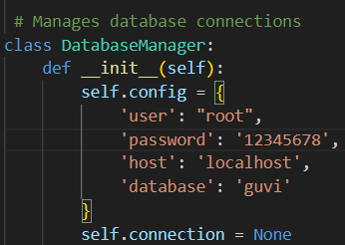

1. Execute **streamlit run main.py**

**Expected outcome:**

1. A browser is launched with the url [http://locahost:{port}](http://locahost:%7bport%7d)
2. The side navigation bar has two pages**, CandidateScreening & Dashboard**
3. The **CandidateScreening** section has a form with various input criteria and submit button to filter the candidates
4. The **Dashboard** section is the readonly section which provides some key insights on the placement side.