**CAD PHASE-4**

**E-COMMERCE APPLICATION**

**PET ACCESSORIES AND SUPPLIES SHOP**

**JS CODE FOR ADD ITEM TO CART**

**SOURCE CODE**

<script>

const cart = [];

const cartItems = document.getElementById('cart-items');

const cartTotal = document.getElementById('cart-total');

const cartSection = document.getElementById('cart');

const orderSuccessMessage = document.getElementById('order-success');

function addToCart(itemName, itemPrice) {

cart.push({ name: itemName, price: itemPrice });

updateCart();

}

function updateCart() {

cartItems.innerHTML = '';

let total = 0;

cart.forEach(item => {

const li = document.createElement('li');

li.innerText = `${item.name} - $${item.price.toFixed(2)}`;

cartItems.appendChild(li);

total += item.price;

});

cartTotal.innerText = total.toFixed(2);

if (cart.length > 0) {

cartSection.style.display = 'block';

}

}

</script>

**ADD TO CART BUTTON**

<pre style="font-size:12px;color:white;font-family:sans-serif;"><img src="beds.jpg" width="225px">

Dog Beds

<span style="background-color:rgb(0,116,228);padding:3px;border-radius:5px;font-weight:800;font-size:15px;"> -15% </span> <span style="color:rgb(151,151,151);"><s>&#8377;1,179</s></span> <span>&#8377;1,002.15</span>

<button onclick="addToCart('Dog Beds', 1002.15)">Add to Cart</button>

</pre>

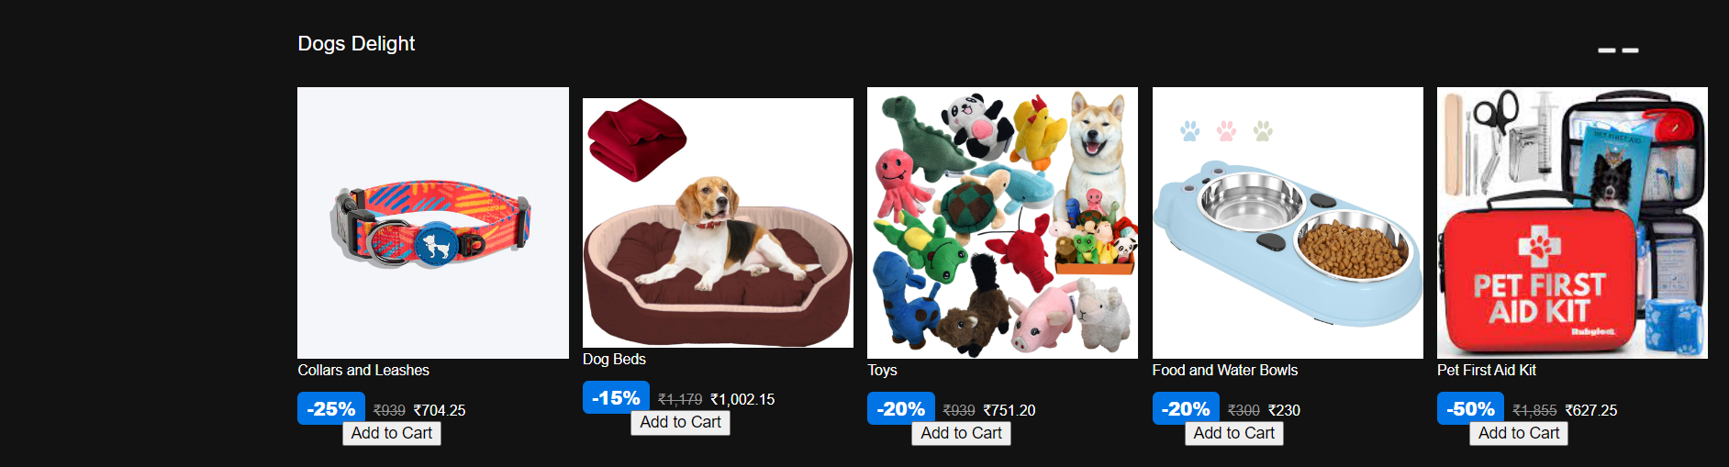

**CART DETAILS DISPLAYING SECTION**

<h1 style="font-family:sans-serif;font-weight:300;font-size:25px;color:white;">Your Shopping Cart</h1>

<div id="cart" style="background-color:rgb(42,42,42);font-family:sans-serif;font-weight:400;font-size:13px;color:white;">

<ul id="cart-items">

</ul>

<p>Total: $<span id="cart-total">0.00</span></p>

<button onclick="placeOrder()">Place Order</button>

</div>

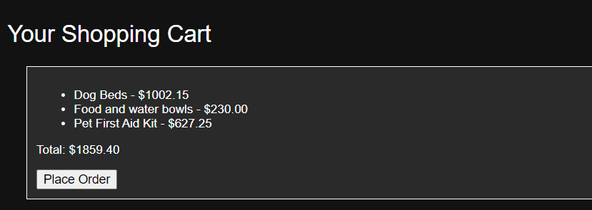

**PLACE ORDER JAVASCRIPT CODE**

<script>

function placeOrder() {

// You can implement the order placement logic here (e.g., sending data to a server).

// For now, we'll just show a success message and clear the cart.

cart.length = 0; // Clear the cart

updateCart(); // Update the cart display

// Set a flag in the URL

const url = new URL(window.location.href);

url.searchParams.set('orderPlaced', 'true');

// Redirect to the success page

window.location.href = 'order-success.html' + url.search;

}

</script>

**ORDER SUCCESSFULLY PLACED PAGE**

<!DOCTYPE html>

<html lang="en">

<head>

<meta charset="UTF-8">

<title>Order Success</title>

<style>

.success-message {

text-align: center;

font-size: 24px;

color: green;

}

.tick-mark {

font-size: 48px;

color: green;

}

</style>

</head>

<body>

<div class="success-message">

<span class="tick-mark">&#10004;</span> Order Successfully Placed

</div>

</body>

</html>

