**CAD PHASE-5**

**E-COMMERCE APPLICATION**

**PET ACCESSORIES AND SUPPLIES SHOP**

**Problem definition and design thinking:**

In this part we need to understand the problem statement and create a document on what we have understood and how we will proceed ahead with solving the problem.

**Problem Definition:**

The project is to build an artisanal e-commerce platform using IBM Cloud Foundry. The goal is to connect skilled artisans with a global audience, showcasing their handmade products and providing features like secure shopping carts, payment gateways, and an intuitive checkout process. This involves designing the e-commerce platform, implementing the necessary features, and ensuring a seamless user experience.

**DESIGN THINKING:**

**1. Platform Design:** Design the platform layout with sections for product category, individual product pages, shopping cart, checkout, and payment.

**2. Product Showcase:** Create a database to store product information such as images, descriptions, prices, and categories.

**3. User Authentication:** Implement user registration and authentication features to enable artisans and customers to access the platform.

**4. Shopping cart AND Checkout:** Design and develop the shopping cart functionality and a smooth checkout process.

**5. Payment Integration:** Integrate secure payment gateways to facilitate transactions.

**6. User Experience:** Focus on providing an intuitive and visually appealing user experience for both artisans and customers.

**MAINPAGE CONTENT**

<!DOCTYPE html>

<html lang="en">

<head>

<meta charset="UTF-8">

<title>Sniffy Nosses</title>

<link rel = "icon" href = "logo.png"

type = "image/x-icon">

<link rel="stylesheet" type="text/css" href="galaxy.css">

<link href="https://fonts.googleapis.com/css?family=Open+Sans:300,300italic,regular,italic,600,600italic,700,700italic,800,800italic" rel="stylesheet" />

<link href="https://fonts.googleapis.com/css?family=Poppins:100,100italic,200,200italic,300,300italic,regular,italic,500,500italic,600,600italic,700,700italic,800,800italic,900,900italic" rel="stylesheet" />

<link href="https://fonts.googleapis.com/css?family=Righteous:regular" rel="stylesheet" />

<style>

/* Add some basic CSS styles for presentation */

#cart {

border: 1px solid white;

padding: 10px;

margin: 20px;

display: none;

}

</style>

</head>

<body style="background-color:rgb(18,18,18);">

<table>

<tr>

<td>&nbsp&nbsp</td>

<td><img src="logo.png" style="width:87px;" /></td>

<td style="font-family:'vermin_vibes_vregular';color:White;font-size:25px;">SNIFFY NOSSES</td>

<td>&nbsp;&nbsp;&nbsp;&nbsp;</td>

<td><img src="icons8-less-than-64.png" style="margin-top:7.5px;" width="20px"></td>

<td>&nbsp;&nbsp;</td>

<td><img src="search.png" width="180px"></td>

<td>&nbsp;&nbsp;</td>

<td style="font-family:sans-serif;color:rgb(151,151,151)"><a>Discover</a></td>

<td>&nbsp;&nbsp;</td>

<td style="font-family:sans-serif;color:rgb(151,151,151);"><a>Browse</a></td>

<td>&nbsp;&nbsp;</td>

<td style="font-family:sans-serif;color:rgb(151,151,151)"><a>News</a></td>

<td style="font-family:sans-serif;color:rgb(151,151,151)"><a>Wishlist</a></td>

<td>&nbsp;&nbsp;</td>

<td style="font-family:sans-serif;color:rgb(151,151,151)"><a>Cart</a></td>

<td style="color:rgb(151,151,151);">&nbsp;&nbsp;|&nbsp;&nbsp;</td>

<td><img src="Screenshot 2022-07-16 231857.png" width="45px"></td>

<td>&nbsp;</td>

<td style="color:white;font-family:'Matura MT Script Capitals';font-size:23px;"><?php echo $_SESSION['username']; ?></td>

<td>&nbsp;&nbsp;</td>

</tr>

</table>

<table>

<tr>

<td>

<nav>

<dl style="color:white;font-family:Segoe UI;line-height:1.65em;">

<dd><pre> </pre></dd>

<dd style="font-family:sans-serif;color:rgb(151,151,151);"><img src='tag.png' width="27px">&nbsp;&nbsp;&nbsp;&nbsp;Store</dd>

<dd>&nbsp;</dd>

<dd style="font-family:sans-serif;color:rgb(151,151,151);"><img src='icons8-logout-30.png' width="29px">&nbsp;&nbsp;&nbsp;&nbsp;<a href="index.php?logout='1'" style="text-decoration:none;color:rgb(151,151,151);">Log out</a></dd>

</dl>

</nav></td>

<td><div id="div1" class="targetDiv" style="background-color:rgb(35,34,68);

background-image: linear-gradient(to bottom right,

#120a34,

#6625a3,

#0a2bb6, #05d6b3);border-radius:15px;width:900px;padding-bottom:55px;" width="70%" height="70"><a href="#" style="text-decoration:none;"><img src="sale.png" style="float:right;width:390px;">

<pre id="tag1" style="font-family:sans-serif;color:White;font-size:17px;font-weight:650;">

<span style="font-family:Niagara solid;color:White;font-size:50px;font-weight:400;">HOLIDAY SEASON</span>

<span style="font-family:Niagara solid;color:White;font-size:30px;line-height:0.6em;font-weight:400;">OCT 20-NOV 01</span>

<span style="font-family:sans-serif;color:White;font-size:17px;">SALES AND SPECIALS</span>

Accessories and supplies for your favourite pets

Sale! Save upto 45% on top products and

finish the season off right

<span style="padding:18px;background-color:white;color:black;border-radius:10px;font-weight:700;"> SAVE NOW </span>

</pre> </a>

</div>

</td>

<script>

$(function() {

$('.showSingle').click(function() {

$('.targetDiv').not('#div' + $(this).attr('target')).hide();

$('#div' + $(this).attr('target')).toggle();

});

});

</script>

<div><table style="font-family:sans-serif;font-weight:400">

<tr><td><pre> </pre></td></tr>

<tr style="color:White"><td><pre> </pre></td><td style="font-size:17px;font-weight:400;">Dogs Delight<i class="arrow right"></i></td>

<td>&nbsp;</td><td>&nbsp;</td><td>&nbsp;</td><td>&nbsp;</td><td>&nbsp;</td><td>&nbsp;</td><td>&nbsp;</td><td>&nbsp;&nbsp;&nbsp;&nbsp;&nbsp;&nbsp;&nbsp;&nbsp;&nbsp;&nbsp;&nbsp;&nbsp;&nbsp;&nbsp;&nbsp;&nbsp;&nbsp;&nbsp;&nbsp;&nbsp;&nbsp;&nbsp;&nbsp;&nbsp;&nbsp;&nbsp;&nbsp;&nbsp;&nbsp;&nbsp;<button class="button round"><i class="arrow left"></i></button> <button class="button round"><i class="arrow right"></i></button></td>

</tr>

<tr>

<td><pre> </pre></td>

<div><td><pre style="font-size:12px;color:white;font-family:sans-serif;"><img src="collar.png" width="225px">

Collars and Leashes

<span style="background-color:rgb(0,116,228);padding:3px;border-radius:5px;font-weight:800;font-size:15px;"> -25% </span> <span style="color:rgb(151,151,151);"><s>&#8377;939</s></span> <span>&#8377;704.25</span>

<button onclick="addToCart('Collar and leashes', 704.00)">Add to Cart</button>

</pre></td>

<td>&nbsp;</td>

<td><pre style="font-size:12px;color:white;font-family:sans-serif;"><img src="beds.jpg" width="225px">

Dog Beds

<span style="background-color:rgb(0,116,228);padding:3px;border-radius:5px;font-weight:800;font-size:15px;"> -15% </span> <span style="color:rgb(151,151,151);"><s>&#8377;1,179</s></span> <span>&#8377;1,002.15</span>

<button onclick="addToCart('Dog Beds', 1002.15)">Add to Cart</button>

</pre></td>

<td>&nbsp;</td>

<td><pre style="font-size:12px;color:white;font-family:sans-serif;"><a href="sifu.html"><img src="toys.jpg" width="225px"></a>

Toys

<span style="background-color:rgb(0,116,228);padding:3px;border-radius:5px;font-weight:800;font-size:15px;"> -20% </span> <span style="color:rgb(151,151,151);"><s>&#8377;939</s></span> <span>&#8377;751.20</span>

<button onclick="addToCart('Toys', 751.20)">Add to Cart</button>

</pre></td>

<td>&nbsp;</td>

<td><pre style="font-size:12px;color:white;font-family:sans-serif;"><img src="food.jpg" width="225px">

Food and Water Bowls

<span style="background-color:rgb(0,116,228);padding:3px;border-radius:5px;font-weight:800;font-size:15px;"> -20% </span> <span style="color:rgb(151,151,151);"><s>&#8377;300</s></span> <span>&#8377;230</span>

<button onclick="addToCart('Food and water bowls', 230.00)">Add to Cart</button>

</pre></td>

<td>&nbsp;</td>

<td><pre style="font-size:12px;color:white;font-family:sans-serif;"><img src="fak.jpg" width="225px">

Pet First Aid Kit

<span style="background-color:rgb(0,116,228);padding:3px;border-radius:5px;font-weight:800;font-size:15px;"> -50% </span> <span style="color:rgb(151,151,151);"><s>&#8377;1,855</s></span> <span>&#8377;627.25</span>

<button onclick="addToCart('Pet First Aid Kit', 627.25)">Add to Cart</button>

</pre></td>

</div>

</tr></table></div>

<pre style="font-size:17px;color:white;font-family:sans-serif;"> Cats Supplies</pre>

<div style="margin-right:200px;">

<table style="font-family:sans-serif;font-weight:400;color:white;">

<tr><td><pre> </pre></td><td><pre style="font-size:15px;color:white;font-family:sans-serif;"><img src="catbed.jpg" style="border-radius:15px;width:380px;">&nbsp;

Cat Beds

<span>&#8377;770</span></pre></td>

<td><pre style="font-size:15px;color:white;font-family:sans-serif;"><img src="litter.jpg" style="border-radius:15px;width:380px;">&nbsp;

Litter Box

<span>&#8377;240</span></pre></td>

<td><pre style="font-size:15px;color:white;font-family:sans-serif;"><img src="laser.jpg" style="border-radius:15px;width:380px;">

Laser Pointers

<span style="color:rgb(255, 255, 255);">Coming Soon</span></pre></td>

</tr>

</table>

</div>

<pre style="font-size:17px;color:white;font-family:sans-serif;"> Birds</pre>

<div style="margin-right:200px;">

<table style="font-family:sans-serif;font-weight:400;color:white;">

<tr><td><pre> </pre></td><td><pre style="font-size:15px;color:white;font-family:sans-serif;"><img src="cage.jpg" style="border-radius:15px;width:280px;">&nbsp;&nbsp;

Cages and Aviaries

<span style="font-size:20px;color:rgb(255, 255, 255);font-family:sans-serif;">&#8377;900</span>

</pre></td>

<td><pre style="font-size:15px;color:white;font-family:sans-serif;"><img src="feed.jpg" style="border-radius:15px;width:260px;">&nbsp;&nbsp;

Feeding Accessories

<span style="font-size:20px;color:rgb(255, 255, 255);font-family:sans-serif;">&#8377;180</span>

</pre></td>

<td><pre style="font-size:15px;color:white;font-family:sans-serif;"><img src="birdfood.jpg" style="border-radius:15px;width:260px;height:370px;">&nbsp;&nbsp;

Bird Food

<span style="font-size:20px;color:rgb(255, 255, 255);font-family:sans-serif;">&#8377;99</span>

</pre></td>

<td><pre style="font-size:15px;color:white;font-family:sans-serif;"><img src="birdbath.jpg" style="border-radius:15px;width:247px;">

Bird Baths

<span style="font-size:20px;color:rgb(255, 255, 255);font-family:sans-serif;">&#8377;750</span>

</pre></td>

</tr>

</table>

</div>

<h1 style="font-family:sans-serif;font-weight:300;font-size:25px;color:white;">Your Shopping Cart</h1>

<div id="cart" style="background-color:rgb(42,42,42);font-family:sans-serif;font-weight:400;font-size:13px;color:white;">

<ul id="cart-items">

</ul>

<p>Total: $<span id="cart-total">0.00</span></p>

<button onclick="placeOrder()">Place Order</button>

</div>

<div style="background-color:rgb(42,42,42);font-family:sans-serif;font-weight:400;font-size:13px;color:white;">

<pre style="font-family:sans-serif;color:white;">

<img src="facebook.png" width="30px"> <img src="twitter.png" width="30px"> <img src="you.png" width="30px">

<span style="color:rgb(151,151,151)">© 2023, Sniffy Nosses, Inc. All Rights Reserved.

Non-US transaction through Sniffy Nosses International $, a.r.l.</span>

Terms of Service Privacy Policy Store Refund Policy

</pre>

</div>

<script>

const cart = [];

const cartItems = document.getElementById('cart-items');

const cartTotal = document.getElementById('cart-total');

const cartSection = document.getElementById('cart');

const orderSuccessMessage = document.getElementById('order-success');

function addToCart(itemName, itemPrice) {

cart.push({ name: itemName, price: itemPrice });

updateCart();

}

function updateCart() {

cartItems.innerHTML = '';

let total = 0;

cart.forEach(item => {

const li = document.createElement('li');

li.innerText = `${item.name} - $${item.price.toFixed(2)}`;

cartItems.appendChild(li);

total += item.price;

});

cartTotal.innerText = total.toFixed(2);

if (cart.length > 0) {

cartSection.style.display = 'block';

}

}

function placeOrder() {

// You can implement the order placement logic here (e.g., sending data to a server).

// For now, we'll just show a success message and clear the cart.

cart.length = 0; // Clear the cart

updateCart(); // Update the cart display

// Set a flag in the URL

const url = new URL(window.location.href);

url.searchParams.set('orderPlaced', 'true');

// Redirect to the success page

window.location.href = 'order-success.html' + url.search;

}

</script>

</body>

</html>

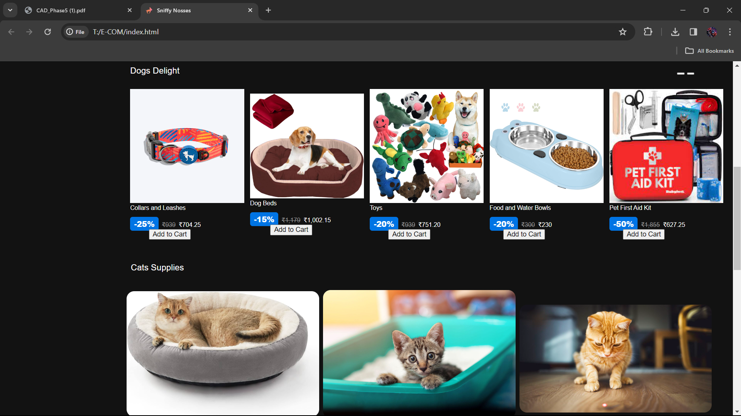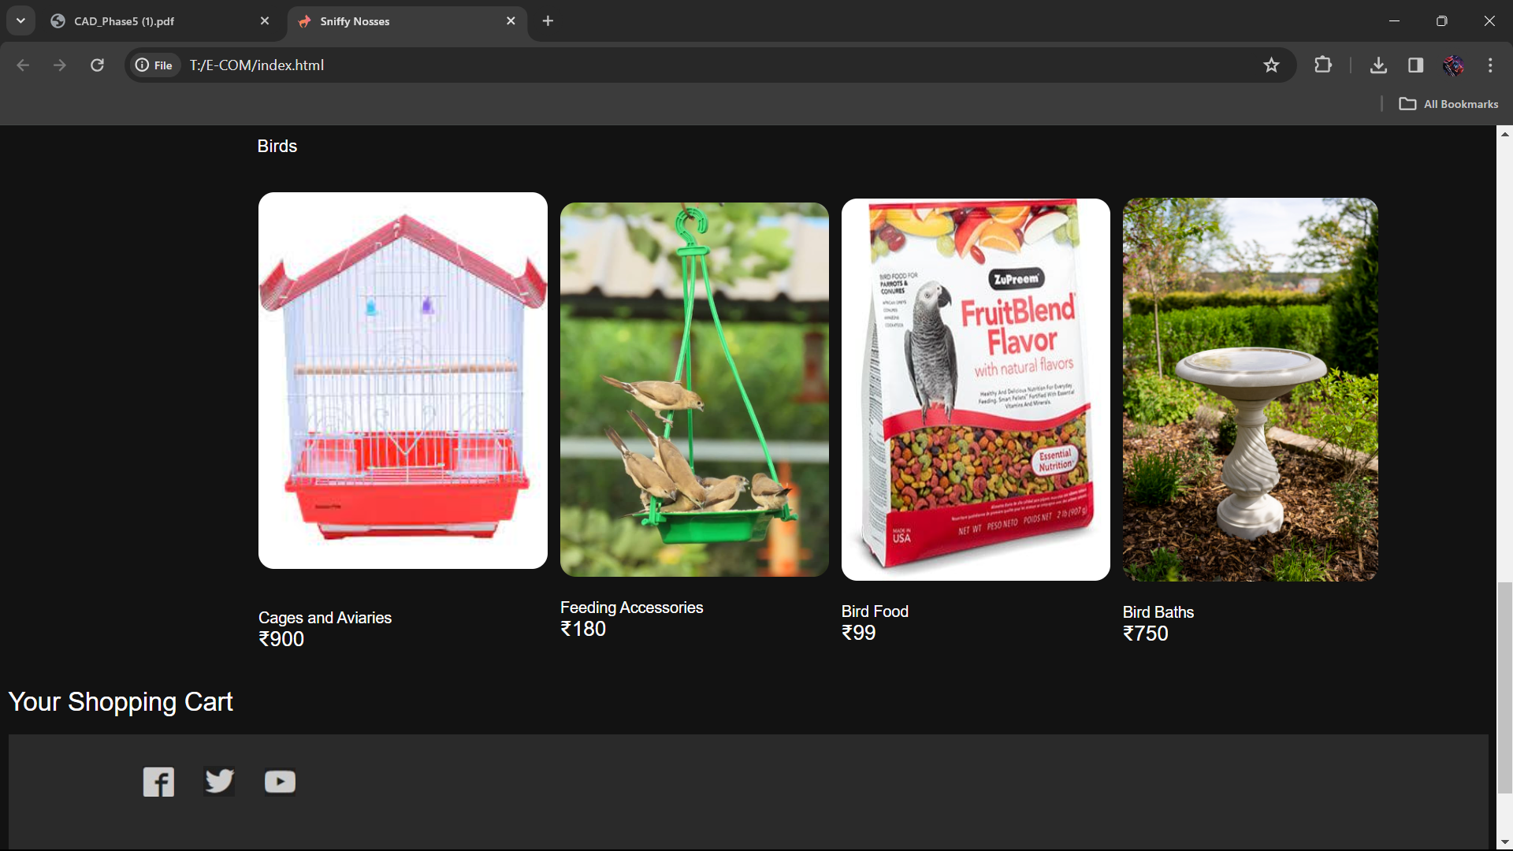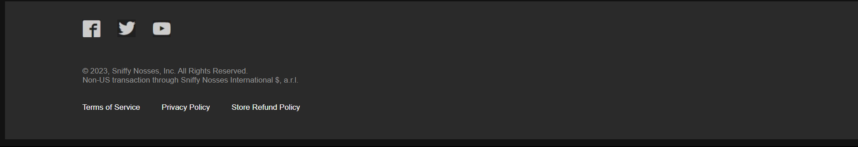

**JS CODE FOR ADD ITEM TO CART**

**SOURCE CODE**

<script>

const cart = [];

const cartItems = document.getElementById('cart-items');

const cartTotal = document.getElementById('cart-total');

const cartSection = document.getElementById('cart');

const orderSuccessMessage = document.getElementById('order-success');

function addToCart(itemName, itemPrice) {

cart.push({ name: itemName, price: itemPrice });

updateCart();

}

function updateCart() {

cartItems.innerHTML = '';

let total = 0;

cart.forEach(item => {

const li = document.createElement('li');

li.innerText = `${item.name} - $${item.price.toFixed(2)}`;

cartItems.appendChild(li);

total += item.price;

});

cartTotal.innerText = total.toFixed(2);

if (cart.length > 0) {

cartSection.style.display = 'block';

}

}

</script>

**ADD TO CART BUTTON**

<pre style="font-size:12px;color:white;font-family:sans-serif;"><img src="beds.jpg" width="225px">

Dog Beds

<span style="background-color:rgb(0,116,228);padding:3px;border-radius:5px;font-weight:800;font-size:15px;"> -15% </span> <span style="color:rgb(151,151,151);"><s>&#8377;1,179</s></span> <span>&#8377;1,002.15</span>

<button onclick="addToCart('Dog Beds', 1002.15)">Add to Cart</button>

</pre>

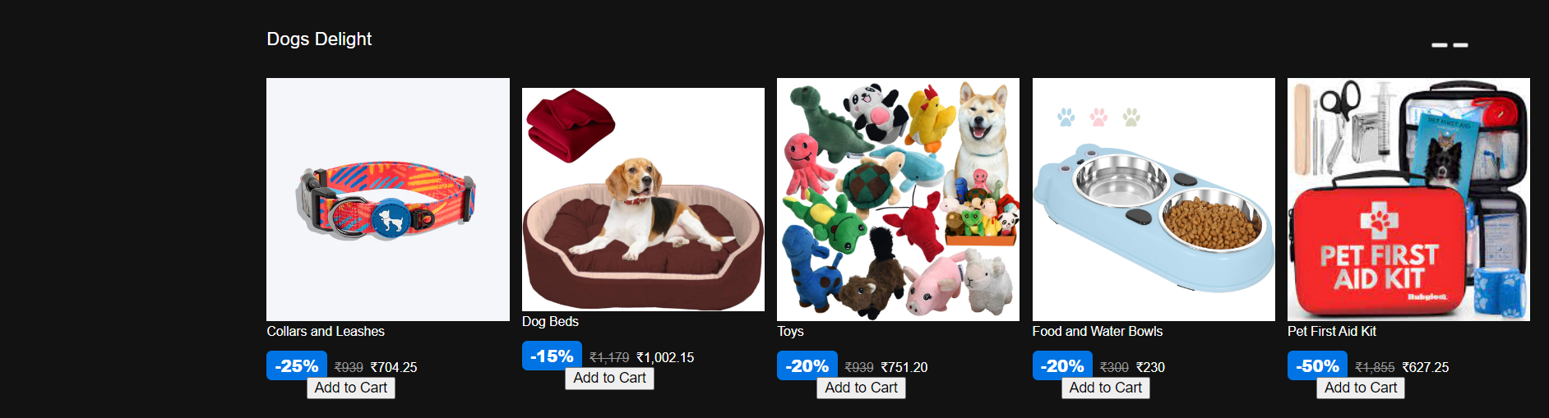

**CART DETAILS DISPLAYING SECTION**

<h1 style="font-family:sans-serif;font-weight:300;font-size:25px;color:white;">Your Shopping Cart</h1>

<div id="cart" style="background-color:rgb(42,42,42);font-family:sans-serif;font-weight:400;font-size:13px;color:white;">

<ul id="cart-items">

</ul>

<p>Total: $<span id="cart-total">0.00</span></p>

<button onclick="placeOrder()">Place Order</button>

</div>

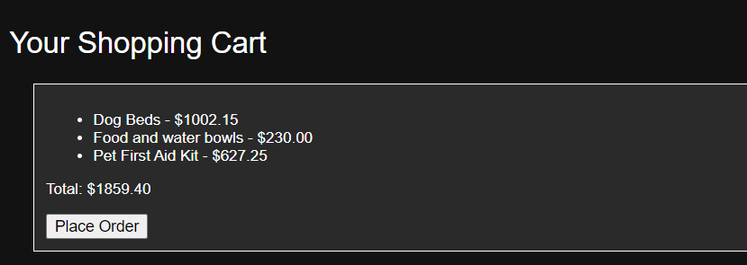

**PLACE ORDER JAVASCRIPT CODE**

<script>

function placeOrder() {

// You can implement the order placement logic here (e.g., sending data to a server).

// For now, we'll just show a success message and clear the cart.

cart.length = 0; // Clear the cart

updateCart(); // Update the cart display

// Set a flag in the URL

const url = new URL(window.location.href);

url.searchParams.set('orderPlaced', 'true');

// Redirect to the success page

window.location.href = 'order-success.html' + url.search;

}

</script>

**ORDER SUCCESSFULLY PLACED PAGE**

<!DOCTYPE html>

<html lang="en">

<head>

<meta charset="UTF-8">

<title>Order Success</title>

<style>

.success-message {

text-align: center;

font-size: 24px;

color: green;

}

.tick-mark {

font-size: 48px;

color: green;

}

</style>

</head>

<body>

<div class="success-message">

<span class="tick-mark">&#10004;</span> Order Successfully Placed

</div>

</body>

</html>

