*Building Dynamic Personal Blogs with IBM Cloud Static Web Apps*



*Abstract*:

In the digital age, personal blogs have evolved from simple static websites to dynamic platforms for sharing thoughts, ideas, and experiences. IBM Cloud Static Web Apps offers a modern and efficient way to create and host such blogs, combining the benefits of static site generation with the flexibility of serverless computing. This abstract presents key modules and features for building dynamic personal blogs using IBM Cloud Static Web Apps.

Modules

1. *Static Site Generation*

IBM Cloud Static Web Apps simplifies the process of creating static websites. With popular site generators like Jekyll, Hugo, or Gatsby, bloggers can generate dynamic content and pages at build time. This module ensures fast loading times and optimal performance for visitors.

1. *Content Management System (CMS)*

For bloggers who prefer a user-friendly interface for content creation and management, IBM Cloud Static Web Apps offers CMS integration. This module allows bloggers to easily add, edit, and organize their posts and media assets, all within a familiar and intuitive environment.

1. *Serverless Functions*

To add interactivity and dynamic features to personal blogs, IBM Cloud Static Web Apps includes serverless functions. This module enables bloggers to create custom APIs, forms, and dynamic widgets without the need for a traditional server setup, enhancing the user experience.

1. *Authentication and User Management*

Personal blogs often require user authentication and management for comment sections, subscriptions, or exclusive content. IBM Cloud Static Web Apps provides authentication modules, enabling bloggers to implement secure login systems and manage user access efficiently.

1. *Content Versioning and Collaboration*

For bloggers working with a team or wanting to maintain content versions, IBM Cloud Static Web Apps includes version control and collaboration features. This module helps bloggers track changes, collaborate with editors, and revert to previous content versions when needed.

1. *SEO and Analytics*

IBM Cloud Static Web Apps offers built-in SEO tools and analytics integrations to help bloggers improve their website’s discoverability and understand audience behavior. This module enables bloggers to optimize content and track key performance metrics.

1. Custom Domain and SSL

To establish a professional online presence, bloggers can easily configure custom domains and enable SSL certificates with IBM Cloud Static Web Apps. This module ensures that personal blogs are secure and accessible through branded domain names.

1. *Scalability and Global Distribution*

As personal blogs grow in popularity, IBM Cloud Static Web Apps provides scalable hosting and content delivery. This module ensures that blogs can handle increased traffic and deliver content quickly to a global audience.

1. *Social Media Integration*

To increase the reach and engagement of your personal blog, consider integrating social media modules. These modules enable readers to easily share content on social platforms and display social media feeds on your blog, fostering a sense of community and interaction.

1. *Comment Moderation and Interaction*

Enhance the user experience by implementing comment moderation and interaction modules. These modules allow you to manage comments effectively, filter out spam, and engage with your readers through discussions and responses.

1. *Email Subscription and Newsletter Integration*

For bloggers looking to build a loyal audience, email subscription and newsletter integration modules are invaluable. They enable readers to subscribe to updates, receive newsletters, and stay informed about new content, events, or promotions.

1. *Advanced Search and Navigation*

As your blog grows, it’s essential to provide readers with efficient ways to discover and navigate your content. Advanced search and navigation modules help users find relevant articles, explore categories, and access related posts easily.

1. *Content Personalization*

To tailor the user experience, content personalization modules can be employed. These modules analyze user behavior and preferences to recommend related articles or suggest personalized content, increasing engagement and retention.

1. *Monetization and E-commerce*

For bloggers interested in generating income, monetization and e-commerce modules can be integrated. These modules enable you to sell digital products, merchandise, or offer premium content, diversifying revenue streams.

1. *Multilingual Support*

Expanding your blog’s reach globally requires multilingual support modules. They allow you to provide content in multiple languages, catering to a broader audience and enhancing accessibility.

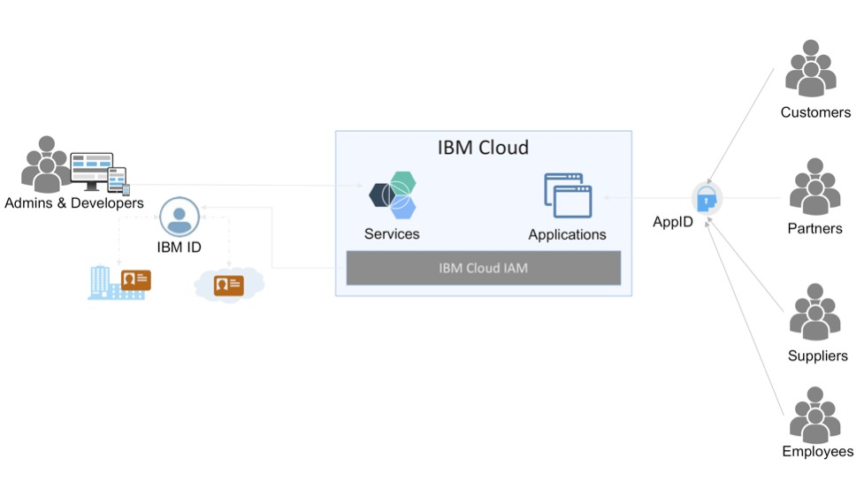

*Conclusion*

These modules can help bloggers create a more engaging, personalized, and functional experience for their readers. By selectively integrating the modules that align with their goals and audience, bloggers can take their personal blogs to the next level on IBM Cloud Static Web Apps.

|  |  |  |
| --- | --- | --- |
|  |  |  |

**Thank You**

***PHASE 1 PROJECT SUBMITTED BY***

**SAKTHIVEL R**

**822221106033**

**COLLEGE CODE : 8222**