*PERSONAL BLOG ON IBM CLOUD STATIC WEB APPS*

***Introduction:***

**Integrating social media sharing buttons on a website or app is a great way to encourage users to share your content. Here are the general steps to consider:**

**Choose the Social Media Platforms: Decide which social media platforms you want to include sharing buttons for. Common options include Facebook, Twitter, Instagram, LinkedIn, Pinterest, and others. Focus on platforms relevant to your audience.**

**Use Official Sharing Buttons: It's recommended to use official sharing buttons provided by the social media platforms themselves. They are usually more reliable and provide better user experiences.**

**Obtain API Access (if necessary): Some platforms may require API access to implement sharing buttons. For instance, Twitter and Facebook often require API keys for integration.**

***Some example HTML program:***

**<!DOCTYPE html>**

**<html>**

**<head>**

**<!—Include necessary scripts and stylesheets 🡪**

**</head>**

**<body>**

**<!—Your content goes here 🡪**

**<!—Twitter Share Button 🡪**

**<a href=**[**https://twitter.com/intent/tweet?url=YOUR_URL&text=YOUR_TEXT**](https://twitter.com/intent/tweet?url=YOUR_URL&text=YOUR_TEXT) **target=”_blank” rel=”noopener”>**

**Share on Twitter**

**</a>**

**<!—Other social media buttons can be added similarly 🡪**

**</body>**

**</html>**

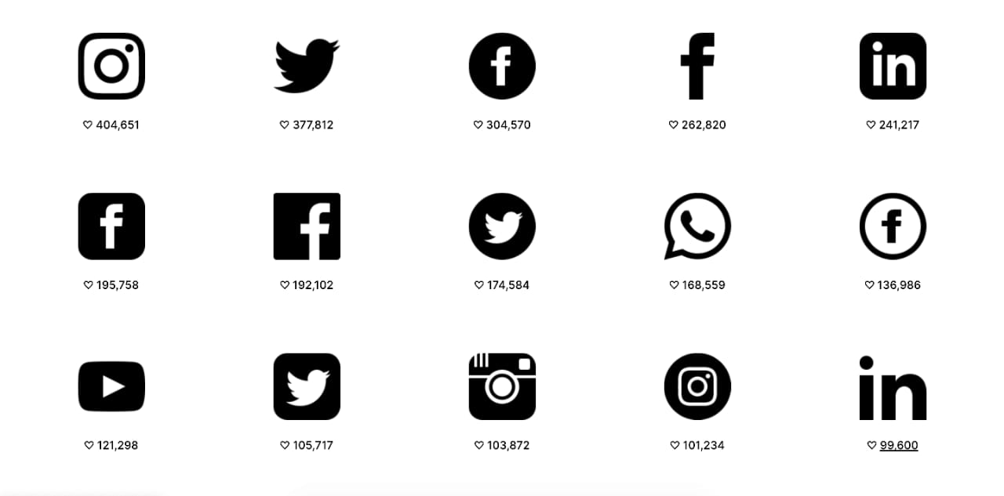

**Enhance user engagement and interaction in personal blogs, you can consider adding interactive maps and comment sections. Here’s how you can create and integrate both of these elements:**

***Interactive Maps:***

**To create interactive maps for your personal blog, you can use popular mapping platforms like Google Maps or Mapbox. Here are the general steps:**

***Choose a Mapping Platform:***

**Decide whether you want to use Google Maps or Mapbox. Both offer interactive map features, but Mapbox provides more customization options.**

***Create an Account:***

**Sign up for an account on the chosen platform and obtain the necessary API keys or access tokens.**

***Generate an Embeddable Map:***

**Use the platform’s tools to create an interactive map. Customize it with markers, overlays, and other elements relevant to your blog content.**

***Embed the Map:***

**Once your map is ready, you’ll typically receive an HTML code snippet to embed the map into your blog post or page. Copy and paste this code into your blog’s HTML editor.**

**Customize Map Appearance:**

**Adjust the map’s appearance and interactivity using CSS and JavaScript if needed. You can make it responsive to different screen sizes and customize the map’s style to match your blog’s design.**

***Provide Context:***

**Include descriptions or captions for map markers to provide context to your readers about the locations you’re highlighting.**

***Interactive Maps:***

***Choose a Mapping Platform:* Decide whether to use Google Maps or Mapbox.**

**Create an Account and Get API Key: Sign up for an account on your chosen platform and obtain an API key or access token.**

***Embed the Map:* Here’s a simplified example of how to embed a Google Map into your HTML:**

**<!DOCTYPE html>**

**<html>**

**<head>**

**<!—Include necessary scripts 🡪**

**<script src=**[**https://maps.googleapis.com/maps/api/js?key=YOUR_API_KEY&callback=initMap**](https://maps.googleapis.com/maps/api/js?key=YOUR_API_KEY&callback=initMap) **async defer></script> <script>**

**Function initMap() {**

**Var map = new google.maps.Map(document.getElementById(‘map’), {**

**Center: {lat: YOUR_LATITUDE, lng: YOUR_LONGITUDE},**

**Zoom: YOUR_ZOOM_LEVEL**

**});**

**// Customize your map with markers, overlays, etc.**

**}**

**</script>**

**</head>**

**<body>**

**<!—Your blog content goes here 🡪**

**<div id=”map” style=”height: 400px;”></div>**

**</body>**

**</html>**



***Comment Sections:***

**Adding a comment section to your blog encourages interaction and discussions among your readers. Here’s how to do it:**

***Choose a Comment System:* Decide whether you want to use a built-in comment system (if your blogging platform provides one) or an external service like Disqus or Commento.**

***Register for the Comment Service:* If you choose an external service, sign up for an account and configure the comment system settings according to your preferences.**

***Integrate the Comment System:***

**For built-in comment systems, follow your blogging platform’s documentation to enable comments on your blog posts. For external services, you’ll usually receive a code snippet to embed in your blog’s template or individual posts.**

***Moderation and Spam Filtering:***

**Configure moderation settings to prevent spam and ensure a positive user experience. Most comment systems provide moderation tools.**

***Engage with Commenters:***

**Encourage discussions by actively participating in the comment section. Respond to comments, ask questions, and engage with your readers.**

***Notify Users:***

**Consider enabling email notifications for comment replies to keep your readers engaged in the discussion.**

***Customize Comment Section Design:***

**Customize the appearance of the comment section to match your blog’s style using CSS if the comment system allows for it.**

**Remember to be responsive and engage with your readers in both the interactive maps and comment sections. These features can foster a sense of community and improve user engagement on your personal blog.**

***Comment Sections:***

***Choose a Comment System:* Decide whether to use a built-in comment system or an external service like Disqus.**

***Integrate the Comment System:* If you’re using an external service like Disqus, follow their documentation to embed the comment section.**

***Customize Comment Section Appearance:* Customize the appearance of the comment section using CSS. Here’s a simplified example:**

**/* Style the comment section container */**

**#comments {**

**Background-color: #f7f7f7;**

**Padding: 20px;**

**Border: 1px solid #ddd;**

**Border-radius: 5px;**

**}**

**/* Style individual comments */**

**.comment {**

**Margin-bottom: 10px;**

**Padding: 10px;**

**Border: 1px solid #ccc;**

**Background-color: #fff;**

**}**

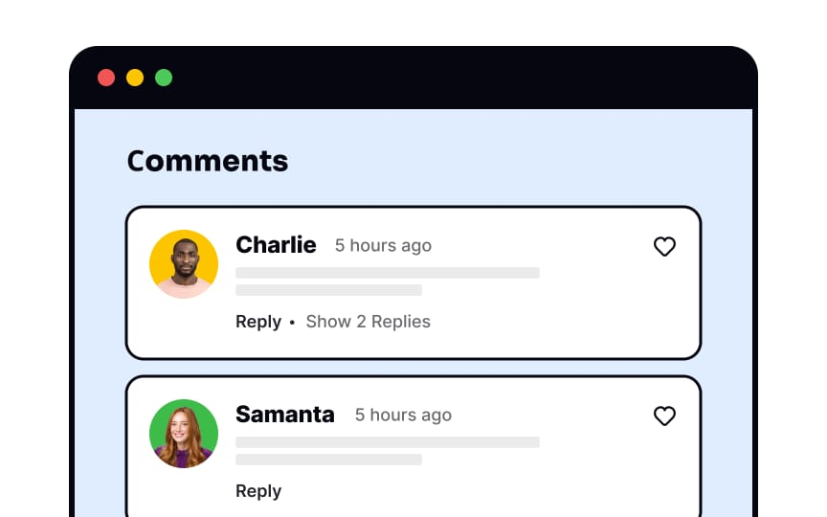

***Moderation and Engagement:***

**Set up moderation settings and engage with your readers by responding to comments and participating in discussions.**

***Notify Users:***

**Consider adding features like email notifications for comment replies to keep users engaged.**

**Remember to replace placeholders in the code snippets with your specific details and customize the appearance and functionality to match your blog’s design and requirements.**

***Conclusion:***

**In Conclusion, creating a personal blog with IBM Cloud Static Web Apps offers an exceptional opportunity to share your passions, knowledge, and experiences with the world. With the power of static site generation and the flexibility of serverless computing, this platform empowers bloggers to craft dynamic and engaging web experiences.**

**Through the integration of modules like content management systems, social media engagement, and personalized content, you can create a blog that not only captivates your audience but also fosters meaningful interactions. IBM Cloud Static Web Apps enables you to focus on your content without worrying about infrastructure management, ensuring a seamless and hassle-free blogging experience.**

**Additionally, the platform’s scalability, security, and support for custom domains and SSL certificates ensure that your blog is ready to grow and thrive in today’s digital landscape. Whether you’re a seasoned blogger or just starting your online journey, IBM Cloud Static Web Apps provides the tools and features you need to make your personal blog a standout success.**

**So, go ahead and unleash your creativity, share your stories, and connect with your audience through the power of IBM Cloud Static Web Apps. Your personal blog awaits, and with it, the opportunity to make your mark on the digital world. Start crafting your online presence today, and let your voice be heard. Happy blogging!**

**Team members: Sakthivel R**

**College code:8222**

**College name: University college of engineering thriukkuvalai, Nagapattinam**

**Nm I’d:au822221106033**