PERSONAL Blog on ibm cloud static web apps

# *Introduction*:

When working with datasets for your personal blog website, it’s important to ensure data quality, perform data cleaning, transformation, and reduction where necessary. Here’s how you can incorporate these steps into your data handling process:

**Data Quality Assessment**:

**Data Validation**: Ensure the data is valid and follows the expected format. Validate data types, ranges, and constraints.

**Data Completeness**: Check for missing data and decide how to handle it. You may choose to omit, impute, or provide default values for missing data.

**Data Accuracy**: Verify the accuracy of data by cross-referencing it with reliable sources or using data validation techniques.

**Data Consistency:** Ensure consistency across different parts of the dataset. For example, consistent date formats, units of measurement, and naming conventions

**Data Cleaning**:

**Handling Outliers:** Identify and decide how to handle outliers that might negatively affect your analysis or presentation. You can choose to remove them or adjust them based on the context.

**Text and HTML Cleaning:** If your data includes text or HTML content, sanitize it to remove any potentially harmful code or unwanted formatting that could disrupt your blog’s layout.

**Data Formatting:** Ensure data is formatted consistently, especially when incorporating it into HTML. Format dates, numbers, and text to ensure they display correctly.

**Data Enrichment:** If necessary, add missing or additional information to your dataset to enhance the quality and depth of your content.

**Data Transformation:**

**Aggregation**: Summarize or aggregate data to create more concise content, such as monthly statistics or quarterly reports.

**Normalization**: Normalize data to ensure it is on a consistent scale. For example, scale numerical data to a 0-1 range to provide meaningful visualizations.

**Text Processing:** If your dataset contains text, consider text preprocessing techniques such as stemming, lemmatization, and stop-word removal to improve natural language understanding.

**Image Compression:** If your dataset includes images, you might want to optimize them for web use to ensure faster loading times on your blog.

**Content Categorization:** Organize and categorize your content for easier navigation. Create tags or categories for your blog posts to help users find relevant information.

**Data Reduction:**

**Selecting Relevant Data:** Choose the most relevant data to present on your blog. Depending on your blog’s focus, you may not need to display the entire dataset. Select the subset that matters to your readers.

**Aggregated Views:** Consider providing summary or aggregated views of data, such as charts and graphs, rather than displaying the entire dataset for a more concise and reader-friendly presentation.

**Data Pagination:** Implement data pagination for long lists or datasets, allowing users to navigate through your content in manageable chunks.

**Lazy Loading:** If your blog includes images, consider implementing lazy loading to improve page load times. This loads images as users scroll down the page rather than all at once

**Design and developing my travel blog :**



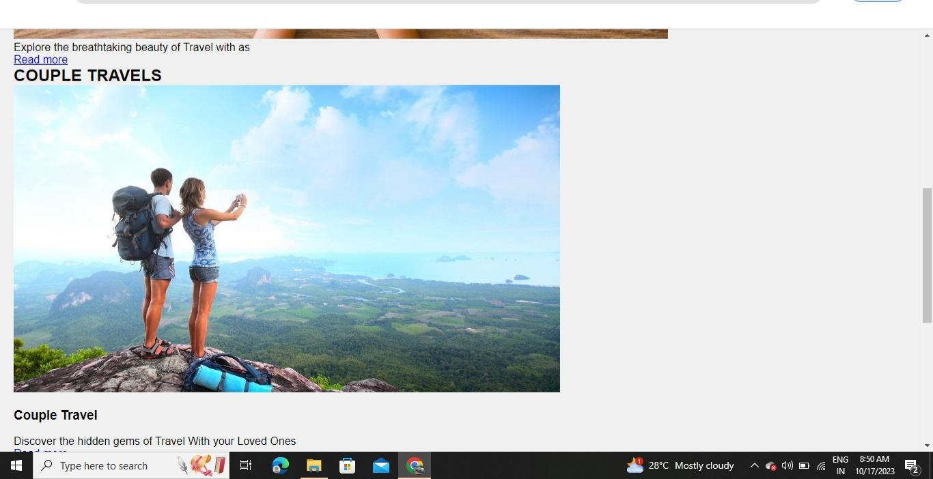

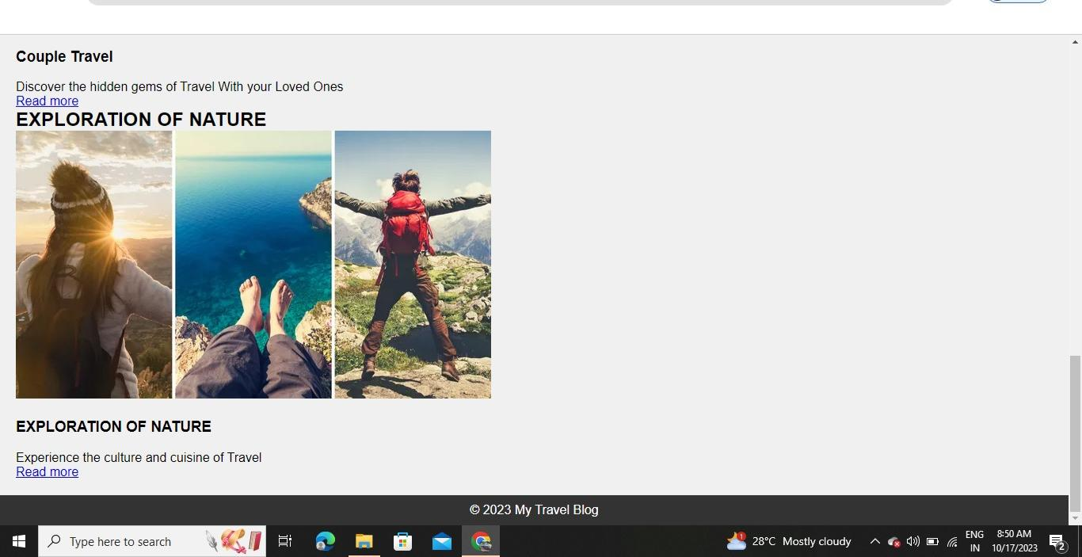

**Conclusion:**

Incorporating these steps into your data handling process ensures that your blog presents high-quality, clean, and relevant content to your readers, enhancing their experience and engagement. Remember that the specific implementation details may vary based on your dataset and the tools and technologies you’re using for your blog.

**TEAM MEMBERS: SAKTHIVEL R**

**COLLEGE CODE: 8222**

**COLLEGE NAME: UNIVERSITY COLLEGE OF ENGINEERING, THIRUKKUVALAI, NAGAPATTINAM**

**NM ID: au822221106033**