1. Reverse the string without string function.

**Way 1:**

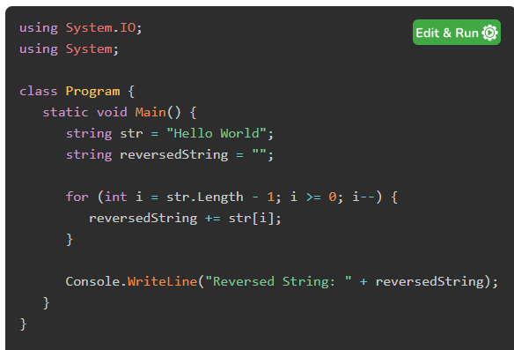

**Way 2:**

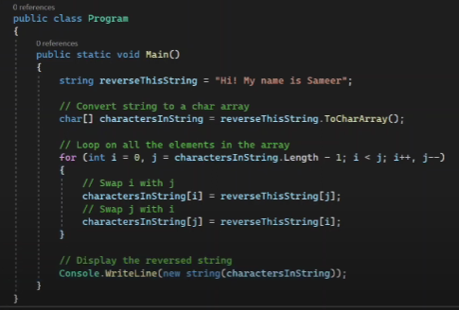

**2.. Emp table identify the same salary report.**

SELECT s1.Name, s1.Station, s1.Salary

FROM Staff s1

INNER JOIN Staff s2 ON s1.Salary = s2.Salary AND s1.Name <> s2.Name

**Find duplicate rows based on a single column**

SELECT email, COUNT(*) AS count

FROM employees

GROUP BY email

HAVING COUNT(*) > 1;

**3.Find the second highest salary list in the emp table.**

SELECT MAX(salary)

FROM employee

WHERE salary NOT IN (SELECT MAX(salary) FROM employee);

SELECT DISTINCT salary

FROM employee

ORDER BY salary DESC LIMIT 1,1;

**4. Count the repeated string in the sentences.**

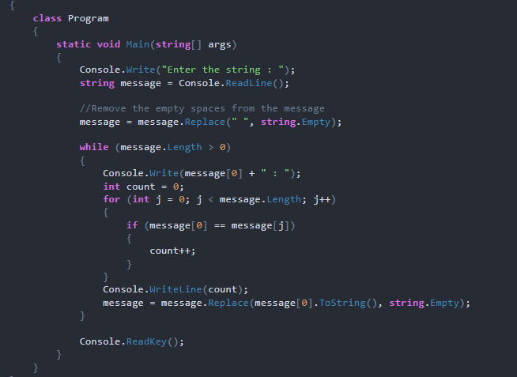

static void Main() {

string repeatedWord = "woooooooow";

for (int i = 0; i < repeatedWord.Count()-1; i++)

{

if (repeatedWord[i] == repeatedWord[i+1])

{

// ....

}

}

**5. Remove the list of duplicate record.**

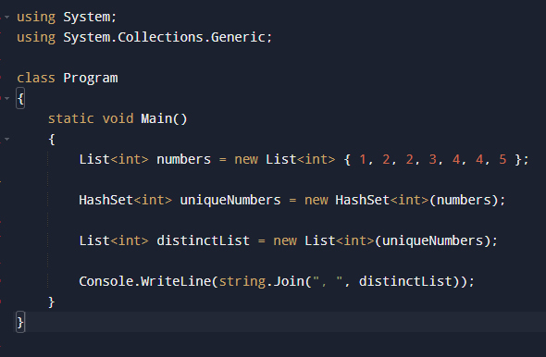

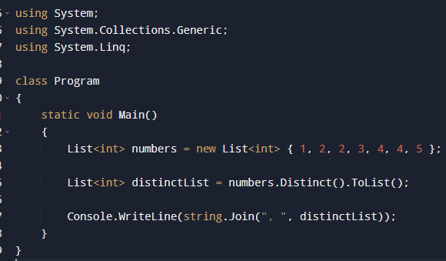

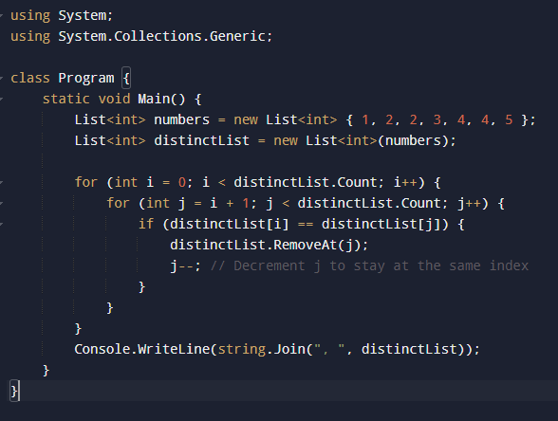

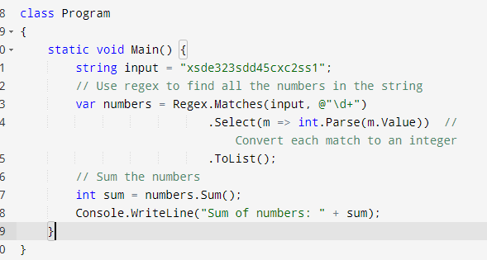

list a = 1, 2, 3

list b = 3, 4, 5

forEach (value in a) {

writeline.console("")

}

class program {

static void Main() {

List<int> numbers = new List<int> {1, 2, 3, 3, 4, 5}

IEnumrable<int> dubilcateNumbers = numbers.Disncit().toList();

}

}

Employee

Emp ID

Salary

Dep ID

Emp Name

Department

Dep ID

Dep Name

select s1.EmpID, s1.Salary, s1.DepID, s1.EmpName salary s1 inner join

Select max(salary) from Employee where salary not in (select max(salary) from employe).

Solid principle