Chapter — Results
Module 1: Dynamic Scenario Generation — Evaluation of RQ1–RQ4

This chapter reports the empirical evaluation of the dynamic scenario-generation pipeline for Module 1. The evaluation provides evidence for all four research questions, with Research Question 4 (RQ4) as its primary focus because it is the only research question that is inherently empirical — it asks to what extent repeated generation yields different scenarios and whether difficulty and randomness settings measurably change scenario structure, which can be answered only by generating many scenarios and applying statistical tests. Research Questions 1–3 are primarily design-and-correctness questions, answered in the Design and Implementation chapter and the validation layer; the experiments reported here nonetheless supply direct supporting evidence for each of them, as set out in Section 1.
The evaluator-facing dashboard exposes six parameters — layout type, room count (3–5), room size, entry type, terrorist count (1–4) and placement strategy — together with an optional generation seed. Difficulty, randomness and hostage-risk level were removed from the form and fixed at production defaults (difficulty 3, randomness medium, risk medium), but are retained programmatically within the pipeline. Six batch experiments comprising 2,000 generated scenarios were analysed. Omnibus group differences were assessed with one-way ANOVA where Shapiro–Wilk tests confirmed normality in every group, and with the Kruskal–Wallis H test otherwise; effect sizes are reported as eta-squared (η²) for ANOVA and epsilon-squared (ε²) for Kruskal–Wallis, and post-hoc comparisons used Tukey's HSD or Dunn's test with Bonferroni correction respectively. Effect sizes are interpreted using the conventional thresholds of 0.01 (small), 0.06 (medium) and 0.14 (large).

1 Research Questions and Evidence Mapping
Table 1 maps each research question to the phase in which it is principally addressed and to the experiments in this chapter that provide supporting empirical evidence. Although RQ4 is the primary target of the evaluation phase, Experiments B and E in particular extend the evidence base to RQ1 and RQ3, and the navigation-context metrics throughout bear on RQ2.
Table 1. Research questions, where each is principally addressed, and the experiments that supply supporting evidence in this chapter.
RQ | Focus | Principally addressed in | Supporting evidence here
RQ1 | Parameter-to-layout translation with spatial validity | Design & Implementation | Exp. B (parameter traceability); Exp. E (spatial-validity pass rate)
RQ2 | Meaningful NPC role & navigation context | Design & Implementation | Exp. B (guard/patrol metrics); Exp. D (role reconfiguration)
RQ3 | Scenario validation: coherent, mission-ready, loadable | Validation Layer (Phase 3) | Exp. E (validation reliability, failure analysis)
RQ4 | Repeat-generation variability; difficulty & randomness effects | Evaluation (Phase 5) — PRIMARY | Exp. A/A2 (variability); Exp. C & D (settings)

2 Variability at Production Settings (Experiment A)
▸ Primary evidence for RQ4, clause 1 (repeat-generation variability).
Experiment A generated 100 scenarios from a single, identical production parameter set (branching layout, four rooms, medium room size, single entry, three terrorists, dispersed placement, difficulty 3, randomness medium), yielding 4,950 unique scenario pairs for pairwise comparison. This is the primary variability result because it reflects the configuration evaluators actually receive.
A clear structural pattern emerged: at production settings the room graph itself is deterministic, whereas variation is concentrated in entity placement, navigation-role assignment, furniture and graph depth. Across all 100 repeats, room count, door count, average connectivity, cyclicity, entry-point count and locked-door count each took exactly one value (coefficient of variation, CV = 0%). Substantial variation was observed downstream, as summarised in Table 2.
Table 2. Coefficient of variation for the principal metrics across 100 repeats of the identical production parameter set (medium randomness).
Metric | Mean | SD | CV (%)
roamingGuardCount | 0.30 | 0.46 | 153.5
entityDepthVariance | 0.175 | 0.115 | 65.8
stationaryGuardCount | 0.70 | 0.46 | 65.8
minHostageTerroristDistance | 2.69 | 1.63 | 60.6
entityClusteringCoefficient | 0.698 | 0.256 | 36.6
patrolCoverage | 0.335 | 0.119 | 35.5
avgHostageTerroristDistance | 8.82 | 2.80 | 31.7
maxDepth | 1.70 | 0.46 | 27.1
furnitureFloorCoverage | 0.068 | 0.018 | 26.6
totalFurnitureCount | 18.97 | 3.33 | 17.6
Structural metrics (roomCount, doorCount, avgConnectivity, entryPointCount) | — | 0.00 | 0.0

Pairwise diversity confirmed this interpretation (Figure 1). The mean pairwise graph edit distance was 0.85 (SD 0.99, range 0–2) and the mean Jaccard room-connectivity similarity was 0.79 (SD 0.25), indicating that scenario graphs remained broadly similar to one another while still admitting occasional topological depth changes. Entity position distance was the dominant axis of variation (mean 10.06, SD 3.20, range 0.34–19.64) and, unlike the discrete structural distances, formed a smooth bell-shaped distribution — establishing entity placement as the principal source of scenario-to-scenario difference at production settings. Role-distribution and depth-profile distances co-varied exactly with graph edit distance, reflecting that a change in reachable graph depth simultaneously alters the role and depth profile.
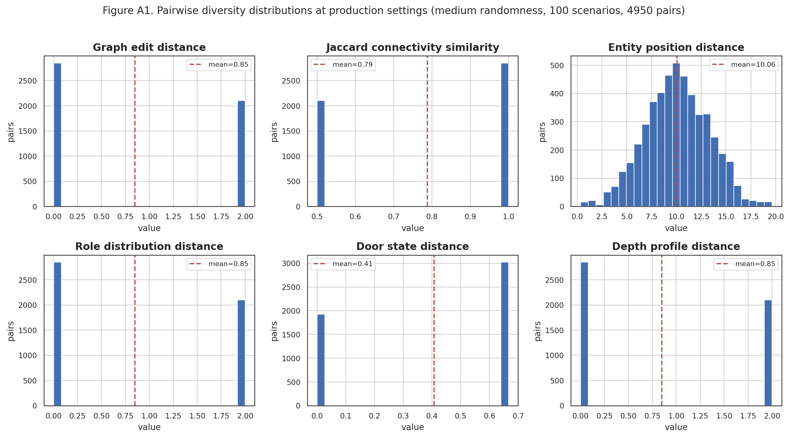
Figure 1 (A1). Pairwise diversity distributions at production settings (medium randomness, 100 scenarios, 4,950 pairs). Entity position distance (top right) is continuous and bell-shaped; the graph, role and depth distances are discrete.

2.1 High-randomness ceiling (Experiment A2)
To quantify the diversity available but not currently exposed, Experiment A2 repeated the protocol at high randomness. Mann–Whitney U tests comparing the two pairwise-diversity distributions found the differences to be statistically detectable but practically marginal. Structural distances (graph edit, role distribution and depth profile) each increased by 14.3% (from 0.848 to 0.970; p < 0.0001), but the associated rank-biserial effect sizes were negligible (≤ 0.061). Entity-position diversity and furniture-count diversity in fact decreased slightly under high randomness (−1.7% and −12.8% respectively). The additional structural diversity that re-exposing high randomness would unlock is therefore modest — on the order of a 0.12-unit increase on the 0–2 graph-edit-distance scale — and comes at no benefit, or a small cost, to placement and furniture diversity.
In answer to the first clause of RQ4: the pipeline does produce meaningfully different scenarios from an identical evaluator parameter set, but the difference is tactical rather than topological. Entity positions, guard and patrol role composition, furniture arrangement, door states and graph depth all vary substantially (CV 18–154%), while the room graph is held constant for a fixed parameter set.

3 Evaluator Parameter Traceability (Experiment B)
▸ Primary evidence that the form controls behave predictably ([22]); direct supporting evidence for RQ1 (parameter-to-layout translation) and RQ2 (navigation-context control).
Experiment B generated 1,000 scenarios in which each of the six form parameters was varied in isolation from the production baseline (50 scenarios per level). The metric distributions were overwhelmingly non-normal, so the Kruskal–Wallis H test with Dunn's post-hoc (Bonferroni-corrected) was applied throughout. The central traceability result is presented in Table 3: every target relationship reached significance at p < 0.0001 with a large effect size, with the sole exception of two genuinely null entry-type relationships discussed below.
Table 3. Core traceability matrix. For each evaluator-facing parameter, the omnibus p-value and effect size (ε²) on each pre-registered target metric. L = large effect.
Parameter | Target metric | p | Effect (ε²)
layoutType | avgConnectivity | <0.0001 | 1.000 (L)
 | cyclicityMeasure | <0.0001 | 1.000 (L)
 | graphDiameter | <0.0001 | 0.765 (L)
 | maxDepth | <0.0001 | 0.890 (L)
 | patrolCoverage | <0.0001 | 0.758 (L)
roomCount | roomCount (actual) | <0.0001 | 1.000 (L)
 | graphDiameter | <0.0001 | 0.734 (L)
 | maxDepth | <0.0001 | 0.182 (L)
 | totalFurnitureCount | <0.0001 | 0.611 (L)
 | patrolCoverage | <0.0001 | 0.190 (L)
roomSize | avgEntityDistanceFromEntry | <0.0001 | 0.689 (L)
 | avgFurniturePerRoom | <0.0001 | 0.878 (L)
 | furnitureFloorCoverage | <0.0001 | 0.312 (L)
 | minHostageTerroristDistance | <0.0001 | 0.549 (L)
placementStrategy | avgEntityDistanceFromEntry | <0.0001 | 0.248 (L)
 | entityClusteringCoefficient | <0.0001 | 0.327 (L)
 | entityDepthVariance | <0.0001 | 0.420 (L)
 | avgEntityDepth | <0.0001 | 0.278 (L)
terroristCount | patrolCount | <0.0001 | 1.000 (L)
 | stationaryGuardCount | <0.0001 | 0.546 (L)
 | roamingGuardCount | <0.0001 | 0.801 (L)
 | avgPatrolRouteLength | <0.0001 | 0.901 (L)
 | patrolCoverage | <0.0001 | 0.901 (L)
entryType | entryPointCount | <0.0001 | 1.000 (L)
 | avgConnectivity | constant | 0.000
 | doorsOpen | constant | 0.000

Layout type was the strongest and most globally influential control (Figure 2). Beyond its own targets it perfectly separated average connectivity and cyclicity (ε² = 1.000): the loop layout alone produced connectivity 2.0 and non-zero cyclicity, while linear, branching and hub-and-spoke held connectivity at 1.5 with zero cycles. Graph diameter, maximum depth and patrol coverage likewise varied sharply by layout, with the branching baseline occupying an intermediate position. This directly evidences RQ1: the layout-type parameter translates into predictable, well-separated graph structure.
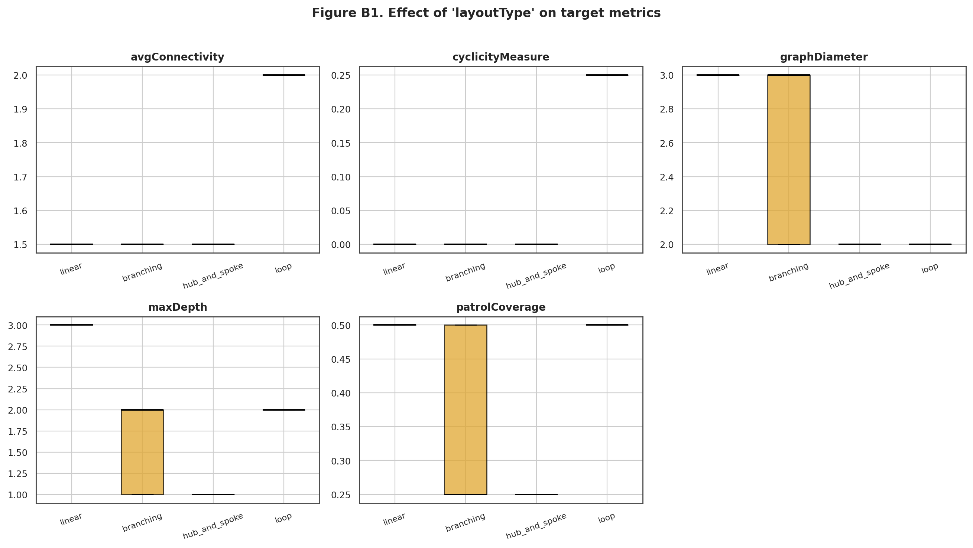
Figure 2 (B1). Effect of layout type on target metrics. The loop layout is cleanly separated on connectivity and cyclicity; branching shows the widest within-type spread on graph diameter, depth and patrol coverage.
Terrorist count produced the most direct control over navigation structure (Figure 3), which is the evidence most relevant to RQ2. Patrol count was perfectly determined (ε² = 1.000): at one or two terrorists no patrols are instantiated, whereas from three terrorists a patrol appears. Higher counts progressively introduce stationary and roaming guards (ε² = 0.546 and 0.801) and lengthen patrol routes (ε² = 0.901). The role composition is therefore a deterministic, monotonic function of terrorist count rather than an arbitrary assignment — the semantic-meaningfulness property RQ2 requires.
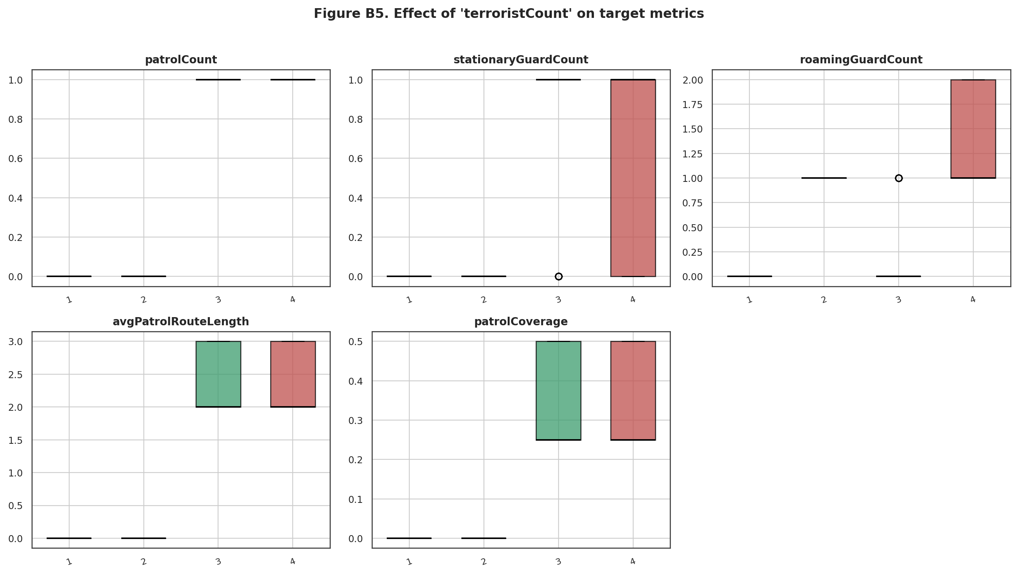
Figure 3 (B5). Effect of terrorist count on navigation-context metrics. Patrols emerge at three terrorists; stationary and roaming guards scale with count, evidencing structured (non-random) role assignment for RQ2.
Room count, room size and placement strategy each produced large, targeted effects on their intended metrics (full matrix in Table 3). Room size, for instance, drove average entity distance from entry (ε² = 0.689) and furniture density (ε² = 0.878), while placement strategy reshaped entity clustering and depth variance (ε² = 0.327 and 0.420).

3.1 The weak relationship: entry type
Entry type was the only parameter to exhibit a null relationship on any target metric. It controlled the number of entry points deterministically and perfectly (single → 1, multiple → 3; ε² = 1.000), but had no effect on average connectivity (constant 1.50) or on the open-door count (constant 0). The interpretation is that additional entries are attached to the existing layout as supplementary exterior access points, without rewiring interior room connectivity or altering the baseline open-door configuration. This is a correct but bounded behaviour: entry type is fully traceable with respect to access, but does not propagate into interior structure.

3.2 Relation to the traceability requirement [22] and to RQ1
These results directly satisfy the traceability requirement of [22], which holds that an evaluator must be able to trust that a generated scenario reflects their configured intent, and they provide the empirical component of the answer to RQ1. The five structural parameters produce statistically significant, large-effect and predictable changes on precisely the metrics they are designed to control, so a configured value is reliably observable in the output. The single qualification is that entry type is traceable on entry-point count only; an evaluator should not expect it to alter interior connectivity in the current build.

4 Pipeline Capability: Difficulty and Randomness (Experiments C and D)
▸ Primary evidence for RQ4, clause 2 (difficulty & randomness settings); Experiment D additionally evidences RQ2 through role reconfiguration.
Experiments C and D address the second clause of RQ4 directly. Although difficulty and randomness are fixed in the current evaluator form (at 3 and medium respectively), the pipeline retains both, and each was varied programmatically across 150 scenarios (50 per level).

4.1 Difficulty (Experiment D)
Difficulty produced strong, measurable structural change, concentrated in navigation and guard configuration and in threat spacing (Figure 4, Table 4). The clearest effect was a wholesale reconfiguration of guard behaviour: moving from difficulty 1 to 5 converted patrolling guards into stationary guards, collapsing patrol count and patrol coverage to zero at difficulty 5 (both p < 0.0001, ε² = 0.760–1.000), while stationary guard count rose from zero at difficulty 1. Minimum hostage–terrorist distance increased monotonically with difficulty (3.00 → 3.51 → 3.93; p < 0.0001, ε² = 0.287). General spatial-spread metrics such as average entity distance from entry and entity depth variance were unaffected, indicating that difficulty targets guard behaviour and threat proximity rather than global spatial distribution. This guard-role reconfiguration is also concrete evidence that the navigation context of RQ2 responds meaningfully to mission parameters.
Table 4. Difficulty differentiation: omnibus p-values, effect sizes and group means for the focus metrics (Kruskal–Wallis).
Metric | p | ε² | Mean (1 / 3 / 5)
patrolCount | <0.0001 | 1.000 (L) | 1.00 / 1.00 / 0.00
avgPatrolRouteLength | <0.0001 | 0.760 (L) | 2.36 / 2.38 / 0.00
patrolCoverage | <0.0001 | 0.760 (L) | 0.34 / 0.35 / 0.00
stationaryGuardCount | <0.0001 | 0.365 (L) | 0.00 / 0.66 / 0.62
minHostageTerroristDistance | <0.0001 | 0.287 (L) | 3.00 / 3.51 / 3.93
avgEntityDistanceFromEntry | 0.323 | negligible | 9.66 / 10.06 / 9.54
avgHostageTerroristDistance | 0.360 | negligible | 8.87 / 9.72 / 9.37
entityDepthVariance | 0.820 | negligible | 0.15 / 0.17 / 0.16

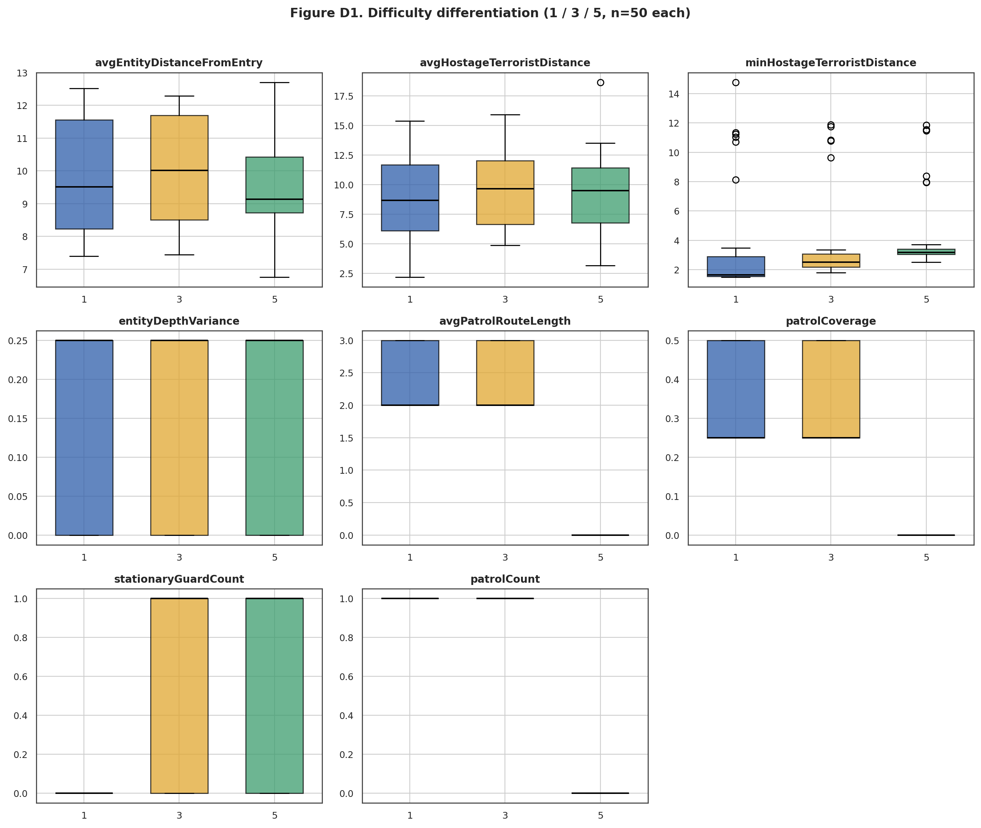
Figure 4 (D1). Difficulty differentiation (levels 1 / 3 / 5, n = 50 each). Patrol count, route length and coverage collapse to zero at difficulty 5 as guards become stationary; minimum hostage–terrorist distance rises with difficulty; global spatial metrics are unaffected.

4.2 Randomness (Experiment C)
Randomness, evaluated at the fixed production configuration, produced only marginal placement-level change and no measurable topological change. With the layout skeleton pinned by the fixed parameter set, average connectivity, cyclicity, room count and locked-door fraction were invariant across low, medium and high randomness. The only movement was a slight, non-significant decline in entity depth variance (0.190 → 0.185 → 0.140; Kruskal–Wallis p = 0.061, ε² = 0.025) and in average patrol-route length (p = 0.342). This is consistent with Experiment A2: randomness perturbs placement and depth micro-structure rather than topology, and its structural footprint at a fixed parameter set is small.
Taken together, these two experiments confirm that the difficulty and randomness capabilities are implemented and validated within the pipeline. The controls were withdrawn from the evaluator form to simplify the interface for the current training programme; because they remain fully functional at the pipeline level, they can be re-exposed to evaluators without any change to the generation code.

5 Furniture and Door State
Procedural furniture and door-state assignment supply additional tactical variation on top of the fixed graph at production settings. Total furniture count averaged 18.97 items per scenario (SD 3.33, range 13–28, CV 17.6%), and furniture floor coverage varied with CV 26.6%, so no two scenarios share an identical interior layout even when their room graph is the same. Door-state distance across scenario pairs averaged 0.41 (range 0–0.67), with a single locked door consistently present (locked-door fraction 0.333). Both mechanisms therefore contribute meaningful tactical variety — differing cover, sightlines and access constraints — that is not captured by the topological metrics.

6 Validation Reliability (Experiment E)
▸ Primary evidence for RQ3 (validation: coherent, mission-ready, loadable); also evidences the spatial-validity clause of RQ1.
Experiment E generated 500 scenarios spanning the full pipeline parameter space and split them by whether each configuration is reachable through the evaluator form. The headline reliability figure is unambiguous: every configuration reachable through the form validated successfully (43 of 43; 100.0%). Across the extended pipeline range the pass rate was 81.6% (373 of 457), giving an overall pass rate of 83.2% (Figure 5, Table 5).
Table 5. Validation pass rate by parameter scope.
Scope | n | Pass | Fail | Pass rate
Form-reachable (roomCount 3–5, terrorist 1–4) — primary | 43 | 43 | 0 | 100.0%
Extended-range (outside form) | 457 | 373 | 84 | 81.6%
Overall (full pipeline space) | 500 | 416 | 84 | 83.2%

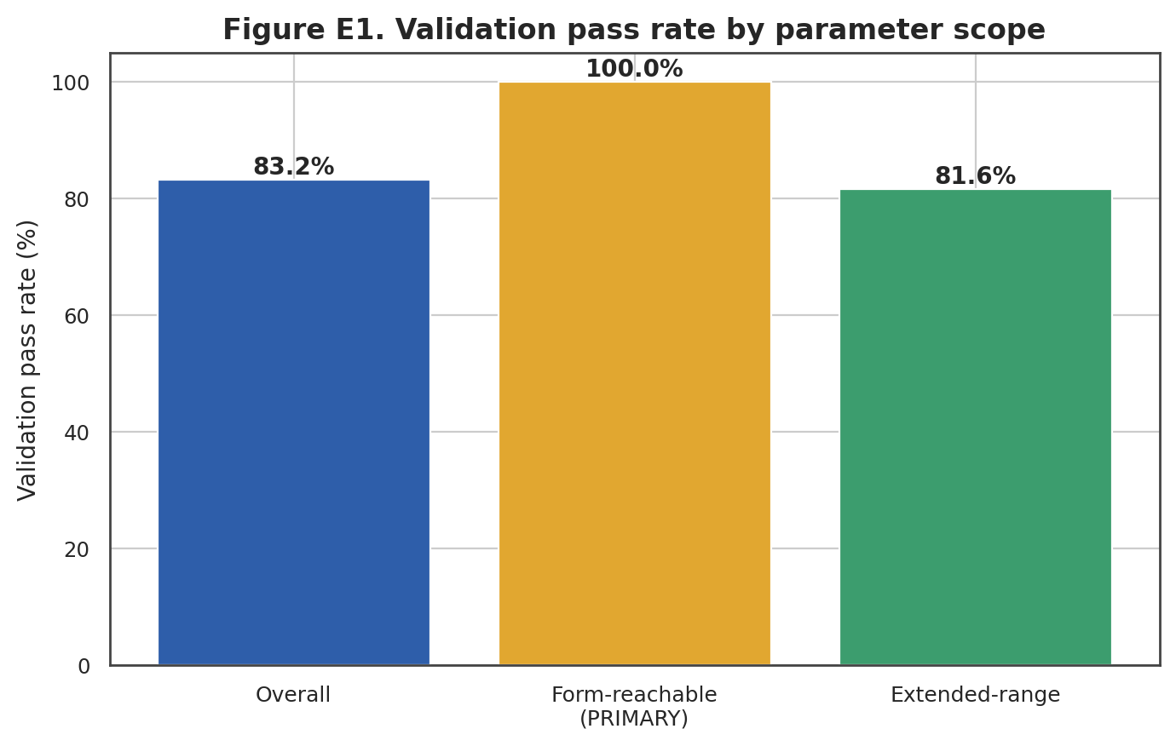
Figure 5 (E1). Validation pass rate by parameter scope. Every form-reachable configuration passes; the reduced extended-range rate reflects configurations no evaluator can request.
All 84 failures occurred in the extended range and fell into two categories: entity-bounds violations (76; 90.5%) and entity overlaps (8; 9.5%). Both are spatial-validity failures — precisely the constraints RQ1 and RQ3 require the pipeline to enforce — and they arise only when many terrorists are packed into few or small rooms. The pass-rate surface across layout type and room count (Figure 6) shows that reliability remains high across the form-reachable region (room counts 3–5) for every layout type, and degrades gracefully only at larger room counts and in the sparser high-terrorist configurations. No form-reachable combination falls below 100%.
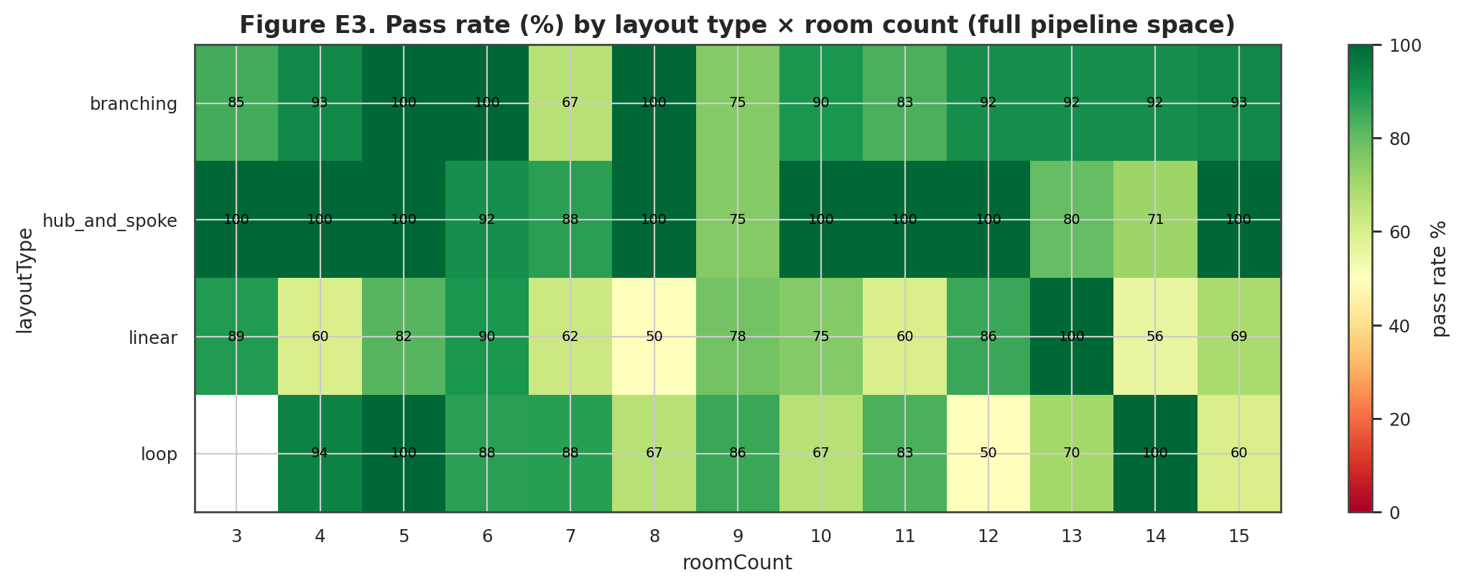
Figure 6 (E3). Pass rate (%) by layout type × room count across the full pipeline space. The form-reachable band (room counts 3–5) is uniformly high; lower cells occur only in extended-range, high-room-count configurations.

7 Direct Answers to the Research Questions
RQ1 (parameter-to-layout translation with validity). Experiment B shows every structural form parameter maps to its intended layout metrics with large, significant effects, and Experiment E shows the resulting layouts satisfy spatial-validity constraints in 100% of form-reachable cases — together evidencing that evaluator parameters are translated into valid, structurally varied layouts.
RQ2 (meaningful NPC role and navigation context). Guard and patrol composition is a deterministic, monotonic function of terrorist count (Experiment B) and is systematically reconfigured by difficulty (Experiment D), demonstrating that role and navigation context derive from scenario structure rather than being assigned arbitrarily.
RQ3 (validation: coherent, mission-ready, loadable). Experiment E demonstrates a 100% validation pass rate for every configuration an evaluator can request, with all failures confined to unreachable extended-range configurations and attributable to two well-characterised spatial-validity categories.
RQ4 (repeat variability; difficulty and randomness effects). Experiment A shows meaningful scenario-to-scenario variation at production settings — driven by entity placement, role composition, furniture, door states and graph depth (CV up to 154%) — while the room topology is deterministic for a fixed set and high randomness adds only marginal further diversity. Experiments C and D show difficulty produces large, significant structural change (p < 0.0001, ε² up to 1.000) and randomness a small placement-level change, confirming both settings measurably affect scenario structure and that the capability is validated even though the controls are currently withheld from the form.

8 Limitations
- Parameter-range restriction. The evaluator form constrains room count to 3–5 and terrorist count to 1–4. The pipeline supports wider ranges that evaluators cannot currently reach, and validation reliability degrades only within that unreachable region.
- Withheld controls. Difficulty, randomness and hostage-risk level are implemented and validated but are not evaluator-accessible in the current build.
- Front-loaded placement depth. Front-loaded placement uses ceil(maxDepth/3) rather than the design document's ceil(maxDepth/2), concentrating threats closer to the entry than originally specified.
- Patrol-route truncation. Patrol routes are collapsed to two waypoints at runtime because Module 2's PatrolLine component exposes only start and end transforms; the generated multi-room routes are present in Scenario.json but are not fully consumed.
- Structural scope. The current build supports a single floor only, and hostage count is fixed at one.
- Furniture comparability. Furniture companion grouping increases furniture density relative to earlier standalone placement, so furniture metrics are not directly comparable across generator versions.
- Entry-type scope. Entry type affects entry-point count only and does not propagate to interior connectivity, bounding the traceability of that particular control.
- Fixed-set topology. At a fixed production parameter set the layout topology is deterministic; the production-setting diversity reported in Experiment A is therefore diversity of entity placement, role assignment, furniture, door state and graph depth, rather than topological diversity.

