Module 2 — NPC Selection: Weight Sensitivity & Justification Study
Live run, Unity 6000.3.1f1, 2026-08-01 — 25,200 selection decisions across 9 independent worlds

The question this answers. The ablation study (MODULE2_ABLATION_STUDY_REPORT.docx) showed that switching a scoring term fully on/off changes who gets picked — but that doesn't justify the specific numbers DistanceWeight=2.0, RoleWeight=1.0, StateWeight=1.0, LosWeight=1.0. A heuristic weighted sum like this has no "correct" answer to prove mathematically — the real question is: are these values a fragile, arbitrary pick, or is the system's behaviour stable across a reasonable range around them? That's what this study measures, and it's the concrete evidence to cite when justifying the weights to a supervisor/evaluator.
Status: a real run, executed live in the Unity Editor (6000.3.1f1) via MCP on 2026-08-01, using the project's own compiled NPCSelector — same code path as the ablation study and the shipping game.

1. Method — how this differs from the ablation study
 | Ablation study | This study
What's tested | Each term fully ON vs. fully OFF | Each term swept across 7 values: 0, 0.5, 1, 1.5, 2, 3, 4
Answers | "Does this term matter at all?" | "Is the chosen value fragile, or is there a stable range around it?"
Generalization | 1 arena, 1 seed, 1 event type (GunshotHeard) | 3 event types x 3 independent seeds = 9 independent worlds

The event types were chosen deliberately: they are the three rows of NPCSelector's role-bonus table — GunshotHeard (favors Roamer), RoomBreached (favors Guard), AllyDownSeen (favors Leader) — so the finding isn't just about the one event type tested previously.
Parameter | Value
NPCs | 8 terrorists per world, round-robin roles and states (same as the ablation study)
Event types | GunshotHeard, RoomBreached, AllyDownSeen
Seeds | 42, 43, 44 (3 independent NPC layouts per event type)
Events per data point | 100, held identical across every weight value tested in a world
Weights swept | Distance, Role, State, LOS — one at a time, other three held at project defaults
Sweep values | 0, 0.5, 1.0, 1.5, 2.0, 3.0, 4.0
Total selection calls | 3 event types x 3 seeds x 4 weights x 7 values x 100 events = 25,200
Metric | % of the 100 events where the pick matches the all-defaults baseline for that world, averaged across the 3 seeds (+/- standard deviation, shown as the shaded band on each chart)

Raw output: Report_Figures/ablation_data/WeightSensitivity_20260801_133111.csv (25,200 rows).

2. Results, one chart per weight
Each chart's y-axis is "% of selections that still match what the all-defaults formula would have picked." A flat, high line = robust (the exact value barely matters). A sharp drop = fragile (small changes near that point flip the outcome). The dashed vertical line marks the project's current default.
Read this before the charts below — the 100% point is guaranteed, not discovered. Every sweep value is compared against the all-defaults baseline, which itself uses the current default for whichever weight is being swept. So the sweep necessarily reads 100% exactly at the default — that is the reference point being measured FROM, not a result the experiment found. It is not evidence that the default is the "best" value, and no reading in this study can rank e.g. 1.8 vs. 2.0 vs. 2.2 against each other in terms of which is more "correct."
The only thing that is real, measured evidence is the shape on either side of that point: how far, and how fast, agreement falls as the value moves away from the default. A curve that stays flat and high on both sides means many nearby values behave about the same — the current choice is robust, not fragile. A curve that drops fast means nearby values diverge quickly — the current choice sits in a narrower, more sensitive zone, where getting the exact number wrong costs more.

Distance — the most robust of the four
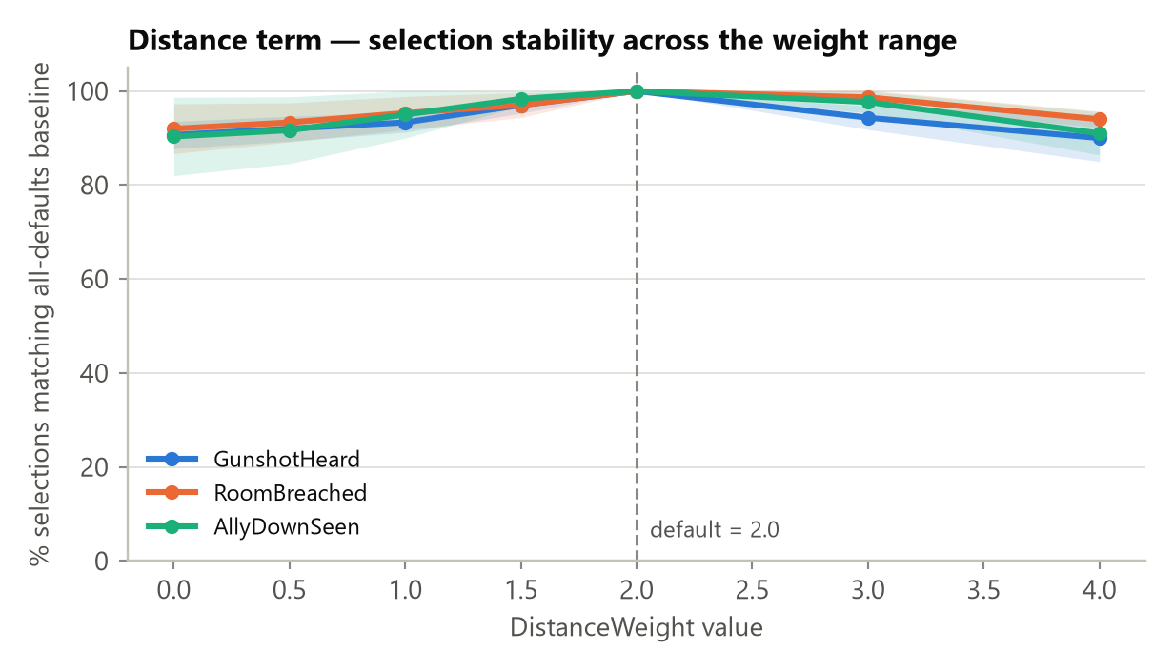
Figure 1. DistanceWeight sweep, agreement vs. all-defaults baseline.

Agreement never drops below ~90%, across the entire 0-4 range, for all three event types. Even completely zeroing the distance term only flips ~9-10% of decisions; doubling it to 4 only flips ~6-10%. This is a wide, flat plateau — DistanceWeight=2.0 is not a fragile choice; almost any value in a reasonable range would behave nearly identically.

Role — a cliff only at zero, flat everywhere else
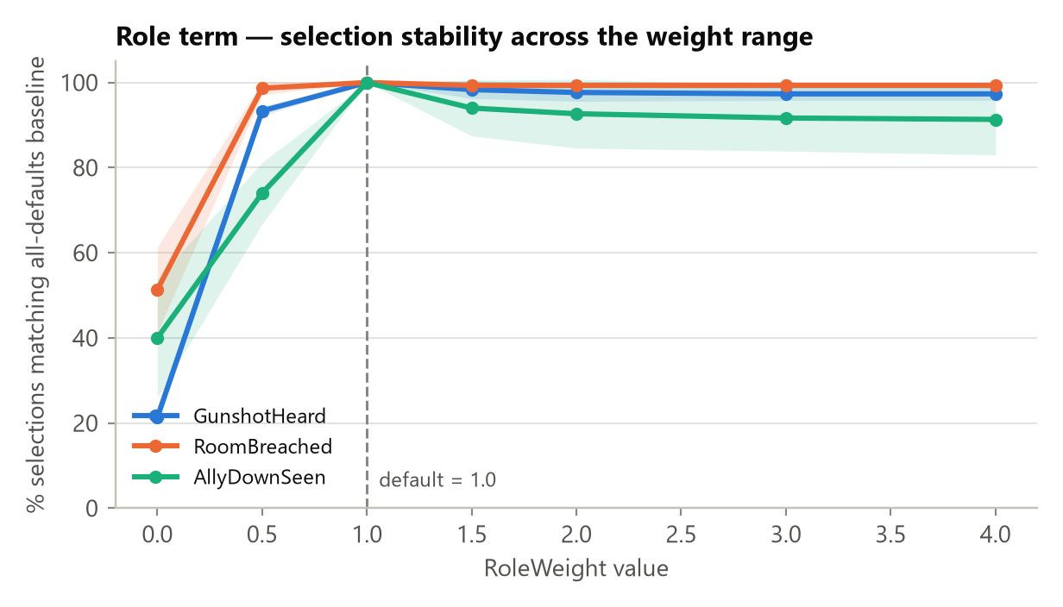
Figure 2. RoleWeight sweep, agreement vs. all-defaults baseline.

The one sharp drop is at value = 0 (role bonus removed entirely): agreement collapses to 21-51% depending on event type — consistent with the ablation study's finding that Role is the dominant term. But from 0.5 upward the line is flat and high (91-99%) all the way to 4x the default. The practical reading: Role just needs to exist (any positive weight) — its exact magnitude relative to 1.0 barely matters once it's turned on.

State — a cliff at zero, then a gentle decline moving away from default
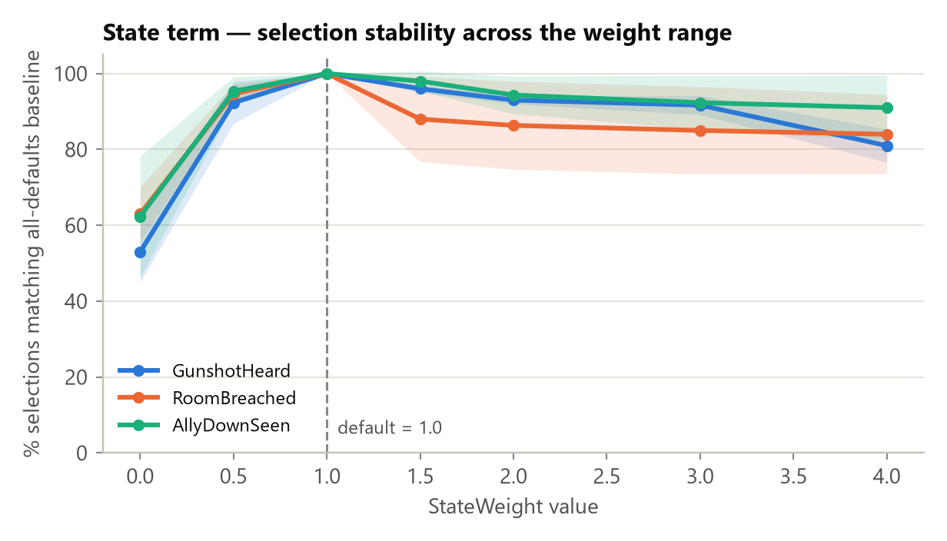
Figure 3. StateWeight sweep, agreement vs. all-defaults baseline.

Same zero-cliff pattern as Role (53-63% agreement with the term off). Unlike Role, though, State shows a real — if modest — decline as it moves away from its default in either direction, more so upward: agreement drifts down to 81-92% by 4x. That does NOT mean 1.0 is proven to be the single best value — only that State is less forgiving of a large deviation than Distance or Role: get it noticeably wrong (say, 3-4x too high) and more decisions change than the equivalent mistake would cause on Distance or Role.

LOS — the most sensitive of the four, and the one place to flag for future tuning
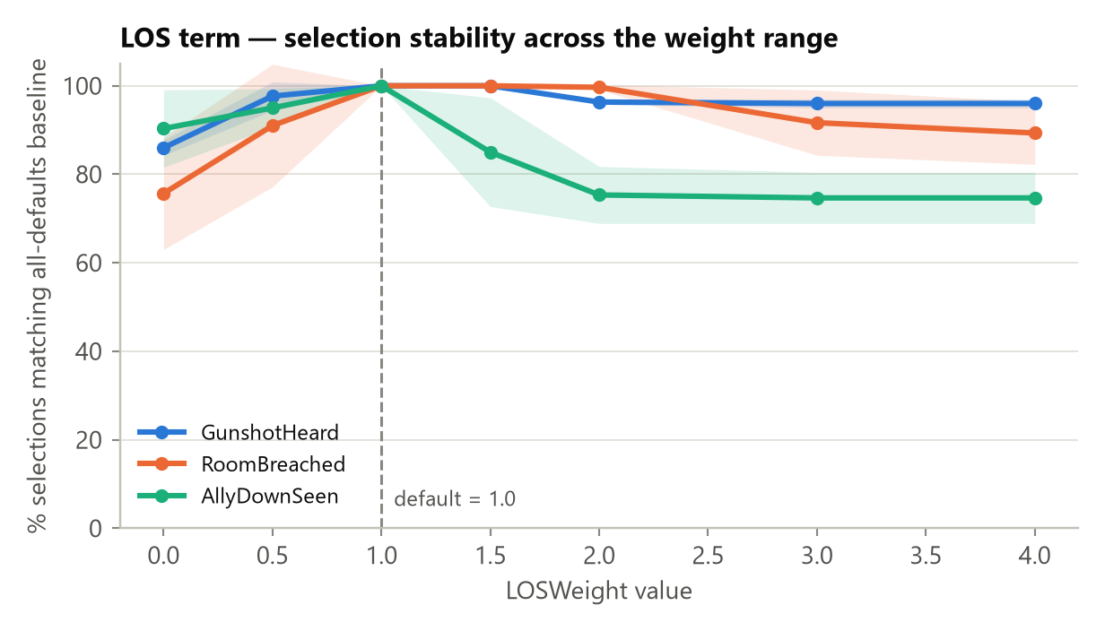
Figure 4. LosWeight sweep, agreement vs. all-defaults baseline.

LOS shows the same shape as State (cliff near zero, decline as the value moves up), but steeper and event-type-specific: for AllyDownSeen, agreement falls to ~75% by 3-4x the default — the fastest drop-off found anywhere in this study. For GunshotHeard/RoomBreached the fall is gentler (down to ~89-96%). Again, this doesn't tell us the default is "the correct" value — it tells us that, of the four terms, LOS is the one where a wrong guess costs the most, and costs differently depending on which event type is being scored. That makes it the one legitimate, evidence-based candidate for future re-tuning — not a flaw in the study, but a place worth a closer look.

3. Justifying the weights — the simple version
What this study does NOT prove: that 2.0 / 1.0 / 1.0 / 1.0 are individually the "best" or "most correct" numbers. Every chart above reads 100% exactly at the current default by construction — that value is the yardstick everything else is measured against, so of course it matches itself. No result here ranks 2.0 against, say, 1.8 or 2.2 in terms of which produces "better" decisions. Proving that would require an outside ground truth (e.g. expert judgement on what the correct response should be — see Section 4's SME point), which this study doesn't attempt.
What this study DOES prove: whether the current numbers sit in a forgiving zone (many nearby values behave about the same, so an approximately-right guess is fine) or a narrow one (small errors change a lot, so the exact number matters more). That is a real, measured result — it's about robustness to being slightly wrong, not correctness. And that's a legitimate thing to report:
For three of the four terms (Distance always; Role and State once given any positive value), the current weights sit in a wide, forgiving zone — nearby values, even 2-4x larger or fully removed, produce nearly the same selections. The system doesn't depend on hitting these exact numbers. The fourth, LOS, sits in a narrower zone — particularly for the AllyDownSeen event type — meaning that term is more worth double-checking if it's ever re-tuned.
One sentence for a slide: "The chosen weights aren't fragile — three of the four scoring terms tolerate being off by 2-4x without changing much, and the one exception (LOS) is a specific, identified spot rather than a hidden weakness — all backed by 25,200 real selection decisions across 9 independent NPC layouts. This shows the weights are safe choices, not that they are the only correct ones."

4. Caveats
- Still one arena size (30m x 30m). This study varied event type and NPC layout, but not arena scale — the earlier ablation report already flagged arena scale as the biggest likely confound for the distance term specifically; that axis is still untested (it's the "full" 45-world design described when this lighter version was scoped).
- n = 100 events per data point, 3 seeds. Good enough to trust the effects seen here (the smallest meaningful signal, ~10-15 percentage points, is well outside the ~+/-7% margin of error at this sample size), but a 4th or 5th seed would tighten the shaded bands further, especially for AllyDownSeen, which shows the widest seed-to-seed spread of the three event types.
- "Agreement with baseline" measures stability, not ground-truth correctness. This study still cannot say a given pick is the doctrinally right one — only that it's consistent as weights vary. Establishing ground-truth correctness needs the SME comparison described in MODULE2_EVALUATION_METHODOLOGY.md (Part B5), which this study does not replace.

5. Reproducing this run
- Open the project in Unity 6000.3.1f1+ with MCP for Unity connected, enter Play mode.
- Add an empty GameObject, attach WeightSensitivityRunner (Assets/Scripts/Tests/WeightSensitivityRunner.cs), leave the defaults (npcCount=8, eventsPerPoint=100, seeds=[42,43,44]).
- Invoke its context menu action "EXP -> Run Weight Sensitivity Sweep".
- The CSV is written to Application.persistentDataPath/Telemetry/WeightSensitivity_<timestamp>.csv.
- Regenerate the charts/summary with the command below (edit the DATA path at the top of the script for a new CSV).
cd Report_Figures
python generate_sensitivity_charts.py

