Interim Report
Level 4
Dynamic Scenario Generation and Evaluation
for VR-Based Military Training
By Team Sentinels
Group Members
Index Number | Name
214036J | Chathuranga S.P.Y.N
214057A | Dilshan R.P
214217P | Wadumulla G.M.D
214237C | Wijesinghe W.N.U

Faculty of Information Technology
University of Moratuwa
2026

Interim Report
Level 4
Dynamic Scenario Generation and Evaluation
for VR-Based Military Training
By Team Sentinels
Group Members
Index Number | Name | Signature
214036J | Chathuranga S.P.Y.N | ……………………
214057A | Dilshan R.P | ……………………
214217P | Wadumulla G.M.D | ……………………
214237C | Wijesinghe W.N.U | ……………………

Supervised by: Dr. S.C. Premaratne

Faculty of Information Technology
University of Moratuwa
2026

Abstract
Live military training in close-quarters scenarios such as hostage rescue is essential, but it is also expensive, logistically demanding, and difficult to repeat under controlled conditions. Virtual Reality (VR) offers a safe, repeatable alternative, yet many existing VR tactical prototypes still rely on fixed scenarios, simple non-player character (NPC) scripts, and shallow post-mission feedback that limit their training value.
This report presents the design and partial implementation of an integrated Unity-based VR hostage-rescue training prototype, targeted at the Meta Quest 3 platform, that combines four cooperating modules. An evaluator configures mission parameters through a structured interface; the Dynamic Scenario Generation module converts those parameters into a valid, playable Scenario JSON describing layout, entity placement, role assignments and navigation context. During runtime, the NPC Behavior and Coordination module interprets trainee actions as structured events and drives terrorist and hostage state transitions through an event-driven, finite-state model with responder selection and alert propagation. In parallel, the Cognitive Behavior Analysis module captures reaction-time and full-body movement evidence and uses lightweight machine learning to estimate cognitive indicators such as load, stress and attention. After the mission, the Logging, After-Action Review and Session Replay module transforms structured telemetry into score summaries, evidence-linked incident timelines and synchronized replay views.
The four modules communicate through a shared Scenario JSON contract and a common event schema, allowing them to be developed in parallel and validated independently before integration. The implementation work to date has produced the data models, generation pipeline, validator and exporter for the scenario module, an evaluator configuration panel, an editor tooling layer and a baseline VR runtime that supports movement, weapon interaction, door interaction, hostage interaction and mission completion. Design documents and prototype skeletons are in place for the remaining three modules. The system is intended to support repeatable, structured and reviewable training that is grounded in measurable evidence rather than fixed scripted outcomes.

Table of Contents
Page
Abstract iii
Table of Contents iv
List of Figures vi
List of Tables vii
Chapter 1 — Introduction 1
1.1 Introduction 1
1.2 Background and Motivation 2
1.3 Problem in Brief 3
1.4 Aim and Objectives 4
1.4.1 Aim 4
1.4.2 Objectives 4
1.5 Proposed Solution 5
1.6 Structure of the Dissertation 6
1.7 Summary 6
Chapter 2 — Review of Existing Work 7
2.1 Introduction 7
2.2 VR Tactical Training Systems 7
2.3 Procedural Content Generation for Training 8
2.4 NPC Behavior and Coordination Models 9
2.5 Cognitive Behavior Analysis in Immersive Training 10
2.6 After-Action Review and Replay Systems 11
2.7 Comparative Summary 12
2.8 Summary 13
Chapter 3 — Technology Adapted 14
3.1 Introduction 14
3.2 Game Engine and VR Platform 14
3.3 Programming Language and Core Libraries 15
3.4 Development Environment and Tools 16
3.5 Module-Specific Technology Choices 17
3.6 Version Control and Collaboration 18
3.7 Summary 18
Chapter 4 — Our Approach 19
4.1 Introduction 19
4.2 Proposed System 19
4.3 Users 20
4.4 Inputs 20
4.5 Process 21
4.6 Outputs 22
4.7 Module-Level Approach 22
4.8 Summary 23
Chapter 5 — Analysis and Design 24
5.1 Introduction 24
5.2 High-Level System Architecture 24
5.3 Module 1 Design — Dynamic Scenario Generation 26
5.4 Module 2 Design — NPC Behavior and Coordination 28
5.5 Module 3 Design — Cognitive Behavior Analysis 30
5.6 Module 4 Design — Logging, AAR and Session Replay 32
5.7 Inter-Module Integration and Data Contracts 34
5.8 Summary 35
Chapter 6 — Implementation 36
6.1 Introduction 36
6.2 Development Environment Setup 36
6.3 Baseline VR Mission Runtime 37
6.4 Module 1 Implementation Progress 38
6.5 Module 2 Implementation Progress 40
6.6 Module 3 Implementation Progress 41
6.7 Module 4 Implementation Progress 42
6.8 Summary 43
Chapter 7 — Discussion 44
7.1 Introduction 44
7.2 Current Progress 44
7.3 Comparison with Existing Solutions 45
7.4 Plan for Evaluation 46
7.5 Future Work 47
7.6 Summary 47
References 48
Appendix A — Individual Contribution to the Project 50

List of Figures
Page
Figure 4.1 — End-to-end training workflow 19
Figure 5.1 — High-level system architecture of the integrated VR training prototype 25
Figure 5.2 — Module 1 — dynamic scenario generation pipeline 27
Figure 5.3 — Module 2 — event-driven NPC behavior loop 29
Figure 5.4 — Module 3 — cognitive behavior analysis pipeline 31
Figure 5.5 — Module 4 — logging, AAR and replay structure 33
Figure 5.6 — Inter-module data contract centred on Scenario.json 35

List of Tables
Page
Table 2.1 — Comparative summary of related VR-training and PCG approaches 12
Table 4.1 — User categories of the proposed system 20
Table 4.2 — Input categories of the proposed system 21
Table 4.3 — Output categories of the proposed system 22
Table 5.1 — Functional modules of the proposed system 26
Table 5.2 — Module 2 — representative event categories and reactions 30
Table 5.3 — Suggested NPC state sets for Module 2 30
Table 5.4 — Module 4 — suggested data artefacts and fields 33
Table 6.1 — Phase 2 implementation status of Module 1 (Stages 1–8) 39
Table 6.2 — Implementation status of Module 2 (Stages 1–8) 40
Table 6.3 — Implementation status of Module 3 (Stages 1–8) 41
Table 6.4 — Implementation status of Module 4 (Stages 1–8) 42

Chapter 1
Introduction
1.1 Introduction
Modern military and law-enforcement teams routinely operate in high-pressure tactical situations such as hostage rescue, where decisions must be made under time pressure, uncertainty and strict safety constraints. Live training remains the gold standard for preparing personnel for these situations, but it is expensive, logistically demanding and difficult to repeat under varying conditions because it requires dedicated facilities, instructors, safety supervision and significant set-up time before each exercise [10].
Virtual Reality (VR) offers a controlled and repeatable alternative. Trainees can practise the full mission flow safely, while the system records objective evidence such as task completion time, interaction order, weapon accuracy and hostage outcomes [10], [2]. When this evidence is combined with structured scenario generation and structured review, VR can support repeated training without reducing every session to the same fixed exercise.
This report describes the design, current implementation status and planned evaluation of an integrated VR hostage-rescue training prototype developed by Team Sentinels using Unity 2022.3 LTS for the Meta Quest 3 headset. The prototype is organised into four cooperating modules: dynamic scenario generation, NPC behaviour and coordination, cognitive behaviour analysis, and logging with after-action review (AAR) and synchronized session replay.
1.2 Background and Motivation
VR is increasingly used for skill training because it enables safe repetition, controlled exposure to difficult situations and structured performance evaluation. Recent surveys of VR skill-training applications consistently report that effectiveness depends not only on visual immersion, but also on meaningful scenario structure, measurable trainee response and informative review mechanisms [10]. In tactical contexts, this matters because the training goal is transferable decision-making skill, not memorisation of one fixed mission.
Many existing VR prototypes still rely on fixed scenarios or only light randomisation, such as changing spawn points within an otherwise identical scene. This reduces replayability and limits the training value of repeated use. Research on mission-based scenario generation and procedural content generation (PCG) for training stresses that scenarios should be produced from configurable inputs, while preserving feasibility and mission coherence [8], [9], [3], [11]. A second gap exists between live runtime behaviour and post-mission review. A scenario can contain rooms, hostages and adversaries, but if NPCs always behave in the same predictable way, or if the system only records a final score, the training value remains limited [6].
Motivated by these observations, Team Sentinels brings four concerns into one integrated system: parameter-driven scenario generation, event-driven NPC behaviour and coordination, cognitive behaviour analysis from runtime evidence, and structured post-mission review through logging, AAR and session replay.
1.3 Problem in Brief
Current VR tactical-training prototypes typically suffer from three weaknesses simultaneously: missions are fixed or only lightly varied; runtime NPC behaviour is repetitive and lacks coordination; and the post-mission review is limited to a final score or a short summary. As a result, trainees experience monotonous missions, hostages and adversaries behave in overly static ways, and evaluators receive insufficient evidence to provide meaningful feedback after the run.
Therefore, the specific problem addressed by this project is to design and prototype a VR hostage-terrorist training system that can:
- generate varied indoor training scenarios from evaluator-defined parameters while ensuring that each scenario remains valid, loadable and mission-ready;
- support runtime terrorist and hostage behaviour through an event-driven, finite-state NPC model rather than fixed scripting alone;
- capture reaction-time and movement-related evidence from the trainee, and transform those measurements into structured cognitive report elements;
- produce an explainable post-mission review package containing objective metrics, an event timeline and synchronized session replay.
1.4 Aim and Objectives
1.4.1 Aim
The aim of this project is to develop a VR training prototype for dynamic hostage-terrorist scenario generation and evaluation, combining scenario generation, NPC behaviour and coordination, cognitive behaviour analysis and structured after-action review within one integrated Unity-based system that runs on the Meta Quest 3 platform.
1.4.2 Objectives
To achieve this aim, the following objectives have been defined:
- Study the VR tactical-training domain and relevant evaluation measures.
- Study scenario-generation and procedural content approaches relevant to training environments.
- Design and develop a VR vertical slice that supports movement, weapon interaction, door interaction, hostage interaction and mission completion on Meta Quest 3.
- Implement parameter-driven scenario generation that produces a validated layout, entity placement, NPC role assignments and an initial navigation context.
- Implement event-driven terrorist and hostage behaviour using state transitions, responder selection and coordination logic during runtime.
- Implement cognitive behaviour analysis using event timestamps, reaction-time capture, movement features and machine-learning-based cognitive indicators.
- Implement structured logging, score summary, event timeline and synchronized session replay.
- Evaluate the system through integrated testing, module-level validation and complete mission runs.
1.5 Proposed Solution
The proposed solution is a Unity-based VR hostage-rescue training prototype, organised into four cooperating modules:
- Module 1 — Dynamic Scenario Generation. Converts evaluator-defined parameters into a structured Scenario JSON containing layout data, entity placements, role assignments and navigation context.
- Module 2 — NPC Behaviour and Coordination. Interprets trainee actions and mission conditions as runtime events and uses an event-driven finite-state model to drive terrorist and hostage behaviour, including responder selection and alert propagation.
- Module 3 — Cognitive Behaviour Analysis. Captures reaction-time and movement-related evidence from the VR session, extracts features and uses lightweight machine-learning models to estimate cognitive indicators such as load, stress and attention.
- Module 4 — Logging, AAR and Session Replay. Transforms a completed mission into structured review evidence, including a session summary, an event timeline, evidence-linked incidents and a synchronized replay system that supports pause / scrub / playback control.
All four modules communicate through a shared Scenario JSON contract and a common event schema. This makes it possible to develop the modules in parallel, to validate each module independently, and then to integrate them with manageable risk.
1.6 Structure of the Dissertation
The remainder of this report is organised as follows. Chapter 2 reviews related work on VR tactical training, procedural content generation, NPC behaviour, cognitive analysis and after-action review, and identifies the gaps the project addresses. Chapter 3 describes the technology adapted for the project, including the Unity engine, OpenXR / Meta Quest 3 platform, the C# language, and supporting libraries. Chapter 4 explains the proposed solution in terms of users, inputs, process and outputs. Chapter 5 presents the analysis and design of the four modules and their integration via the shared Scenario JSON contract. Chapter 6 reports on the implementation progress to date, with particular emphasis on the completed Module 1 pipeline. Chapter 7 discusses the current progress, comparisons with related work, the planned evaluation procedure and future work. The report concludes with the references and an appendix containing each member's individual contribution.
1.7 Summary
This chapter introduced the motivation for the project, defined the problem of fixed and shallow VR tactical-training prototypes, and stated the aim and objectives of the proposed integrated solution. The next chapter reviews existing work in VR training, scenario generation, NPC behaviour, cognitive analysis and after-action review, and uses that review to position the contribution of this project.

Chapter 2
Review of Existing Work
2.1 Introduction
This chapter reviews the existing literature most relevant to the project. The review is organised around five themes: VR tactical-training systems, procedural content generation (PCG) for training, NPC behaviour and coordination, cognitive behaviour analysis in immersive training and after-action review (AAR) with replay support. For each theme, the current state of the art is summarised, the limitations are identified, and the connection to the proposed solution is highlighted. The chapter ends with a comparative summary and a closing remark linking the gaps identified to the design choices presented in later chapters.
2.2 VR Tactical Training Systems
Xie et al. published a comprehensive review of VR skill-training applications and reported that VR training is most effective when three conditions are met: scenarios are structured rather than randomised, trainee responses are measurable, and informative review mechanisms are available [10]. Boyce et al. extended this analysis to the specific context of military tactics comprehension and observed that extended-reality training can match or exceed traditional methods on selected outcomes when the design preserves the decision-making structure of the original task [2].
However, both reviews note recurring weaknesses in tactical prototypes: fixed scripted scenarios, limited NPC behaviour and shallow post-session feedback. These weaknesses match the problem statement of this project and motivate the integrated four-module design described in Chapter 5.
2.3 Procedural Content Generation for Training
Procedural content generation has been studied extensively in the games research community. Shaker, Togelius and Nelson provide a textbook treatment that classifies PCG approaches by the type of artefact produced (geometry, missions, narrative, rules) and by the level of designer control [11]. Cook describes the use of PCG in information games and emphasises the need for generated content to be coherent, feasible and re-playable [3].
Closer to the application domain of this project, Luo et al. propose a mission-based scenario modelling and generation framework for virtual training, where the mission structure rather than the surface geometry drives the generation process [8]. Sottilare et al. apply genetic algorithms to scenario generation in serious games and report that automated variation can improve the training value of repeated sessions when feasibility constraints are respected [9]. Kalafatis et al. describe an automated evaluation framework for PCG in serious games using deep reinforcement-learning agents, providing useful evaluation principles for generated content [5].
The proposed Module 1 design follows the same direction. The evaluator defines high-level parameters such as room counts, layout type, placement strategy and difficulty; the generator produces a structured Scenario JSON; and a dedicated validator ensures that the generated mission remains spatially valid and reachable, retrying with a different seed when validation fails.
2.4 NPC Behavior and Coordination Models
NPC behaviour in interactive simulations is most commonly modelled with finite state machines, behaviour trees or utility-based controllers. For tactical training, the desired outcome is not unrestricted autonomy but a controlled, explainable and reproducible response to scenario events. An event-driven design that converts trainee actions into structured events (e.g., shot fired, door opened, player seen) and then routes those events through an Event Manager is widely used in tactical games and serious training simulations because it keeps behaviour code modular and observable [11], [3].
Coordination behaviour, where multiple hostile NPCs share alerts, escalate together or support one another, has also received attention. Even simple coordination rules — alert propagation, leader-issued reaction bias and supportive movement under high-threat conditions — significantly improve perceived realism without requiring full-blown planning systems. Module 2 of the proposed system adopts this approach by combining a small finite-state set per NPC type with a context-aware responder-selection mechanism, as described in Section 5.4.
2.5 Cognitive Behavior Analysis in Immersive Training
Reaction time has long been used in cognitive psychology and human factors research as a behavioural index of perceptual processing, decision-making and motor response. In immersive training, reaction time can be measured directly in software as the difference between an event timestamp and a trainee response timestamp. Recent VR studies extend this with full-body tracking of head and hand transforms to derive movement-initiation and stability features that correlate with attention and stress [13].
Subjective workload is conventionally assessed with the NASA-TLX instrument and its simulator-oriented adaptation SIM-TLX, which captures dimensions such as mental demand, temporal demand, frustration, distraction and presence [13]. Combining objective behavioural evidence with self-reported subjective workload provides a stronger basis for cognitive analysis than either source alone.
The proposed Module 3 follows this combined approach. It collects event and response timestamps and head, hand and body transforms during the mission, derives features such as reaction time, movement initiation and stability, and uses lightweight classifiers (Random Forest and Logistic Regression) to estimate cognitive indicators that are then presented to the evaluator as part of the AAR.
2.6 After-Action Review and Replay Systems
Kleygrewe et al. show that a structured after-action review can significantly enhance learning efficacy in VR training for police, especially when AAR is combined with synchronized replay that allows the reviewer to pause, scrub and inspect critical moments [6]. The same authors also stress that effective AAR is evidence-linked: each claim about trainee performance should reference a concrete event, time and replay position, rather than relying on aggregate scores alone.
Module 4 of the proposed system adopts this principle. It records timestamped mission events, weapon outcomes, NPC state transitions, hostage outcomes and selected cognitive indicators, and transforms them into a session summary, an event timeline, evidence-linked incidents and a synchronized replay surface. Importantly, the module is scoped to evidence-based explanatory feedback rather than automated military-tactical recommendations that would require domain-dependent expert judgment.
2.7 Comparative Summary
Table 2.1 — Comparative summary of related VR-training and PCG approaches
Approach | Strengths | Limitations addressed by this project
VR skill-training reviews [10] | Confirm value of measurable response and informative review | Often discuss design without prescribing an integrated implementation
XR military tactics study [2] | Evidence that XR can match traditional tactics training | Does not provide a generation pipeline for varied scenarios
Mission-based PCG [8] | Mission structure drives generation; coherent missions | Limited integration with runtime NPC behaviour and review
GA-based scenario generation [9] | Automated variation of training content | Does not address cognitive analysis or AAR
PCG textbook / information games [11], [3] | Foundational PCG taxonomy and evaluation principles | General-purpose; not tailored to tactical VR training
VR AAR for police training [6] | Evidence that structured AAR improves learning | Does not specify a parameterized scenario generator
This project (Team Sentinels) | Integrated 4-module pipeline: generation, NPC, cognition, AAR | Bridges generation, runtime behaviour and structured review

2.8 Summary
The literature shows clear support for parameter-driven scenario generation, event-driven NPC behaviour, behaviourally-grounded cognitive analysis and evidence-linked AAR with replay. However, no single existing prototype combines all four of these elements into one integrated VR hostage-rescue system on a consumer headset such as the Meta Quest 3. The next chapter describes the technology adapted to construct this integrated system.

Chapter 3
Technology Adapted
3.1 Introduction
This chapter describes the technologies adopted for the project, justifies the choices in relation to the requirements of the four modules and explains how the components fit together. The chosen technologies prioritise stability on the target Meta Quest 3 headset, support for structured runtime data, and a standard collaborative development workflow.
3.2 Game Engine and VR Platform
Unity 2022.3 LTS is used as the primary game engine because it is a long-term-support release, it has mature XR tooling, and it is widely used in academic VR projects. The engine provides scene management, physics, animation, navigation, UI and asset pipelines out of the box, which lets the team focus on module-specific logic instead of engine infrastructure. The Meta Quest 3 was selected as the deployment target because it is a stand-alone headset with positional tracking and on-device compute, which makes user trials and demonstrations practical.
The OpenXR runtime, together with the Unity XR Interaction Toolkit and Meta XR packages, provides a vendor-neutral abstraction over headset and controller input. The Unity AI Navigation package (com.unity.ai.navigation) is used at runtime to bake a NavMesh from the generated scenario so that NPCs can patrol, wander and respond to events. ProBuilder is used during development to greybox interior layouts and prefabs.
3.3 Programming Language and Core Libraries
C# is the language used throughout the codebase. All Module 1 code lives under the TeamSentinels.ScenarioGeneration namespace and is bound to a dedicated assembly definition (asmdef) so that it is isolated from Assembly-CSharp and can be unit-tested in isolation. The Newtonsoft.Json package (com.unity.nuget.newtonsoft-json) is used for all JSON serialisation because it supports Dictionary<>, nullable types and custom converters, which the built-in Unity JsonUtility does not.
Enums are serialised as snake_case strings via a StringEnumConverter combined with EnumMember attributes. A small SerializableVector3 wrapper is used to store positions because Newtonsoft cannot directly serialise Unity's Vector3. Shared serialisation settings are centralised in a single ScenarioJsonSettings class so that producers and consumers of Scenario JSON always agree on format.
3.4 Development Environment and Tools
The Unity Editor on Windows 11 is the primary IDE for scene editing, asset management and play-mode testing. Visual Studio 2022 / VS Code are used for C# editing, debugging and static analysis. Unity Editor menu items under Tools / Scenario Generator allow the evaluator and developers to run the full load → generate → export pipeline without entering play mode, which is particularly useful for batch testing the generator against different configuration files.
For machine-learning experiments related to Module 3, Python 3 is used together with Jupyter notebooks (locally and via Google Colab / Kaggle for GPU-backed exploration). scikit-learn is the primary classifier library, NumPy and pandas are used for data manipulation, and matplotlib is used for visualisation. Mature frameworks (PyTorch, TensorFlow / Keras) are available as a fall-back path if the team later decides to experiment with deeper sequence models.
3.5 Module-Specific Technology Choices
Module 1 (scenario generation) is implemented as plain C# classes outside of MonoBehaviour, which keeps the generation pipeline deterministic, unit-testable and decoupled from the Unity scene lifecycle. Only the SceneBuilder and editor tooling are MonoBehaviour or Editor classes. Module 1 exposes its assembly via autoReferenced: true so that consuming scripts in Assembly-CSharp can use the data models without an explicit reference.
Module 2 (NPC behaviour) is implemented as a set of MonoBehaviour controllers (e.g., TerroristController, HostageController, EventManager) attached to spawned NPCs at runtime. State machines are kept small and explicit so that transitions are observable from the inspector and from logs.
Module 3 (cognitive analysis) uses Unity's XR API to capture head and controller transforms. Body-proxy data is derived from these transforms in the absence of full-body tracking on Meta Quest 3. Feature extraction and model evaluation can run either in-engine (using lightweight C# implementations of trained models) or out-of-engine (Python post-session).
Module 4 (logging, AAR and replay) writes structured JSON artefacts to local storage and renders them through a Unity-side AAR dashboard. The replay system is built on stored transforms and state snapshots rather than rendered video so that the reviewer can switch viewpoints (player, observer, overhead) at any time during playback.
3.6 Version Control and Collaboration
GitHub is used for source control, branching and code review. The repository follows a feature-branch workflow: feature branches are merged into a long-lived dev branch through pull requests, and dev is promoted to main when a coherent integration milestone is reached. Large binary assets that do not benefit from text diffs are tracked outside of source control where appropriate. A project-level CLAUDE.md and a Module 1 development log are maintained as living technical references for the team.
3.7 Summary
The technology stack pairs a stable Unity LTS release and the Meta Quest 3 headset with C# and Newtonsoft.Json on the engine side, and Python plus scikit-learn for machine-learning experiments related to cognitive analysis. These choices give the team the flexibility needed to develop the four modules in parallel while keeping the integrated runtime manageable on the target hardware. The next chapter explains how these tools are used together in the proposed solution.

Chapter 4
Our Approach
4.1 Introduction
This chapter describes the proposed solution from a system-level perspective. It covers the user categories, the inputs evaluators provide, the runtime process, the outputs the system produces and the per-module approach. Detailed design and implementation are deferred to Chapters 5 and 6.
4.2 Proposed System
The proposed system is a single-player VR hostage-rescue training prototype developed in Unity 2022.3 LTS for the Meta Quest 3 platform. An evaluator defines mission parameters such as layout preferences, room structure, entity counts, placement strategy, difficulty-related settings and randomness level. Module 1 converts those inputs into a structured Scenario data object containing the generated layout, entity placement, NPC roles and initial navigation context. During runtime, the mission scene loads the generated scenario and instantiates the trainee, hostages and terrorists. Module 2 interprets weapon fire, door interaction, room entry, visibility results, hostage interaction and related mission conditions as structured events; Module 3 collects runtime evidence to derive cognitive indicators; and Module 4 transforms the full session into structured review artefacts after the run.
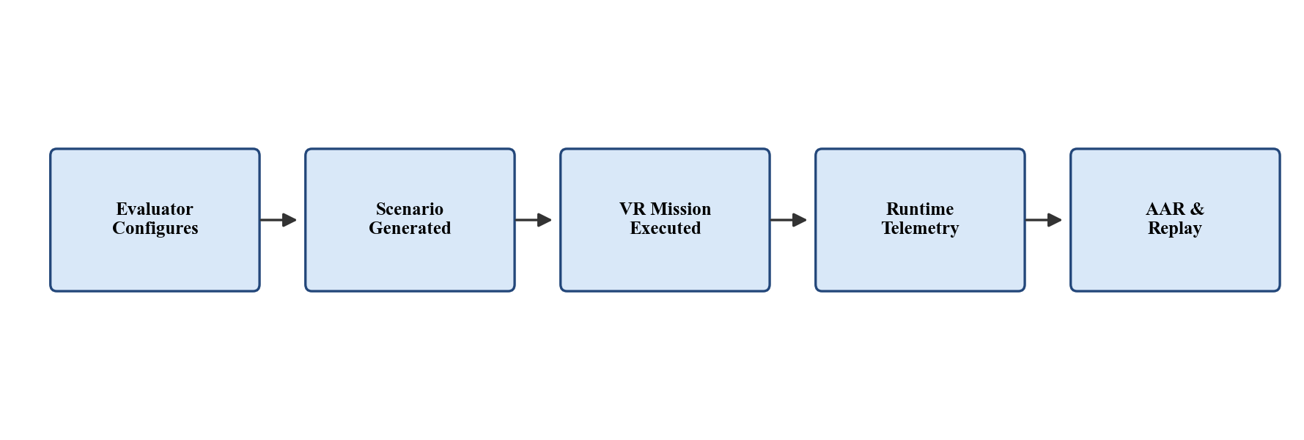
Figure 4.1 — End-to-end training workflow
4.3 Users
Table 4.1 — User categories of the proposed system
Category | Description
Trainee | Executes the mission in VR, interacts with the generated environment, engages with hostages and hostile NPCs and completes the mission objective.
Evaluator | Configures mission parameters before the run and reviews session evidence after the mission through summaries, timeline views and replay controls.

4.4 Inputs
Table 4.2 — Input categories of the proposed system
Category | Description
Mission structure | Mission type, number of rooms, floors, room size, layout type, entry type and floor connection type.
Entity configuration | Number of hostages, number of terrorists, placement strategy and hostage-risk level.
Execution controls | Difficulty-related settings, randomness level, optional seed and evaluator-defined mission configuration.

4.5 Process
The end-to-end process of the proposed system can be summarised as follows:
- The evaluator selects or edits a configuration in the Evaluator Configuration Panel (or in a JSON file under Resources/ScenarioConfigs/).
- Module 1 validates the configuration, then runs LayoutGenerator → EntityPlacer → RoleAssigner → NavigationContextBuilder, and finally ScenarioValidator.
- If validation fails, the generator retries with seed + 1 up to a fixed retry budget; if it succeeds, the result is exported to Output/GeneratedScenarios/Scenario_<id>.json.
- The SceneBuilder loads the generated Scenario.json, instantiates rooms and doors, spawns the trainee, hostages and terrorists, and bakes a NavMesh from the resulting scene.
- EventManager.NotifyScenarioReady() is called; this is the explicit hand-off from Module 1 to Module 2.
- During the mission, Module 2 processes runtime events and updates NPC states; Module 3 captures behavioural evidence; Module 4 logs every relevant event and snapshot.
- When the mission ends, Module 4 produces a SessionSummary, an EventTimeline and replay data and presents them through the AAR dashboard for evaluator review.
4.6 Outputs
Table 4.3 — Output categories of the proposed system
Category | Description
Scenario outputs | Generated playable mission instance and structured Scenario JSON containing layout, placements, NPC roles and navigation context.
Runtime outputs | Mission events, NPC state transitions, hostage outcomes and cognitive report elements collected during the session.
Review outputs | Session summary, event timeline, replay data and AAR views, including a hostage-perspective panel with evidence-linked state timelines and distress scoring.

4.7 Module-Level Approach
Module 1 is implemented as a deterministic pipeline of plain C# classes driven by a single System.Random seeded from the configuration; this guarantees that the same configuration and seed always produce the same scenario. Module 2 implements an event-driven, finite-state model with a small set of states per NPC type and a context-aware responder-selection mechanism. Module 3 captures objective behavioural evidence from VR and enriches it with self-reported SIM-TLX data, then uses lightweight classifiers to derive cognitive indicators. Module 4 treats the completed mission as inspectable evidence and presents it through structured logs, summary metrics, an event timeline and synchronized replay.
4.8 Summary
This chapter described the proposed solution at a system level, identified its users, inputs, process and outputs, and outlined the per-module approach. The next chapter presents the analysis and design of each module and explains how they integrate via the shared Scenario JSON contract.

Chapter 5
Analysis and Design
5.1 Introduction
This chapter presents the analysis and design of the integrated VR training system. It begins with the high-level architecture, then describes the design of each of the four modules, and ends with the integration model and the shared data contracts that connect them. Each module is presented in terms of its responsibilities, its key components and its inputs and outputs.
5.2 High-Level System Architecture
The proposed system is organised as four cooperating modules running on top of a Unity VR runtime. Module 1 produces a Scenario JSON before the mission begins. Module 2 operates during the mission, converting trainee actions and mission conditions into structured events and using those events to update terrorist and hostage states. Module 3 observes the trainee in parallel and produces cognitive indicators. Module 4 consumes runtime telemetry and post-session indicators to build the AAR and replay views. Figure 5.1 illustrates the relationships between these components.
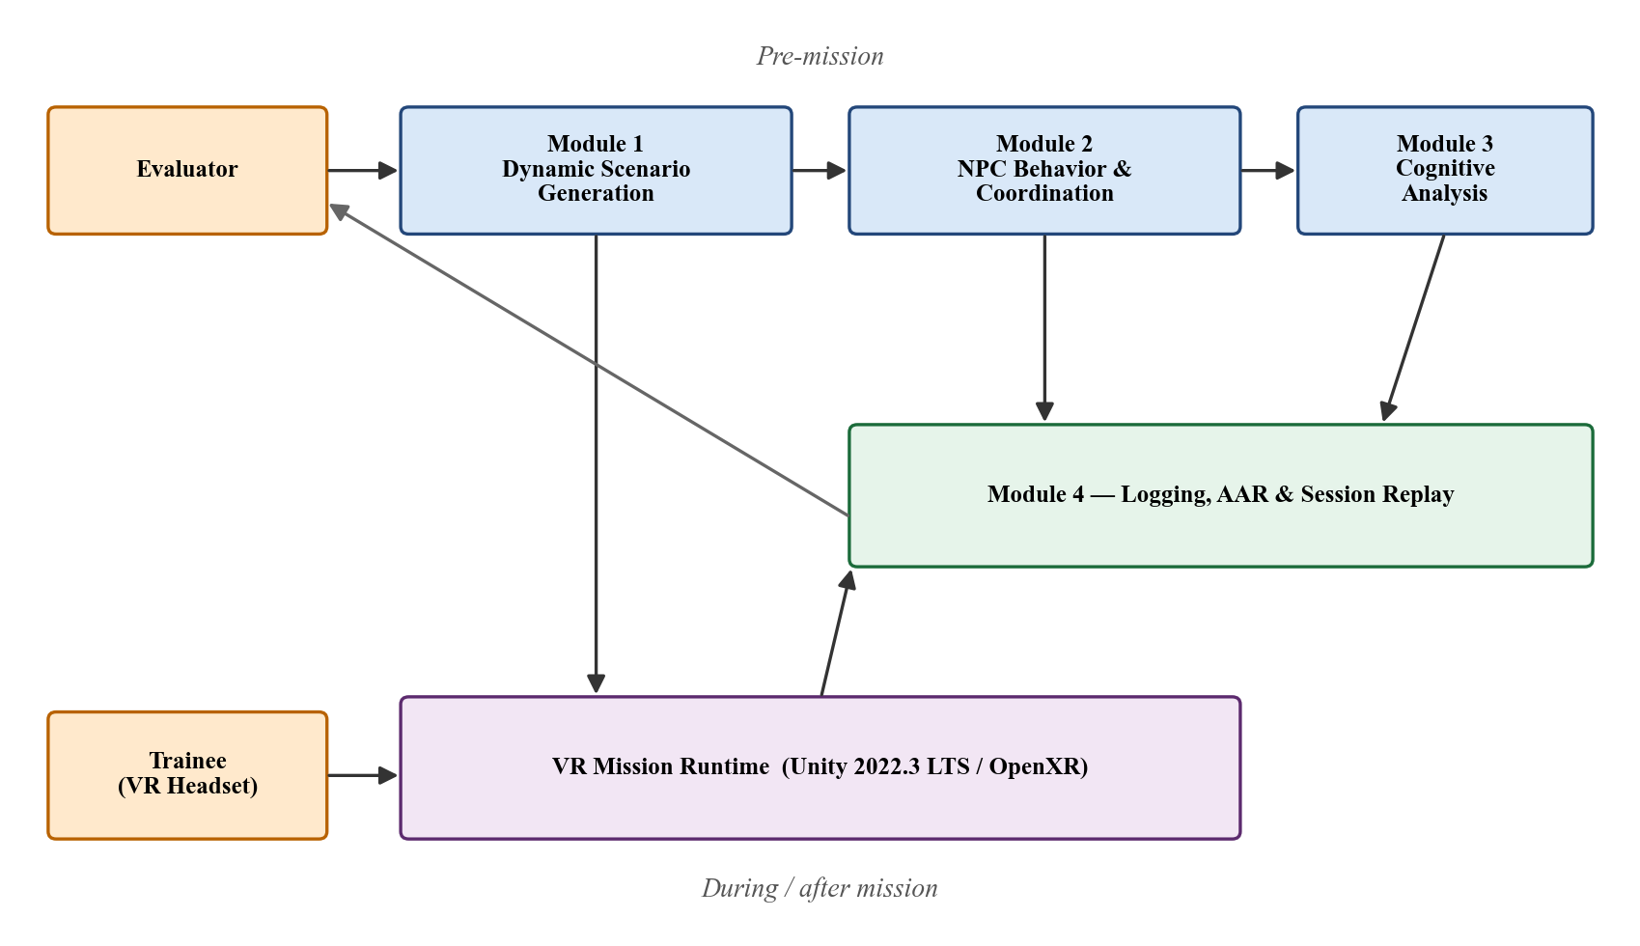
Figure 5.1 — High-level system architecture of the integrated VR training prototype
Table 5.1 — Functional modules of the proposed system
Module | Title | Primary role
Module 1 | Dynamic Scenario Generation | Generates the structured mission package before runtime begins.
Module 2 | NPC Behaviour and Coordination | Drives live terrorist and hostage behaviour during the mission.
Module 3 | Cognitive Behaviour Analysis | Captures and processes trainee response and movement evidence.
Module 4 | Logging, AAR and Session Replay | Transforms a completed mission into structured review evidence.

5.3 Module 1 Design — Dynamic Scenario Generation
Module 1 is responsible for converting evaluator-defined parameters into a structured, valid and playable Scenario JSON. The design prioritises three properties: determinism (same configuration plus same seed always produces the same scenario), traceability (every generated value can be traced back to a configuration parameter) and modular composition (each pipeline stage is a small, testable C# class).
The generation pipeline is illustrated in Figure 5.2.
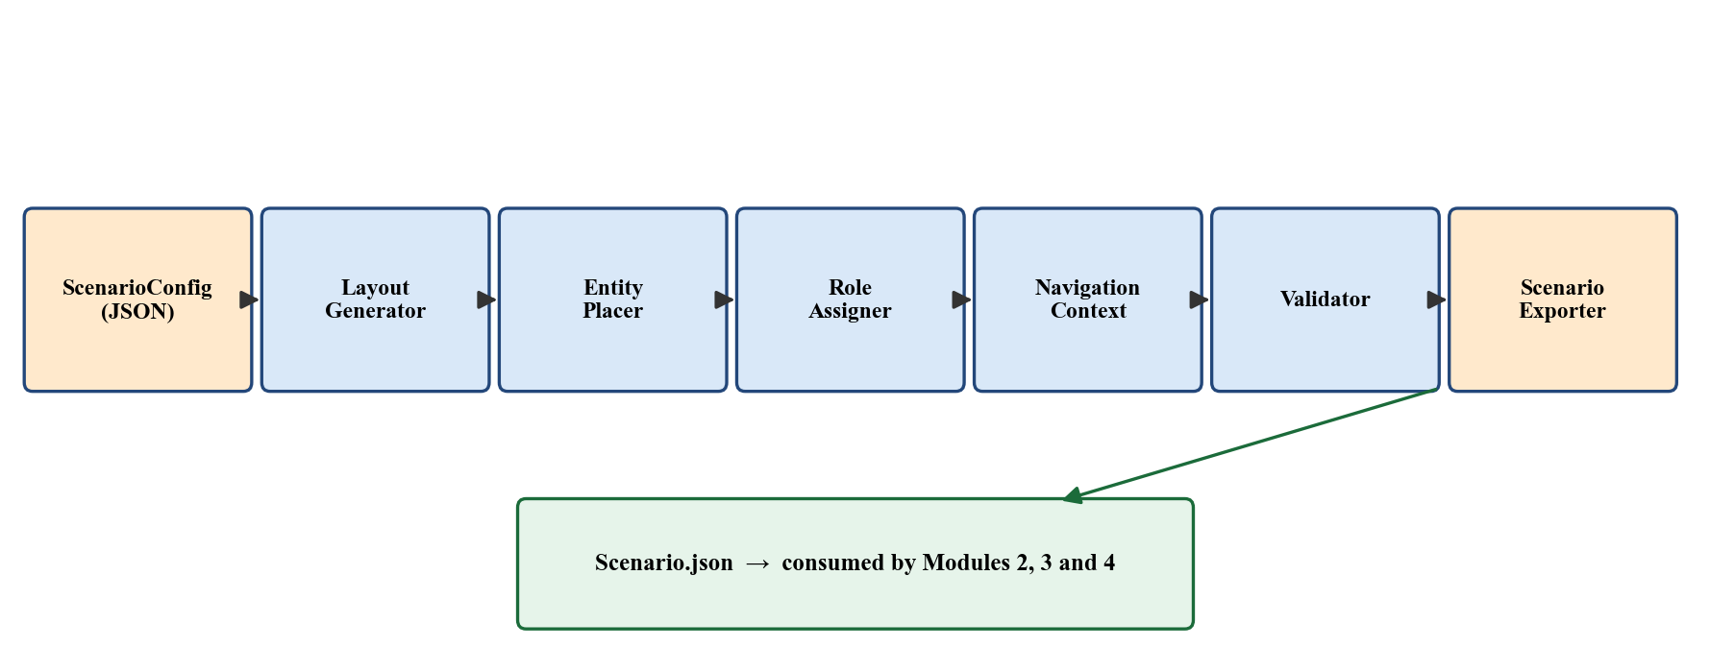
Figure 5.2 — Module 1: dynamic scenario generation pipeline
ScenarioConfigLoader loads and validates the configuration JSON. LayoutGenerator produces the indoor layout (rooms, doors and entry points). EntityPlacer places the trainee, hostages and terrorists according to the chosen placement strategy and hostage-risk level. RoleAssigner assigns NPC roles such as Patrol, RoamingGuard, StationaryGuard or HostageGuardian. NavigationContextBuilder builds the role-specific navigation context (patrol waypoints, roam centres, facing directions). ScenarioValidator checks for the validation rules listed below; if validation fails, the orchestrator retries with seed + 1 up to a fixed retry budget. ScenarioExporter writes the final Scenario.json to Output/GeneratedScenarios/.
The validator enforces:
- no overlapping rooms (VR-1) and all rooms reachable (VR-2);
- entities placed inside valid room boundaries with no overlaps (VR-3);
- at least one valid path from the trainee entry point to every hostage (VR-4);
- no conflicting events or impossible role assignments (VR-5);
- terrorist count ≤ roomCount.max × 2.
5.4 Module 2 Design — NPC Behavior and Coordination
Module 2 is the live runtime behaviour engine of the system. Its responsibility begins after the mission has loaded and Module 1 has handed control over via EventManager.NotifyScenarioReady(). The module evaluates events, updates NPC states, coordinates reactions and emits behaviour-linked telemetry.
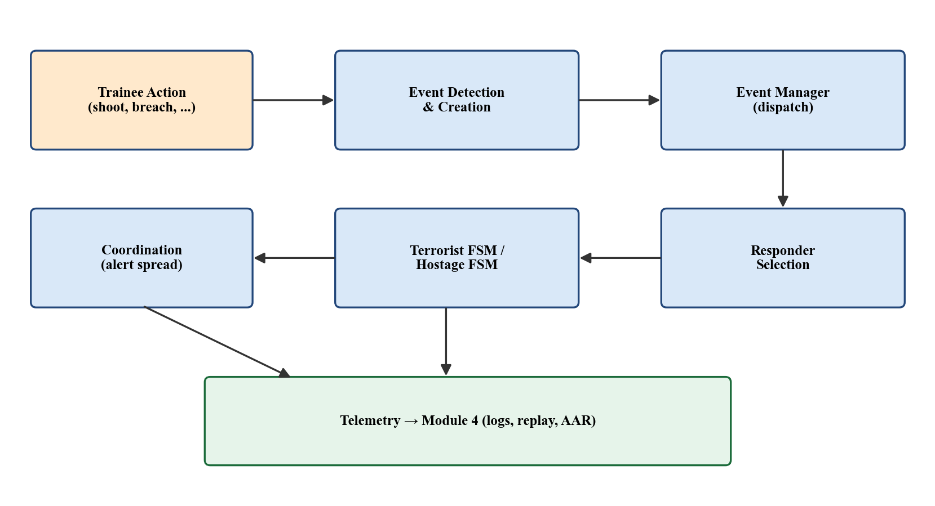
Figure 5.3 — Module 2: event-driven NPC behaviour loop
Table 5.2 — Module 2: representative event categories and reactions
Event category | Representative events | Typical module reaction
Combat / weapon use | ShotFired, GunshotHeard, TerroristHit, TerroristDown | Escalate alertness, trigger investigation or engagement.
Door / movement context | DoorOpened, RoomBreached, PlayerEnteredZone | Trigger suspicion, defensive alert or zone-based behaviour change.
Perception / exposure | PlayerSeen, TargetConfirmed, AllyDownSeen | Promote stronger hostile response and coordination spread.
Hostage interaction | HostageContactStarted, HostageFreed, HostageFollowing | Update hostage state and nearby hostile urgency.
Timing / escalation | DelayExceeded, NoProgressWindow | Increase tension-related behaviour readiness or trigger secondary logic.

Table 5.3 — Suggested NPC state sets for Module 2
NPC type | Suggested state set | Purpose
Terrorist | Idle, Suspicious, Alert, Engage, TakeCover, Reposition | Threat discovery, escalation, confrontation and tactical repositioning.
Hostage | Calm, Fearful, Panic, Freeze, Follow | Distress escalation and rescue-oriented interaction.

Responder selection is implemented as a lightweight scoring function over candidate NPCs, using factors such as distance to the event source, NPC role, current state, perception relevance, current engagement level and cooldown constraints. Coordination logic supports alert propagation (a leader spreads alerts to nearby allies), prioritisation (the most suitable responder reacts first) and role-sensitive response (e.g., a guard prioritises the room it is responsible for).
5.5 Module 3 Design — Cognitive Behavior Analysis
Module 3 analyses trainee cognitive behaviour using reaction time and full-body movement. It receives runtime events from Module 2, captures head, hand and body-proxy transforms from the VR runtime, extracts behavioural features and uses lightweight classifiers to estimate cognitive indicators that are surfaced to the evaluator through the AAR.
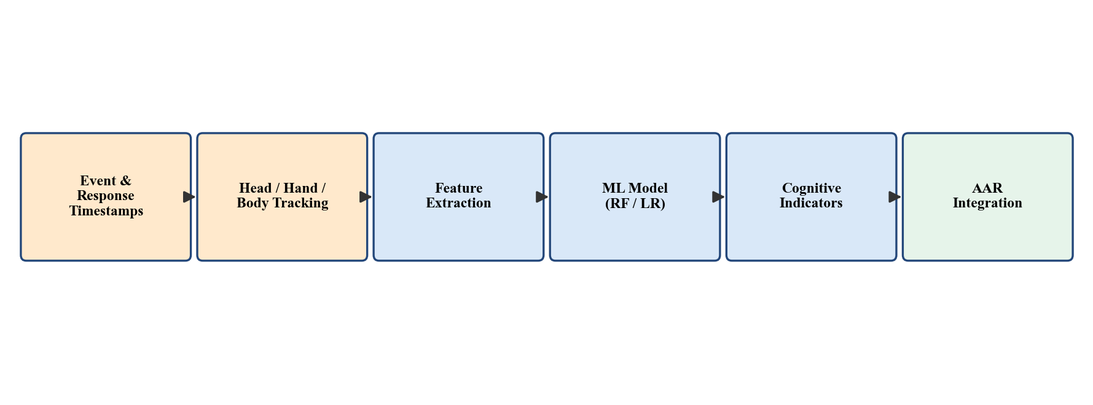
Figure 5.4 — Module 3: cognitive behaviour analysis pipeline
Reaction time is defined as the difference between a system-triggered event timestamp and the trainee's response timestamp (e.g., first weapon discharge, first head turn towards the source, first controller motion). Movement features include initiation latency, stability of head and hand transforms, attention-related orientation patterns and temporal trends. The features are passed to a Random Forest or Logistic Regression classifier that produces estimates of cognitive indicators such as load, stress and attention.
Subjective workload is collected through the SIM-TLX questionnaire after the mission, covering mental demand, physical demand, temporal demand, frustration, task complexity, situational stress, distraction, perceptual strain, task control and presence. The objective and subjective measures are reported side by side in the AAR. Module 3 deliberately observes the trainee rather than driving runtime NPC behaviour, so its outputs cannot break the simulation.
5.6 Module 4 Design — Logging, AAR and Session Replay
Module 4 transforms a completed mission into inspectable evidence. It does not attempt to recommend the next scenario or to generate automated tactical advice; instead, it captures what happened, when it happened, how the trainee performed and how the session can be replayed.
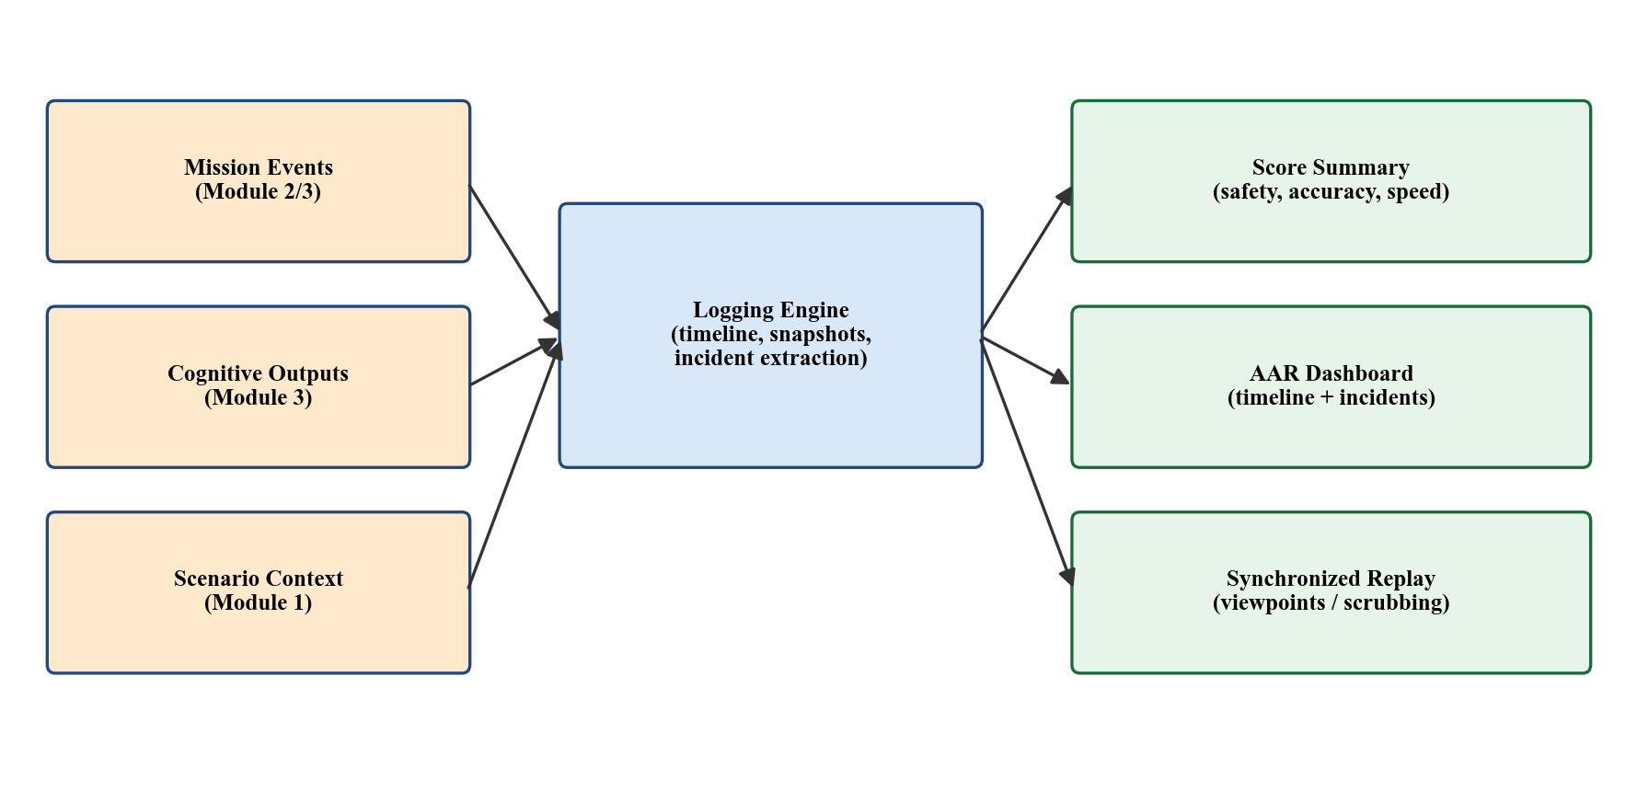
Figure 5.5 — Module 4: logging, AAR and replay structure
The module is composed of a session logging engine, a multi-metric performance summary (safety, accuracy, speed, mission success), an interactive AAR dashboard and a synchronized session-replay system. The replay is built on stored transforms and state snapshots rather than rendered video, which lets the reviewer pause, scrub, change playback speed and switch viewpoints. A key incident list (e.g., first enemy sighting, first shot fired, hostage contact, hostage injury, terrorist neutralised, mission end) links each entry to a precise replay position.
Table 5.4 — Module 4: suggested data artefacts and fields
Artefact | Recommended fields
ScenarioEvent | eventType, timestamp, sourceActorId, targetActorId, roomId, position, tags
NPCStateChange | actorId, actorType, previousState, newState, triggerEvent, timestamp
ResponderDecision | eventId, candidateIds, selectedResponder, scoreSummary, timestamp
BehaviorSnapshot | timestamp, actorId, state, transform, notes
SessionSummary | scenarioId, missionOutcome, safetyScore, accuracyScore, speedScore, majorIncidents, replayLinks

5.7 Inter-Module Integration and Data Contracts
The integration model is centred on a single shared artefact, Scenario.json, produced by Module 1 and consumed by Modules 2, 3 and 4 (Figure 5.6). Runtime behaviour is exchanged through a structured event stream emitted by Module 2 and observed by Modules 3 and 4. After-session telemetry is exchanged through SessionSummary.json, EventTimeline.json and a structured replay file. This separation keeps each module independently testable: Module 1 has unit tests for its data models, generators and validator; Module 2 can be exercised by feeding it a Scenario JSON and a synthetic event sequence; Module 3 can be evaluated against logged telemetry; and Module 4 can be driven by a recorded session even when the live runtime is not running.
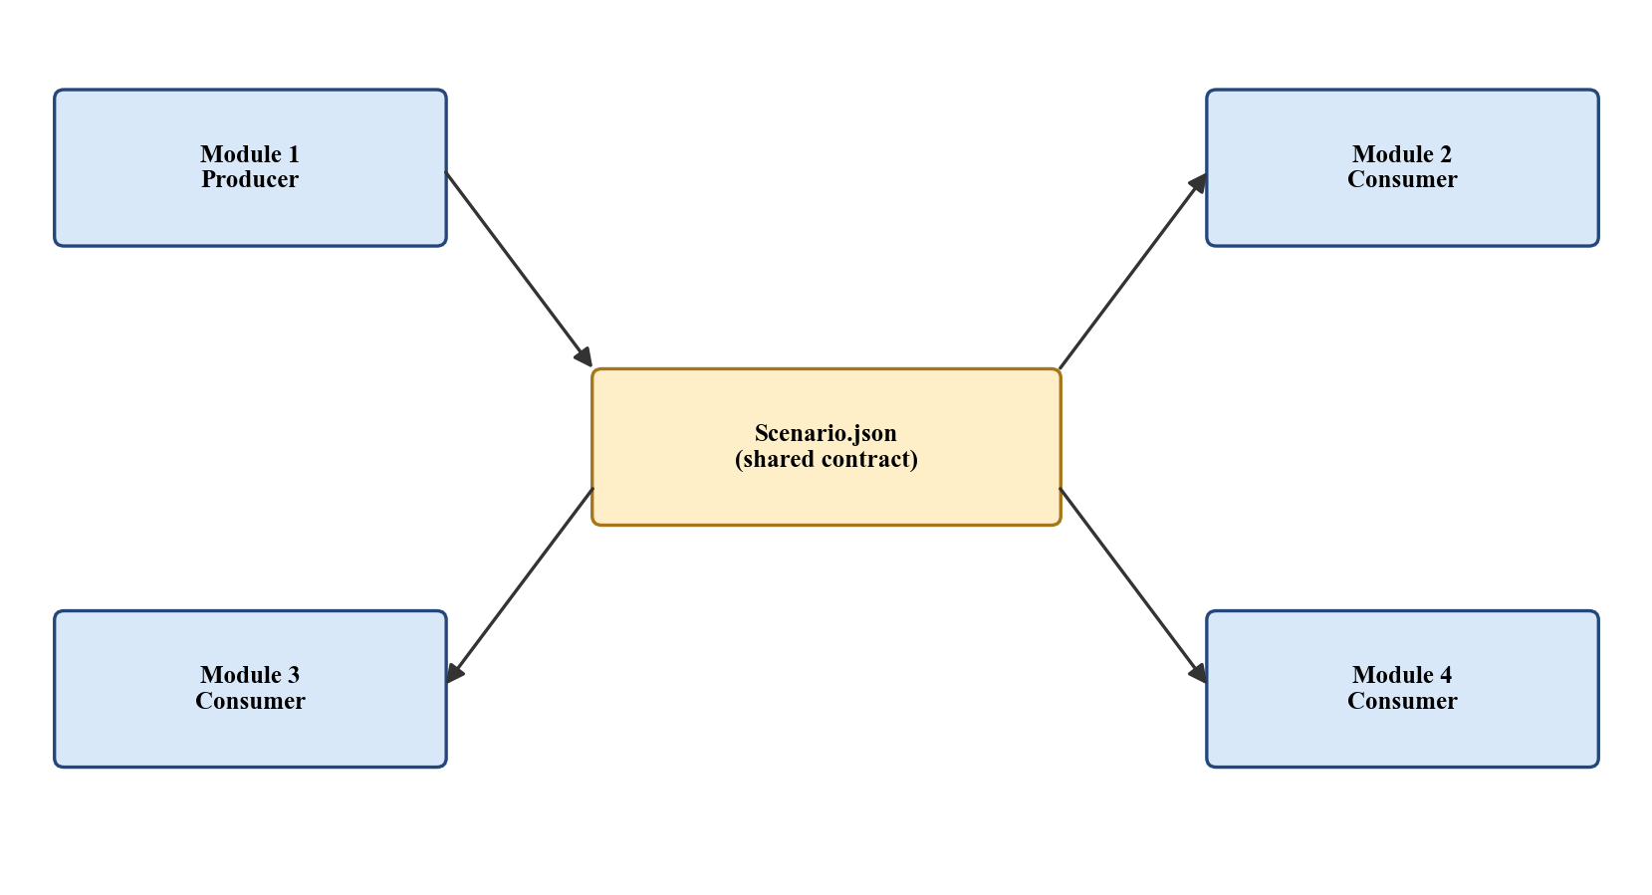
Figure 5.6 — Inter-module data contract centred on Scenario.json
5.8 Summary
This chapter described the high-level architecture of the proposed system, the design of each of the four modules and the shared data contracts that integrate them. The next chapter reports on the implementation progress to date.

Chapter 6
Implementation
6.1 Introduction
This chapter reports on the implementation work completed up to the time of this interim report. Each module's progress is described in turn, with emphasis on the completed components, the data structures used and the verification performed.
6.2 Development Environment Setup
The Unity 2022.3 LTS project has been set up with the OpenXR runtime, the Meta XR / XR Interaction Toolkit packages, the Unity AI Navigation package and the Newtonsoft.Json package. The repository is structured under Assets/ as follows: Module 1 code lives in Assets/Module1_DataModels_and_IO/Scripts/ScenarioGeneration/, the SceneBuilder and evaluator-facing UI live under Assets/Module1_DataModels_and_IO/Scripts/SceneBuilder/, and Module 2 code (NPC controllers, EventManager and supporting types) lives under Assets/Scripts/. Reference documents and the Phase 1 algorithm pseudocode live under Assets/Docs/.
6.3 Baseline VR Mission Runtime
A baseline VR vertical slice has been constructed and verified. It supports XR rig movement, weapon interaction with hit detection, door interaction (open / close), hostage interaction (detection of trainee proximity and hostage state response) and mission completion conditions. The vertical slice is the integration target for the remaining modules: Module 1 produces the scenario it loads; Module 2 drives the NPC behaviours that occur in it; Module 3 observes the trainee inside it; and Module 4 captures the session it produces.
6.4 Module 1 Implementation Progress
Module 1 is implementation-complete for Phase 2 of the project. The pipeline runs end to end and produces validated Scenario JSON files for the included evaluator configurations (default, minimal-easy, max-difficulty). The status of each Phase 2 stage is summarised in Table 6.1.
Table 6.1 — Phase 2 implementation status of Module 1 (Stages 1–8)
Stage | Description | Status
Stage 1 | Data Models and IO (DataModels, ScenarioJsonSettings, ScenarioConfigLoader, ScenarioExporter) | Complete
Stage 2 | LayoutGenerator (rooms, doors, entry points) | Complete
Stage 3 | EntityPlacer (trainee, hostages, terrorists; placement strategies) | Complete
Stage 4 | RoleAssigner + NavigationContextBuilder | Complete
Stage 5 | ScenarioGenerator orchestrator + ScenarioValidator + 21 tests | Complete
Stage 6 | SceneBuilder (Unity scene integration, NavMesh bake, NPC spawn) | Complete
Stage 7 | EvaluatorConfigPanel (TextMeshPro Canvas; runtime generation) | Complete
Stage 8 | ScenarioGeneratorEditor (Tools / Scenario Generator menu commands) | Complete

Validation behaviour follows the design from Chapter 5: when ScenarioValidator reports a failure, the orchestrator retries the generation with seed + 1 up to a fixed retry budget before reporting a hard failure to the caller. The deterministic single-System.Random design has been verified to produce identical Scenario JSON files when the same configuration and seed are used. SceneBuilder spawns hostages (driving HostageController.currentState) and terrorists (driving TerroristController.idleMode with a mapping from the Module 1 NpcRole to the Module 2 IdleMode), and finally calls EventManager.Instance.NotifyScenarioReady() to hand control over to the runtime.
6.5 Module 2 Implementation Progress
Module 2 has its supporting runtime types and overall design in place, with active development of the event-driven dispatch model and finite-state NPC controllers described in Section 5.4. The C# scaffolding (TerroristController, HostageController, EventManager and the event types) was already part of the baseline VR runtime, and the migration from the earlier scripted controllers to the event-driven model is currently being implemented in parallel with internal testing. The status of each implementation stage is summarised in Table 6.2.
Table 6.2 — Implementation status of Module 2 (Stages 1–8)
Stage | Description | Status
Stage 1 | Runtime data types (ScenarioEvent, EventType, NPCStateChange, ResponderDecision) | Complete
Stage 2 | Central EventManager and dispatch path (subscription, priority, filtering) | Complete
Stage 3 | Terrorist FSM (Idle, Suspicious, Alert, Engage; transition rules) | In progress
Stage 4 | Hostage FSM (Calm, Fearful, Panic, Freeze, Follow; transition rules) | In progress
Stage 5 | Responder-selection scoring (distance, role, state, perception) | In progress
Stage 6 | Coordination logic (alert propagation, role-sensitive response) | Prototype
Stage 7 | Telemetry stream to Module 4 (event timeline, state changes) | Prototype
Stage 8 | Integration testing against generated Scenario.json fixtures | Pending

Stages 1 and 2 are complete: the event types are defined under the same JSON-compatible schema used by Module 4, and the EventManager exposes a single dispatch entry point that Modules 3 and 4 can subscribe to. The Notification path from Module 1 — EventManager.Instance.NotifyScenarioReady() — is wired and verified through the SceneBuilder hand-off described in Section 6.4. Stages 3 and 4 are in active migration: the existing controllers already drive idle, patrol, wander and static behaviour from the scenario JSON, and the new explicit state sets and transition rules are being added without breaking the scenarios already generated by Module 1. Stub coordination behaviour (alert propagation between nearby terrorists in response to a GunshotHeard event, with leader-issued reaction bias) has been prototyped and is undergoing internal testing. Stage 8 is deferred until Stages 3–7 stabilise so that integration tests exercise the fully event-driven model rather than a partial migration.
6.6 Module 3 Implementation Progress
Module 3 is at the instrumentation and feature-engineering stage. The Unity-side capture path for head and controller transforms has been confirmed against the XR rig used in the vertical slice, the event-and-response timestamp logging schema is in place and the off-engine analysis pipeline (scikit-learn, NumPy, pandas) is being built in parallel. The status of each implementation stage is summarised in Table 6.3.
Table 6.3 — Implementation status of Module 3 (Stages 1–8)
Stage | Description | Status
Stage 1 | VR capture path (head, hand and body-proxy transforms via OpenXR) | Complete
Stage 2 | Event and response timestamp logging schema (aligned with Module 4) | Complete
Stage 3 | Reaction-time feature extraction (event-to-response latency) | In progress
Stage 4 | Movement feature extraction (initiation, stability, attention patterns) | In progress
Stage 5 | SIM-TLX post-session questionnaire and ground-truth labelling | Drafted
Stage 6 | ML classifier training (Random Forest, Logistic Regression) | In progress
Stage 7 | Cognitive-output schema for Module 4 AAR consumption | Drafted
Stage 8 | Pilot data collection and statistical validation | Pending

Stages 1 and 2 are complete: the capture pipeline subscribes to Module 2's EventManager to associate every system-triggered event with a system clock timestamp and the trainee's earliest matching response (first weapon discharge, first orientation change above a threshold, first controller motion). The recorded stream is written to disk in the same JSON-compatible structure that Module 4 expects, which keeps the analysis path decoupled from the engine. Stages 3 and 4 — reaction-time and movement features — are implemented as a small set of pure functions over the captured stream so that the same code can run inside Unity (for live indicators) or off-engine (for batch experiments). Stage 5 is drafted: the SIM-TLX questionnaire covering mental, physical and temporal demand, frustration, task complexity, situational stress, distraction, perceptual strain, task control and presence is integrated into the post-mission flow and produces the subjective-workload labels that the classifiers in Stage 6 are being trained against. The next concrete step (Stage 8) is to collect a pilot data set from internal play-throughs to verify that reaction time and movement initiation can be reliably extracted from real captured streams under the noise levels seen on the Meta Quest 3.
6.7 Module 4 Implementation Progress
Module 4 has a complete data schema and a working first version of the score-summary computation, with the structured-JSON logging engine and the AAR / replay surfaces under active development. The status of each implementation stage is summarised in Table 6.4.
Table 6.4 — Implementation status of Module 4 (Stages 1–8)
Stage | Description | Status
Stage 1 | Data schema (ScenarioEvent, NPCStateChange, ResponderDecision, BehaviorSnapshot, SessionSummary) | Complete
Stage 2 | Structured-JSON logging engine on top of Module 2 EventManager | In progress
Stage 3 | Score-summary computation (safety, accuracy, speed, mission success) | Complete (v1)
Stage 4 | Event timeline and key-incident extraction (first sighting, first shot, hostage contact, ...) | In progress
Stage 5 | AAR dashboard UI (summary cards, timeline, drill-down panels) | Prototype
Stage 6 | Synchronized replay (transforms, state snapshots, viewpoint switching) | Pending
Stage 7 | Hostage-perspective panel and per-hostage distress scoring | Drafted
Stage 8 | Optional player-perspective video export and integration testing | Pending

Stage 1 is complete: the data model from Section 5.6 has been drafted in C# and exposed to Modules 2 and 3 through a small shared types library. Stage 3 has a first working version: the four normalised sub-scores (safety, accuracy, speed, mission success) are computed from the recorded event stream and combined into the SessionSummary artefact. Stage 2 is in progress: the logging engine subscribes to the Module 2 EventManager and writes timestamped event records, periodic state snapshots and session summary files to the local disk under a per-session directory. Stage 4 (key-incident extraction) is being implemented as a deterministic pass over the event timeline, identifying first enemy sighting, first shot fired, hostage contact, hostage injury, NPC alert cascade, terrorist neutralisation and mission end so that each AAR entry can link to a precise replay position. Stages 5 and 6 (the AAR dashboard and synchronized replay) are scheduled for the next implementation block; the replay system is deliberately built on stored transforms and state snapshots rather than rendered video so that the reviewer can switch viewpoints (player, observer, overhead) at any time during playback. Stage 7, the hostage-perspective panel, is drafted as a derived view over the existing hostage state telemetry and is on track to land alongside the dashboard.
6.8 Summary
Module 1 is implementation-complete and verified end to end. Module 2 has its types and design in place and is being migrated to the event-driven model. Modules 3 and 4 have their schemas drafted and prototype logging in place, and the next phase of work is focused on data collection (Module 3) and AAR / replay surfaces (Module 4). The next chapter discusses the project's progress, comparisons with related work and the planned evaluation.

Chapter 7
Discussion
7.1 Introduction
This chapter reflects on the progress reported in Chapter 6, contrasts the proposed system with the related work surveyed in Chapter 2, presents the planned evaluation procedure and outlines the future work that remains to complete the dissertation.
7.2 Current Progress
At the time of this interim report, the project has produced an end-to-end VR vertical slice on Meta Quest 3, a complete Phase 2 implementation of Module 1 covering Stages 1 through 8, the design specifications and prototype skeletons of Modules 2, 3 and 4 and the agreed integration contract centred on Scenario.json. The deterministic generation pipeline is verified: the same configuration and seed always produce the same generated scenario, and validation failures correctly trigger the seed+1 retry path.
7.3 Comparison with Existing Solutions
Compared to the related work reviewed in Chapter 2, the proposed solution is differentiated along three axes. First, it integrates parameter-driven scenario generation, event-driven NPC behaviour, behaviourally-grounded cognitive analysis and evidence-linked AAR with replay in a single Unity-based system, whereas most cited prototypes address only a subset of these concerns. Second, it targets a consumer-grade headset (Meta Quest 3) rather than a high-end laboratory rig, which makes evaluator deployment and user trials more practical. Third, the AAR / replay surface is deliberately scoped to evidence-based explanatory feedback rather than automatic tactical recommendations, which keeps the project within manageable engineering scope and avoids domain-dependent expert judgment.
7.4 Plan for Evaluation
The evaluation will follow three phases. The first phase is module-level validation: Module 1 is exercised by an automated test suite of 21 generation tests covering layout validity, reachability, entity placement, role assignment and validation retry behaviour; Module 2 is exercised through scripted event sequences fed into the Event Manager and observed against the expected NPC state transitions; Module 3 is evaluated by computing reaction-time and movement features against pilot recordings and by measuring classifier accuracy on a held-out split; Module 4 is evaluated against recorded sessions to confirm correct timeline reconstruction and replay synchronisation.
The second phase is integrated end-to-end testing across full mission runs. Each configuration in Resources/ScenarioConfigs/ is loaded, generated, exported, loaded into the SceneBuilder and played to completion, with telemetry captured by Module 4. The third phase is a small-scale user study. Following the SIM-TLX protocol, 15 to 30 participants will play two contrasting scenario configurations (a low-difficulty and a high-difficulty configuration) in counterbalanced order. Reaction time, movement features, mission outcomes and self-reported workload will be analysed using paired comparisons, and Module 3 classifier outputs will be correlated with SIM-TLX subscales.
7.5 Future Work
Beyond completing the implementation of Modules 2, 3 and 4 to the level of Module 1, future work includes: extending the layout generator to multi-floor environments; introducing more diverse NPC behaviour patterns and richer coordination rules; experimenting with deeper sequence models for cognitive analysis once a sufficient data set has been collected; expanding the AAR with comparative views across multiple sessions; and running a larger user study with trained personnel to assess transfer of training.
7.6 Summary
The project has reached a healthy mid-point: a fully implemented and verified scenario generation module, a clear design and prototype foundation for the remaining three modules and a defined evaluation plan. The remaining time will focus on completing the runtime behaviour, cognitive analysis and AAR layers and on running module-level, integrated and user-study evaluations.

References
[1] Anthropic, "Claude Code: Reference for Anthropic Claude developer tooling," Anthropic, 2024-2026 (online developer documentation).
[2] Boyce, M. W. et al., "Enhancing Military Training Using Extended Reality: A Study of Military Tactics Comprehension," Frontiers in Virtual Reality, vol. 3, Art. no. 754627, 2022.
[3] Cook, M., "Procedural Generation and Information Games," in Proc. IEEE Conf. on Games (CoG), 2020, pp. 253–260.
[4] Hart, S. G. and Staveland, L. E., "Development of NASA-TLX (Task Load Index): Results of empirical and theoretical research," in Human Mental Workload, North-Holland, 1988, pp. 139–183.
[5] Kalafatis, E., Mitsis, K., Zarkogianni, K., Athanasiou, M. and Nikita, K., "A modular framework for automated evaluation of procedural content generation in serious games with deep reinforcement learning agents," arXiv preprint arXiv:2505.16801, 2025.
[6] Kleygrewe, L., Vana Hutter, R. I., Koedijk, M. and Oudejans, R. R. D., "Changing perspectives: enhancing learning efficacy with the after-action review in virtual reality training for police," Ergonomics, vol. 67, no. 5, pp. 628–637, 2024.
[7] Klingner, J., Kumar, R. and Hanrahan, P., "Effects of task difficulty on pupillary response and reaction time," Behavior Research Methods, vol. 40, no. 1, pp. 1–7, 2008.
[8] Luo, L., Yin, H., Zhong, J., Cai, W., Lees, M. and Zhou, S., "Mission-Based Scenario Modeling and Generation for Virtual Training," in Proc. Ninth AAAI Conf. on Artificial Intelligence and Interactive Digital Entertainment (AIIDE-13), 2013.
[9] Sottilare, R. A., Ballinger, C., Litvinas, M., Hu, S. and McGroarty, C., "Using Genetic Algorithms to Automate Scenario Generation and Enhance the Training Value of Serious Games for Adaptive Instruction," The International FLAIRS Conference Proceedings, vol. 37, no. 1, 2024.
[10] Xie, B. et al., "A Review on Virtual Reality Skill Training Applications," Frontiers in Virtual Reality, vol. 2, Art. no. 645153, 2021.
[11] Shaker, N., Togelius, J. and Nelson, M. J., Procedural Content Generation in Games: A Textbook and an Overview of Current Research, Springer, 2016.
[12] Unity Technologies, "Unity 2022.3 LTS Documentation," 2022 (online manual).
[13] Wickens, C. D., Hollands, J. G., Banbury, S. and Parasuraman, R., Engineering Psychology and Human Performance, 4th ed., Pearson, 2013.

Appendix A
Individual Contribution to the Project
Name of student: Chathuranga S.P.Y.N (214036J)
Primary module: Module 1 — Dynamic Scenario Generation
My main contribution to this project has been the design and implementation of Module 1 — Dynamic Scenario Generation, which converts evaluator-defined parameters into a structured, valid Scenario JSON that the rest of the system consumes. I specified the data models (ScenarioConfig, LayoutData, EntityRecord, RoleAssignment, NavigationContextEntry and ScenarioData), wrote the JSON serialisation settings using Newtonsoft.Json, and implemented the LayoutGenerator, EntityPlacer, RoleAssigner and NavigationContextBuilder as plain C# classes outside of MonoBehaviour to keep the pipeline deterministic and unit-testable. I also wrote the ScenarioGenerator orchestrator, the ScenarioValidator (with the seed+1 retry behaviour), the ScenarioExporter, the SceneBuilder that loads generated scenarios into the Unity scene, the EvaluatorConfigPanel and the editor tooling under Tools / Scenario Generator. Through this work I learned how to keep a generation pipeline deterministic with a single seeded System.Random, how to design a JSON contract that is robust against schema drift, and how to balance separation between an asmdef-bound generation library and the surrounding Assembly-CSharp code. The main difficulty I encountered was making validation failures recover gracefully; I addressed this with a fixed retry budget and a clean ValidationResult so the rest of the team can rely on Module 1 producing playable scenarios.

Name of student: Dilshan R.P (214057A)
Primary module: Module 2 — NPC Behaviour and Coordination
My main contribution has been the design of Module 2 — NPC Behaviour and Coordination, which is the live runtime behaviour engine of the system. I produced the Module 2 specification (event model, terrorist and hostage state sets, responder selection and coordination rules) and implemented the supporting C# types (TerroristController, HostageController and the EventManager dispatch path). I also prototyped the alert-propagation behaviour that is triggered by GunshotHeard events and the IdleMode mapping that connects Module 1's NpcRole to the existing terrorist controller. Through this work I learned how to keep an NPC system observable: by converting trainee actions into structured events and by keeping each NPC's state set small and explicit, the runtime becomes much easier to debug and to log. The main difficulty was deciding the right set of states; I addressed this by starting with a minimal set (Idle, Suspicious, Alert, Engage for terrorists; Calm, Fearful, Panic, Freeze, Follow for hostages) and only adding states when concrete behaviour required them.

Name of student: Wadumulla G.M.D (214217P)
Primary module: Module 3 — Cognitive Behaviour Analysis
My contribution focuses on Module 3 — Cognitive Behaviour Analysis. I prepared the research plan that defines reaction time, movement initiation, stability and attention features, and that maps these features onto cognitive indicators such as load, stress and attention via a Random Forest / Logistic Regression classifier. I also drafted the SIM-TLX questionnaire used to collect subjective workload scores after each mission, and the experiment design that compares low-stress and high-stress scenario configurations across 15 to 30 participants. On the implementation side, I designed the head and controller capture path inside Unity, drafted the per-event timestamp logging schema and prepared the Python notebooks (scikit-learn, NumPy, pandas) used for feature extraction and classifier training. Through this work I learned how to ground cognitive interpretation in concrete behavioural evidence rather than aggregate impressions, and how to combine objective measures with self-reported workload. The main difficulty is the small data-set size at this stage; the planned pilot trials and the SIM-TLX cross-checks will address this in the next phase.

Name of student: Wijesinghe W.N.U (214237C)
Primary module: Module 4 — Logging, AAR and Session Replay
My contribution focuses on Module 4 — Logging, After-Action Review and Session Replay. I produced the revised module specification that scopes Module 4 to evidence-based review (logging, score summary, AAR dashboard and synchronized replay) and away from automated tactical recommendation, and I drafted the data schema (ScenarioEvent, NPCStateChange, ResponderDecision, BehaviorSnapshot and SessionSummary) used to capture the completed mission. On the implementation side, I started the structured-JSON logging engine on top of the Module 2 Event Manager, wrote the first version of the score-summary computation (safety, accuracy, speed and mission outcome) and prototyped the AAR dashboard layout (summary cards, key incidents, event timeline). The synchronized replay system is built on stored transforms and state snapshots rather than rendered video so the reviewer can switch viewpoints at any time. Through this work I learned how a small but consistent data schema is worth far more than a large but ad-hoc one. The main difficulty was distinguishing rendered video from genuine replay; I addressed this by recording transforms and states explicitly and by treating video export as an optional convenience rather than the primary review surface.

