Module 2 — Evaluation Briefing
A living reference document — how to explain Module 2 (NPC behaviour & coordination) to your supervisor and evaluators, with the evidence behind every claim. Last updated 2026-08-04.
This document consolidates everything established across the ablation study, the weight-sensitivity study, the literature grounding, the real human evaluation results, and the recent behaviour fixes — organised in the order you would actually present it, not the order it was discovered. Update this file as new findings come in; it is designed to grow with the project rather than be rewritten each time.
────────────────────────────────────────────────────────────

1. What Module 2 Is — the one-minute pitch
"Module 2 is the enemy AI — a squad of terrorists that reacts, searches, and coordinates like a real (if not elite) hostile force, instead of standing still or shooting on sight."
This framing matters because it tells an evaluator what standard to judge the work against: not "is it hard to beat," but "does it behave believably." Everything in this document is evidence for that specific claim.

The problem that motivated the redesign
The starting point had a specific, concrete bug: a terrorist who saw the trainee and then lost sight of them would simply abandon the chase and return to its post — even if a squadmate was standing right there. Real react-to-contact doctrine says the opposite: a confirmed sighting should commit the whole squad to a coordinated pursuit, not a private memory that expires. That gap — and the U.S. Army doctrine that contradicts it — is the origin story for the whole squad-coordination architecture (see Section 3).

2. How It Is Built — conceptual architecture (no code)
- Individually, each terrorist runs a small finite-state machine: Idle → Suspicious → Alert → Engage → TakeCover / Retreat → Down.
- Above the individual level, a squad layer holds SHARED knowledge — where the trainee was last seen, whether a hunt is currently active — so the group acts as a team instead of isolated agents with private memories.
- When an event needs exactly one responder (e.g. "who investigates this gunshot?"), a selection formula (NPCSelector) scores every eligible NPC on four factors — distance, role, how ready they currently are, and whether they can actually see the event — and picks the highest scorer.
That is the whole architecture in three sentences. Depth beyond this belongs in Q&A answers, not the opening pitch — see Section 8.

3. Why It Is Built This Way — literature grounding, summarised
The two-layer structure (individual behaviour under squad coordination) mirrors F.E.A.R.'s well-known enemy AI (Orkin, 2006). The react-to-contact and shared-sighting behaviour follows actual U.S. Army battle-drill doctrine (CALL Handbook 96-3; FM 3-21.71). The expanding-search-on-lost-contact model follows peer-reviewed wilderness search-and-rescue theory (Phillips et al., 2014) — anchor on the point last seen, grow the search radius with elapsed time. The responder-selection technique is standard utility-based AI (Mark, 2009; Dill, 2010/2011/2012), with two citations specifically about virtual characters for military training simulators — the same domain as this project. Full citations, verified working links, and what each source backs are in Section 9 (Bibliography).

4. The Responder-Selection Formula — full justification

4.1 What it is
NPCSelector.SelectBest scores every eligible NPC on four weighted factors and picks the highest total:
score = (1/distance) x DistanceWeight
+ roleBonus[role][eventType] x RoleWeight
+ stateReadiness x StateWeight
+ losBonus x LosWeight

Project defaults: DistanceWeight=2.0, RoleWeight=1.0, StateWeight=1.0, LosWeight=1.0
Role bonuses: Guard+RoomBreached=3.0, Roamer+GunshotHeard=2.0, Leader+AllyDownSeen=1.5
No published source specifies this exact four-factor combination or these exact numbers — that combination is this project's own design. What IS well-grounded is the technique itself (weighted multi-factor scoring) and each individual factor, matched independently across three literatures: game-AI utility theory, multi-robot task allocation, and military/emergency dispatch operations research (Section 9, Group 4).

4.2 Ablation study — does each factor actually matter?
Method: the real NPCSelector was run live inside Unity, switching each of the four factors fully OFF one at a time, across 250 real selection decisions (50 gunshot events x 5 modes: Full, NoDistance, NoRole, NoState, NoLOS), and comparing each ablated mode against the full formula on the same events.
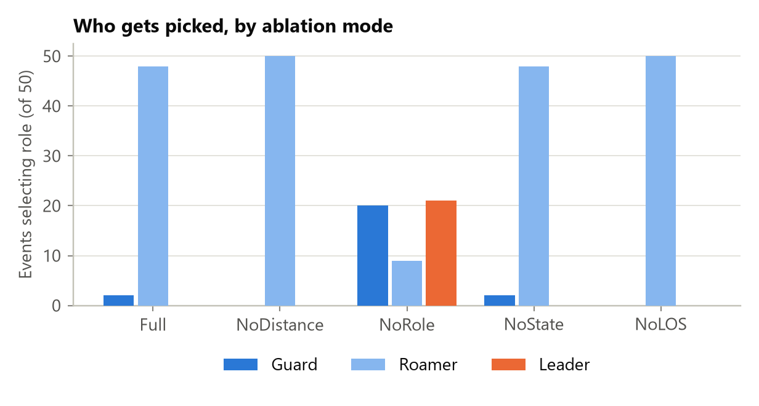
Figure 1. Which role gets picked, by ablation mode. Roamers win almost every event under Full/NoDistance/NoState/NoLOS; only removing Role itself changes the picture.

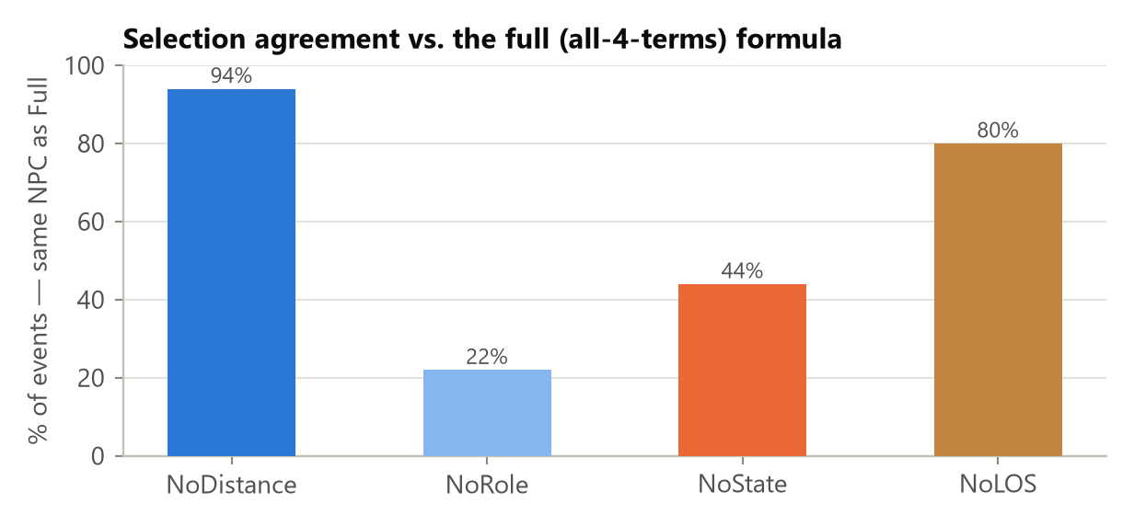
Figure 2. % of events where each ablated mode picked the same NPC as the full formula. This is the headline ranking of how much each term matters.

Factor | Agreement with Full | Decisions that flip when removed
Role | 22% | 78% — the dominant term
State | 44% | 56% — a strong secondary factor
LOS | 80% | 20% — real but smaller
Distance | 94% | 6% — smallest effect in this configuration

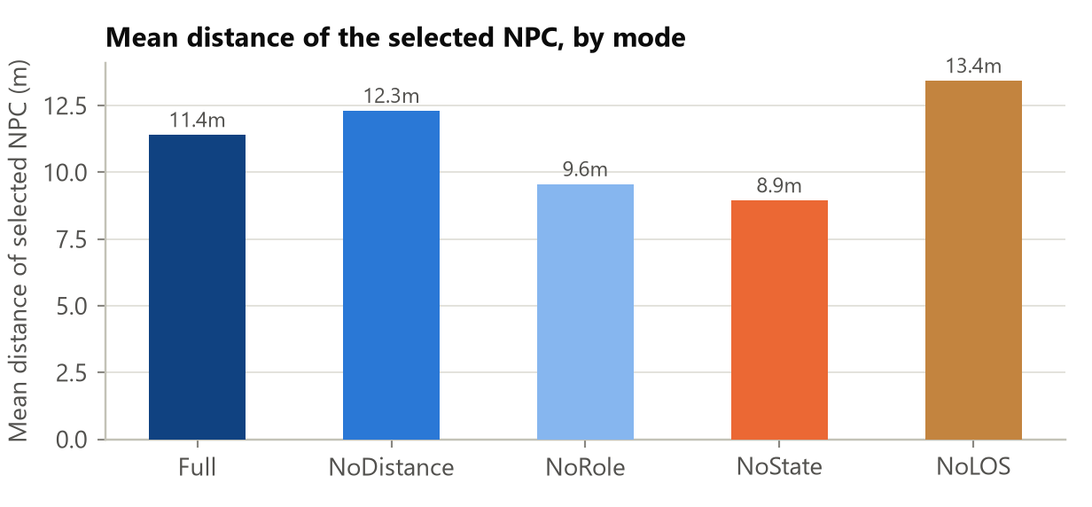
Figure 3. Mean distance of the selected NPC, by mode. Full vs. NoDistance is the only valid pairwise comparison here (11.4m vs 12.3m) — removing distance sends a responder about 0.9m farther away on average.

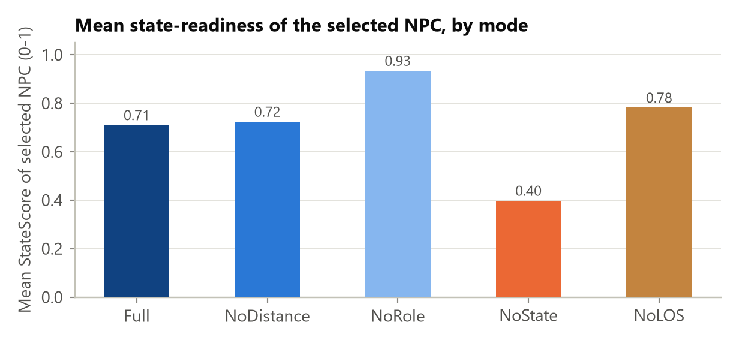
Figure 4. Mean state-readiness of the selected NPC. Full (0.71) vs NoState (0.40): removing the state term nearly halves the average readiness of who gets sent.

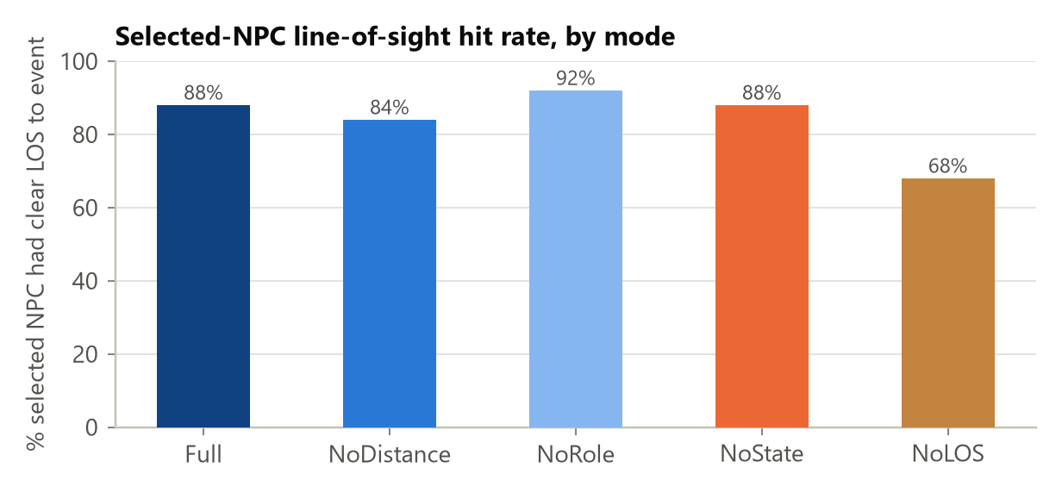
Figure 5. % of selections with clear line-of-sight to the event. Full (88%) vs NoLOS (68%): without the perception term, the selector sends a "blind" responder almost 3x more often.

What this proves: every one of the four factors has real, measurable influence on the outcome — none of them is dead weight in the formula. What this does NOT prove: that including a factor makes the decision "better" or "more correct" — only that the formula's output genuinely depends on it. Whether that dependency helps or hurts training realism would need an external ground truth (an expert's judgement of who SHOULD respond), which this study does not have.

4.3 Weight-sensitivity study — are the chosen numbers fragile or robust?
Method: each factor's weight was swept across seven values (0, 0.5, 1, 1.5, 2, 3, 4) while holding the other three at their defaults, across 25,200 real selection decisions — 3 event types (the three rows of the role-bonus table) x 3 independent random NPC layouts x 4 weights x 7 values x 100 shared events per point.
Read this before the charts: the 100% point exactly at each default is guaranteed by construction (the sweep is compared against itself at that point), not a discovered result. It is NOT evidence the default is optimal. The only real evidence is the SHAPE around that point: a flat curve on both sides = robust (many nearby values behave the same); a steep drop = sensitive (the exact number matters more).
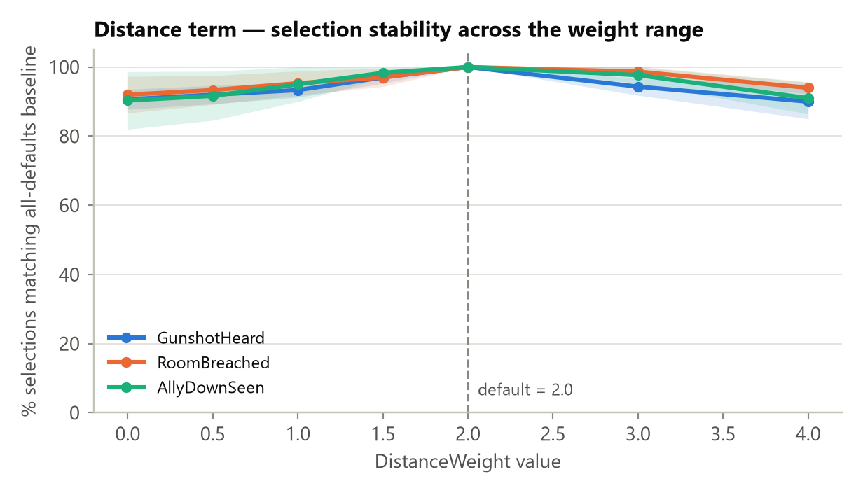
Figure 6. Distance — the most robust of the four. Agreement never drops below ~90% across the entire 0-4x range. Even zeroing it out only flips ~9-10% of decisions.

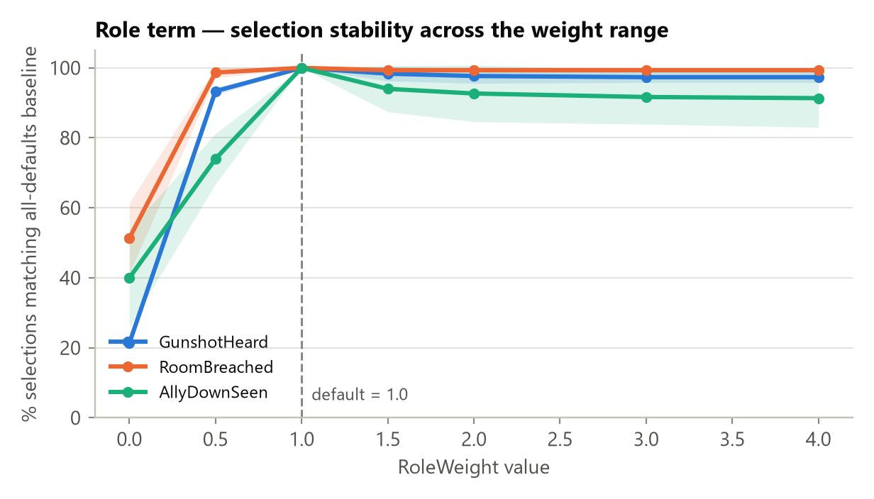
Figure 7. Role — a cliff only at zero (21-51% agreement), flat and high (91-99%) from half the default value all the way to 4x it. It just needs to exist; the exact magnitude barely matters once turned on.

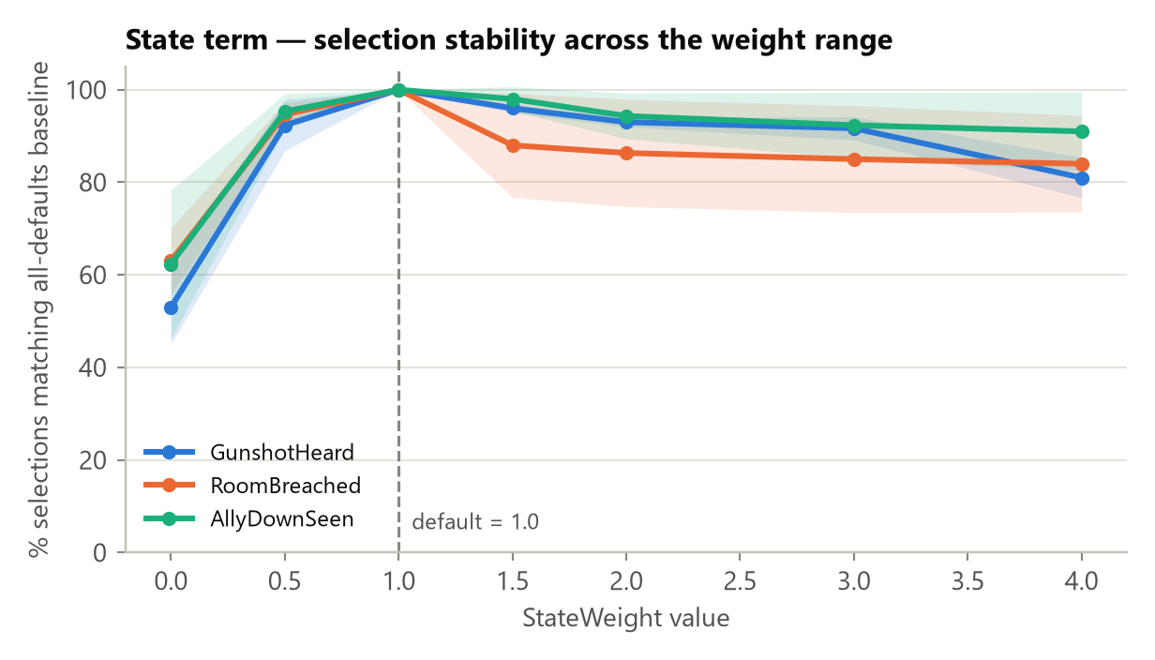
Figure 8. State — same zero-cliff as Role, but a real (if modest) decline when over-weighted (down to 81-92% at 4x). Less forgiving of a large deviation than Role or Distance.

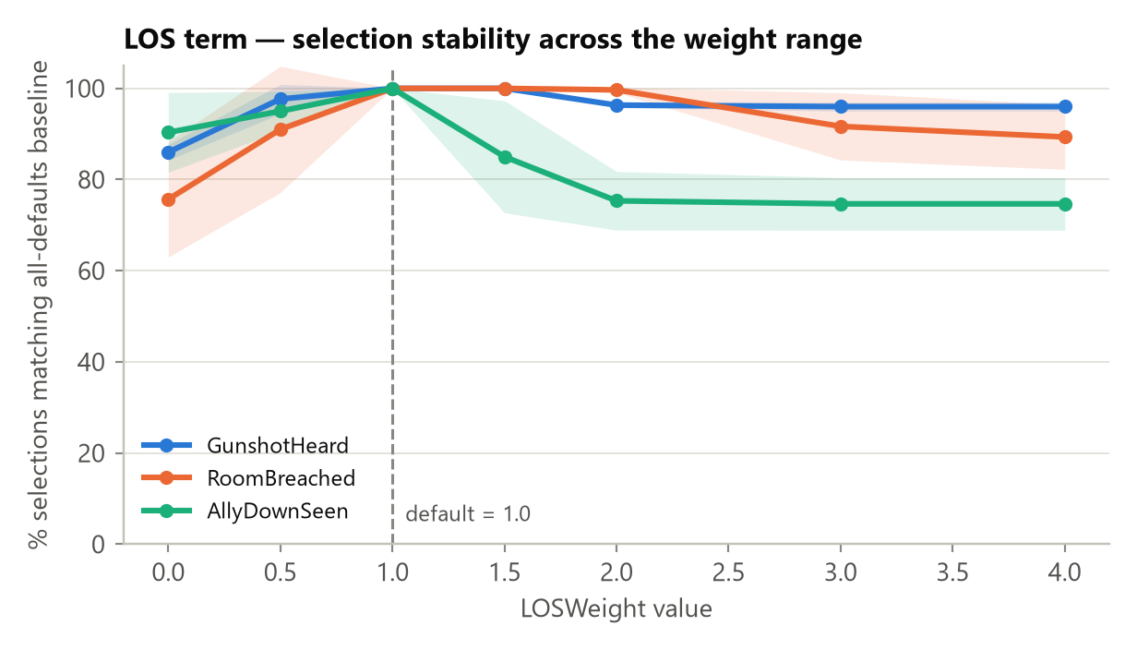
Figure 9. LOS — the most sensitive of the four. Steepest decline when over-weighted, and event-type specific: for AllyDownSeen, stability drops to ~75% by 3-4x the default. The one legitimate, evidence-based candidate for future re-tuning.

What this proves: for three of the four factors (Distance always; Role and State once given any positive value), the current weights sit in a wide, forgiving zone — nearby values, even 2-4x larger or fully removed, produce nearly the same selections. The system does not depend on hitting these exact numbers. What this does NOT prove: that 2.0/1.0/1.0/1.0 are individually the "best" possible numbers — no experiment run here, or runnable without expert ground truth, can show that.

4.4 The honest, calibrated defense
"The specific combination of distance, role, state-readiness, and line-of-sight — and the exact weights used — is our own design; no single paper prescribes this formula. Each factor individually, and the overall technique of weighted multi-factor scoring, is well-established in three separate literatures. Since no source specifies the exact numbers for our specific combination, we validated them ourselves: an ablation study showing each factor genuinely changes the outcome (i.e. none is dead weight), and a sensitivity study showing the chosen weights are not fragile. Neither study proves the decisions are doctrinally correct — only that the formula behaves the way it is supposed to, structurally. Establishing correctness would need comparison against expert judgement, which we have not done and say so plainly."
This is deliberately a narrower claim than "these are the best weights" — and that narrower, calibrated claim is what makes it defensible. Overclaiming optimality is the single easiest way to lose credibility with an evaluator who pushes back on this exact point.

5. Human Evaluation Results

5.1 What was tested
The same trainees played the identical mission three times — once against "Basic" AI, once "Intermediate," once "Advanced" — and rated the enemy after each play. n = 20 Basic-tagged sessions, 14 Intermediate, 11 Advanced; n = 9 participants completed all three tiers (the set the significance tests run on). Source: evaluation results.pdf (dashboard export), reported in full in MODULE2_FULL_REPORT.md Section 6.7.

5.2 What each survey measure actually asks
Measure | What it asks | Instrument
Perceived Intelligence | Did the enemy seem smart? (Competent, Knowledgeable, Responsible, Intelligent, Sensible) | Godspeed (Bartneck et al. 2009)
Animacy | Did it feel alive, not robotic? (Alive, Lively, Organic, Lifelike, Interactive, Responsive) | Godspeed (Bartneck et al. 2009)
Tactical realism | Did they act like real hostiles would? (reacted to being shot at, searched, overall behaviour realistically) | Author-defined, 3 items
Pragmatic (UEQ) | Was fighting them frustrating or smooth? (usability — Supportive, Easy, Efficient, Clear) | UEQ-S (Schrepp et al. 2017)
Hedonic (UEQ) | Was fighting them fun/engaging? (Exciting, Interesting, Inventive, Leading edge) | UEQ-S (Schrepp et al. 2017)

Perceived Intelligence and Tactical Realism are the core "does this AI seem believable" measures — the actual Module 2 research question. Pragmatic and Hedonic are standard UX checks (is the experience usable and fun) — a different, complementary construct, deliberately kept separate.

5.3 The statistics, explained plainly
Term | Plain-English meaning
p-value | How likely the observed difference is just random luck. p=0.004 means a 0.4% chance it is luck — i.e. very likely a real effect.
Friedman test | The first check: "is there ANY difference at all among the 3 AI tiers?" (an omnibus test, not yet saying which pair differs).
Kendall's W | How consistently participants agreed on the pattern, 0 to 1. W=0.60 means most people rated the tiers in the same increasing order.
Wilcoxon signed-rank | The follow-up check: "which SPECIFIC pair (e.g. Basic vs Intermediate) actually differs?" — run once per pair.
Bonferroni correction | Running 3 pairwise tests instead of 1 raises the odds of a false alarm, so the significance bar is tightened from p<0.05 to p<0.017 per pair to compensate.
Effect size (r) | How BIG the difference is (0-1), independent of sample size. ~0.1 small, ~0.3 medium, ~0.5 large. This study's values (0.85-0.89) are very large.

The exact formulas, and a hand-worked example that reproduces the numbers in your own report's validation note exactly, are recorded separately if needed for a methods appendix — ask and this section can be expanded with them.

5.4 The results
Measure | Basic | Intermediate | Advanced | Friedman p | Effect size
Perceived Intelligence (/5) | 1.6 | 3.7 | 4.4 | 0.004 | r=0.85-0.89 (all pairs significant)
Animacy — life-like (/5) | 2.0 | 3.8 | 4.1 | <0.001 | r=0.89 (Basic pairs sig.; Int.-vs-Adv. NOT significant, p=0.188)
Tactical realism (/5) | 1.7 | 3.5 | 4.4 | 0.003 | r=0.85-0.89 (all pairs significant)

Summary sentence: real trainees playing the identical mission rated the smarter AI tiers as significantly more intelligent and tactically realistic than the dumbest tier — not a small pilot trend, but a statistically significant, large effect. The one honest exception: Intermediate and Advanced were NOT reliably distinguished on "does it feel alive" specifically (p=0.188) — both felt about equally life-like to trainees, even though Advanced still scored higher on intelligence and tactical realism.

5.5 How this connects back to the selection formula — and what it does NOT prove
TerroristController.cs gates squad coordination behind AI tier: AllowTeam => aiLevel >= AILevel.Intermediate. This is the exact switch that determines whether NPCSelector's picks are ever acted on — at Basic tier, NPCSelector still runs and picks an investigator, but that NPC silently declines to act on it. So the Basic-vs-Intermediate jump above is real evidence that the coordinated-response package (of which NPCSelector's selection is one necessary ingredient) meaningfully improves perceived intelligence.
What this does NOT prove: AllowTeam gates the ENTIRE squad-coordination package at once — dispatch, persistent hunt, leader directives, converge-on-contact all switch on together. This evaluation cannot isolate NPCSelector's specific contribution from the rest of that package. It corroborates that the mechanism is worth having; it does not validate its specific weights — that remains the job of Section 4's ablation/sensitivity studies.

6. Recent Behaviour Fixes (verified compiling; playtest still needed)
Three concrete bugs were found and fixed while preparing for evaluation. Listed here because they are good evidence of iterative rigor if asked "what did you find and fix during testing?" — and as a reminder to actually playtest them before the evaluation.
- Advance-to-engage threshold: engaging terrorists previously only closed distance if the trainee was farther than 5.5m — in small indoor rooms this almost never triggered, so they would just plant and shoot from wherever first spotted. Fixed: they now advance to a ~3.5m firing ring the moment the trainee is beyond it, no dead zone.
- Squad-support routine hijacking a live sighting: a background search routine could still send an NPC off to search a different room during the ~0.5s window between "I see you" and "confirmed, engaging" — even while that NPC was actively looking straight at the trainee. Fixed: the routine now backs off completely while there is a live sighting.
- Fan-out search not prioritising the witness: when a trainee broke line of sight, the squad search assigned "lanes" (direct line vs. side vs. up to 180 degrees behind) by pure distance-sort — so the NPC who actually saw the trainee could be assigned a rearward lane while an uninvolved squadmate got the direct line. Fixed: the witness now always gets dispatched straight to the exact last-seen position first; other squad members still fan out around that point to cover the wider approach.
Status: all three changes compile cleanly (verified live in the Unity Editor via MCP). None have been confirmed with an actual VR playtest yet — do that before the evaluation, specifically: get spotted at close range and confirm the terrorist closes in; then break line of sight and confirm he goes to where you actually were, not somewhere else.

7. Presentation Structure — how to actually run the demo
- One-sentence framing (Section 1) — set the standard you want to be judged against before showing anything.
- The problem, in 20 seconds — the origin-story bug and the doctrine that contradicts it (Section 1).
- Live demo — show 3 things, not everything: (a) individual reaction to a threat, (b) squad coordination surviving broken contact — your strongest moment, it is literally the bug that motivated the redesign, (c) the hostage-guard escalation ladder.
- How it is built — 30 seconds, conceptual only, no code (Section 2).
- Why it is built this way — 30 seconds, name 2-3 sources (Section 3).
- How you know it works — do not rush this, it is your strongest material: the ablation numbers, the sensitivity numbers, and the real significance results (Sections 4 and 5).
- State one limitation, unprompted — e.g. "the specific weights are not from a published source; we validated them ourselves" (Section 4.4). Volunteering it reads as rigor, not weakness.

8. Anticipated Questions — quick answers
If asked... | Say...
Why these specific weights? | Not claimed to be provably optimal — shown to be robust (small changes don't flip decisions) and that each factor has real influence, backed by 25,000+ test decisions.
Isn't the ablation study circular — testing the formula with the formula? | Not circular: the result was not guaranteed. Removing Distance barely changed anything (6%); removing Role changed 78% of decisions. That is a real, falsifiable finding, not an assumption.
Where does the selection logic come from — is it published research? | The technique (utility-based scoring) is standard and cited; the specific four-factor combination is original, validated empirically since no paper covers this exact combination.
How do you know the AI is more believable, not just harder? | Perceived Intelligence and Tactical Realism, not difficulty, were what was measured — and Basic was reliably distinguished from both higher tiers with large effect sizes.
Are these weights proven to be the best possible? | No — and no capstone project could prove that without a full expert-comparison study, which is out of scope here. This is stated plainly rather than hidden.

9. Bibliography — every cited source, with working links
Grouped by what each cluster of sources backs. Links verified by direct fetch, not guessed; where a link is genuinely dead or access-restricted, that is stated rather than invented.

9.1 Squad-tactics doctrine & AI architecture
Source | Link | What it backs
Orkin, J. (2006). "Three States and a Plan: The AI of F.E.A.R." GDC. | https://www.gamedevs.org/uploads/three-states-plan-ai-of-fear.pdf | The two-layer squad architecture (individual FSM + squad coordination) that Squad.cs / TerroristController.cs directly follows.
U.S. Army (1996). CALL Handbook 96-3, "Battle Drill 2: React to Contact." | https://www.globalsecurity.org/military/library/report/call/call_96-3_cpt2bd2.htm | Source of the "return fire within 3s, converge on contact" doctrine.
FM 3-21.71 — Mechanized Infantry Platoon and Squad. | https://www.globalsecurity.org/military/library/policy/army/fm/3-21-71/index.html | Battle drills — "pursuit is default, disengagement is deliberate."
Phillips, K. et al. (2014). "Wilderness Search Strategy and Tactics." Wilderness & Environmental Medicine, 25(2). | https://doi.org/10.1016/j.wem.2014.02.006 | Peer-reviewed basis for the expanding-search-radius model (radius = speed x elapsed time).
The Dupuy Institute (2018). "Breakpoints in U.S. Army Doctrine." | https://dupuyinstitute.org/2018/04/18/breakpoints-in-u-s-army-doctrine/ | Basis for the morale-collapse model (leadership loss, casualties, surprise).

9.2 Believability / Turing-test evaluation methodology
Source | Link | What it backs
Hingston, P. (2009). "A Turing test for computer game bots." IEEE ToCIAIG, 1(3). | https://ieeexplore.ieee.org/document/5247069/ | The "humanness ratio" Turing-test paradigm the believability study is built on.
Gorman, B. et al. (2006). "Believability Testing and Bayesian Imitation." SAB. | https://link.springer.com/chapter/10.1007/11840541_54 | Source of the main believability instrument (5-point gradient + experience-weighted index).
Justesen, N. et al. "Human-like Bots for Tactical Shooters." arXiv:2501.00078. | https://arxiv.org/abs/2501.00078 | Argues human-likeness, not win-rate, is the right target for tactical-shooter AI.

9.3 Player-experience & workload questionnaires (the actual survey instruments)
Source | Link | What it backs
Bartneck, C. et al. (2009). "Godspeed" measurement instruments. Int J Social Robotics, 1. | https://doi.org/10.1007/s12369-008-0001-3 | Exact source of the "Perceived Intelligence" and "Animacy" survey items.
Schrepp, M. et al. (2017). UEQ-S short form. IJIMAI, 4(6). | https://doi.org/10.9781/ijimai.2017.09.001 | Source of the Pragmatic / Hedonic UEQ-S questions.
Harris, D.J. et al. (2020). "SIM-TLX." Virtual Reality, 24. | https://doi.org/10.1007/s10055-019-00422-9 | The instrument the "Workload" tab (SimTlxTab.jsx) implements.
Harris, D.J. et al. (2020). Frontiers in Psychology, art. 605. | https://pmc.ncbi.nlm.nih.gov/articles/PMC7136518/ | "Face validity is not construct validity" — the argument the SME-review plan is built on.

9.4 NPC responder-selection technique grounding
Source | Link | What it backs
Mark, D. (2009). Behavioral Mathematics for Game AI. | archive.org (borrow-only — see note below) | Foundational utility-AI text: the technique NPCSelector follows.
Mark, D. & Dill, K. (2010). "Improving AI Decision Modeling Through Utility Theory." GDC. | https://media.gdcvault.com/gdc10/slides/MarkDill_ImprovingAIUtilityTheory.pdf | Confirmed working direct PDF. Pitched the technique to the wider industry as a shippable architecture.
Dill, K. & Martin, L. (2011). "A Game AI Approach to Autonomous Control of Virtual Characters." I/ITSEC. | https://web.archive.org/web/20240416015323/https://course.ccs.neu.edu/cs5150f13/readings/dill_granny.pdf | Utility-based AI for MILITARY-TRAINING virtual characters specifically — the strongest domain-match citation.
Dill, K. (2012). "Design Patterns for the Configuration of Utility-Based AI." I/ITSEC. | https://web.archive.org/web/20250709085313/https://course.ccs.neu.edu/cs5150f13/readings/dill_designpatterns.pdf | Structuring/configuring a utility-AI scoring system.

Note on the Mark (2009) book: confirmed via direct check that archive.org lists it under Controlled Digital Lending ("Access-restricted-item: true") — it requires a free account and a temporary borrow, not a download. This is normal for a commercially published book (unlike the papers above) and is not a broken link.
Note on the two Dill I/ITSEC papers: the original course.ccs.neu.edu links are dead (404 — the hosting course page was taken down). The links above are Wayback Machine snapshots, confirmed live via the Wayback availability API. If either stops working, search "site:web.archive.org [paper title]" for a fresh snapshot.
Full 43-source bibliography with every group (statistics methodology, multi-robot task allocation, weapon-target assignment, etc.) is in MODULE2_MASTER_BIBLIOGRAPHY.md / .docx — this section covers only the sources most likely to come up in a live Q&A.

10. Open Items — track before the evaluation
- No SME (subject-matter expert) comparison has been run yet — this is the only thing that could establish ground-truth "correctness" for the selection formula, as opposed to robustness. Planned in MODULE2_EVALUATION_METHODOLOGY.md Part B5, not yet executed.
- The 45-world "full" weight-sensitivity design (varying arena scale, not just event type and seed) was scoped but not run — the current sensitivity study still only tests one arena size (30m x 30m).
- ATP 3-21.8 has no verified free authoritative link — only unofficial mirrors.
- Two citation discrepancies flagged in the master bibliography (#12 DiVA thesis title/authors, #20 Almeida FPS-AI review authors) — re-check against original sources before citing in front of an evaluator.
- The three behaviour fixes in Section 6 need an actual VR playtest confirmation — not yet done.
Add new findings to this section (or a new numbered section above it) as they come up — that is the point of this being a living document.

