Name: Bhavesh Punjabi
Roll no : 40

Experiment 1 – Design Star and Snowflake Schema

Aim
To design Two Star Schema and Snowflake Schema for a Movie Ticket Booking system using a suitable fact table and dimension tables.

Objective
- To understand the concept of Data Warehouse Schema.
- To design a Star Schema.
- To design a Snowflake Schema.

Theory

→ What is Data Warehouse Schema ?
Data warehouse schema is the logical blueprint that shows how data is organized, connected, and used for analysis in a data warehouse . It defines the tables, keys, relationships, and rules that help BI tools and analysts query data consistently.

What it includes :

- Fact tables: store measurable business events, like sales or orders .
- Dimension tables: store descriptive details, like customer, product, or date .
- Relationships: connect facts and dimensions so analytical queries work correctly .

Star Schema
A star schema is a way of organizing data in a data warehouse for reporting and analytics. It is called a star schema because the structure looks like a star: a central fact table is connected to several surrounding dimension tables.

Structure of Star schema ( Ticket Sales) :
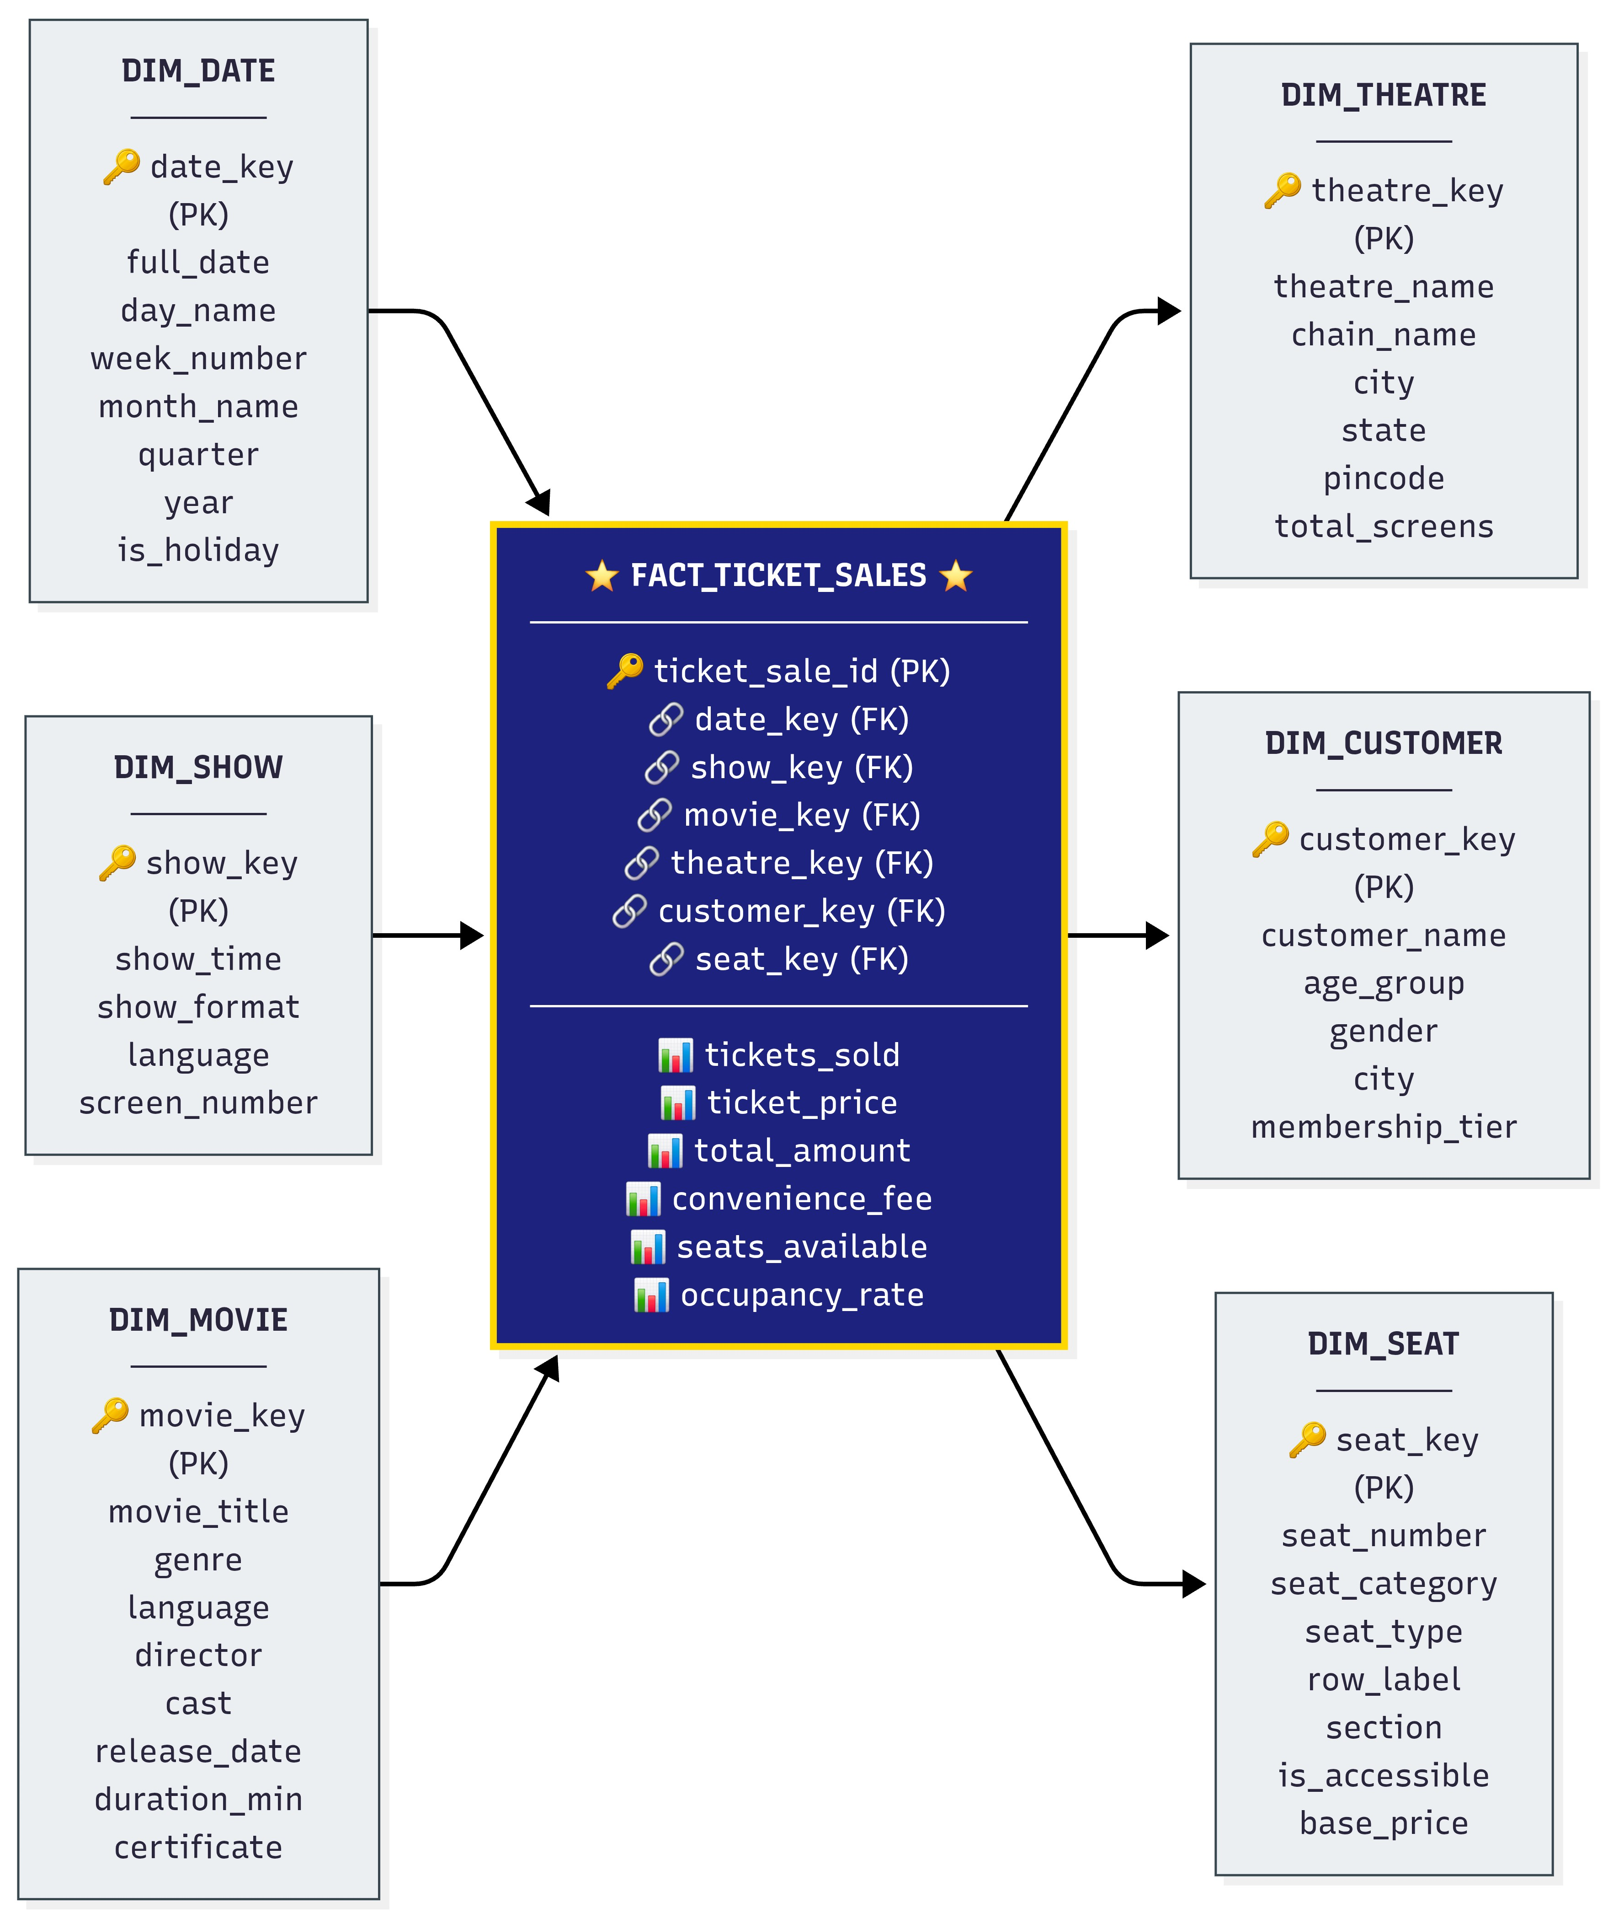

Fact Tables :
Ticket_sales

Column | Description
ticket_sale_id | Primary Key
date_key | Foreign Key
show_key | Foreign Key
theatre_key | Foreign Key
customer_key | Foreign Key
seat_key | Foreign Key
Total_Amoun t | Total sales amount

Dimension Tables
Date_Dimension

Column | Description
Date_ID | Primary Key
Date | Date of transaction
Day | Day
Month | Month
Quarter | Quarter
Year | Year

Show_Dimension

Column | Description
Show_key | Primary Key
show_time | Foreign Key
show_format | Foreign Key
language | Foreign Key
screen_number | Foreign Key

Movie_Dimension

Column | Description
movie_key | Primary Key
movie_title | Foreign Key
genre | Foreign Key
language | Foreign Key
director | Foreign Key
cast | Foreign Key
release_date | Foreign Key
duration_min | Foreign Key
certificate | Foreign Key

Theatre_Dimension

Column | Description
theatre_key | Primary Key
theatre_name | Foreign Key
chain_name | Foreign Key
city | Foreign Key
state | Foreign Key
pincode | Foreign Key
total_screens | Foreign Key

Customer_Dimension

Column | Description
customer_key | Primary key
customer_name | Foreign Key
age_group | Foreign Key
gender | Foreign Key
city | Foreign Key
membership_tier | Foreign Key

Seat_Dimension

Column | Description
seat_key | Primary key
seat_number | Foreign Key
seat_category | Foreign Key
seat_type | Foreign Key
row_label | Foreign Key
section | Foreign Key
is_accessible | Foreign Key
base_price | Foreign Key

Structure of Star schema ( Revenue )

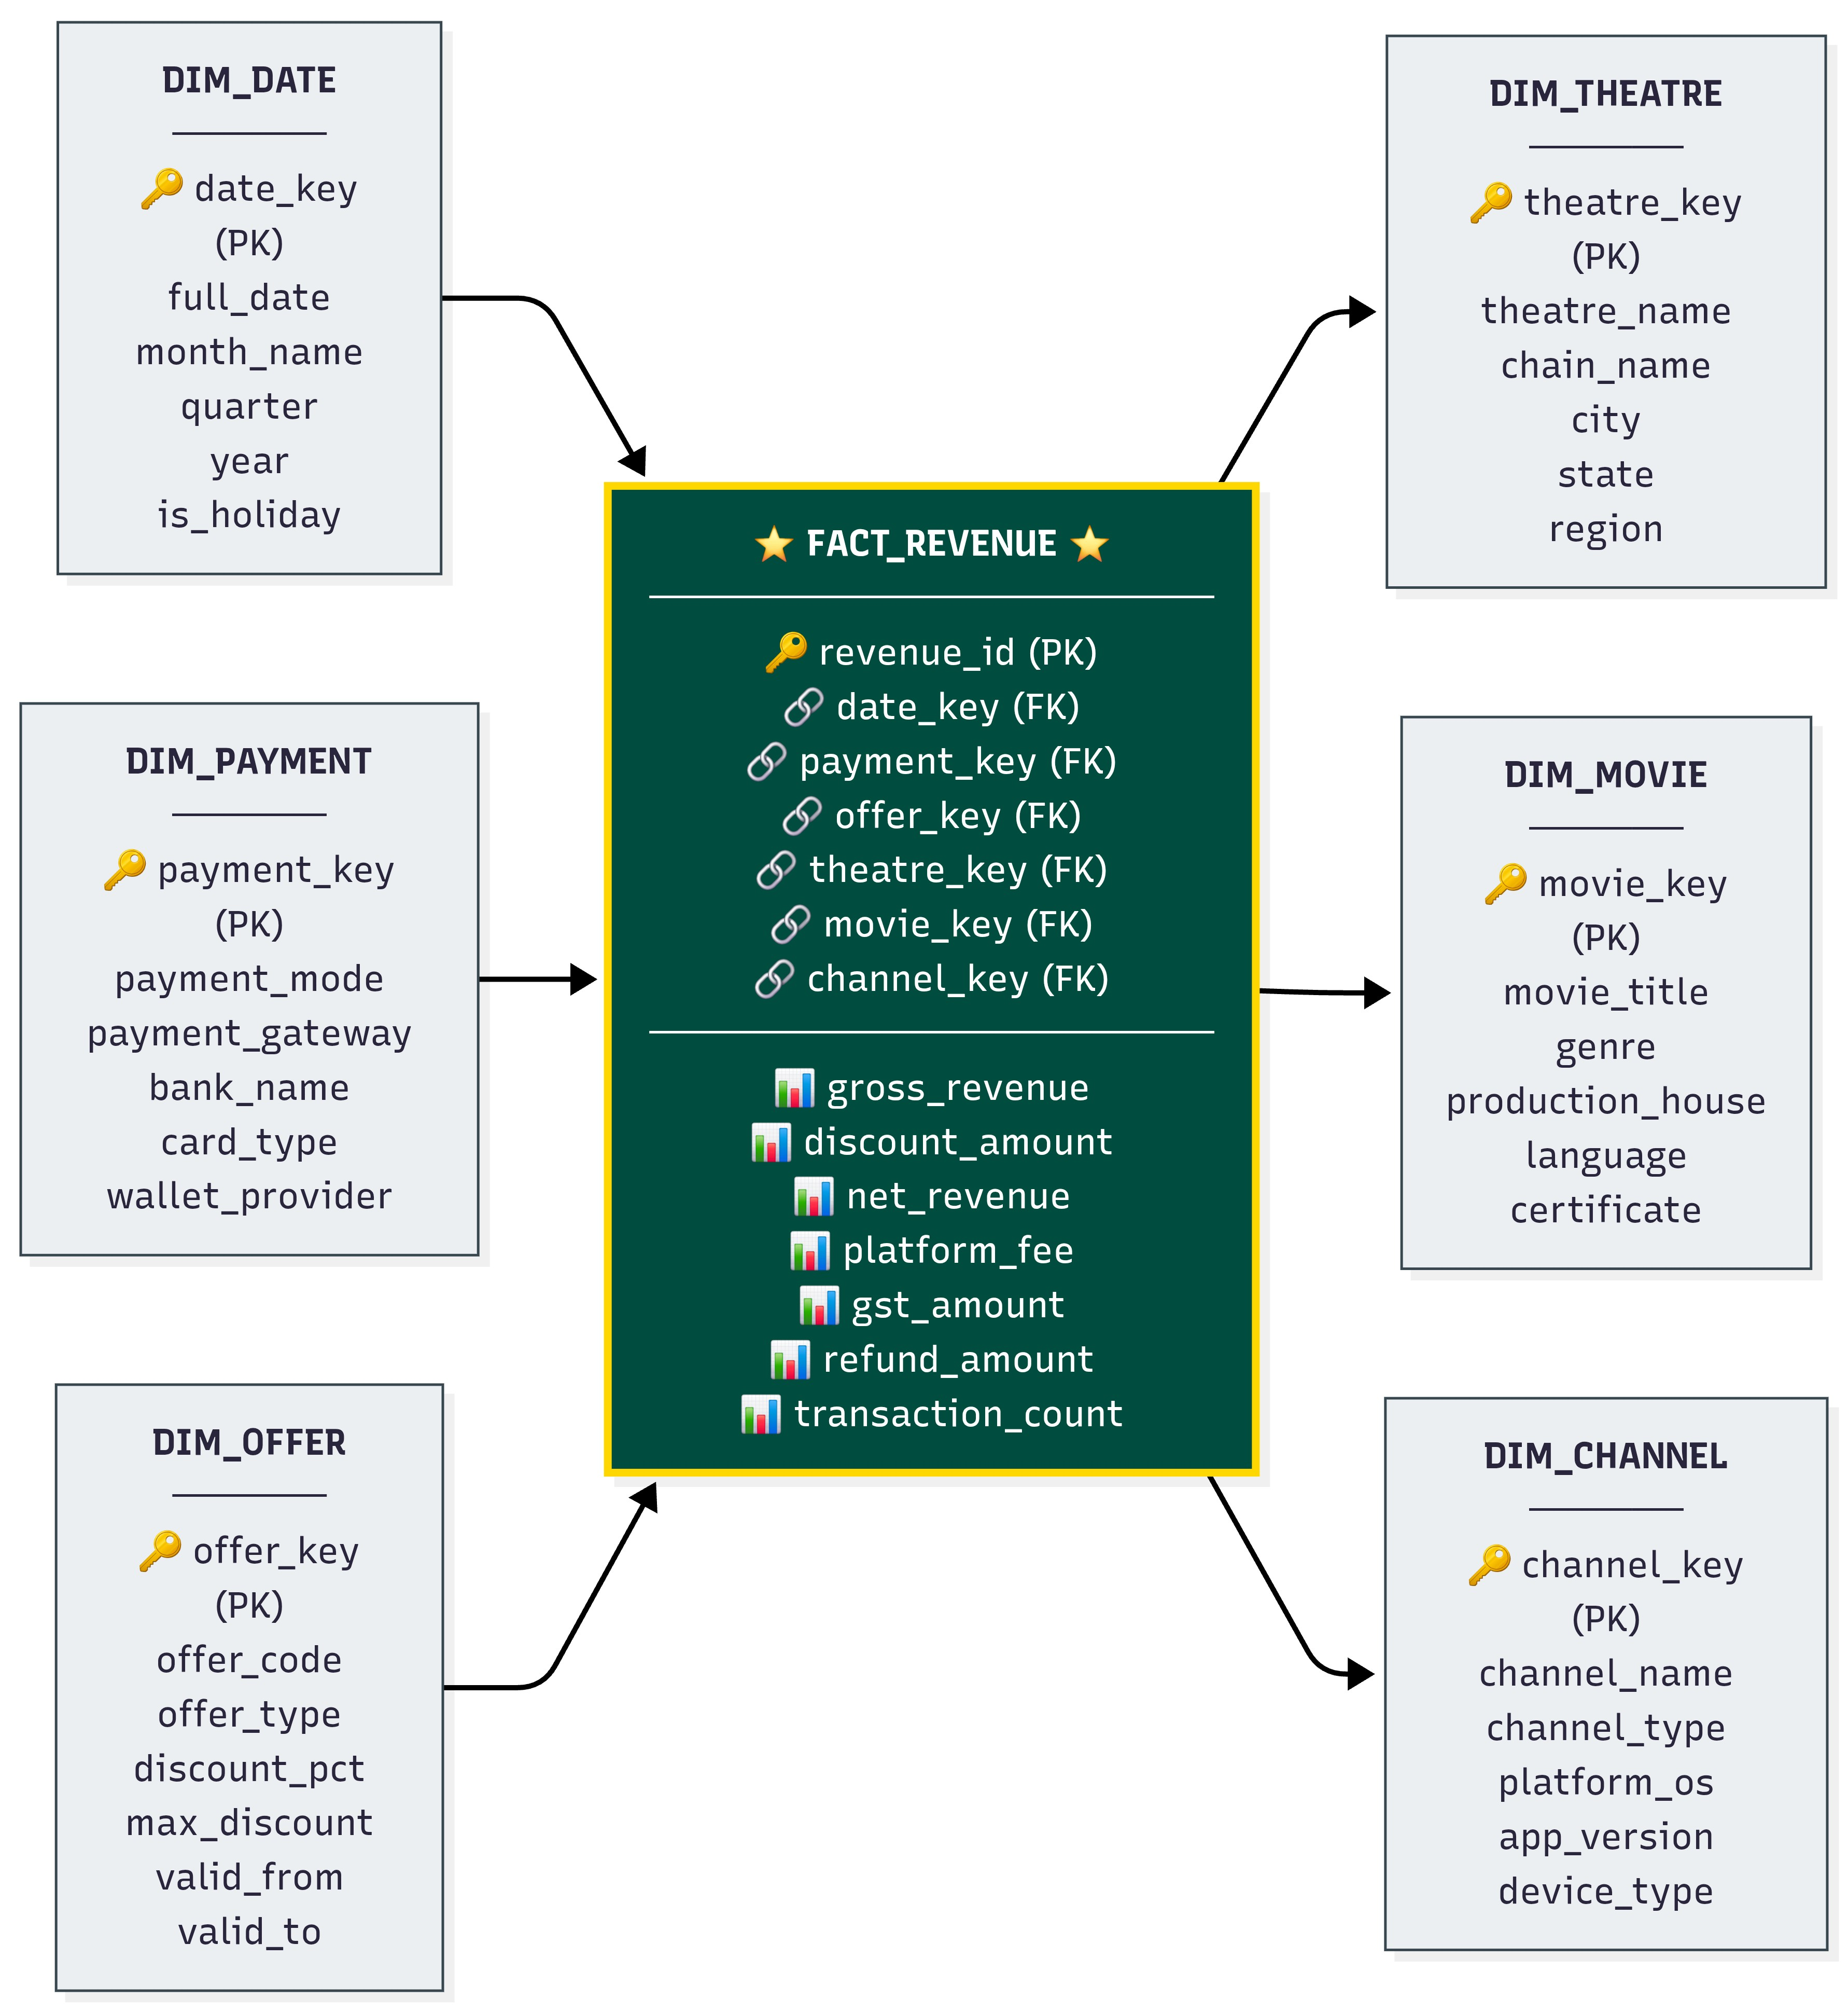

Fact table:
Revenue :

Column | Description
revenue_id | Primary Key
date_key | Foreign Key
payment_key | Foreign Key
offer_key | Foreign Key
theatre_key | Foreign Key
movie_key | Foreign Key
channel_key | Foreign Key

Dimension tables :

Date_Dimension

Column | Description
date_key | Primary Key
full_date | Foreign Key
month_name | Foreign Key
quarter | Foreign Key
year | Foreign Key
is_holiday | Foreign Key

Payment_Dimension

Column | Description
payment_key | Primary Key
payment_mode | Foreign Key
payment_gateway | Foreign Key
bank_name | Foreign Key
card_type | Foreign Key
wallet_provider | Foreign Key

Offer_Dimension

Column | Description
offer_key | Primary Key
offer_code | Foreign Key
offer_type | Foreign Key
discount_pct | Foreign Key
max_discount | Foreign Key
valid_from | Foreign Key
valid_to | Foreign Key

Theatre_Dimension

Column | Description
theatre_key | Primary Key
theatre_name | Foreign Key
chain_name | Foreign Key
city | Foreign Key
state | Foreign Key
region | Foreign Key

Movie_Dimension

Column | Description
movie_key | Primary key
movie_title | Foreign Key
genre | Foreign Key
production_house | Foreign Key
language | Foreign Key
certificate | Foreign Key

Channel_Dimension

Column | Description
channel_key | Primary Key
channel_name | Foreign Key
channel_type | Foreign Key
platform_os | Foreign Key
app_version | Foreign Key
device_type | Foreign Key

2 . Snowflake Schema

A Snowflake Schema is a data warehouse schema design where dimension tables are normalized into smaller, separate sub-dimension tables. It extends the Star Schema structure to reduce data redundancy and save storage space by organizing attributes into hierarchical relationships.

Structure:

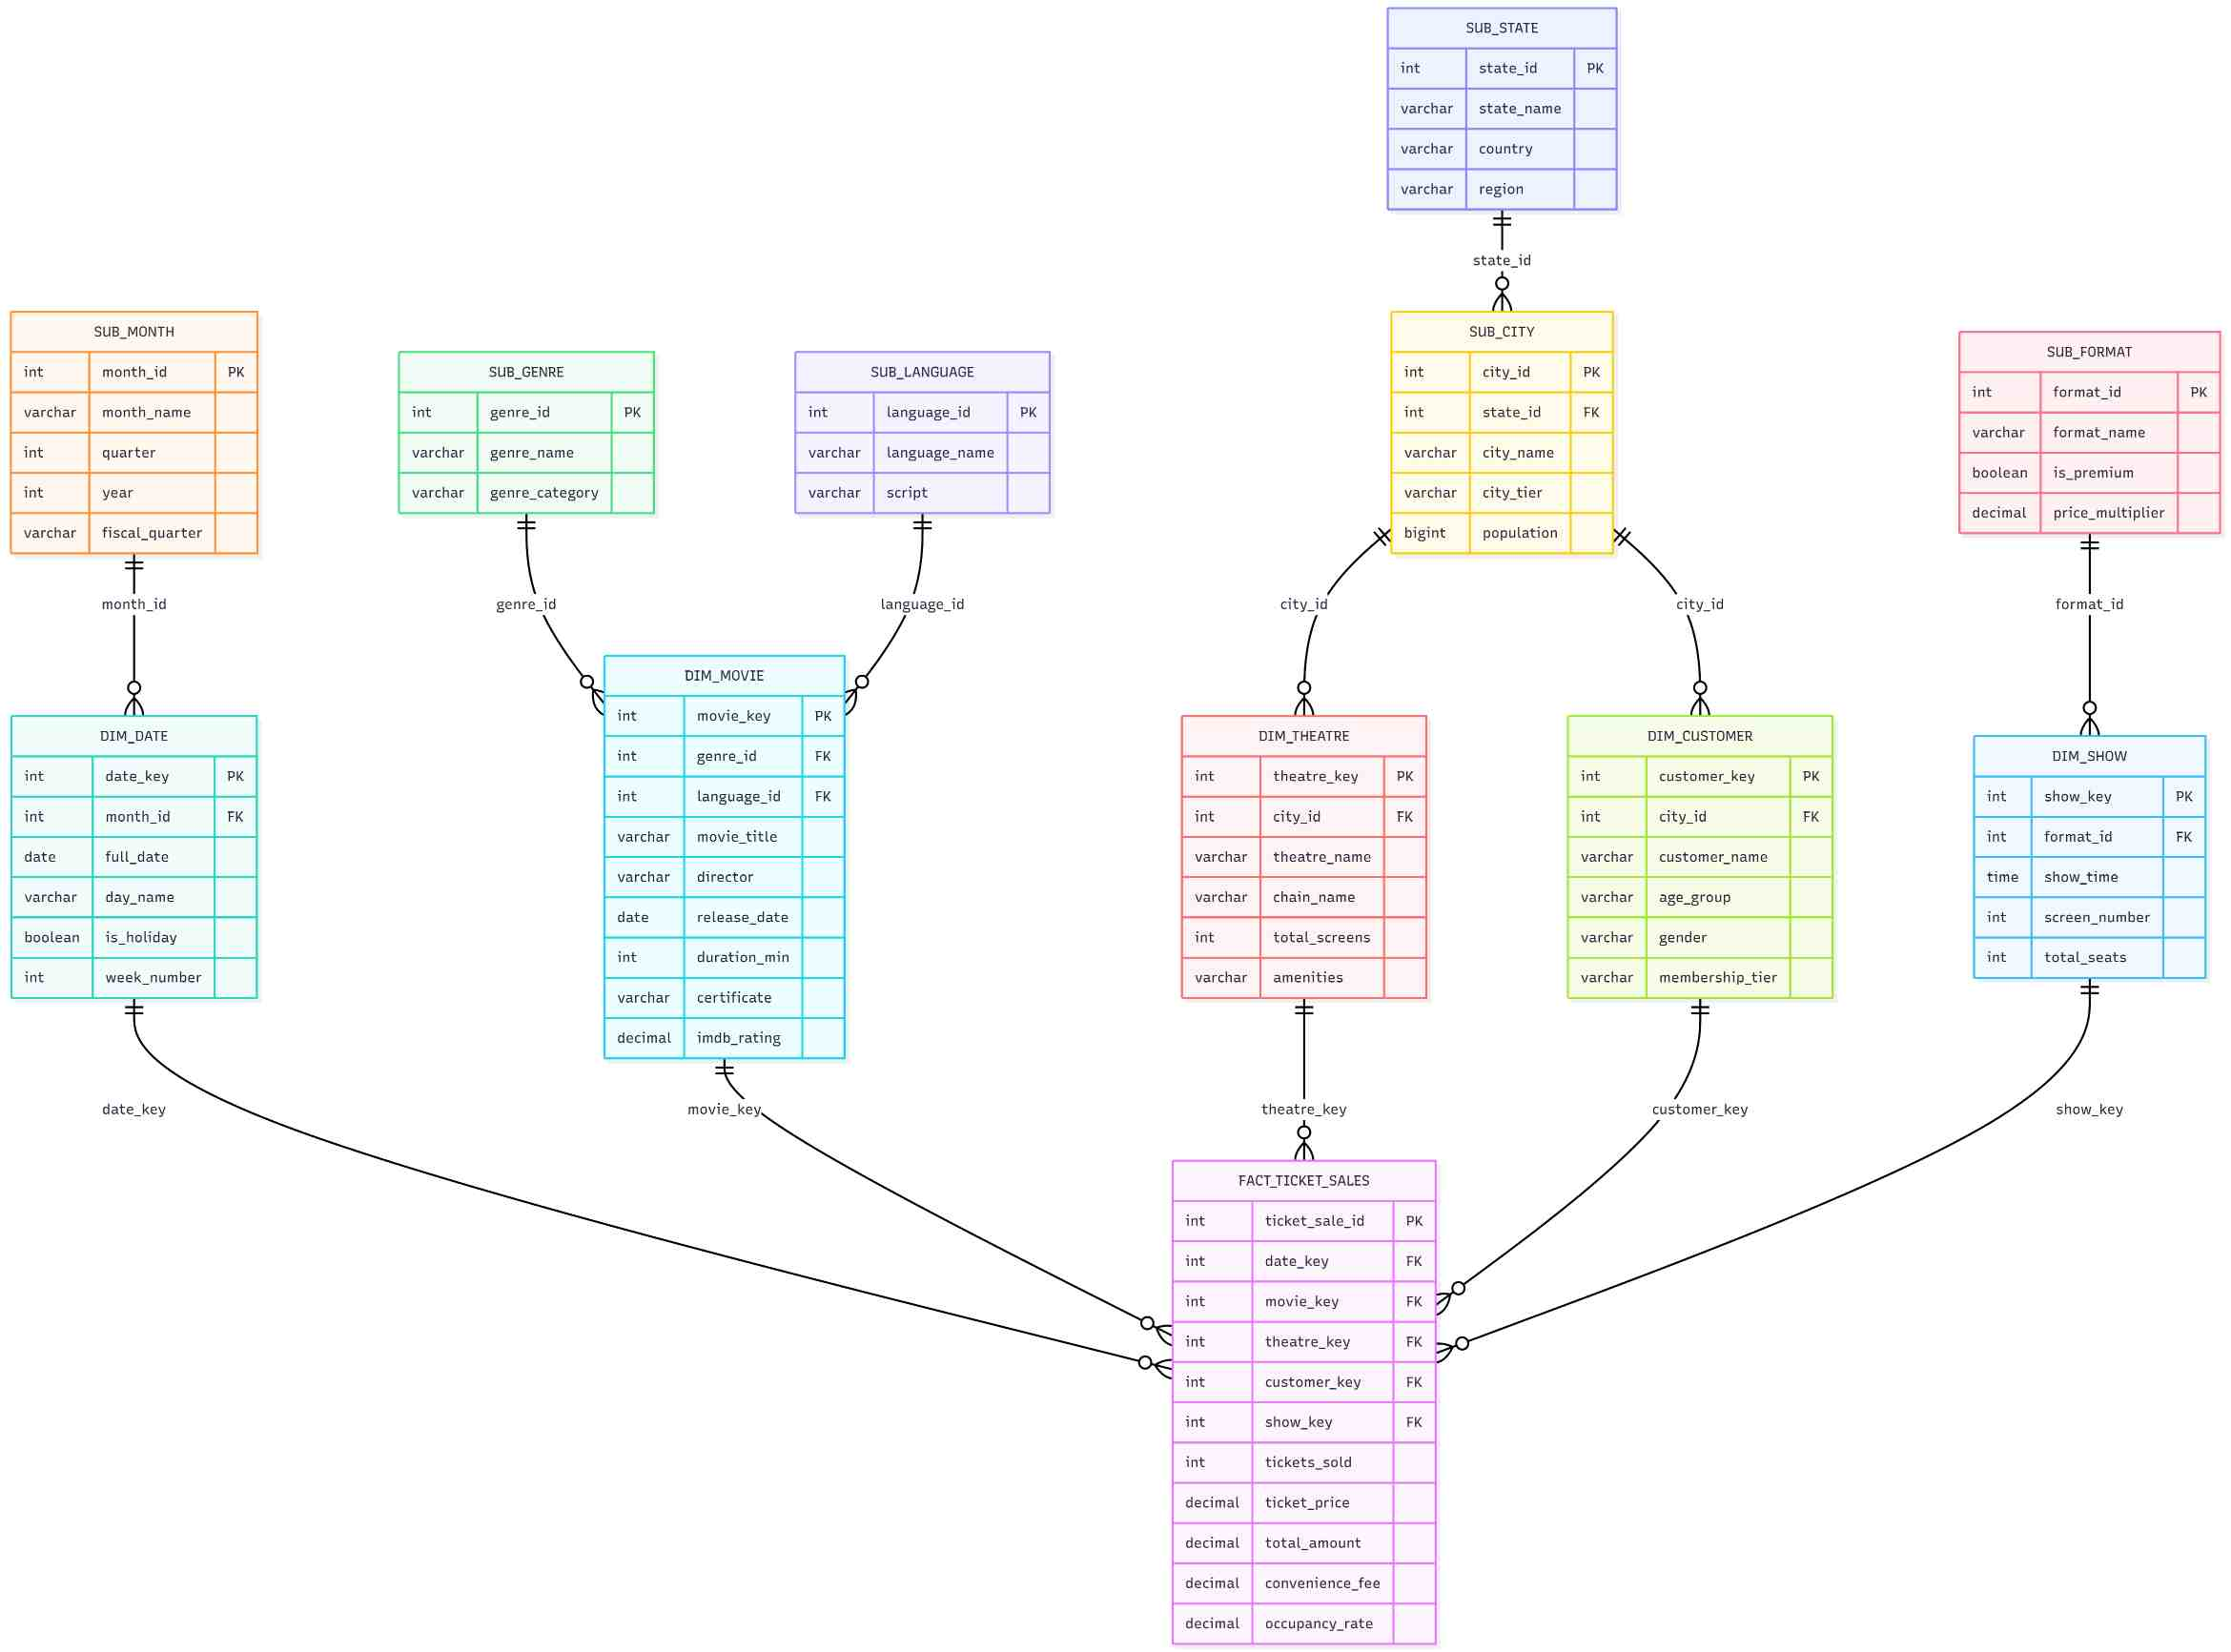

Main Difference :

Star schema uses a central fact table directly linked to fully denormalized dimension tables, forming a star-like shape. All dimensional data is stored in a single table, which means fewer joins and faster query performance, but at the cost of data redundancy and higher storage usage.

Snowflake schema is an extension of the star schema where dimension tables are further normalized into sub-dimension tables. For example, instead of storing city, state, and country in a single Dim_Location table, each gets its own table linked hierarchically. This reduces redundancy and saves storage, but requires more joins, making queries more complex and relatively slower.

Result :

Thus, the Star Schema and Snowflake Schema for the Movie Ticket booking system were successfully designed by identifying the Sales & Revenue Fact Table and corresponding Dimension Tables.

============================================================
GitHub Repository Link:
https://github.com/Sentry2311/DMBI_EXPERIMENTS/tree/main/Experiment_01_Star_and_Snowflake_Schema
(Contains complete documentation, dataset, and program code for Experiment 1: Star and Snowflake Schema)

