Name: Bhavesh Punjabi
Class: D15A
Roll. No: 40

Experiment 03: Exploratory Data Analysis and Visualization
Aim:
To perform exploratory data analysis (EDA) and data visualization on the movie ticket booking system using Python.
Theory:
Dataset Overview:
The dataset used in this study represents a Movie Ticket Booking System. It contains information about customer bookings and movie-related transactions. The dataset includes attributes such as Booking_ID, Movie, City, Tickets, Ticket_Price, Total_Amount, and Booking_Rating. Exploratory Data Analysis (EDA) is performed on the raw dataset to understand its characteristics, distributions, relationships, and patterns before applying further analysis or predictive techniques.
Significance of EDA for movie ticket booking :
EDA is an important step in data analysis because it helps understand the quality and behavior of the movie ticket booking data.

1. Data Cleaning and Quality Check
EDA helps identify missing values, inconsistent data and unusual observations in the booking dataset. For example, unusually high booking amounts or ticket quantities can be detected during analysis.

2. Understanding Data Distribution
Statistical measures and visualizations help understand how variables such as ticket price, number of tickets and total booking amount are distributed. This can help identify whether the data contains skewness or unusual values.

3. Identifying Important Features
EDA helps identify attributes that are useful for understanding customer booking behavior. For example, Movie, City, Tickets, Ticket_Price, and Total_Amount can provide important information about booking patterns.

4. Detecting Relationships and Patterns

Correlation analysis helps identify relationships between numerical attributes. For example, the number of tickets booked is expected to have a positive relationship with the total booking amount.

5. Improving Decision Making
EDA provides useful insights into popular movies, booking quantities, ticket prices and customer spending patterns. These insights can help a movie ticket booking system improve its services and understand customer preferences.

1. Descriptive Analysis - Statistical Measures of Central Tendency
Measures of central tendency describe the center or typical value of a dataset. The main measures are:
- Mean: Represents the average value of a numerical attribute, such as the average number of tickets booked.
- Median: Represents the middle value when the observations are arranged in order. It is less affected by extreme values.
- Mode: Represents the most frequently occurring value. It can be useful for identifying the most common ticket price or booking quantity.

2. Descriptive Analysis - Statistical Measures of Dispersion
Measures of dispersion describe how widely the values are spread around the center of the
dataset.
The main measures include:
- Standard Deviation: Shows how much the values differ from the mean.
- Variance: Measures the spread of data and is the square of standard deviation.
- Range: Represents the difference between the maximum and minimum values.
- Interquartile Range (IQR): Represents the range of the middle 50% of observations and can be useful for detecting outliers.

3. Correlation Between Attributes
Correlation measures the strength and direction of the relationship between numerical variables. The Pearson correlation coefficient ranges from -1 to +1.
For example:
- A positive correlation between Tickets and Total_Amount indicates that customers booking more tickets generally have a higher total booking amount.
- The relationship between Ticket_Price and Total_Amount can also be studied to understand their effect on total spending.
- Weak correlation between two attributes indicates that they have a limited linear relationship.
Correlation analysis helps identify important relationships and patterns within the movie ticket booking data.

4. Different Visualization Techniques & Their Uses
Visualization makes it easier to understand patterns, distributions and relationships in the dataset.
- Histogram: Shows the distribution of numerical data such as ticket prices.
- Boxplot: Shows the spread of data and helps identify possible outliers in total booking amounts.
- Heatmap: Displays the correlation between numerical attributes using different intensity levels.
- Scatter Plot: Shows the relationship between two numerical variables, such as the number of tickets and total booking amount.
- Bar Chart: Compares categorical data, such as the number of bookings for different movies or cities.

Code:
Step 1: Loading the Dataset and Initial Exploration Output:
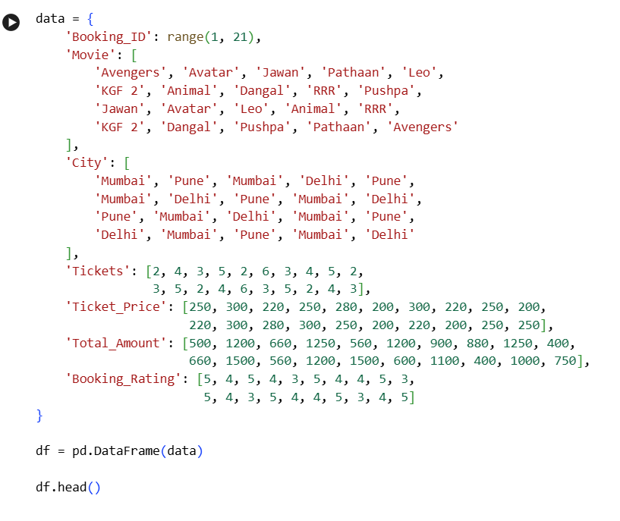
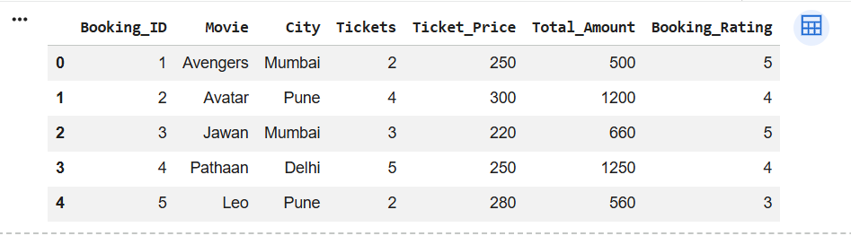
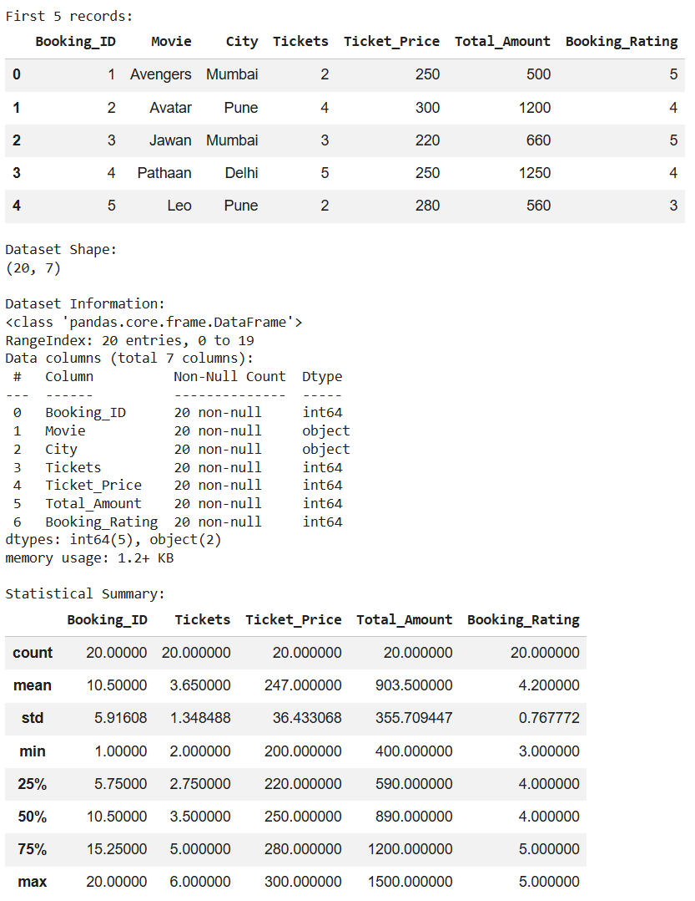
Step 2: Task 1 - Descriptive Analysis - Statistical Measures of Central Tendency
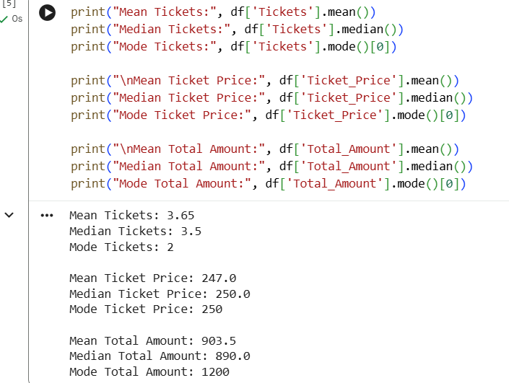
Inferences:
- The mean represents the average number of tickets booked, ticket price and total booking amount.
- The median represents the middle value and is less affected by unusually large bookings.
- The mode identifies the most frequently occurring ticket quantity and ticket price.
- These measures help identify the typical booking behavior of customers.

Step 3: Task 2 - Descriptive Analysis - Statistical Measures of Dispersion
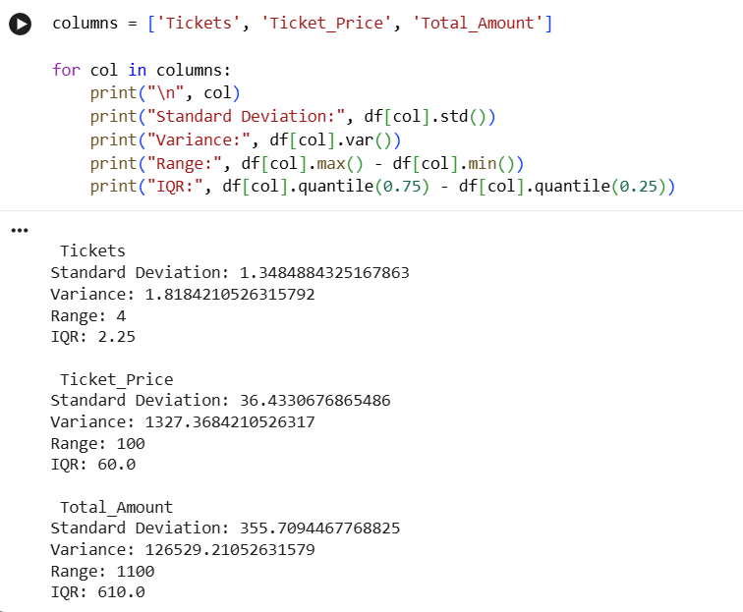

Inferences:
- Standard deviation shows the variation in the number of tickets, ticket price and total booking amount.
- Variance provides another measure of how widely the booking values are distributed.
- Range shows the difference between the highest and lowest booking values.
- IQR helps understand the spread of the middle 50% of bookings and identify possible outliers.

Step 4: Task 3 - Correlation Between Attributes 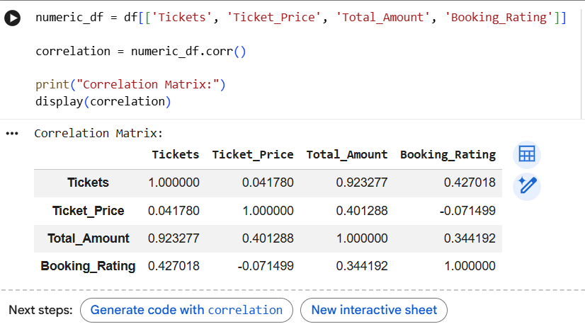
Inferences:
- Tickets and Total_Amount are expected to have a strong positive relationship because booking more tickets generally increases the total amount.
- Ticket_Price and Total_Amount can also show a positive relationship.
- Correlation between Booking_Rating and other numerical attributes can help determine whether customer ratings vary with booking behavior.
- Weak correlations indicate that the corresponding attributes have limited linear relationships.
Step 5 : Histogram
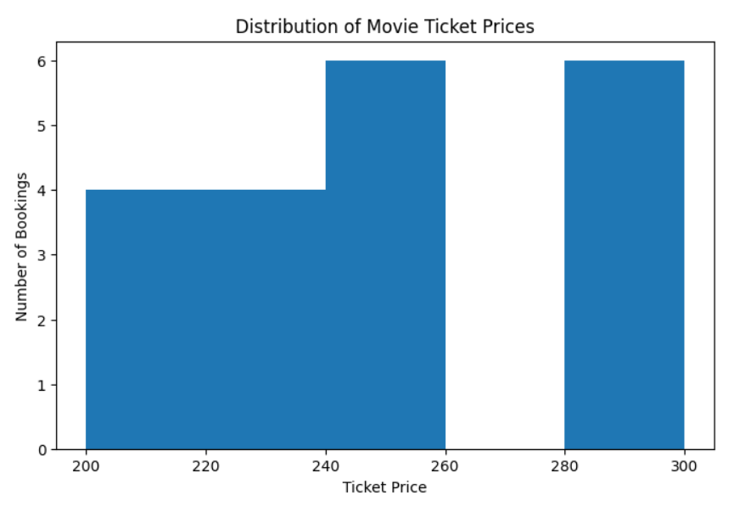
Inferences:
- The histogram shows the distribution of ticket prices in the dataset.
- It helps identify the most common ticket-price range.
- It also makes it easier to observe whether ticket prices are evenly distributed or concentrated around certain values.

Step 6: Boxplot
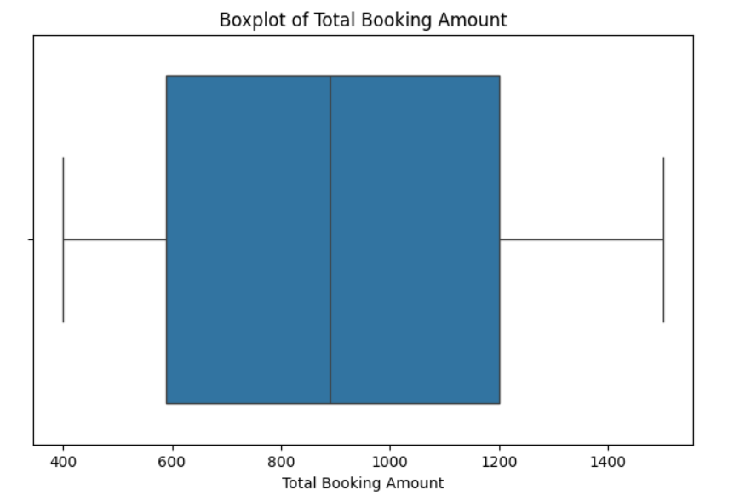
Inference:
- The boxplot shows the spread of Total_Amount values.
- It helps identify the median and variation in booking amounts.
- Any values appearing far from the main distribution may indicate unusually large or small bookings.

Step 7 : scatter plot
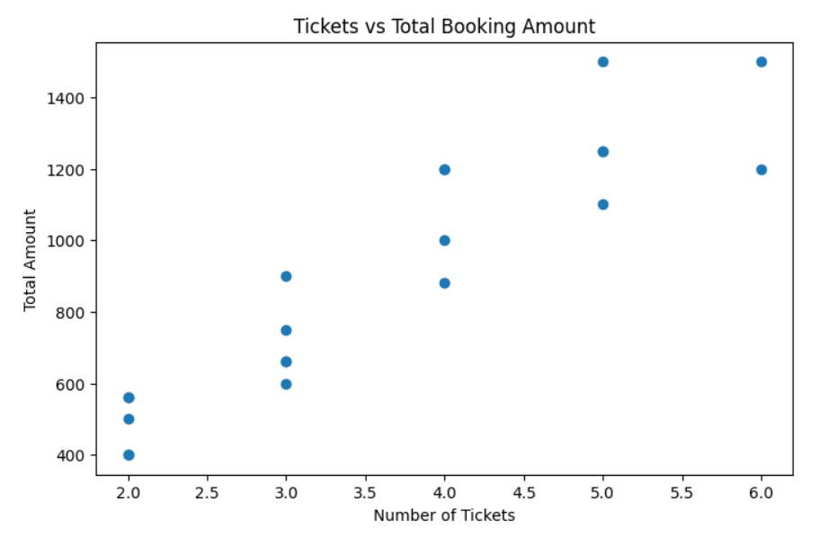
Inferences :
- The scatter plot shows the relationship between Tickets and Total_Amount.
- A positive upward trend indicates that customers booking more tickets generally have higher total booking amounts.
- The plot also helps identify unusual booking combinations.

Step 8 : Heatmap
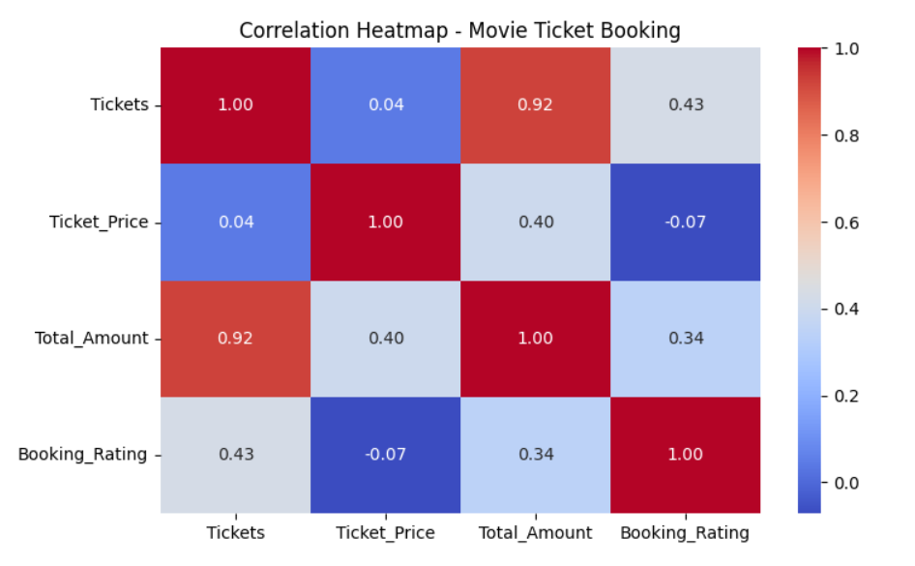
Step 9: Movie & City wise booking analysis
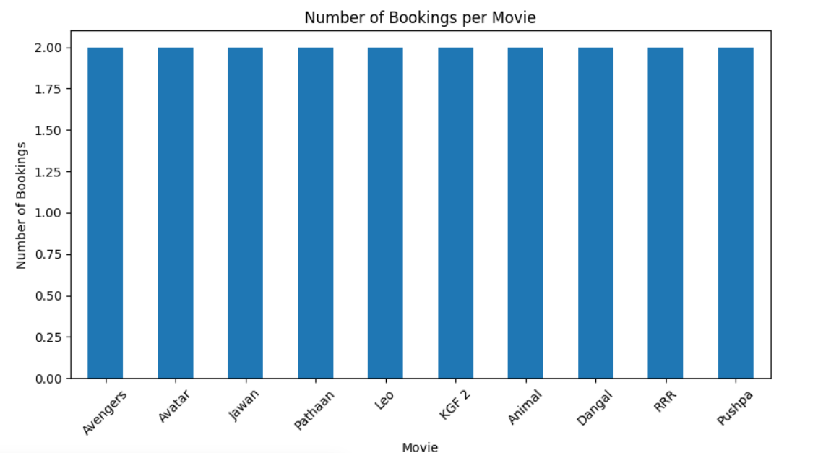

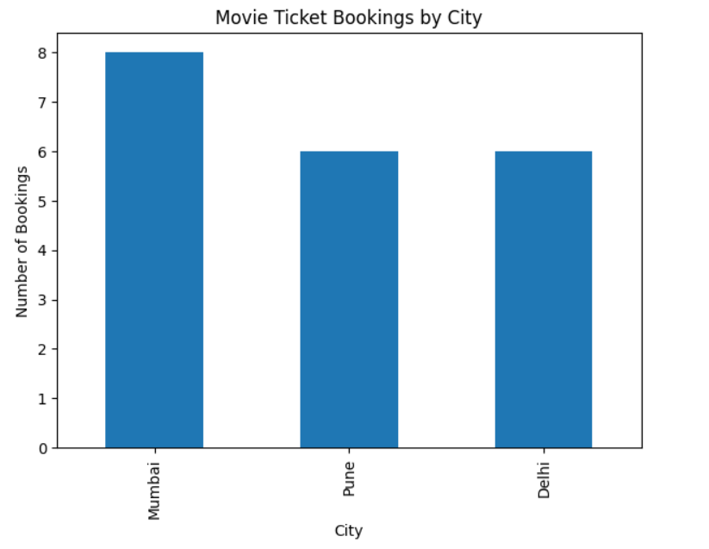
Conclusion:
The exploratory data analysis of the Movie Ticket Booking dataset provided useful insights into customer booking behavior. Descriptive statistics helped understand the typical number of tickets, ticket prices and total booking amounts. Dispersion measures showed the variation in customer spending. Correlation analysis identified the relationship between the number of tickets and total booking amount. Histograms, boxplots, scatter plots, heatmaps and bar charts helped visualize ticket prices, booking amounts, relationships and movie popularity. Overall, EDA helps the movie ticket booking system understand customer preferences, popular movies and booking patterns, which can support better decision-making and service improvement.
============================================================
GitHub Repository Link:
https://github.com/Sentry2311/DMBI_EXPERIMENTS/tree/main/Experiment_03_Exploratory_Data_Analysis_Visualization
(Contains complete documentation, dataset, and program code for Experiment 3: Exploratory Data Analysis and Visualization)

