Name: Bhavesh Punjabi
Class: D15A
Roll: 40

Experiment -7 (K-Means Clustering Using RapidMiner)

Aim
To prepare a RapidMiner workflow that clusters the UCI Seeds records into three groups using all seven numeric kernel measurements, after replacing missing values and applying Z-score normalization.

Theory
Clustering: Clustering is an unsupervised learning method that groups records by similarity without using known variety labels to assign groups.
K-Means: K-Means assigns each record to the nearest centroid, recalculates each centroid from its assigned records, and repeats until the assignments stabilize. The parameter k sets the number of groups.
Seeds dataset: The UCI dataset has 210 wheat kernel records and seven numeric measurements: area, perimeter, compactness, kernel length, kernel width, asymmetry coefficient, and kernel groove length. The variety label is excluded from the clustering inputs. Source: UCI Machine Learning Repository, DOI 10.24432/C5H30K, CC BY 4.0.
Preprocessing: Replacing missing numeric values with the attribute average allows distance calculations to proceed when values are absent. Z-score normalization centers each feature and scales it by its standard deviation, so differences in units do not dominate Euclidean distance.

Tools Required
Altair AI Studio (RapidMiner), UCI Seeds dataset, Select Attributes, Replace Missing Values, Normalize, K-Means, and the cluster model and scatter plot visualizers.

RapidMiner Procedure
1. Start a blank process in Altair AI Studio. Import the supplied Seeds CSV with the seven numeric measurement columns. Confirm that it contains 210 rows and numeric attributes.
2. Add Select Attributes and retain all seven measurement columns. Do not include a variety/class column as an input; the task is unsupervised clustering.
3. Add Replace Missing Values after Select Attributes. Select all numeric attributes and set the replacement to average. The UCI file used here has no missing values, so this step should leave its values unchanged.
4. Add Normalize after Replace Missing Values and apply it to all seven numeric features. The resulting centroid table is in standardized units.
5. Add K-Means after Normalize. Set k to 3, keep Add cluster attribute enabled, set max runs to 10, and keep Determine good start values enabled.
6. Connect the K-Means model and clustered ExampleSet outputs to the process result ports, then click Run.
7. Open the cluster model result. Record the member count for each cluster and inspect the centroid values. To describe means in original units, compare with the unnormalized input or calculate group means from the clustered records.
8. In the ExampleSet visualization, create a scatter plot with area on the x-axis and perimeter on the y-axis. The plot shows their positive relationship. The captured AI Studio color selector did not offer the cluster assignment, so the screenshot is a feature scatter plot without cluster colors.

Process Flow
Read CSV → Select Attributes → Replace Missing Values → Normalize → K-Means (k = 3) → Cluster Model and Scatter Plot

RapidMiner Execution Evidence
This process was assembled and executed in Altair AI Studio. It retrieves the imported Seeds data, selects all seven measurements, replaces missing values with the average, normalizes the attributes, and applies K-Means with k = 3.
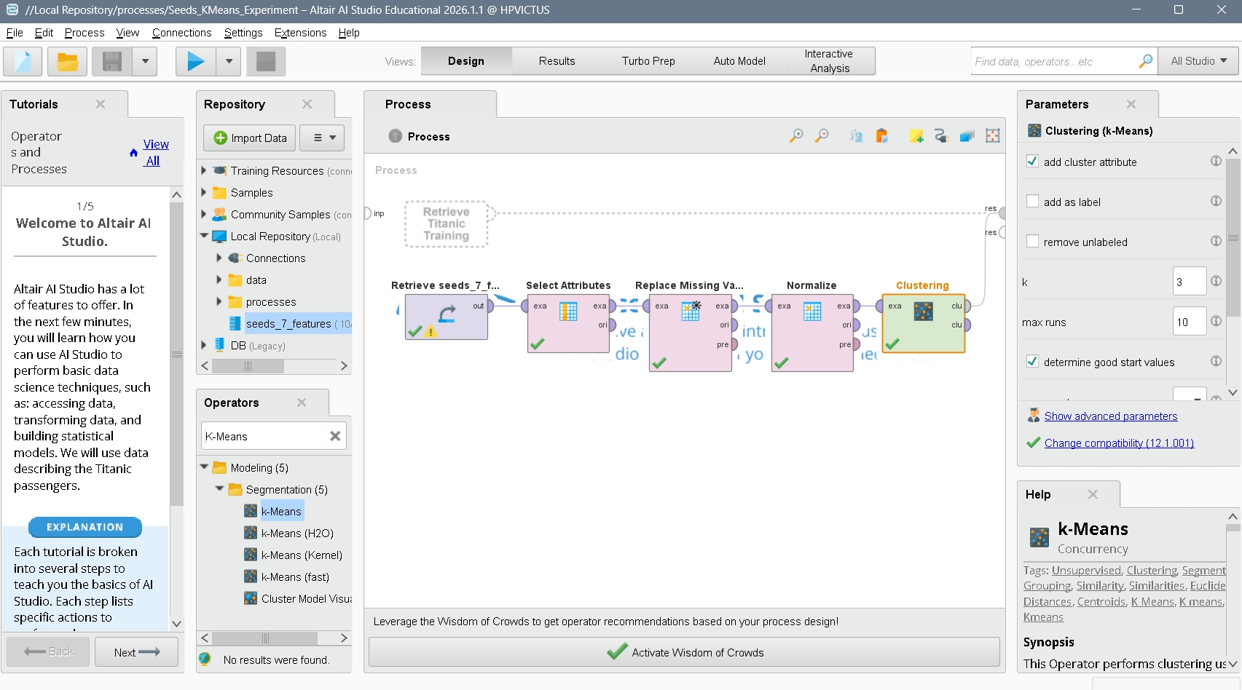
Figure 1. Completed Altair AI Studio process with the K-Means parameters set to k = 3.

Cluster Model Output
The executed RapidMiner model contains all 210 records. It assigned 70 records to Cluster 0, 75 to Cluster 1, and 65 to Cluster 2. These are the counts shown in the AI Studio Cluster Model result.
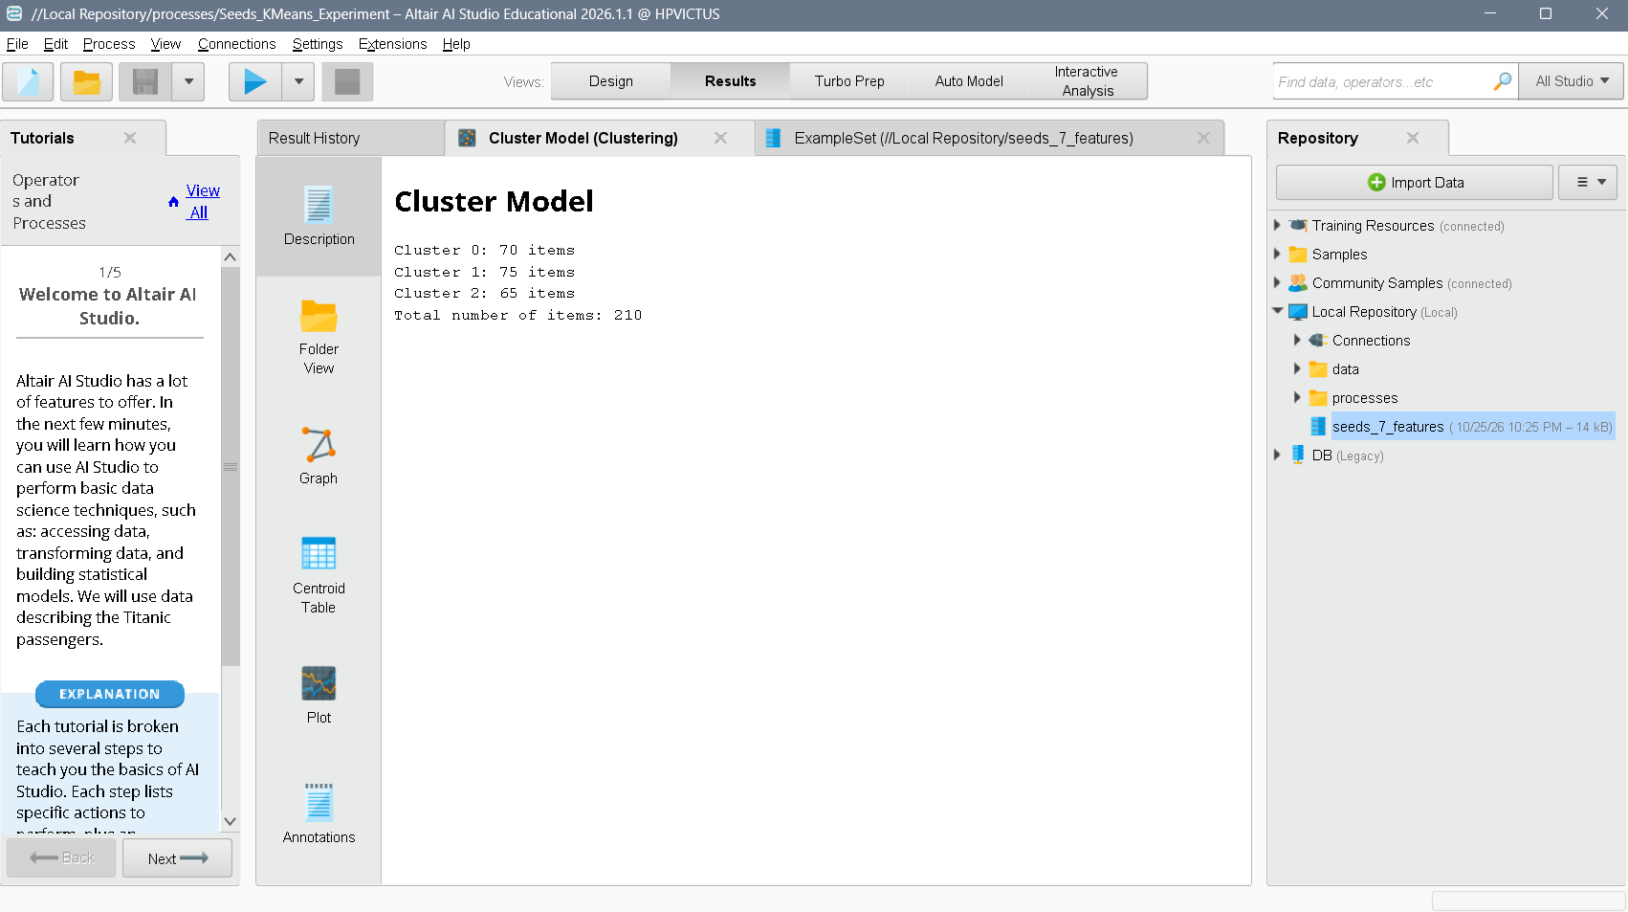
Figure 2. RapidMiner Cluster Model result showing cluster sizes.

Scatter Plot and Centroids
The elbow analysis used in the Python implementation indicated k = 3. The RapidMiner run used this value for its K-Means parameter. The centroid table below displays the seven feature centers in normalized units; values above or below zero indicate measurements above or below the dataset mean after standardization.
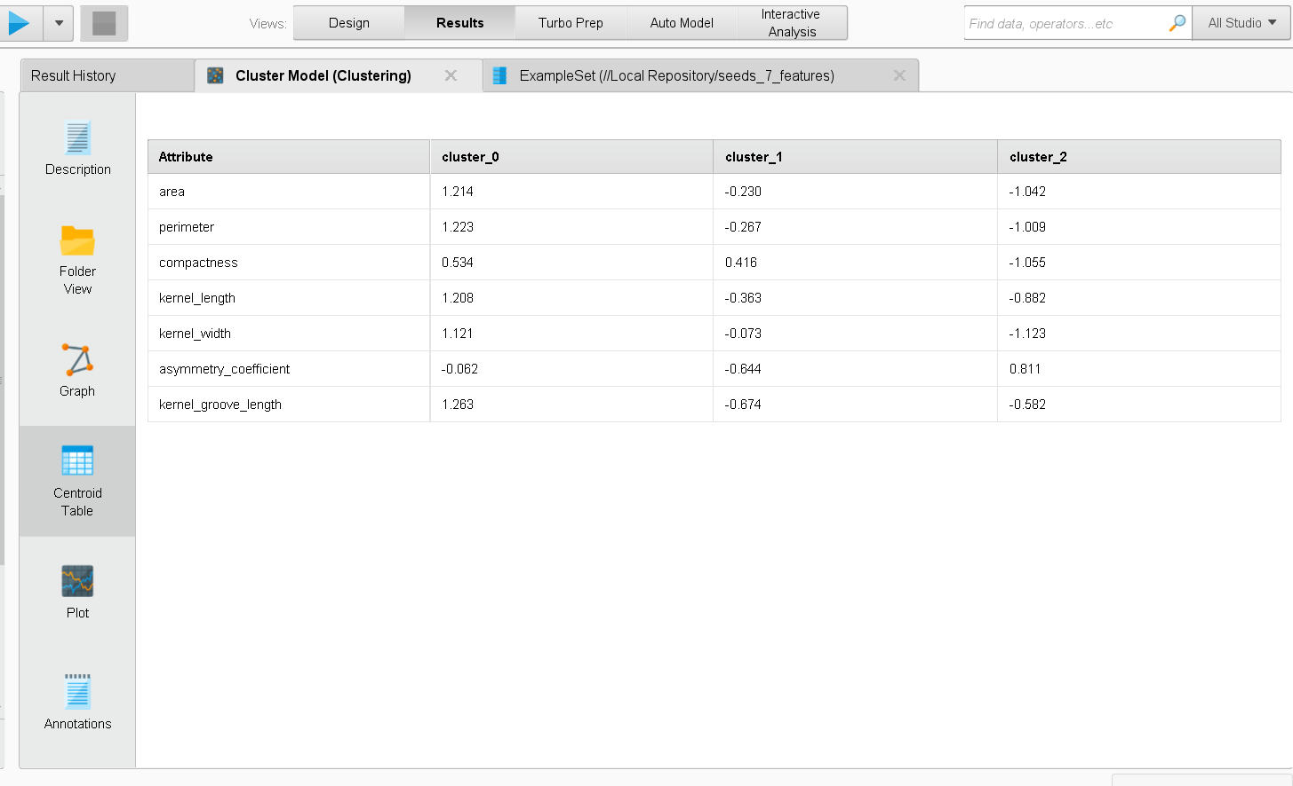
Figure 3. RapidMiner centroid table for the three clusters.
Area and perimeter show a positive relationship in the RapidMiner scatter plot. K-Means used all seven standardized measurements; the two-dimensional plot is only a visual projection of the clustering input space.
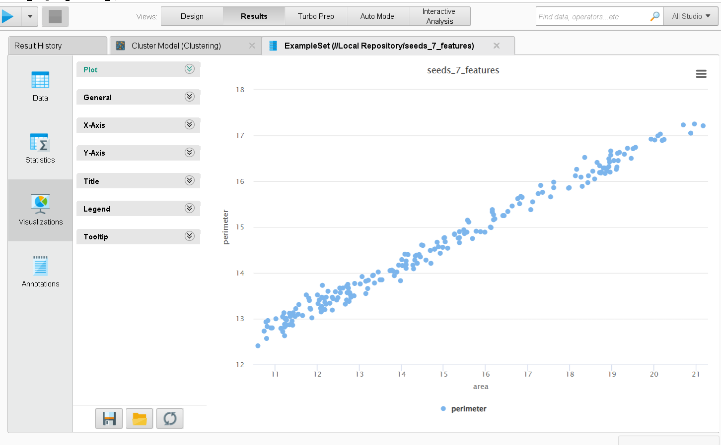
Figure 4. RapidMiner scatter plot of area versus perimeter.

Details About Clusters
Cluster | Records | Count share
Cluster 0 | 70 | 33.3%
Cluster 1 | 75 | 35.7%
Cluster 2 | 65 | 31.0%
Total | 210 | 100%
The centroid table uses normalized feature values, not the Seeds dataset's original measurement units. It supports comparing each cluster with the overall standardized mean of zero. The scatter plot shows that kernels with larger area tend to have larger perimeter.

Comparison of RapidMiner and Python
Feature | RapidMiner | Python
Workflow | Visual operators and parameter panels | Code-based pipeline
Ease of use | Accessible for GUI workflows | Requires programming familiarity
Customization | Standard operators and settings | Flexible algorithms and preprocessing
Visualization | Built-in model and data views | Custom charts with plotting libraries
Validation | Cluster summaries and metric operators | Metrics can be calculated directly
Reproducibility | Save process and operator settings | Save code, package versions, and seed

Inference

Result

Conclusion

============================================================
GitHub Repository Link:
https://github.com/Sentry2311/DMBI_EXPERIMENTS/tree/main/Experiment_07_KMeans_Clustering_RapidMiner
(Contains complete documentation, dataset, and program code for Experiment 7: K-Means Clustering Using RapidMiner)

