Experiment 8
Association Mining for Movie Ticket Bookings
This experiment applies the Apriori algorithm to booking baskets in a movie ticket system. It shows how recurring combinations of movie, show time, seat type, payment method, and refreshments can be measured with support, confidence, and lift. The notebook creates a reproducible demonstration dataset and runs in Google Colab.
Platform | Google Colab (Python 3)
Algorithm | Apriori association rule mining
Dataset | 120 reproducible synthetic bookings
Thresholds | Minimum support 10%; confidence 40%; lift at least 1.0

Aim
To prepare booking data as transaction baskets, identify frequent itemsets with Apriori, generate positive association rules, and interpret the strongest booking pattern.

Learning outcomes
- Represent each booking as a set of items suitable for association mining.
- Calculate support, confidence, and lift for candidate rules.
- Use discovered patterns to suggest practical show or snack promotions.

Theory
Association rule mining finds items that appear together across transactions. An item can be a categorical value such as Movie=Sky Warriors or Snack=Popcorn. A rule A → B means that transactions containing A also tend to contain B.
Support: Fraction of all bookings that contain both the antecedent and consequent.
Confidence: Fraction of bookings containing the antecedent that also contain the consequent.
Lift: Confidence divided by the support of the consequent. Lift above 1 indicates that the items co-occur more often than expected if they were independent.
Support(A → B) = Support(A ∪ B) | Confidence = Support(A ∪ B) / Support(A) | Lift = Confidence / Support(B)

Dataset and preparation
The notebook generates 120 synthetic bookings with a fixed random seed. Each record contains a booking ID, movie, show slot, seat class, payment method, and two snack indicators. Booking IDs are identifiers and are excluded from the baskets. Movie, show, seat, and payment values become categorical items; popcorn and drink become items only when selected.
The patterns are deliberately generated with varied preferences so the example can demonstrate association mining. They are not observations about a real cinema, real customers, or actual sales.

Procedure
- Import Python libraries and generate the booking records.
- Check missing values, duplicate booking IDs, and attribute counts.
- Convert each booking into a basket and encode item presence as a binary transaction matrix.
- Run Apriori with minimum support of 10%, pruning candidate itemsets whose subsets are not frequent.
- Generate rules with confidence of at least 40% and lift of at least 1.0; rank them by confidence, lift, and support.

Colab notebook code and output captures
The following captures show every executed code cell and its printed output. The companion notebook contains the same runnable code.

Cell 1. Import libraries used by the analysis.
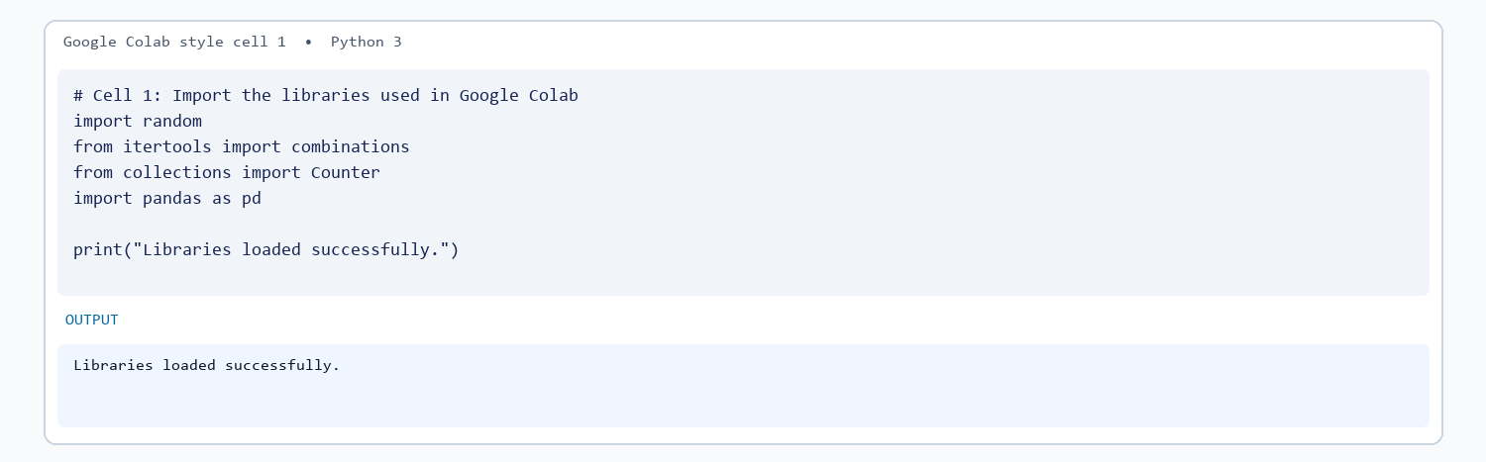

Cell 2. Generate the reproducible booking data.
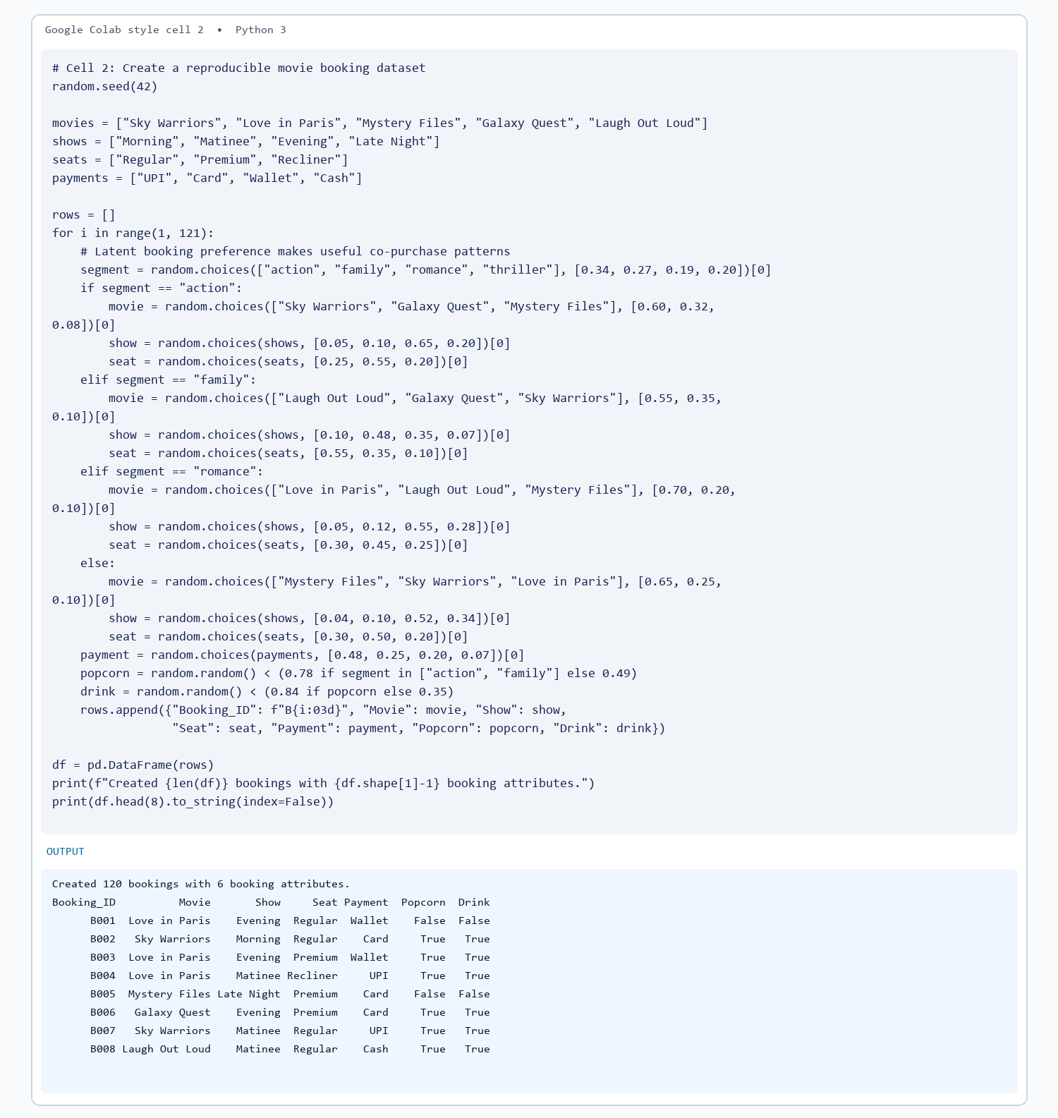

Cell 3. Validate records and summarize booking attributes.
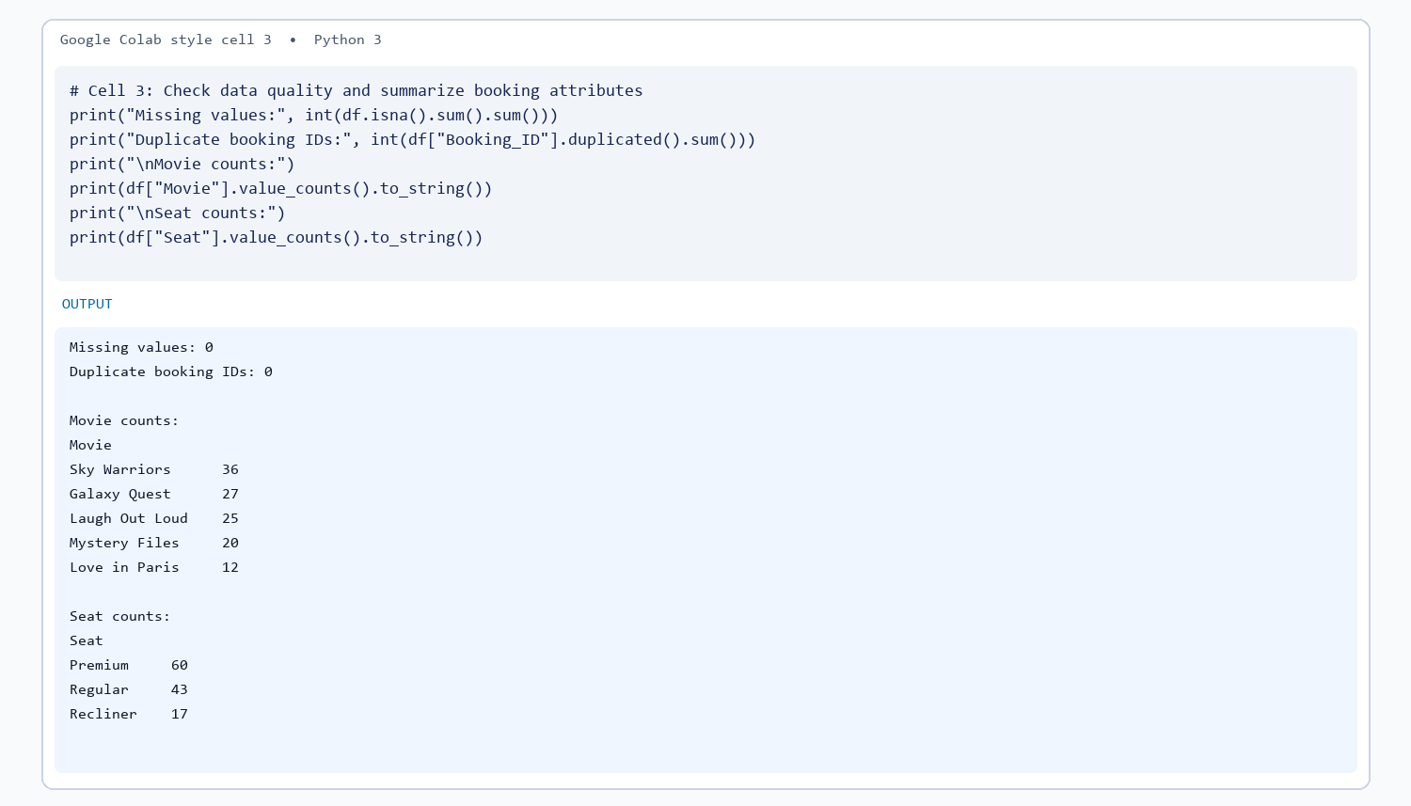

Cell 4. Convert bookings into transaction baskets.
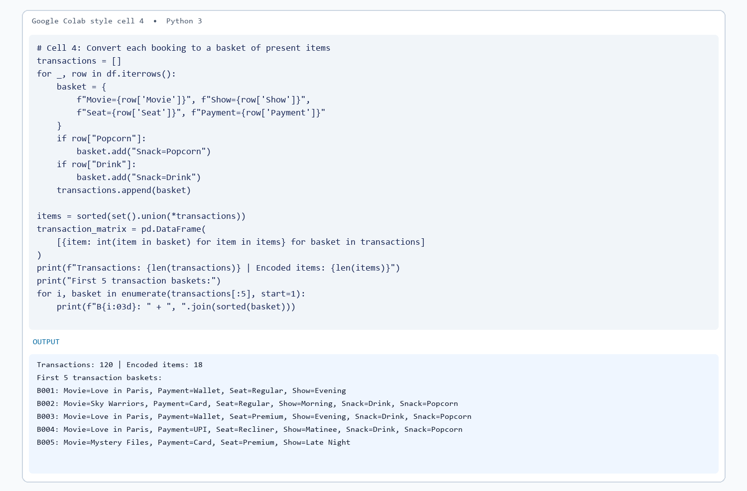

Cell 5. Find frequent itemsets with Apriori.
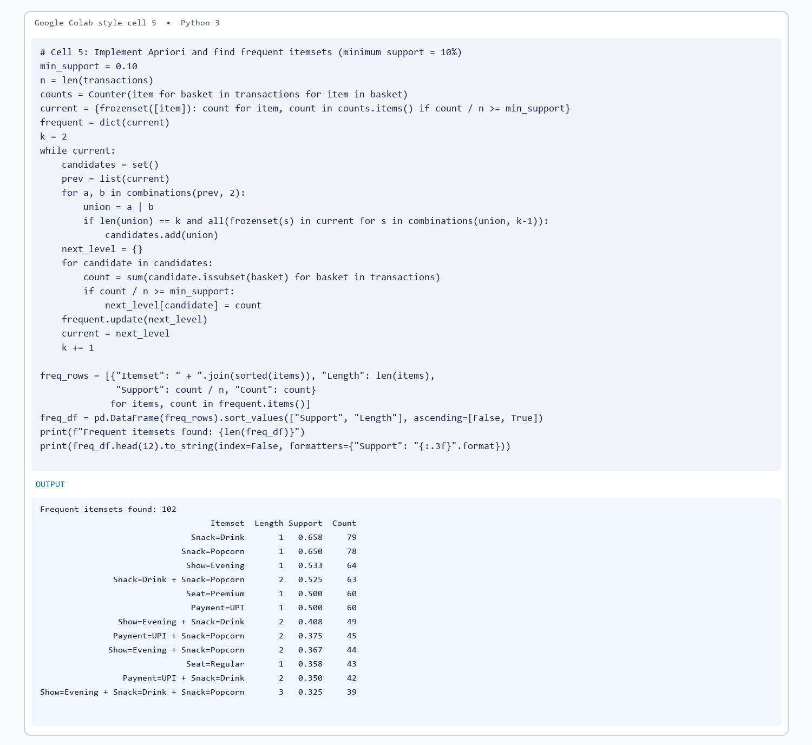

Cell 6. Generate and rank association rules.
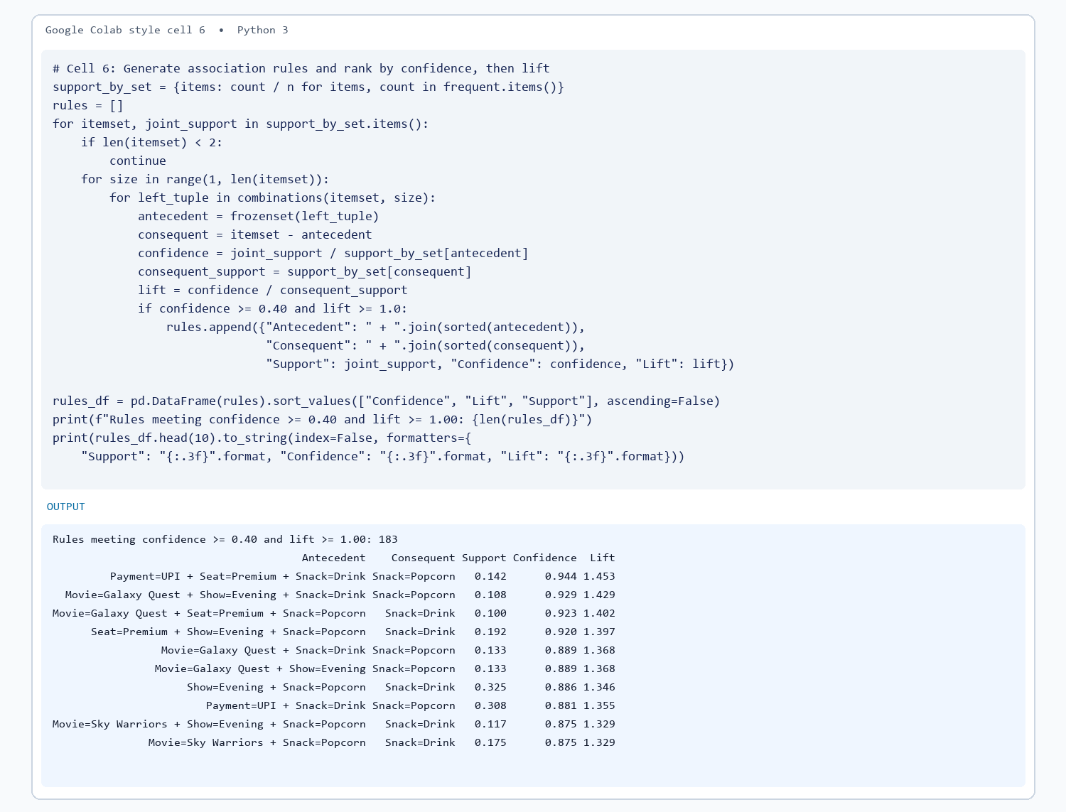

Cell 7. Interpret the strongest rule and state the conclusion.
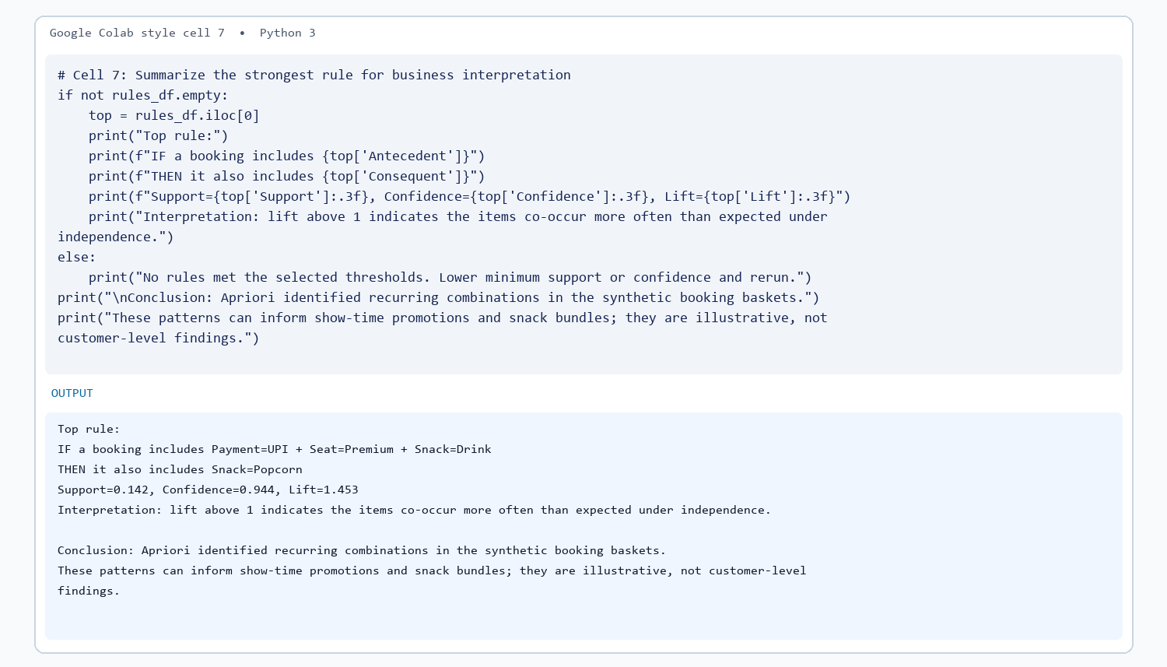

Results and observations

Conclusion

============================================================
GitHub Repository Link:
https://github.com/Sentry2311/DMBI_EXPERIMENTS/tree/main/Experiment_08_Association_Mining_Apriori_Python
(Contains complete documentation, dataset, and program code for Experiment 8: Association Mining for Movie Ticket Bookings)

