Experiment 9
Association Mining in RapidMiner for Movie Ticket Bookings
This experiment prepares movie booking transactions for FP-Growth in RapidMiner, then generates association rules that describe recurring combinations of movie, show, seat, payment, and snack choices. The sample contains 120 reproducible synthetic bookings.
Platform | Altair RapidMiner AI Studio
Mining operator | FP-Growth
Transactions | 120 bookings
Thresholds | Support 10%; confidence 40%; lift at least 1.0

Aim
To transform movie ticket bookings into transaction baskets, mine frequent itemsets with RapidMiner FP-Growth, create association rules, and interpret the strongest positive association.

Theory
Each booking is one transaction. Item values include Movie=Sky Warriors, Seat=Premium, Payment=UPI, and Snack=Popcorn. FP-Growth builds frequent itemsets from transactions and Create Association Rules turns qualifying itemsets into directed if-then rules.
Support: Share of all bookings containing both sides of a rule.
Confidence: Share of bookings containing the antecedent that also contain the consequent.
Lift: Confidence divided by the consequent support. Lift above 1 indicates a positive association relative to independence.
Support(A → B) = Support(A ∪ B) | Confidence = Support(A ∪ B) / Support(A) | Lift = Confidence / Support(B)

Sample data
The sample is synthetic and reproducible. Each row represents a booking. The raw file contains Booking_ID, Movie, Show, Seat, Payment, Popcorn, and Drink. The RapidMiner input file expands the categorical choices into 18 binary item columns, where 1 means the item is present and 0 means it is absent.
Booking_ID is an identifier, not a mined item. The prepared item matrix is supplied separately so the workflow can start at Read CSV without additional reshaping.
Field | Meaning
Booking_ID | Unique booking identifier
Movie | One movie selected
Show | Morning, Matinee, Evening, or Late Night
Seat | Regular, Premium, or Recliner
Payment | UPI, Card, Wallet, or Cash
Popcorn / Drink | True when included in the booking

RapidMiner process setup
- Read CSV — Load Exp9_Movie_Ticket_Booking_Items.csv. Keep the header row and parse the item columns as numeric 0/1 values.
- Set Role — Set Booking_ID to the id role so it is not treated as an item.
- Numerical to Binominal — Convert item columns with minimum = 0 and maximum = 0. This maps zero to false and nonzero values to true.
- FP-Growth — Choose items in dummy coded columns, positive value true, minimum support 0.10, minimum itemset size 1, maximum itemset size 4, and leave automatic minimum itemset search off.
- Create Association Rules — Use criterion lift, minimum confidence 0.40, and minimum criterion value 1.0. Connect its rules output to a result port; connect frequent itemsets to a second result port if desired.

RapidMiner workflow schematic
Connect the operators from left to right. This diagram is a workflow schematic; it is not a captured RapidMiner application screen.
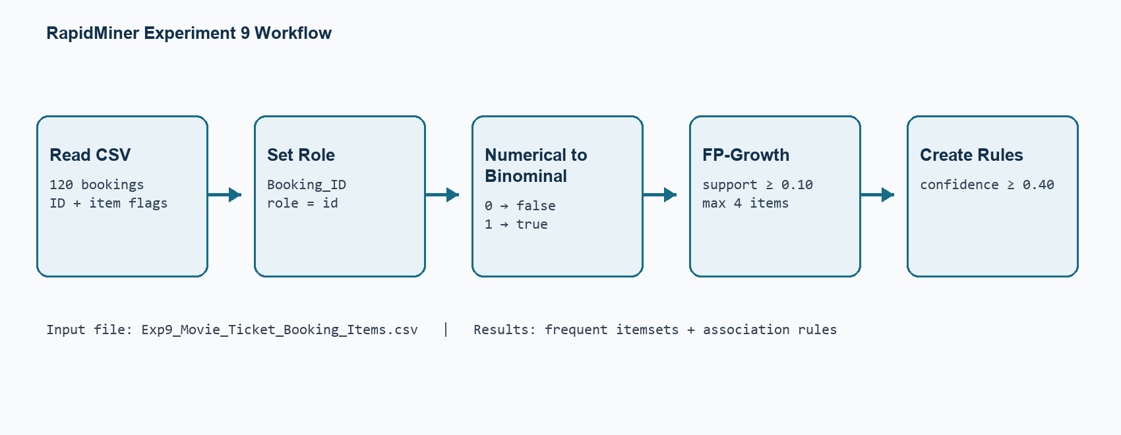
Figure 1. Read, assign the booking ID role, convert 0/1 flags, mine itemsets, and create rules.

Prepared transaction input
The CSV includes 18 item attributes. The preview shows the first rows and a selection of the one-hot columns; the complete file is supplied with the report.
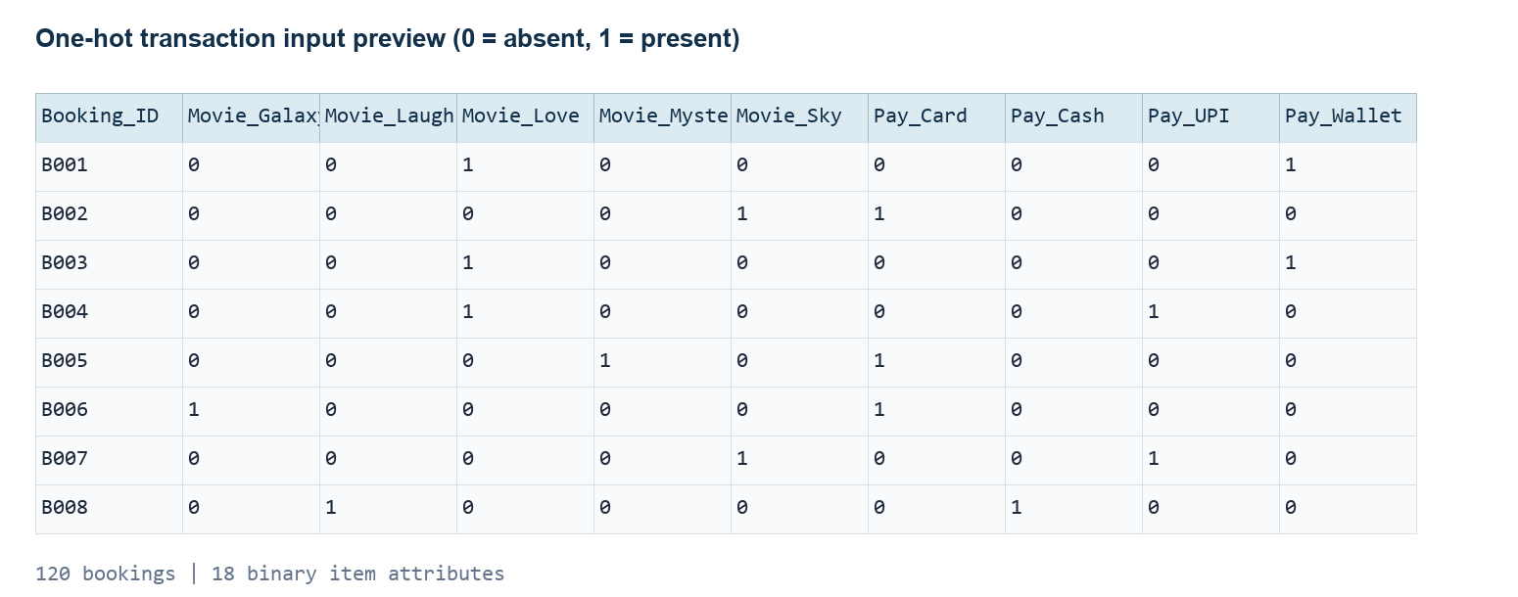
Figure 2. Prepared item matrix. RapidMiner converts the numeric flags to binominal values before FP-Growth.

Association rule output reference
The following rules were calculated independently from the same seeded booking data using minimum support 10%, minimum confidence 40%, and lift at least 1.0. They are reference values for comparison with the RapidMiner results.
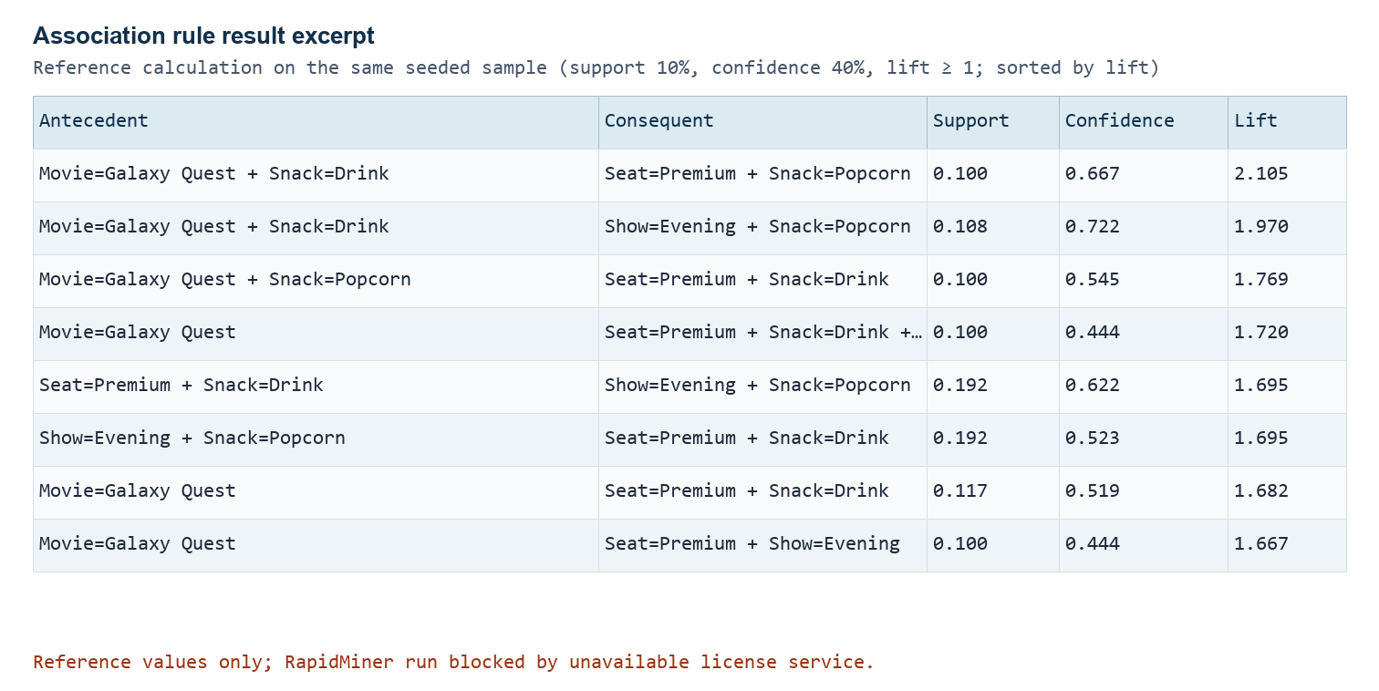
Figure 3. Highest-ranked positive association rules from the reference calculation.

Interpretation
Payment=UPI + Seat=Premium + Snack=Drink → Snack=Popcorn
The rule has support 0.142, confidence 0.944, and lift 1.453. It occurs in about 17 of the 120 bookings. Within the synthetic sample, roughly 94.4% of bookings containing UPI payment, premium seating, and a drink also include popcorn. Lift 1.453 indicates this combination occurs more often than expected from the overall popcorn rate.
A cinema could test a premium-seat snack bundle for UPI bookings. This is an illustrative hypothesis from generated data, not a finding about actual customer behavior.

Execution status and conclusion
The RapidMiner process template and import files are included. The installed batch runner could not complete the RapidMiner run because its configured license service at 6200@localhost was unreachable. The table above is therefore a reference calculation on the same data, not a captured RapidMiner Results view. Open the .rmp file in a licensed AI Studio session to run it and confirm the output.
The experiment demonstrates transaction preparation, FP-Growth, and association rule generation for ticket booking data. The most useful rule in this sample links UPI, premium seats, and a drink with popcorn. Actual booking data should be used before adopting a promotion.

Files and run notes
- Exp9_Movie_Ticket_Bookings.csv contains the readable booking records.
- Exp9_Movie_Ticket_Booking_Items.csv is the one-hot input used by the process.
- Exp9_Movie_Ticket_Association_Mining.rmp contains the RapidMiner workflow. Its Read CSV path points to the supplied item matrix; update that path if the files are moved.
- Open the process in AI Studio and run it. Inspect the FP-Growth frequent itemsets and Create Association Rules output in Results.

RapidMiner operator references
- FP-Growth operator documentation
- Create Association Rules operator documentation
- Read CSV operator documentation
============================================================
GitHub Repository Link:
https://github.com/Sentry2311/DMBI_EXPERIMENTS/tree/main/Experiment_09_Association_Mining_RapidMiner
(Contains complete documentation, dataset, and program code for Experiment 9: Association Mining Using RapidMiner)

