Тема 1
Блок Схемы:
Общая архитектура приложения
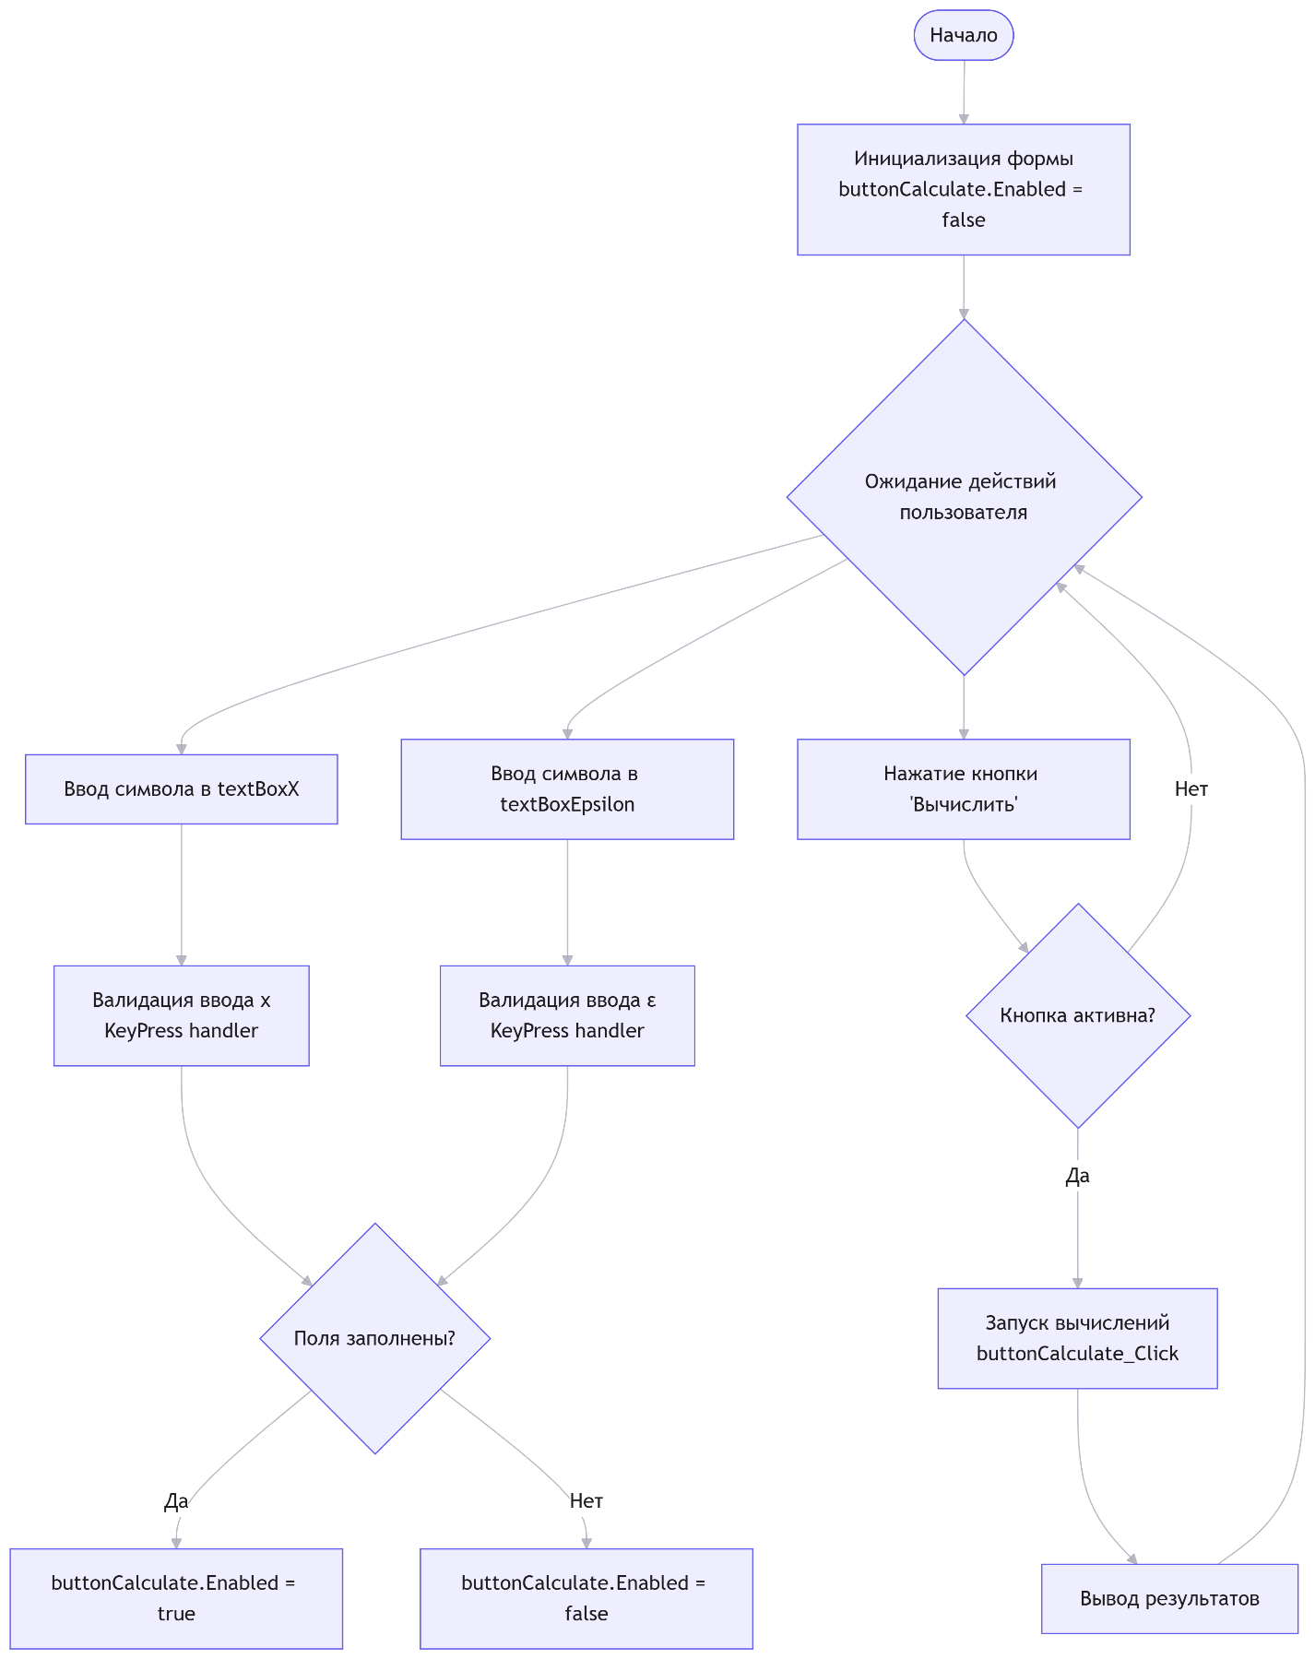

Валидация ввода (событие KeyPress):
TextBoxX:
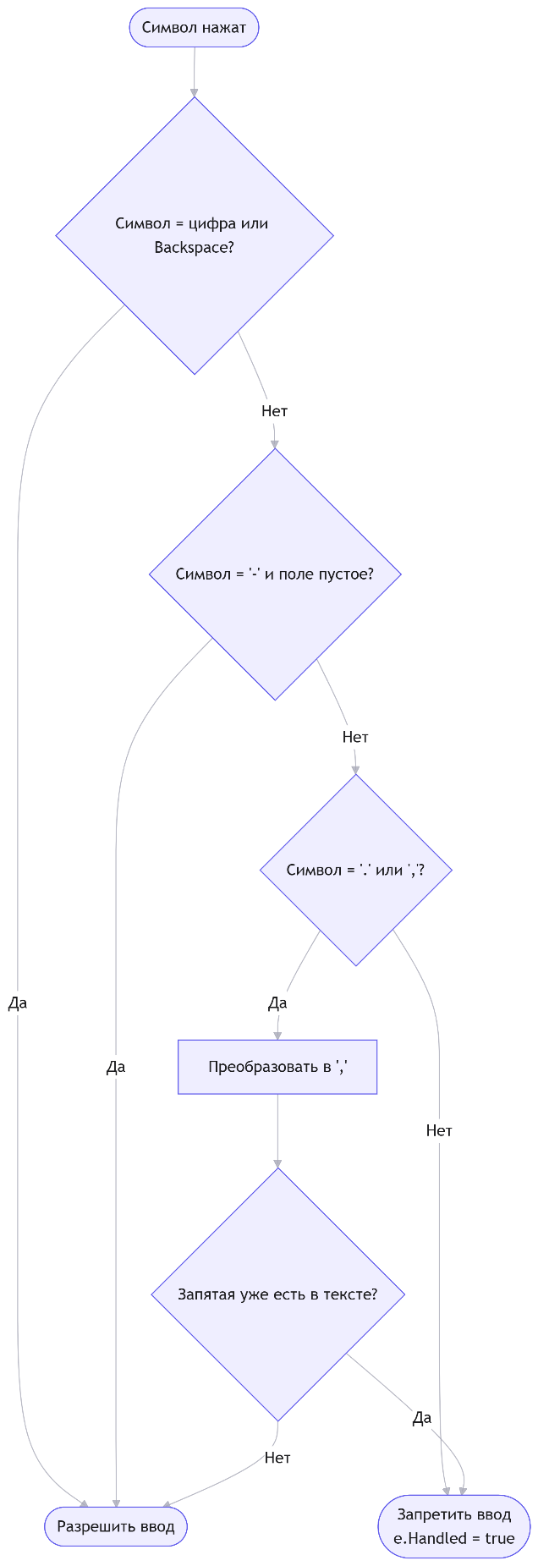

Для поля textBoxEpsilon:
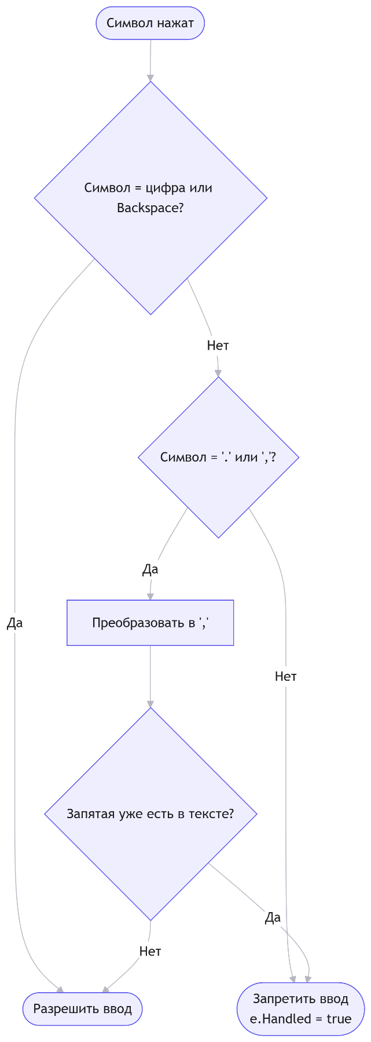

Основной алгоритм вычисления (кнопка Calculate):
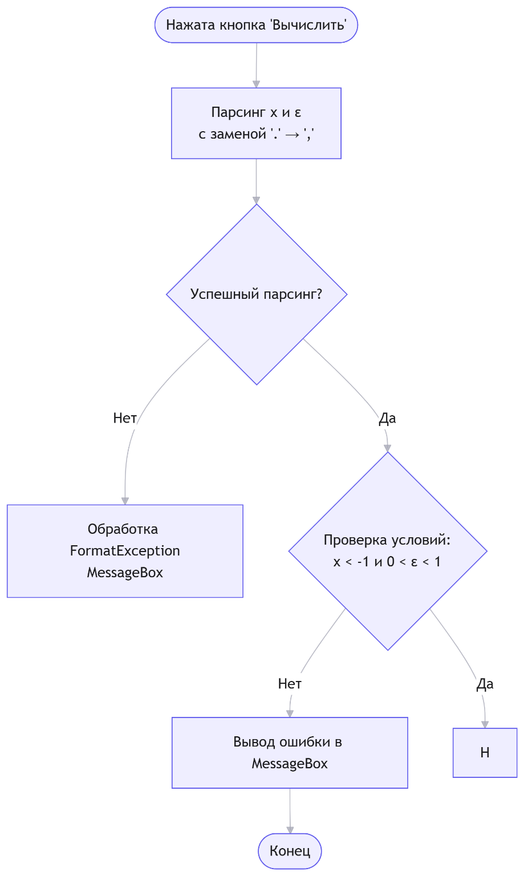

Задание 3 работа с отладчиком:
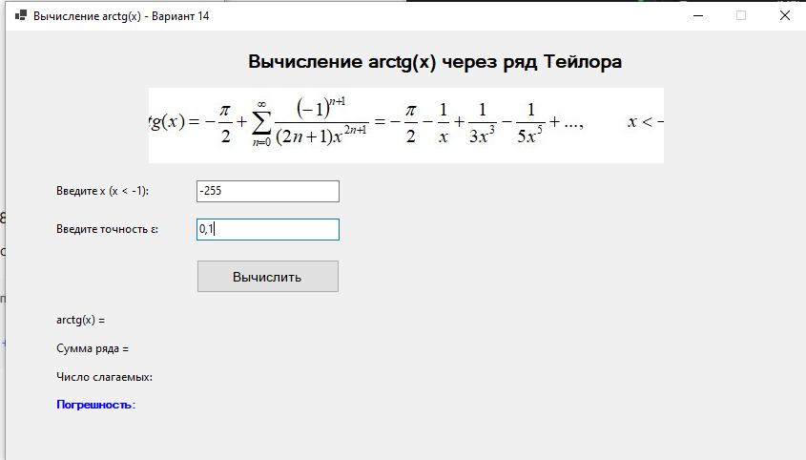
Вводим данные, не нажимаем вычислить
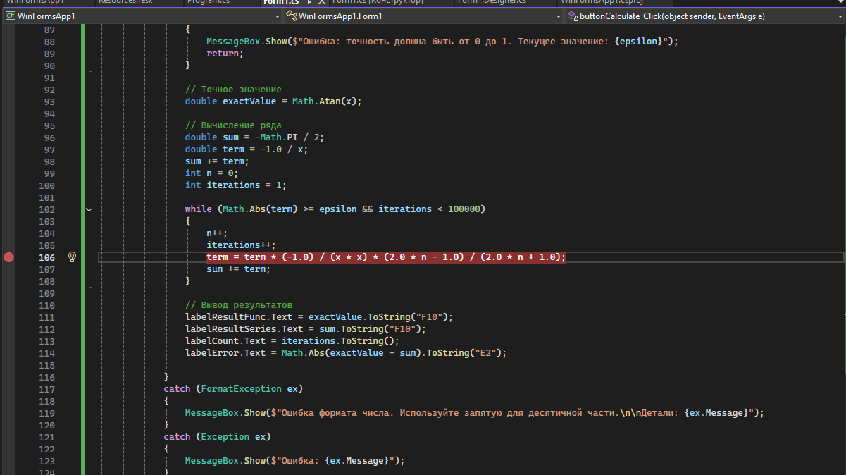
Устанавливаем точку остановки
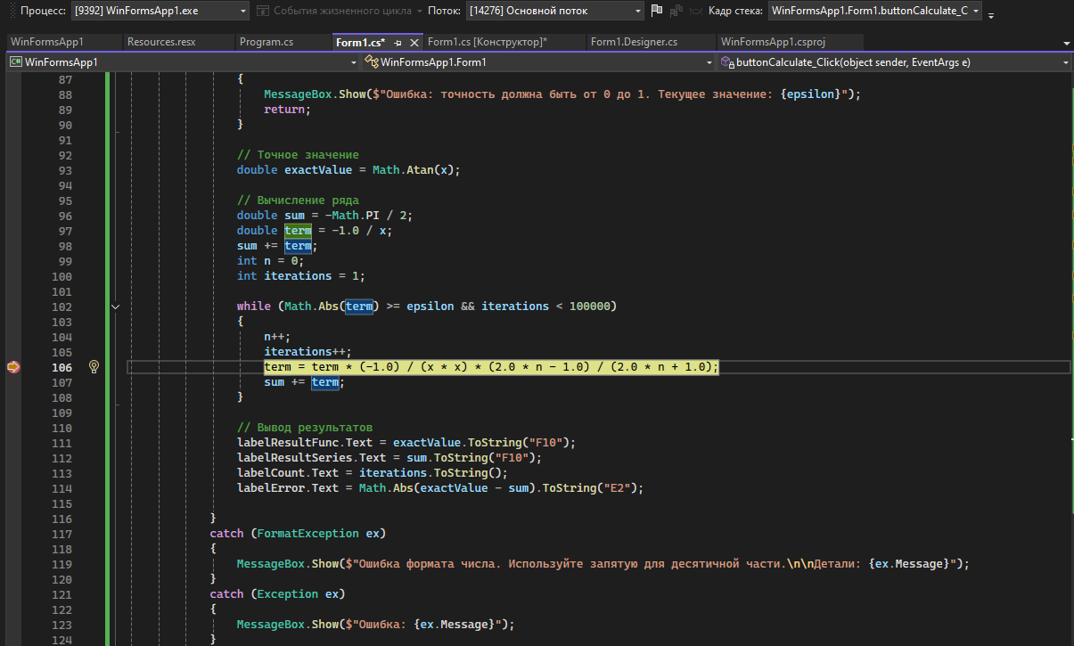
Программа остановилась на точке остановки (стала желтой)
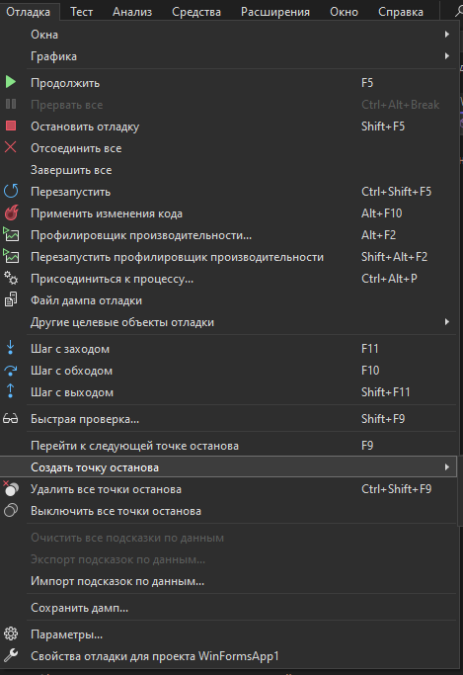
Окно отладки с настройкой точек остановки
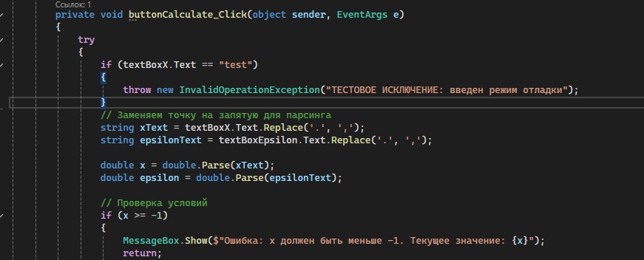
Добавляем в функцию calculate исключение
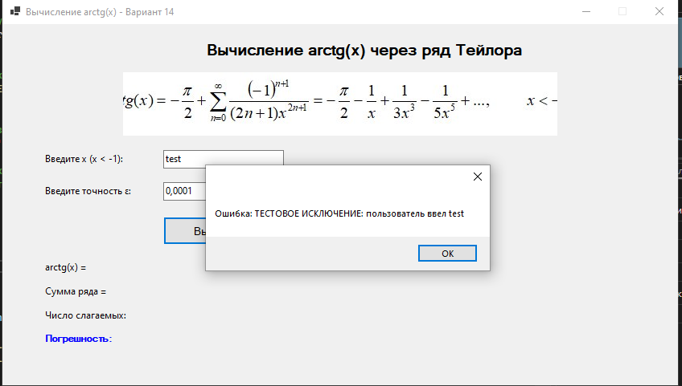
Ввод в поле x test и последующая работа исключения
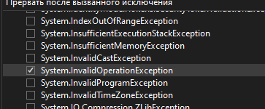
Включение настройки исключения
Остановка после нажатия вычислить
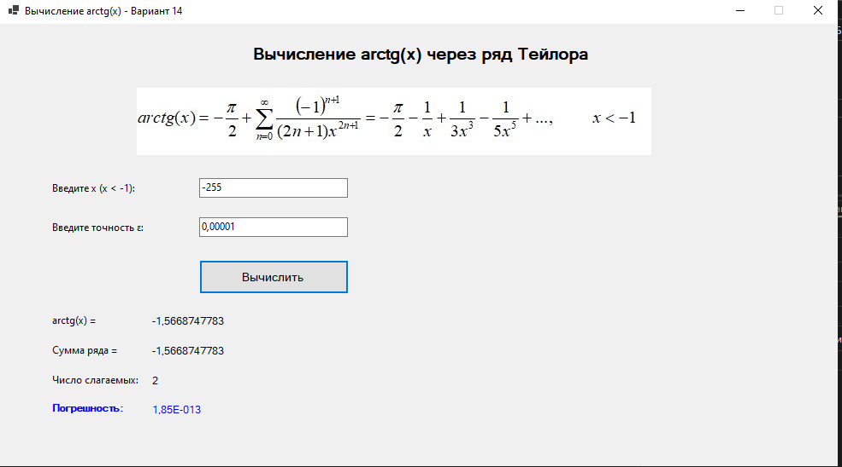
Успешное вычисление
Код Form1.cs:
using System;
using System.Windows.Forms;

namespace WinFormsApp1
{
public partial class Form1 : Form
{
public Form1()
{
InitializeComponent();
buttonCalculate.Enabled = false;
}

private void textBoxX_KeyPress(object sender, KeyPressEventArgs e)
{
// Разрешаем цифры, минус, запятую/точку и backspace
if (char.IsDigit(e.KeyChar) || e.KeyChar == 8) // 8 = backspace
return;

// Разрешаем минус только в начале строки
if (e.KeyChar == '-' && string.IsNullOrEmpty(textBoxX.Text))
return;

// Разрешаем запятую или точку (преобразуем точку в запятую)
if (e.KeyChar == '.' || e.KeyChar == ',')
{
e.KeyChar = ','; // Преобразуем точку в запятую
// Проверяем, что запятая еще не встречалась
if (!textBoxX.Text.Contains(","))
return;
}

// Все остальное запрещаем
e.Handled = true;
}

private void textBoxX_TextChanged(object sender, EventArgs e)
{
buttonCalculate.Enabled = !string.IsNullOrEmpty(textBoxX.Text) &&
!string.IsNullOrEmpty(textBoxEpsilon.Text);
}

private void textBoxEpsilon_KeyPress(object sender, KeyPressEventArgs e)
{
// Разрешаем цифры, запятую/точку и backspace
if (char.IsDigit(e.KeyChar) || e.KeyChar == 8)
return;

// Разрешаем запятую или точку (преобразуем точку в запятую)
if (e.KeyChar == '.' || e.KeyChar == ',')
{
e.KeyChar = ','; // Преобразуем точку в запятую
// Проверяем, что запятая еще не встречалась
if (!textBoxEpsilon.Text.Contains(","))
return;
}

// Все остальное запрещаем
e.Handled = true;
}

private void textBoxEpsilon_TextChanged(object sender, EventArgs e)
{
buttonCalculate.Enabled = !string.IsNullOrEmpty(textBoxX.Text) &&
!string.IsNullOrEmpty(textBoxEpsilon.Text);
}

private void buttonCalculate_Click(object sender, EventArgs e)
{
try
{
// Заменяем точку на запятую для парсинга
string xText = textBoxX.Text.Replace('.', ',');
string epsilonText = textBoxEpsilon.Text.Replace('.', ',');

double x = double.Parse(xText);
double epsilon = double.Parse(epsilonText);

// Проверка условий
if (x >= -1)
{
MessageBox.Show($"Ошибка: x должен быть меньше -1. Текущее значение: {x}");
return;
}

if (epsilon <= 0 || epsilon >= 1)
{
MessageBox.Show($"Ошибка: точность должна быть от 0 до 1. Текущее значение: {epsilon}");
return;
}

// Точное значение
double exactValue = Math.Atan(x);

// Вычисление ряда
double sum = -Math.PI / 2;
double term = -1.0 / x;
sum += term;
int n = 0;
int iterations = 1;

while (Math.Abs(term) >= epsilon && iterations < 100000)
{
n++;
iterations++;
term = term * (-1.0) / (x * x) * (2.0 * n - 1.0) / (2.0 * n + 1.0);
sum += term;
}

// Вывод результатов
labelResultFunc.Text = exactValue.ToString("F10");
labelResultSeries.Text = sum.ToString("F10");
labelCount.Text = iterations.ToString();
labelError.Text = Math.Abs(exactValue - sum).ToString("E2");

}
catch (FormatException ex)
{
MessageBox.Show($"Ошибка формата числа. Используйте запятую для десятичной части.\n\nДетали: {ex.Message}");
}
catch (Exception ex)
{
MessageBox.Show($"Ошибка: {ex.Message}");
}
}
}
}
Код Form1.Designer.cs:
namespace WinFormsApp1
{
partial class Form1
{
private System.ComponentModel.IContainer components = null;

protected override void Dispose(bool disposing)
{
if (disposing && (components != null))
{
components.Dispose();
}
base.Dispose(disposing);
}

#region Windows Form Designer generated code

private void InitializeComponent()
{
labelTitle = new Label();
labelX = new Label();
textBoxX = new TextBox();
labelEpsilon = new Label();
textBoxEpsilon = new TextBox();
buttonCalculate = new Button();
labelResultFuncTitle = new Label();
labelResultSeriesTitle = new Label();
labelCountTitle = new Label();
labelErrorTitle = new Label();
labelResultFunc = new Label();
labelResultSeries = new Label();
labelCount = new Label();
labelError = new Label();
pictureBoxFormula = new PictureBox();
((System.ComponentModel.ISupportInitialize)pictureBoxFormula).BeginInit();
SuspendLayout();
//
// labelTitle
//
labelTitle.AutoSize = true;
labelTitle.Font = new Font("Microsoft Sans Serif", 14F, FontStyle.Bold, GraphicsUnit.Point, 204);
labelTitle.Location = new Point(292, 23);
labelTitle.Margin = new Padding(4, 0, 4, 0);
labelTitle.Name = "labelTitle";
labelTitle.Size = new Size(402, 24);
labelTitle.TabIndex = 0;
labelTitle.Text = "Вычисление arctg(x) через ряд Тейлора";
labelTitle.TextAlign = ContentAlignment.MiddleCenter;
//
// labelX
//
labelX.AutoSize = true;
labelX.Location = new Point(58, 185);
labelX.Margin = new Padding(4, 0, 4, 0);
labelX.Name = "labelX";
labelX.Size = new Size(104, 15);
labelX.TabIndex = 2;
labelX.Text = "Введите x (x < -1):";
//
// textBoxX
//
textBoxX.Location = new Point(233, 181);
textBoxX.Margin = new Padding(4, 3, 4, 3);
textBoxX.Name = "textBoxX";
textBoxX.Size = new Size(174, 23);
textBoxX.TabIndex = 3;
textBoxX.TextChanged += textBoxX_TextChanged;
textBoxX.KeyPress += textBoxX_KeyPress;
//
// labelEpsilon
//
labelEpsilon.AutoSize = true;
labelEpsilon.Location = new Point(58, 231);
labelEpsilon.Margin = new Padding(4, 0, 4, 0);
labelEpsilon.Name = "labelEpsilon";
labelEpsilon.Size = new Size(114, 15);
labelEpsilon.TabIndex = 4;
labelEpsilon.Text = "Введите точность ε:";
//
// textBoxEpsilon
//
textBoxEpsilon.Location = new Point(233, 227);
textBoxEpsilon.Margin = new Padding(4, 3, 4, 3);
textBoxEpsilon.Name = "textBoxEpsilon";
textBoxEpsilon.Size = new Size(174, 23);
textBoxEpsilon.TabIndex = 5;
textBoxEpsilon.TextChanged += textBoxEpsilon_TextChanged;
textBoxEpsilon.KeyPress += textBoxEpsilon_KeyPress;
//
// buttonCalculate
//
buttonCalculate.Enabled = false;
buttonCalculate.Font = new Font("Microsoft Sans Serif", 10F, FontStyle.Regular, GraphicsUnit.Point, 204);
buttonCalculate.Location = new Point(233, 277);
buttonCalculate.Margin = new Padding(4, 3, 4, 3);
buttonCalculate.Name = "buttonCalculate";
buttonCalculate.Size = new Size(175, 40);
buttonCalculate.TabIndex = 6;
buttonCalculate.Text = "Вычислить";
buttonCalculate.UseVisualStyleBackColor = true;
buttonCalculate.Click += buttonCalculate_Click;
//
// labelResultFuncTitle
//
labelResultFuncTitle.AutoSize = true;
labelResultFuncTitle.Location = new Point(58, 340);
labelResultFuncTitle.Margin = new Padding(4, 0, 4, 0);
labelResultFuncTitle.Name = "labelResultFuncTitle";
labelResultFuncTitle.Size = new Size(59, 15);
labelResultFuncTitle.TabIndex = 7;
labelResultFuncTitle.Text = "arctg(x) =";
//
// labelResultSeriesTitle
//
labelResultSeriesTitle.AutoSize = true;
labelResultSeriesTitle.Location = new Point(58, 375);
labelResultSeriesTitle.Margin = new Padding(4, 0, 4, 0);
labelResultSeriesTitle.Name = "labelResultSeriesTitle";
labelResultSeriesTitle.Size = new Size(84, 15);
labelResultSeriesTitle.TabIndex = 9;
labelResultSeriesTitle.Text = "Сумма ряда =";
//
// labelCountTitle
//
labelCountTitle.AutoSize = true;
labelCountTitle.Location = new Point(58, 410);
labelCountTitle.Margin = new Padding(4, 0, 4, 0);
labelCountTitle.Name = "labelCountTitle";
labelCountTitle.Size = new Size(108, 15);
labelCountTitle.TabIndex = 11;
labelCountTitle.Text = "Число слагаемых:";
//
// labelErrorTitle
//
labelErrorTitle.AutoSize = true;
labelErrorTitle.Font = new Font("Microsoft Sans Serif", 8.25F, FontStyle.Bold, GraphicsUnit.Point, 204);
labelErrorTitle.ForeColor = Color.Blue;
labelErrorTitle.Location = new Point(58, 444);
labelErrorTitle.Margin = new Padding(4, 0, 4, 0);
labelErrorTitle.Name = "labelErrorTitle";
labelErrorTitle.Size = new Size(90, 13);
labelErrorTitle.TabIndex = 13;
labelErrorTitle.Text = "Погрешность:";
//
// labelResultFunc
//
labelResultFunc.AutoSize = true;
labelResultFunc.Font = new Font("Microsoft Sans Serif", 9F, FontStyle.Regular, GraphicsUnit.Point, 204);
labelResultFunc.Location = new Point(175, 340);
labelResultFunc.Margin = new Padding(4, 0, 4, 0);
labelResultFunc.Name = "labelResultFunc";
labelResultFunc.Size = new Size(0, 15);
labelResultFunc.TabIndex = 8;
//
// labelResultSeries
//
labelResultSeries.AutoSize = true;
labelResultSeries.Font = new Font("Microsoft Sans Serif", 9F, FontStyle.Regular, GraphicsUnit.Point, 204);
labelResultSeries.Location = new Point(175, 375);
labelResultSeries.Margin = new Padding(4, 0, 4, 0);
labelResultSeries.Name = "labelResultSeries";
labelResultSeries.Size = new Size(0, 15);
labelResultSeries.TabIndex = 10;
//
// labelCount
//
labelCount.AutoSize = true;
labelCount.Font = new Font("Microsoft Sans Serif", 9F, FontStyle.Regular, GraphicsUnit.Point, 204);
labelCount.Location = new Point(175, 410);
labelCount.Margin = new Padding(4, 0, 4, 0);
labelCount.Name = "labelCount";
labelCount.Size = new Size(0, 15);
labelCount.TabIndex = 12;
//
// labelError
//
labelError.AutoSize = true;
labelError.Font = new Font("Microsoft Sans Serif", 9F, FontStyle.Regular, GraphicsUnit.Point, 204);
labelError.ForeColor = Color.Blue;
labelError.Location = new Point(175, 444);
labelError.Margin = new Padding(4, 0, 4, 0);
labelError.Name = "labelError";
labelError.Size = new Size(0, 15);
labelError.TabIndex = 14;
//
// pictureBoxFormula
//
pictureBoxFormula.Image = Properties.Resources.formula;
pictureBoxFormula.Location = new Point(117, 69);
pictureBoxFormula.Margin = new Padding(4, 3, 4, 3);
pictureBoxFormula.Name = "pictureBoxFormula";
pictureBoxFormula.Size = new Size(688, 92);
pictureBoxFormula.SizeMode = PictureBoxSizeMode.CenterImage;
pictureBoxFormula.TabIndex = 1;
pictureBoxFormula.TabStop = false;
//
// Form1
//
AutoScaleDimensions = new SizeF(7F, 15F);
AutoScaleMode = AutoScaleMode.Font;
ClientSize = new Size(980, 519);
Controls.Add(labelError);
Controls.Add(labelErrorTitle);
Controls.Add(labelCount);
Controls.Add(labelCountTitle);
Controls.Add(labelResultSeries);
Controls.Add(labelResultSeriesTitle);
Controls.Add(labelResultFunc);
Controls.Add(labelResultFuncTitle);
Controls.Add(buttonCalculate);
Controls.Add(textBoxEpsilon);
Controls.Add(labelEpsilon);
Controls.Add(textBoxX);
Controls.Add(labelX);
Controls.Add(pictureBoxFormula);
Controls.Add(labelTitle);
FormBorderStyle = FormBorderStyle.FixedSingle;
Margin = new Padding(4, 3, 4, 3);
MaximizeBox = false;
Name = "Form1";
StartPosition = FormStartPosition.CenterScreen;
Text = "Вычисление arctg(x) - Вариант 14";
((System.ComponentModel.ISupportInitialize)pictureBoxFormula).EndInit();
ResumeLayout(false);
PerformLayout();
}

#endregion

private System.Windows.Forms.Label labelTitle;
private System.Windows.Forms.PictureBox pictureBoxFormula;
private System.Windows.Forms.Label labelX;
private System.Windows.Forms.TextBox textBoxX;
private System.Windows.Forms.Label labelEpsilon;
private System.Windows.Forms.TextBox textBoxEpsilon;
private System.Windows.Forms.Button buttonCalculate;
private System.Windows.Forms.Label labelResultFuncTitle;
private System.Windows.Forms.Label labelResultSeriesTitle;
private System.Windows.Forms.Label labelCountTitle;
private System.Windows.Forms.Label labelErrorTitle;
private System.Windows.Forms.Label labelResultFunc;
private System.Windows.Forms.Label labelResultSeries;
private System.Windows.Forms.Label labelCount;
private System.Windows.Forms.Label labelError;
}
}

Тема 2
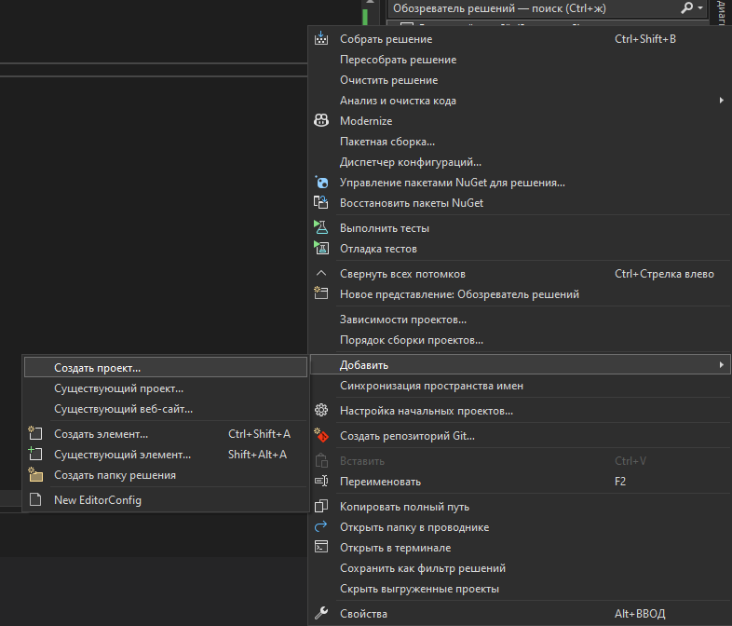
Добавляем новый проект в наш основной (тесты)

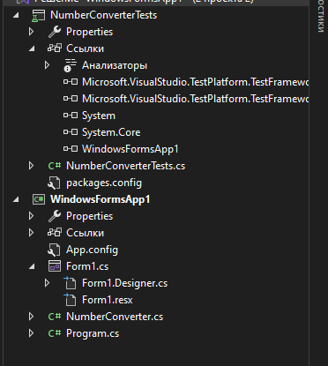
Итоговый проект
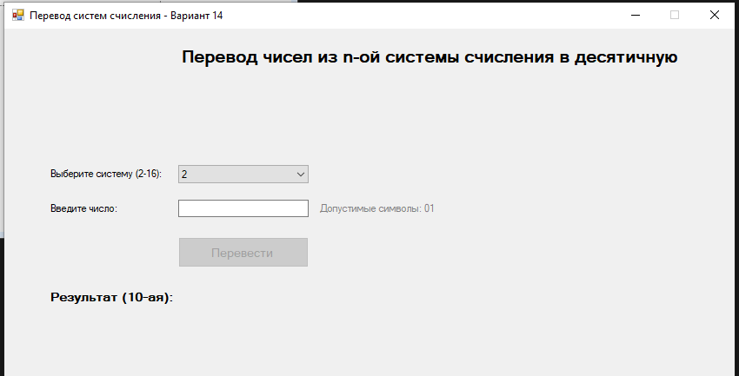
Форма
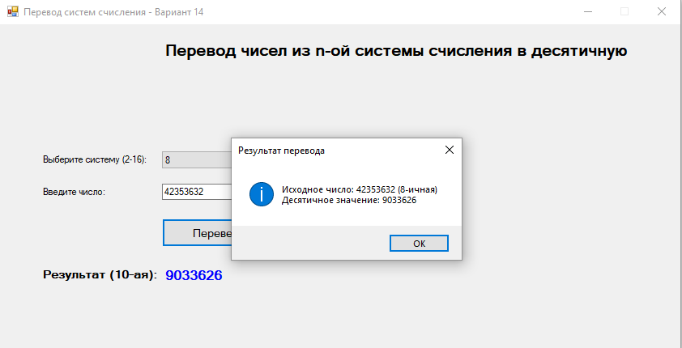
Форма рабочая
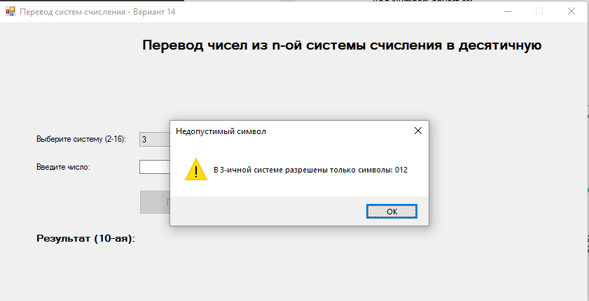
Случай, если ввести неправильные значения
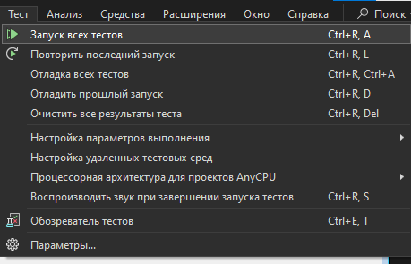
Запуск тестов
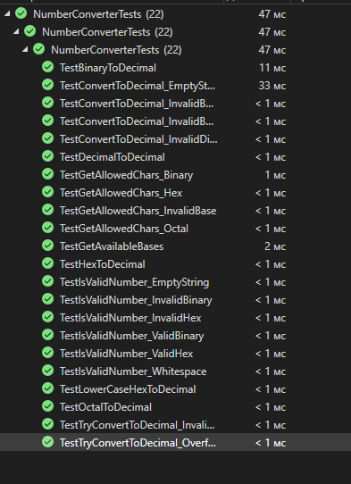
Тесты все успешны
Код NumberConvert.cs:
using System;
using System.Collections.Generic;
using System.Linq;
using System.Text;
using System.Threading.Tasks;

namespace WindowsFormsApp1
{
/// <summary>
/// Класс для перевода чисел из различных систем счисления в десятичную
/// Вариант 14: перевод из n-ой системы (2-16) в десятичную
/// </summary>
public static class NumberConverter
{
/// <summary>
/// Словарь соответствия символов и их значений в системах счисления до 16
/// </summary>
private static readonly Dictionary<char, int> CharToValue = new Dictionary<char, int>
{
{'0', 0}, {'1', 1}, {'2', 2}, {'3', 3}, {'4', 4},
{'5', 5}, {'6', 6}, {'7', 7}, {'8', 8}, {'9', 9},
{'A', 10}, {'B', 11}, {'C', 12}, {'D', 13}, {'E', 14}, {'F', 15},
{'a', 10}, {'b', 11}, {'c', 12}, {'d', 13}, {'e', 14}, {'f', 15}
};

/// <summary>
/// Проверяет, является ли строка допустимым числом в заданной системе счисления
/// </summary>
/// <param name="number">Строка с числом</param>
/// <param name="baseSystem">Основание системы счисления (2-16)</param>
/// <returns>true, если число корректно, иначе false</returns>
public static bool IsValidNumber(string number, int baseSystem)
{
if (string.IsNullOrWhiteSpace(number))
return false;

if (baseSystem < 2 || baseSystem > 16)
return false;

string upperNumber = number.ToUpper().Trim();

foreach (char c in upperNumber)
{
// Проверяем, есть ли символ в словаре
if (!CharToValue.ContainsKey(c))
return false;

// Проверяем, не превышает ли значение допустимое для данной системы
if (CharToValue[c] >= baseSystem)
return false;
}

return true;
}

/// <summary>
/// Переводит число из заданной системы счисления в десятичную
/// </summary>
/// <param name="number">Строка с числом в исходной системе</param>
/// <param name="baseSystem">Основание исходной системы счисления (2-16)</param>
/// <returns>Десятичное представление числа</returns>
/// <exception cref="ArgumentException">Выбрасывается при некорректных входных данных</exception>
public static long ConvertToDecimal(string number, int baseSystem)
{
// Проверка входных данных
if (string.IsNullOrWhiteSpace(number))
throw new ArgumentException("Число не может быть пустым.");

if (baseSystem < 2 || baseSystem > 16)
throw new ArgumentException("Основание системы счисления должно быть от 2 до 16.");

if (!IsValidNumber(number, baseSystem))
throw new ArgumentException($"Число '{number}' не является допустимым в {baseSystem}-ичной системе счисления.");

// Приводим к верхнему регистру и убираем пробелы
string upperNumber = number.ToUpper().Trim();
long result = 0;
int power = 0;

// Проходим по цифрам числа справа налево
for (int i = upperNumber.Length - 1; i >= 0; i--)
{
char digit = upperNumber[i];
int value = CharToValue[digit];

// Вычисляем: result += value * (baseSystem ^ power)
result += value * (long)Math.Pow(baseSystem, power);
power++;
}

return result;
}

/// <summary>
/// Перегруженный метод для перевода с проверкой на переполнение
/// </summary>
/// <param name="number">Строка с числом</param>
/// <param name="baseSystem">Основание системы</param>
/// <param name="result">Результат перевода</param>
/// <returns>true если перевод успешен, false при переполнении</returns>
public static bool TryConvertToDecimal(string number, int baseSystem, out long result)
{
result = 0;
try
{
// Проверяем валидность числа
if (!IsValidNumber(number, baseSystem))
return false;

string upperNumber = number.ToUpper().Trim();
long temp = 0;
int power = 0;

for (int i = upperNumber.Length - 1; i >= 0; i--)
{
char digit = upperNumber[i];
int value = CharToValue[digit];

// Проверка на переполнение
checked
{
temp += value * (long)Math.Pow(baseSystem, power);
}
power++;
}

result = temp;
return true;
}
catch (OverflowException)
{
return false;
}
catch (Exception)
{
return false;
}
}

/// <summary>
/// Получает список допустимых систем счисления
/// </summary>
public static int[] GetAvailableBases()
{
return Enumerable.Range(2, 15).ToArray(); // 2..16
}

/// <summary>
/// Получает строку с примерами допустимых цифр для системы
/// </summary>
public static string GetAllowedChars(int baseSystem)
{
if (baseSystem < 2 || baseSystem > 16)
return "";

string chars = "0123456789ABCDEF";
return chars.Substring(0, baseSystem);
}
}
}
Код Form1.cs:
using System;
using System.Windows.Forms;

namespace WindowsFormsApp1
{
public partial class Form1 : Form
{
public Form1()
{
InitializeComponent();
buttonCalculate.Enabled = false;

// Заполняем ComboBox системами счисления
comboBoxBase.Items.Clear();
foreach (int baseSystem in NumberConverter.GetAvailableBases())
{
comboBoxBase.Items.Add(baseSystem.ToString());
}
comboBoxBase.SelectedIndex = 0; // Выбираем 2-ичную систему по умолчанию

// Подсказка для пользователя
UpdateAllowedCharsHint();
}

private void UpdateAllowedCharsHint()
{
if (comboBoxBase.SelectedItem != null)
{
int baseSystem = int.Parse(comboBoxBase.SelectedItem.ToString());
string allowedChars = NumberConverter.GetAllowedChars(baseSystem);
labelAllowedChars.Text = $"Допустимые символы: {allowedChars}";
}
}

private void comboBoxBase_SelectedIndexChanged(object sender, EventArgs e)
{
UpdateAllowedCharsHint();
CheckFields();
}

private void textBoxNumber_KeyPress(object sender, KeyPressEventArgs e)
{
// Разрешаем цифры, буквы A-F (в любом регистре) и backspace
if (char.IsControl(e.KeyChar))
return;

if (comboBoxBase.SelectedItem == null)
{
e.Handled = true;
return;
}

int baseSystem = int.Parse(comboBoxBase.SelectedItem.ToString());
string allowedChars = NumberConverter.GetAllowedChars(baseSystem);

// Проверяем, разрешен ли введенный символ (в верхнем регистре)
char upperChar = char.ToUpper(e.KeyChar);
if (!allowedChars.Contains(upperChar.ToString()))
{
e.Handled = true;
MessageBox.Show($"В {baseSystem}-ичной системе разрешены только символы: {allowedChars}",
"Недопустимый символ", MessageBoxButtons.OK, MessageBoxIcon.Warning);
}
}

private void textBoxNumber_TextChanged(object sender, EventArgs e)
{
CheckFields();
}

private void CheckFields()
{
bool fieldsFilled = !string.IsNullOrWhiteSpace(textBoxNumber.Text) &&
comboBoxBase.SelectedItem != null;

buttonCalculate.Enabled = fieldsFilled;
}

private void buttonCalculate_Click(object sender, EventArgs e)
{
try
{
string number = textBoxNumber.Text.Trim();
int baseSystem = int.Parse(comboBoxBase.SelectedItem.ToString());

// Проверка на пустое число
if (string.IsNullOrWhiteSpace(number))
{
MessageBox.Show("Введите число для перевода.", "Ошибка",
MessageBoxButtons.OK, MessageBoxIcon.Warning);
return;
}

// Проверка на допустимые символы
if (!NumberConverter.IsValidNumber(number, baseSystem))
{
string allowed = NumberConverter.GetAllowedChars(baseSystem);
MessageBox.Show($"Число '{number}' не является допустимым в {baseSystem}-ичной системе.\n" +
$"Разрешены только символы: {allowed}",
"Ошибка ввода", MessageBoxButtons.OK, MessageBoxIcon.Warning);
return;
}

// Пытаемся перевести число
if (NumberConverter.TryConvertToDecimal(number, baseSystem, out long decimalValue))
{
// Выводим результат
labelResult.Text = decimalValue.ToString();

// Показываем подробности
string details = $"Исходное число: {number} ({baseSystem}-ичная)\n" +
$"Десятичное значение: {decimalValue}";
MessageBox.Show(details, "Результат перевода",
MessageBoxButtons.OK, MessageBoxIcon.Information);
}
else
{
MessageBox.Show("Произошло переполнение. Число слишком большое для преобразования.",
"Ошибка", MessageBoxButtons.OK, MessageBoxIcon.Error);
}
}
catch (Exception ex)
{
MessageBox.Show($"Ошибка: {ex.Message}", "Ошибка",
MessageBoxButtons.OK, MessageBoxIcon.Error);
}
}
}
}
Код Form1.Designer.cs:
using System.Windows.Forms;

namespace WindowsFormsApp1
{
partial class Form1
{
private System.ComponentModel.IContainer components = null;

protected override void Dispose(bool disposing)
{
if (disposing && (components != null))
{
components.Dispose();
}
base.Dispose(disposing);
}

#region Windows Form Designer generated code

private void InitializeComponent()
{
this.labelTitle = new System.Windows.Forms.Label();
this.labelBase = new System.Windows.Forms.Label();
this.comboBoxBase = new System.Windows.Forms.ComboBox();
this.labelNumber = new System.Windows.Forms.Label();
this.textBoxNumber = new System.Windows.Forms.TextBox();
this.labelAllowedChars = new System.Windows.Forms.Label();
this.buttonCalculate = new System.Windows.Forms.Button();
this.labelResultTitle = new System.Windows.Forms.Label();
this.labelResult = new System.Windows.Forms.Label();
this.pictureBoxFormula = new System.Windows.Forms.PictureBox();
((System.ComponentModel.ISupportInitialize)(this.pictureBoxFormula)).BeginInit();
this.SuspendLayout();
//
// labelTitle
//
this.labelTitle.AutoSize = true;
this.labelTitle.Font = new System.Drawing.Font("Microsoft Sans Serif", 14F, System.Drawing.FontStyle.Bold);
this.labelTitle.Location = new System.Drawing.Point(200, 20);
this.labelTitle.Name = "labelTitle";
this.labelTitle.Size = new System.Drawing.Size(580, 24);
this.labelTitle.TabIndex = 0;
this.labelTitle.Text = "Перевод чисел из n-ой системы счисления в десятичную";
this.labelTitle.TextAlign = System.Drawing.ContentAlignment.MiddleCenter;
//
// labelBase
//
this.labelBase.AutoSize = true;
this.labelBase.Location = new System.Drawing.Point(50, 160);
this.labelBase.Name = "labelBase";
this.labelBase.Size = new System.Drawing.Size(135, 13);
this.labelBase.TabIndex = 2;
this.labelBase.Text = "Выберите систему (2-16):";
//
// comboBoxBase
//
this.comboBoxBase.DropDownStyle = System.Windows.Forms.ComboBoxStyle.DropDownList;
this.comboBoxBase.Location = new System.Drawing.Point(200, 157);
this.comboBoxBase.Name = "comboBoxBase";
this.comboBoxBase.Size = new System.Drawing.Size(150, 21);
this.comboBoxBase.TabIndex = 3;
this.comboBoxBase.SelectedIndexChanged += new System.EventHandler(this.comboBoxBase_SelectedIndexChanged);
//
// labelNumber
//
this.labelNumber.AutoSize = true;
this.labelNumber.Location = new System.Drawing.Point(50, 200);
this.labelNumber.Name = "labelNumber";
this.labelNumber.Size = new System.Drawing.Size(84, 13);
this.labelNumber.TabIndex = 4;
this.labelNumber.Text = "Введите число:";
//
// textBoxNumber
//
this.textBoxNumber.Location = new System.Drawing.Point(200, 197);
this.textBoxNumber.Name = "textBoxNumber";
this.textBoxNumber.Size = new System.Drawing.Size(150, 20);
this.textBoxNumber.TabIndex = 5;
this.textBoxNumber.TextChanged += new System.EventHandler(this.textBoxNumber_TextChanged);
this.textBoxNumber.KeyPress += new System.Windows.Forms.KeyPressEventHandler(this.textBoxNumber_KeyPress);
//
// labelAllowedChars
//
this.labelAllowedChars.AutoSize = true;
this.labelAllowedChars.ForeColor = System.Drawing.Color.Gray;
this.labelAllowedChars.Location = new System.Drawing.Point(360, 200);
this.labelAllowedChars.Name = "labelAllowedChars";
this.labelAllowedChars.Size = new System.Drawing.Size(124, 13);
this.labelAllowedChars.TabIndex = 6;
this.labelAllowedChars.Text = "Допустимые символы:";
//
// buttonCalculate
//
this.buttonCalculate.Enabled = false;
this.buttonCalculate.Font = new System.Drawing.Font("Microsoft Sans Serif", 10F);
this.buttonCalculate.Location = new System.Drawing.Point(200, 240);
this.buttonCalculate.Name = "buttonCalculate";
this.buttonCalculate.Size = new System.Drawing.Size(150, 35);
this.buttonCalculate.TabIndex = 7;
this.buttonCalculate.Text = "Перевести";
this.buttonCalculate.UseVisualStyleBackColor = true;
this.buttonCalculate.Click += new System.EventHandler(this.buttonCalculate_Click);
//
// labelResultTitle
//
this.labelResultTitle.AutoSize = true;
this.labelResultTitle.Font = new System.Drawing.Font("Microsoft Sans Serif", 10F, System.Drawing.FontStyle.Bold);
this.labelResultTitle.Location = new System.Drawing.Point(50, 300);
this.labelResultTitle.Name = "labelResultTitle";
this.labelResultTitle.Size = new System.Drawing.Size(149, 17);
this.labelResultTitle.TabIndex = 8;
this.labelResultTitle.Text = "Результат (10-ая):";
//
// labelResult
//
this.labelResult.AutoSize = true;
this.labelResult.Font = new System.Drawing.Font("Microsoft Sans Serif", 12F, System.Drawing.FontStyle.Bold);
this.labelResult.ForeColor = System.Drawing.Color.Blue;
this.labelResult.Location = new System.Drawing.Point(200, 300);
this.labelResult.Name = "labelResult";
this.labelResult.Size = new System.Drawing.Size(0, 20);
this.labelResult.TabIndex = 9;
//
// pictureBoxFormula
//
this.pictureBoxFormula.Location = new System.Drawing.Point(150, 60);
this.pictureBoxFormula.Name = "pictureBoxFormula";
this.pictureBoxFormula.Size = new System.Drawing.Size(540, 80);
this.pictureBoxFormula.SizeMode = System.Windows.Forms.PictureBoxSizeMode.CenterImage;
this.pictureBoxFormula.TabIndex = 1;
this.pictureBoxFormula.TabStop = false;
//
// Form1
//
this.AutoScaleDimensions = new System.Drawing.SizeF(6F, 13F);
this.AutoScaleMode = System.Windows.Forms.AutoScaleMode.Font;
this.ClientSize = new System.Drawing.Size(840, 400);
this.Controls.Add(this.labelResult);
this.Controls.Add(this.labelResultTitle);
this.Controls.Add(this.buttonCalculate);
this.Controls.Add(this.labelAllowedChars);
this.Controls.Add(this.textBoxNumber);
this.Controls.Add(this.labelNumber);
this.Controls.Add(this.comboBoxBase);
this.Controls.Add(this.labelBase);
this.Controls.Add(this.pictureBoxFormula);
this.Controls.Add(this.labelTitle);
this.FormBorderStyle = System.Windows.Forms.FormBorderStyle.FixedSingle;
this.MaximizeBox = false;
this.Name = "Form1";
this.StartPosition = System.Windows.Forms.FormStartPosition.CenterScreen;
this.Text = "Перевод систем счисления - Вариант 14";
((System.ComponentModel.ISupportInitialize)(this.pictureBoxFormula)).EndInit();
this.ResumeLayout(false);
this.PerformLayout();

}

#endregion

private System.Windows.Forms.Label labelTitle;
private System.Windows.Forms.PictureBox pictureBoxFormula;
private System.Windows.Forms.Label labelBase;
private System.Windows.Forms.ComboBox comboBoxBase;
private System.Windows.Forms.Label labelNumber;
private System.Windows.Forms.TextBox textBoxNumber;
private System.Windows.Forms.Label labelAllowedChars;
private System.Windows.Forms.Button buttonCalculate;
private System.Windows.Forms.Label labelResultTitle;
private System.Windows.Forms.Label labelResult;
}
}
Тема 3
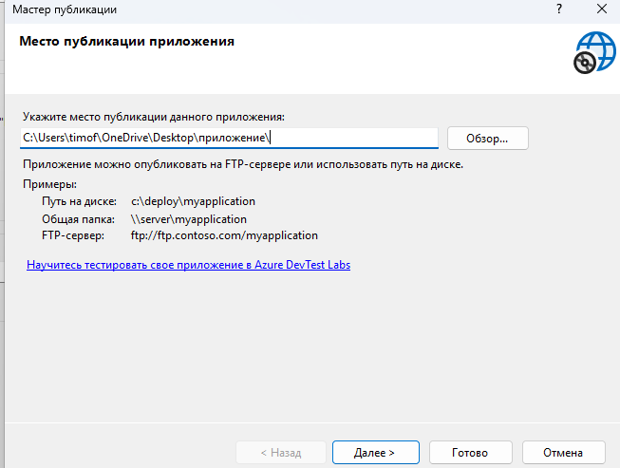
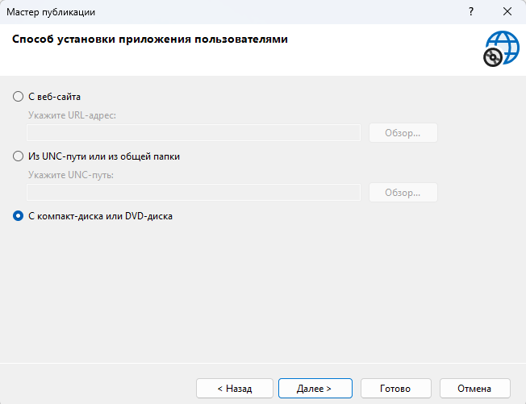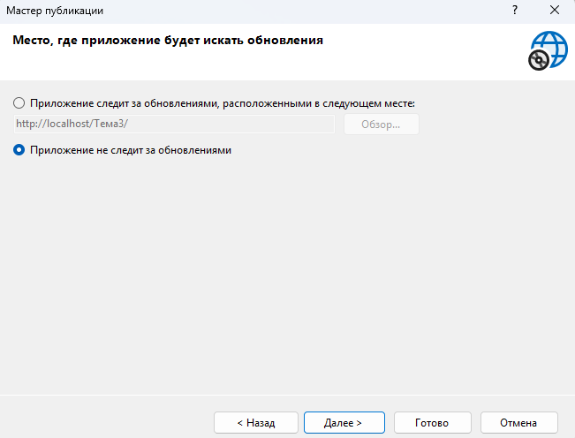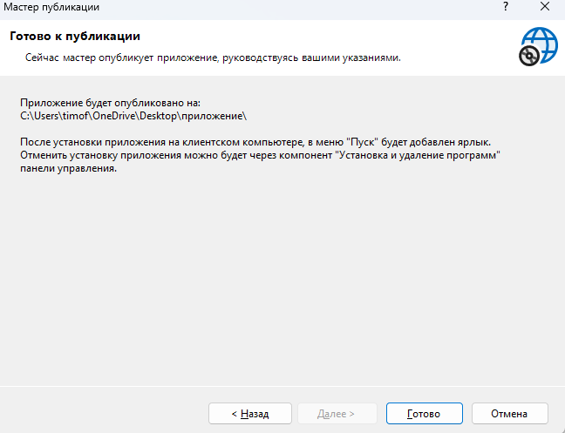
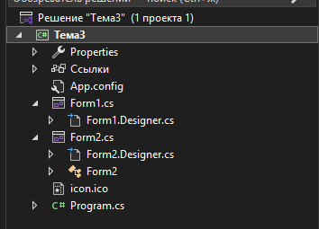
Структура проекта
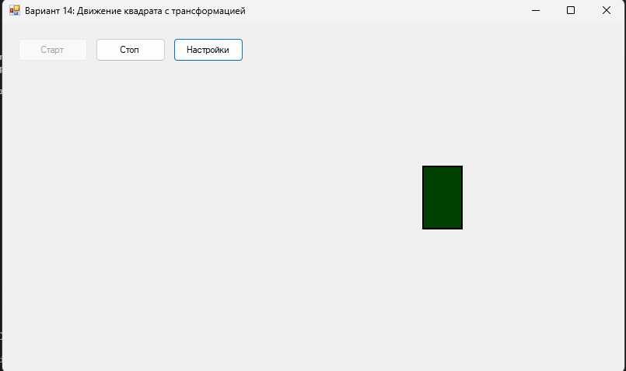
Можно менять цвет, скорость, кнопки старт стоп рабочие
Код Form1.cs:
using System;
using System.Drawing;
using System.Windows.Forms;

namespace WindowsFormsApp1
{
public partial class Form1 : Form
{
// Параметры фигуры
private RectangleF shapeRect; // Прямоугольник фигуры
private float shapeWidth = 50; // Ширина фигуры
private float shapeHeight = 50; // Высота фигуры
private Color shapeColor = Color.Blue; // Цвет фигуры

// Параметры движения
private float stepX = 2; // Шаг движения по X
private float minX = 10; // Минимальная позиция по X
private float maxX; // Максимальная позиция по X

// Параметры трансформации
private float currentHeight = 50; // Текущая высота
private float minHeight = 50; // Минимальная высота (квадрат)
private float maxHeight = 100; // Максимальная высота (прямоугольник)
private float heightStep = 0.5f; // Шаг изменения высоты
private bool expanding = true; // Растягиваемся или сжимаемся

// Таймер
private Timer animationTimer;

// Флаг для завершения программы
private bool isRunning = true;

public Form1()
{
InitializeComponent();

// Настройка таймера
animationTimer = new Timer();
animationTimer.Interval = 30;
animationTimer.Tick += AnimationTimer_Tick;

// Подписка на события клавиш
this.KeyPreview = true;
this.KeyDown += Form1_KeyDown;

// Инициализация позиции
InitializeShape();
}

private void InitializeShape()
{
// Начальная позиция - левая часть формы
minX = shapeWidth / 2 + 5;
maxX = this.ClientSize.Width - shapeWidth / 2 - 5;

float startX = minX;
float startY = this.ClientSize.Height / 2;

shapeRect = new RectangleF(
startX - shapeWidth / 2,
startY - currentHeight / 2,
shapeWidth,
currentHeight
);
}

private void AnimationTimer_Tick(object sender, EventArgs e)
{
// Движение по горизонтали
shapeRect.X += stepX;

// Проверка достижения границ
if (shapeRect.X <= minX)
{
shapeRect.X = minX;
stepX = Math.Abs(stepX);
}
else if (shapeRect.X + shapeRect.Width >= maxX + shapeRect.Width / 2)
{
shapeRect.X = maxX + shapeRect.Width / 2 - shapeRect.Width;
stepX = -Math.Abs(stepX);
}

// Трансформация высоты
if (expanding)
{
currentHeight += heightStep;
if (currentHeight >= maxHeight)
{
currentHeight = maxHeight;
expanding = false;
}
}
else
{
currentHeight -= heightStep;
if (currentHeight <= minHeight)
{
currentHeight = minHeight;
expanding = true;
}
}

// Обновление прямоугольника
shapeRect.Height = currentHeight;
shapeRect.Y = this.ClientSize.Height / 2 - currentHeight / 2;

// Перерисовка
this.Invalidate();
}

private void Form1_Paint(object sender, PaintEventArgs e)
{
// Рисование фигуры
using (SolidBrush brush = new SolidBrush(shapeColor))
{
e.Graphics.FillRectangle(brush, shapeRect);
}

// Рисование рамки
using (Pen pen = new Pen(Color.Black, 2))
{
e.Graphics.DrawRectangle(pen, Rectangle.Round(shapeRect));
}
}

private void Form1_KeyDown(object sender, KeyEventArgs e)
{
// Завершение при нажатии любой клавиши
if (isRunning)
{
animationTimer.Stop();
isRunning = false;
this.Close();
}
}

private void Form1_Resize(object sender, EventArgs e)
{
if (this.ClientSize.Width > 0 && this.ClientSize.Height > 0)
{
maxX = this.ClientSize.Width - shapeWidth / 2 - 10;

if (shapeRect != null)
{
if (shapeRect.X < minX)
shapeRect.X = minX;
if (shapeRect.X + shapeRect.Width > this.ClientSize.Width - minX)
shapeRect.X = this.ClientSize.Width - shapeRect.Width - minX;

shapeRect.Y = this.ClientSize.Height / 2 - currentHeight / 2;
}
}
}

private void btnStart_Click(object sender, EventArgs e)
{
animationTimer.Start();
btnStart.Enabled = false;
btnStop.Enabled = true;
}

private void btnStop_Click(object sender, EventArgs e)
{
animationTimer.Stop();
btnStart.Enabled = true;
btnStop.Enabled = false;
}

private void btnSettings_Click(object sender, EventArgs e)
{
Form2 settingsForm = new Form2(shapeColor, animationTimer.Interval);

if (settingsForm.ShowDialog() == DialogResult.OK)
{
shapeColor = settingsForm.SelectedColor;
animationTimer.Interval = settingsForm.Speed;
}
}

private void Form1_Load(object sender, EventArgs e)
{
animationTimer.Start();
btnStart.Enabled = false;
btnStop.Enabled = true;
}
}
}
Код Form1.designer.cs:
using System.Windows.Forms;

namespace WindowsFormsApp1
{
partial class Form1
{
private System.ComponentModel.IContainer components = null;
private Button btnStart;
private Button btnStop;
private Button btnSettings;

protected override void Dispose(bool disposing)
{
if (disposing && (components != null))
{
components.Dispose();
}
base.Dispose(disposing);
}

#region Windows Form Designer generated code

private void InitializeComponent()
{
this.btnStart = new System.Windows.Forms.Button();
this.btnStop = new System.Windows.Forms.Button();
this.btnSettings = new System.Windows.Forms.Button();
this.SuspendLayout();

// btnStart
this.btnStart.Location = new System.Drawing.Point(20, 20);
this.btnStart.Name = "btnStart";
this.btnStart.Size = new System.Drawing.Size(90, 30);
this.btnStart.TabIndex = 0;
this.btnStart.Text = "Старт";
this.btnStart.UseVisualStyleBackColor = true;
this.btnStart.Click += new System.EventHandler(this.btnStart_Click);

// btnStop
this.btnStop.Location = new System.Drawing.Point(120, 20);
this.btnStop.Name = "btnStop";
this.btnStop.Size = new System.Drawing.Size(90, 30);
this.btnStop.TabIndex = 1;
this.btnStop.Text = "Стоп";
this.btnStop.UseVisualStyleBackColor = true;
this.btnStop.Enabled = false;
this.btnStop.Click += new System.EventHandler(this.btnStop_Click);

// btnSettings
this.btnSettings.Location = new System.Drawing.Point(220, 20);
this.btnSettings.Name = "btnSettings";
this.btnSettings.Size = new System.Drawing.Size(90, 30);
this.btnSettings.TabIndex = 2;
this.btnSettings.Text = "Настройки";
this.btnSettings.UseVisualStyleBackColor = true;
this.btnSettings.Click += new System.EventHandler(this.btnSettings_Click);

// Form1
this.AutoScaleDimensions = new System.Drawing.SizeF(6F, 13F);
this.AutoScaleMode = System.Windows.Forms.AutoScaleMode.Font;
this.ClientSize = new System.Drawing.Size(800, 450);
this.Controls.Add(this.btnSettings);
this.Controls.Add(this.btnStop);
this.Controls.Add(this.btnStart);
this.DoubleBuffered = true;
this.Name = "Form1";
this.StartPosition = System.Windows.Forms.FormStartPosition.CenterScreen;
this.Text = "Вариант 14: Движение квадрата с трансформацией";
this.Paint += new System.Windows.Forms.PaintEventHandler(this.Form1_Paint);
this.Resize += new System.EventHandler(this.Form1_Resize);
this.Load += new System.EventHandler(this.Form1_Load);
this.KeyDown += new System.Windows.Forms.KeyEventHandler(this.Form1_KeyDown);
this.ResumeLayout(false);
this.PerformLayout();
}

#endregion
}
}
Код Form2.cs:
using System;
using System.Drawing;
using System.Windows.Forms;

namespace WindowsFormsApp1
{
public partial class Form2 : Form
{
private ColorDialog colorDialog;
private Timer speedPreviewTimer;
private int currentSpeed;
private Color currentColor;

public Color SelectedColor { get; private set; }
public int Speed { get; private set; }

public Form2(Color initialColor, int initialSpeed)
{
InitializeComponent();

currentColor = initialColor;
currentSpeed = initialSpeed;

SelectedColor = initialColor;
Speed = initialSpeed;

// Отображение текущих значений
UpdateColorDisplay();
trackBarSpeed.Value = initialSpeed;
lblSpeedValue.Text = $"{initialSpeed} мс";

// Таймер для предпросмотра
speedPreviewTimer = new Timer();
speedPreviewTimer.Interval = initialSpeed;
speedPreviewTimer.Tick += SpeedPreviewTimer_Tick;

colorDialog = new ColorDialog();
}

private void UpdateColorDisplay()
{
panelColor.BackColor = currentColor;
lblColor.Text = $"Текущий цвет: {currentColor.Name}";
}

private void SpeedPreviewTimer_Tick(object sender, EventArgs e)
{
// Мигание панели для предпросмотра скорости
panelPreview.BackColor = panelPreview.BackColor == Color.Red ?
Color.Transparent : Color.Red;
}

private void btnSelectColor_Click(object sender, EventArgs e)
{
colorDialog.Color = currentColor;

if (colorDialog.ShowDialog() == DialogResult.OK)
{
currentColor = colorDialog.Color;
UpdateColorDisplay();
}
}

private void trackBarSpeed_Scroll(object sender, EventArgs e)
{
currentSpeed = trackBarSpeed.Value;
lblSpeedValue.Text = $"{currentSpeed} мс";

// Обновление предпросмотра
speedPreviewTimer.Interval = currentSpeed;
}

private void btnPreview_Click(object sender, EventArgs e)
{
if (btnPreview.Text == "Предпросмотр")
{
speedPreviewTimer.Start();
btnPreview.Text = "Стоп";
}
else
{
speedPreviewTimer.Stop();
panelPreview.BackColor = Color.Transparent;
btnPreview.Text = "Предпросмотр";
}
}

private void btnOK_Click(object sender, EventArgs e)
{
SelectedColor = currentColor;
Speed = currentSpeed;

speedPreviewTimer.Stop();
this.DialogResult = DialogResult.OK;
this.Close();
}

private void btnCancel_Click(object sender, EventArgs e)
{
speedPreviewTimer.Stop();
this.DialogResult = DialogResult.Cancel;
this.Close();
}

private void Form2_FormClosing(object sender, FormClosingEventArgs e)
{
speedPreviewTimer.Stop();
}
}
}
Код Form2.designer.cs:
using System.Windows.Forms;

namespace WindowsFormsApp1
{
partial class Form2
{
private System.ComponentModel.IContainer components = null;
private Panel panelColor;
private Label lblColor;
private Button btnSelectColor;
private Label lblSpeed;
private TrackBar trackBarSpeed;
private Label lblSpeedValue;
private Button btnPreview;
private Panel panelPreview;
private Button btnOK;
private Button btnCancel;

protected override void Dispose(bool disposing)
{
if (disposing && (components != null))
{
components.Dispose();
}
base.Dispose(disposing);
}

#region Windows Form Designer generated code

private void InitializeComponent()
{
this.panelColor = new System.Windows.Forms.Panel();
this.lblColor = new System.Windows.Forms.Label();
this.btnSelectColor = new System.Windows.Forms.Button();
this.lblSpeed = new System.Windows.Forms.Label();
this.trackBarSpeed = new System.Windows.Forms.TrackBar();
this.lblSpeedValue = new System.Windows.Forms.Label();
this.btnPreview = new System.Windows.Forms.Button();
this.panelPreview = new System.Windows.Forms.Panel();
this.btnOK = new System.Windows.Forms.Button();
this.btnCancel = new System.Windows.Forms.Button();
((System.ComponentModel.ISupportInitialize)(this.trackBarSpeed)).BeginInit();
this.SuspendLayout();

// panelColor
this.panelColor.BorderStyle = System.Windows.Forms.BorderStyle.FixedSingle;
this.panelColor.Location = new System.Drawing.Point(20, 30);
this.panelColor.Name = "panelColor";
this.panelColor.Size = new System.Drawing.Size(50, 50);
this.panelColor.TabIndex = 0;

// lblColor
this.lblColor.AutoSize = true;
this.lblColor.Location = new System.Drawing.Point(80, 30);
this.lblColor.Name = "lblColor";
this.lblColor.Size = new System.Drawing.Size(100, 13);
this.lblColor.TabIndex = 1;
this.lblColor.Text = "Текущий цвет: Blue";

// btnSelectColor
this.btnSelectColor.Location = new System.Drawing.Point(80, 50);
this.btnSelectColor.Name = "btnSelectColor";
this.btnSelectColor.Size = new System.Drawing.Size(120, 30);
this.btnSelectColor.TabIndex = 2;
this.btnSelectColor.Text = "Выбрать цвет";
this.btnSelectColor.UseVisualStyleBackColor = true;
this.btnSelectColor.Click += new System.EventHandler(this.btnSelectColor_Click);

// lblSpeed
this.lblSpeed.AutoSize = true;
this.lblSpeed.Location = new System.Drawing.Point(20, 100);
this.lblSpeed.Name = "lblSpeed";
this.lblSpeed.Size = new System.Drawing.Size(98, 13);
this.lblSpeed.TabIndex = 3;
this.lblSpeed.Text = "Скорость (мс/кадр):";

// trackBarSpeed
this.trackBarSpeed.Location = new System.Drawing.Point(20, 120);
this.trackBarSpeed.Minimum = 1;
this.trackBarSpeed.Maximum = 100;
this.trackBarSpeed.Name = "trackBarSpeed";
this.trackBarSpeed.Size = new System.Drawing.Size(200, 45);
this.trackBarSpeed.TabIndex = 4;
this.trackBarSpeed.TickFrequency = 10;
this.trackBarSpeed.Scroll += new System.EventHandler(this.trackBarSpeed_Scroll);

// lblSpeedValue
this.lblSpeedValue.AutoSize = true;
this.lblSpeedValue.Location = new System.Drawing.Point(230, 120);
this.lblSpeedValue.Name = "lblSpeedValue";
this.lblSpeedValue.Size = new System.Drawing.Size(31, 13);
this.lblSpeedValue.TabIndex = 5;
this.lblSpeedValue.Text = "30 мс";

// btnPreview
this.btnPreview.Location = new System.Drawing.Point(20, 170);
this.btnPreview.Name = "btnPreview";
this.btnPreview.Size = new System.Drawing.Size(100, 30);
this.btnPreview.TabIndex = 6;
this.btnPreview.Text = "Предпросмотр";
this.btnPreview.UseVisualStyleBackColor = true;
this.btnPreview.Click += new System.EventHandler(this.btnPreview_Click);

// panelPreview
this.panelPreview.BorderStyle = System.Windows.Forms.BorderStyle.FixedSingle;
this.panelPreview.Location = new System.Drawing.Point(130, 170);
this.panelPreview.Name = "panelPreview";
this.panelPreview.Size = new System.Drawing.Size(90, 30);
this.panelPreview.TabIndex = 7;

// btnOK
this.btnOK.Location = new System.Drawing.Point(80, 220);
this.btnOK.Name = "btnOK";
this.btnOK.Size = new System.Drawing.Size(80, 30);
this.btnOK.TabIndex = 8;
this.btnOK.Text = "OK";
this.btnOK.UseVisualStyleBackColor = true;
this.btnOK.Click += new System.EventHandler(this.btnOK_Click);

// btnCancel
this.btnCancel.Location = new System.Drawing.Point(170, 220);
this.btnCancel.Name = "btnCancel";
this.btnCancel.Size = new System.Drawing.Size(80, 30);
this.btnCancel.TabIndex = 9;
this.btnCancel.Text = "Отмена";
this.btnCancel.UseVisualStyleBackColor = true;
this.btnCancel.Click += new System.EventHandler(this.btnCancel_Click);

// Form2
this.AutoScaleDimensions = new System.Drawing.SizeF(6F, 13F);
this.AutoScaleMode = System.Windows.Forms.AutoScaleMode.Font;
this.ClientSize = new System.Drawing.Size(300, 280);
this.Controls.Add(this.btnCancel);
this.Controls.Add(this.btnOK);
this.Controls.Add(this.panelPreview);
this.Controls.Add(this.btnPreview);
this.Controls.Add(this.lblSpeedValue);
this.Controls.Add(this.trackBarSpeed);
this.Controls.Add(this.lblSpeed);
this.Controls.Add(this.btnSelectColor);
this.Controls.Add(this.lblColor);
this.Controls.Add(this.panelColor);
this.FormBorderStyle = System.Windows.Forms.FormBorderStyle.FixedDialog;
this.MaximizeBox = false;
this.MinimizeBox = false;
this.Name = "Form2";
this.StartPosition = System.Windows.Forms.FormStartPosition.CenterParent;
this.Text = "Настройки";
this.FormClosing += new System.Windows.Forms.FormClosingEventHandler(this.Form2_FormClosing);
((System.ComponentModel.ISupportInitialize)(this.trackBarSpeed)).EndInit();
this.ResumeLayout(false);
this.PerformLayout();
}

#endregion
}
}

Тема 4
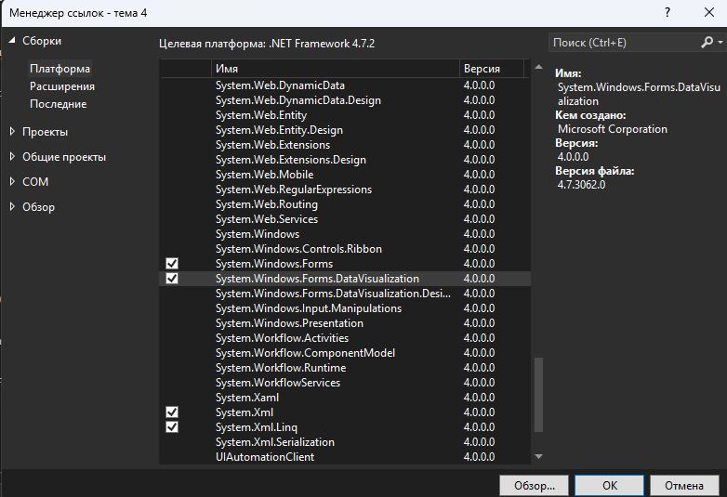
Добавляем System.Windows.Forms.DataVisualization
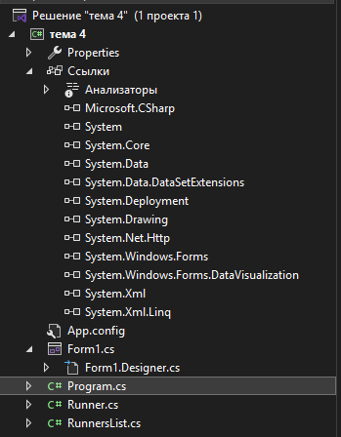
Итоговая структура проекта

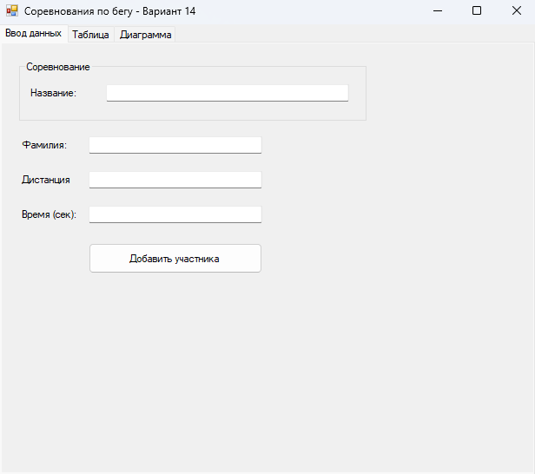
До загрузки файла
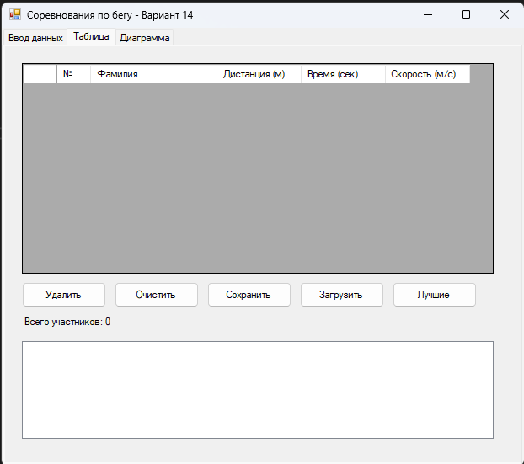
До загрузки файла
Примеры содержания txt файлов, в отдельной папке в проекте
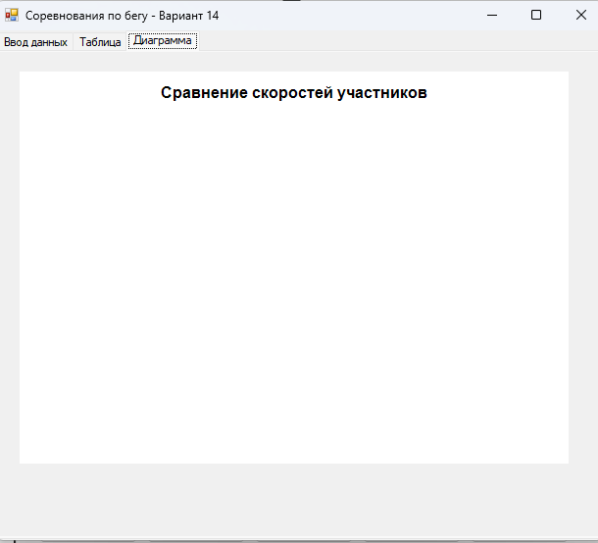
До загрузки файла

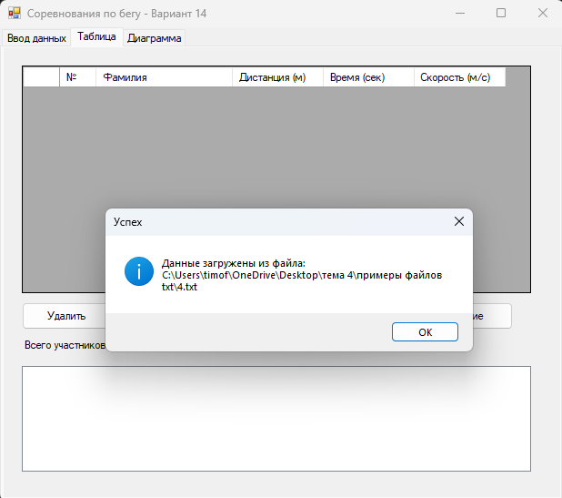
Успешный импорт txt

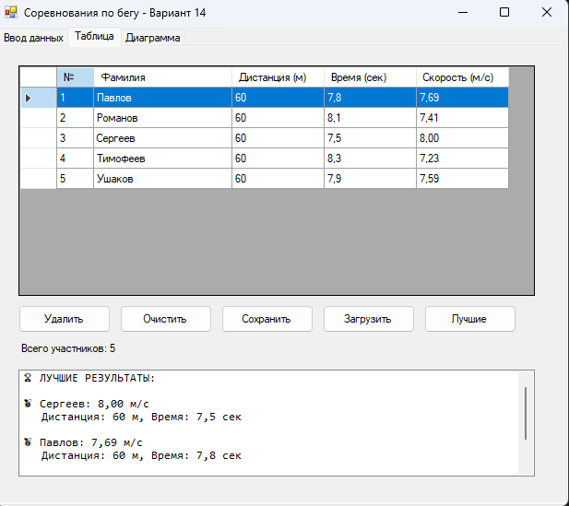
После загрузки
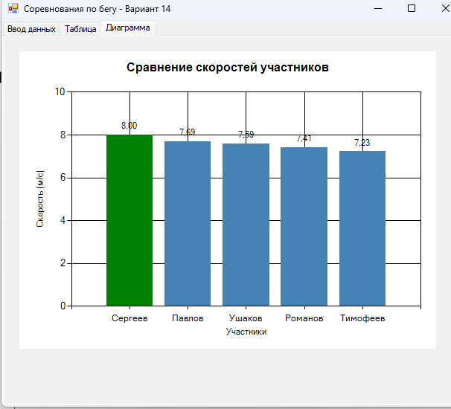
После загрузки

Код Form1.cs:
using System;
using System.Collections.Generic;
using System.Drawing;
using System.Windows.Forms;
using System.Windows.Forms.DataVisualization.Charting;

namespace WindowsFormsApp1
{
public partial class Form1 : Form
{
private RunnersList runnersList;
private string currentFileName = "";

public Form1()
{
InitializeComponent();

// Инициализация списка
runnersList = new RunnersList();

// Настройка DataGridView
SetupDataGridView();

// Настройка Chart
SetupChart();

// Обновление списка
UpdateRunnersList();
}

/// <summary>
/// Настройка таблицы
/// </summary>
private void SetupDataGridView()
{
dataGridViewRunners.AutoGenerateColumns = false;
dataGridViewRunners.Columns.Clear();

// Колонка с номером
DataGridViewTextBoxColumn colNumber = new DataGridViewTextBoxColumn();
colNumber.HeaderText = "№";
colNumber.Name = "Number";
colNumber.Width = 40;
colNumber.ReadOnly = true;
dataGridViewRunners.Columns.Add(colNumber);

// Колонка с фамилией
DataGridViewTextBoxColumn colName = new DataGridViewTextBoxColumn();
colName.HeaderText = "Фамилия";
colName.Name = "Name";
colName.Width = 150;
colName.DataPropertyName = "Name";
dataGridViewRunners.Columns.Add(colName);

// Колонка с дистанцией
DataGridViewTextBoxColumn colDistance = new DataGridViewTextBoxColumn();
colDistance.HeaderText = "Дистанция (м)";
colDistance.Name = "Distance";
colDistance.Width = 100;
colDistance.DataPropertyName = "Distance";
dataGridViewRunners.Columns.Add(colDistance);

// Колонка со временем
DataGridViewTextBoxColumn colTime = new DataGridViewTextBoxColumn();
colTime.HeaderText = "Время (сек)";
colTime.Name = "Time";
colTime.Width = 100;
colTime.DataPropertyName = "Time";
dataGridViewRunners.Columns.Add(colTime);

// Колонка со скоростью
DataGridViewTextBoxColumn colSpeed = new DataGridViewTextBoxColumn();
colSpeed.HeaderText = "Скорость (м/с)";
colSpeed.Name = "Speed";
colSpeed.Width = 100;
colSpeed.DataPropertyName = "Speed";
colSpeed.DefaultCellStyle.Format = "F2";
colSpeed.ReadOnly = true;
dataGridViewRunners.Columns.Add(colSpeed);
}

/// <summary>
/// Настройка диаграммы
/// </summary>
private void SetupChart()
{
chartSpeed.ChartAreas.Clear();
chartSpeed.Series.Clear();
chartSpeed.Titles.Clear();

// Создание области диаграммы
ChartArea chartArea = new ChartArea("MainArea");
chartArea.AxisX.Title = "Участники";
chartArea.AxisY.Title = "Скорость (м/с)";
chartArea.AxisY.Minimum = 0;
chartSpeed.ChartAreas.Add(chartArea);

// Создание серии (столбчатая диаграмма)
Series series = new Series("SpeedSeries");
series.ChartType = SeriesChartType.Column;
series.IsValueShownAsLabel = true;
series.LabelFormat = "F2";
series.Color = Color.SteelBlue;
chartSpeed.Series.Add(series);

// Заголовок
Title title = new Title("Сравнение скоростей участников");
title.Font = new Font("Arial", 12, FontStyle.Bold);
chartSpeed.Titles.Add(title);
}

/// <summary>
/// Обновление списка в DataGridView
/// </summary>
private void UpdateRunnersList()
{
dataGridViewRunners.Rows.Clear();

for (int i = 0; i < runnersList.Count; i++)
{
Runner runner = runnersList[i];
dataGridViewRunners.Rows.Add(
(i + 1).ToString(),
runner.Name,
runner.Distance,
runner.Time,
runner.Speed
);
}

// Обновление информации
labelTotalCount.Text = $"Всего участников: {runnersList.Count}";

// Обновление диаграммы
UpdateChart();
}

/// <summary>
/// Обновление диаграммы
/// </summary>
private void UpdateChart()
{
Series series = chartSpeed.Series["SpeedSeries"];
series.Points.Clear();

List<Runner> runners = runnersList.GetAllRunners();

// Сортируем по скорости для лучшего отображения
runners.Sort((a, b) => b.Speed.CompareTo(a.Speed));

foreach (Runner runner in runners)
{
int pointIndex = series.Points.AddXY(runner.Name, runner.Speed);

// Раскраска: лучший - зеленый, остальные - синие
if (pointIndex == 0) // Самый быстрый
{
series.Points[pointIndex].Color = Color.Green;
}
else
{
series.Points[pointIndex].Color = Color.SteelBlue;
}
}

// Обновление лучших результатов
UpdateBestResults();
}

/// <summary>
/// Обновление информации о лучших
/// </summary>
private void UpdateBestResults()
{
listBoxBestResults.Items.Clear();

List<Runner> bestRunners = runnersList.FindBestRunners(3);

if (bestRunners.Count > 0)
{
listBoxBestResults.Items.Add("🏆 ЛУЧШИЕ РЕЗУЛЬТАТЫ:");
listBoxBestResults.Items.Add("");

for (int i = 0; i < bestRunners.Count; i++)
{
Runner runner = bestRunners[i];
string medal = i == 0 ? "🥇" : (i == 1 ? "🥈" : "🥉");
listBoxBestResults.Items.Add($"{medal} {runner.Name}: {runner.Speed:F2} м/с");
listBoxBestResults.Items.Add($" Дистанция: {runner.Distance} м, Время: {runner.Time} сек");
listBoxBestResults.Items.Add("");
}
}
}

/// <summary>
/// Добавление участника
/// </summary>
private void btnAdd_Click(object sender, EventArgs e)
{
try
{
// Проверка ввода
if (string.IsNullOrWhiteSpace(textBoxName.Text))
{
MessageBox.Show("Введите фамилию участника", "Ошибка",
MessageBoxButtons.OK, MessageBoxIcon.Warning);
return;
}

if (!double.TryParse(textBoxDistance.Text, out double distance) || distance <= 0)
{
MessageBox.Show("Введите корректную дистанцию (положительное число)", "Ошибка",
MessageBoxButtons.OK, MessageBoxIcon.Warning);
return;
}

if (!double.TryParse(textBoxTime.Text, out double time) || time <= 0)
{
MessageBox.Show("Введите корректное время (положительное число)", "Ошибка",
MessageBoxButtons.OK, MessageBoxIcon.Warning);
return;
}

// Добавление участника
runnersList.Add(textBoxName.Text.Trim(), distance, time);

// Обновление списка
UpdateRunnersList();

// Очистка полей
textBoxName.Clear();
textBoxDistance.Clear();
textBoxTime.Clear();

MessageBox.Show("Участник успешно добавлен!", "Успех",
MessageBoxButtons.OK, MessageBoxIcon.Information);
}
catch (Exception ex)
{
MessageBox.Show($"Ошибка при добавлении: {ex.Message}", "Ошибка",
MessageBoxButtons.OK, MessageBoxIcon.Error);
}
}

/// <summary>
/// Удаление выбранного участника
/// </summary>
private void btnRemove_Click(object sender, EventArgs e)
{
if (dataGridViewRunners.SelectedRows.Count > 0)
{
int index = dataGridViewRunners.SelectedRows[0].Index;

DialogResult result = MessageBox.Show(
$"Удалить участника {runnersList[index]?.Name}?",
"Подтверждение",
MessageBoxButtons.YesNo,
MessageBoxIcon.Question);

if (result == DialogResult.Yes)
{
runnersList.Remove(index);
UpdateRunnersList();
}
}
else
{
MessageBox.Show("Выберите участника для удаления", "Информация",
MessageBoxButtons.OK, MessageBoxIcon.Information);
}
}

/// <summary>
/// Очистка списка
/// </summary>
private void btnClear_Click(object sender, EventArgs e)
{
if (runnersList.Count > 0)
{
DialogResult result = MessageBox.Show(
"Очистить список участников?",
"Подтверждение",
MessageBoxButtons.YesNo,
MessageBoxIcon.Question);

if (result == DialogResult.Yes)
{
runnersList.Clear();
UpdateRunnersList();
}
}
}

/// <summary>
/// Сохранение в файл
/// </summary>
private void btnSave_Click(object sender, EventArgs e)
{
if (runnersList.Count == 0)
{
MessageBox.Show("Нет данных для сохранения", "Информация",
MessageBoxButtons.OK, MessageBoxIcon.Information);
return;
}

saveFileDialog.Filter = "Текстовые файлы (*.txt)|*.txt|Все файлы (*.*)|*.*";
saveFileDialog.DefaultExt = "txt";
saveFileDialog.FileName = "runners.txt";

if (saveFileDialog.ShowDialog() == DialogResult.OK)
{
try
{
// Если название соревнования не задано, используем имя файла
if (string.IsNullOrWhiteSpace(runnersList.CompetitionName))
{
runnersList.CompetitionName =
System.IO.Path.GetFileNameWithoutExtension(saveFileDialog.FileName);
}

runnersList.SaveToFile(saveFileDialog.FileName);
currentFileName = saveFileDialog.FileName;

MessageBox.Show($"Данные сохранены в файл:\n{currentFileName}", "Успех",
MessageBoxButtons.OK, MessageBoxIcon.Information);
}
catch (Exception ex)
{
MessageBox.Show($"Ошибка при сохранении: {ex.Message}", "Ошибка",
MessageBoxButtons.OK, MessageBoxIcon.Error);
}
}
}

/// <summary>
/// Загрузка из файла
/// </summary>
private void btnLoad_Click(object sender, EventArgs e)
{
openFileDialog.Filter = "Текстовые файлы (*.txt)|*.txt|Все файлы (*.*)|*.*";
openFileDialog.DefaultExt = "txt";

if (openFileDialog.ShowDialog() == DialogResult.OK)
{
try
{
// Проверка формата файла
if (!RunnersList.IsValidFileFormat(openFileDialog.FileName))
{
MessageBox.Show("Неверный формат файла", "Ошибка",
MessageBoxButtons.OK, MessageBoxIcon.Error);
return;
}

runnersList.LoadFromFile(openFileDialog.FileName);
currentFileName = openFileDialog.FileName;

// Отображение названия соревнования
textBoxCompetition.Text = runnersList.CompetitionName;

UpdateRunnersList();

MessageBox.Show($"Данные загружены из файла:\n{currentFileName}", "Успех",
MessageBoxButtons.OK, MessageBoxIcon.Information);
}
catch (Exception ex)
{
MessageBox.Show($"Ошибка при загрузке: {ex.Message}", "Ошибка",
MessageBoxButtons.OK, MessageBoxIcon.Error);
}
}
}

/// <summary>
/// Обновление названия соревнования
/// </summary>
private void textBoxCompetition_TextChanged(object sender, EventArgs e)
{
runnersList.CompetitionName = textBoxCompetition.Text.Trim();
}

/// <summary>
/// Поиск лучших
/// </summary>
private void btnFindBest_Click(object sender, EventArgs e)
{
tabControl1.SelectedIndex = 2; // Переключаемся на вкладку с диаграммой
UpdateBestResults();
}

/// <summary>
/// Обновление при изменении вкладки
/// </summary>
private void tabControl1_SelectedIndexChanged(object sender, EventArgs e)
{
if (tabControl1.SelectedIndex == 2) // Вкладка диаграммы
{
UpdateChart();
}
}
}
}
Код Form1.Designer.cs:
using System.Windows.Forms;

namespace WindowsFormsApp1
{
partial class Form1
{
private System.ComponentModel.IContainer components = null;

// Элементы управления
private TabControl tabControl1;
private TabPage tabPageInput;
private TabPage tabPageTable;
private TabPage tabPageChart;

// Вкладка 1: Ввод данных
private Label labelName;
private TextBox textBoxName;
private Label labelDistance;
private TextBox textBoxDistance;
private Label labelTime;
private TextBox textBoxTime;
private Button btnAdd;
private GroupBox groupBoxCompetition;
private Label labelCompetition;
private TextBox textBoxCompetition;

// Вкладка 2: Таблица
private DataGridView dataGridViewRunners;
private Button btnRemove;
private Button btnClear;
private Button btnSave;
private Button btnLoad;
private Button btnFindBest;
private Label labelTotalCount;
private ListBox listBoxBestResults;

// Вкладка 3: Диаграмма
private System.Windows.Forms.DataVisualization.Charting.Chart chartSpeed;

// Диалоги
private SaveFileDialog saveFileDialog;
private OpenFileDialog openFileDialog;

protected override void Dispose(bool disposing)
{
if (disposing && (components != null))
{
components.Dispose();
}
base.Dispose(disposing);
}

#region Windows Form Designer generated code

private void InitializeComponent()
{
this.components = new System.ComponentModel.Container();

// Создание диалогов
this.saveFileDialog = new SaveFileDialog();
this.openFileDialog = new OpenFileDialog();

// Создание TabControl
this.tabControl1 = new TabControl();
this.tabPageInput = new TabPage();
this.tabPageTable = new TabPage();
this.tabPageChart = new TabPage();

// === Вкладка 1: Ввод данных ===
this.groupBoxCompetition = new GroupBox();
this.labelCompetition = new Label();
this.textBoxCompetition = new TextBox();

this.labelName = new Label();
this.textBoxName = new TextBox();
this.labelDistance = new Label();
this.textBoxDistance = new TextBox();
this.labelTime = new Label();
this.textBoxTime = new TextBox();
this.btnAdd = new Button();

// groupBoxCompetition
this.groupBoxCompetition.Controls.Add(this.labelCompetition);
this.groupBoxCompetition.Controls.Add(this.textBoxCompetition);
this.groupBoxCompetition.Location = new System.Drawing.Point(20, 20);
this.groupBoxCompetition.Size = new System.Drawing.Size(400, 70);
this.groupBoxCompetition.Text = "Соревнование";

this.labelCompetition.Text = "Название:";
this.labelCompetition.Location = new System.Drawing.Point(10, 30);
this.labelCompetition.Size = new System.Drawing.Size(80, 20);

this.textBoxCompetition.Location = new System.Drawing.Point(100, 27);
this.textBoxCompetition.Size = new System.Drawing.Size(280, 20);
this.textBoxCompetition.TextChanged += new System.EventHandler(this.textBoxCompetition_TextChanged);

// labelName
this.labelName.Text = "Фамилия:";
this.labelName.Location = new System.Drawing.Point(20, 110);
this.labelName.Size = new System.Drawing.Size(80, 20);

this.textBoxName.Location = new System.Drawing.Point(100, 107);
this.textBoxName.Size = new System.Drawing.Size(200, 20);

// labelDistance
this.labelDistance.Text = "Дистанция (м):";
this.labelDistance.Location = new System.Drawing.Point(20, 150);
this.labelDistance.Size = new System.Drawing.Size(80, 20);

this.textBoxDistance.Location = new System.Drawing.Point(100, 147);
this.textBoxDistance.Size = new System.Drawing.Size(200, 20);

// labelTime
this.labelTime.Text = "Время (сек):";
this.labelTime.Location = new System.Drawing.Point(20, 190);
this.labelTime.Size = new System.Drawing.Size(80, 20);

this.textBoxTime.Location = new System.Drawing.Point(100, 187);
this.textBoxTime.Size = new System.Drawing.Size(200, 20);

// btnAdd
this.btnAdd.Text = "Добавить участника";
this.btnAdd.Location = new System.Drawing.Point(100, 230);
this.btnAdd.Size = new System.Drawing.Size(200, 35);
this.btnAdd.UseVisualStyleBackColor = true;
this.btnAdd.Click += new System.EventHandler(this.btnAdd_Click);

// Добавление элементов на вкладку 1
this.tabPageInput.Controls.Add(this.groupBoxCompetition);
this.tabPageInput.Controls.Add(this.labelName);
this.tabPageInput.Controls.Add(this.textBoxName);
this.tabPageInput.Controls.Add(this.labelDistance);
this.tabPageInput.Controls.Add(this.textBoxDistance);
this.tabPageInput.Controls.Add(this.labelTime);
this.tabPageInput.Controls.Add(this.textBoxTime);
this.tabPageInput.Controls.Add(this.btnAdd);
this.tabPageInput.Text = "Ввод данных";

// === Вкладка 2: Таблица ===
this.dataGridViewRunners = new DataGridView();
this.btnRemove = new Button();
this.btnClear = new Button();
this.btnSave = new Button();
this.btnLoad = new Button();
this.btnFindBest = new Button();
this.labelTotalCount = new Label();
this.listBoxBestResults = new ListBox();

// dataGridViewRunners
this.dataGridViewRunners.Location = new System.Drawing.Point(20, 20);
this.dataGridViewRunners.Size = new System.Drawing.Size(560, 250);
this.dataGridViewRunners.AllowUserToAddRows = false;
this.dataGridViewRunners.AllowUserToDeleteRows = false;
this.dataGridViewRunners.ReadOnly = true;
this.dataGridViewRunners.SelectionMode = DataGridViewSelectionMode.FullRowSelect;
this.dataGridViewRunners.MultiSelect = false;

// btnRemove
this.btnRemove.Text = "Удалить";
this.btnRemove.Location = new System.Drawing.Point(20, 280);
this.btnRemove.Size = new System.Drawing.Size(100, 30);
this.btnRemove.Click += new System.EventHandler(this.btnRemove_Click);

// btnClear
this.btnClear.Text = "Очистить";
this.btnClear.Location = new System.Drawing.Point(130, 280);
this.btnClear.Size = new System.Drawing.Size(100, 30);
this.btnClear.Click += new System.EventHandler(this.btnClear_Click);

// btnSave
this.btnSave.Text = "Сохранить";
this.btnSave.Location = new System.Drawing.Point(240, 280);
this.btnSave.Size = new System.Drawing.Size(100, 30);
this.btnSave.Click += new System.EventHandler(this.btnSave_Click);

// btnLoad
this.btnLoad.Text = "Загрузить";
this.btnLoad.Location = new System.Drawing.Point(350, 280);
this.btnLoad.Size = new System.Drawing.Size(100, 30);
this.btnLoad.Click += new System.EventHandler(this.btnLoad_Click);

// btnFindBest
this.btnFindBest.Text = "Лучшие";
this.btnFindBest.Location = new System.Drawing.Point(460, 280);
this.btnFindBest.Size = new System.Drawing.Size(100, 30);
this.btnFindBest.Click += new System.EventHandler(this.btnFindBest_Click);

// labelTotalCount
this.labelTotalCount.Text = "Всего участников: 0";
this.labelTotalCount.Location = new System.Drawing.Point(20, 320);
this.labelTotalCount.Size = new System.Drawing.Size(200, 20);

// listBoxBestResults
this.listBoxBestResults.Location = new System.Drawing.Point(20, 350);
this.listBoxBestResults.Size = new System.Drawing.Size(560, 120);
this.listBoxBestResults.Font = new System.Drawing.Font("Consolas", 9F);

// Добавление элементов на вкладку 2
this.tabPageTable.Controls.Add(this.dataGridViewRunners);
this.tabPageTable.Controls.Add(this.btnRemove);
this.tabPageTable.Controls.Add(this.btnClear);
this.tabPageTable.Controls.Add(this.btnSave);
this.tabPageTable.Controls.Add(this.btnLoad);
this.tabPageTable.Controls.Add(this.btnFindBest);
this.tabPageTable.Controls.Add(this.labelTotalCount);
this.tabPageTable.Controls.Add(this.listBoxBestResults);
this.tabPageTable.Text = "Таблица";

// === Вкладка 3: Диаграмма ===
this.chartSpeed = new System.Windows.Forms.DataVisualization.Charting.Chart();

// chartSpeed
this.chartSpeed.Location = new System.Drawing.Point(20, 20);
this.chartSpeed.Size = new System.Drawing.Size(560, 400);
this.chartSpeed.Text = "Диаграмма скоростей";

// Добавление элементов на вкладку 3
this.tabPageChart.Controls.Add(this.chartSpeed);
this.tabPageChart.Text = "Диаграмма";

// === Настройка TabControl ===
this.tabControl1.Controls.Add(this.tabPageInput);
this.tabControl1.Controls.Add(this.tabPageTable);
this.tabControl1.Controls.Add(this.tabPageChart);
this.tabControl1.Dock = DockStyle.Fill;

// === Form1 ===
this.ClientSize = new System.Drawing.Size(620, 520);
this.Controls.Add(this.tabControl1);
this.Text = "Соревнования по бегу - Вариант 14";
this.StartPosition = FormStartPosition.CenterScreen;

// Подключение Chart
this.chartSpeed.ChartAreas.Add(new System.Windows.Forms.DataVisualization.Charting.ChartArea());

this.ResumeLayout(false);
}

#endregion
}
}
Код Runner.cs:
using System;
using System.Collections.Generic;
using System.Linq;

namespace WindowsFormsApp1
{
/// <summary>
/// Класс участника соревнований
/// </summary>
public class Runner
{
private string name; // Фамилия участника
private double distance; // Длина дистанции (в метрах)
private double time; // Время (в секундах)
private double speed; // Скорость бега (м/с)

/// <summary>
/// Конструктор
/// </summary>
public Runner(string name, double distance, double time)
{
this.name = name;
this.distance = distance;
this.time = time;
CalculateSpeed();
}

/// <summary>
/// Вычисление скорости
/// </summary>
private void CalculateSpeed()
{
if (time > 0)
speed = distance / time;
else
speed = 0;
}

// Свойства
public string Name
{
get { return name; }
set { name = value; }
}

public double Distance
{
get { return distance; }
set
{
distance = value;
CalculateSpeed();
}
}

public double Time
{
get { return time; }
set
{
time = value;
CalculateSpeed();
}
}

public double Speed
{
get { return speed; }
}

/// <summary>
/// Представление для сохранения в файл
/// </summary>
public string ToFileString()
{
return $"{name};{distance};{time}";
}

/// <summary>
/// Создание участника из строки файла
/// </summary>
public static Runner FromFileString(string line)
{
string[] parts = line.Split(';');
if (parts.Length == 3)
{
string name = parts[0];
double distance = double.Parse(parts[1]);
double time = double.Parse(parts[2]);
return new Runner(name, distance, time);
}
throw new Exception("Неверный формат строки");
}

public override string ToString()
{
return $"{name}\t{distance} м\t{time} сек\t{speed:F2} м/с";
}
}
}
Код RunnerList.cs:
using System;
using System.Collections.Generic;
using System.IO;
using System.Linq;

namespace WindowsFormsApp1
{
/// <summary>
/// Класс для управления списком участников
/// </summary>
public class RunnersList
{
private List<Runner> runners;
private string competitionName; // Название соревнования
private double commonDistance; // Общая дистанция

/// <summary>
/// Конструктор
/// </summary>
public RunnersList()
{
runners = new List<Runner>();
competitionName = "";
commonDistance = 0;
}

/// <summary>
/// Конструктор с загрузкой из файла
/// </summary>
public RunnersList(string fileName)
{
runners = new List<Runner>();
LoadFromFile(fileName);
}

// Свойства
public string CompetitionName
{
get { return competitionName; }
set { competitionName = value; }
}

public double CommonDistance
{
get { return commonDistance; }
set { commonDistance = value; }
}

public int Count
{
get { return runners.Count; }
}

/// <summary>
/// Индексатор для доступа к участникам
/// </summary>
public Runner this[int index]
{
get
{
if (index >= 0 && index < runners.Count)
return runners[index];
else
return null;
}
}

/// <summary>
/// Добавление участника
/// </summary>
public void Add(Runner runner)
{
runners.Add(runner);
}

/// <summary>
/// Добавление участника с параметрами
/// </summary>
public void Add(string name, double distance, double time)
{
runners.Add(new Runner(name, distance, time));
}

/// <summary>
/// Удаление участника
/// </summary>
public bool Remove(int index)
{
if (index >= 0 && index < runners.Count)
{
runners.RemoveAt(index);
return true;
}
return false;
}

/// <summary>
/// Очистка списка
/// </summary>
public void Clear()
{
runners.Clear();
}

/// <summary>
/// Получение всех участников
/// </summary>
public List<Runner> GetAllRunners()
{
return new List<Runner>(runners);
}

/// <summary>
/// Поиск участников с лучшей скоростью (топ N)
/// </summary>
public List<Runner> FindBestRunners(int topCount = 3)
{
return runners.OrderByDescending(r => r.Speed).Take(topCount).ToList();
}

/// <summary>
/// Получение максимальной скорости (для диаграммы)
/// </summary>
public double GetMaxSpeed()
{
if (runners.Count == 0) return 0;
return runners.Max(r => r.Speed);
}

/// <summary>
/// Сохранение в файл
/// </summary>
public void SaveToFile(string fileName)
{
using (StreamWriter writer = new StreamWriter(fileName))
{
// Первая строка: название соревнования
writer.WriteLine(competitionName);

// Вторая строка: общая дистанция и количество участников
writer.WriteLine($"{commonDistance};{runners.Count}");

// Остальные строки: данные участников
foreach (Runner runner in runners)
{
writer.WriteLine(runner.ToFileString());
}
}
}

/// <summary>
/// Загрузка из файла
/// </summary>
public void LoadFromFile(string fileName)
{
runners.Clear();

using (StreamReader reader = new StreamReader(fileName))
{
// Читаем название соревнования
competitionName = reader.ReadLine();

// Читаем дистанцию и количество
string secondLine = reader.ReadLine();
string[] parts = secondLine.Split(';');

if (parts.Length == 2)
{
commonDistance = double.Parse(parts[0]);
int count = int.Parse(parts[1]);

// Читаем участников
for (int i = 0; i < count; i++)
{
string line = reader.ReadLine();
if (!string.IsNullOrEmpty(line))
{
Runner runner = Runner.FromFileString(line);
runners.Add(runner);
}
}
}
}
}

/// <summary>
/// Проверка формата файла
/// </summary>
public static bool IsValidFileFormat(string fileName)
{
try
{
using (StreamReader reader = new StreamReader(fileName))
{
// Проверяем, что есть хотя бы 2 строки
if (reader.ReadLine() == null) return false;
if (reader.ReadLine() == null) return false;
}
return true;
}
catch
{
return false;
}
}
}
}

Тема 5
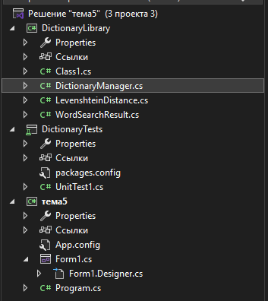
Итоговая структура
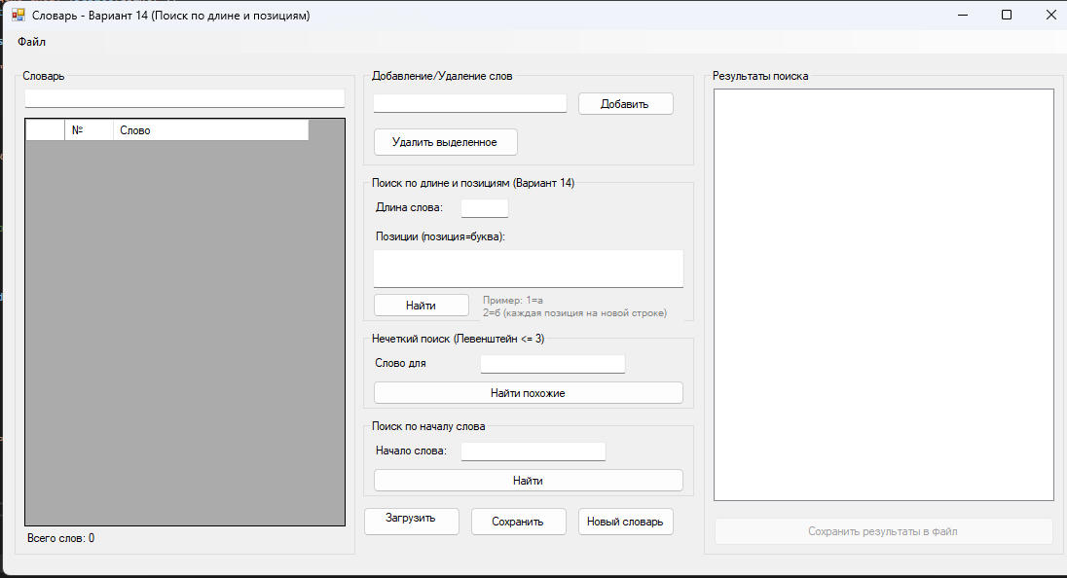
Рабочая форма
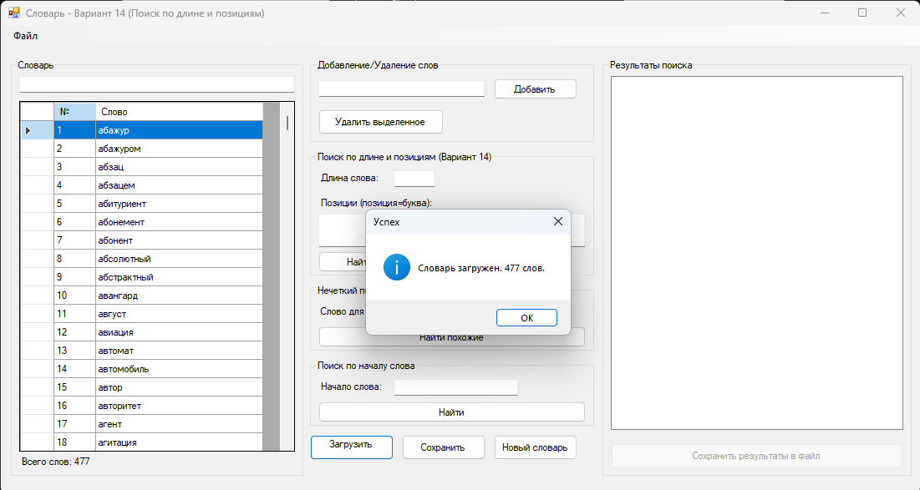
Успешная загрузка (файл с словами в папке)
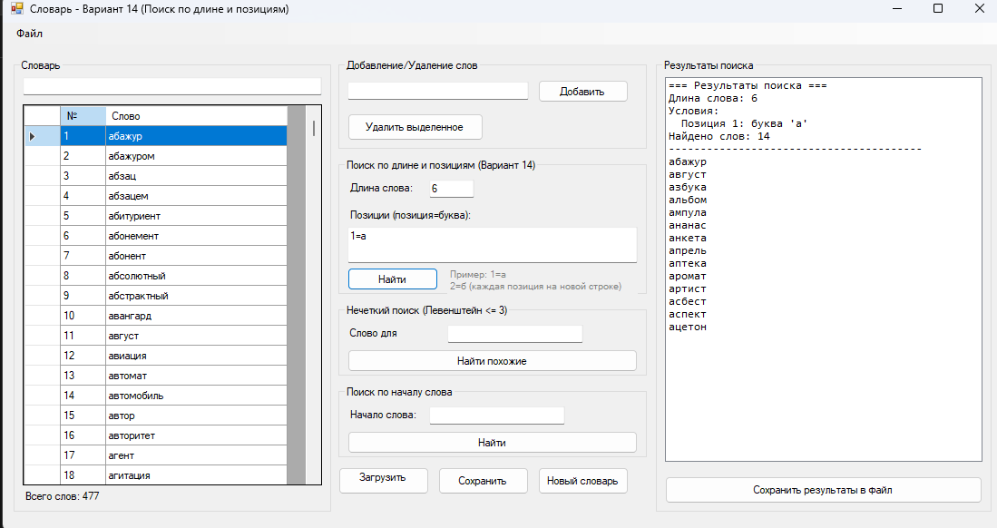
Длина слова 6, первая буква а
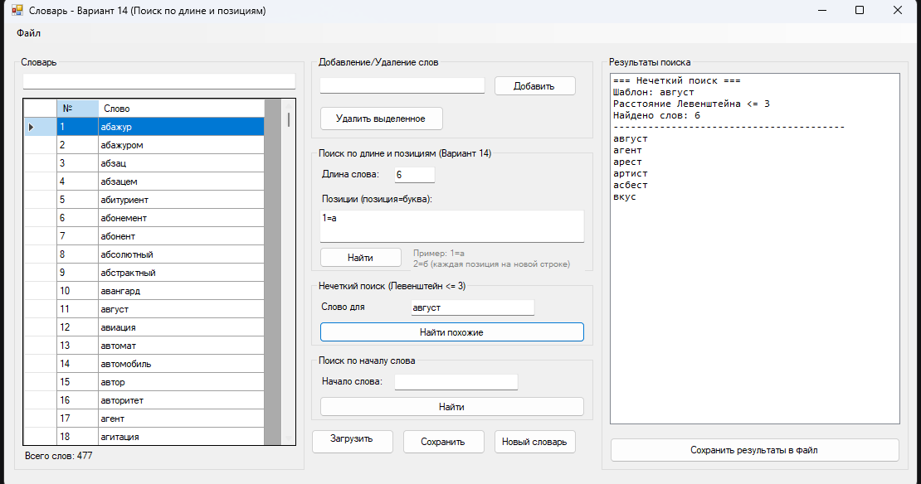
Похожие слова
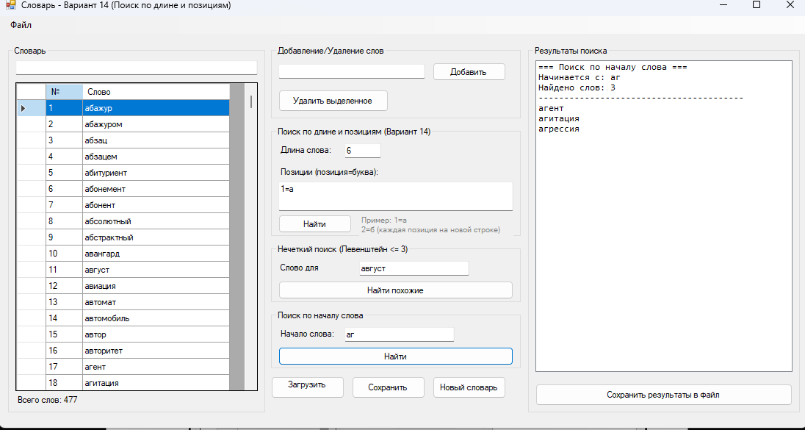
Начало слова аг
Код DicronaryManager.cs:
using System;
using System.Collections.Generic;
using System.IO;
using System.Text;
using System.Linq;

namespace DictionaryLibrary
{
public class DictionaryManager
{
private List<string> dictionary;
private string currentFilePath;
private bool isModified;
private string dictionaryName;

public DictionaryManager()
{
dictionary = new List<string>();
currentFilePath = "";
isModified = false;
dictionaryName = "Новый словарь";
}

public DictionaryManager(string filePath)
{
dictionary = new List<string>();
currentFilePath = filePath;
dictionaryName = Path.GetFileNameWithoutExtension(filePath);
LoadDictionary(filePath);
}

public int Count
{
get { return dictionary.Count; }
}

public bool IsModified
{
get { return isModified; }
}

public string DictionaryName
{
get { return dictionaryName; }
set { dictionaryName = value; }
}

public string CurrentFilePath
{
get { return currentFilePath; }
}

public List<string> GetAllWords()
{
return new List<string>(dictionary);
}

public List<string> GetWordsStartingWith(string prefix)
{
if (string.IsNullOrEmpty(prefix))
return new List<string>(dictionary);

return dictionary.Where(w => w.StartsWith(prefix, StringComparison.OrdinalIgnoreCase)).ToList();
}

/// <summary>
/// Загрузка словаря из файла с автоматическим определением кодировки
/// </summary>
public void LoadDictionary(string filePath)
{
try
{
dictionary.Clear();

Encoding encoding = GetFileEncoding(filePath);

using (StreamReader reader = new StreamReader(filePath, encoding))
{
string line;
while ((line = reader.ReadLine()) != null)
{
line = line.Trim().ToLower();
if (!string.IsNullOrEmpty(line) && !dictionary.Contains(line))
{
dictionary.Add(line);
}
}
}

dictionary.Sort();
currentFilePath = filePath;
dictionaryName = Path.GetFileNameWithoutExtension(filePath);
isModified = false;
}
catch (Exception ex)
{
throw new Exception($"Ошибка загрузки словаря: {ex.Message}");
}
}

/// <summary>
/// Определение кодировки файла
/// </summary>
private Encoding GetFileEncoding(string filePath)
{
// Сначала пробуем UTF-8 с BOM
byte[] bom = new byte[4];
using (FileStream fs = new FileStream(filePath, FileMode.Open, FileAccess.Read))
{
fs.Read(bom, 0, 4);
}

// Проверка BOM
if (bom[0] == 0xEF && bom[1] == 0xBB && bom[2] == 0xBF)
return Encoding.UTF8;

if (bom[0] == 0xFF && bom[1] == 0xFE)
return Encoding.Unicode;

if (bom[0] == 0xFE && bom[1] == 0xFF)
return Encoding.BigEndianUnicode;

// Для русского языка чаще всего используется Windows-1251
try
{
string content1251;
using (StreamReader reader = new StreamReader(filePath, Encoding.GetEncoding(1251)))
{
content1251 = reader.ReadToEnd();
}

// Проверяем наличие русских букв
if (System.Text.RegularExpressions.Regex.IsMatch(content1251, @"[а-яА-Я]"))
{
return Encoding.GetEncoding(1251);
}
}
catch { }

// По умолчанию UTF-8
return Encoding.UTF8;
}

/// <summary>
/// Сохранение словаря в файл в UTF-8
/// </summary>
public void SaveDictionary(string filePath)
{
try
{
using (StreamWriter writer = new StreamWriter(filePath, false, Encoding.UTF8))
{
foreach (string word in dictionary)
{
writer.WriteLine(word);
}
}

currentFilePath = filePath;
dictionaryName = Path.GetFileNameWithoutExtension(filePath);
isModified = false;
}
catch (Exception ex)
{
throw new Exception($"Ошибка сохранения словаря: {ex.Message}");
}
}

/// <summary>
/// Добавление слова в словарь
/// </summary>
public bool AddWord(string word)
{
if (string.IsNullOrWhiteSpace(word))
return false;

string lowerWord = word.Trim().ToLower();

if (dictionary.Contains(lowerWord))
return false;

dictionary.Add(lowerWord);
dictionary.Sort();
isModified = true;
return true;
}

/// <summary>
/// Удаление слова из словаря
/// </summary>
public bool RemoveWord(string word)
{
string lowerWord = word.Trim().ToLower();

if (dictionary.Remove(lowerWord))
{
isModified = true;
return true;
}

return false;
}

/// <summary>
/// Поиск слов по длине и позициям букв (Вариант 14)
/// </summary>
public WordSearchResult FindByLengthAndPositions(int length, Dictionary<int, char> positions)
{
WordSearchResult result = new WordSearchResult();

string pattern = $"Длина: {length}, Позиции: ";
foreach (var pos in positions)
{
pattern += $"{pos.Key + 1}={pos.Value} ";
}
result.SearchPattern = pattern;

foreach (string word in dictionary)
{
if (word.Length != length)
continue;

bool matches = true;

foreach (var pos in positions)
{
int position = pos.Key;
char expectedChar = pos.Value;

if (position >= word.Length || word[position] != expectedChar)
{
matches = false;
break;
}
}

if (matches)
{
result.AddWord(word);
}
}

result.Sort();
return result;
}

/// <summary>
/// Поиск слов по длине и позициям с несколькими вариантами букв
/// </summary>
public WordSearchResult FindByLengthAndMultiplePositions(int length, Dictionary<int, List<char>> positions)
{
WordSearchResult result = new WordSearchResult();

foreach (string word in dictionary)
{
if (word.Length != length)
continue;

bool matches = true;

foreach (var pos in positions)
{
int position = pos.Key;
List<char> allowedChars = pos.Value;

if (position >= word.Length || !allowedChars.Contains(word[position]))
{
matches = false;
break;
}
}

if (matches)
{
result.AddWord(word);
}
}

result.Sort();
return result;
}

/// <summary>
/// Нечеткий поиск слов с расстоянием Левенштейна не более 3
/// </summary>
public WordSearchResult FuzzySearch(string pattern, int maxDistance = 3)
{
WordSearchResult result = new WordSearchResult(pattern);

foreach (string word in dictionary)
{
if (LevenshteinDistance.IsWithinDistance(word, pattern, maxDistance))
{
result.AddWord(word);
}
}

result.Sort();
return result;
}

/// <summary>
/// Поиск по началу слова
/// </summary>
public WordSearchResult SearchByPrefix(string prefix)
{
WordSearchResult result = new WordSearchResult($"Начинается с: {prefix}");

foreach (string word in dictionary)
{
if (word.StartsWith(prefix, StringComparison.OrdinalIgnoreCase))
{
result.AddWord(word);
}
}

result.Sort();
return result;
}

/// <summary>
/// Сохранение результатов поиска в файл
/// </summary>
public void SaveSearchResult(WordSearchResult result, string filePath)
{
try
{
using (StreamWriter writer = new StreamWriter(filePath, false, Encoding.UTF8))
{
writer.WriteLine($"Результаты поиска");
writer.WriteLine($"Дата: {result.SearchTime}");
writer.WriteLine($"Условие: {result.SearchPattern}");
writer.WriteLine($"Найдено слов: {result.Count}");
writer.WriteLine(new string('-', 50));

for (int i = 0; i < result.FoundWords.Count; i++)
{
writer.WriteLine($"{i + 1,4}. {result.FoundWords[i]}");
}
}
}
catch (Exception ex)
{
throw new Exception($"Ошибка сохранения результатов: {ex.Message}");
}
}

/// <summary>
/// Проверка наличия слова в словаре
/// </summary>
public bool Contains(string word)
{
return dictionary.Contains(word.Trim().ToLower());
}

/// <summary>
/// Создание нового словаря
/// </summary>
public void CreateNewDictionary()
{
dictionary.Clear();
dictionaryName = "Новый словарь";
currentFilePath = "";
isModified = false;
}
}
}
Код Levesthtein.cs:
using System;

namespace DictionaryLibrary
{
/// <summary>
/// Класс для вычисления расстояния Левенштейна
/// </summary>
public static class LevenshteinDistance
{
/// <summary>
/// Вычисление расстояния Левенштейна между двумя строками
/// </summary>
public static int Compute(string s, string t)
{
if (string.IsNullOrEmpty(s))
{
return string.IsNullOrEmpty(t) ? 0 : t.Length;
}

if (string.IsNullOrEmpty(t))
{
return s.Length;
}

int n = s.Length;
int m = t.Length;
int[,] d = new int[n + 1, m + 1];

// Инициализация
for (int i = 0; i <= n; d[i, 0] = i++) ;
for (int j = 0; j <= m; d[0, j] = j++) ;

// Вычисление
for (int i = 1; i <= n; i++)
{
for (int j = 1; j <= m; j++)
{
int cost = (t[j - 1] == s[i - 1]) ? 0 : 1;
d[i, j] = Math.Min(
Math.Min(d[i - 1, j] + 1, d[i, j - 1] + 1),
d[i - 1, j - 1] + cost);
}
}

return d[n, m];
}

/// <summary>
/// Проверка, является ли расстояние Левенштейна не более maxDistance
/// </summary>
public static bool IsWithinDistance(string word, string pattern, int maxDistance)
{
return Compute(word, pattern) <= maxDistance;
}
}
}
Код WordSearchResult.cs:
using System;
using System.Collections.Generic;

namespace DictionaryLibrary
{
/// <summary>
/// Класс для хранения результатов поиска
/// </summary>
public class WordSearchResult
{
private List<string> foundWords;
private string searchPattern;
private DateTime searchTime;

public WordSearchResult()
{
foundWords = new List<string>();
searchPattern = "";
searchTime = DateTime.Now;
}

public WordSearchResult(string pattern)
{
foundWords = new List<string>();
searchPattern = pattern;
searchTime = DateTime.Now;
}

public List<string> FoundWords
{
get { return foundWords; }
set { foundWords = value; }
}

public string SearchPattern
{
get { return searchPattern; }
set { searchPattern = value; }
}

public DateTime SearchTime
{
get { return searchTime; }
set { searchTime = value; }
}

public int Count
{
get { return foundWords.Count; }
}

public void AddWord(string word)
{
if (!foundWords.Contains(word))
{
foundWords.Add(word);
}
}

public void AddRange(IEnumerable<string> words)
{
foreach (string word in words)
{
AddWord(word);
}
}

public void Sort()
{
foundWords.Sort();
}

public override string ToString()
{
return $"Поиск: {searchPattern} - Найдено: {Count} слов";
}
}
}
Код Form1.cs:
using System;
using System.Collections.Generic;
using System.Drawing;
using System.Windows.Forms;
using DictionaryLibrary;

namespace DictionaryApp
{
public partial class Form1 : Form
{
private DictionaryManager dictionaryManager;
private string currentDictionaryPath;

public Form1()
{
InitializeComponent();
dictionaryManager = new DictionaryManager();
currentDictionaryPath = "";

// Настройка DataGridView
SetupDataGridView();
}

private void SetupDataGridView()
{
dataGridViewWords.AutoGenerateColumns = false;
dataGridViewWords.Columns.Clear();

DataGridViewTextBoxColumn colNumber = new DataGridViewTextBoxColumn();
colNumber.HeaderText = "№";
colNumber.Name = "Number";
colNumber.Width = 50;
colNumber.ReadOnly = true;
dataGridViewWords.Columns.Add(colNumber);

DataGridViewTextBoxColumn colWord = new DataGridViewTextBoxColumn();
colWord.HeaderText = "Слово";
colWord.Name = "Word";
colWord.Width = 200;
colWord.DataPropertyName = "Word";
dataGridViewWords.Columns.Add(colWord);
}

private void UpdateWordsList()
{
dataGridViewWords.Rows.Clear();

List<string> words = dictionaryManager.GetAllWords();
for (int i = 0; i < words.Count; i++)
{
dataGridViewWords.Rows.Add((i + 1).ToString(), words[i]);
}

labelWordCount.Text = $"Всего слов: {dictionaryManager.Count}";
}

// === Загрузка словаря ===
private void btnLoadDictionary_Click(object sender, EventArgs e)
{
using (OpenFileDialog openFileDialog = new OpenFileDialog())
{
openFileDialog.Filter = "Текстовые файлы (*.txt)|*.txt|Все файлы (*.*)|*.*";
openFileDialog.Title = "Выберите файл словаря";

if (openFileDialog.ShowDialog() == DialogResult.OK)
{
try
{
dictionaryManager.LoadDictionary(openFileDialog.FileName);
currentDictionaryPath = openFileDialog.FileName;
UpdateWordsList();

// Очистка результатов поиска
listBoxResults.Items.Clear();
ClearSearchInputs();

MessageBox.Show($"Словарь загружен. {dictionaryManager.Count} слов.",
"Успех", MessageBoxButtons.OK, MessageBoxIcon.Information);
}
catch (Exception ex)
{
MessageBox.Show($"Ошибка загрузки: {ex.Message}",
"Ошибка", MessageBoxButtons.OK, MessageBoxIcon.Error);
}
}
}
}

// === Сохранение словаря ===
private void btnSaveDictionary_Click(object sender, EventArgs e)
{
if (!dictionaryManager.IsModified)
{
MessageBox.Show("Словарь не был изменен.", "Информация",
MessageBoxButtons.OK, MessageBoxIcon.Information);
return;
}

DialogResult result = MessageBox.Show("Сохранить изменения в словаре?",
"Подтверждение", MessageBoxButtons.YesNo, MessageBoxIcon.Question);

if (result == DialogResult.Yes)
{
try
{
if (string.IsNullOrEmpty(currentDictionaryPath))
{
using (SaveFileDialog saveDialog = new SaveFileDialog())
{
saveDialog.Filter = "Текстовые файлы (*.txt)|*.txt";
saveDialog.DefaultExt = "txt";

if (saveDialog.ShowDialog() == DialogResult.OK)
{
dictionaryManager.SaveDictionary(saveDialog.FileName);
currentDictionaryPath = saveDialog.FileName;
}
}
}
else
{
dictionaryManager.SaveDictionary(currentDictionaryPath);
}

MessageBox.Show("Словарь сохранен.", "Успех",
MessageBoxButtons.OK, MessageBoxIcon.Information);
}
catch (Exception ex)
{
MessageBox.Show($"Ошибка сохранения: {ex.Message}",
"Ошибка", MessageBoxButtons.OK, MessageBoxIcon.Error);
}
}
}

// === Добавление слова ===
private void btnAddWord_Click(object sender, EventArgs e)
{
string word = textBoxNewWord.Text.Trim();

if (string.IsNullOrEmpty(word))
{
MessageBox.Show("Введите слово для добавления.", "Ошибка",
MessageBoxButtons.OK, MessageBoxIcon.Warning);
return;
}

if (dictionaryManager.AddWord(word))
{
UpdateWordsList();
textBoxNewWord.Clear();
MessageBox.Show($"Слово \"{word}\" добавлено.", "Успех",
MessageBoxButtons.OK, MessageBoxIcon.Information);
}
else
{
MessageBox.Show($"Слово \"{word}\" уже есть в словаре.", "Ошибка",
MessageBoxButtons.OK, MessageBoxIcon.Warning);
}
}

// === Удаление слова ===
private void btnRemoveWord_Click(object sender, EventArgs e)
{
if (dataGridViewWords.SelectedRows.Count > 0)
{
string word = dataGridViewWords.SelectedRows[0].Cells["Word"].Value.ToString();

DialogResult result = MessageBox.Show($"Удалить слово \"{word}\"?",
"Подтверждение", MessageBoxButtons.YesNo, MessageBoxIcon.Question);

if (result == DialogResult.Yes)
{
if (dictionaryManager.RemoveWord(word))
{
UpdateWordsList();
MessageBox.Show($"Слово \"{word}\" удалено.", "Успех",
MessageBoxButtons.OK, MessageBoxIcon.Information);
}
}
}
else
{
MessageBox.Show("Выберите слово для удаления.", "Ошибка",
MessageBoxButtons.OK, MessageBoxIcon.Warning);
}
}

// === Поиск по Варианту 14 ===
private void btnSearch_Click(object sender, EventArgs e)
{
try
{
// Получение длины слова
if (!int.TryParse(textBoxLength.Text, out int length) || length <= 0)
{
MessageBox.Show("Введите корректную длину слова (положительное число).",
"Ошибка", MessageBoxButtons.OK, MessageBoxIcon.Warning);
return;
}

// Сбор позиций и букв
Dictionary<int, char> positions = new Dictionary<int, char>();

string[] lines = textBoxPositions.Lines;
foreach (string line in lines)
{
if (string.IsNullOrWhiteSpace(line))
continue;

string[] parts = line.Split('=');
if (parts.Length == 2)
{
if (int.TryParse(parts[0], out int position) && parts[1].Length == 1)
{
// Позиции с 0 (пользователь вводит с 1)
positions[position - 1] = parts[1][0];
}
}
}

if (positions.Count == 0)
{
MessageBox.Show("Введите условия поиска (позиция=буква, например: 1=а).",
"Ошибка", MessageBoxButtons.OK, MessageBoxIcon.Warning);
return;
}

// Поиск
WordSearchResult result = dictionaryManager.FindByLengthAndPositions(length, positions);

// Отображение результатов
listBoxResults.Items.Clear();
listBoxResults.Items.Add($"=== Результаты поиска ===");
listBoxResults.Items.Add($"Длина слова: {length}");
listBoxResults.Items.Add($"Условия: ");
foreach (var pos in positions)
{
listBoxResults.Items.Add($" Позиция {pos.Key + 1}: буква '{pos.Value}'");
}
listBoxResults.Items.Add($"Найдено слов: {result.Count}");
listBoxResults.Items.Add(new string('-', 40));

foreach (string word in result.FoundWords)
{
listBoxResults.Items.Add(word);
}

if (result.Count == 0)
{
listBoxResults.Items.Add("(Ничего не найдено)");
}

// Сохраняем результат для возможного сохранения в файл
currentSearchResult = result;
btnSaveResults.Enabled = result.Count > 0;
}
catch (Exception ex)
{
MessageBox.Show($"Ошибка поиска: {ex.Message}",
"Ошибка", MessageBoxButtons.OK, MessageBoxIcon.Error);
}
}

private WordSearchResult currentSearchResult;

// === Нечеткий поиск ===
private void btnFuzzySearch_Click(object sender, EventArgs e)
{
string pattern = textBoxFuzzyPattern.Text.Trim();

if (string.IsNullOrEmpty(pattern))
{
MessageBox.Show("Введите слово для нечеткого поиска.", "Ошибка",
MessageBoxButtons.OK, MessageBoxIcon.Warning);
return;
}

try
{
WordSearchResult result = dictionaryManager.FuzzySearch(pattern, 3);

listBoxResults.Items.Clear();
listBoxResults.Items.Add($"=== Нечеткий поиск ===");
listBoxResults.Items.Add($"Шаблон: {pattern}");
listBoxResults.Items.Add($"Расстояние Левенштейна <= 3");
listBoxResults.Items.Add($"Найдено слов: {result.Count}");
listBoxResults.Items.Add(new string('-', 40));

foreach (string word in result.FoundWords)
{
listBoxResults.Items.Add(word);
}

if (result.Count == 0)
{
listBoxResults.Items.Add("(Ничего не найдено)");
}

currentSearchResult = result;
btnSaveResults.Enabled = result.Count > 0;
}
catch (Exception ex)
{
MessageBox.Show($"Ошибка поиска: {ex.Message}",
"Ошибка", MessageBoxButtons.OK, MessageBoxIcon.Error);
}
}

// === Поиск по началу слова ===
private void btnPrefixSearch_Click(object sender, EventArgs e)
{
string prefix = textBoxPrefix.Text.Trim();

if (string.IsNullOrEmpty(prefix))
{
MessageBox.Show("Введите начало слова для поиска.", "Ошибка",
MessageBoxButtons.OK, MessageBoxIcon.Warning);
return;
}

try
{
WordSearchResult result = dictionaryManager.SearchByPrefix(prefix);

listBoxResults.Items.Clear();
listBoxResults.Items.Add($"=== Поиск по началу слова ===");
listBoxResults.Items.Add($"Начинается с: {prefix}");
listBoxResults.Items.Add($"Найдено слов: {result.Count}");
listBoxResults.Items.Add(new string('-', 40));

foreach (string word in result.FoundWords)
{
listBoxResults.Items.Add(word);
}

if (result.Count == 0)
{
listBoxResults.Items.Add("(Ничего не найдено)");
}

currentSearchResult = result;
btnSaveResults.Enabled = result.Count > 0;
}
catch (Exception ex)
{
MessageBox.Show($"Ошибка поиска: {ex.Message}",
"Ошибка", MessageBoxButtons.OK, MessageBoxIcon.Error);
}
}

// === Сохранение результатов в файл ===
private void btnSaveResults_Click(object sender, EventArgs e)
{
if (currentSearchResult == null || currentSearchResult.Count == 0)
{
MessageBox.Show("Нет результатов для сохранения.", "Ошибка",
MessageBoxButtons.OK, MessageBoxIcon.Warning);
return;
}

using (SaveFileDialog saveDialog = new SaveFileDialog())
{
saveDialog.Filter = "Текстовые файлы (*.txt)|*.txt";
saveDialog.DefaultExt = "txt";
saveDialog.FileName = "search_results.txt";

if (saveDialog.ShowDialog() == DialogResult.OK)
{
try
{
dictionaryManager.SaveSearchResult(currentSearchResult, saveDialog.FileName);
MessageBox.Show($"Результаты сохранены в:\n{saveDialog.FileName}",
"Успех", MessageBoxButtons.OK, MessageBoxIcon.Information);
}
catch (Exception ex)
{
MessageBox.Show($"Ошибка сохранения: {ex.Message}",
"Ошибка", MessageBoxButtons.OK, MessageBoxIcon.Error);
}
}
}
}

// === Создание нового словаря ===
private void btnNewDictionary_Click(object sender, EventArgs e)
{
if (dictionaryManager.IsModified)
{
DialogResult result = MessageBox.Show("Словарь был изменен. Сохранить изменения?",
"Подтверждение", MessageBoxButtons.YesNoCancel, MessageBoxIcon.Question);

if (result == DialogResult.Yes)
{
btnSaveDictionary_Click(sender, e);
}
else if (result == DialogResult.Cancel)
{
return;
}
}

dictionaryManager.CreateNewDictionary();
currentDictionaryPath = "";
UpdateWordsList();
listBoxResults.Items.Clear();
ClearSearchInputs();

MessageBox.Show("Создан новый пустой словарь.", "Информация",
MessageBoxButtons.OK, MessageBoxIcon.Information);
}

private void ClearSearchInputs()
{
textBoxLength.Clear();
textBoxPositions.Clear();
textBoxFuzzyPattern.Clear();
textBoxPrefix.Clear();
}

// === Обновление списка при вводе ===
private void textBoxSearch_TextChanged(object sender, EventArgs e)
{
string filter = textBoxSearch.Text.Trim().ToLower();

if (string.IsNullOrEmpty(filter))
{
UpdateWordsList();
return;
}

dataGridViewWords.Rows.Clear();

List<string> words = dictionaryManager.GetAllWords();
int index = 1;

foreach (string word in words)
{
if (word.Contains(filter))
{
dataGridViewWords.Rows.Add(index.ToString(), word);
index++;
}
}

labelWordCount.Text = $"Показано: {index - 1} из {dictionaryManager.Count}";
}
}
}
Код Form1.Designer.cs:
using System.Windows.Forms;

namespace DictionaryApp
{
partial class Form1
{
private System.ComponentModel.IContainer components = null;

// Элементы управления
private MenuStrip menuStrip;
private ToolStripMenuItem fileMenu;
private ToolStripMenuItem loadMenu;
private ToolStripMenuItem saveMenu;
private ToolStripMenuItem newMenu;
private ToolStripMenuItem exitMenu;

private GroupBox groupBoxDictionary;
private DataGridView dataGridViewWords;
private Label labelWordCount;
private TextBox textBoxSearch;

private GroupBox groupBoxAddRemove;
private TextBox textBoxNewWord;
private Button btnAddWord;
private Button btnRemoveWord;

private GroupBox groupBoxSearch;
private Label labelLength;
private TextBox textBoxLength;
private Label labelPositions;
private TextBox textBoxPositions;
private Button btnSearch;

private GroupBox groupBoxFuzzy;
private Label labelFuzzyPattern;
private TextBox textBoxFuzzyPattern;
private Button btnFuzzySearch;

private GroupBox groupBoxPrefix;
private Label labelPrefix;
private TextBox textBoxPrefix;
private Button btnPrefixSearch;

private GroupBox groupBoxResults;
private ListBox listBoxResults;
private Button btnSaveResults;

private Button btnLoadDictionary;
private Button btnSaveDictionary;
private Button btnNewDictionary;
private Label labelInfo;

protected override void Dispose(bool disposing)
{
if (disposing && (components != null))
{
components.Dispose();
}
base.Dispose(disposing);
}

private void InitializeComponent()
{
this.menuStrip = new MenuStrip();
this.fileMenu = new ToolStripMenuItem();
this.newMenu = new ToolStripMenuItem();
this.loadMenu = new ToolStripMenuItem();
this.saveMenu = new ToolStripMenuItem();
this.exitMenu = new ToolStripMenuItem();

this.groupBoxDictionary = new GroupBox();
this.dataGridViewWords = new DataGridView();
this.labelWordCount = new Label();
this.textBoxSearch = new TextBox();

this.groupBoxAddRemove = new GroupBox();
this.textBoxNewWord = new TextBox();
this.btnAddWord = new Button();
this.btnRemoveWord = new Button();

this.groupBoxSearch = new GroupBox();
this.labelLength = new Label();
this.textBoxLength = new TextBox();
this.labelPositions = new Label();
this.textBoxPositions = new TextBox();
this.btnSearch = new Button();
this.labelInfo = new Label();

this.groupBoxFuzzy = new GroupBox();
this.labelFuzzyPattern = new Label();
this.textBoxFuzzyPattern = new TextBox();
this.btnFuzzySearch = new Button();

this.groupBoxPrefix = new GroupBox();
this.labelPrefix = new Label();
this.textBoxPrefix = new TextBox();
this.btnPrefixSearch = new Button();

this.groupBoxResults = new GroupBox();
this.listBoxResults = new ListBox();
this.btnSaveResults = new Button();

this.btnLoadDictionary = new Button();
this.btnSaveDictionary = new Button();
this.btnNewDictionary = new Button();

this.menuStrip.SuspendLayout();
this.groupBoxDictionary.SuspendLayout();
((System.ComponentModel.ISupportInitialize)(this.dataGridViewWords)).BeginInit();
this.groupBoxAddRemove.SuspendLayout();
this.groupBoxSearch.SuspendLayout();
this.groupBoxFuzzy.SuspendLayout();
this.groupBoxPrefix.SuspendLayout();
this.groupBoxResults.SuspendLayout();
this.SuspendLayout();

// menuStrip
this.menuStrip.Items.AddRange(new ToolStripItem[] { this.fileMenu });
this.menuStrip.Location = new System.Drawing.Point(0, 0);
this.menuStrip.Name = "menuStrip";
this.menuStrip.Size = new System.Drawing.Size(1100, 24);
this.menuStrip.TabIndex = 0;

// fileMenu
this.fileMenu.Text = "Файл";
this.fileMenu.DropDownItems.AddRange(new ToolStripItem[] {
this.newMenu, this.loadMenu, this.saveMenu, this.exitMenu });

this.newMenu.Text = "Новый словарь";
this.newMenu.Click += new System.EventHandler(this.btnNewDictionary_Click);

this.loadMenu.Text = "Загрузить словарь";
this.loadMenu.Click += new System.EventHandler(this.btnLoadDictionary_Click);

this.saveMenu.Text = "Сохранить словарь";
this.saveMenu.Click += new System.EventHandler(this.btnSaveDictionary_Click);

this.exitMenu.Text = "Выход";
this.exitMenu.Click += (s, e) => this.Close();

// groupBoxDictionary
this.groupBoxDictionary.Controls.Add(this.dataGridViewWords);
this.groupBoxDictionary.Controls.Add(this.labelWordCount);
this.groupBoxDictionary.Controls.Add(this.textBoxSearch);
this.groupBoxDictionary.Location = new System.Drawing.Point(12, 40);
this.groupBoxDictionary.Size = new System.Drawing.Size(350, 500);
this.groupBoxDictionary.Text = "Словарь";

// textBoxSearch
this.textBoxSearch.Location = new System.Drawing.Point(10, 20);
this.textBoxSearch.Size = new System.Drawing.Size(330, 20);
this.textBoxSearch.TextChanged += new System.EventHandler(this.textBoxSearch_TextChanged);

// dataGridViewWords
this.dataGridViewWords.Location = new System.Drawing.Point(10, 50);
this.dataGridViewWords.Size = new System.Drawing.Size(330, 420);
this.dataGridViewWords.AllowUserToAddRows = false;
this.dataGridViewWords.AllowUserToDeleteRows = false;
this.dataGridViewWords.ReadOnly = true;
this.dataGridViewWords.SelectionMode = DataGridViewSelectionMode.FullRowSelect;

// labelWordCount
this.labelWordCount.Text = "Всего слов: 0";
this.labelWordCount.Location = new System.Drawing.Point(10, 475);
this.labelWordCount.Size = new System.Drawing.Size(330, 20);

// groupBoxAddRemove
this.groupBoxAddRemove.Controls.Add(this.textBoxNewWord);
this.groupBoxAddRemove.Controls.Add(this.btnAddWord);
this.groupBoxAddRemove.Controls.Add(this.btnRemoveWord);
this.groupBoxAddRemove.Location = new System.Drawing.Point(370, 40);
this.groupBoxAddRemove.Size = new System.Drawing.Size(340, 100);
this.groupBoxAddRemove.Text = "Добавление/Удаление слов";

this.textBoxNewWord.Location = new System.Drawing.Point(10, 25);
this.textBoxNewWord.Size = new System.Drawing.Size(200, 20);

this.btnAddWord.Text = "Добавить";
this.btnAddWord.Location = new System.Drawing.Point(220, 23);
this.btnAddWord.Size = new System.Drawing.Size(100, 25);
this.btnAddWord.Click += new System.EventHandler(this.btnAddWord_Click);

this.btnRemoveWord.Text = "Удалить выделенное";
this.btnRemoveWord.Location = new System.Drawing.Point(10, 60);
this.btnRemoveWord.Size = new System.Drawing.Size(150, 30);
this.btnRemoveWord.Click += new System.EventHandler(this.btnRemoveWord_Click);

// groupBoxSearch
this.groupBoxSearch.Controls.Add(this.labelLength);
this.groupBoxSearch.Controls.Add(this.textBoxLength);
this.groupBoxSearch.Controls.Add(this.labelPositions);
this.groupBoxSearch.Controls.Add(this.textBoxPositions);
this.groupBoxSearch.Controls.Add(this.btnSearch);
this.groupBoxSearch.Controls.Add(this.labelInfo);
this.groupBoxSearch.Location = new System.Drawing.Point(370, 150);
this.groupBoxSearch.Size = new System.Drawing.Size(340, 150);
this.groupBoxSearch.Text = "Поиск по длине и позициям (Вариант 14)";

this.labelLength.Text = "Длина слова:";
this.labelLength.Location = new System.Drawing.Point(10, 25);
this.labelLength.Size = new System.Drawing.Size(80, 20);

this.textBoxLength.Location = new System.Drawing.Point(100, 23);
this.textBoxLength.Size = new System.Drawing.Size(50, 20);

this.labelPositions.Text = "Позиции (позиция=буква):";
this.labelPositions.Location = new System.Drawing.Point(10, 55);
this.labelPositions.Size = new System.Drawing.Size(150, 20);

this.textBoxPositions.Location = new System.Drawing.Point(10, 75);
this.textBoxPositions.Size = new System.Drawing.Size(320, 20);
this.textBoxPositions.Multiline = true;
this.textBoxPositions.Height = 40;

this.btnSearch.Text = "Найти";
this.btnSearch.Location = new System.Drawing.Point(10, 120);
this.btnSearch.Size = new System.Drawing.Size(100, 25);
this.btnSearch.Click += new System.EventHandler(this.btnSearch_Click);

this.labelInfo.Text = "Пример: 1=а\n2=б (каждая позиция на новой строке)";
this.labelInfo.Location = new System.Drawing.Point(120, 120);
this.labelInfo.Size = new System.Drawing.Size(210, 30);
this.labelInfo.Font = new System.Drawing.Font("Microsoft Sans Serif", 7F);
this.labelInfo.ForeColor = System.Drawing.Color.Gray;

// groupBoxFuzzy
this.groupBoxFuzzy.Controls.Add(this.labelFuzzyPattern);
this.groupBoxFuzzy.Controls.Add(this.textBoxFuzzyPattern);
this.groupBoxFuzzy.Controls.Add(this.btnFuzzySearch);
this.groupBoxFuzzy.Location = new System.Drawing.Point(370, 310);
this.groupBoxFuzzy.Size = new System.Drawing.Size(340, 80);
this.groupBoxFuzzy.Text = "Нечеткий поиск (Левенштейн <= 3)";

this.labelFuzzyPattern.Text = "Слово для поиска:";
this.labelFuzzyPattern.Location = new System.Drawing.Point(10, 25);
this.labelFuzzyPattern.Size = new System.Drawing.Size(100, 20);

this.textBoxFuzzyPattern.Location = new System.Drawing.Point(120, 23);
this.textBoxFuzzyPattern.Size = new System.Drawing.Size(150, 20);

this.btnFuzzySearch.Text = "Найти похожие";
this.btnFuzzySearch.Location = new System.Drawing.Point(10, 50);
this.btnFuzzySearch.Size = new System.Drawing.Size(320, 25);
this.btnFuzzySearch.Click += new System.EventHandler(this.btnFuzzySearch_Click);

// groupBoxPrefix
this.groupBoxPrefix.Controls.Add(this.labelPrefix);
this.groupBoxPrefix.Controls.Add(this.textBoxPrefix);
this.groupBoxPrefix.Controls.Add(this.btnPrefixSearch);
this.groupBoxPrefix.Location = new System.Drawing.Point(370, 400);
this.groupBoxPrefix.Size = new System.Drawing.Size(340, 80);
this.groupBoxPrefix.Text = "Поиск по началу слова";

this.labelPrefix.Text = "Начало слова:";
this.labelPrefix.Location = new System.Drawing.Point(10, 25);
this.labelPrefix.Size = new System.Drawing.Size(80, 20);

this.textBoxPrefix.Location = new System.Drawing.Point(100, 23);
this.textBoxPrefix.Size = new System.Drawing.Size(150, 20);

this.btnPrefixSearch.Text = "Найти";
this.btnPrefixSearch.Location = new System.Drawing.Point(10, 50);
this.btnPrefixSearch.Size = new System.Drawing.Size(320, 25);
this.btnPrefixSearch.Click += new System.EventHandler(this.btnPrefixSearch_Click);

// groupBoxResults
this.groupBoxResults.Controls.Add(this.listBoxResults);
this.groupBoxResults.Controls.Add(this.btnSaveResults);
this.groupBoxResults.Location = new System.Drawing.Point(720, 40);
this.groupBoxResults.Size = new System.Drawing.Size(370, 500);
this.groupBoxResults.Text = "Результаты поиска";

this.listBoxResults.Location = new System.Drawing.Point(10, 20);
this.listBoxResults.Size = new System.Drawing.Size(350, 430);
this.listBoxResults.Font = new System.Drawing.Font("Consolas", 9F);

this.btnSaveResults.Text = "Сохранить результаты в файл";
this.btnSaveResults.Location = new System.Drawing.Point(10, 460);
this.btnSaveResults.Size = new System.Drawing.Size(350, 30);
this.btnSaveResults.Enabled = false;
this.btnSaveResults.Click += new System.EventHandler(this.btnSaveResults_Click);

// Кнопки управления
this.btnLoadDictionary = new Button();
this.btnSaveDictionary = new Button();
this.btnNewDictionary = new Button();

this.btnLoadDictionary.Text = "Загрузить словарь";
this.btnLoadDictionary.Location = new System.Drawing.Point(370, 490);
this.btnLoadDictionary.Size = new System.Drawing.Size(100, 30);
this.btnLoadDictionary.Click += new System.EventHandler(this.btnLoadDictionary_Click);

this.btnSaveDictionary.Text = "Сохранить";
this.btnSaveDictionary.Location = new System.Drawing.Point(480, 490);
this.btnSaveDictionary.Size = new System.Drawing.Size(100, 30);
this.btnSaveDictionary.Click += new System.EventHandler(this.btnSaveDictionary_Click);

this.btnNewDictionary.Text = "Новый словарь";
this.btnNewDictionary.Location = new System.Drawing.Point(590, 490);
this.btnNewDictionary.Size = new System.Drawing.Size(100, 30);
this.btnNewDictionary.Click += new System.EventHandler(this.btnNewDictionary_Click);

// Form1
this.ClientSize = new System.Drawing.Size(1100, 560);
this.Controls.Add(this.groupBoxDictionary);
this.Controls.Add(this.groupBoxAddRemove);
this.Controls.Add(this.groupBoxSearch);
this.Controls.Add(this.groupBoxFuzzy);
this.Controls.Add(this.groupBoxPrefix);
this.Controls.Add(this.groupBoxResults);
this.Controls.Add(this.btnLoadDictionary);
this.Controls.Add(this.btnSaveDictionary);
this.Controls.Add(this.btnNewDictionary);
this.Controls.Add(this.menuStrip);
this.Text = "Словарь - Вариант 14 (Поиск по длине и позициям)";
this.StartPosition = FormStartPosition.CenterScreen;

this.menuStrip.ResumeLayout(false);
this.groupBoxDictionary.ResumeLayout(false);
((System.ComponentModel.ISupportInitialize)(this.dataGridViewWords)).EndInit();
this.groupBoxAddRemove.ResumeLayout(false);
this.groupBoxSearch.ResumeLayout(false);
this.groupBoxFuzzy.ResumeLayout(false);
this.groupBoxPrefix.ResumeLayout(false);
this.groupBoxResults.ResumeLayout(false);
this.ResumeLayout(false);
this.PerformLayout();
}
}
}

Тема 6
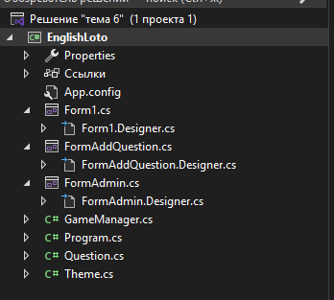
Итоговая структура
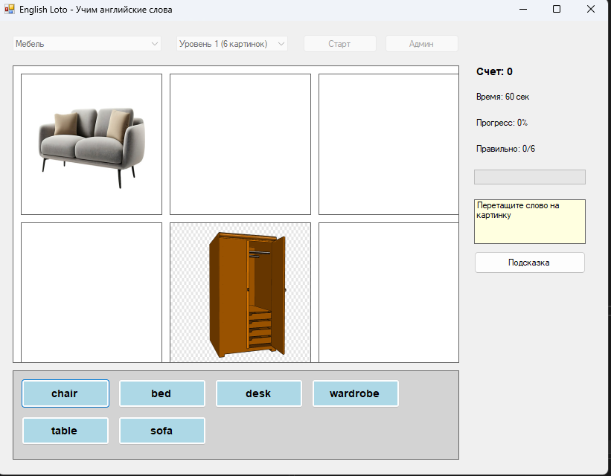
Рабочая форма (добавил не так много картинок но все работает)
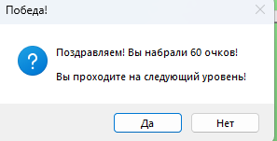
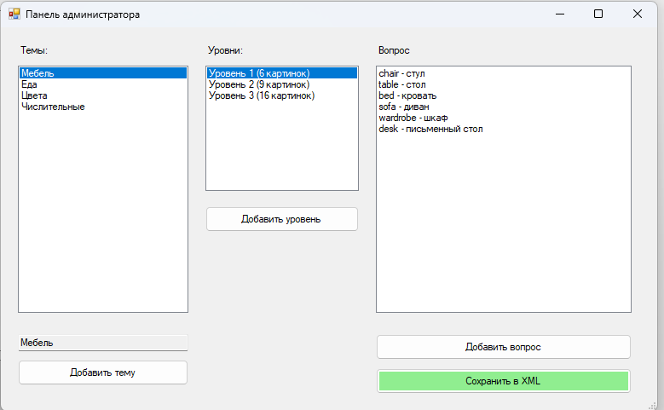
Панель админа
Код Form1.cs:
using System;
using System.Collections.Generic;
using System.Drawing;
using System.Windows.Forms;
using тема_6;

namespace EnglishLoto
{
public partial class Form1 : Form
{
private GameManager gameManager;
private List<PictureBox> pictureBoxes;
private List<Button> wordButtons;
private Question currentDraggedQuestion;
private Button currentDraggedButton;
private Timer gameTimer;
private int timeRemaining;
private bool gameActive;

public Form1()
{
InitializeComponent();
gameManager = new GameManager();
pictureBoxes = new List<PictureBox>();
wordButtons = new List<Button>();
gameTimer = new Timer();
gameTimer.Interval = 1000;
gameTimer.Tick += GameTimer_Tick;

// Загрузка данных
if (!gameManager.LoadXML())
{
MessageBox.Show("Не удалось загрузить данные игры!", "Ошибка",
MessageBoxButtons.OK, MessageBoxIcon.Error);
}

LoadThemes();
}

private void LoadThemes()
{
comboBoxTheme.Items.Clear();
foreach (Theme theme in gameManager.Themes)
{
comboBoxTheme.Items.Add(theme);
}
if (comboBoxTheme.Items.Count > 0)
comboBoxTheme.SelectedIndex = 0;
}

private void comboBoxTheme_SelectedIndexChanged(object sender, EventArgs e)
{
Theme selectedTheme = comboBoxTheme.SelectedItem as Theme;
if (selectedTheme != null)
{
LoadLevels(selectedTheme);
}
}

private void LoadLevels(Theme theme)
{
comboBoxLevel.Items.Clear();
foreach (int level in theme.GetLevels())
{
Level levelObj = theme.GetLevel(level);
comboBoxLevel.Items.Add($"Уровень {level} ({levelObj.CardsCount} картинок)");
}
if (comboBoxLevel.Items.Count > 0)
comboBoxLevel.SelectedIndex = 0;
}

private void btnStartGame_Click(object sender, EventArgs e)
{
if (comboBoxTheme.SelectedItem == null || comboBoxLevel.SelectedItem == null)
{
MessageBox.Show("Выберите тему и уровень!", "Внимание",
MessageBoxButtons.OK, MessageBoxIcon.Warning);
return;
}

Theme theme = comboBoxTheme.SelectedItem as Theme;
int level = comboBoxLevel.SelectedIndex + 1;

gameManager.StartGame(theme.Id, level);
SetupGameBoard();

// Запуск таймера (60 секунд)
timeRemaining = 60;
lblTimer.Text = $"Время: {timeRemaining} сек";
gameTimer.Start();
gameActive = true;

btnStartGame.Enabled = false;
btnAdmin.Enabled = false;
comboBoxTheme.Enabled = false;
comboBoxLevel.Enabled = false;
}

private void SetupGameBoard()
{
// Очистка игрового поля
foreach (var pb in pictureBoxes) pb.Dispose();
foreach (var btn in wordButtons) btn.Dispose();
pictureBoxes.Clear();
wordButtons.Clear();
panelGame.Controls.Clear();

List<Question> questions = gameManager.CurrentQuestions;
int cardsCount = questions.Count;

// Определяем размер сетки
int cols = 0, rows = 0;
switch (cardsCount)
{
case 6:
cols = 3; rows = 2;
break;
case 9:
cols = 3; rows = 3;
break;
case 16:
cols = 4; rows = 4;
break;
}

int cellWidth = panelGame.Width / cols - 10;
int cellHeight = panelGame.Height / rows - 10;

// Создаем картинки
List<Question> shuffledQuestions = new List<Question>(questions);
Shuffle(shuffledQuestions);

for (int i = 0; i < cardsCount; i++)
{
int row = i / cols;
int col = i % cols;

PictureBox pb = new PictureBox();
pb.Image = shuffledQuestions[i].Image;
pb.SizeMode = PictureBoxSizeMode.StretchImage;
pb.BorderStyle = BorderStyle.FixedSingle;
pb.BackColor = Color.White;
pb.Location = new Point(col * (cellWidth + 10) + 10, row * (cellHeight + 10) + 10);
pb.Size = new Size(cellWidth, cellHeight);
pb.Tag = shuffledQuestions[i];
pb.AllowDrop = true;
pb.DragEnter += PictureBox_DragEnter;
pb.DragDrop += PictureBox_DragDrop;

panelGame.Controls.Add(pb);
pictureBoxes.Add(pb);
}

// Создаем кнопки со словами
List<string> words = new List<string>();
foreach (Question q in questions)
{
words.Add(q.EnglishWord);
}
Shuffle(words);

int buttonWidth = 120;
int buttonHeight = 40;
int buttonsPerRow = 4;
int startY = panelWords.Height - 100;

for (int i = 0; i < words.Count; i++)
{
Button btn = new Button();
btn.Text = words[i];
btn.Size = new Size(buttonWidth, buttonHeight);
btn.BackColor = Color.LightBlue;
btn.Font = new Font("Arial", 10, FontStyle.Bold);
btn.Tag = words[i];
btn.MouseDown += WordButton_MouseDown;

int row = i / buttonsPerRow;
int col = i % buttonsPerRow;
btn.Location = new Point(col * (buttonWidth + 10) + 10, row * (buttonHeight + 10) + 10);

panelWords.Controls.Add(btn);
wordButtons.Add(btn);
}

// Обновляем счет
UpdateScore();
}

private void Shuffle<T>(List<T> list)
{
Random rng = new Random();
int n = list.Count;
while (n > 1)
{
n--;
int k = rng.Next(n + 1);
T value = list[k];
list[k] = list[n];
list[n] = value;
}
}

private void WordButton_MouseDown(object sender, MouseEventArgs e)
{
Button btn = sender as Button;
if (btn != null && gameActive)
{
currentDraggedButton = btn;
btn.DoDragDrop(btn.Text, DragDropEffects.Move);
}
}

private void PictureBox_DragEnter(object sender, DragEventArgs e)
{
if (e.Data.GetDataPresent(DataFormats.Text))
{
e.Effect = DragDropEffects.Move;
}
}

private void PictureBox_DragDrop(object sender, DragEventArgs e)
{
PictureBox pb = sender as PictureBox;
if (pb != null && gameActive)
{
string droppedWord = e.Data.GetData(DataFormats.Text).ToString();
Question question = pb.Tag as Question;

if (question != null && !string.IsNullOrEmpty(droppedWord))
{
bool isCorrect = gameManager.CheckAnswer(question, droppedWord);

if (isCorrect)
{
pb.BackColor = Color.LightGreen;
pb.BorderStyle = BorderStyle.Fixed3D;

// Удаляем использованную кнопку
if (currentDraggedButton != null)
{
currentDraggedButton.Enabled = false;
currentDraggedButton.BackColor = Color.Gray;
currentDraggedButton.Text = "✓";
}

UpdateScore();

// Проверка окончания игры
if (gameManager.GetCorrectAnswersCount() == gameManager.CurrentQuestions.Count)
{
EndGame(true);
}
}
else
{
pb.BackColor = Color.LightCoral;
Timer t = new Timer();
t.Interval = 500;
t.Tick += (s, ev) => {
pb.BackColor = Color.White;
t.Stop();
};
t.Start();

// Показываем подсказку
ShowHint(question);
}
}
}
}

private void ShowHint(Question question)
{
lblHint.Text = $"Подсказка: {question.Hint} ({question.RussianWord})";
Timer t = new Timer();
t.Interval = 3000;
t.Tick += (s, ev) => {
lblHint.Text = "Перетащите слово на картинку";
t.Stop();
};
t.Start();
}

private void UpdateScore()
{
lblScore.Text = $"Счет: {gameManager.CurrentScore}";
lblProgress.Text = $"Прогресс: {gameManager.GetProgressPercent()}%";
lblCorrectCount.Text = $"Правильно: {gameManager.GetCorrectAnswersCount()}/{gameManager.CurrentQuestions.Count}";

progressBar.Value = gameManager.GetProgressPercent();
}

private void GameTimer_Tick(object sender, EventArgs e)
{
timeRemaining--;
lblTimer.Text = $"Время: {timeRemaining} сек";

if (timeRemaining <= 0)
{
EndGame(false);
}
}

private void EndGame(bool won)
{
gameTimer.Stop();
gameActive = false;

string message;
if (won)
{
message = $"Поздравляем! Вы набрали {gameManager.CurrentScore} очков!\n";

if (gameManager.CanGoToNextLevel())
{
message += "\nВы проходите на следующий уровень!";
DialogResult result = MessageBox.Show(message, "Победа!",
MessageBoxButtons.YesNo, MessageBoxIcon.Question);

if (result == DialogResult.Yes)
{
if (gameManager.GoToNextLevel())
{
SetupGameBoard();
timeRemaining = 60;
gameTimer.Start();
gameActive = true;
return;
}
else
{
message += "\nЭто был последний уровень! Игра завершена!";
}
}
}
else
{
message += $"\nВам нужно набрать {gameManager.GetCurrentLevel().RequiredScore}% для перехода на следующий уровень.";
}
}
else
{
message = "Время вышло! Игра окончена.";
}

MessageBox.Show(message, won ? "Победа!" : "Время вышло",
MessageBoxButtons.OK, MessageBoxIcon.Information);

// Возврат в главное меню
btnStartGame.Enabled = true;
btnAdmin.Enabled = true;
comboBoxTheme.Enabled = true;
comboBoxLevel.Enabled = true;
panelGame.Controls.Clear();
panelWords.Controls.Clear();
pictureBoxes.Clear();
wordButtons.Clear();
lblHint.Text = "Выберите тему и уровень, нажмите Старт";
}

private void btnAdmin_Click(object sender, EventArgs e)
{
if (gameActive)
{
DialogResult result = MessageBox.Show("Игра активна! Выйти в меню администратора?",
"Предупреждение", MessageBoxButtons.YesNo, MessageBoxIcon.Warning);
if (result != DialogResult.Yes) return;

gameTimer.Stop();
gameActive = false;
}

FormAdmin adminForm = new FormAdmin(gameManager);
adminForm.ShowDialog();

// Перезагружаем данные после закрытия админки
gameManager.LoadXML();
LoadThemes();
}

private void btnHint_Click(object sender, EventArgs e)
{
if (!gameActive)
{
MessageBox.Show("Сначала начните игру!", "Внимание",
MessageBoxButtons.OK, MessageBoxIcon.Information);
return;
}

// Показываем подсказку для любого неотвеченного вопроса
foreach (PictureBox pb in pictureBoxes)
{
if (pb.BackColor != Color.LightGreen)
{
Question q = pb.Tag as Question;
if (q != null)
{
ShowHint(q);
return;
}
}
}

MessageBox.Show("Все вопросы уже решены!", "Информация",
MessageBoxButtons.OK, MessageBoxIcon.Information);
}
}
}
Код Form1.designer.cs:
using System;
using System.Drawing;
using System.Windows.Forms;

namespace EnglishLoto
{
partial class Form1
{
private System.ComponentModel.IContainer components = null;

// Явно указываем полные имена типов
private System.Windows.Forms.ComboBox comboBoxTheme;
private System.Windows.Forms.ComboBox comboBoxLevel;
private System.Windows.Forms.Button btnStartGame;
private System.Windows.Forms.Button btnAdmin;
private System.Windows.Forms.Panel panelGame;
private System.Windows.Forms.Panel panelWords;
private System.Windows.Forms.Label lblScore;
private System.Windows.Forms.Label lblTimer;
private System.Windows.Forms.Label lblProgress;
private System.Windows.Forms.Label lblCorrectCount;
private System.Windows.Forms.ProgressBar progressBar;
private System.Windows.Forms.Label lblHint;
private System.Windows.Forms.Button btnHint;

protected override void Dispose(bool disposing)
{
if (disposing && (components != null))
{
components.Dispose();
}
base.Dispose(disposing);
}

private void InitializeComponent()
{
this.comboBoxTheme = new System.Windows.Forms.ComboBox();
this.comboBoxLevel = new System.Windows.Forms.ComboBox();
this.btnStartGame = new System.Windows.Forms.Button();
this.btnAdmin = new System.Windows.Forms.Button();
this.panelGame = new System.Windows.Forms.Panel();
this.panelWords = new System.Windows.Forms.Panel();
this.lblScore = new System.Windows.Forms.Label();
this.lblTimer = new System.Windows.Forms.Label();
this.lblProgress = new System.Windows.Forms.Label();
this.lblCorrectCount = new System.Windows.Forms.Label();
this.progressBar = new System.Windows.Forms.ProgressBar();
this.lblHint = new System.Windows.Forms.Label();
this.btnHint = new System.Windows.Forms.Button();
this.SuspendLayout();

// comboBoxTheme
this.comboBoxTheme.DropDownStyle = System.Windows.Forms.ComboBoxStyle.DropDownList;
this.comboBoxTheme.Location = new System.Drawing.Point(20, 20);
this.comboBoxTheme.Size = new System.Drawing.Size(200, 21);
this.comboBoxTheme.SelectedIndexChanged += new System.EventHandler(this.comboBoxTheme_SelectedIndexChanged);

// comboBoxLevel
this.comboBoxLevel.DropDownStyle = System.Windows.Forms.ComboBoxStyle.DropDownList;
this.comboBoxLevel.Location = new System.Drawing.Point(240, 20);
this.comboBoxLevel.Size = new System.Drawing.Size(150, 21);

// btnStartGame
this.btnStartGame.Location = new System.Drawing.Point(410, 18);
this.btnStartGame.Size = new System.Drawing.Size(100, 25);
this.btnStartGame.Text = "Старт";
this.btnStartGame.UseVisualStyleBackColor = true;
this.btnStartGame.Click += new System.EventHandler(this.btnStartGame_Click);

// btnAdmin
this.btnAdmin.Location = new System.Drawing.Point(520, 18);
this.btnAdmin.Size = new System.Drawing.Size(100, 25);
this.btnAdmin.Text = "Админ";
this.btnAdmin.UseVisualStyleBackColor = true;
this.btnAdmin.Click += new System.EventHandler(this.btnAdmin_Click);

// panelGame
this.panelGame.Location = new System.Drawing.Point(20, 60);
this.panelGame.Size = new System.Drawing.Size(600, 400);
this.panelGame.BorderStyle = System.Windows.Forms.BorderStyle.FixedSingle;
this.panelGame.BackColor = System.Drawing.Color.White;

// panelWords
this.panelWords.Location = new System.Drawing.Point(20, 470);
this.panelWords.Size = new System.Drawing.Size(600, 120);
this.panelWords.BorderStyle = System.Windows.Forms.BorderStyle.FixedSingle;
this.panelWords.BackColor = System.Drawing.Color.LightGray;
this.panelWords.AutoScroll = true;

// lblScore
this.lblScore.Location = new System.Drawing.Point(640, 60);
this.lblScore.Size = new System.Drawing.Size(150, 25);
this.lblScore.Text = "Счет: 0";
this.lblScore.Font = new System.Drawing.Font("Arial", 10, System.Drawing.FontStyle.Bold);

// lblTimer
this.lblTimer.Location = new System.Drawing.Point(640, 95);
this.lblTimer.Size = new System.Drawing.Size(150, 25);
this.lblTimer.Text = "Время: 60 сек";

// lblProgress
this.lblProgress.Location = new System.Drawing.Point(640, 130);
this.lblProgress.Size = new System.Drawing.Size(150, 25);
this.lblProgress.Text = "Прогресс: 0%";

// lblCorrectCount
this.lblCorrectCount.Location = new System.Drawing.Point(640, 165);
this.lblCorrectCount.Size = new System.Drawing.Size(150, 25);
this.lblCorrectCount.Text = "Правильно: 0/0";

// progressBar
this.progressBar.Location = new System.Drawing.Point(640, 200);
this.progressBar.Size = new System.Drawing.Size(150, 20);

// lblHint
this.lblHint.Location = new System.Drawing.Point(640, 240);
this.lblHint.Size = new System.Drawing.Size(150, 60);
this.lblHint.Text = "Перетащите слово на картинку";
this.lblHint.BackColor = System.Drawing.Color.LightYellow;
this.lblHint.BorderStyle = System.Windows.Forms.BorderStyle.FixedSingle;

// btnHint
this.btnHint.Location = new System.Drawing.Point(640, 310);
this.btnHint.Size = new System.Drawing.Size(150, 30);
this.btnHint.Text = "Подсказка";
this.btnHint.UseVisualStyleBackColor = true;
this.btnHint.Click += new System.EventHandler(this.btnHint_Click);

// Form1
this.ClientSize = new System.Drawing.Size(820, 610);
this.Controls.Add(this.comboBoxTheme);
this.Controls.Add(this.comboBoxLevel);
this.Controls.Add(this.btnStartGame);
this.Controls.Add(this.btnAdmin);
this.Controls.Add(this.panelGame);
this.Controls.Add(this.panelWords);
this.Controls.Add(this.lblScore);
this.Controls.Add(this.lblTimer);
this.Controls.Add(this.lblProgress);
this.Controls.Add(this.lblCorrectCount);
this.Controls.Add(this.progressBar);
this.Controls.Add(this.lblHint);
this.Controls.Add(this.btnHint);
this.Text = "English Loto - Учим английские слова";
this.StartPosition = System.Windows.Forms.FormStartPosition.CenterScreen;
this.ResumeLayout(false);
this.PerformLayout();
}
}
}
Код FormAddQuestion.cs:
using System;
using System.Drawing;
using System.Windows.Forms;
using System.IO;

namespace EnglishLoto
{
public partial class FormAddQuestion : Form
{
private string selectedImagePath = "";

public string ImagePath { get; private set; }
public string EnglishWord { get; private set; }
public string RussianWord { get; private set; }
public string Hint { get; private set; }

public FormAddQuestion()
{
InitializeComponent();
}

private void btnSelectImage_Click(object sender, EventArgs e)
{
using (OpenFileDialog ofd = new OpenFileDialog())
{
ofd.Filter = "Image Files|*.jpg;*.jpeg;*.png;*.gif;*.bmp";
ofd.Title = "Выберите изображение";

if (ofd.ShowDialog() == DialogResult.OK)
{
selectedImagePath = ofd.FileName;
lblImagePath.Text = Path.GetFileName(selectedImagePath);

// Предпросмотр
try
{
pictureBoxPreview.Image = Image.FromFile(selectedImagePath);
pictureBoxPreview.SizeMode = PictureBoxSizeMode.StretchImage;
}
catch { }
}
}
}

private void btnOK_Click(object sender, EventArgs e)
{
if (string.IsNullOrEmpty(txtEnglish.Text))
{
MessageBox.Show("Введите английское слово!", "Ошибка",
MessageBoxButtons.OK, MessageBoxIcon.Warning);
return;
}

if (string.IsNullOrEmpty(txtRussian.Text))
{
MessageBox.Show("Введите русский перевод!", "Ошибка",
MessageBoxButtons.OK, MessageBoxIcon.Warning);
return;
}

if (string.IsNullOrEmpty(selectedImagePath))
{
MessageBox.Show("Выберите изображение!", "Ошибка",
MessageBoxButtons.OK, MessageBoxIcon.Warning);
return;
}

ImagePath = selectedImagePath;
EnglishWord = txtEnglish.Text.Trim();
RussianWord = txtRussian.Text.Trim();
Hint = txtHint.Text.Trim();

this.DialogResult = DialogResult.OK;
this.Close();
}

private void btnCancel_Click(object sender, EventArgs e)
{
this.DialogResult = DialogResult.Cancel;
this.Close();
}
}
}
Код FormAddQuestion.cs:
using System;
using System.Drawing;
using System.Windows.Forms;

namespace EnglishLoto
{
partial class FormAddQuestion
{
private System.ComponentModel.IContainer components = null;

private System.Windows.Forms.TextBox txtEnglish;
private System.Windows.Forms.TextBox txtRussian;
private System.Windows.Forms.TextBox txtHint;
private System.Windows.Forms.Button btnSelectImage;
private System.Windows.Forms.Button btnOK;
private System.Windows.Forms.Button btnCancel;
private System.Windows.Forms.Label lblEnglish;
private System.Windows.Forms.Label lblRussian;
private System.Windows.Forms.Label lblHint;
private System.Windows.Forms.Label lblImage;
private System.Windows.Forms.Label lblImagePath;
private System.Windows.Forms.PictureBox pictureBoxPreview;

protected override void Dispose(bool disposing)
{
if (disposing && (components != null))
{
components.Dispose();
}
base.Dispose(disposing);
}

private void InitializeComponent()
{
this.txtEnglish = new System.Windows.Forms.TextBox();
this.txtRussian = new System.Windows.Forms.TextBox();
this.txtHint = new System.Windows.Forms.TextBox();
this.btnSelectImage = new System.Windows.Forms.Button();
this.btnOK = new System.Windows.Forms.Button();
this.btnCancel = new System.Windows.Forms.Button();
this.lblEnglish = new System.Windows.Forms.Label();
this.lblRussian = new System.Windows.Forms.Label();
this.lblHint = new System.Windows.Forms.Label();
this.lblImage = new System.Windows.Forms.Label();
this.lblImagePath = new System.Windows.Forms.Label();
this.pictureBoxPreview = new System.Windows.Forms.PictureBox();
((System.ComponentModel.ISupportInitialize)(this.pictureBoxPreview)).BeginInit();
this.SuspendLayout();

// lblEnglish
this.lblEnglish.Text = "Английское слово:";
this.lblEnglish.Location = new System.Drawing.Point(20, 20);
this.lblEnglish.Size = new System.Drawing.Size(120, 20);

// txtEnglish
this.txtEnglish.Location = new System.Drawing.Point(150, 17);
this.txtEnglish.Size = new System.Drawing.Size(200, 20);

// lblRussian
this.lblRussian.Text = "Русский перевод:";
this.lblRussian.Location = new System.Drawing.Point(20, 55);
this.lblRussian.Size = new System.Drawing.Size(120, 20);

// txtRussian
this.txtRussian.Location = new System.Drawing.Point(150, 52);
this.txtRussian.Size = new System.Drawing.Size(200, 20);

// lblHint
this.lblHint.Text = "Подсказка:";
this.lblHint.Location = new System.Drawing.Point(20, 90);
this.lblHint.Size = new System.Drawing.Size(120, 20);

// txtHint
this.txtHint.Location = new System.Drawing.Point(150, 87);
this.txtHint.Size = new System.Drawing.Size(200, 60);
this.txtHint.Multiline = true;

// lblImage
this.lblImage.Text = "Изображение:";
this.lblImage.Location = new System.Drawing.Point(20, 165);
this.lblImage.Size = new System.Drawing.Size(120, 20);

// btnSelectImage
this.btnSelectImage.Location = new System.Drawing.Point(150, 162);
this.btnSelectImage.Size = new System.Drawing.Size(100, 25);
this.btnSelectImage.Text = "Выбрать";
this.btnSelectImage.UseVisualStyleBackColor = true;
this.btnSelectImage.Click += new System.EventHandler(this.btnSelectImage_Click);

// lblImagePath
this.lblImagePath.Location = new System.Drawing.Point(260, 165);
this.lblImagePath.Size = new System.Drawing.Size(200, 20);
this.lblImagePath.Text = "";

// pictureBoxPreview
this.pictureBoxPreview.Location = new System.Drawing.Point(150, 200);
this.pictureBoxPreview.Size = new System.Drawing.Size(200, 150);
this.pictureBoxPreview.BorderStyle = System.Windows.Forms.BorderStyle.FixedSingle;

// btnOK
this.btnOK.Location = new System.Drawing.Point(100, 370);
this.btnOK.Size = new System.Drawing.Size(100, 30);
this.btnOK.Text = "OK";
this.btnOK.UseVisualStyleBackColor = true;
this.btnOK.Click += new System.EventHandler(this.btnOK_Click);

// btnCancel
this.btnCancel.Location = new System.Drawing.Point(220, 370);
this.btnCancel.Size = new System.Drawing.Size(100, 30);
this.btnCancel.Text = "Отмена";
this.btnCancel.UseVisualStyleBackColor = true;
this.btnCancel.Click += new System.EventHandler(this.btnCancel_Click);

// FormAddQuestion
this.ClientSize = new System.Drawing.Size(500, 420);
this.Controls.Add(this.txtEnglish);
this.Controls.Add(this.txtRussian);
this.Controls.Add(this.txtHint);
this.Controls.Add(this.btnSelectImage);
this.Controls.Add(this.btnOK);
this.Controls.Add(this.btnCancel);
this.Controls.Add(this.lblEnglish);
this.Controls.Add(this.lblRussian);
this.Controls.Add(this.lblHint);
this.Controls.Add(this.lblImage);
this.Controls.Add(this.lblImagePath);
this.Controls.Add(this.pictureBoxPreview);
this.Text = "Добавление вопроса";
this.StartPosition = System.Windows.Forms.FormStartPosition.CenterParent;
((System.ComponentModel.ISupportInitialize)(this.pictureBoxPreview)).EndInit();
this.ResumeLayout(false);
this.PerformLayout();
}
}
}
Код Form1admim.cs:
using System;
using System.Collections.Generic;
using System.Drawing;
using System.IO;
using System.Windows.Forms;
using System.Xml;

namespace EnglishLoto
{
public partial class FormAdmin : Form
{
private GameManager gameManager;
private string xmlPath;

public FormAdmin(GameManager manager)
{
InitializeComponent();
gameManager = manager;
xmlPath = Path.Combine(Application.StartupPath, "data", "questions.xml");
LoadThemes();
}

/// <summary>
/// Простой диалог ввода текста
/// </summary>
private string ShowInputDialog(string title, string prompt, string defaultValue = "")
{
Form dialog = new Form();
dialog.Text = title;
dialog.StartPosition = FormStartPosition.CenterParent;
dialog.Size = new Size(300, 150);
dialog.FormBorderStyle = FormBorderStyle.FixedDialog;
dialog.MaximizeBox = false;
dialog.MinimizeBox = false;

Label label = new Label();
label.Text = prompt;
label.Location = new Point(10, 20);
label.Size = new Size(260, 20);

TextBox textBox = new TextBox();
textBox.Text = defaultValue;
textBox.Location = new Point(10, 50);
textBox.Size = new Size(260, 20);

Button okButton = new Button();
okButton.Text = "OK";
okButton.Location = new Point(150, 85);
okButton.Size = new Size(70, 25);
okButton.DialogResult = DialogResult.OK;

Button cancelButton = new Button();
cancelButton.Text = "Отмена";
cancelButton.Location = new Point(230, 85);
cancelButton.Size = new Size(70, 25);
cancelButton.DialogResult = DialogResult.Cancel;

dialog.Controls.Add(label);
dialog.Controls.Add(textBox);
dialog.Controls.Add(okButton);
dialog.Controls.Add(cancelButton);

if (dialog.ShowDialog() == DialogResult.OK)
{
return textBox.Text;
}
return "";
}

private void LoadThemes()
{
listBoxThemes.Items.Clear();
foreach (Theme theme in gameManager.Themes)
{
listBoxThemes.Items.Add(theme);
}
}

private void listBoxThemes_SelectedIndexChanged(object sender, EventArgs e)
{
if (listBoxThemes.SelectedItem != null)
{
Theme theme = listBoxThemes.SelectedItem as Theme;
txtThemeName.Text = theme.Name;
LoadLevels(theme);
}
}

private void LoadLevels(Theme theme)
{
listBoxLevels.Items.Clear();
foreach (int level in theme.GetLevels())
{
Level levelObj = theme.GetLevel(level);
listBoxLevels.Items.Add($"Уровень {level} ({levelObj.CardsCount} картинок)");
}

if (listBoxLevels.Items.Count > 0)
listBoxLevels.SelectedIndex = 0;
}

private void listBoxLevels_SelectedIndexChanged(object sender, EventArgs e)
{
if (listBoxThemes.SelectedItem != null && listBoxLevels.SelectedItem != null)
{
Theme theme = listBoxThemes.SelectedItem as Theme;
int levelIndex = listBoxLevels.SelectedIndex + 1;
Level level = theme.GetLevel(levelIndex);

if (level != null)
{
LoadQuestions(level);
}
}
}

private void LoadQuestions(Level level)
{
listBoxQuestions.Items.Clear();
foreach (Question q in level.Questions)
{
listBoxQuestions.Items.Add($"{q.EnglishWord} - {q.RussianWord}");
}
}

private void btnAddTheme_Click(object sender, EventArgs e)
{
string themeName = ShowInputDialog("Добавление темы", "Введите название темы:", "");

if (!string.IsNullOrEmpty(themeName))
{
int newId = gameManager.Themes.Count + 1;
Theme newTheme = new Theme(themeName, newId);

// Добавляем три уровня
newTheme.AddLevel(1, 6, 80);
newTheme.AddLevel(2, 9, 85);
newTheme.AddLevel(3, 16, 90);

gameManager.Themes.Add(newTheme);
SaveToXML();
LoadThemes();
}
}

private void btnAddLevel_Click(object sender, EventArgs e)
{
if (listBoxThemes.SelectedItem == null)
{
MessageBox.Show("Сначала выберите тему!", "Ошибка",
MessageBoxButtons.OK, MessageBoxIcon.Warning);
return;
}

string levelNum = ShowInputDialog("Добавление уровня", "Введите номер уровня (1,2,3):", "");

if (int.TryParse(levelNum, out int levelNumber) && levelNumber >= 1 && levelNumber <= 3)
{
Theme theme = listBoxThemes.SelectedItem as Theme;

if (!theme.HasLevel(levelNumber))
{
int cardsCount = levelNumber == 1 ? 6 : (levelNumber == 2 ? 9 : 16);
int requiredScore = levelNumber == 1 ? 80 : (levelNumber == 2 ? 85 : 90);

theme.AddLevel(levelNumber, cardsCount, requiredScore);
SaveToXML();
LoadLevels(theme);
}
else
{
MessageBox.Show("Уровень уже существует!", "Ошибка",
MessageBoxButtons.OK, MessageBoxIcon.Warning);
}
}
}

private void btnAddQuestion_Click(object sender, EventArgs e)
{
if (listBoxThemes.SelectedItem == null || listBoxLevels.SelectedItem == null)
{
MessageBox.Show("Выберите тему и уровень!", "Ошибка",
MessageBoxButtons.OK, MessageBoxIcon.Warning);
return;
}

FormAddQuestion addForm = new FormAddQuestion();
if (addForm.ShowDialog() == DialogResult.OK)
{
Theme theme = listBoxThemes.SelectedItem as Theme;
int levelIndex = listBoxLevels.SelectedIndex + 1;

Question newQuestion = new Question(
addForm.ImagePath,
addForm.EnglishWord,
addForm.RussianWord,
addForm.Hint
);

theme.AddQuestion(levelIndex, newQuestion);
SaveToXML();

Level level = theme.GetLevel(levelIndex);
LoadQuestions(level);
}
}

private void btnSaveXML_Click(object sender, EventArgs e)
{
SaveToXML();
MessageBox.Show("Данные сохранены!", "Успех",
MessageBoxButtons.OK, MessageBoxIcon.Information);
}

private void SaveToXML()
{
try
{
// Создаем папку data, если её нет
string dataPath = Path.GetDirectoryName(xmlPath);
if (!Directory.Exists(dataPath))
{
Directory.CreateDirectory(dataPath);
}

XmlDocument doc = new XmlDocument();
XmlDeclaration decl = doc.CreateXmlDeclaration("1.0", "utf-8", null);
doc.AppendChild(decl);

XmlElement root = doc.CreateElement("game");
doc.AppendChild(root);

XmlElement gameinfo = doc.CreateElement("gameinfo");
root.AppendChild(gameinfo);

XmlElement name = doc.CreateElement("name");
name.InnerText = "English Loto";
gameinfo.AppendChild(name);

XmlElement version = doc.CreateElement("version");
version.InnerText = "1.0";
gameinfo.AppendChild(version);

XmlElement themes = doc.CreateElement("themes");
root.AppendChild(themes);

foreach (Theme theme in gameManager.Themes)
{
XmlElement themeElem = doc.CreateElement("theme");
themeElem.SetAttribute("name", theme.Name);
themeElem.SetAttribute("id", theme.Id.ToString());
themes.AppendChild(themeElem);

foreach (int levelNum in theme.GetLevels())
{
Level level = theme.GetLevel(levelNum);
XmlElement levelElem = doc.CreateElement("level");
levelElem.SetAttribute("level", levelNum.ToString());
levelElem.SetAttribute("cards", level.CardsCount.ToString());
levelElem.SetAttribute("required_score", level.RequiredScore.ToString());
themeElem.AppendChild(levelElem);

foreach (Question q in level.Questions)
{
XmlElement questionElem = doc.CreateElement("question");
levelElem.AppendChild(questionElem);

XmlElement imageElem = doc.CreateElement("image");
imageElem.InnerText = q.ImagePath;
questionElem.AppendChild(imageElem);

XmlElement englishElem = doc.CreateElement("english");
englishElem.InnerText = q.EnglishWord;
questionElem.AppendChild(englishElem);

XmlElement russianElem = doc.CreateElement("russian");
russianElem.InnerText = q.RussianWord;
questionElem.AppendChild(russianElem);

XmlElement hintElem = doc.CreateElement("hint");
hintElem.InnerText = q.Hint;
questionElem.AppendChild(hintElem);
}
}
}

doc.Save(xmlPath);
gameManager.LoadXML();
}
catch (Exception ex)
{
MessageBox.Show($"Ошибка сохранения: {ex.Message}", "Ошибка",
MessageBoxButtons.OK, MessageBoxIcon.Error);
}
}
}
}
Код FormAdmin.designer.cs:
using System;
using System.Drawing;
using System.Windows.Forms;

namespace EnglishLoto
{
partial class FormAdmin
{
private System.ComponentModel.IContainer components = null;

private System.Windows.Forms.ListBox listBoxThemes;
private System.Windows.Forms.ListBox listBoxLevels;
private System.Windows.Forms.ListBox listBoxQuestions;
private System.Windows.Forms.TextBox txtThemeName;
private System.Windows.Forms.Button btnAddTheme;
private System.Windows.Forms.Button btnAddLevel;
private System.Windows.Forms.Button btnAddQuestion;
private System.Windows.Forms.Button btnSaveXML;
private System.Windows.Forms.Label lblTheme;
private System.Windows.Forms.Label lblLevel;
private System.Windows.Forms.Label lblQuestion;

protected override void Dispose(bool disposing)
{
if (disposing && (components != null))
{
components.Dispose();
}
base.Dispose(disposing);
}

private void InitializeComponent()
{
this.listBoxThemes = new System.Windows.Forms.ListBox();
this.listBoxLevels = new System.Windows.Forms.ListBox();
this.listBoxQuestions = new System.Windows.Forms.ListBox();
this.txtThemeName = new System.Windows.Forms.TextBox();
this.btnAddTheme = new System.Windows.Forms.Button();
this.btnAddLevel = new System.Windows.Forms.Button();
this.btnAddQuestion = new System.Windows.Forms.Button();
this.btnSaveXML = new System.Windows.Forms.Button();
this.lblTheme = new System.Windows.Forms.Label();
this.lblLevel = new System.Windows.Forms.Label();
this.lblQuestion = new System.Windows.Forms.Label();
this.SuspendLayout();

// lblTheme
this.lblTheme.Text = "Темы:";
this.lblTheme.Location = new System.Drawing.Point(20, 20);
this.lblTheme.Size = new System.Drawing.Size(50, 20);

// listBoxThemes
this.listBoxThemes.Location = new System.Drawing.Point(20, 45);
this.listBoxThemes.Size = new System.Drawing.Size(200, 300);
this.listBoxThemes.SelectedIndexChanged += new System.EventHandler(this.listBoxThemes_SelectedIndexChanged);

// lblLevel
this.lblLevel.Text = "Уровни:";
this.lblLevel.Location = new System.Drawing.Point(240, 20);
this.lblLevel.Size = new System.Drawing.Size(50, 20);

// listBoxLevels
this.listBoxLevels.Location = new System.Drawing.Point(240, 45);
this.listBoxLevels.Size = new System.Drawing.Size(180, 150);
this.listBoxLevels.SelectedIndexChanged += new System.EventHandler(this.listBoxLevels_SelectedIndexChanged);

// lblQuestion
this.lblQuestion.Text = "Вопросы:";
this.lblQuestion.Location = new System.Drawing.Point(440, 20);
this.lblQuestion.Size = new System.Drawing.Size(50, 20);

// listBoxQuestions
this.listBoxQuestions.Location = new System.Drawing.Point(440, 45);
this.listBoxQuestions.Size = new System.Drawing.Size(300, 300);

// txtThemeName
this.txtThemeName.Location = new System.Drawing.Point(20, 360);
this.txtThemeName.Size = new System.Drawing.Size(200, 20);
this.txtThemeName.ReadOnly = true;

// btnAddTheme
this.btnAddTheme.Location = new System.Drawing.Point(20, 390);
this.btnAddTheme.Size = new System.Drawing.Size(200, 30);
this.btnAddTheme.Text = "Добавить тему";
this.btnAddTheme.UseVisualStyleBackColor = true;
this.btnAddTheme.Click += new System.EventHandler(this.btnAddTheme_Click);

// btnAddLevel
this.btnAddLevel.Location = new System.Drawing.Point(240, 210);
this.btnAddLevel.Size = new System.Drawing.Size(180, 30);
this.btnAddLevel.Text = "Добавить уровень";
this.btnAddLevel.UseVisualStyleBackColor = true;
this.btnAddLevel.Click += new System.EventHandler(this.btnAddLevel_Click);

// btnAddQuestion
this.btnAddQuestion.Location = new System.Drawing.Point(440, 360);
this.btnAddQuestion.Size = new System.Drawing.Size(300, 30);
this.btnAddQuestion.Text = "Добавить вопрос";
this.btnAddQuestion.UseVisualStyleBackColor = true;
this.btnAddQuestion.Click += new System.EventHandler(this.btnAddQuestion_Click);

// btnSaveXML
this.btnSaveXML.Location = new System.Drawing.Point(440, 400);
this.btnSaveXML.Size = new System.Drawing.Size(300, 30);
this.btnSaveXML.Text = "Сохранить в XML";
this.btnSaveXML.BackColor = System.Drawing.Color.LightGreen;
this.btnSaveXML.UseVisualStyleBackColor = false;
this.btnSaveXML.Click += new System.EventHandler(this.btnSaveXML_Click);

// FormAdmin
this.ClientSize = new System.Drawing.Size(770, 450);
this.Controls.Add(this.listBoxThemes);
this.Controls.Add(this.listBoxLevels);
this.Controls.Add(this.listBoxQuestions);
this.Controls.Add(this.txtThemeName);
this.Controls.Add(this.btnAddTheme);
this.Controls.Add(this.btnAddLevel);
this.Controls.Add(this.btnAddQuestion);
this.Controls.Add(this.btnSaveXML);
this.Controls.Add(this.lblTheme);
this.Controls.Add(this.lblLevel);
this.Controls.Add(this.lblQuestion);
this.Text = "Панель администратора";
this.StartPosition = System.Windows.Forms.FormStartPosition.CenterParent;
this.ResumeLayout(false);
this.PerformLayout();
}
}
}
Код Gamemanager:
using System;
using System.Collections.Generic;
using System.IO;
using System.Linq;
using System.Windows.Forms;
using System.Xml;

namespace EnglishLoto
{
/// <summary>
/// Класс управления игрой - загрузка XML, хранение данных
/// </summary>
public class GameManager
{
private List<Theme> themes;
private string xmlFilePath;
private int currentThemeId;
private int currentLevel;
private int currentScore;
private List<Question> currentQuestions;
private Dictionary<Question, string> playerAnswers;
private Random random;

public GameManager()
{
themes = new List<Theme>();
currentQuestions = new List<Question>();
playerAnswers = new Dictionary<Question, string>();
random = new Random();
string basePath = Path.GetFullPath(Path.Combine(Application.StartupPath, "..", "..", ".."));
xmlFilePath = Path.Combine(basePath, "data", "questions.xml");
}

public List<Theme> Themes
{
get { return themes; }
}

public int CurrentThemeId
{
get { return currentThemeId; }
set { currentThemeId = value; }
}

public int CurrentLevel
{
get { return currentLevel; }
set { currentLevel = value; }
}

public int CurrentScore
{
get { return currentScore; }
set { currentScore = value; }
}

public List<Question> CurrentQuestions
{
get { return currentQuestions; }
}

/// <summary>
/// Загрузка данных из XML-файла
/// </summary>
public bool LoadXML()
{
if (!File.Exists(xmlFilePath))
{
MessageBox.Show($"Файл {xmlFilePath} не найден!", "Ошибка",
MessageBoxButtons.OK, MessageBoxIcon.Error);
return false;
}

try
{
themes.Clear();
XmlDocument doc = new XmlDocument();
doc.Load(xmlFilePath);

XmlNodeList themeNodes = doc.SelectNodes("/game/themes/theme");

foreach (XmlNode themeNode in themeNodes)
{
string themeName = themeNode.Attributes["name"]?.Value;
int themeId = int.Parse(themeNode.Attributes["id"]?.Value ?? "0");

Theme theme = new Theme(themeName, themeId);

// Загрузка уровней
XmlNodeList levelNodes = themeNode.SelectNodes("level");
foreach (XmlNode levelNode in levelNodes)
{
int levelNumber = int.Parse(levelNode.Attributes["level"]?.Value ?? "1");
int cardsCount = int.Parse(levelNode.Attributes["cards"]?.Value ?? "6");
int requiredScore = int.Parse(levelNode.Attributes["required_score"]?.Value ?? "80");

theme.AddLevel(levelNumber, cardsCount, requiredScore);

// Загрузка вопросов
XmlNodeList questionNodes = levelNode.SelectNodes("question");
foreach (XmlNode questionNode in questionNodes)
{
string imagePath = questionNode.SelectSingleNode("image")?.InnerText ?? "";
string english = questionNode.SelectSingleNode("english")?.InnerText ?? "";
string russian = questionNode.SelectSingleNode("russian")?.InnerText ?? "";
string hint = questionNode.SelectSingleNode("hint")?.InnerText ?? "";

Question question = new Question(imagePath, english, russian, hint);
theme.AddQuestion(levelNumber, question);
}
}

themes.Add(theme);
}

return themes.Count > 0;
}
catch (Exception ex)
{
MessageBox.Show($"Ошибка загрузки XML: {ex.Message}", "Ошибка",
MessageBoxButtons.OK, MessageBoxIcon.Error);
return false;
}
}

/// <summary>
/// Получить тему по ID
/// </summary>
public Theme GetTheme(int id)
{
return themes.Find(t => t.Id == id);
}

/// <summary>
/// Получить текущую тему
/// </summary>
public Theme GetCurrentTheme()
{
return GetTheme(currentThemeId);
}

/// <summary>
/// Получить текущий уровень
/// </summary>
public Level GetCurrentLevel()
{
Theme theme = GetCurrentTheme();
return theme?.GetLevel(currentLevel);
}

/// <summary>
/// Начать новую игру
/// </summary>
public void StartGame(int themeId, int level)
{
currentThemeId = themeId;
currentLevel = level;
currentScore = 0;
playerAnswers.Clear();

Level currentLevelObj = GetCurrentLevel();
if (currentLevelObj != null)
{
currentQuestions = currentLevelObj.GetRandomQuestions();
// Перемешиваем вопросы
currentQuestions = new List<Question>(currentQuestions.OrderBy(x => random.Next()));
}
}

/// <summary>
/// Проверить ответ
/// </summary>
public bool CheckAnswer(Question question, string answer)
{
bool isCorrect = question.EnglishWord.Equals(answer, StringComparison.OrdinalIgnoreCase);
if (isCorrect)
{
currentScore += 10;
}
playerAnswers[question] = answer;
return isCorrect;
}

/// <summary>
/// Проверить, можно ли перейти на следующий уровень
/// </summary>
public bool CanGoToNextLevel()
{
Level currentLevelObj = GetCurrentLevel();
if (currentLevelObj == null) return false;

int maxScore = currentQuestions.Count * 10;
int requiredPoints = (int)(maxScore * currentLevelObj.RequiredScore / 100.0);

return currentScore >= requiredPoints;
}

/// <summary>
/// Перейти на следующий уровень
/// </summary>
public bool GoToNextLevel()
{
int nextLevel = currentLevel + 1;
Theme theme = GetCurrentTheme();
if (theme.HasLevel(nextLevel))
{
currentLevel = nextLevel;
StartGame(currentThemeId, currentLevel);
return true;
}
return false;
}

/// <summary>
/// Получить прогресс в процентах
/// </summary>
public int GetProgressPercent()
{
if (currentQuestions.Count == 0) return 0;
int maxScore = currentQuestions.Count * 10;
return (int)((double)currentScore / maxScore * 100);
}

/// <summary>
/// Получить количество правильных ответов
/// </summary>
public int GetCorrectAnswersCount()
{
int correct = 0;
foreach (var pair in playerAnswers)
{
if (pair.Key.EnglishWord.Equals(pair.Value, StringComparison.OrdinalIgnoreCase))
{
correct++;
}
}
return correct;
}
}
}
Код Question:
using System;
using System.Drawing;
using System.Windows.Forms;

namespace EnglishLoto
{
/// <summary>
/// Класс вопроса (картинка-слово)
/// </summary>
public class Question
{
private string imagePath;
private string englishWord;
private string russianWord;
private string hint;
private Image image;

public Question(string imagePath, string englishWord, string russianWord, string hint)
{
this.imagePath = imagePath;
this.englishWord = englishWord;
this.russianWord = russianWord;
this.hint = hint;
LoadImage();
}

private void LoadImage()
{
try
{
string basePath = System.IO.Path.GetFullPath(
System.IO.Path.Combine(Application.StartupPath, "..", "..", ".."));
string fullPath = System.IO.Path.Combine(basePath, "images", imagePath);

if (System.IO.File.Exists(fullPath))
{
image = Image.FromFile(fullPath);
}
}
catch
{
image = null;
}
}

public string ImagePath
{
get { return imagePath; }
}

public string EnglishWord
{
get { return englishWord; }
}

public string RussianWord
{
get { return russianWord; }
}

public string Hint
{
get { return hint; }
}

public Image Image
{
get { return image; }
}

public override string ToString()
{
return $"{englishWord} - {russianWord}";
}
}
}
Код Theme.cs:
using System;
using System.Collections.Generic;
using System.Linq;

namespace EnglishLoto
{
/// <summary>
/// Класс темы с уровнями сложности
/// </summary>
public class Theme
{
private string name;
private int id;
private Dictionary<int, Level> levels;

public Theme(string name, int id)
{
this.name = name;
this.id = id;
this.levels = new Dictionary<int, Level>();
}

public string Name
{
get { return name; }
}

public int Id
{
get { return id; }
}

public void AddLevel(int levelNumber, int cardsCount, int requiredScore)
{
if (!levels.ContainsKey(levelNumber))
{
levels[levelNumber] = new Level(levelNumber, cardsCount, requiredScore);
}
}

public Level GetLevel(int levelNumber)
{
return levels.ContainsKey(levelNumber) ? levels[levelNumber] : null;
}

public List<int> GetLevels()
{
return levels.Keys.OrderBy(k => k).ToList();
}

public void AddQuestion(int levelNumber, Question question)
{
if (levels.ContainsKey(levelNumber))
{
levels[levelNumber].AddQuestion(question);
}
}

public bool HasLevel(int levelNumber)
{
return levels.ContainsKey(levelNumber);
}

public override string ToString()
{
return name;
}
}

/// <summary>
/// Класс уровня сложности
/// </summary>
public class Level
{
private int levelNumber;
private int cardsCount;
private int requiredScore;
private List<Question> questions;

public Level(int levelNumber, int cardsCount, int requiredScore)
{
this.levelNumber = levelNumber;
this.cardsCount = cardsCount;
this.requiredScore = requiredScore;
this.questions = new List<Question>();
}

public int LevelNumber
{
get { return levelNumber; }
}

public int CardsCount
{
get { return cardsCount; }
}

public int RequiredScore
{
get { return requiredScore; }
}

public List<Question> Questions
{
get { return questions; }
}

public void AddQuestion(Question question)
{
questions.Add(question);
}

/// <summary>
/// Получить случайные вопросы для игры (количество = cardsCount)
/// </summary>
public List<Question> GetRandomQuestions()
{
Random rnd = new Random();
return questions.OrderBy(x => rnd.Next()).Take(cardsCount).ToList();
}
}
}

Тема 7
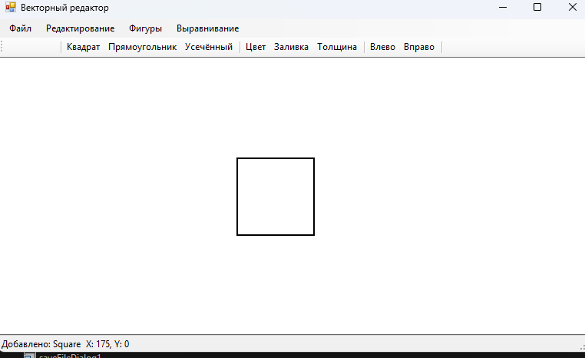
квадрат
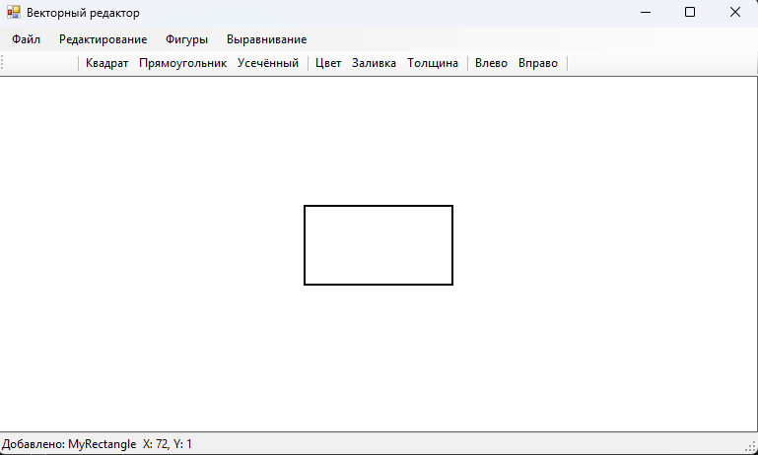
прямоугольник
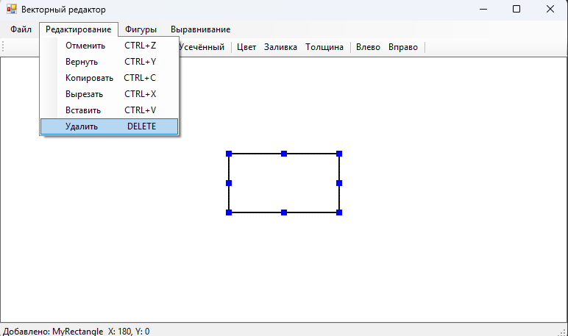
Также есть возможность удаления вставки и копирование элемента
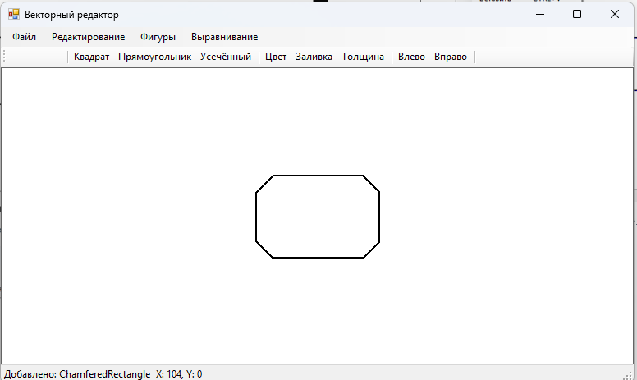
Усеченный
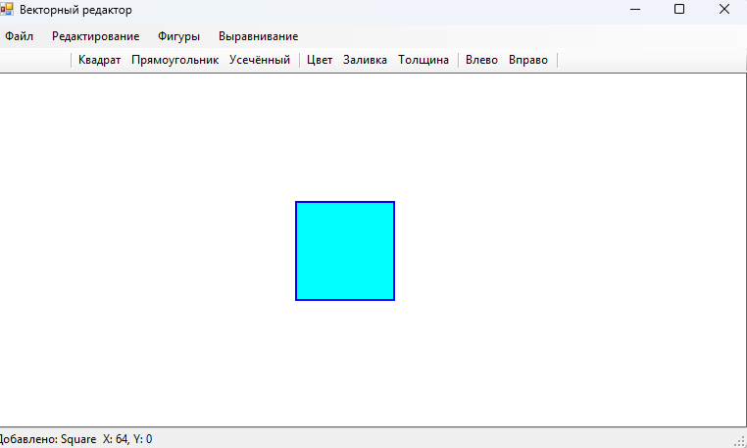
Изменение заливки толщины
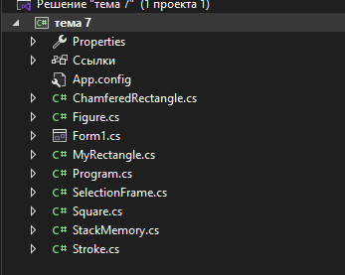
Структура проекта
Код ChamiferesRectangle.cs:
using System;
using System.Drawing;
using System.Drawing.Drawing2D;

namespace тема_7
{
[Serializable]
public class ChamferedRectangle : Figure
{
public int ChamferSize { get; set; } = 20;
public int Type { get; set; } = 0;

public ChamferedRectangle(Point location, Size size, Stroke stroke) : base(location, size, stroke) { }

public override void Draw(Graphics g)
{
int w = Size.Width;
int h = Size.Height;
int c = Math.Min(ChamferSize, Math.Min(w, h) / 2);
var path = new GraphicsPath();

if (Type == 0)
{
path.AddLine(Location.X + c, Location.Y, Location.X + w - c, Location.Y);
path.AddLine(Location.X + w, Location.Y + c, Location.X + w, Location.Y + h - c);
path.AddLine(Location.X + w - c, Location.Y + h, Location.X + c, Location.Y + h);
path.AddLine(Location.X, Location.Y + h - c, Location.X, Location.Y + c);
}
else if (Type == 1)
{
path.AddLine(Location.X + c, Location.Y, Location.X + w - c, Location.Y);
path.AddLine(Location.X + w, Location.Y, Location.X + w, Location.Y + h);
path.AddLine(Location.X + w - c, Location.Y + h, Location.X + c, Location.Y + h);
path.AddLine(Location.X, Location.Y + h, Location.X, Location.Y);
}
else
{
path.AddLine(Location.X, Location.Y + c, Location.X + w, Location.Y + c);
path.AddLine(Location.X + w, Location.Y + c, Location.X + w, Location.Y + h - c);
path.AddLine(Location.X + w, Location.Y + h - c, Location.X, Location.Y + h - c);
path.AddLine(Location.X, Location.Y + h - c, Location.X, Location.Y + c);
}
path.CloseFigure();

if (Stroke.HasFill && Stroke.FillColor != Color.Transparent)
using (var brush = new SolidBrush(Stroke.FillColor)) g.FillPath(brush, path);

using (var pen = Stroke.GetPen()) g.DrawPath(pen, path);
path.Dispose();
}
}
}
Код Figure.cs:
using System;
using System.Drawing;

namespace тема_7
{
[Serializable]
public abstract class Figure
{
public Point Location { get; set; }
public Size Size { get; set; }
public Stroke Stroke { get; set; }
public int Id { get; set; }

protected Figure(Point location, Size size, Stroke stroke)
{
Location = location;
Size = size;
Stroke = stroke?.Clone() ?? new Stroke();
Id = GetHashCode();
}

public Rectangle Bounds => new Rectangle(Location.X, Location.Y, Size.Width, Size.Height);
public abstract void Draw(Graphics g);
public virtual void Move(int dx, int dy) => Location = new Point(Location.X + dx, Location.Y + dy);

public void ShiftRight(int pixels) => Move(pixels, 0);
public void ShiftLeft(int pixels) => Move(-pixels, 0);
public void ShiftUp(int pixels) => Move(0, -pixels);
public void ShiftDown(int pixels) => Move(0, pixels);

public virtual bool ContainsPoint(Point point) => Bounds.Contains(point);
public virtual Figure Clone() { var f = (Figure)MemberwiseClone(); f.Stroke = Stroke.Clone(); return f; }
public virtual void Resize(int w, int h) => Size = new Size(Math.Max(20, w), Math.Max(20, h));

public void AlignLeft()
{
if (Id > 0)
{
int minX = Id;
Location = new Point(minX, Location.Y);
}
}

public void AlignRight(int canvasWidth)
{
Location = new Point(canvasWidth - Size.Width, Location.Y);
}
}
}
Код Form1.cs:
using System;
using System.Collections.Generic;
using System.Drawing;
using System.IO;
using System.Runtime.Serialization.Formatters.Binary;
using System.Windows.Forms;

namespace тема_7
{
public partial class Form1 : Form
{
private List<Figure> _figures = new List<Figure>();
private List<Figure> _clipboard = new List<Figure>();
private Figure _selectedFigure;
private SelectionFrame _selectionFrame = new SelectionFrame();
private StackMemory _undoStack = new StackMemory(20);
private StackMemory _redoStack = new StackMemory(20);
private Color _currentColor = Color.Black;
private Color _currentFillColor = Color.Transparent;
private bool _hasFill = false;
private float _currentStrokeWidth = 2f;

public Form1()
{
InitializeComponent();
DoubleBuffered = true;
}

private void SaveState()
{
_undoStack.Push(ObjectToStream(_figures));
_redoStack.Clear();
}

private MemoryStream ObjectToStream(List<Figure> figures)
{
var ms = new MemoryStream();
new BinaryFormatter().Serialize(ms, figures);
ms.Position = 0;
return ms;
}

private List<Figure> StreamToObject(MemoryStream ms)
{
ms.Position = 0;
return (List<Figure>)new BinaryFormatter().Deserialize(ms);
}

private void PanelCanvas_Paint(object sender, PaintEventArgs e)
{
Graphics g = e.Graphics;
g.Clear(Color.White);

foreach (var figure in _figures)
figure.Draw(g);

if (_selectedFigure != null)
{
_selectionFrame.Update(_selectedFigure);
_selectionFrame.Draw(g);
}
}

private void PanelCanvas_MouseDown(object sender, MouseEventArgs e)
{
Figure clicked = FindFigureAt(e.Location);
if (clicked != null)
{
if (_selectedFigure != clicked)
{
SaveState();
_selectedFigure = clicked;
}
}
else
{
_selectedFigure = null;
}
panelCanvas.Invalidate();
}

private Figure FindFigureAt(Point point)
{
for (int i = _figures.Count - 1; i >= 0; i--)
if (_figures[i].ContainsPoint(point))
return _figures[i];
return null;
}

private void CreateFigure(FigureType type)
{
if (_figures.Count > 0)
{
MessageBox.Show("Сначала удалите или переместите существующую фигуру!", "Внимание", MessageBoxButtons.OK, MessageBoxIcon.Warning);
return;
}

var stroke = new Stroke(_currentColor, _currentStrokeWidth)
{
FillColor = _currentFillColor,
HasFill = _hasFill
};

Figure figure;
Point loc = new Point(panelCanvas.Width / 2 - 75, panelCanvas.Height / 2 - 50);

switch (type)
{
case FigureType.Square:
figure = new Square(loc, new Size(100, 100), stroke);
break;
case FigureType.Rectangle:
figure = new MyRectangle(loc, new Size(150, 80), stroke);
break;
case FigureType.ChamferedTopBottom:
figure = new ChamferedRectangle(loc, new Size(150, 100), stroke) { Type = 0 };
break;
case FigureType.ChamferedOpposite:
figure = new ChamferedRectangle(loc, new Size(150, 100), stroke) { Type = 1 };
break;
case FigureType.ChamferedSide:
figure = new ChamferedRectangle(loc, new Size(150, 100), stroke) { Type = 2 };
break;
default:
figure = new MyRectangle(loc, new Size(150, 80), stroke);
break;
}

SaveState();
_figures.Add(figure);
_selectedFigure = figure;
panelCanvas.Invalidate();
lblStatus.Text = "Добавлено: " + figure.GetType().Name;
}

private int _figureOffset = 0;
private enum FigureType { Square, Rectangle, ChamferedTopBottom, ChamferedOpposite, ChamferedSide }

private void MainForm_KeyDown(object sender, KeyEventArgs e)
{
if (_selectedFigure == null) return;
int pixels = e.Shift ? 1 : 5;

SaveState();

switch (e.KeyCode)
{
case Keys.Left: _selectedFigure.ShiftLeft(pixels); break;
case Keys.Right: _selectedFigure.ShiftRight(pixels); break;
case Keys.Up: _selectedFigure.ShiftUp(pixels); break;
case Keys.Down: _selectedFigure.ShiftDown(pixels); break;
case Keys.Delete: DeleteSelected(); return;
default: return;
}
panelCanvas.Invalidate();
}

private void DeleteSelected()
{
if (_selectedFigure != null)
{
SaveState();
_figures.Remove(_selectedFigure);
_selectedFigure = null;
panelCanvas.Invalidate();
lblStatus.Text = "Удалено";
}
}

private void AlignSelectedFigures(string alignment)
{
if (_figures.Count < 1) return;

SaveState();

if (alignment == "Left")
{
int minX = int.MaxValue;
foreach (var f in _figures) if (f.Location.X < minX) minX = f.Location.X;
foreach (var f in _figures) f.Location = new Point(minX, f.Location.Y);
}
else if (alignment == "Right")
{
int maxX = int.MinValue;
foreach (var f in _figures) if (f.Location.X + f.Size.Width > maxX) maxX = f.Location.X + f.Size.Width;
foreach (var f in _figures) f.Location = new Point(maxX - f.Size.Width, f.Location.Y);
}
else if (alignment == "Top")
{
int minY = int.MaxValue;
foreach (var f in _figures) if (f.Location.Y < minY) minY = f.Location.Y;
foreach (var f in _figures) f.Location = new Point(f.Location.X, minY);
}
else if (alignment == "Bottom")
{
int maxY = int.MinValue;
foreach (var f in _figures) if (f.Location.Y + f.Size.Height > maxY) maxY = f.Location.Y + f.Size.Height;
foreach (var f in _figures) f.Location = new Point(f.Location.X, maxY - f.Size.Height);
}

panelCanvas.Invalidate();
lblStatus.Text = "Выровнено по " + alignment;
}

private void NewToolStripMenuItem_Click(object sender, EventArgs e)
{
if (_figures.Count > 0 && MessageBox.Show("Очистить холст?", "Новый", MessageBoxButtons.YesNo) != DialogResult.Yes)
return;
SaveState();
_figures.Clear();
_selectedFigure = null;
panelCanvas.Invalidate();
lblStatus.Text = "Новый холст";
}

private void SaveToolStripMenuItem_Click(object sender, EventArgs e)
{
if (saveFileDialog1.ShowDialog() == DialogResult.OK)
{
try
{
using (var fs = new FileStream(saveFileDialog1.FileName, FileMode.Create))
new BinaryFormatter().Serialize(fs, _figures);
lblStatus.Text = "Сохранено";
}
catch (Exception ex) { MessageBox.Show("Ошибка: " + ex.Message); }
}
}

private void LoadToolStripMenuItem_Click(object sender, EventArgs e)
{
if (openFileDialog1.ShowDialog() == DialogResult.OK)
{
try
{
using (var fs = new FileStream(openFileDialog1.FileName, FileMode.Open))
_figures = (List<Figure>)new BinaryFormatter().Deserialize(fs);
_selectedFigure = null;
panelCanvas.Invalidate();
lblStatus.Text = "Загружено";
}
catch (Exception ex) { MessageBox.Show("Ошибка: " + ex.Message); }
}
}

private void UndoToolStripMenuItem_Click(object sender, EventArgs e)
{
if (_undoStack.Count > 0)
{
var ms = new MemoryStream();
_undoStack.Pop(ms);
_redoStack.Push(ObjectToStream(_figures));
_figures = StreamToObject(ms);
_selectedFigure = null;
panelCanvas.Invalidate();
lblStatus.Text = "Отменено";
}
}

private void RedoToolStripMenuItem_Click(object sender, EventArgs e)
{
if (_redoStack.Count > 0)
{
var ms = new MemoryStream();
_redoStack.Pop(ms);
_undoStack.Push(ObjectToStream(_figures));
_figures = StreamToObject(ms);
_selectedFigure = null;
panelCanvas.Invalidate();
lblStatus.Text = "Возврат";
}
}

private void CopyToolStripMenuItem_Click(object sender, EventArgs e)
{
if (_selectedFigure != null)
{
_clipboard.Clear();
_clipboard.Add(_selectedFigure.Clone());
lblStatus.Text = "Скопировано";
}
}

private void CutToolStripMenuItem_Click(object sender, EventArgs e)
{
if (_selectedFigure != null)
{
_clipboard.Clear();
_clipboard.Add(_selectedFigure.Clone());
SaveState();
_figures.Remove(_selectedFigure);
_selectedFigure = null;
panelCanvas.Invalidate();
lblStatus.Text = "Вырезано";
}
}

private void PasteToolStripMenuItem_Click(object sender, EventArgs e)
{
if (_clipboard.Count > 0)
{
SaveState();
var pasted = _clipboard[0].Clone();
pasted.Location = new Point(pasted.Location.X + 20, pasted.Location.Y + 20);
_figures.Add(pasted);
_selectedFigure = pasted;
panelCanvas.Invalidate();
lblStatus.Text = "Вставлено";
}
}

private void DeleteToolStripMenuItem_Click(object sender, EventArgs e) => DeleteSelected();

private void SquareToolStripMenuItem_Click(object sender, EventArgs e) => CreateFigure(FigureType.Square);
private void RectangleToolStripMenuItem_Click(object sender, EventArgs e) => CreateFigure(FigureType.Rectangle);
private void ChamferedTopBottomToolStripMenuItem_Click(object sender, EventArgs e) => CreateFigure(FigureType.ChamferedTopBottom);
private void ChamferedOppositeToolStripMenuItem_Click(object sender, EventArgs e) => CreateFigure(FigureType.ChamferedOpposite);
private void ChamferedSideToolStripMenuItem_Click(object sender, EventArgs e) => CreateFigure(FigureType.ChamferedSide);

private void AlignLeftToolStripMenuItem_Click(object sender, EventArgs e) => AlignSelectedFigures("Left");
private void AlignRightToolStripMenuItem_Click(object sender, EventArgs e) => AlignSelectedFigures("Right");
private void AlignTopToolStripMenuItem_Click(object sender, EventArgs e) => AlignSelectedFigures("Top");
private void AlignBottomToolStripMenuItem_Click(object sender, EventArgs e) => AlignSelectedFigures("Bottom");

private void BtnColor_Click(object sender, EventArgs e)
{
if (colorDialog1.ShowDialog() == DialogResult.OK)
{
_currentColor = colorDialog1.Color;
if (_selectedFigure != null)
{
SaveState();
_selectedFigure.Stroke.Color = _currentColor;
panelCanvas.Invalidate();
}
}
}

private void BtnFillColor_Click(object sender, EventArgs e)
{
if (colorDialog1.ShowDialog() == DialogResult.OK)
{
_currentFillColor = colorDialog1.Color;
_hasFill = true;
if (_selectedFigure != null)
{
SaveState();
_selectedFigure.Stroke.FillColor = _currentFillColor;
_selectedFigure.Stroke.HasFill = true;
panelCanvas.Invalidate();
}
}
}

private void BtnStrokeWidth_Click(object sender, EventArgs e)
{
using (var form = new Form())
{
form.Text = "Толщина линии";
form.StartPosition = FormStartPosition.CenterParent;
form.ClientSize = new Size(200, 60);
form.FormBorderStyle = FormBorderStyle.FixedDialog;

var numeric = new NumericUpDown { Location = new Point(10, 15), Size = new Size(80, 25), Value = (decimal)_currentStrokeWidth, Minimum = 1, Maximum = 20 };
var okBtn = new Button { Text = "OK", Location = new Point(100, 15), Size = new Size(80, 25), DialogResult = DialogResult.OK };

form.Controls.Add(numeric);
form.Controls.Add(okBtn);

if (form.ShowDialog() == DialogResult.OK)
{
_currentStrokeWidth = (float)numeric.Value;
if (_selectedFigure != null)
{
SaveState();
_selectedFigure.Stroke.Width = _currentStrokeWidth;
panelCanvas.Invalidate();
}
}
}
}

private void PanelCanvas_MouseMove(object sender, MouseEventArgs e)
{
lblCoords.Text = string.Format("X: {0}, Y: {1}", e.X, e.Y);
}
}
}
Код Form1.designer.cs:
namespace тема_7
{
partial class Form1
{
private System.ComponentModel.IContainer components = null;

protected override void Dispose(bool disposing)
{
if (disposing && (components != null))
components.Dispose();
base.Dispose(disposing);
}

private void InitializeComponent()
{
this.menuStrip = new System.Windows.Forms.MenuStrip();
this.fileToolStripMenuItem = new System.Windows.Forms.ToolStripMenuItem();
this.newToolStripMenuItem = new System.Windows.Forms.ToolStripMenuItem();
this.saveToolStripMenuItem = new System.Windows.Forms.ToolStripMenuItem();
this.loadToolStripMenuItem = new System.Windows.Forms.ToolStripMenuItem();
this.exitToolStripMenuItem = new System.Windows.Forms.ToolStripMenuItem();
this.editToolStripMenuItem = new System.Windows.Forms.ToolStripMenuItem();
this.undoToolStripMenuItem = new System.Windows.Forms.ToolStripMenuItem();
this.redoToolStripMenuItem = new System.Windows.Forms.ToolStripMenuItem();
this.copyToolStripMenuItem = new System.Windows.Forms.ToolStripMenuItem();
this.cutToolStripMenuItem = new System.Windows.Forms.ToolStripMenuItem();
this.pasteToolStripMenuItem = new System.Windows.Forms.ToolStripMenuItem();
this.deleteToolStripMenuItem = new System.Windows.Forms.ToolStripMenuItem();
this.figureToolStripMenuItem = new System.Windows.Forms.ToolStripMenuItem();
this.squareToolStripMenuItem = new System.Windows.Forms.ToolStripMenuItem();
this.rectangleToolStripMenuItem = new System.Windows.Forms.ToolStripMenuItem();
this.chamferedTopBottomToolStripMenuItem = new System.Windows.Forms.ToolStripMenuItem();
this.chamferedOppositeToolStripMenuItem = new System.Windows.Forms.ToolStripMenuItem();
this.chamferedSideToolStripMenuItem = new System.Windows.Forms.ToolStripMenuItem();
this.alignToolStripMenuItem = new System.Windows.Forms.ToolStripMenuItem();
this.alignLeftToolStripMenuItem = new System.Windows.Forms.ToolStripMenuItem();
this.alignRightToolStripMenuItem = new System.Windows.Forms.ToolStripMenuItem();
this.alignTopToolStripMenuItem = new System.Windows.Forms.ToolStripMenuItem();
this.alignBottomToolStripMenuItem = new System.Windows.Forms.ToolStripMenuItem();
this.toolStrip = new System.Windows.Forms.ToolStrip();
this.btnNew = new System.Windows.Forms.ToolStripButton();
this.btnSave = new System.Windows.Forms.ToolStripButton();
this.btnLoad = new System.Windows.Forms.ToolStripButton();
this.toolStripSeparator1 = new System.Windows.Forms.ToolStripSeparator();
this.btnSquare = new System.Windows.Forms.ToolStripButton();
this.btnRectangle = new System.Windows.Forms.ToolStripButton();
this.btnChamfered = new System.Windows.Forms.ToolStripButton();
this.toolStripSeparator2 = new System.Windows.Forms.ToolStripSeparator();
this.btnColor = new System.Windows.Forms.ToolStripButton();
this.btnFillColor = new System.Windows.Forms.ToolStripButton();
this.btnStrokeWidth = new System.Windows.Forms.ToolStripButton();
this.toolStripSeparator3 = new System.Windows.Forms.ToolStripSeparator();
this.btnAlignLeft = new System.Windows.Forms.ToolStripButton();
this.btnAlignRight = new System.Windows.Forms.ToolStripButton();
this.toolStripSeparator4 = new System.Windows.Forms.ToolStripSeparator();
this.btnUndo = new System.Windows.Forms.ToolStripButton();
this.btnRedo = new System.Windows.Forms.ToolStripButton();
this.statusStrip = new System.Windows.Forms.StatusStrip();
this.lblStatus = new System.Windows.Forms.ToolStripStatusLabel();
this.lblCoords = new System.Windows.Forms.ToolStripStatusLabel();
this.panelCanvas = new System.Windows.Forms.Panel();
this.colorDialog1 = new System.Windows.Forms.ColorDialog();
this.openFileDialog1 = new System.Windows.Forms.OpenFileDialog();
this.saveFileDialog1 = new System.Windows.Forms.SaveFileDialog();
this.menuStrip.SuspendLayout();
this.toolStrip.SuspendLayout();
this.statusStrip.SuspendLayout();
this.SuspendLayout();
//
// menuStrip
//
this.menuStrip.Items.AddRange(new System.Windows.Forms.ToolStripItem[] {
this.fileToolStripMenuItem,
this.editToolStripMenuItem,
this.figureToolStripMenuItem,
this.alignToolStripMenuItem});
this.menuStrip.Location = new System.Drawing.Point(0, 0);
this.menuStrip.Name = "menuStrip";
this.menuStrip.Size = new System.Drawing.Size(900, 24);
this.menuStrip.TabIndex = 0;
//
// fileToolStripMenuItem
//
this.fileToolStripMenuItem.DropDownItems.AddRange(new System.Windows.Forms.ToolStripItem[] {
this.newToolStripMenuItem,
this.saveToolStripMenuItem,
this.loadToolStripMenuItem,
this.exitToolStripMenuItem});
this.fileToolStripMenuItem.Name = "fileToolStripMenuItem";
this.fileToolStripMenuItem.Size = new System.Drawing.Size(59, 20);
this.fileToolStripMenuItem.Text = "Файл";
//
// newToolStripMenuItem
//
this.newToolStripMenuItem.Name = "newToolStripMenuItem";
this.newToolStripMenuItem.ShortcutKeys = ((System.Windows.Forms.Keys)((System.Windows.Forms.Keys.Control | System.Windows.Forms.Keys.N)));
this.newToolStripMenuItem.Size = new System.Drawing.Size(180, 22);
this.newToolStripMenuItem.Text = "Новый";
this.newToolStripMenuItem.Click += new System.EventHandler(this.NewToolStripMenuItem_Click);
//
// saveToolStripMenuItem
//
this.saveToolStripMenuItem.Name = "saveToolStripMenuItem";
this.saveToolStripMenuItem.ShortcutKeys = ((System.Windows.Forms.Keys)((System.Windows.Forms.Keys.Control | System.Windows.Forms.Keys.S)));
this.saveToolStripMenuItem.Size = new System.Drawing.Size(180, 22);
this.saveToolStripMenuItem.Text = "Сохранить";
this.saveToolStripMenuItem.Click += new System.EventHandler(this.SaveToolStripMenuItem_Click);
//
// loadToolStripMenuItem
//
this.loadToolStripMenuItem.Name = "loadToolStripMenuItem";
this.loadToolStripMenuItem.ShortcutKeys = ((System.Windows.Forms.Keys)((System.Windows.Forms.Keys.Control | System.Windows.Forms.Keys.O)));
this.loadToolStripMenuItem.Size = new System.Drawing.Size(180, 22);
this.loadToolStripMenuItem.Text = "Загрузить";
this.loadToolStripMenuItem.Click += new System.EventHandler(this.LoadToolStripMenuItem_Click);
//
// exitToolStripMenuItem
//
this.exitToolStripMenuItem.Name = "exitToolStripMenuItem";
this.exitToolStripMenuItem.Size = new System.Drawing.Size(180, 22);
this.exitToolStripMenuItem.Text = "Выход";
//
// editToolStripMenuItem
//
this.editToolStripMenuItem.DropDownItems.AddRange(new System.Windows.Forms.ToolStripItem[] {
this.undoToolStripMenuItem,
this.redoToolStripMenuItem,
this.copyToolStripMenuItem,
this.cutToolStripMenuItem,
this.pasteToolStripMenuItem,
this.deleteToolStripMenuItem});
this.editToolStripMenuItem.Name = "editToolStripMenuItem";
this.editToolStripMenuItem.Size = new System.Drawing.Size(118, 20);
this.editToolStripMenuItem.Text = "Редактирование";
//
// undoToolStripMenuItem
//
this.undoToolStripMenuItem.Name = "undoToolStripMenuItem";
this.undoToolStripMenuItem.ShortcutKeys = ((System.Windows.Forms.Keys)((System.Windows.Forms.Keys.Control | System.Windows.Forms.Keys.Z)));
this.undoToolStripMenuItem.Size = new System.Drawing.Size(180, 22);
this.undoToolStripMenuItem.Text = "Отменить";
this.undoToolStripMenuItem.Click += new System.EventHandler(this.UndoToolStripMenuItem_Click);
//
// redoToolStripMenuItem
//
this.redoToolStripMenuItem.Name = "redoToolStripMenuItem";
this.redoToolStripMenuItem.ShortcutKeys = ((System.Windows.Forms.Keys)((System.Windows.Forms.Keys.Control | System.Windows.Forms.Keys.Y)));
this.redoToolStripMenuItem.Size = new System.Drawing.Size(180, 22);
this.redoToolStripMenuItem.Text = "Вернуть";
this.redoToolStripMenuItem.Click += new System.EventHandler(this.RedoToolStripMenuItem_Click);
//
// copyToolStripMenuItem
//
this.copyToolStripMenuItem.Name = "copyToolStripMenuItem";
this.copyToolStripMenuItem.ShortcutKeys = ((System.Windows.Forms.Keys)((System.Windows.Forms.Keys.Control | System.Windows.Forms.Keys.C)));
this.copyToolStripMenuItem.Size = new System.Drawing.Size(180, 22);
this.copyToolStripMenuItem.Text = "Копировать";
this.copyToolStripMenuItem.Click += new System.EventHandler(this.CopyToolStripMenuItem_Click);
//
// cutToolStripMenuItem
//
this.cutToolStripMenuItem.Name = "cutToolStripMenuItem";
this.cutToolStripMenuItem.ShortcutKeys = ((System.Windows.Forms.Keys)((System.Windows.Forms.Keys.Control | System.Windows.Forms.Keys.X)));
this.cutToolStripMenuItem.Size = new System.Drawing.Size(180, 22);
this.cutToolStripMenuItem.Text = "Вырезать";
this.cutToolStripMenuItem.Click += new System.EventHandler(this.CutToolStripMenuItem_Click);
//
// pasteToolStripMenuItem
//
this.pasteToolStripMenuItem.Name = "pasteToolStripMenuItem";
this.pasteToolStripMenuItem.ShortcutKeys = ((System.Windows.Forms.Keys)((System.Windows.Forms.Keys.Control | System.Windows.Forms.Keys.V)));
this.pasteToolStripMenuItem.Size = new System.Drawing.Size(180, 22);
this.pasteToolStripMenuItem.Text = "Вставить";
this.pasteToolStripMenuItem.Click += new System.EventHandler(this.PasteToolStripMenuItem_Click);
//
// deleteToolStripMenuItem
//
this.deleteToolStripMenuItem.Name = "deleteToolStripMenuItem";
this.deleteToolStripMenuItem.ShortcutKeys = System.Windows.Forms.Keys.Delete;
this.deleteToolStripMenuItem.Size = new System.Drawing.Size(180, 22);
this.deleteToolStripMenuItem.Text = "Удалить";
this.deleteToolStripMenuItem.Click += new System.EventHandler(this.DeleteToolStripMenuItem_Click);
//
// figureToolStripMenuItem
//
this.figureToolStripMenuItem.DropDownItems.AddRange(new System.Windows.Forms.ToolStripItem[] {
this.squareToolStripMenuItem,
this.rectangleToolStripMenuItem,
this.chamferedTopBottomToolStripMenuItem,
this.chamferedOppositeToolStripMenuItem,
this.chamferedSideToolStripMenuItem});
this.figureToolStripMenuItem.Name = "figureToolStripMenuItem";
this.figureToolStripMenuItem.Size = new System.Drawing.Size(73, 20);
this.figureToolStripMenuItem.Text = "Фигуры";
//
// squareToolStripMenuItem
//
this.squareToolStripMenuItem.Name = "squareToolStripMenuItem";
this.squareToolStripMenuItem.Size = new System.Drawing.Size(180, 22);
this.squareToolStripMenuItem.Text = "Квадрат";
this.squareToolStripMenuItem.Click += new System.EventHandler(this.SquareToolStripMenuItem_Click);
//
// rectangleToolStripMenuItem
//
this.rectangleToolStripMenuItem.Name = "rectangleToolStripMenuItem";
this.rectangleToolStripMenuItem.Size = new System.Drawing.Size(180, 22);
this.rectangleToolStripMenuItem.Text = "Прямоугольник";
this.rectangleToolStripMenuItem.Click += new System.EventHandler(this.RectangleToolStripMenuItem_Click);
//
// chamferedTopBottomToolStripMenuItem
//
this.chamferedTopBottomToolStripMenuItem.Name = "chamferedTopBottomToolStripMenuItem";
this.chamferedTopBottomToolStripMenuItem.Size = new System.Drawing.Size(180, 22);
this.chamferedTopBottomToolStripMenuItem.Text = "Усеч. верх/низ";
this.chamferedTopBottomToolStripMenuItem.Click += new System.EventHandler(this.ChamferedTopBottomToolStripMenuItem_Click);
//
// chamferedOppositeToolStripMenuItem
//
this.chamferedOppositeToolStripMenuItem.Name = "chamferedOppositeToolStripMenuItem";
this.chamferedOppositeToolStripMenuItem.Size = new System.Drawing.Size(180, 22);
this.chamferedOppositeToolStripMenuItem.Text = "Усеч. противоп.";
this.chamferedOppositeToolStripMenuItem.Click += new System.EventHandler(this.ChamferedOppositeToolStripMenuItem_Click);
//
// chamferedSideToolStripMenuItem
//
this.chamferedSideToolStripMenuItem.Name = "chamferedSideToolStripMenuItem";
this.chamferedSideToolStripMenuItem.Size = new System.Drawing.Size(180, 22);
this.chamferedSideToolStripMenuItem.Text = "Усеч. боковое";
this.chamferedSideToolStripMenuItem.Click += new System.EventHandler(this.ChamferedSideToolStripMenuItem_Click);
//
// alignToolStripMenuItem
//
this.alignToolStripMenuItem.DropDownItems.AddRange(new System.Windows.Forms.ToolStripItem[] {
this.alignLeftToolStripMenuItem,
this.alignRightToolStripMenuItem,
this.alignTopToolStripMenuItem,
this.alignBottomToolStripMenuItem});
this.alignToolStripMenuItem.Name = "alignToolStripMenuItem";
this.alignToolStripMenuItem.Size = new System.Drawing.Size(91, 20);
this.alignToolStripMenuItem.Text = "Выравнивание";
//
// alignLeftToolStripMenuItem
//
this.alignLeftToolStripMenuItem.Name = "alignLeftToolStripMenuItem";
this.alignLeftToolStripMenuItem.Size = new System.Drawing.Size(180, 22);
this.alignLeftToolStripMenuItem.Text = "По левому краю";
this.alignLeftToolStripMenuItem.Click += new System.EventHandler(this.AlignLeftToolStripMenuItem_Click);
//
// alignRightToolStripMenuItem
//
this.alignRightToolStripMenuItem.Name = "alignRightToolStripMenuItem";
this.alignRightToolStripMenuItem.Size = new System.Drawing.Size(180, 22);
this.alignRightToolStripMenuItem.Text = "По правому краю";
this.alignRightToolStripMenuItem.Click += new System.EventHandler(this.AlignRightToolStripMenuItem_Click);
//
// alignTopToolStripMenuItem
//
this.alignTopToolStripMenuItem.Name = "alignTopToolStripMenuItem";
this.alignTopToolStripMenuItem.Size = new System.Drawing.Size(180, 22);
this.alignTopToolStripMenuItem.Text = "По верхнему краю";
this.alignTopToolStripMenuItem.Click += new System.EventHandler(this.AlignTopToolStripMenuItem_Click);
//
// alignBottomToolStripMenuItem
//
this.alignBottomToolStripMenuItem.Name = "alignBottomToolStripMenuItem";
this.alignBottomToolStripMenuItem.Size = new System.Drawing.Size(180, 22);
this.alignBottomToolStripMenuItem.Text = "По нижнему краю";
this.alignBottomToolStripMenuItem.Click += new System.EventHandler(this.AlignBottomToolStripMenuItem_Click);
//
// toolStrip
//
this.toolStrip.Items.AddRange(new System.Windows.Forms.ToolStripItem[] {
this.btnNew,
this.btnSave,
this.btnLoad,
this.toolStripSeparator1,
this.btnSquare,
this.btnRectangle,
this.btnChamfered,
this.toolStripSeparator2,
this.btnColor,
this.btnFillColor,
this.btnStrokeWidth,
this.toolStripSeparator3,
this.btnAlignLeft,
this.btnAlignRight,
this.toolStripSeparator4,
this.btnUndo,
this.btnRedo});
this.toolStrip.Location = new System.Drawing.Point(0, 24);
this.toolStrip.Name = "toolStrip";
this.toolStrip.Size = new System.Drawing.Size(900, 25);
this.toolStrip.TabIndex = 1;
//
// btnNew
//
this.btnNew.DisplayStyle = System.Windows.Forms.ToolStripItemDisplayStyle.Image;
this.btnNew.ImageTransparentColor = System.Drawing.Color.Magenta;
this.btnNew.Name = "btnNew";
this.btnNew.Size = new System.Drawing.Size(23, 22);
this.btnNew.Text = "Новый";
this.btnNew.Click += new System.EventHandler(this.NewToolStripMenuItem_Click);
//
// btnSave
//
this.btnSave.DisplayStyle = System.Windows.Forms.ToolStripItemDisplayStyle.Image;
this.btnSave.ImageTransparentColor = System.Drawing.Color.Magenta;
this.btnSave.Name = "btnSave";
this.btnSave.Size = new System.Drawing.Size(23, 22);
this.btnSave.Text = "Сохранить";
this.btnSave.Click += new System.EventHandler(this.SaveToolStripMenuItem_Click);
//
// btnLoad
//
this.btnLoad.DisplayStyle = System.Windows.Forms.ToolStripItemDisplayStyle.Image;
this.btnLoad.ImageTransparentColor = System.Drawing.Color.Magenta;
this.btnLoad.Name = "btnLoad";
this.btnLoad.Size = new System.Drawing.Size(23, 22);
this.btnLoad.Text = "Загрузить";
this.btnLoad.Click += new System.EventHandler(this.LoadToolStripMenuItem_Click);
//
// toolStripSeparator1
//
this.toolStripSeparator1.Name = "toolStripSeparator1";
this.toolStripSeparator1.Size = new System.Drawing.Size(6, 25);
//
// btnSquare
//
this.btnSquare.DisplayStyle = System.Windows.Forms.ToolStripItemDisplayStyle.Text;
this.btnSquare.Name = "btnSquare";
this.btnSquare.Size = new System.Drawing.Size(70, 22);
this.btnSquare.Text = "Квадрат";
this.btnSquare.Click += new System.EventHandler(this.SquareToolStripMenuItem_Click);
//
// btnRectangle
//
this.btnRectangle.DisplayStyle = System.Windows.Forms.ToolStripItemDisplayStyle.Text;
this.btnRectangle.Name = "btnRectangle";
this.btnRectangle.Size = new System.Drawing.Size(100, 22);
this.btnRectangle.Text = "Прямоугольник";
this.btnRectangle.Click += new System.EventHandler(this.RectangleToolStripMenuItem_Click);
//
// btnChamfered
//
this.btnChamfered.DisplayStyle = System.Windows.Forms.ToolStripItemDisplayStyle.Text;
this.btnChamfered.Name = "btnChamfered";
this.btnChamfered.Size = new System.Drawing.Size(80, 22);
this.btnChamfered.Text = "Усечённый";
this.btnChamfered.Click += new System.EventHandler(this.ChamferedTopBottomToolStripMenuItem_Click);
//
// toolStripSeparator2
//
this.toolStripSeparator2.Name = "toolStripSeparator2";
this.toolStripSeparator2.Size = new System.Drawing.Size(6, 25);
//
// btnColor
//
this.btnColor.DisplayStyle = System.Windows.Forms.ToolStripItemDisplayStyle.Text;
this.btnColor.Name = "btnColor";
this.btnColor.Size = new System.Drawing.Size(50, 22);
this.btnColor.Text = "Цвет";
this.btnColor.Click += new System.EventHandler(this.BtnColor_Click);
//
// btnFillColor
//
this.btnFillColor.DisplayStyle = System.Windows.Forms.ToolStripItemDisplayStyle.Text;
this.btnFillColor.Name = "btnFillColor";
this.btnFillColor.Size = new System.Drawing.Size(60, 22);
this.btnFillColor.Text = "Заливка";
this.btnFillColor.Click += new System.EventHandler(this.BtnFillColor_Click);
//
// btnStrokeWidth
//
this.btnStrokeWidth.DisplayStyle = System.Windows.Forms.ToolStripItemDisplayStyle.Text;
this.btnStrokeWidth.Name = "btnStrokeWidth";
this.btnStrokeWidth.Size = new System.Drawing.Size(65, 22);
this.btnStrokeWidth.Text = "Толщина";
this.btnStrokeWidth.Click += new System.EventHandler(this.BtnStrokeWidth_Click);
//
// toolStripSeparator3
//
this.toolStripSeparator3.Name = "toolStripSeparator3";
this.toolStripSeparator3.Size = new System.Drawing.Size(6, 25);
//
// btnAlignLeft
//
this.btnAlignLeft.DisplayStyle = System.Windows.Forms.ToolStripItemDisplayStyle.Text;
this.btnAlignLeft.Name = "btnAlignLeft";
this.btnAlignLeft.Size = new System.Drawing.Size(70, 22);
this.btnAlignLeft.Text = "Влево";
this.btnAlignLeft.Click += new System.EventHandler(this.AlignLeftToolStripMenuItem_Click);
//
// btnAlignRight
//
this.btnAlignRight.DisplayStyle = System.Windows.Forms.ToolStripItemDisplayStyle.Text;
this.btnAlignRight.Name = "btnAlignRight";
this.btnAlignRight.Size = new System.Drawing.Size(70, 22);
this.btnAlignRight.Text = "Вправо";
this.btnAlignRight.Click += new System.EventHandler(this.AlignRightToolStripMenuItem_Click);
//
// toolStripSeparator4
//
this.toolStripSeparator4.Name = "toolStripSeparator4";
this.toolStripSeparator4.Size = new System.Drawing.Size(6, 25);
//
// btnUndo
//
this.btnUndo.DisplayStyle = System.Windows.Forms.ToolStripItemDisplayStyle.Image;
this.btnUndo.ImageTransparentColor = System.Drawing.Color.Magenta;
this.btnUndo.Name = "btnUndo";
this.btnUndo.Size = new System.Drawing.Size(23, 22);
this.btnUndo.Text = "Отмена";
this.btnUndo.Click += new System.EventHandler(this.UndoToolStripMenuItem_Click);
//
// btnRedo
//
this.btnRedo.DisplayStyle = System.Windows.Forms.ToolStripItemDisplayStyle.Image;
this.btnRedo.ImageTransparentColor = System.Drawing.Color.Magenta;
this.btnRedo.Name = "btnRedo";
this.btnRedo.Size = new System.Drawing.Size(23, 22);
this.btnRedo.Text = "Вернуть";
this.btnRedo.Click += new System.EventHandler(this.RedoToolStripMenuItem_Click);
//
// statusStrip
//
this.statusStrip.Items.AddRange(new System.Windows.Forms.ToolStripItem[] {
this.lblStatus,
this.lblCoords});
this.statusStrip.Location = new System.Drawing.Point(0, 478);
this.statusStrip.Name = "statusStrip";
this.statusStrip.Size = new System.Drawing.Size(900, 22);
this.statusStrip.TabIndex = 2;
//
// lblStatus
//
this.lblStatus.Name = "lblStatus";
this.lblStatus.Size = new System.Drawing.Size(70, 17);
this.lblStatus.Text = "Готово";
//
// lblCoords
//
this.lblCoords.Name = "lblCoords";
this.lblCoords.Size = new System.Drawing.Size(100, 17);
this.lblCoords.Text = "";
//
// panelCanvas
//
this.panelCanvas.BorderStyle = System.Windows.Forms.BorderStyle.FixedSingle;
this.panelCanvas.Dock = System.Windows.Forms.DockStyle.Fill;
this.panelCanvas.Location = new System.Drawing.Point(0, 49);
this.panelCanvas.Name = "panelCanvas";
this.panelCanvas.Size = new System.Drawing.Size(900, 429);
this.panelCanvas.TabIndex = 3;
this.panelCanvas.Paint += new System.Windows.Forms.PaintEventHandler(this.PanelCanvas_Paint);
this.panelCanvas.MouseDown += new System.Windows.Forms.MouseEventHandler(this.PanelCanvas_MouseDown);
this.panelCanvas.MouseMove += new System.Windows.Forms.MouseEventHandler(this.PanelCanvas_MouseMove);
//
// openFileDialog1
//
this.openFileDialog1.Filter = "Vector Files|*.vec";
this.openFileDialog1.Title = "Загрузить";
//
// saveFileDialog1
//
this.saveFileDialog1.Filter = "Vector Files|*.vec";
this.saveFileDialog1.Title = "Сохранить";
//
// Form1
//
this.AutoScaleDimensions = new System.Drawing.SizeF(7F, 15F);
this.AutoScaleMode = System.Windows.Forms.AutoScaleMode.Font;
this.ClientSize = new System.Drawing.Size(900, 500);
this.Controls.Add(this.panelCanvas);
this.Controls.Add(this.statusStrip);
this.Controls.Add(this.toolStrip);
this.Controls.Add(this.menuStrip);
this.MainMenuStrip = this.menuStrip;
this.Name = "Form1";
this.StartPosition = System.Windows.Forms.FormStartPosition.CenterScreen;
this.Text = "Векторный редактор";
this.KeyPreview = true;
this.KeyDown += new System.Windows.Forms.KeyEventHandler(this.MainForm_KeyDown);
this.menuStrip.ResumeLayout(false);
this.menuStrip.PerformLayout();
this.toolStrip.ResumeLayout(false);
this.toolStrip.PerformLayout();
this.statusStrip.ResumeLayout(false);
this.statusStrip.PerformLayout();
this.ResumeLayout(false);
this.PerformLayout();
}

private System.Windows.Forms.MenuStrip menuStrip;
private System.Windows.Forms.ToolStripMenuItem fileToolStripMenuItem;
private System.Windows.Forms.ToolStripMenuItem newToolStripMenuItem;
private System.Windows.Forms.ToolStripMenuItem saveToolStripMenuItem;
private System.Windows.Forms.ToolStripMenuItem loadToolStripMenuItem;
private System.Windows.Forms.ToolStripMenuItem exitToolStripMenuItem;
private System.Windows.Forms.ToolStripMenuItem editToolStripMenuItem;
private System.Windows.Forms.ToolStripMenuItem undoToolStripMenuItem;
private System.Windows.Forms.ToolStripMenuItem redoToolStripMenuItem;
private System.Windows.Forms.ToolStripMenuItem copyToolStripMenuItem;
private System.Windows.Forms.ToolStripMenuItem cutToolStripMenuItem;
private System.Windows.Forms.ToolStripMenuItem pasteToolStripMenuItem;
private System.Windows.Forms.ToolStripMenuItem deleteToolStripMenuItem;
private System.Windows.Forms.ToolStripMenuItem figureToolStripMenuItem;
private System.Windows.Forms.ToolStripMenuItem squareToolStripMenuItem;
private System.Windows.Forms.ToolStripMenuItem rectangleToolStripMenuItem;
private System.Windows.Forms.ToolStripMenuItem chamferedTopBottomToolStripMenuItem;
private System.Windows.Forms.ToolStripMenuItem chamferedOppositeToolStripMenuItem;
private System.Windows.Forms.ToolStripMenuItem chamferedSideToolStripMenuItem;
private System.Windows.Forms.ToolStripMenuItem alignToolStripMenuItem;
private System.Windows.Forms.ToolStripMenuItem alignLeftToolStripMenuItem;
private System.Windows.Forms.ToolStripMenuItem alignRightToolStripMenuItem;
private System.Windows.Forms.ToolStripMenuItem alignTopToolStripMenuItem;
private System.Windows.Forms.ToolStripMenuItem alignBottomToolStripMenuItem;
private System.Windows.Forms.ToolStrip toolStrip;
private System.Windows.Forms.ToolStripButton btnNew;
private System.Windows.Forms.ToolStripButton btnSave;
private System.Windows.Forms.ToolStripButton btnLoad;
private System.Windows.Forms.ToolStripSeparator toolStripSeparator1;
private System.Windows.Forms.ToolStripButton btnSquare;
private System.Windows.Forms.ToolStripButton btnRectangle;
private System.Windows.Forms.ToolStripButton btnChamfered;
private System.Windows.Forms.ToolStripSeparator toolStripSeparator2;
private System.Windows.Forms.ToolStripButton btnColor;
private System.Windows.Forms.ToolStripButton btnFillColor;
private System.Windows.Forms.ToolStripButton btnStrokeWidth;
private System.Windows.Forms.ToolStripSeparator toolStripSeparator3;
private System.Windows.Forms.ToolStripButton btnAlignLeft;
private System.Windows.Forms.ToolStripButton btnAlignRight;
private System.Windows.Forms.ToolStripSeparator toolStripSeparator4;
private System.Windows.Forms.ToolStripButton btnUndo;
private System.Windows.Forms.ToolStripButton btnRedo;
private System.Windows.Forms.StatusStrip statusStrip;
private System.Windows.Forms.ToolStripStatusLabel lblStatus;
private System.Windows.Forms.ToolStripStatusLabel lblCoords;
private System.Windows.Forms.Panel panelCanvas;
private System.Windows.Forms.ColorDialog colorDialog1;
private System.Windows.Forms.OpenFileDialog openFileDialog1;
private System.Windows.Forms.SaveFileDialog saveFileDialog1;
}
}
Код Myrectagle.cs:
using System;
using System.Drawing;

namespace тема_7
{
[Serializable]
public class MyRectangle : Figure
{
public MyRectangle(Point location, Size size, Stroke stroke) : base(location, size, stroke) { }

public override void Draw(Graphics g)
{
var rect = new Rectangle(Location.X, Location.Y, Size.Width, Size.Height);

if (Stroke.HasFill && Stroke.FillColor != Color.Transparent)
using (var brush = new SolidBrush(Stroke.FillColor)) g.FillRectangle(brush, rect);

using (var pen = Stroke.GetPen()) g.DrawRectangle(pen, rect);
}
}
}
Код SelectionFrame:
using System;
using System.Drawing;

namespace тема_7
{
[Serializable]
public class SelectionFrame
{
private const int MarkerSize = 8;
public Rectangle Bounds { get; set; }
public bool Visible { get; set; } = false;

public SelectionFrame() { }

public void Draw(Graphics g)
{
if (!Visible) return;

using (var pen = new Pen(Color.Blue, 1) { DashStyle = System.Drawing.Drawing2D.DashStyle.Dash })
g.DrawRectangle(pen, Bounds);

Brush brush = new SolidBrush(Color.Blue);
try
{
g.FillRectangle(brush, Bounds.X - MarkerSize / 2, Bounds.Y - MarkerSize / 2, MarkerSize, MarkerSize);
g.FillRectangle(brush, Bounds.Right - MarkerSize / 2, Bounds.Y - MarkerSize / 2, MarkerSize, MarkerSize);
g.FillRectangle(brush, Bounds.X - MarkerSize / 2, Bounds.Bottom - MarkerSize / 2, MarkerSize, MarkerSize);
g.FillRectangle(brush, Bounds.Right - MarkerSize / 2, Bounds.Bottom - MarkerSize / 2, MarkerSize, MarkerSize);
g.FillRectangle(brush, Bounds.X + Bounds.Width / 2 - MarkerSize / 2, Bounds.Y - MarkerSize / 2, MarkerSize, MarkerSize);
g.FillRectangle(brush, Bounds.X + Bounds.Width / 2 - MarkerSize / 2, Bounds.Bottom - MarkerSize / 2, MarkerSize, MarkerSize);
g.FillRectangle(brush, Bounds.X - MarkerSize / 2, Bounds.Y + Bounds.Height / 2 - MarkerSize / 2, MarkerSize, MarkerSize);
g.FillRectangle(brush, Bounds.Right - MarkerSize / 2, Bounds.Y + Bounds.Height / 2 - MarkerSize / 2, MarkerSize, MarkerSize);
}
finally { brush.Dispose(); }
}

public void Update(Figure figure)
{
if (figure != null) { Bounds = figure.Bounds; Visible = true; }
else Visible = false;
}
}
}
Код Square.cs:
using System;
using System.Drawing;

namespace тема_7
{
[Serializable]
public class Square : Figure
{
public Square(Point location, Size size, Stroke stroke) : base(location, size, stroke) { }

public override void Draw(Graphics g)
{
int side = Math.Min(Size.Width, Size.Height);
var rect = new Rectangle(Location.X, Location.Y, side, side);

if (Stroke.HasFill && Stroke.FillColor != Color.Transparent)
using (var brush = new SolidBrush(Stroke.FillColor)) g.FillRectangle(brush, rect);

using (var pen = Stroke.GetPen()) g.DrawRectangle(pen, rect);
}

public override void Resize(int w, int h)
{
int side = Math.Max(w, h);
Size = new Size(side, side);
}

public override bool ContainsPoint(Point point)
{
int side = Math.Min(Size.Width, Size.Height);
return new Rectangle(Location.X, Location.Y, side, side).Contains(point);
}
}
}

Код StackMemory.cs:
using System;
using System.Collections.Generic;

namespace тема_7
{
[Serializable]
public class StackMemory
{
private readonly int _stackDepth;
private readonly List<byte[]> _list = new List<byte[]>();

public int Count => _list.Count;
public StackMemory(int depth = 20) { _stackDepth = Math.Max(1, depth); }

public void Push(System.IO.MemoryStream stream)
{
if (_list.Count >= _stackDepth) _list.RemoveAt(0);
_list.Add(stream.ToArray());
}

public bool Pop(System.IO.MemoryStream stream)
{
if (_list.Count <= 0) return false;
var buff = _list[_list.Count - 1];
_list.RemoveAt(_list.Count - 1);
stream.SetLength(0);
stream.Write(buff, 0, buff.Length);
stream.Position = 0;
return true;
}

public void Clear() => _list.Clear();
}
}
Код Stroke.cs:
using System;
using System.Drawing;

namespace тема_7
{
[Serializable]
public class Stroke
{
public Color Color { get; set; } = Color.Black;
public float Width { get; set; } = 2f;
public System.Drawing.Drawing2D.DashStyle DashStyle { get; set; } = System.Drawing.Drawing2D.DashStyle.Solid;
public Color FillColor { get; set; } = Color.Transparent;
public bool HasFill { get; set; } = false;

public Stroke() { }
public Stroke(Color color, float width) { Color = color; Width = width; }

public Pen GetPen() => new Pen(Color, Width) { DashStyle = DashStyle };
public Brush GetBrush() => (HasFill && FillColor != Color.Transparent) ? new SolidBrush(FillColor) : null;

public Stroke Clone() => new Stroke(Color, Width)
{
FillColor = FillColor, HasFill = HasFill, DashStyle = DashStyle
};
}
}

Тема 8
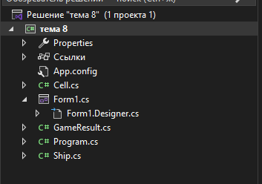
структура
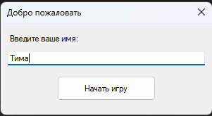
Инициализация имени
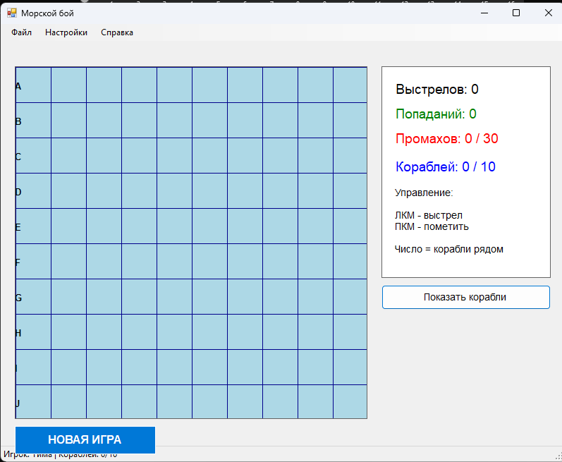
Запуск игры
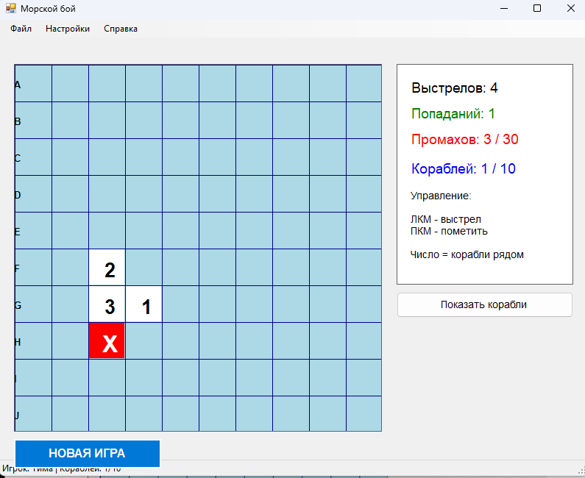
Игра
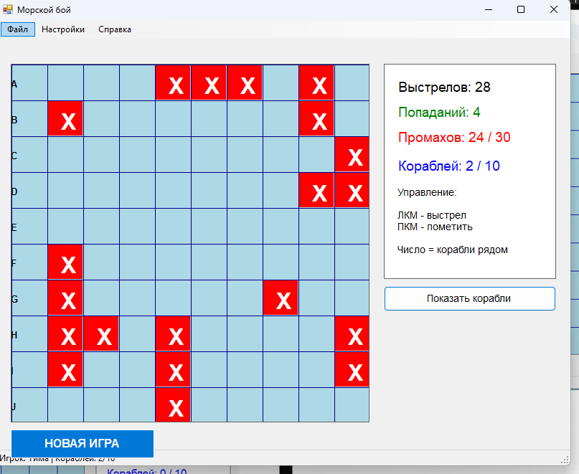
При нажатии на кнопку показать корабли

Вывод
В ходе практики я получил необходимые знания о работе с Windows Form.

