RESULTS
After data cleaning and outlier removal, the final dataset included 581 observations and 141 variables. Differences in VO₂max and QTc were analyzed across sport types and nosology groups using one-way ANOVA or the Kruskal–Wallis test (in cases where assumptions of normality or homogeneity of variances were violated).
1. Differences across sport types
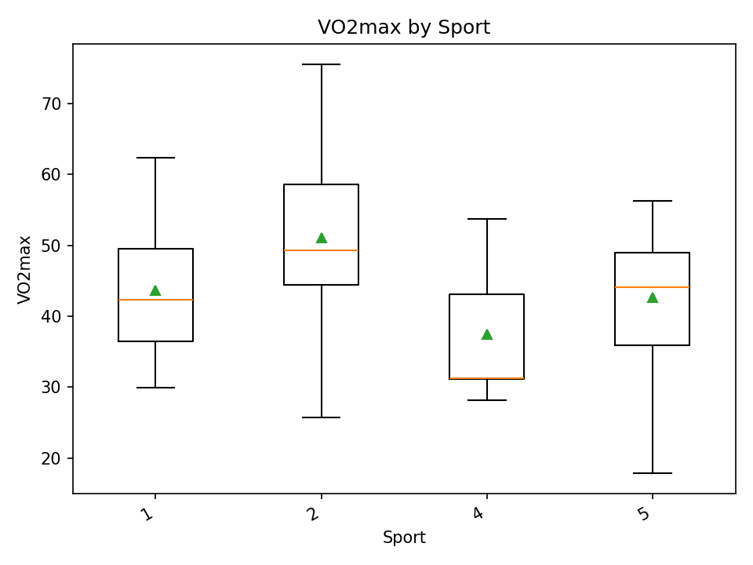
The analysis revealed statistically significant differences in VO₂max across sport-type groups (one-way ANOVA, p = 0.00063; η² = 0.1577).
The effect size indicates a medium magnitude of the influence of sport type on aerobic performance.
These differences are also clearly visible in the boxplot “VO2max by Sport”, where the groups show distinct median levels and variability ranges.
Figure 1 - VO2max by Sport
QTc
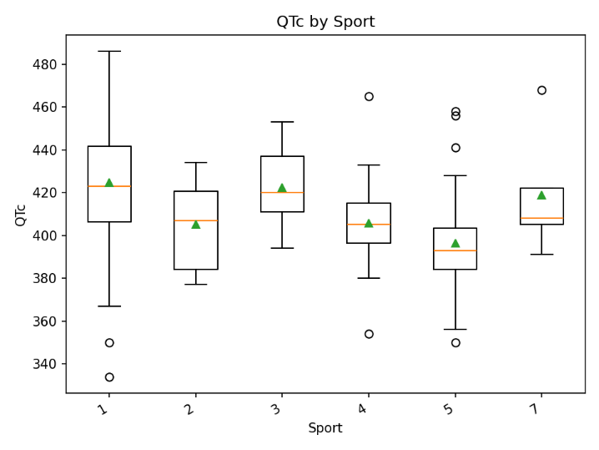
The QTc interval also differed significantly across sport types; however, because the data violated normality assumptions, the Kruskal–Wallis test was applied (p < 0.00001; ε² = 0.1462).
The resulting effect size can also be interpreted as medium, indicating systematic differences in cardiac electrical activity across sports disciplines.
The boxplot “QTc by Sport” illustrates these variations, showing distinct shifts in medians and differences in the overall spread of QTc values.

Рисунок 2 - QTc by Sport
2. Differences across nosology groups
VO₂max
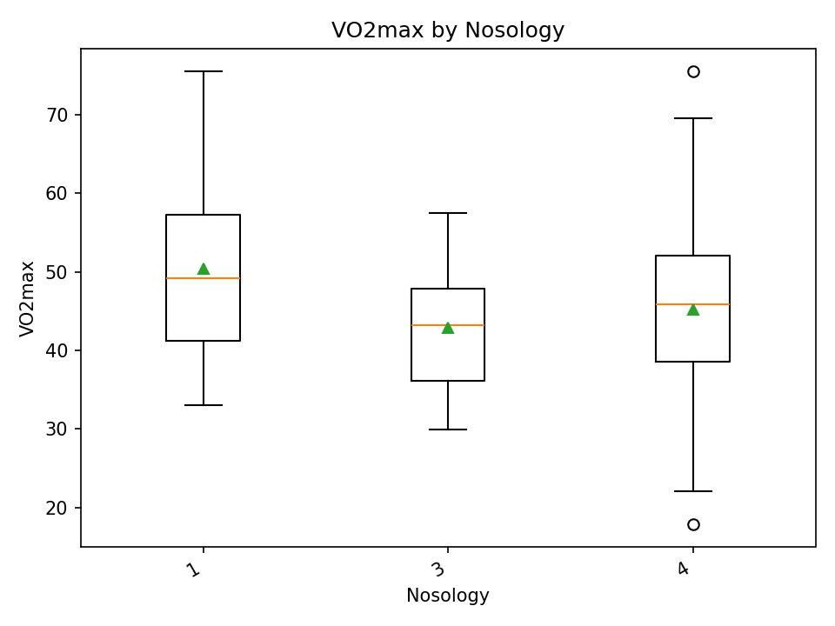
Statistically significant differences in VO₂max were also observed across nosology groups (One-way ANOVA, p = 0.01028; η² = 0.0717).
The effect size can be interpreted as small, indicating moderate variations in aerobic capacity across categories of disability.
As shown in the “VO2max by Nosology” plot, these differences are less pronounced than those observed between sport-type groups, yet they remain present.
Рисунок 3 - VO2max by Nosology
QTc
QTc interval also differed across nosology groups (Kruskal–Wallis, p = 0.02185; ε² = 0.0175).
The effect size is very small, indicating a weak yet statistically detectable trend.
The “QTc by Nosology” visualization confirms that QTc distributions across groups partially overlap, and the differences are modest.

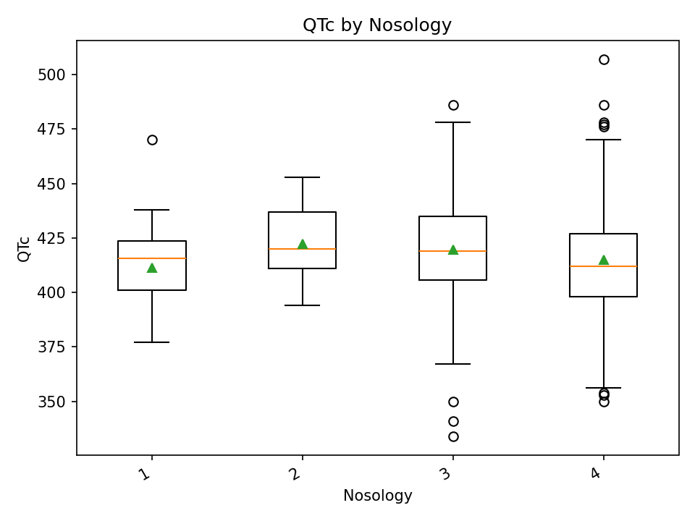
Рисунок 4 - QTc by Nosology

3. Effect sizes
The integrated “Effect sizes for factors Sport/Nosology” diagram shows that:
- The strongest influence is exerted by sport type on VO₂max (η² ≈ 0.158).
- A similar effect magnitude is observed for sport type on QTc (ε² ≈ 0.146).
- Nosology demonstrates a noticeably weaker influence, especially for QTc (ε² ≈ 0.018).
Thus, sport type is a substantially stronger factor explaining variability in physiological indicators compared to nosology.

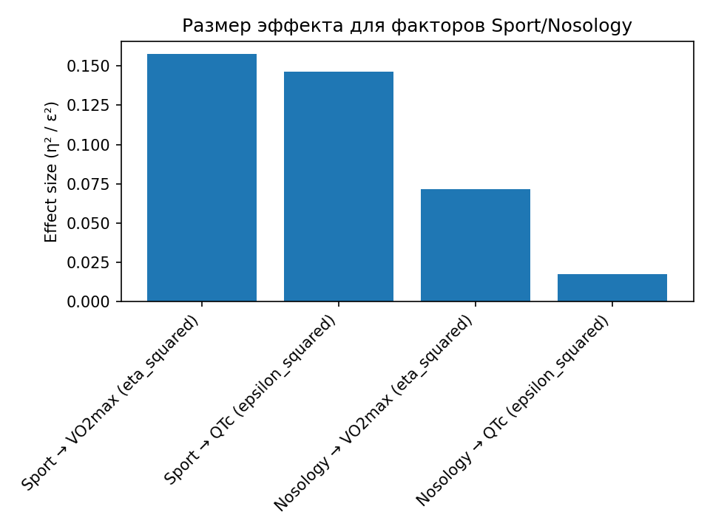
Рисунок 5 - Effect sizes for factors Sport/Nosology

