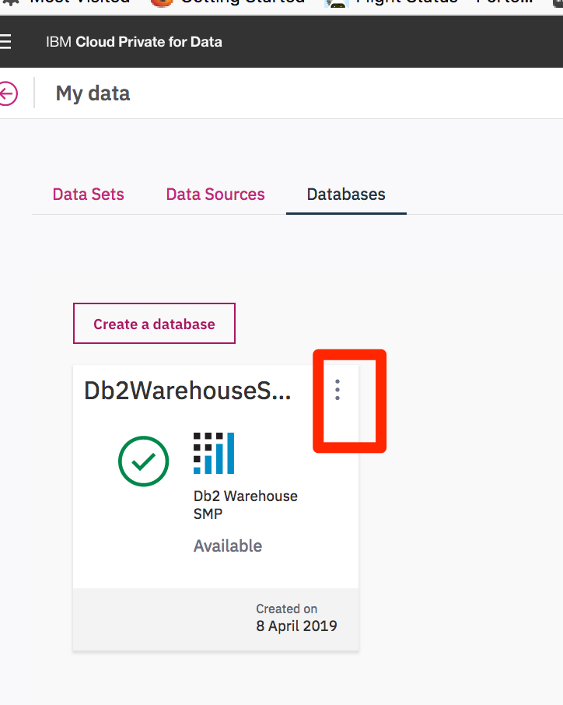

Click on ellipses to ‘Open’

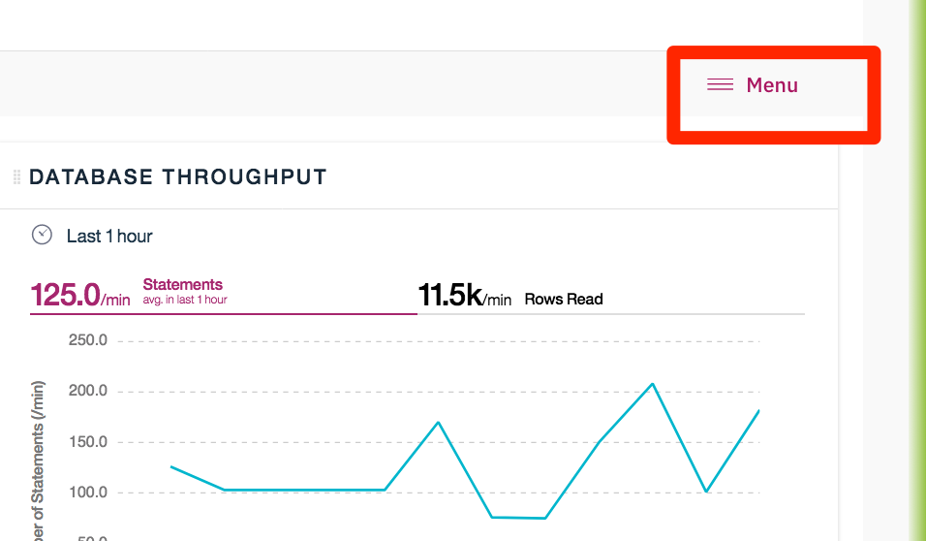

Go to the Menu on far right and click on ‘RunSQL’



Click on the setup widget to set the default Schema to whatever user the database was initially created against.

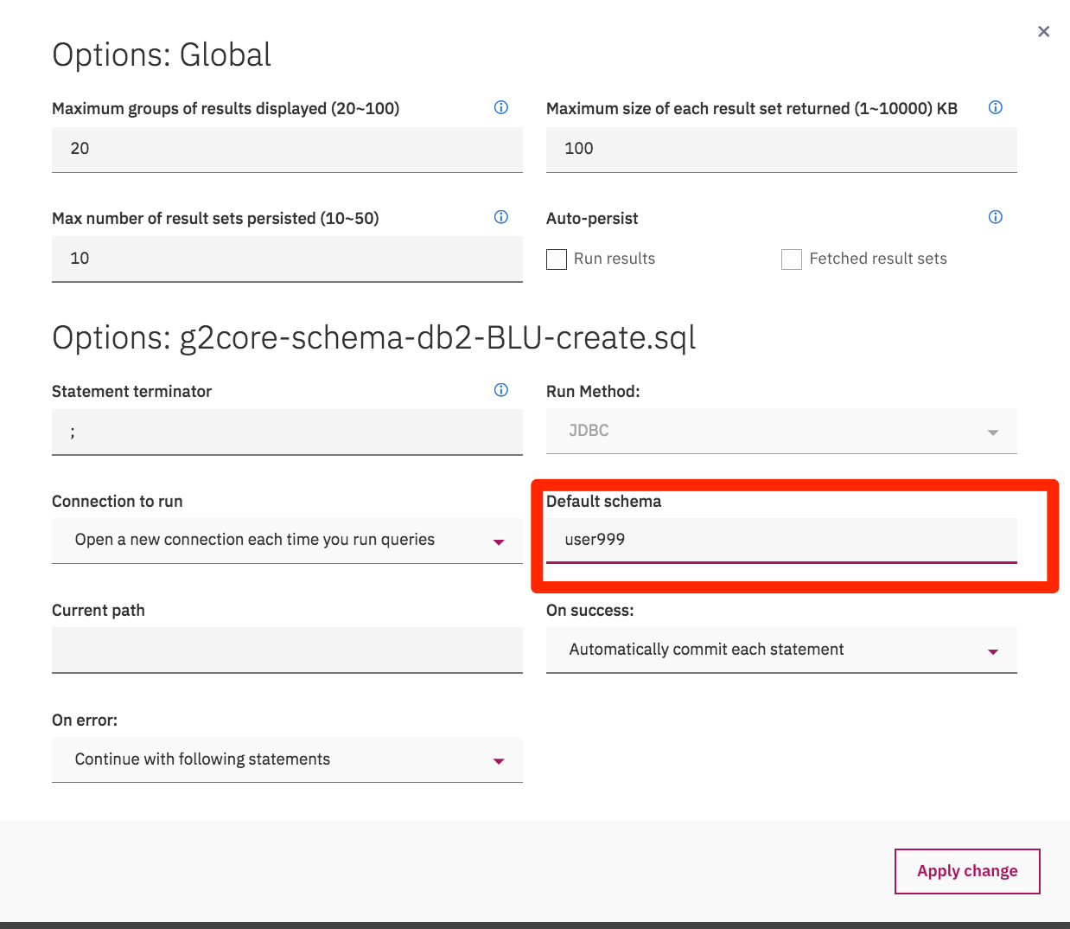

In my case, I have chosen user999

Finally, click the plus sign to bring up the choice for Sql Editor. In this case we are choosing ‘From file’ to utilize the Senzing DDL creation script.

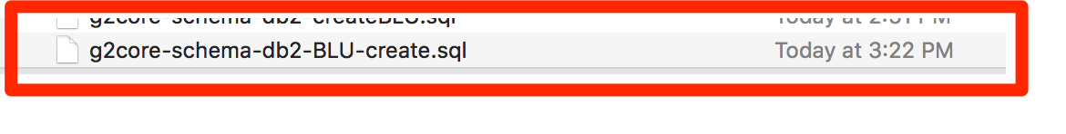

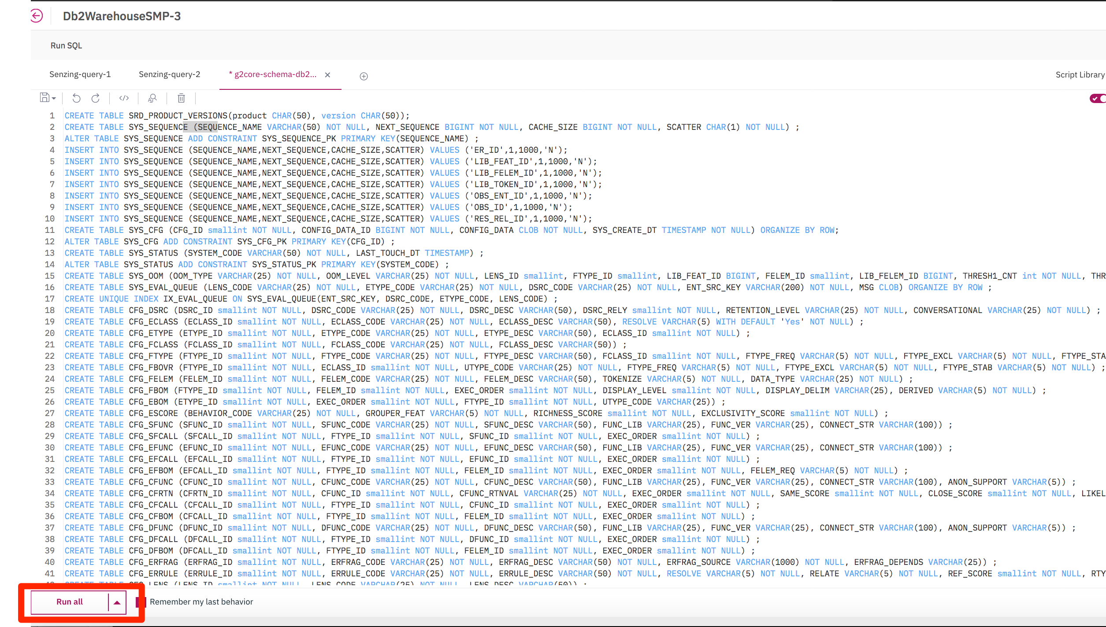

Click on ‘Run all’