

**Storage Management GUI (MTool)**

Samsung Poseidon

User Manual

**Contents**

**1** **Introduction** 4

**2** **MTool GUI: Getting started** 5

**2.1** **Accessing the MTool GUI** 6

**2.2** **MTool Dashboard** 7

**2.3** **MTool Storage Management** 8

***2.3.1*** ***Array Management*** 9

***2.3.2*** ***Volume Management*** 13

**2.4** **MTool Performance View** 22

**2.5** **MTool User Management** 26

**2.6** **MTool Storage Management Start or Stop Operations** 28

**3** **How to install MTool** 30

**4** **How to Uninstall MTool** 31

**Overview**

This document describes the POS Storage Management GUI (also called as MTool). MTool enables a user to perform the following functions:

* Dashboard
* Array management
* Volume management
* System resource availability
* User management
* System status

This document covers the following topics:

* Introduction
* Getting started with MTool
* Array and volume configuration
* Performance monitoring
* User management
* POS start and stop operations

1. **Introduction**

POS Storage Management GUI aka MTool enables an easy way to administer POS storage system.

The major objectives of MTool are:

* **Availability**: MTool is available from various devices, platforms and systems.
* **Speed**: MTool provides data with highest performance so that users have access to important data at right times.
* **Simplicity**: A simple and intuitive design to help productivity and overall cost.
* **Commonality**: Commonly used graphics, widgets and terminology enable easy integration with existing systems and onboarding the users quickly.

With these deliverables in mind, a System Administrator can use the MTool to configure and prepare the storage system for the user workloads quickly after completing the setup. Then the System Administrator can manage the system with minimal knowledge. The GUI provides a performance monitoring tool for the main storage parameters.

Array and volume storage configuration and management is streamlined in MTool. User management is simplified and performance views provide detailed information of the system state.

1. **MTool GUI: Getting started**

This section describes how to accomplish the following tasks:

* Accessing the MTool GUI
* Managing and monitoring the POS system (e.g. array or volume management)
* Performance monitoring of the POS system
* User management
  1. **Accessing the MTool GUI**

The MTool GUI can be accessed using Firefox Mozilla and Google Chrome browser.

The MTool supports the use of a single point of authentication function for the GUI through a centralized data in a lightweight database.

MTool is accessible from the browser as shown in Figure1



1. *MTool GUI URL*

On the first page for MTool GUI, user needs to log on as an administrator.

1. MTool GUI URL: http://<mtool_ip>

*Note: MTool GUI URL may come pre-installed and typically the IP address of the server that the MTool software is installed on*

1. On a new system, users can use the following default credentials:
   * User = admin
   * Password = admin

After initial login, user can add additional users using admin privileges

*Note: MTool supports "admin" role only at this time.*

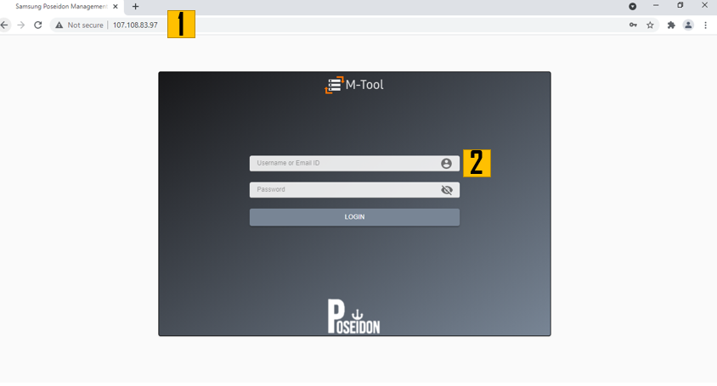

1. *MTool login page*
   1. **MTool Dashboard**

Dashboard provides user an overview of the Poseidon box. It has three sections,

* Performance overview
* Storage Details
* Storage Summary

In addition, it also has links to few admin tasks such as storage management functions, etc. It also shows the current working status of the storage management system and the last time the status is updated.

1. **Performance Overview** shows health metrics and the basic performance details such as Latency, Bandwidth and Throughput of the storage management box.
2. **Last-Updated** shows when the last status was retrieved.
3. **Status Label** shows whether the storage management is available or not.
4. Host IP, MAC address and name.
5. **Storage Details** shows the space utilization.
6. **Array Summary** provides the array level information in the storage management box.
7. **Volume Summary** provides the volume level information in the storage management box.

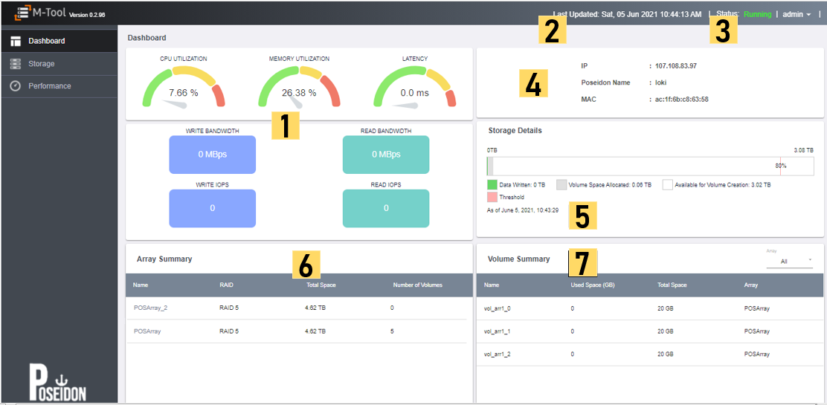

1. *MTool dashboard page*
   1. **MTool Storage Management**

The Storage Management page allows user to create an array and volumes, view existing array and volumes and manage existing arrays and volumes.

1. User can create one or more arrays based on the types of disks selected in the slots .i.e. Storage, Spare and Write Buffer Disks.
2. User can create a single or multiple volumes at a time by specifying the volume name, volume size, volume count and description.
3. User can view the volume information including volume name, volume size, used size, IP, description and status in a tabular format.
4. User can view the existing space for volume creation process.

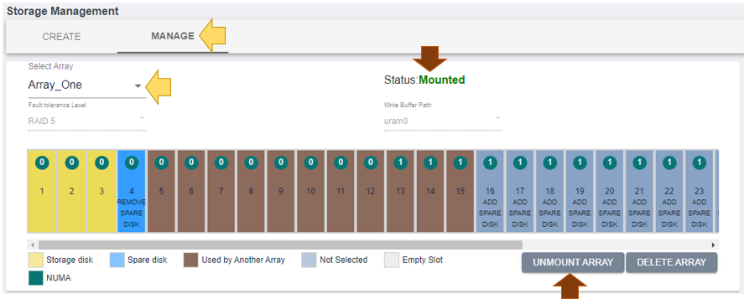

1. MTool storage management page
   * 1. ***Array Management***

Array management option allows user to create and manage one or more arrays.

*Create Array*

Follow the steps below to create sample array creation process:

1. **Array Name -** Select a name for the array (e.g. name = array_1)
2. **Fault Tolerance Level** – Select from the dropdown

*Note: Currently “RAID-5” is the only one supported.*

1. **Disk Type** - Select storage disks from the dropdown list. The 2 options for disk type are
   * Storage Disk
   * Spare Disk
2. **Write Buffer Path** – Select from the dropdown list.
3. User can view the available disks.

*The max number of allowable disks is 32.*

1. User can view the color codes for various types of disk supported by MTool. User can view additional details - name, size- by hovering over disk number
2. User can view the **NUMA** value of the disks.
3. Click **Create Array** button

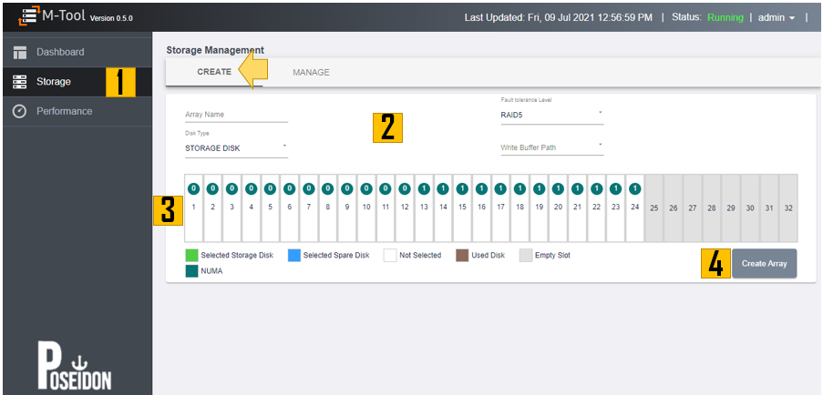

1. *MTool Array Management*

Follow the steps below to create sample array creation process:

1. Selected storage disk is shown in green
2. Select spare disk is shown in blue
3. Additional details of the disk can be seen when hovering on the colored bar
4. Click on the “Create Array” to create an array  
   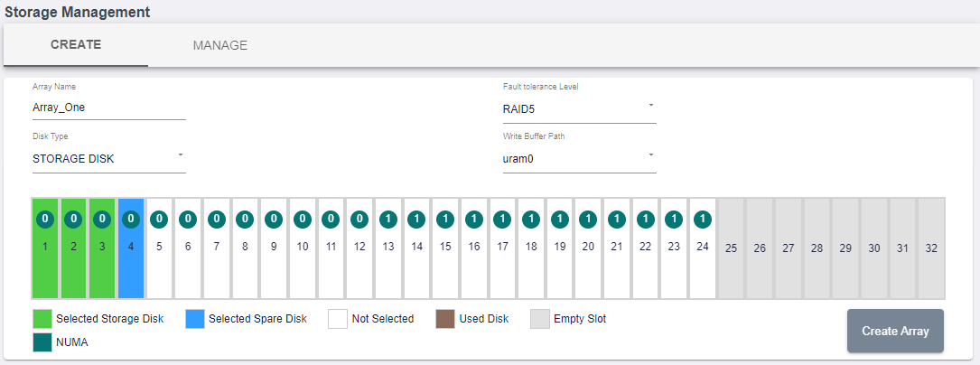
5. *MTool Array creation steps*

A confirmation message, “**Array Created Successfully**” displayed.

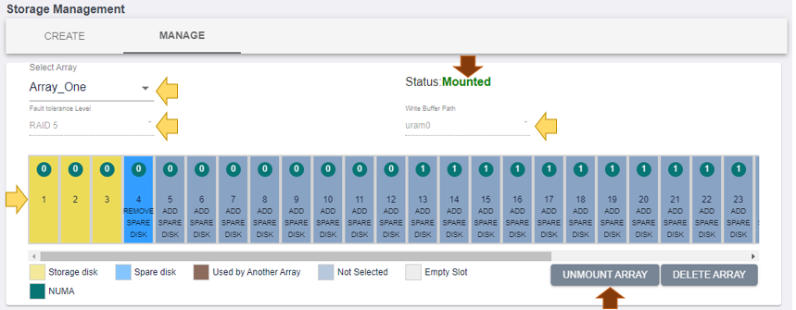

1. *MTool shows array details after successful array creation*

*Manage Array*

After successful array creation, user has the option to either **delete** or **unmount** an array through the manage section.

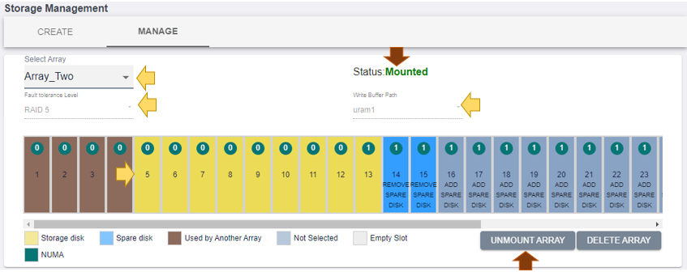

1. *MTool successful array creation and ability to unmount and delete*
   * + 1. *Delete Array*

Follow the steps below to delete array:

1. Click **Delete Array** button
2. A confirmation message is displayed, click **Yes** button to confirm the delete operation

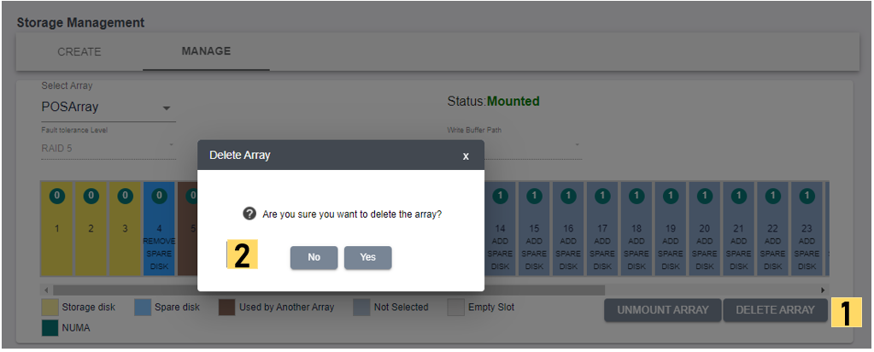

1. *MTool array deletion confirmation*

A confirmation message, “**Array Deleted Successfully**” displayed.

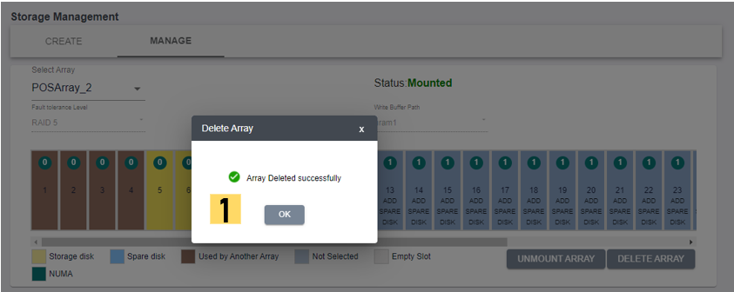

1. *MTool successful array deletion confirmation*
   * + 1. *Unmount Array*

Follow the steps below to unmount array:

1. Click “**Unmount Array**” button
2. By hovering over the “**Unmount Array**” button, the additional info is displayed

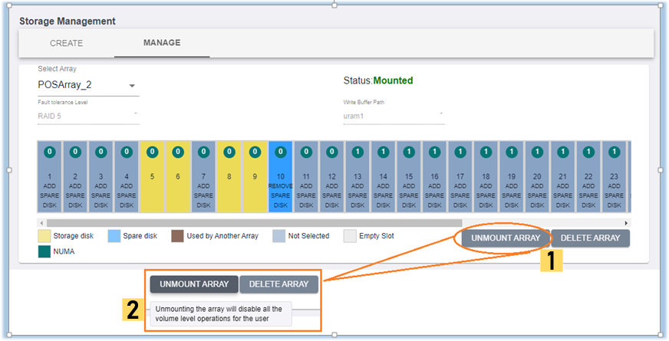

1. *MTool unmount array operation*

A confirmation message, “**Array Unmounted Successfully**” displayed. 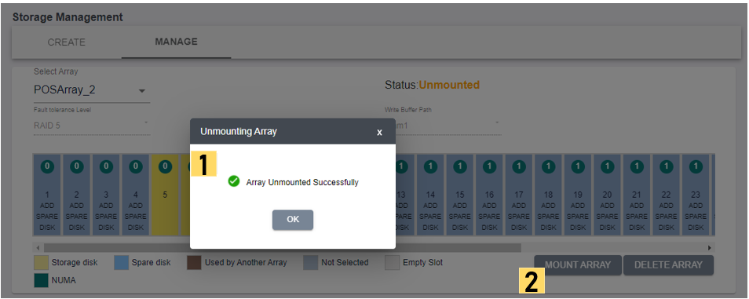

1. *MTool successful array unmount confirmation* 
   * 1. ***Volume Management***

Volume management option allows user to create and manage one volume or multiple volumes.

Follow the steps below to Manage Volume:

1. User can choose to create one volume or multiple volume. User can enter the number of volume he or she wishes to create.
2. User can enter the volume name. When user tries to create multiple volumes, then user can enter the suffix value to append to the multiple volumes that need to be created.
3. User can choose a number suffix value. For example, if user chooses to create 5 volumes with a volume name as “*volume_company*” and numeric suffix value of 0, then volumes with the following names would be created.
   * Volume_company0
   * Volume_company1 and so on to …
   * volume_company4
4. User can choose the max volume size (i.e. enter 0) or a predefined value.
5. User can choose the max IOPS value (i.e. enter 0) or a predefined value.
6. User can choose the max bandwidth size (i.e. enter 0) or a predefined value.
7. User can choose to mount the volume or leave it unmounted.
8. User can stop the volume creation process when an error occurs.  
   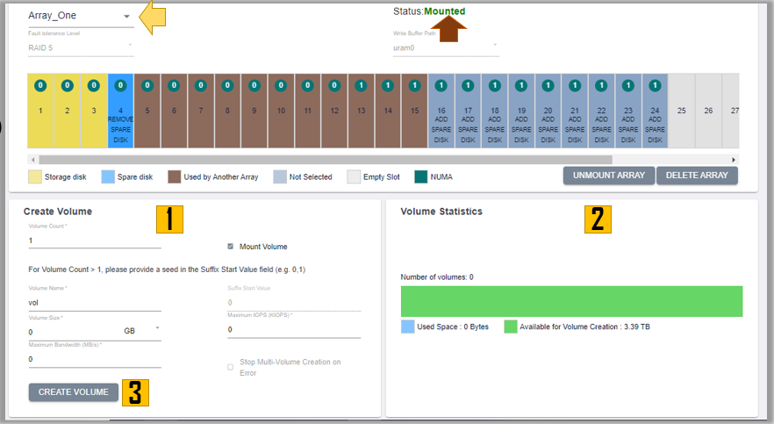
9. *MTool create volume from Array Manage Page*

Below is a screen showing the volume creation step for 5 volumes.

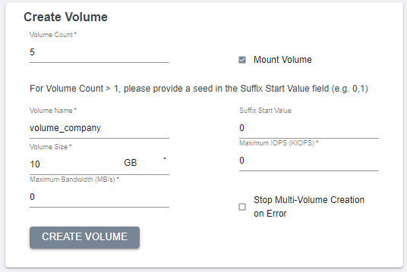

1. *MTool sample volume create steps*

A user can hit the “CREATE VOLUME” button for MTool to create the required volumes. MTool may take a few seconds depending on how many volumes are selected for creation.

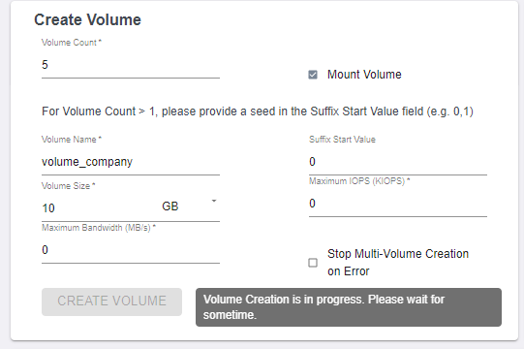

1. *MTool volume creation intermediate step waiting for processing*

Below is a screen showing the volume information for the newly created volumes.

1. User can search for specific volumes by using search terms for size, name, etc.
2. User can select all volumes to delete them.

*Note: Multi volume edit is not supported at this time.*

1. User can select a specific volume to either delete it or edit it.
2. User can mount or unmount a volume
3. User has option to either mount or unmount the volume by toggling the button.
4. User can select edit option for a specific volume
5. User can view the total number of volumes in the system

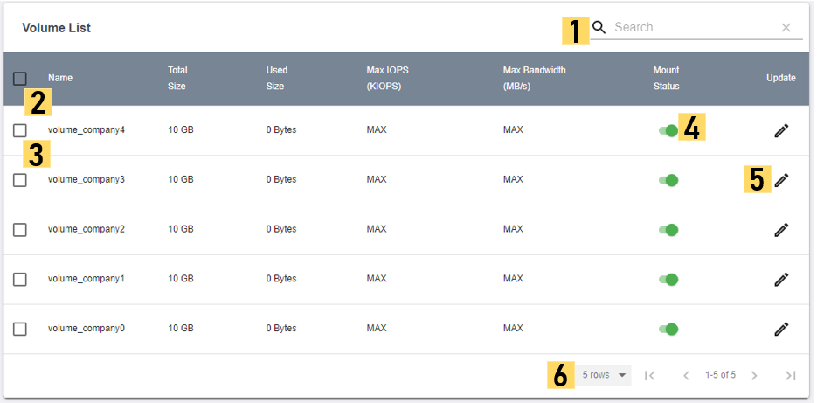

1. *MTool volume information*

Below is a screen showing *search function* for volume data.

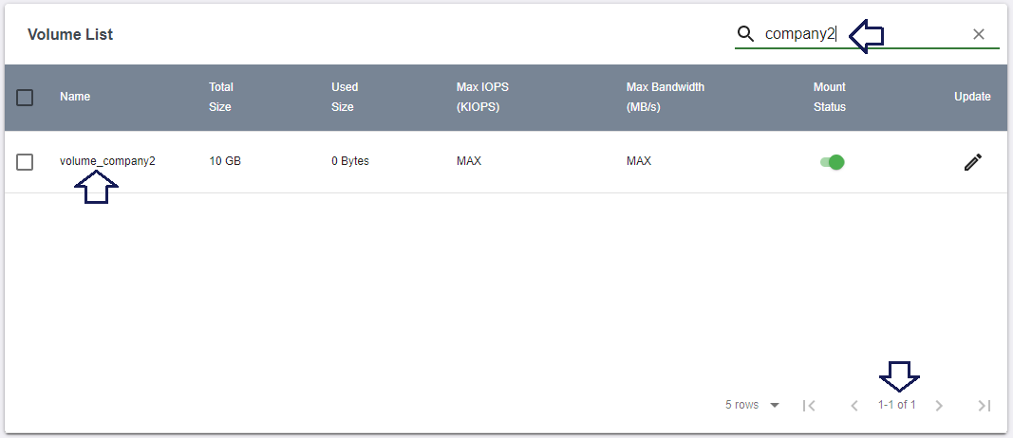

1. *MTool search volume information by keywords*

Below is a screen showing delete function for all volumes.

1. User can select the checkbox to select all volumes
2. User can click on the delete icon to perform delete operation on all volumes

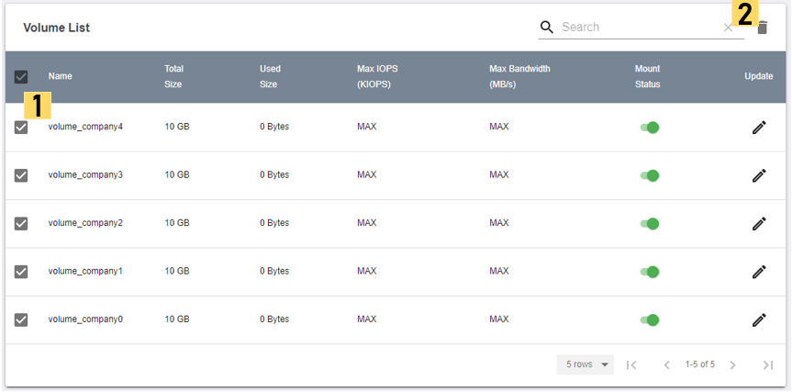

1. *MTool delete all volumes*

Below is a screen that shows delete function for one or many volumes.

1. User is notified whether one, many or all volumes are selected
2. User can select the checkbox to select one or many volumes
3. User can click on the delete icon to perform delete operation on the selected volumes

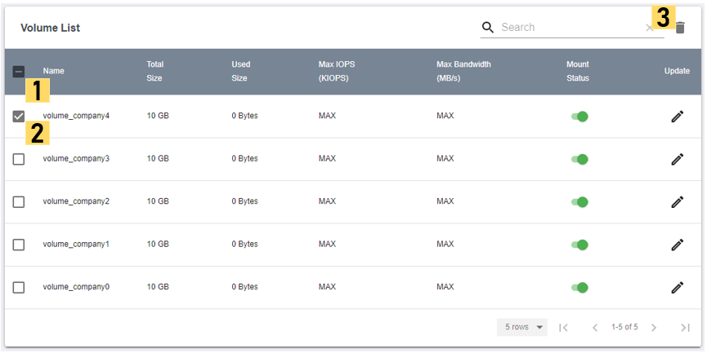

1. *MTool delete one or more volumes*

The screen below shows confirmation of the unmount operation.

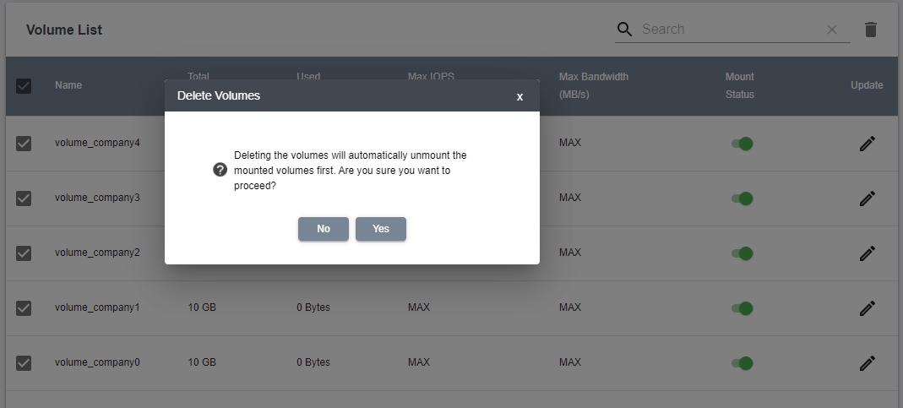

1. *MTool unmount volume confirmation*

The screen below shows unmount or mount operation on a given volume.

1. User is notified whether volume is mounted or unmounted
2. User can view the mount status of the volume

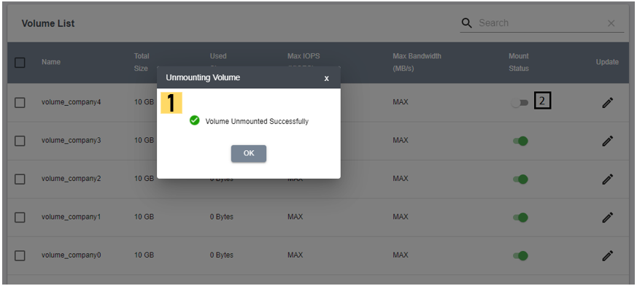

1. *MTool successful unmount operation confirmation*

The screen below shows update function for a given volume.

1. User can update the name of the volume
2. User can update the IOPS value
3. User can update the bandwidth value
4. User can click on the “OK” or “Cancel” button to update or cancel the changes

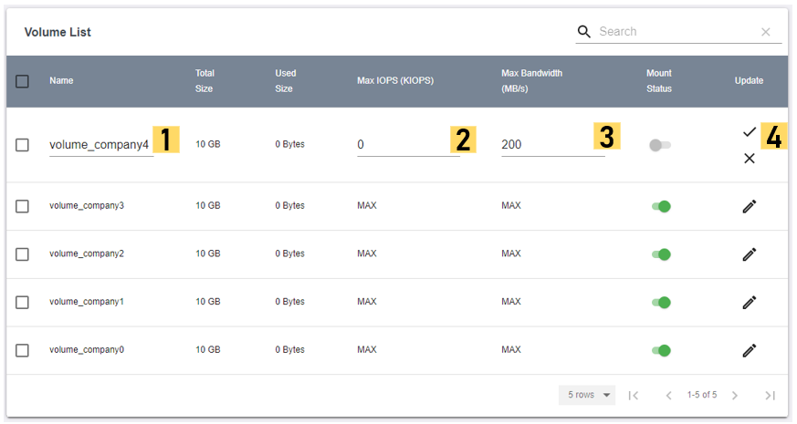

1. *MTool update volume information*

Screen below shows update operation on a given volume.

1. User is notified whether volume is updated successfully
2. User can view the updated data of the volume

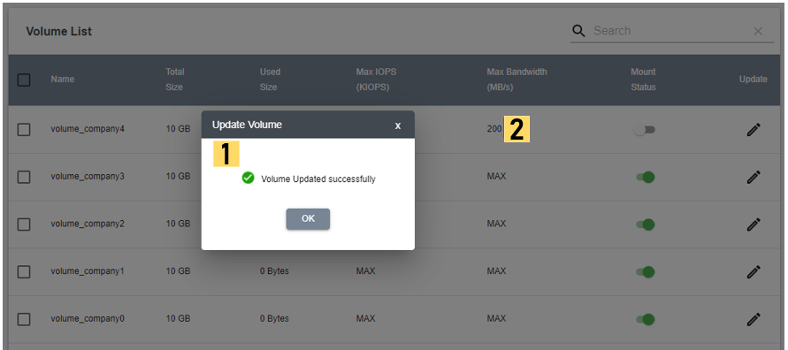

1. *MTool update volume information confirmation*
   1. **MTool Performance View**

Performance page shows the detailed charts regarding performance of the Poseidon box. It has charts for:

1. Throughput
2. IOPS
3. Latency
4. CPU utilization

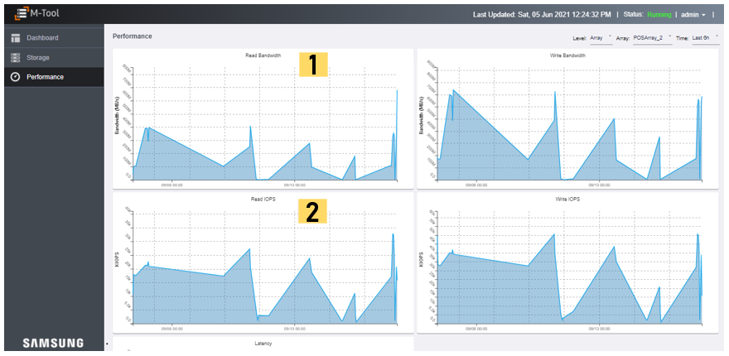

1. *MTool Performance page showing throughput and IOPS data*

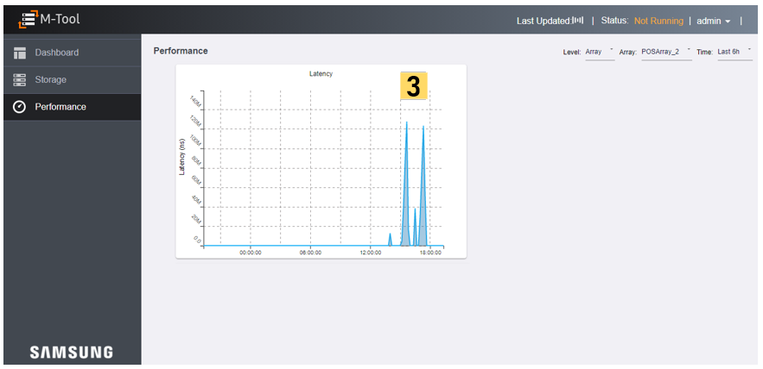

1. *MTool Performance page showing latency data*

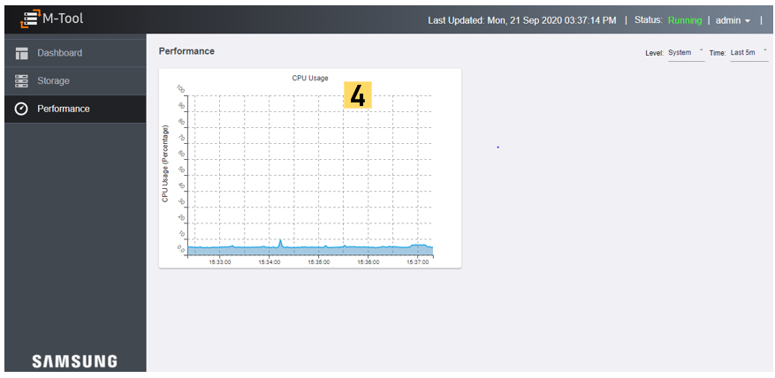

1. *MTool Performance page showing CPU data*

User can choose from following options for performance data

1. Level
   * Array
   * Volume
   * System
2. Array selection
3. Time (various time intervals)

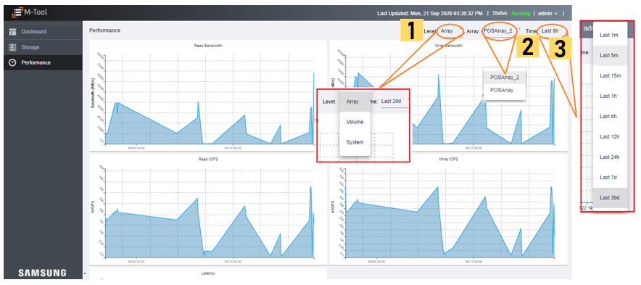

1. *MTool options for various performance data points*

Below is a screen that shows the CPU data for last 1 minute.

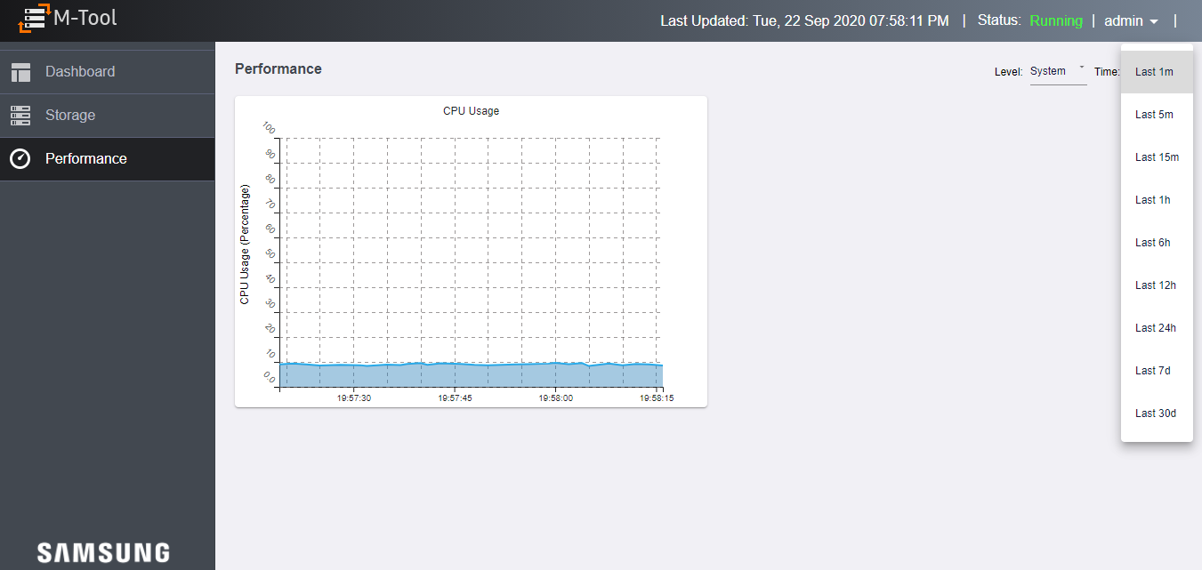

1. *MTool various time intervals available for CPU data*
   1. **MTool User Management**

The user management page allows admins to add a new user and modify Username, Email Id, Mobile Number fields of an existing user.

* + - 1. *New User*

User Addition requires six fields i.e. Username, Role, Password, Confirm password, Mobile Number and Email ID.

Follow the steps below to add a new user:

1. User can add a new user by providing
   * User name
   * Password
   * Phone
2. User can choose the default role “Admin”
3. User can save changes by clicking on “**Submit**” button

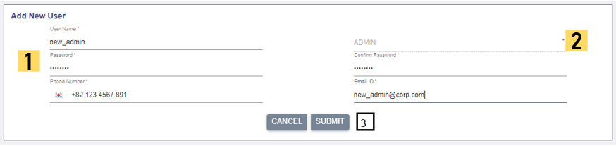

1. *MTool add new user information*
   * + 1. *Delete User*

User Deletion allows the admins to delete the entire user(s) details.

*Note: If a user record is deleted by the admin, the user would not be able to login to the management portal.*

1. Admins can view or update existing users and their information.
2. Admins can use **Add New User** functionality to re-add the user.

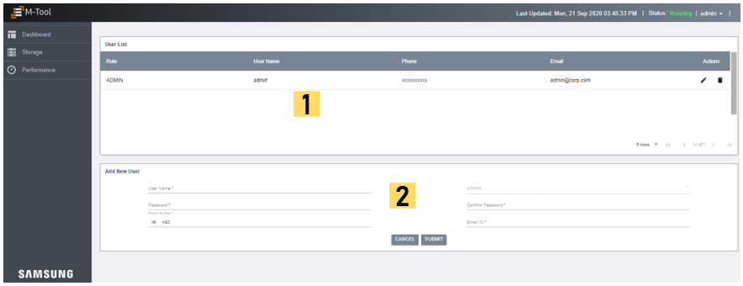

1. *MTool user management page*
   * + 1. *Modify User*

User Modification allows the admins to modify Username, Active Status, Email Id, Mobile Number fields of an existing user.

*Note: If a user's active status is disabled by the admin, then the user would not be able to login till the status is reverted to active state by the admin*

Follow the steps below to update a given user information:

1. User can update the phone
2. User can update an email
3. User can either save changes or discard them

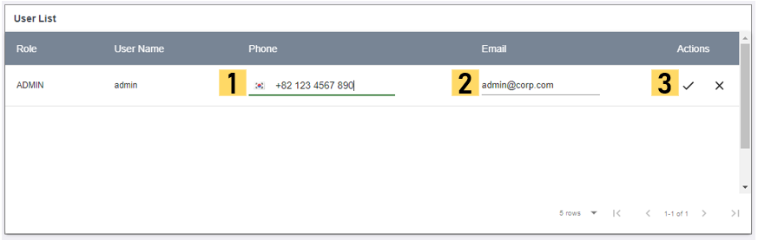

1. *MTool update user information*
   1. **MTool Storage Management Start or Stop Operations**

This page allows users to start or stop the Storage Management system. This will provide the real time status of the system. This feature is available for admin users only.

This page enables users to:

1. View the current status of the storage management system
2. Either start or stop the storage management system based on current status
3. View the response of the operation on the storage management system

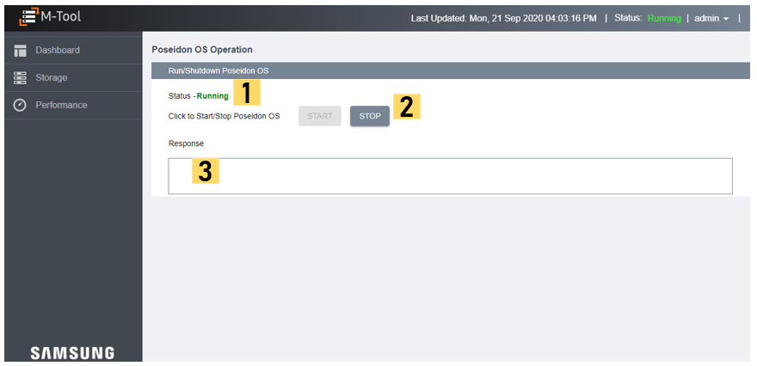

1. *MTool start and stop operation page*
2. **How to install MTool**

Follow the steps below to set up and run the MTool (the scripts shown below are available in the m9k directory)

*1. Install Packages*

These packages are required for proper working of the Management tool. This will install required packages such as influxdb, chronograf, kapacitor on the host.

*./install_all.sh*

*2. Run application*

To run various applications, use this command below.

*./run_all.sh*

*3. Access the MTool application via browser*

The server will run on the local web server and will be accessible from the browser

*http://<ip_address>*

1. **How to Uninstall MTool**

Follow the steps below to uninstall the MTool (the scripts shown below are available in the m9k directory)

*1. Uninstall services and applications running*

*./uninstall.sh*