# GAM400 Project Brief – Team OHL

Created by Keonwoo Ryoo

# Game/Project Summary:

2.5D Party-Based Real-Time Global Cooldown-based Dungeon Looter with character growth and crafting.

Created for mobile devices on the Unity Engine.

# Game/Project Description:

**Overview ==================================================**

The player is a god created to battle a lethal threat to the world. Unable to personally affect the world, the player recruits adventurers turning them into their scions and directs them to combat the threat.

**2.5D ======================================================**

2.5D camera perspective

2D Sprites

3D Environment and VFX

References:

* Octopath Traveler [3D environments with 2D sprites]
* Dungeon Fighter Online [2D environment with 2D sprites]

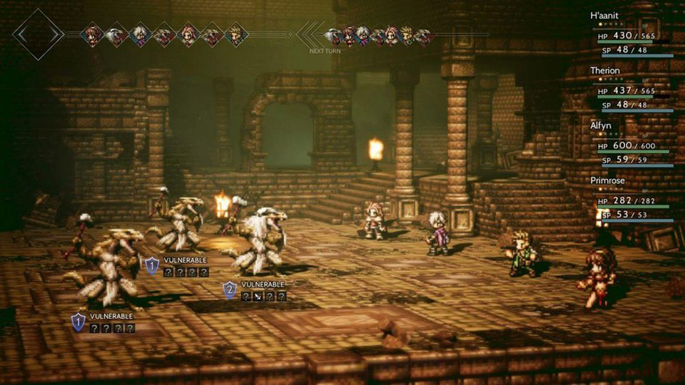

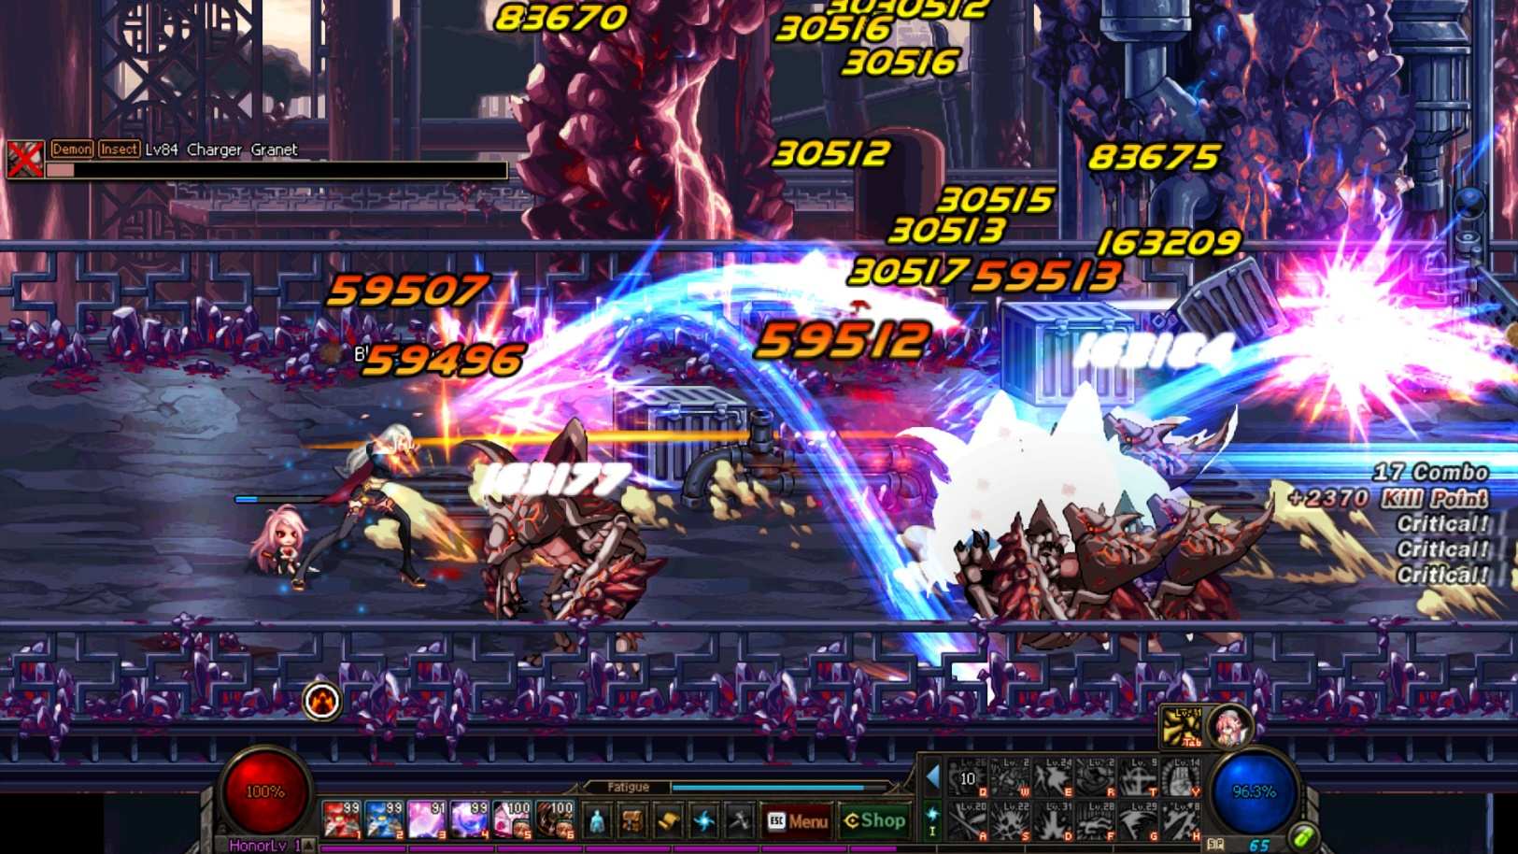

<https://thumbor.forbes.com/thumbor/960x0/https%3A%2F%2Fblogs-images.forbes.com%2Folliebarder%2Ffiles%2F2019%2F04%2Foctopath_traveler_pc-1200x675.jpg>

<https://steamcdn-a.akamaihd.net/steam/apps/495910/ss_2a00a97667016499b450b444eb0a8f01e7ceafc7.1920x1080.jpg?t=1567502793>

**Party-Based Real-Time Global Cooldown- Based Combat ===============**

Party-Based

* The player controls 3 characters that are guided by Holy Trinity archetypes
  + Holy Trinity: (Tank, Healer, DPS)

Real-Time Global Cooldown-Based

* Combat is dictated by two systems
  + **GCDs [Global cooldowns]:** Actions that all share a single cooldown timer. Taking any GCD action triggers a cooldown for all other GCD actions.
  + **OGCDs [Off Global Cooldown]:** Actions that do no share this single cooldown timer. Taking an OGCD action triggers only its specific cooldown.
* The combination of these two systems allows for a well-paced combat loop while allowing players to stay engaged and react to the experience.
* References:
  + World of Warcraft
  + Final Fantasy XIV: A Realm Reborn

**Dungeon Looter =============================================**

Player clears dungeons to gain resources and random items.

Dungeons scale to character power and are specified to give only certain resources.

Ex.

|  |  |  |
| --- | --- | --- |
| Dungeon | Lv10 Party Reward | Lv50 Party Reward |
| Wood Dungeon | 5 Wood | 10 Wood, 5 High-Quality Wood |
| Stone Dungeon | 5 Stone | 10 Stone, 5 High-Quality Stone |
| Experience Dungeon | 50 Bonus XP | 5000 Bonus XP |

* This is meant to avoid a content generation treadmill. This example shows the basic idea, but not the final execution of this idea.

**Character Customization =======================================**

Characters found have random properties that the player can look through before recruiting them.

Characters are made of these parts

|  |  |  |
| --- | --- | --- |
| Part | Description | Purpose of part |
| **Level** | Determines attribute points and class points. | Visualizing progression. |
| **Name** | The characters name (Customizable) | Player investment |
| **Attributes** | Attributes points are gained based on level.  CON (Each point increases max HP)  WIS (Each point increases max Resource [MP/SP])  STR (Each point can be allocated to an strength substat)   * Physical Damage * Physical Resistance * GCD Damage   DEX (Each point can be allocated to an Dexterity substat)   * Critical Chance * Critical Damage * GCD Reduction.   INT (Each point can be allocated to an Intelligence substat)   * Elemental Damage * Elemental Resistance * Casting Speed | The reason each of the 3 main attributes have a substat, such as DEX’s Critical Chance, is to increase customization options while keeping the surface info clean.  Substats should only be visible during level-ups and when the player is looking at their characters.  *Note: We are considering. |
| **Nature** | Gives small tertiary bonuses to the character. Determined at character acquisition and cannot be changed.  Ex. +5% gold earned | Increase character variety |
| **Class** | Each class has a unique class tree.  Class trees contain passive benefits, GCDs, and OGCDs unique to that class.  Class points are gained based on level. Reallocating class points requires time.  Swappable class system. A character with extremely high strength may be a wizard, but it is not optimal. | Guides players by providing templates that can inform attribute allocation.  Players are free to create non-optimal options as they desire. |
| **God Affiliation** | A small text that tells any player whose character this is.  Ex. “Scion of Dionysus” | Player investment |
| [Stretch]  Race | Stretch goal because it requires art.  Characters have a race that cannot be changed.  Simple version – Graphical Change  Complex version – +Racial traits | More customization options. Increased character variety. |
| [Stretch]  Blessing | Stretch goal because it is difficult to balance. Incorporating it isn’t hard, but making it improve the game requires more thought.  Characters can be given swappable blessings that give moderate gameplay changes.  Ex. Blessing of Salamander – +20% fire resistance | More customization options.  Increased character variety.  Potential resource dump. |

The objective behind this design is to create a character system that allows for player creativity and maximizes player investment.

**Items and Crafting ===========================================**

Items include weapons, armor, and accessories.

Items are made of these parts

|  |  |
| --- | --- |
| Part | Description |
| Base Stat | Ex. A dagger does 10-12 damage.  Ex. Steel Armor gives 10% physical resistance.  Ex. A Fairy Necklace gives 10% fire resistance. |
| Gem Slots | Items have a number slots attuned to a certain attribute.  Ex. A dagger with a DEX gem slot that gives +10% critical chance |
| Refinement Level | Increases base damage and increases potency of gems.  Ex. A +10 dagger does 20-24 damage with a DEX gem slot that gives +15% critical chance. |
| Rarity | Higher rarity increases based damage and the number gem slots. |

Items can be broken down to extract their gems.

Higher rarity and higher refinement level results in better gems.

Gems can be slotted into items as long as their attuned attribute is the same.

*The crafting system needs some expansion.

# Team Members:

|  |  |  |  |
| --- | --- | --- | --- |
| Name | Primary Role | Secondary Role | Tertiary Role |
| Keonwoo Ryoo | Producer | Systems Design | General Design |
| Wonjae Jung | Gameplay Programmer | VFX Programming |  |
| Seonghak Kim | Gameplay Programmer | Database Programming |  |

# System Survey / Project Plan:

Milestone 1 [W01 – W05]

|  |  |  |  |  |  |  |
| --- | --- | --- | --- | --- | --- | --- |
| System | | Owner | Duration | Start Date | Due Date | Description |
| Events Logger | | W.J | 3d | W02 | W02 | Visual representation. No parsing or data processing. |
| Game Events Manager | | W.J | 3w, Ongoing | W02 | W05 | Non-Combat Events Manager |
| + Character Events |  | 10d | W02 | W04 | Character level-ups, etc. |
| + Reward Events |  | 10d | W04 | W05 | Dungeon clear rewards, etc. |
| + Debugging |  | Ongoing | W02 | Ongoing |  |
| Combat Events Manager | | | S.K | 3w, Ongoing | W02 | W05 | Core Combat System |
| + Entity Objects |  | 4d | W02 | W03 | Entity Structs and Functions |
| + Core Events Manager |  | 8d | W03 | W04 | Combat Events Resolver |
| + Conflicts Resolver |  | 6d | W04 | W05 | Rudimentary Priority System |
| + Debugging |  | Ongoing | W02 | Ongoing |  |
| [Stretch] Database Integration | | | K.R |  | TBA | TBA | SQLite integration. Integrated for querying item/character generation and rewards. |

Milestone 2 [W05 – W14]

*Week 6/7 are midterm week.

|  |  |  |  |  |  |  |
| --- | --- | --- | --- | --- | --- | --- |
| System | | Owner | Duration | Start Date | Due Date | Description |
| Extended Game Manager | | W.J | 3w, Ongoing | W05 | W10 | Additional necessary game systems. |
| + Item Manager |  | 10d | W05 | W07 | Item storage and application to characters. |
| + Player Event Manager |  | 10d | W07 | W09 | Tutorial sequences. Unlocking dungeons, etc. |
| + Polish |  | Ongoing | W09 | W12 |  |
| Character Generator | | W.J | 5d | W09 | W10 | New character generation. Stats, race, talents etc. |
| Extended Combat Manager | | S.K | 3w | W05 | W10 | Additional combat systems |
| + Status Manager |  | 5d | W05 | W06 | Status effects resolver |
| + Priority Manager |  | 10d | W06 | W08 | Enemy aggro manager. |
| + Polish |  |  |  |  |  |
| Item Generator | | S.K | 3d | W08 | W08 | New item creation. Item rarity, slots, etc. |
| Item Crafting and Modification System | | S.K | 12d | W08 | W10 | Crafting system with item customization systems. |
| [Stretch] Data metrics and player profiling | | TBA | 10d | TBA | TBA | Process logged events to find patterns and create a player profile. |

# Content Survey / Project Plan:

Milestone 1 [W01 – W05]

|  |  |  |  |  |  |
| --- | --- | --- | --- | --- | --- |
| Content | Owner | Duration | Start Date | Due Date | Description |
| Combat UI and Feedback | K.R | 7d | W02 | W03 | Player buttons. Damage feedback. |
| Combat Demo Art | K.R | 5d | W03 | W04 | Low-Fidelity character and enemy art, vfx. |
| Combat Demo Audio | K.R | 4d | W04 | W05 | Simple, unpolished audio. |

Milestone 2 [W05 – W14]

|  |  |  |  |  |  |
| --- | --- | --- | --- | --- | --- |
| Content | Owner | Duration | Start Date | Due Date | Description |
| Combat UI Testing | K.R | 3d | W05 | W06 | Testing core gameplay. Adjusting UI based on data. |
| Hubworld UI and Art | K.R | 4d | W06 | W06 | Basic artwork and UI for hubworld. |
| Character UI | K.R | 4d | W06 | W07 | Shows character parts.  Tells the player what attributes do what. |
| Item/Inventory UI | K.R | 4d | W07 | W07 | Shows items player has and the attributes of each item. |
| Character Progression Spreadsheets | K.R | 5d | W07 | W08 | Character XP/Time pacing.  Character power tiers and balancing. |
| Item Progression Spreadsheets | K.R | 5d | W08 | W09 | Item power balancing.  Item rarity balancing. |
| Player Objective and Tutorial Sequences | K.R | 7d | W08 | W10 | Incorporate player objective and player tutorials. |
| Content Polish | K.R | Ongoing | W10 | -- |  |

*Note: I am aware how important UI is in conveying design. UI will be my main focus in this semester.

# Milestone Deliverables:

## MILESTONE #1 – presentation to audience (week 5)

**Presentation Content**

1. Presentation of finalized game systems, game loops, and game story/setting.
2. Unity demo with simple combat with minimal art, UI, and feedback.
   1. The player will face one battle.
   2. After defeating all enemies, player is rewarded resources and [Stretch] an item.

**Completed Systems and Tech**

* Combat
  + Playable
  + Can demonstrate unique combat design. (real-time turn-based combat design)
* Game
  + Framework complete, not playable.
  + Characters can gain xp, level up, and improve.
  + Defeating enemies and completing dungeons can offer rewards.

**STRETCH GOALS (by priority)**

* [Additional Combat Systems] Aggression System
* [Additional Combat Systems] Status Effects
* Hubworld
  + Skeleton framework of what the player base will be like.
  + Player is able to access a list of their characters, items, and enter a dungeon from the hubworld.
* Database Integration: SQLite

## MILESTONE #2 – demonstration in lab to instructors (week 9,10,11)

**Demo Content**

* Demo Path
  + Player Creation > Hubworld > Player tutorial with finalized combat systems > Reward System > Character Customization sample > Item Customization sample > Player Objective and game loop
* Completed Combat System
* Finalized Combat UI
* Completed Hubworld System

**STRETCH GOALS (by priority)**

* Data Metrics and Player Profiling
  + For monetization

## FINAL MILESTONE (submission)

**Submission Content**

Previous Demo content with…

* Completed Character Progression System
* Completed Character Modification System
* Completed Item Progression System
* Completed Item Modification System

Game should have a single dungeon with a boss in which the game ends after defeating the boss.

* Will either
  + Reset player progress
  + Allow for the player to continue grinding for content (leaning towards this)