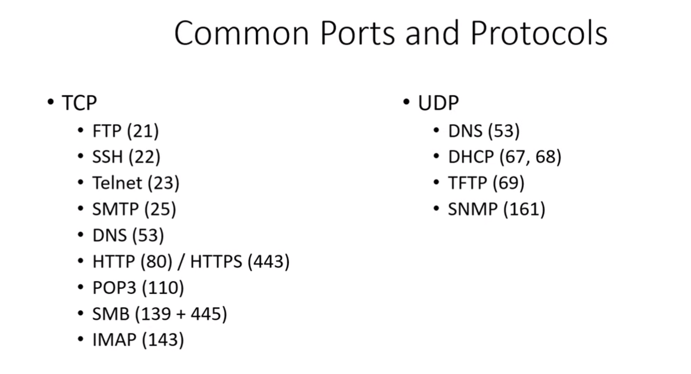

OSI MODEL

Please Do Not Throw Sausage pizza Away

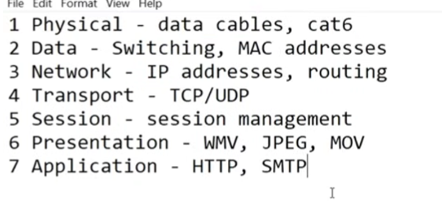

SUBNETTNG  
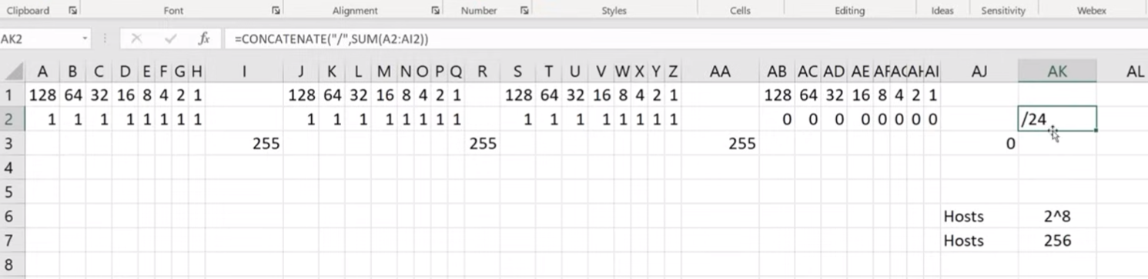  
  
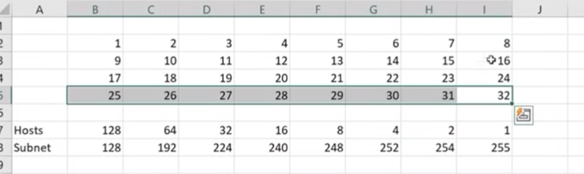  
  
  
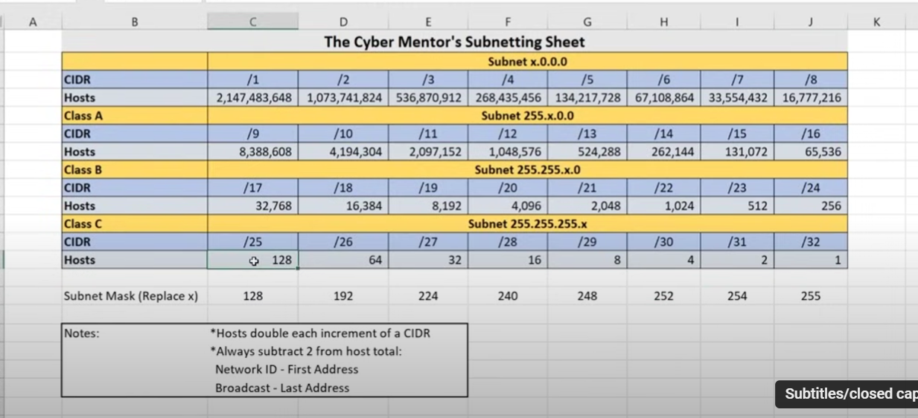

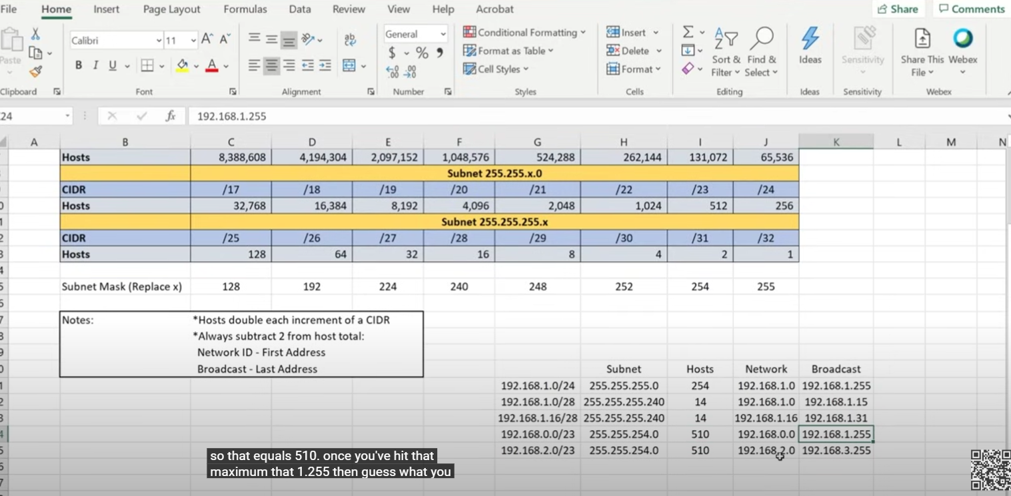

In case of /23 or/22 or any /number that is not the end of a series, we don’t need to fix the x to 1.  
Instead we can write something like 192.168.0.0 which includes all the networks given above

**KALI LINUX**



workstation

directory

user



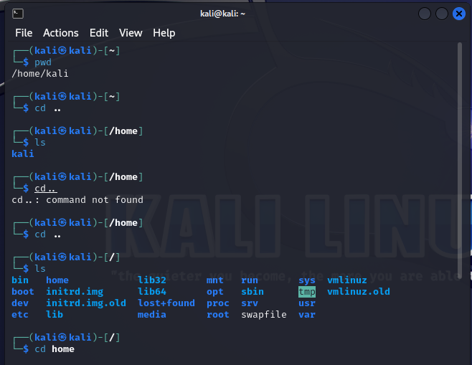

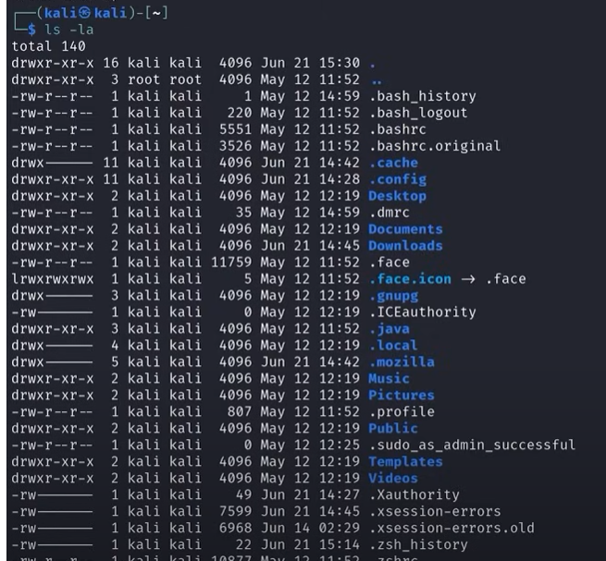

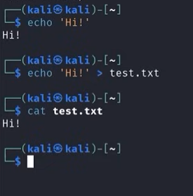

New passwd- hello123

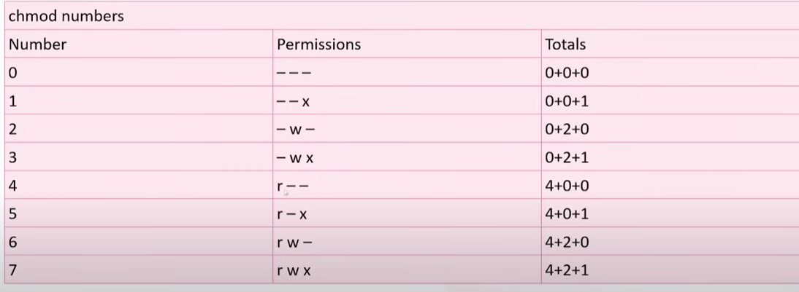



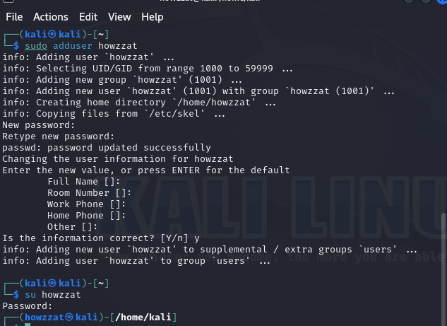

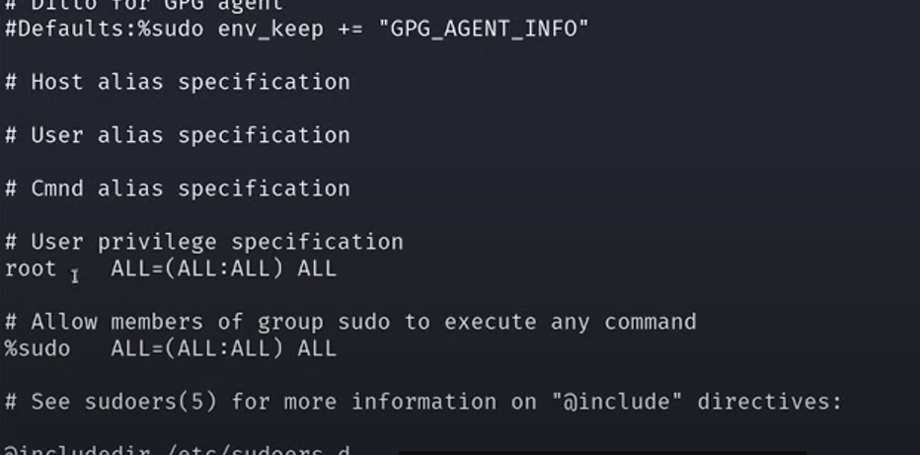

Sudo is accessible to members of the %sudo group.  
now we have to see what are the members of %sudo group



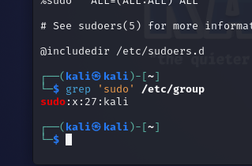

The Grep command extracts a part of text or string from a given file  
here we can se that sudo is accessible to kali only

