**Divers Find Body of Toddler Snatched by Alligator at Disney Resort**

**By NICK MADIGAN and** [**CHRISTINE HAUSER**](http://topics.nytimes.com/top/reference/timestopics/people/h/christine_hauser/index.html)JUNE 15, 2016

Continue reading the main story

Share This Page

* [Share](javascript:;)
* [Tweet](javascript:;)
* [Email](javascript:;)
* [More](javascript:;)
* [Save](javascript:;)

close shareTools

422

close story-meta-footer

close story-meta

Photo



Lane Graves

Credit

Orange County Sheriff's Office

LAKE BUENA VISTA, Fla. — Lane Graves was doing what any 2-year-old boy would be doing on a hot Florida evening — splashing around in the shallow waters of a lagoon. His parents and sister, Nebraskans all, were nearby on the beach at a Disney resort here, relaxing, carefree.

Suddenly, an alligator sprang from the water and clamped its jaws around the boy. Lane’s father, Matt Graves, bounded into the lagoon to wrestle his son from the animal’s steel-trap grasp, but lost the battle, according to an account by the Orange County sheriff, Jerry L. Demings.

The alligator made off with the boy, and an intense search for him yielded nothing in the wide, murky expanse of water until more than 16 hours later, early on Wednesday afternoon, when divers found him about six feet below the surface and only 10 to 15 feet from where he had last been seen. He was placed in a marine patrol boat, covered with a white sheet, and turned over to the medical examiner for an autopsy.

“His body was completely intact,” Sheriff Demings said at a news conference less than a mile from the lagoon, shortly after he and a Catholic priest had delivered the “tough message” of the boy’s death to Mr. Graves, his wife, Melissa, and their 4-year-old daughter, who live in the Elkhorn section of Omaha, Neb.

“The family was distraught but also, I believe, relieved that we were able to find their son,” said the sheriff, who noted that there was no question in his mind that “the child was drowned by the alligator.”

Lane had been splashing about, the sheriff said, despite a sign that said swimming was not permitted in the lagoon. His father also summoned a lifeguard from a nearby pool, but he, too, was unable to rescue the boy.

DANGEROUS ANIMALS **By REUTERS** **00:37**

Sheriff: Boy’s Body Is Found

Video

**Sheriff: Boy’s Body Is Found**

Sheriff Jerry L. Demings of Orange County, Fla., said the body of a 2-year-old boy, snatched by an alligator as he played by the water’s edge at a Walt Disney World lake, had been found. By REUTERS on

Publish Date

June 15, 2016. Photo by John Taggart/European Pressphoto Agency. [Watch in Times Video »](http://www.nytimes.com/video/us/100000004474258/sheriff-boys-body-is-found.html?action=click&contentCollection=us&module=embedded&region=caption&pgtype=article)

* [**Embed**](javascript:;)
* [**Share Tweet**](javascript:;)

The recovery ended a search that began shortly after 9 p.m. on Tuesday in the lagoon at Disney’s Grand Floridian Resort and Spa. The artificial lake, which covers about 200 acres, is 14 feet deep in parts and feeds a series of canals that wind through the Disney complex. It lies across from the Magic Kingdom theme park.

Alligators are a common sight in Florida ponds, lakes, lagoons and canals. The sheriff said five alligators were taken from the lagoon after the boy went under. They have been euthanized to determine if any of them killed the boy.

Sheriff Demings noted that Disney had been in business in the area for 45 years and had never had a similar incident, and that no “nuisance alligators” had been reported in the area recently.

“Everyone here at the [Walt Disney World](http://topics.nytimes.com/top/reference/timestopics/organizations/d/d_disney_walt_world/index.html?inline=nyt-org) Resort is devastated by this tragic accident,” Jacquee Wahler, vice president of the [Walt Disney World](http://topics.nytimes.com/top/reference/timestopics/organizations/d/d_disney_walt_world/index.html?inline=nyt-org) Resort, said in a statement. “Our thoughts are with the family. We are helping the family and doing everything we can to assist law enforcement.”

The resort, which has closed its beaches for the time being, has a wildlife management team that monitors alligators and other animals and regularly removes any that appear to be troublesome, according to Nick Wiley, executive director of the Florida Fish and Wildlife Conservation Commission. He said that alligator attacks were “not common at all” but that alligators were capable of moving across land and underwater so fencing them off was not a feasible option.

But some visitors to the resort on Wednesday said Disney could have done more to protect the child and other visitors beyond simply posting the “No Swimming” signs that dot the periphery of Seven Seas Lagoon and others like it.

“Disney should always have these lakes patrolled, with all the money they’re making,” Jerome Powell, a hotel concierge who works for a Disney competitor, said as he waited for a shuttle bus near the Magic Kingdom. “That alligator should never have been in that water. For the alligator to be able to walk right out of the lagoon and grab that child, that’s crazy.”

Photo

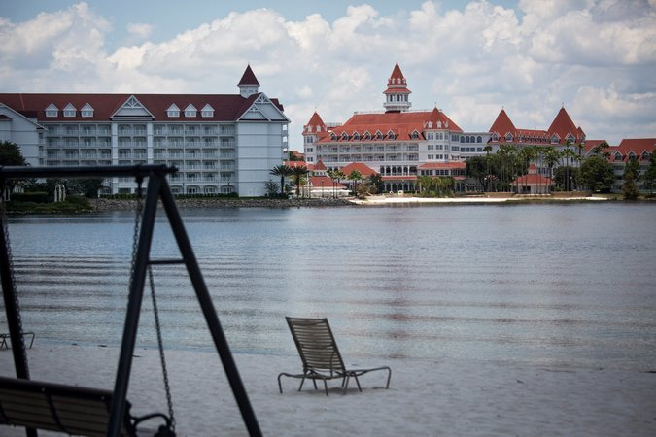

The Seven Seas Lagoon at Disney’s Grand Floridian Resort and Spa near Orlando, where 2-year-old Lane Graves was dragged away by an alligator Tuesday evening.

Credit

John Taggart/European Pressphoto Agency

Kaitlynn Michaud, 16, from Ellington, Conn., who was visiting with her mother, Kim, said a mere “No swimming” sign “isn’t really helpful enough” when alligators were known to be part of the natural population.

“You can still be near the water,” she said, “and get into trouble.”

Thomas Scolaro, a partner at the Miami law firm Leesfield Scolaro, which has represented families after alligator attacks elsewhere, said that in this case, “the facts look horrible for Disney.”

“While this is a tragedy, it was entirely preventable had Disney acted reasonably and not left unwitting tourists at the mercy of dangerous and wild animals that roam its resort,” he said.

The child’s death was another blow to an area already on edge after the shootings at an Orlando nightclub early on Sunday and the murder two days earlier of a popular singer. A state tourism official did not respond to a request for comment.

Wildlife experts estimate that there are 1.3 million alligators in Florida, and that they can be found in all 67 counties. They prefer freshwater lakes and slow-moving rivers and their associated wetlands, but they can also be found in brackish water habitats, said Tammy Sapp, a spokeswoman for the state fish and wildlife commission.

“Anywhere there is standing water, an alligator might be found,” she said,

Last year, the Central Florida area had its first reported fatal alligator attack since 2007. The body of a swimmer, James Okkerse, 61, of DeBary, Fla., was pulled from a lake in Volusia County, north of Orlando, and it was determined that he had been attacked by a 12-foot gator.

**422**

COMMENTS

Also last year, a 22-year-old man who authorities said was fleeing a burglary was killed by an alligator in Brevard County, east of Orlando. The man, Matthew Riggins, drowned, the sheriff’s office said, and his body showed signs of having been mauled.

Ed Frank, visiting from Charlotte, N.C., with his wife and two sons, said Wednesday that he was sure the Graveses had been careful. “But we’re in Florida, and there are alligators in bodies of water,” he said. “Alligators in their natural environment are good at camouflage. It’s what they do.”

Nick Madigan reported from Lake Buena Vista, and Christine Hauser from New York. Reporting was contributed by Daniel Victor, Lew Serviss and Justin Porter from New York; David Moll from Hong Kong; and Sewell Chan from London.