Data Base Table Structure

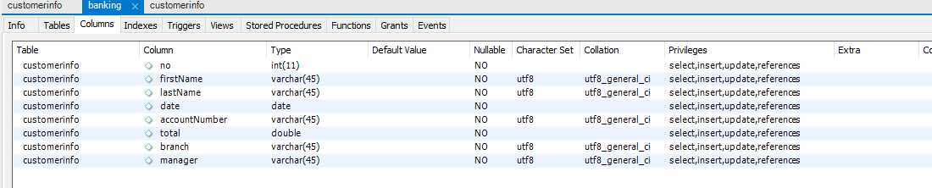

Customer Info Before Change

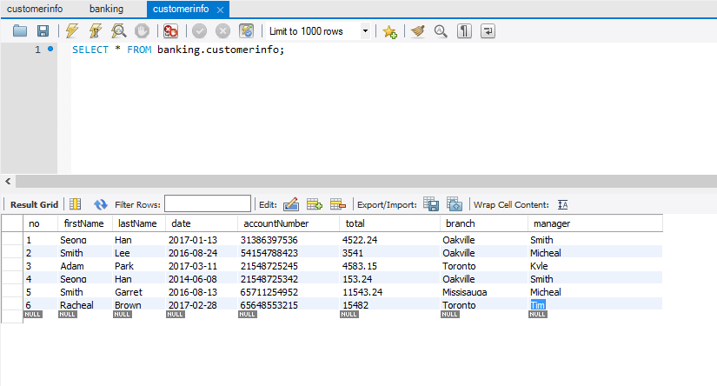

Final Data (After All functions Performed)

