Unit 9, Assignment

Seong il Song

**Problem #1**

Write a JavaScript program that changes the HTML code that prints "Hello World" to have it say "Good Night World" .  Hint: innerHTML

**Answer.**

|  |
| --- |
| unit9_problem1.html |
| <html>  <head>  <meta charset = "utf-8">  <title> Unit 9 - Problem 1 </title>  <script type="text/javascript" src = "unit9_problem1.js"> </script>  </head>  <body>  <!-- HTML code that prints "Hello World" -->  <p id = "greeting"> Hello World </p>  <p> <input type = "button" value = "Change Greeting" id = "changeButton"> </p>  </body>  </html> |
| unit9_problem1.js |
| // register event handlers for the Change Button  function start()  {  document.getElementById("changeButton").addEventListener("click", changeGreeting, false);  }  // A JavaScript code that changes the HTML code that prints "Hello World" to have it say "Good Night World"  function changeGreeting()  {  document.getElementById("greeting").**innerHTML** = "Good Night World";  }  // Call start function to register event handlers when the page is loading  window.addEventListener("load", start, false); |

Screen Shot: Before Click the Change Greeting Button.

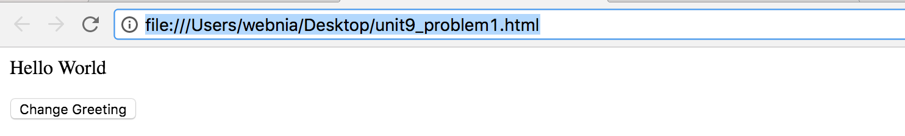

Screen Shot: After Click the Change Greeting Button.

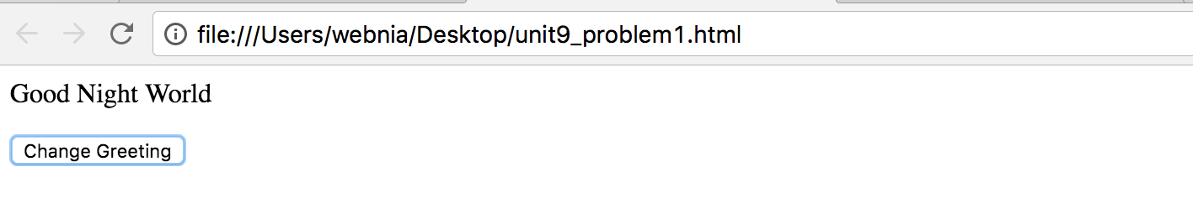

**Problem #2**

Write a JavaScript program to highlight the bold words of the following paragraph by changing the text color to red, on mouse over.

**We** have just started **this** section for the users (**beginner** to intermediate) who want to work with **various** JavaScript **problems** and write scripts online to **test** their JavaScript **skill**.

 Hint: wordItems = document.getElementsByTagName('strong'); // The paragraph uses <strong></strong> tags for the bold words. Change <strong> default behavior.

**Answer.**

|  |
| --- |
| unit9_problem2.html |
| <html>  <head>  <meta charset = "utf-8">  <title> Unit 9 - Problem 2 </title>  <link rel = "stylesheet" type ="text/css" href = "unit9_problem2.css">  <script type="text/javascript" src = "unit9_problem2.js"> </script>  </head>  <body>  <p> A normal paragraph </p>  <p> **<strong>** A Paragraph with with Strong Tag **</strong>**</p>  </body>  </html> |
| unit9_problem2.js |
| // register event handlers  function start()  {  [].forEach.call(document.**getElementsByTagName**("strong"),function(el){  // register event handlers for the mouse over.  el.addEventListener("mouseover",mouseOver);  // register event handlers for the mouse leave.  el.addEventListener("mouseleave",mouseLeave);  });  }  // A JavaScript code that highlights the bold words of the following paragraph by changing the text color to red, on mouse over  function mouseOver()  {  document.getElementsByTagName("strong")[0].setAttribute("style", "color: red;");  }  function mouseLeave()  {  // A JavaScript code that dehighlights the bold words of the following paragraph by changing the text color to black, on mouse leave  document.getElementsByTagName("strong")[0].setAttribute("style", "color: black;");  }  // Call start function to register event handlers when the page is loading  window.addEventListener("load", start, false); |
| unit9_problem2.css |
| /* css for unit9_problem2.html */  boday {font-family: arial, helvetica, sans-serif;  font-weight: normal;  }  p a {color: black;  font-weight: normal;  }  strong { font-weight: bold;} |

ScreenShots

1. before mouse over

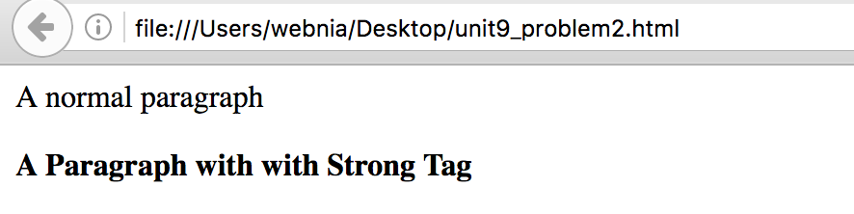

1. mouse over

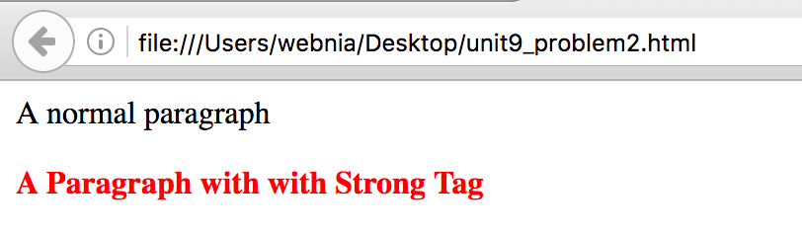

1. after mouse leave

