**Unit 11: Assignment:**

**SEONG IL SONG**

**Problem #1:**Submit Text/Word file Write a short explanation of what is Node.js and how is it related to JavaScript. Min 50 words

**Answer.**

Node.js is a platform built on Chrome's JavaScript runtime for easily building fast and scalable network applications. Node.js uses an event-driven, non-blocking I/O model that makes it lightweight and efficient, perfect for data-intensive real-time applications that run across distributed devices. It's best known as a popular means for JavaScript coders to build real-time Web APIs. Before Node.js, developers would have to use different languages for the backend and frontend of their application. For example, PHP, Java, ASP.Net would run on the server, and JavaScript would run in the client browser. Now with Node.js, developers can use JavaScript on the server as well as the client, meaning that developers can focus on learning one language. However, Node.js is not a JavaScript framework; indeed, several authors have written excellent frameworks specifically for Node.js, including Express.js, Restify.js, and Hapi.js.

**Problem #2:**Submit ScreenshotsSetup a Node.js environment on your local computer. Download and install the Node.js from <https://nodejs.org/en/>

Tip: <https://www.tutorialspoint.com/nodejs/nodejs_environment_setup.htm>

**Answer**. (Screenshots)

1) Install

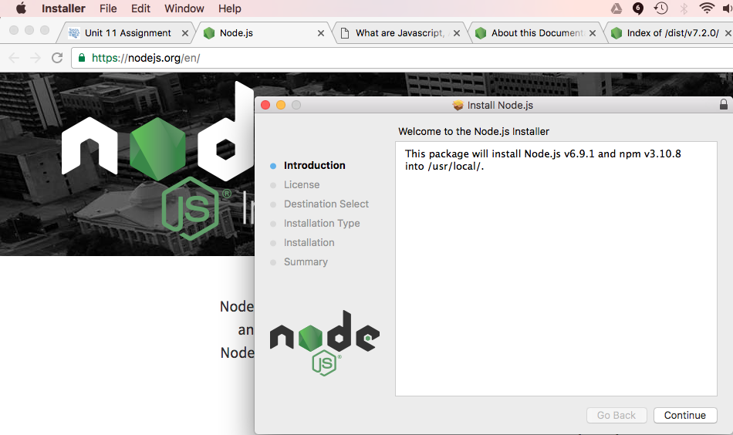

2) test

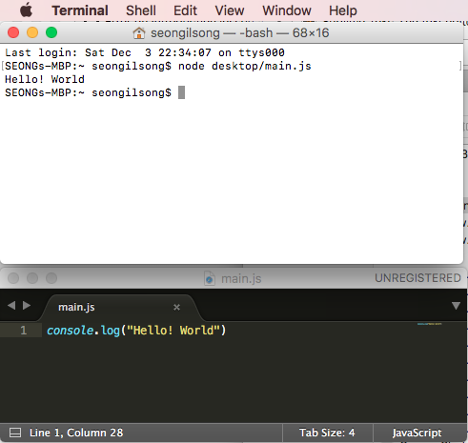

**Problem #3:**Submit file websvr.js  Using Node.js http module, write a Node.js script that starts a simple HTTP Server. The HTTP server should run on port 8001, and writes back to client:

1. response.writeHead(200, {'Content-Type': 'text/html'});

2. response.write('Hello World, my name is John Smith'); //Fill in your name

Submit: Create a Unit11 GitHub Repository. Upload Unit 11 Assignment to Unit11 Repository. Submit URL to Repository to Canvas.

**Answer.**

Executed the websvr.js to start the server as follows −

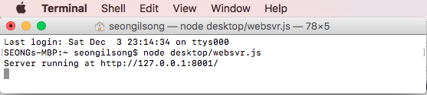

Opened http://127.0.0.1:8001/ in Chrome browser and observed the following result.

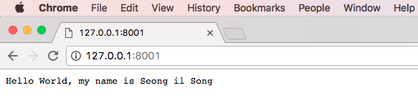

websvr.js **Source Code**

|  |
| --- |
| websvr.js |
| var http = require("http");  http.createServer(function (request, response) {  // Send the HTTP header  // HTTP Status: 200 : OK  // Content Type: text/plain  response.writeHead(200, {'Content-Type': 'text/plain'});    // Send the response body as "Hello World"  response.end('Hello World, my name is Seong il Song\n');  }).listen(8001);  // Console will print the message  console.log('Server running at http://127.0.0.1:8001/'); |