Unit 10, Assignment

Seong il Song

**Problem #1**

Use the animate() method to set the font-size of <div> to 100 pixels.   
The duration of the effect should be "slow".

**Answer.**

|  |
| --- |
| Unit10_problem1.html |
| <!DOCTYPE html>  <html>  <script src ="https://ajax.googleapis.com/ajax/libs/jquery/3.1.1/jquery.min.js"></script>  <script>  $(document).ready(function(){  $("button").click(function(){  var div = $("div");  div.animate({fontSize: '100px'}, "slow");  });  });  </script>  </head>  <body>  <button> Animation Button </button>  <div style = "background:#98bf21;height:200px;width:600px;">Hello World</div>  </body>  </html> |

**ScreenShot. (before clicking Animation button 🡪 After clicking Animation Button).**

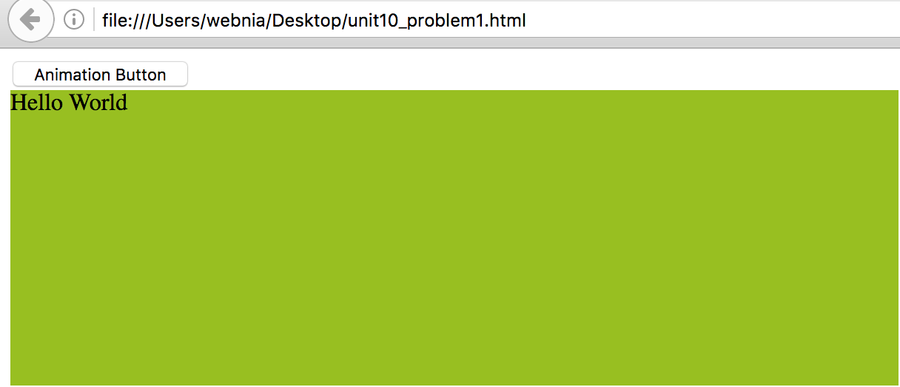

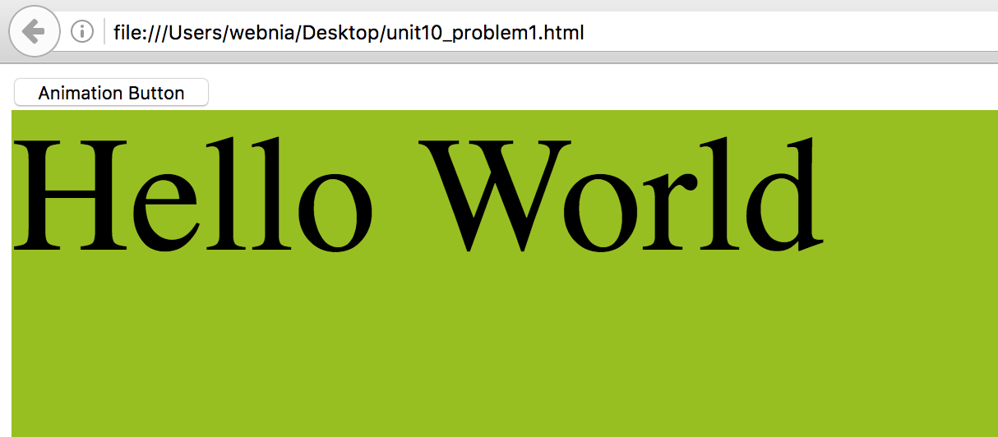

**Problem #2**

**Answer.**

|  |
| --- |
| Unit10_problem2.html |
| <!DOCTYPE html>  <html>  <head>  <script src ="https://ajax.googleapis.com/ajax/libs/jquery/3.1.1/jquery.min.js"></script>  <script>  $(document).ready(function(){  $("#btn1").click(function(){  var p = $("p");  p.append("<strong>Appended text.</strong>");  });  $("#btn2").click(function(){  var ol = $("ol");  ol.append("<li>Appended item.</li");  });  });  </script>  </head>  <body>  <p> This is a paragraph. </p>  <p> This is another paragraph. </p>  <ol>  <li>List item 1</li>  <li>List item 2</li>  <li>List item 3</li>  </ol>  <button id="btn1"> Append text </button>  <button id="btn2"> Append list items </button>  </body>  </html> |



