Reproducing the UHAERO figures with AIOMFAC: comparison report
Written 2026-10-09. 2026-10-11: phase diagrams redrawn with boundary-line tracing, and the organic diagrams recomputed with an improved solver. 2026-10-12: further solver fixes (liquid exchange; water-free molten liquids) and all inorganic and organic phase diagrams recomputed; small regions are numbered and listed beside each panel, and the validity range of the activity model is marked by a red dashed line. 2026-10-17: all boundary lines retraced as zero-phase-fraction (ZPF) lines and the phase diagrams (2006 Figs. 2, 4, 6, 8, 10; 2007 Figs. 8, 9) replaced (Section 2); the seeding of the ZPF lines was then extended (seeds between traces, region consistency) and Fig. 9 retraced. Subject: the figures of Amundson et al. (2006, Atmos. Chem. Phys. 6, 975–992; inorganic systems) and Amundson et al. (2007, Atmos. Chem. Phys. 7, 4675–4698; organic systems). Computation: aiomfac_py v1.3.0 + aiomfac_py.diagram (branch feature/phase-diagram), 298.15 K, closed system (no gas phase), water in equilibrium with RH.

1. Summary
- Of the 26 figures in the two papers, 21 were redrawn with AIOMFAC: 2006 Figs. 1–11 and 2007 Figs. 1–5, 8–10, 11a and 12. The figures not reproduced, and why, are listed in Section 7.
- The phase structure is largely the same. In the inorganic X–RH phase diagrams (2006 Figs. 2, 4, 6, 8, 10), the kinds and arrangement of the phase regions, and the order in which the seven solids (A–G) of the acidic sulfate–nitrate system appear, agree with the paper. In the organic systems, the binary miscibility gaps, the three-phase regions of the ternary systems (2007 Figs. 2 and 4) and the distribution of the number of liquid phases (L1/L2/L3) in particles with organics have the same shape as in the paper.
- Quantitative differences come from the activity models. The paper used the Pitzer–Simonson–Clegg (PSC) model for the inorganic systems and UNIFAC for the organics; here AIOMFAC is used throughout. The invariant-point (mutual deliquescence) RHs agree to about 1 %-point at Y = 1 and in the high-AS region, but are 3–7 %-points higher in nitrate-rich regions (Table 1).
- Solver improvements (Section 6). Four causes of the 8–25 % of solves that did not converge in the organic diagrams were found and fixed. A second fix covers the inorganic A+B region, where the last liquid dried into a water-free 'molten salt' instead of crystallising. A solve that is stuck at the cap on the number of liquids with the wrong set of liquids is now repeated with one liquid exchanged (liquid exchange). In the recomputed diagrams, inorganic and organic alike, the only solves that fail are bisection points right on a boundary line, which do not show in the figures. A new four-liquid (4L) region with two organic and two aqueous liquids appears.
- Validity range of the activity model (red dashed line). The line marks where the ionic strength of an ion-containing liquid reaches 100 mol/kg. Below it (low RH), AIOMFAC extrapolates beyond the data it was fitted to. Zuend et al. (2008) give no numeric limit, so the value is a judgement (Section 2). The 4L regions and the inorganic 2L region all lie outside the line.
- Two results specific to AIOMFAC: (i) in the acid-rich, nearly water-free region (X < 0.4, RH < 25 %) a second, almost molten-salt liquid (2L) is computed to be more stable than solid NH4HSO4; (ii) hydrophobic organics (1-hexacosanol, nonacosane, etc.) stay separated from the salt solution and hardly change the deliquescence RH of AS and letovicite (2007 Fig. 12). In the paper, the deliquescence RH drops for all pairs as the mixing ratio α increases.

2. Methods
- Equilibrium: PhaseEquilibrium (minimisation of the transformed Gibbs energy; solids by a primal–dual active set, liquids by the tangent-plane stability test). All-solid states are found as the optimal assemblage of a linear program.
- Boundary location along RH: trace — solve on an RH grid, then bisect every interval in which the phase state changes down to 10⁻⁴. Phase diagrams: phase_map — a trace at each X of a grid (11 points), with X intervals whose boundary sequence changes refined to 0.02 (inorganic) or 0.05–0.1 (organic).
- Boundary-line tracing: trace_boundaries — starting from the boundary points of phase_map, each boundary line is followed in the (X, RH) plane. The next point is predicted from the last two points and corrected by bisection normal to the line (about four solves per point). Vertical boundaries (stoichiometric compositions) are built from RH scans just left and right of that X, and short lines missing near junctions are found by checking the states around each junction. The lines in the phase diagrams are these traced lines, and the regions are filled between them. Grey dots mark equilibrium solves that did not converge; around them the phase state is not resolved.
- ZPF tracing (used for all phase diagrams of this report since 2026-10-17): trace_boundaries(method="zpf"). Every boundary line is a line on which one phase is present with zero amount (zero phase fraction; Morral, and Hillert's 'mapping' as used in CALPHAD programs). For each phase p a signed function f_p(X, RH) is taken from an ordinary equilibrium solve: for a solid, its amount where it is present and its saturation index (≤ 0) where it is absent; for the k-th liquid (liquids ordered by amount), its amount where there are at least k liquids and, where there are k − 1, minus the smallest tangent-plane distance of a non-trivial trial phase of the stability test, which goes to zero where the k-th liquid is about to form. f_p changes sign exactly where p appears or disappears, so the zero lines of all f_p are the boundary lines. Each zero line is followed by continuation: a predictor along the tangent and a corrector along the normal that finds the zero of f_p by regula falsi. Because f_p is smooth on both sides, the zero is interpolated rather than bisected on the phase state. A ZPF line is defined across junctions, so it continues through them (where it turns sharply, the continuation is searched on small circles around the last point) and ends only on the edge or on itself. The states on both sides are recorded at every point, and the line is split into boundary curves where they change, which gives the junctions. Each curve is the boundary of one phase, so the law of adjoining phase regions holds by construction, and a line cannot end inside the diagram. Coinciding lines (invariant RH, single composition) are kept once per pair of states. Seeds are the phases that change across the boundary points of the phase_map traces. The state tracing described above (method="states") shares the solve cache and was kept for comparison.
- Region labels: each area enclosed by the lines is named from the states of the solves inside it. Areas too small for their label get a blue number, listed to the right of each panel. States that exist only at a stoichiometric composition (e.g. L+B at X = 0.75) are dotted lines; where such a line lies on a traced vertical boundary, it is numbered instead.
- Validity line: for each solve, the largest molal ionic strength I = ½Σm_i z_i² (per kg of water) of the ion-containing liquids is interpolated over the plane, and the contour I = 100 mol/kg is drawn as a red dashed line. The AIOMFAC paper (Zuend et al., 2008, Atmos. Chem. Phys. 8, 4559–4593) fitted data down to supersaturated solutions from electrodynamic-balance measurements. It only states that beyond them the curves are model predictions without experimental support, and gives no numeric limit. 100 mol/kg is therefore a judgement and can be changed.
- Topology rules of phase diagrams: (i) the law of adjoining phase regions (Palatnik–Landau, Rhines): in a two-dimensional section, crossing a boundary line adds or removes exactly one phase. The only exceptions are invariant (horizontal) lines and single-composition (vertical) lines. (ii) A boundary line cannot end inside the diagram; it ends on the edge or where it meets other lines. (iii) The equilibrium is the global minimum of the Gibbs energy. The line tracing checks its results against these rules. Where states two or more phases apart meet on a sloped line, each point is re-solved from the other side's state and with that state's solids, and the lowest F is kept. Around a line end that no other line reaches, the states are probed on circles of 3, 6 and 12 h_min to find the missing line. A line that stops close to the edge is extended to it.
- Topology check of the ZPF lines (2026-10-17). Each diagram was checked for line ends inside the diagram that no other line reaches (within 0.5 % of the axis ranges), and for lines whose two sides differ by other than one phase outside their horizontal (invariant) and vertical (single-composition) parts. The five inorganic diagrams have no such line end (at Y = 0.2 one end lies at X = 0.995, on the edge), and the 13 diagrams have no sloped line between states two phases apart longer than about 3 % of the axis range: what remains are 0–4 short pieces per diagram (1–3 % of the axis range) right at junctions on invariant lines, where a thin region with one more phase is not resolved. Line ends remain only in the organic diagrams Y = 0.85 (a) (two, the 4L+C lens) and (b) (one). In the organic diagrams the ZPF lines and the state-traced lines coincide within the line width at Y = 1 (0–2 short pieces missing per diagram). At Y = 0.85 the first ZPF run missed 6–17 boundary pieces in the crowded region X 0.73–0.79 of (a)–(c), because its seeds came only from the traces of the map (every 0.1 in X). A line check alone cannot see a missing line; this was found by the comparison. Two seeding steps were therefore added. (i) Where the states on two neighbouring traces differ by two or more phases at the same RH, the segment between them is halved until its ends differ by at most one phase, and each piece is seeded; solids that occur on no trace are included through their saturation index. (ii) Region consistency: all solves in a region enclosed by the lines must have the same state, so two neighbouring solves whose states differ with no line between them point to a missing line; both are re-solved from each other's state (a local minimum does not count) and the segment is seeded. Pairs next to failed solves are left out, and the check has a time budget (30 min). With both, the pieces missing at Y = 0.85 fell from 17, 15, 6, 4 to 1, 2, 0, 3 (Section 5), for about 500–3000 extra solves per diagram, and no line appeared that the state tracing does not have, apart from vertical lines at X ≈ 0.78–0.79 in (a) and the X ≈ 0.99 line, which were there before. The ZPF line tracing leaves 0–13 unconverged solves per inorganic and 0–365 per organic diagram, all within 0.01 of a line except 7–9 points at X 0.33–0.37, RH 0.18 in Y = 1 (a), (c) and 23 points around X 0.33–0.43, RH 0.18–0.23 in Y = 0.85 (a) (grey dots). A fault found during the runs was fixed: a time limit (20 s per solve) that interrupted a numpy.linalg call left numpy's floating-point error handler set, after which every solve that met a NaN stopped with 'Singular matrix' (5,123 consecutive failures in Y = 1 (d)); the error state is now restored after each solve, and the affected solves were repeated.
- Solids: (NH4)2SO4 (A), letovicite (B), NH4HSO4 (C), NH4NO3 (D), 2AN·AS (E), 3AN·AS (F), AN·AHS (G). The K of the double salts E, F and G is the K of the single salts (fitted to AIOMFAC) plus the ΔG of the solid-state formation reaction of Clegg et al. (1998).
- pH is given on the mole-fraction scale used in the paper (pH_x = pH_m + 1.744). The AIOMFAC subgroups of the organics were obtained from SMILES with S2AS.
- Run time: one solve takes 0.05–0.15 s for salts, 0.3–0.6 s for acidic sulfate–nitrate mixtures and 1–3 s with two organics (cloud VM, one CPU). One inorganic phase map takes 25–50 min, an organic one 30–60 min.

3. UHAERO 2006 (inorganic systems)
Table 1. Invariant-point RH (%) at which a liquid first appears from an all-solid state. Paper values are those marked on the right of each figure.
Invariant point (solids) | Paper (PSC) | AIOMFAC | Difference (%-points)
A + B (Y = 1) | 68.57 | 70.0 | +1.4
B + C (Y = 1) | 36.65 | 37.5 | +0.9
A + B + E (Y = 0.85, 0.5) | 56.31 | 55.3 | −1.0
B + E + F (Y = 0.5, 0.3) | 53.21 | 53.2 | 0.0
B + D + F (Y = 0.5–0.2) | 43.84–43.86 | 47.2 | +3.3
B + D + G (Y = 0.85–0.2) | 35.89 | 42.7 | +6.8
B + C + G (Y = 0.85) | 29.65 | 33.8 | +4.2

The differences are largest at the invariant points involving nitrate (D, F, G). The same tendency appears in the (NH4)2SO4–NH4NO3–H2O system: at the measured AS saturation point of Clegg et al. (1998), Fig. 22 (m_AS 3.0, m_AN 13.5 mol/kg), the AIOMFAC saturation index of AS is −1.0, i.e. AIOMFAC underestimates the salting-out of AS by NH4NO3.
Fig. 1 (X–Y map of the deliquescence RH). The arrangement of the first-solid regions (A: high X and high Y; B: intermediate; C: high Y and low X; G: intermediate Y; D: low Y; E and F: narrow regions at high X and Y 0.2–0.35) agrees with the paper. The computational grid (20 X × 11 Y) is coarse, so the E and F regions are captured by only a few points. For X < 0.2 no solid forms down to RH 2 %.
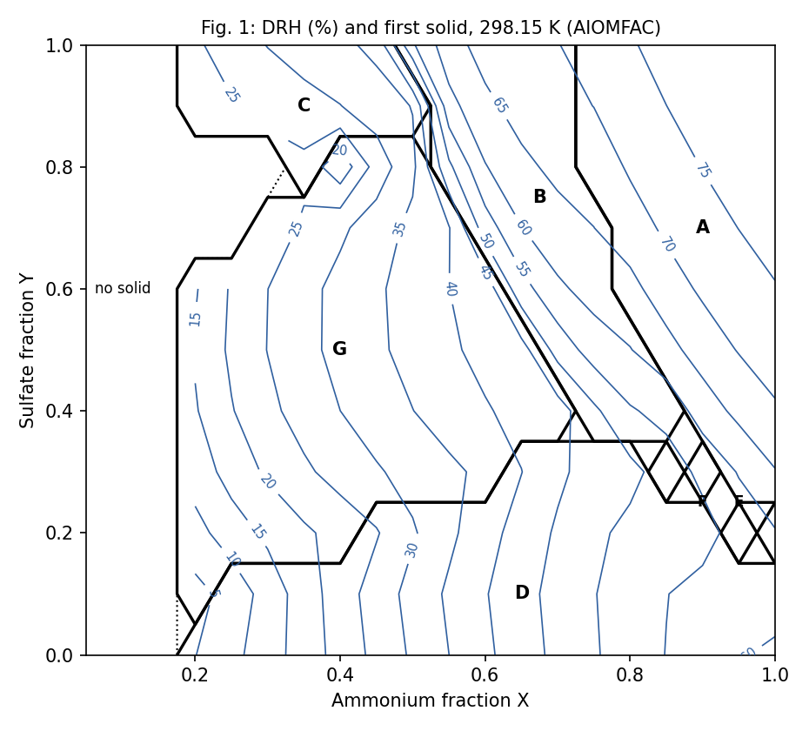
Figure 1. 2006 Fig. 1 reproduced: deliquescence RH (%) contours and the first solid.
Figs. 2, 4, 6, 8, 10 (X–RH phase diagrams). The region layout and the course of the pH and relative-particle-mass contours agree with the paper. Differences: (i) the AIOMFAC-specific 2L region at low X and low RH for Y = 1, 0.85 and 0.5 (Section 4); (ii) the invariant-point differences of Table 1; (iii) at Y = 0.85 and 0.5, part of the high-X region is computed as L+A+B instead of the paper's L+A+E. Redrawing with boundary-line tracing removed the steps and breaks that interpolation between X grid points had produced in the earlier figures. Recomputed with the improved solver, the inorganic diagrams show no unconverged solves (none in the traces; 0–13 in the ZPF line tracing, all right on a line). The grey dots in the A+B region (X > 0.75, RH < 27 %) of the earlier figures came from a dried, water-free molten liquid left behind (Section 6). The red dashed line encloses the low-X, low-RH 2L region at Y = 1, 0.85 and 0.5.
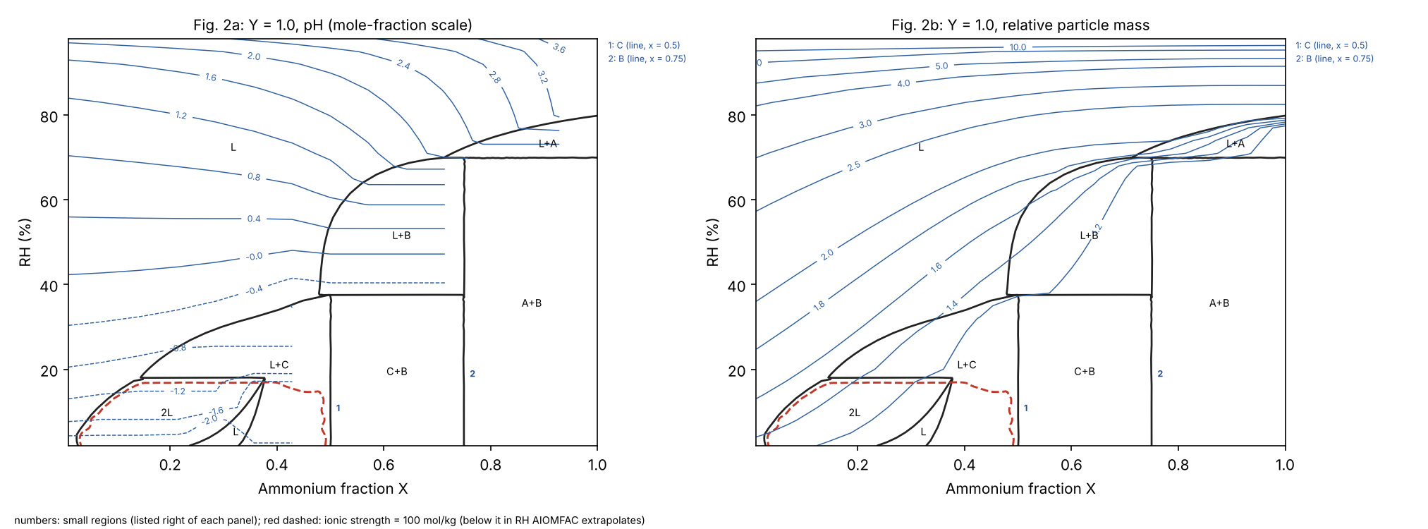
Figure. 2006 Fig. 2 reproduced (Y = 1): (a) pH (mole-fraction scale), (b) relative particle mass. Letters are solids (A–G), dotted lines are states that exist at a single composition only, blue numbers are small regions (list on the right), the red dashed line is an ionic strength of 100 mol/kg (below it AIOMFAC extrapolates). Boundary lines: ZPF tracing.
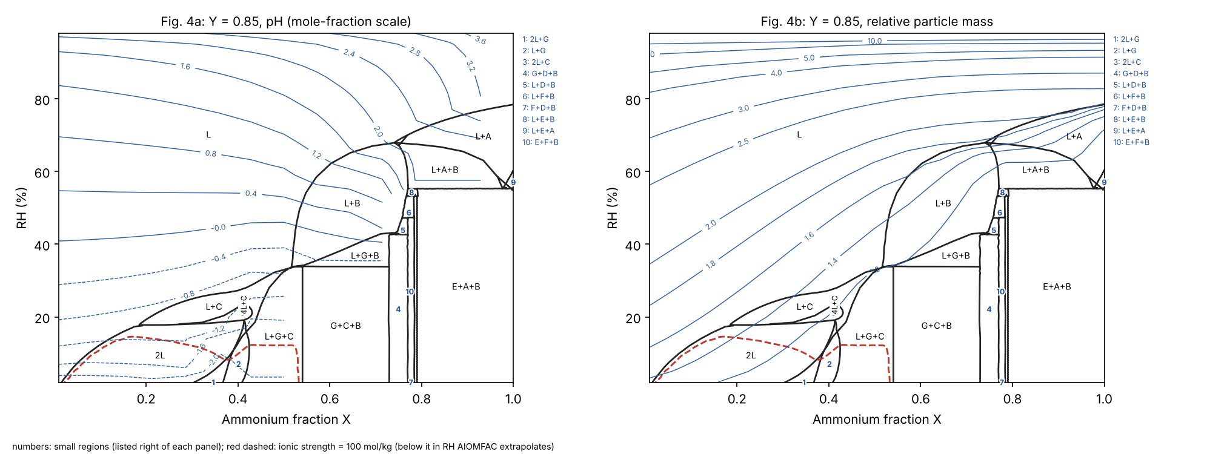
Figure. 2006 Fig. 4 reproduced (Y = 0.85): (a) pH (mole-fraction scale), (b) relative particle mass. Letters are solids (A–G), dotted lines are states that exist at a single composition only, blue numbers are small regions (list on the right), the red dashed line is an ionic strength of 100 mol/kg (below it AIOMFAC extrapolates). Boundary lines: ZPF tracing.
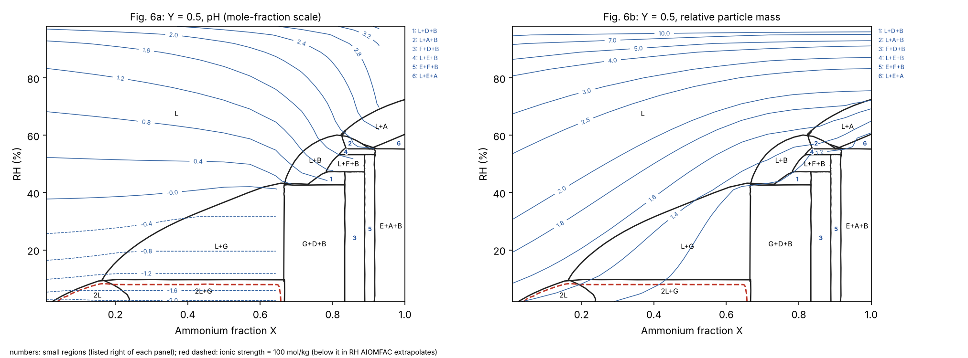
Figure. 2006 Fig. 6 reproduced (Y = 0.5): (a) pH (mole-fraction scale), (b) relative particle mass. Letters are solids (A–G), dotted lines are states that exist at a single composition only, blue numbers are small regions (list on the right), the red dashed line is an ionic strength of 100 mol/kg (below it AIOMFAC extrapolates). Boundary lines: ZPF tracing.
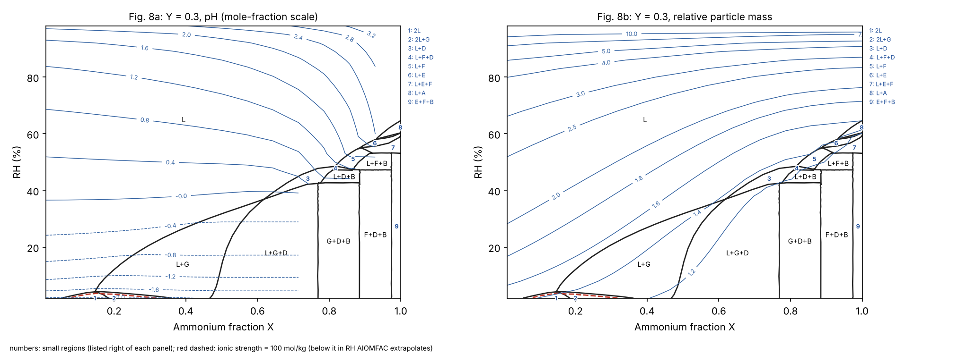
Figure. 2006 Fig. 8 reproduced (Y = 0.3): (a) pH (mole-fraction scale), (b) relative particle mass. Letters are solids (A–G), dotted lines are states that exist at a single composition only, blue numbers are small regions (list on the right), the red dashed line is an ionic strength of 100 mol/kg (below it AIOMFAC extrapolates). Boundary lines: ZPF tracing.
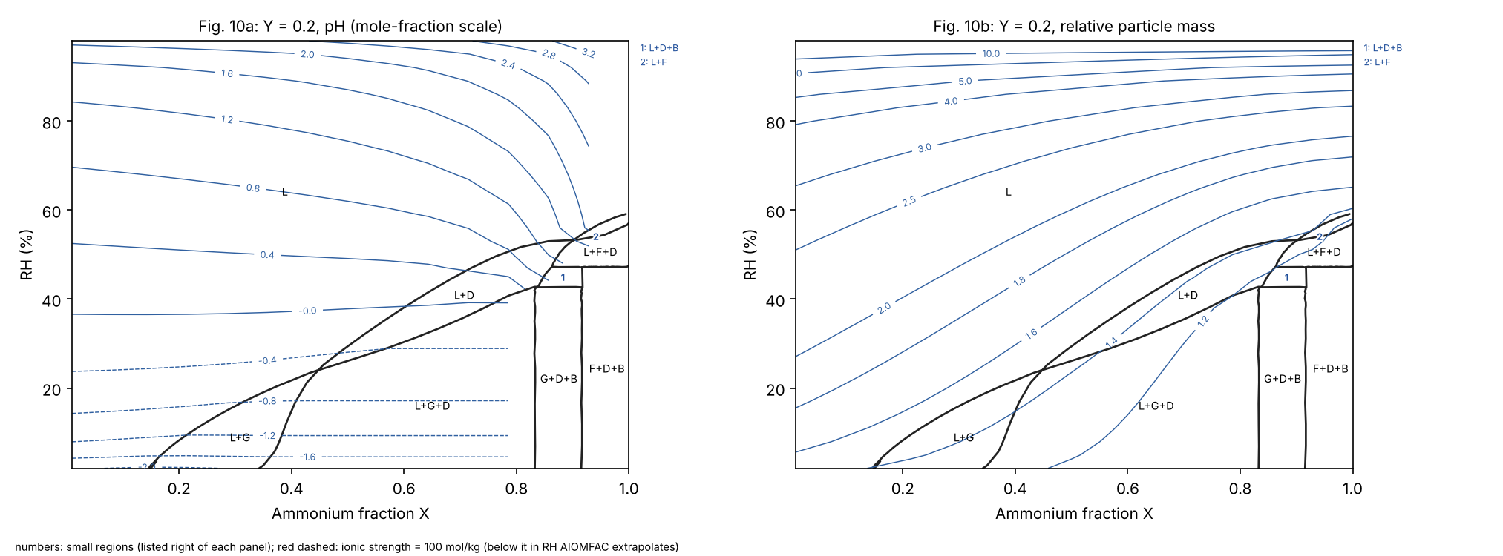
Figure. 2006 Fig. 10 reproduced (Y = 0.2): (a) pH (mole-fraction scale), (b) relative particle mass. Letters are solids (A–G), dotted lines are states that exist at a single composition only, blue numbers are small regions (list on the right), the red dashed line is an ionic strength of 100 mol/kg (below it AIOMFAC extrapolates). Boundary lines: ZPF tracing.
Figs. 3, 5, 7, 9, 11 (deliquescence curves). Drawn with the paper's axis ranges. The positions of the steps (deliquescence) shift by the differences of Table 1; the shape of the curves (multistage deliquescence, water uptake between solids) is the same. The curves are computed every 0.01 in RH, and each change of state is then bisected to 10⁻⁴ in RH, so the deliquescence steps are vertical. The breaks in the earlier curves were solves that did not converge; with the improved solver there are none. Some curves do not reach a relative mass of 1 at low RH: Y = 1 with X ≤ 0.4, and the acidic side of Y = 0.3 and 0.2. These compositions hold more acid than NH4HSO4 (X = 0.5) or AN·AHS (G) can take up, so the excess H2SO4 or HNO3 stays as a liquid. At 298 K no H2SO4 or HNO3 hydrate solids form, so this is physical; the system is closed (no gas phase), so HNO3 does not evaporate. Where the ionic strength exceeds 100 mol/kg, the curve is overlaid with a red dashed line (Y = 1, X ≤ 0.4, below RH 15–18 %).
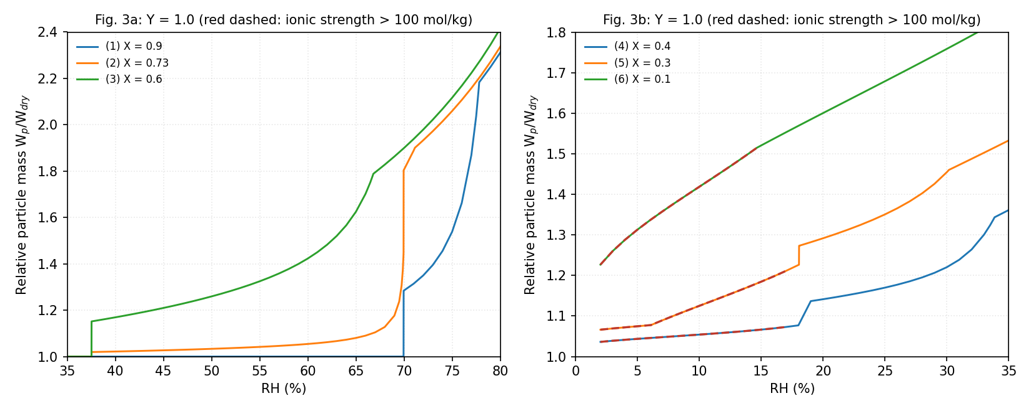
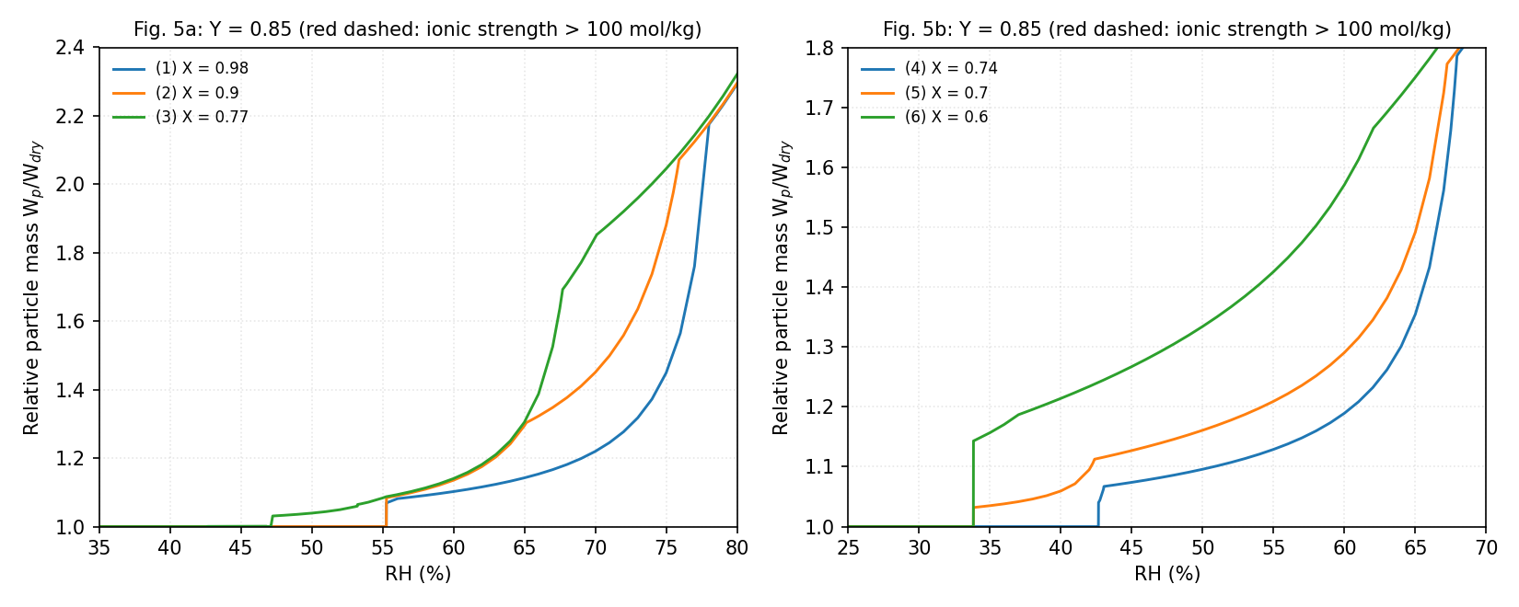
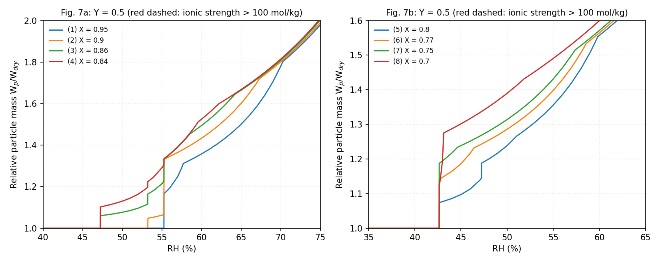
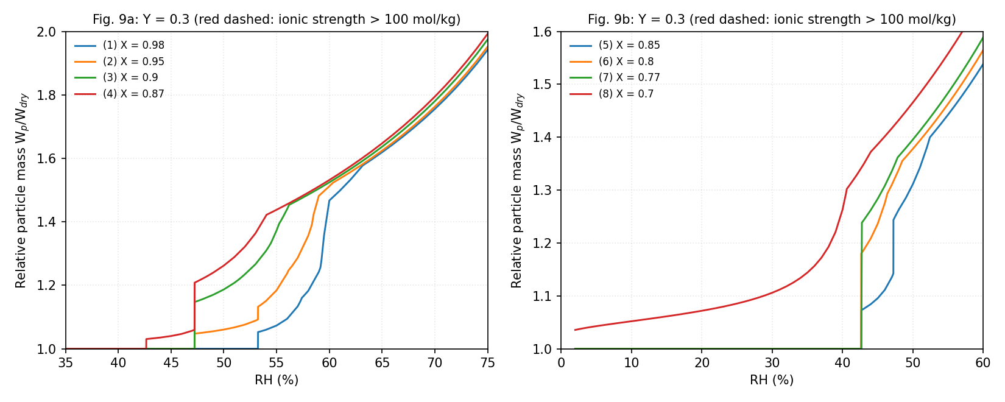
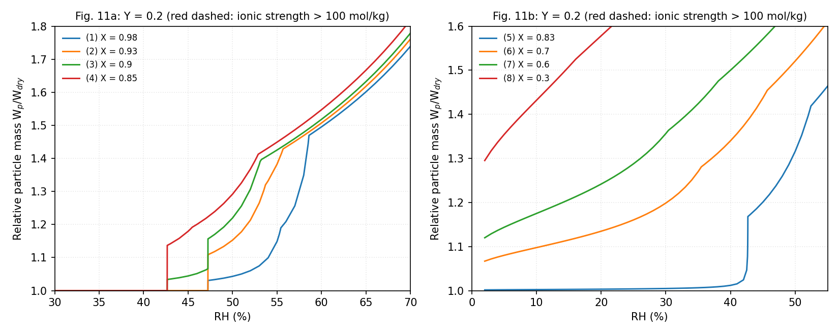
Figure. 2006 Figs. 3, 5, 7, 9 and 11 reproduced (top to bottom).

4. The AIOMFAC 2L region
In the NH4+/H+/SO4²⁻ system at X < 0.4 and RH < 25 %, AIOMFAC gives two liquid phases. For example, at X = 0.2 and RH = 0.1 one liquid holds 2.4 mol NH4+, 22 mol H+ and 17 mol HSO4⁻ per kg of water, while the other holds 75 mol NH4+, 39 mol H+ and 112 mol HSO4⁻, an almost molten salt. The Gibbs energy of the two liquids (3.466) is lower than that of a single liquid (3.530, not converged). With ionic strengths of hundreds of mol/kg, these concentrations lie far beyond the supersaturated-solution data used to fit AIOMFAC, so the result is unlikely to be physical. The red dashed line of the phase diagrams (I = 100 mol/kg) encloses this region. In this region the paper (PSC) gives L+C (liquid + NH4HSO4).

5. UHAERO 2007 (organic systems)
Table 2. Compositions of binary liquid–liquid phase separation (organic mole fraction; paper Table 3, UNIFAC column). The lower limits in our values (10⁻¹² etc.) are the limit of the computational grid.
System | Paper (UNIFAC) | AIOMFAC
water / glutaraldehyde (X3) | 0.0937, 0.345 | 0.0933, 0.345
water / palmitic acid (X4) | 1.2e−7, 0.843 | 2.0e−7, 0.759
water / 1-hexacosanol (X5) | 2.1e−12, 0.898 | ≤1e−12, 0.924
water / nonacosane (X6) | 8.6e−16, 0.998 | ≤1e−12, 0.997
water / pinic acid (X7) | 0.00335, 0.366 | 0.0085, 0.208
water / pinonic acid (X8) | 0.00105, 0.492 | 0.0010, 0.390
1-hexacosanol / pinic acid (X5/X7) | 0.537, 0.933 | 0.537, 0.934
pinonic acid / nonacosane (as X6) | 0.0377, 0.996 (X8) | 0.0036, 0.962 → as X8: 0.038, 0.996
2-hydroxyglutaric acid / palmitic acid (X1/X4) | 0.00289, 0.981 | 0.0035, 0.982
water/X1, water/X2, X2/X3 | no phase separation | no phase separation

The organic–organic systems are nearly identical; in the water–acid systems (pinic, pinonic acid) the composition of the acid-rich phase differs (AIOMFAC 0.21 and 0.39, paper 0.37 and 0.49). The AIOMFAC values are almost the same as the paper's UNIFAC-Peng column (0.208, 0.389).
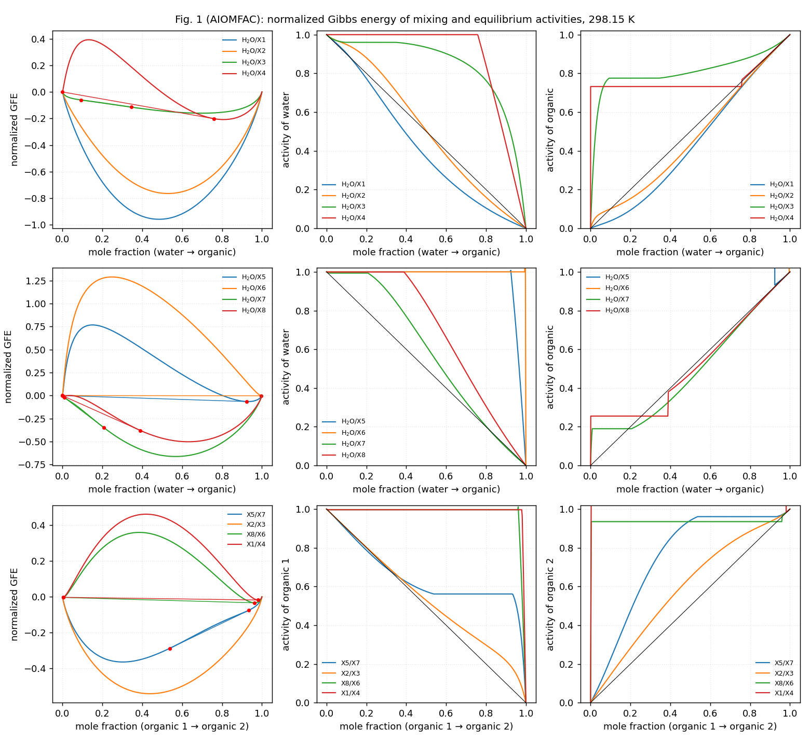
Figure. 2007 Fig. 1 reproduced: normalised Gibbs energy of mixing and equilibrium activities.
Figs. 2–5 (ternary LLE). Running a fixed-composition solver at each point gave unstable results because of local minima, so the diagrams were computed from the lower convex hull of the Gibbs energy of mixing (a global minimum; 5–10 s per figure). As in the paper, three-phase regions appear only in Fig. 2 (water/1-hexacosanol/pinic acid) and Fig. 4 (water/pinonic acid/nonacosane). The vertices of the three-phase triangle in Fig. 2 are (1-hexacosanol, pinic acid) = (≈0, 0.01), (≈0, 0.21) and (0.745, 0.125); compared with the paper's (3e−12, 0.003), (0.002, 0.372) and (0.609, 0.219), the composition of the pinic-acid-rich aqueous phase differs by the binary difference of Table 2. As in the paper, Fig. 3 is mostly a single liquid and Fig. 5 mostly two liquids.
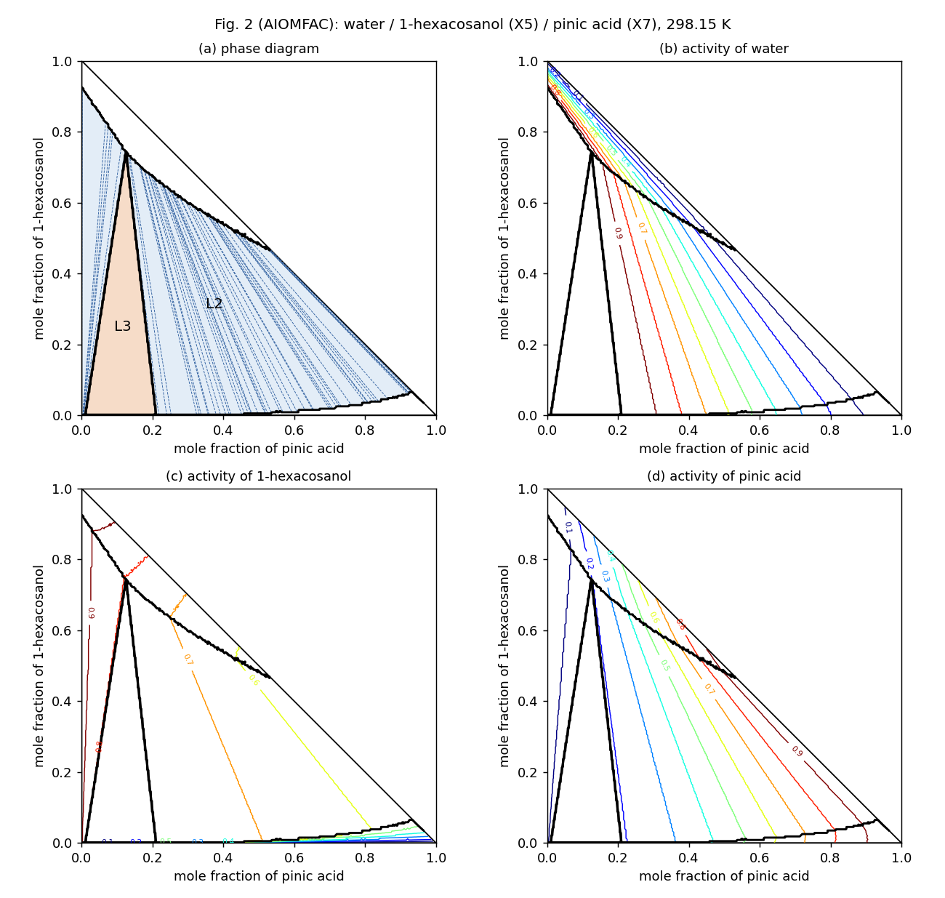
Figure. 2007 Fig. 2 reproduced: (a) phase regions and tie lines, (b–d) equilibrium activities.
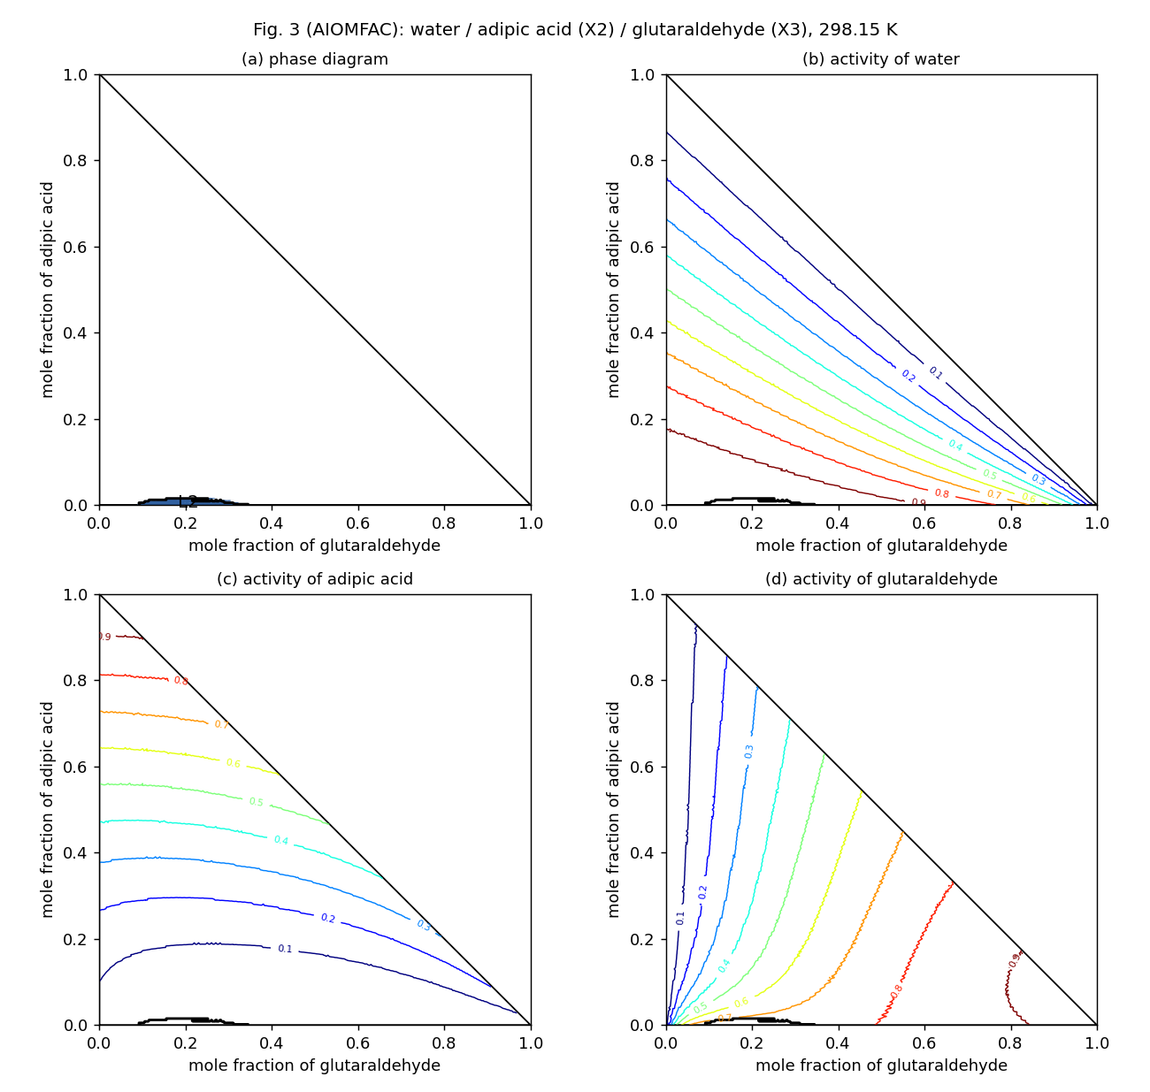
Figure. 2007 Fig. 3 reproduced: (a) phase regions and tie lines, (b–d) equilibrium activities.
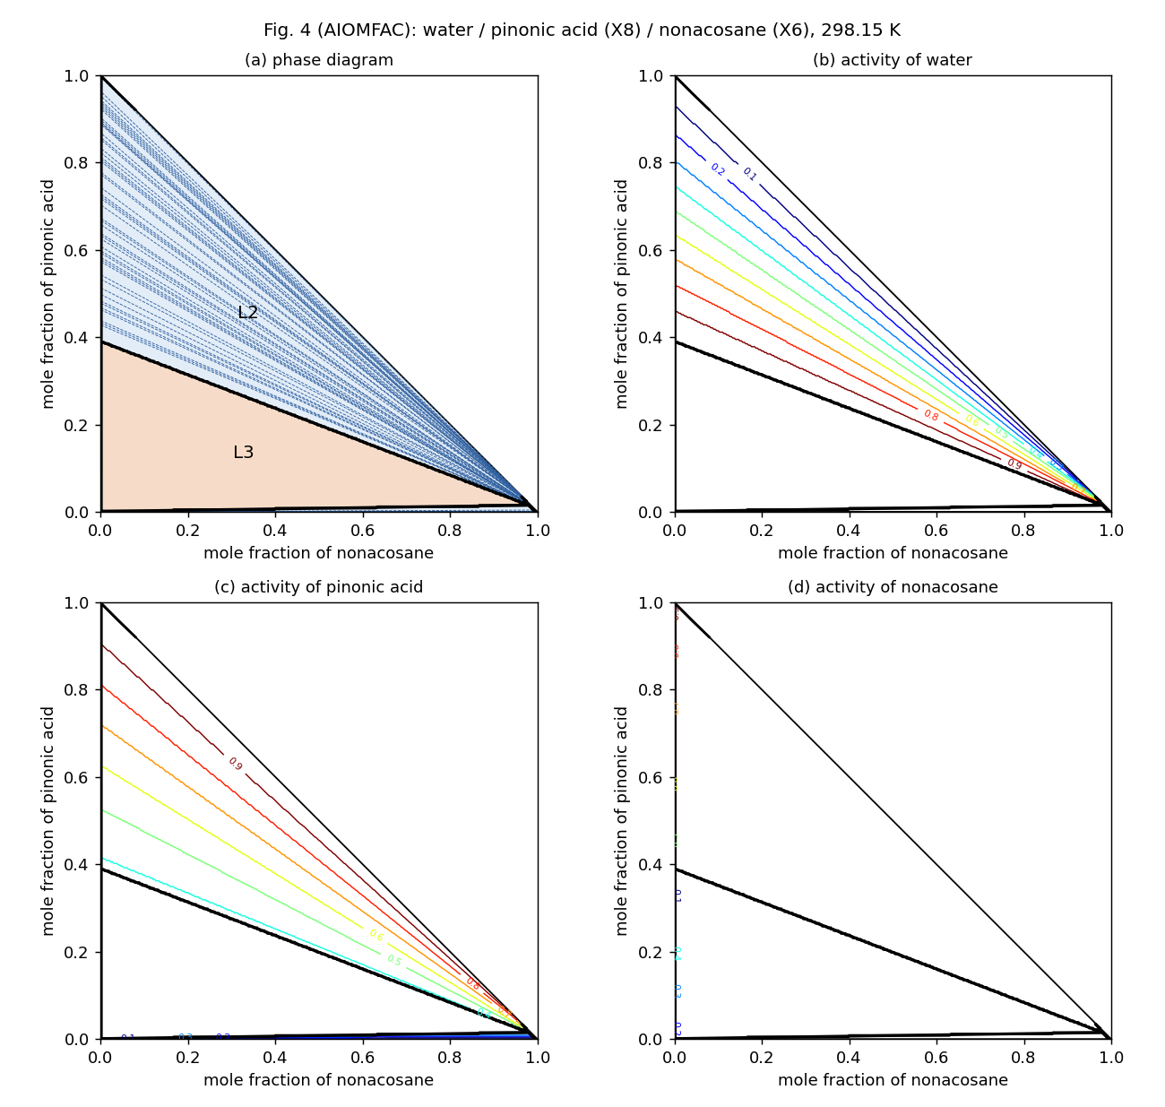
Figure. 2007 Fig. 4 reproduced: (a) phase regions and tie lines, (b–d) equilibrium activities.
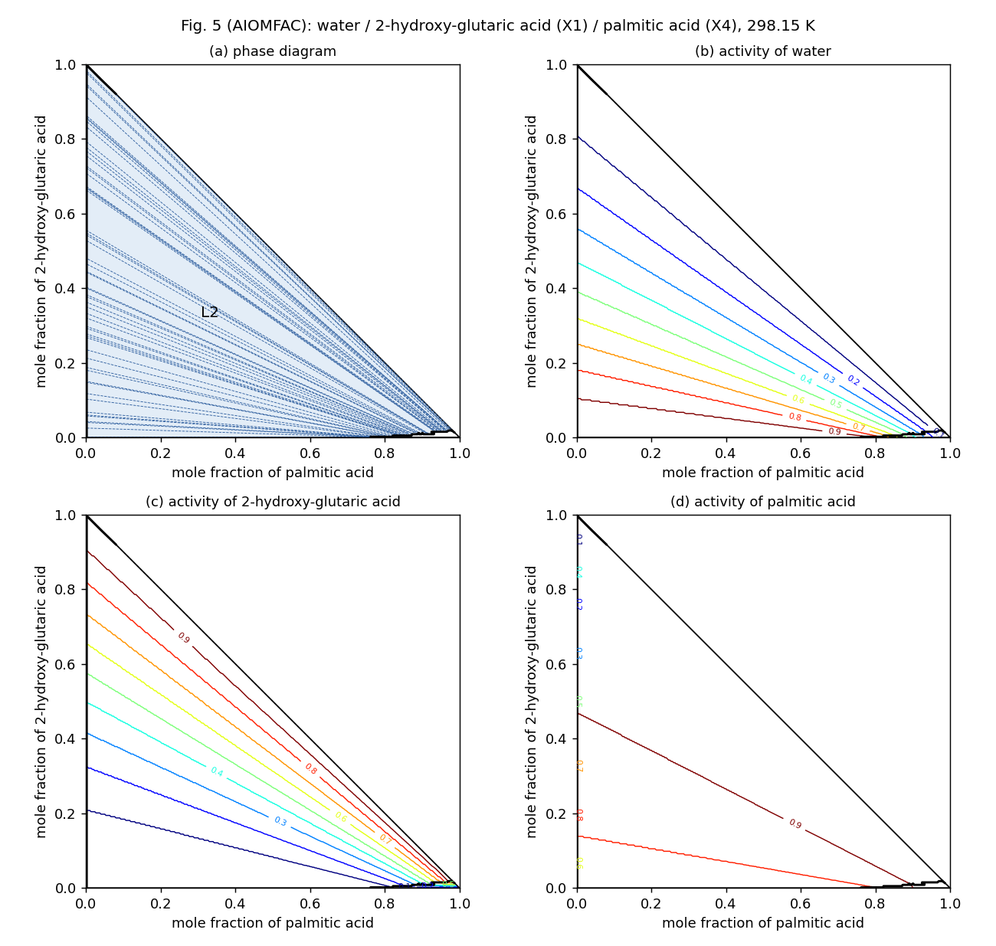
Figure. 2007 Fig. 5 reproduced: (a) phase regions and tie lines, (b–d) equilibrium activities.
Figs. 8 and 9 (two organics + inorganic, α = 0.2). The arrangement of the solid regions (A, B, C, and E, G at Y = 0.85) is the same as in the inorganic system, while the number of liquid phases depends on the organic pair. 1-Hexacosanol/pinic acid (a) and pinonic acid/nonacosane (c) agree well with the paper: the all-liquid and one-solid regions are 3L (paper L3), and the two- and three-solid regions are 2L (paper L2). In (a), however, an L1 band forms below RH 4–5 %. Adipic acid/glutaraldehyde (b) agrees with the paper in that the two-solid regions are L1, but the whole liquid region is 2L (the paper has L1–L2–L1). Its deliquescence RHs are also almost those of the inorganic system (A 80 %, AB 70 %, BC 37.5 %), whereas the paper lowers them to 77, 66 and 34 %, and at Y = 0.85 also ABE and BCG below 46 % and 24 % (here 55 % and 34 %). For 2-hydroxyglutaric acid/palmitic acid (d) the paper has L2 throughout; here the high-RH and two-solid regions are 2L, and there is a 3L region at intermediate RH and low X. The deliquescence RHs drop as in the paper: at Y = 1, A is at 78 % as in the paper, and at Y = 0.85 ABE drops to about 19 % (paper below 34 %). Recomputed with the improved solver, (a) and (c) show a four-liquid (4L) region at low X and low RH (X < 0.33, RH < 18 %): the 2L region of the inorganic system (Section 4, an almost molten second aqueous liquid) plus the two organic liquids. Previously this region was covered by failed solves (grey dots). These 4L regions all lie outside the red dashed line, i.e. where AIOMFAC extrapolates. With liquid exchange, the failures left at X 0.10–0.17, RH 2–5 % in Y = 1 (a) and in the 4L+C island of Y = 0.85 (c) are gone. The corrected line tracing also finds the boundary at X ≈ 0.765 below RH 0.19 in Y = 0.85 (d), and the boundary that bends away from the vertical line at X ≈ 0.99; lines traced twice are removed. What looks like a double line at X ≈ 0.74 in Fig. 8b is a thin L+B region just left of X = 0.75. In Fig. 9 the boundaries of the solids E, F, G, A and B crowd together at X 0.73–0.79: the small regions there are numbered. The Y = 0.85 maps have traces only every 0.1 in X, so a solid present only between two traces (e.g. NH4NO3 between X 0.736 and 0.769; in (b) NH4NO3 and 3AN·AS occur on no trace at all) first gave no seed, and the thin strips there were missing. With the extended seeding (Section 2) they are traced: compared with the state tracing, 1, 2, 0 and 3 short pieces remain missing in (a)–(d) (at most 0.08 of the axis range, next to junctions or at the bottom edge). In (a) the RH 0.18 line at X 0.30–0.33 and part of a 4L+C lens at X 0.39–0.43, RH 0.18–0.23 are not closed, because the solves around them fail (grey dots); the 4L region at low X is therefore labelled with the neighbouring 3L+C. One line end remains in (b) (X ≈ 0.38, RH 0.18).
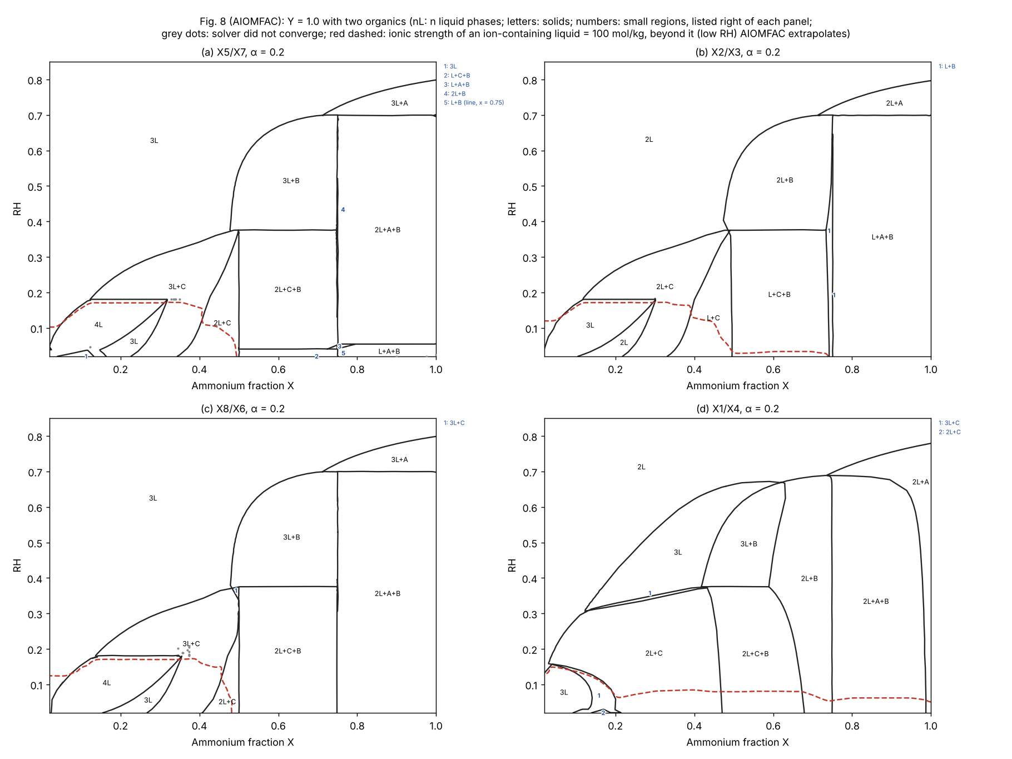
Figure. 2007 Fig. 8 reproduced (Y = 1). Blue numbers: small regions (list on the right). Red dashed: ionic strength 100 mol/kg (below it AIOMFAC extrapolates). Grey dots: solves that did not converge (those right on a line are omitted). Boundary lines: ZPF tracing.
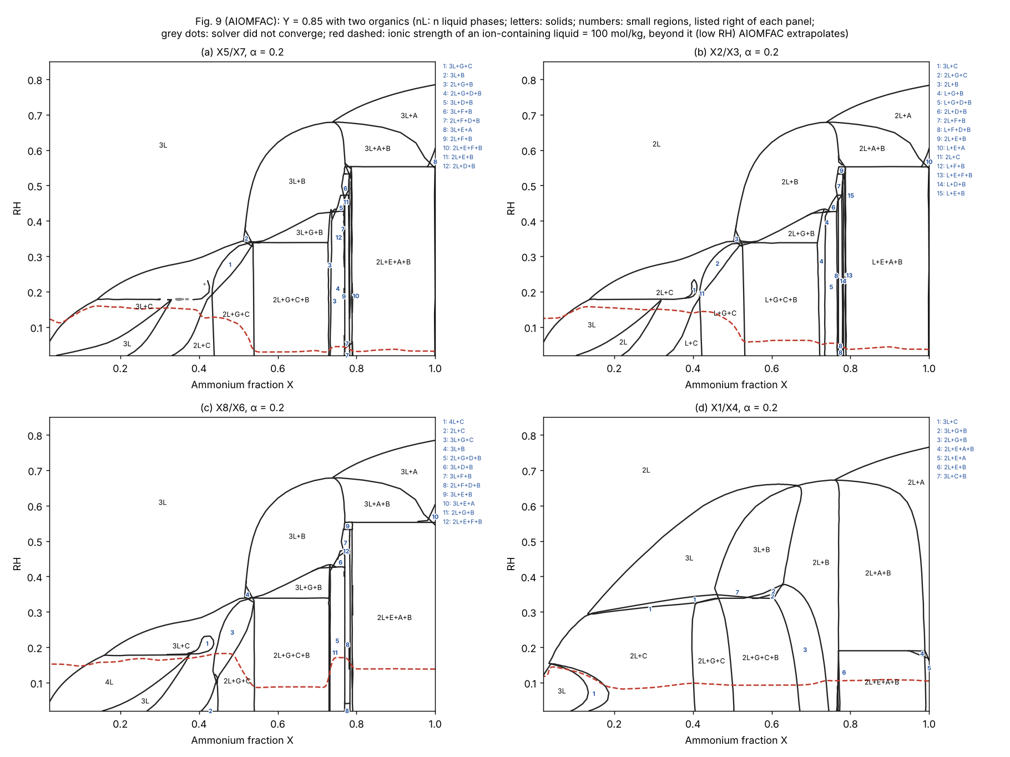
Figure. 2007 Fig. 9 reproduced (Y = 0.85). Blue numbers: small regions (list on the right). Red dashed: ionic strength 100 mol/kg (below it AIOMFAC extrapolates). Grey dots: solves that did not converge (those right on a line are omitted). Boundary lines: ZPF tracing.
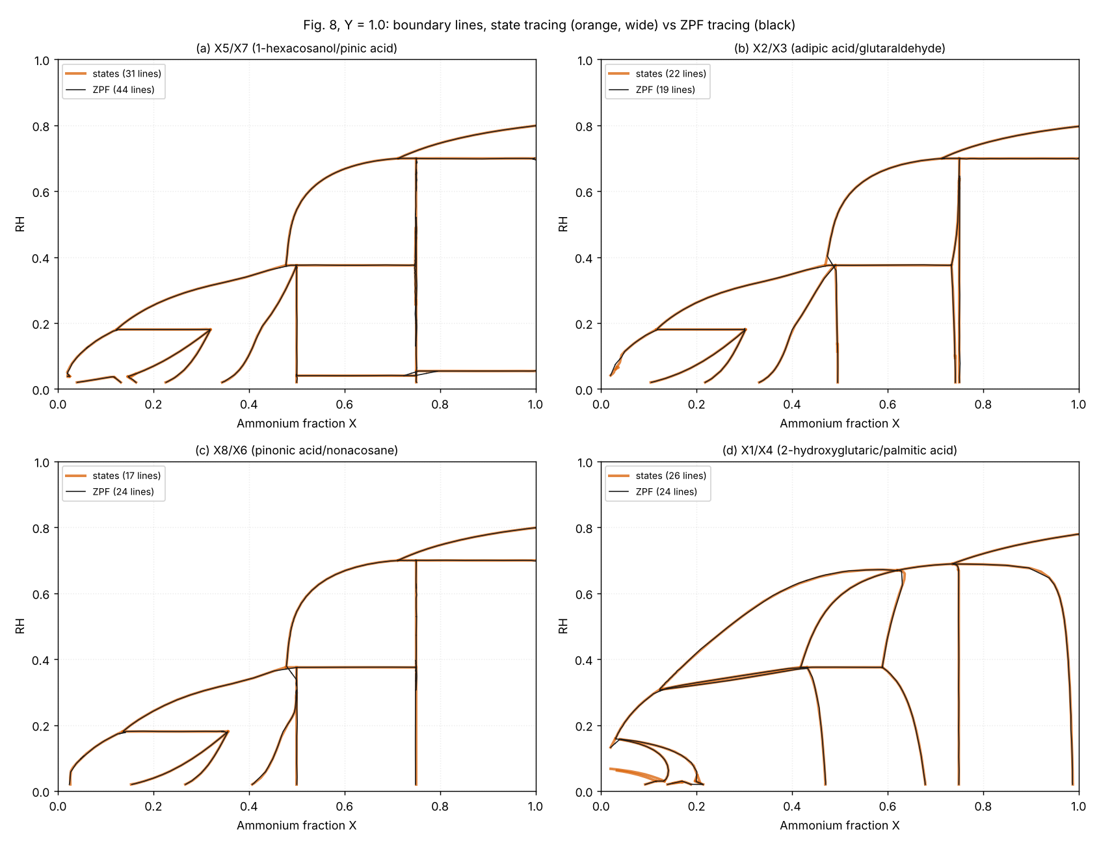
Figure. Boundary lines of 2007 Fig. 8 (Y = 1): state tracing (orange, wide) and ZPF tracing (black).
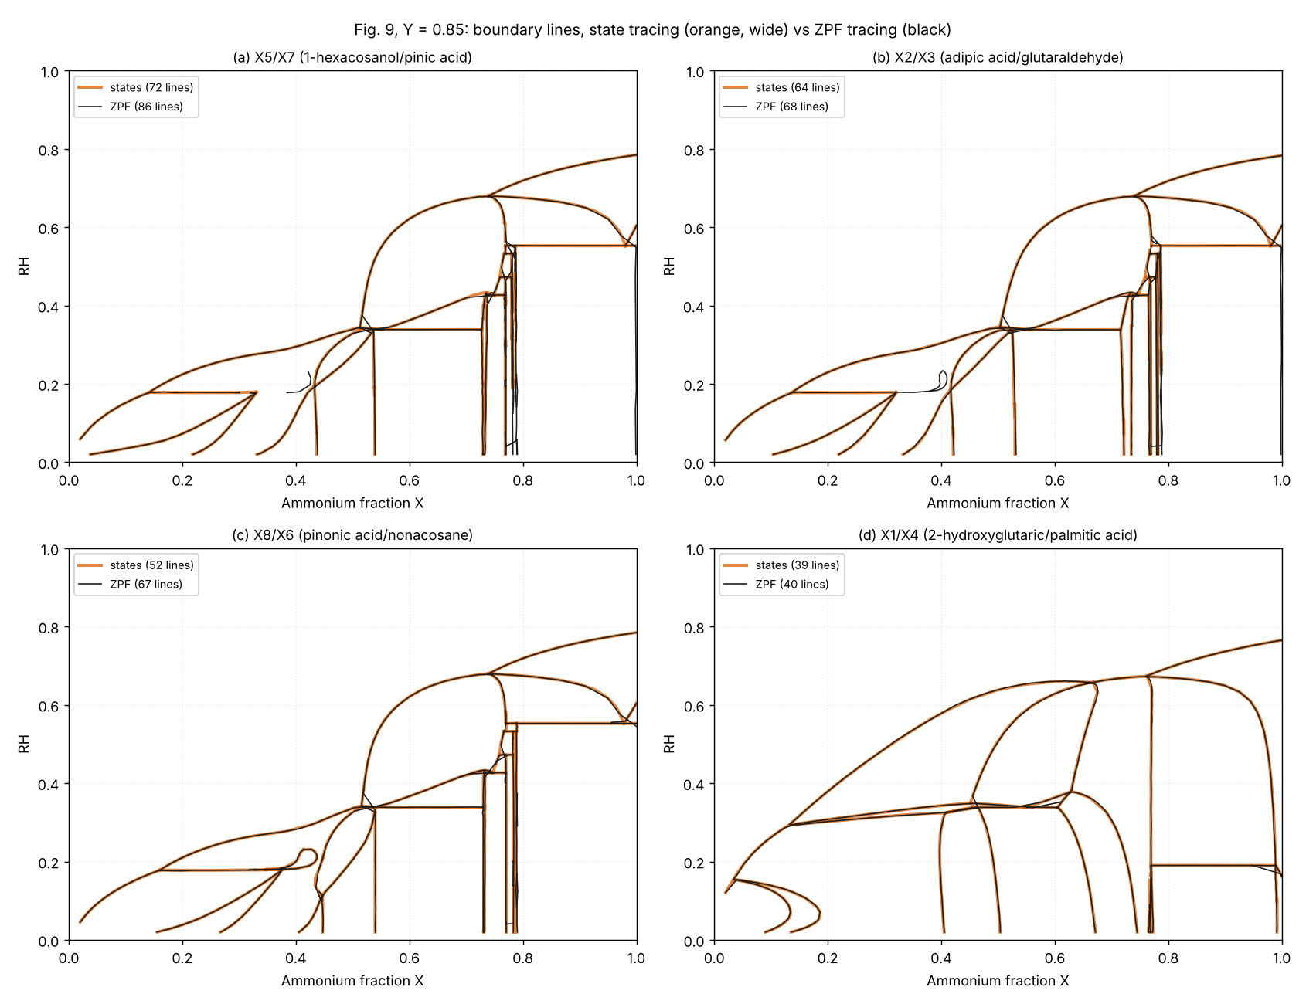
Figure. Boundary lines of 2007 Fig. 9 (Y = 0.85): state tracing (orange, wide) and ZPF tracing (black).
Fig. 10 (deliquescence curves at X = 0.6). For the inorganic system (pair 0) the steps are at 37.5 % and 66–67 % (paper 36.6 % and 63.8 %); organic pairs 1–3 take up slightly more water with the steps at nearly the same positions. As in the paper, only 2-hydroxyglutaric acid/palmitic acid (4) takes up much water at low RH, and its deliquescence steps are smeared out.
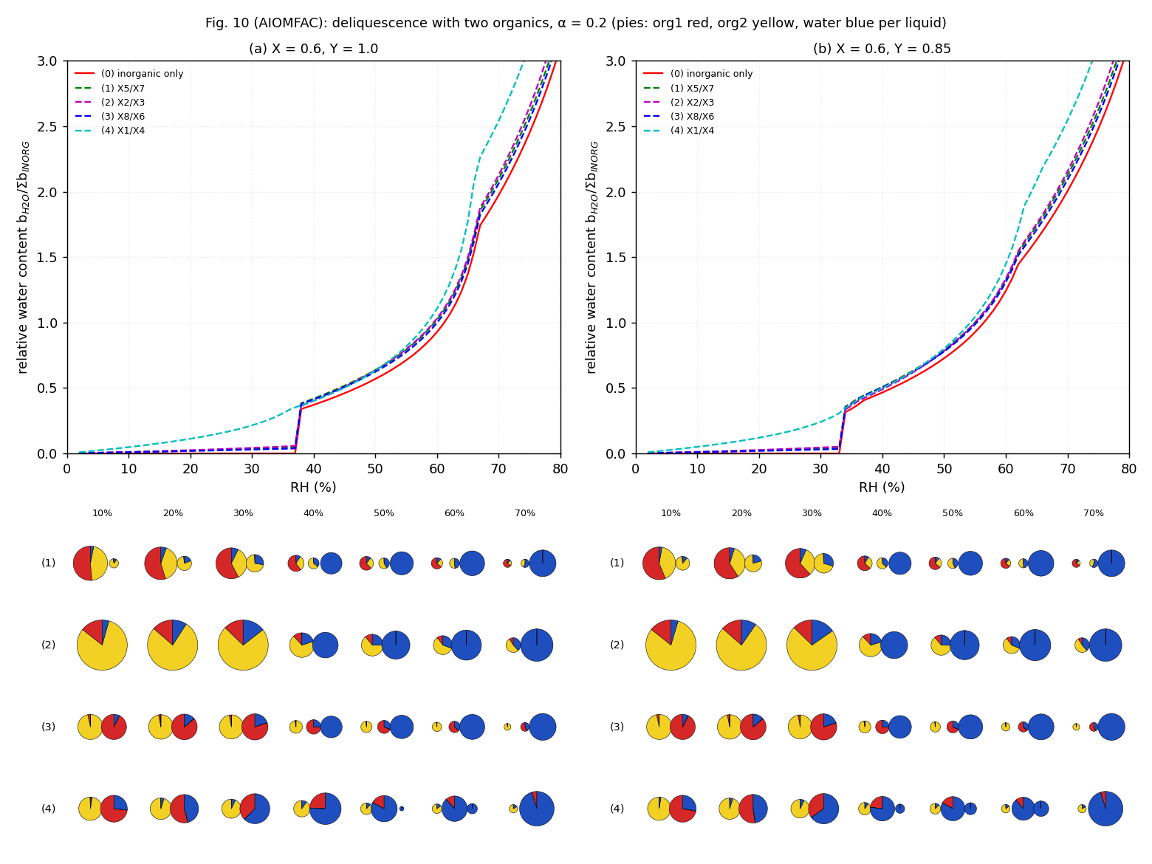
Figure. 2007 Fig. 10 reproduced: relative water content and phase compositions (red organic 1, yellow organic 2, blue water).
Figs. 11a and 12 (AS and letovicite + organics). With AIOMFAC, only the pair containing the highly water-soluble 2-hydroxyglutaric acid (4) lowers the deliquescence RH of AS and letovicite as α increases (AS 11 % at α = 0.9). For the other three pairs the organics remain a separate phase and the deliquescence RH hardly changes (AS 79.7–79.9 %). In the paper the deliquescence RH drops for all pairs at α ≳ 0.8. The value for letovicite with 2-hydroxyglutaric acid/palmitic acid at α = 0.9 is missing because the solver did not finish within 90 s.
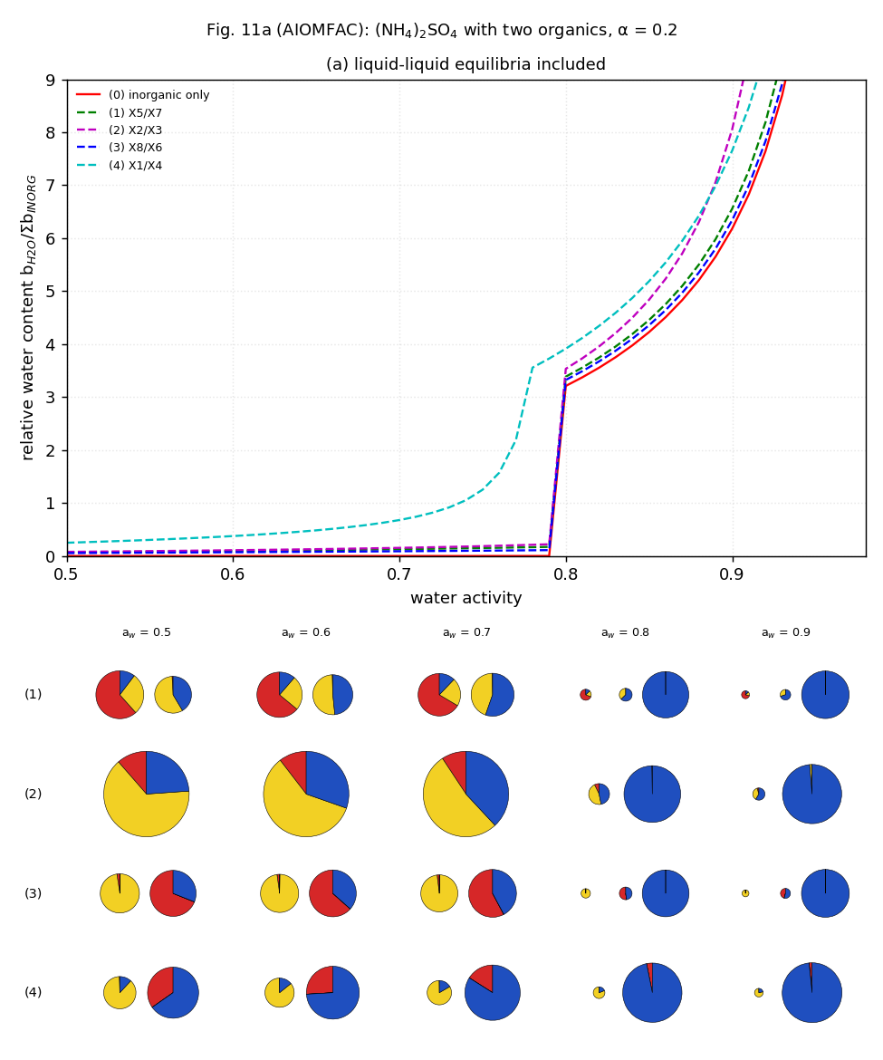
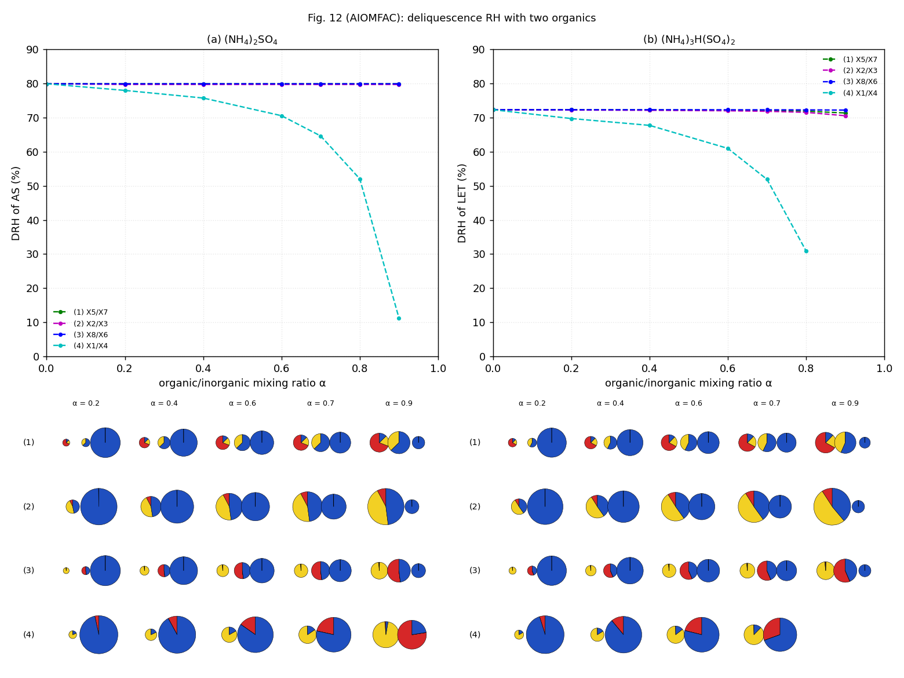
Figure. 2007 Figs. 11a and 12 reproduced.

6. Convergence failures in the organic systems and solver improvements
In the first organic diagrams (about 45 000 solves for the boundary lines), 8–25 % of the solves did not converge. Re-solving the failed points by class identified the causes.
Failure (share) | Cause | Improvement
Supersaturated solid left (about 50 %) | Next to the boundary between two solids (e.g. letovicite and NH4HSO4), the Newton inner solver adds a supersaturated solid at zero, the first Newton direction drives it negative, and it is refused; there is no active-set exchange step. | A solve that does not converge is repeated with the rand (logarithmic amounts) and barrier inner solvers (fallback_inner).
Negative TPD with three liquids (about 30 %) | Cap of three liquids; four-liquid states (two organic, two aqueous) exist. | max_liquids defaults to 4.
Time limit (about 20 %) | The stability test finds a nearly water-free NH4NO3 melt as trial phase; AIOMFAC's ln a diverges (1e17), TPD is −1e8, and the inner iteration spins for tens of seconds on this spurious phase. | Ionic trial phases with water mole fraction below 1e−6 are discarded (tpd_min_water).
Local minimum missing a concentrated acid-sulfate liquid (e.g. Fig. 8b) | The stability test started only from water : ion ratios of 2 and 10. It missed a concentrated acid-sulfate liquid (water : ions about 0.18), so 2L+NH4HSO4 stayed as a converged state instead of the 3L state of lower F (e.g. X = 0.28, RH 0.16: F 1.8966 vs 1.8769). In the diagrams this showed as a violation of the topology rules: states two phases apart (2L+C | 3L) meeting on a sloped line. | A trial composition at water : ions = 0.2 was added. All inorganic and organic diagrams were recomputed from scratch.
a_w residual (three liquids with nonacosane) | Liquids of very different composition (nonacosane mole fraction 0.98 vs 0) stall the line search. | Repeated with the rand inner solver.
Negative TPD with four liquids (low-RH 4L) | The set of liquids at the cap is wrong (with five components at most four phases coexist over an area), and no liquid can be added. | Re-solving with one more liquid allowed drains the wrong liquid; the solve converges to a different 4L state of lower F (liquid exchange, liquid_exchange).
Inorganic A+B region (grey dots of the 2006 figures) | The last liquid does not crystallise; its water drains away and a water-free 'molten salt' of ions remains (water mole fraction about 3×10⁻⁷). AIOMFAC's ion terms diverge (ln a_w ≈ +2×10⁹), and the F of this spurious liquid comes out below that of the all-solid state. | Such a liquid is treated as outside the model and the all-solid state (optimum of the linear program) is taken. The solve stops as soon as the melt forms, cutting it from about 35 s to under 1 s.

Of 60 randomly chosen failed points, 59 converged after the changes; of 60 previously converged points, 59 kept their state and one moved to a state of lower F. Allowing a shallow TPD (tol_tpd = 1e−3) was also tried, but it missed a third liquid in converged states and was not adopted. On these compositions the rand inner solver gives the same states as Newton (F equal to seven digits) about twice as fast (five times next to a liquid–liquid boundary), so the organic scripts use rand first with Newton as fallback. After recomputation, failed solves in the phase-map traces fell from 0–23 to 0–1 per diagram, and unconverged points in the boundary tracing from several hundred to over two thousand per diagram to 0–70. On 2026-10-12–13 all inorganic and organic diagrams were recomputed from scratch with liquid exchange, the molten-liquid fix, the concentrated trial phase and the topology checks. The five inorganic diagrams have no failed trace solves (previously 22–43), and the line tracing leaves 0–27 unconverged points per diagram. In the eight organic diagrams, two trace solves fail in one diagram, and the line tracing leaves 0–95 unconverged points per diagram. All of these are bisection points within 0.01 of a line, so they do not show in the figures. The five unconverged points away from the lines had exceeded the 20 s time limit; re-solved with 120 s, they all converged. Where the topology rules were still violated (sloped lines between states two phases apart, lines ending inside the diagram), the diagrams were refined locally. The states around each such point were re-solved on a fine grid, and every unexplained change of state was traced with half the step and tolerance. New and short lines were checked by fresh solves across them, each side also started from the other side's state, and the lower F was kept. The tips of closed regions were joined. The violations fell from 26 to 6. Four of the remaining six are short line ends at X 0.77–0.79 in Y = 0.85 (a) and (b), and two are short lines between states two phases apart (Y = 0.85 (a) and the inorganic Y = 0.2 diagram at X ≈ 0.99). The three places pointed out earlier are now connected: Fig. 9b at X ≈ 0.735, 9c at X ≈ 0.33, RH 0.18 together with the 4L+C lens, and 9d at X ≈ 0.42, RH 0.33.

7. Figures not reproduced
Figure | Content | Reason
2006 Fig. 12 | Surface tension of (NH4)2SO4/H2SO4 solutions | Not a phase equilibrium (needs a surface-tension model)
2006 Fig. 13 | Efflorescence RH from classical nucleation theory | No nucleation model implemented
2006 Fig. 14 | (f_H+, f_NH4+) coordinates (fixed water content) | The solver supports fixed RH (open water) only
2007 Fig. 6 | Comparison of UNIFAC-Peng and UNIFAC-LL parameters | AIOMFAC has no such parameter sets
2007 Fig. 7 | Inorganic phase diagrams at Y = 1, 0.85 | Same as 2006 Figs. 2 and 4 (reproduced)
2007 Fig. 11b | Single liquid assumed, water activity > 1 | Cannot be computed with a solver at fixed RH < 1

8. How to reproduce
Scripts: tools/uhaero2006_figures.py (fig1 | map Y | lines Y | curves Y | plot) and tools/uhaero2007_figures.py (fig1 | ternary N | curves Y | as | drh | map Y P | lines Y P | plot). Boundary-line tracing (lines; --zpf for ZPF tracing, used for all figures) takes 25–100 min per inorganic diagram and 1.5–5 h per organic one (one CPU); the solves are cached, so redrawing takes a few minutes. Documentation: docs/phase_diagrams.md; example: notebooks/07_phase_diagrams.ipynb. Recomputing all phase maps and boundary lines takes about 20 h on two CPUs.

