In the name of god

nexus mixed reality team description paper
AllameHelli High-school

Mohammad Zareie (mohammad@3ple-A.ir) ,
Ehsan Haj Yasini (ehsan@3ple-A.ir) ,
Sepehr Sameni (sepehr@3ple-A.ir) ,
Pooya Moradi (pooya@3ple-A.ir) ,

abstraction :
we are going to introduce our selves and our team history and then
talk about how mixed reality server & clients work .and then explain our significant ideas and algorithms for improvement of mixed reality platform.
Here the algorithms of dribble, positioning, shoot/pass are explained.

1- Introduction:

1.1- Team Description:

Triple-A(AAA) was created on November 2010 in the AllameHelli computer science lab which is affiliated with National Organization Development of Exceptional Talents (NODET).
we aim to improve artificial intelligence in mixed reality soccer competition.

Team members:

Ehsan Haj Yasini :
student & team developer . He is a client developer.
Sepehr Sameni:
student & team developer . He is a client developer.
Pouya Moradi:
student & team developer . He is a client developer.
He was a member of “ESKILAS” team in 2D competitions.

1.2- Mixed Reality Platform:
1-Mixed :
The mixed reality platform is a mixture of several different modules explained below:
1- Vision tracking: its main duty is to give the application exact positions of the robots
2- Robot control : it's an API which transforms application's commands to simpler commands and send them to robots via infrared.
3-Client : there are 2 clients in each computation. It is the main program each team should develop and it is the part in which controls the robots.
4-Graphics : the application receives commands from application and visualize the robots and their actions . It could also send some commands to application .

FIGURE 1
(Application chart)

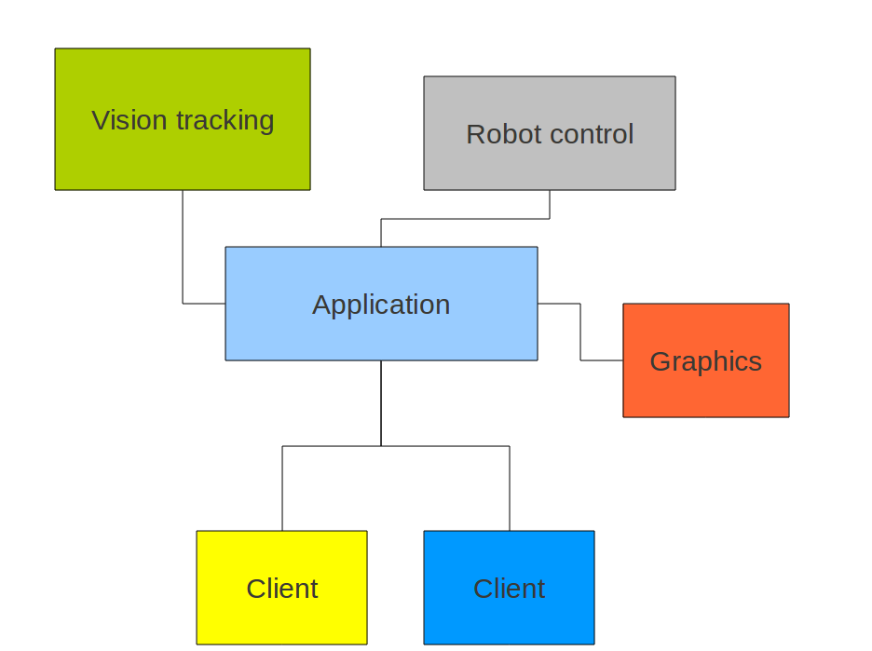

2-Client Development:
2.1. Pass & Shoot algorithms:
one of the most important things in the soccer is Passing the ball to the best available teammate. To do this the first idea was to use circles and find the target. But this had a few problems such as it takes a lot processing time and it sometimes fails .

So we decided to use TRIANGLEs instead of circles.
Triangle: It will define the area in which an opponent could reach the ball and take it. So the function will decide to pass to the best available teammate . To parameters which effect the Triangle's shape are the followings:

1- The velocity of the ball: The more the velocity the less the angle of the triangle
2- The acceleration of the ball: as it becomes more the length of the Triangle will lessen.
3- The player Max speed: The more the speed the more the angle of the triangle.

The function will define a vector starting from the player to the teammate. And in each point of that vector it will calculate the danger area. And sum of the distances of the opponents from the line will define the value of the triangle . And after all the best line for passing or shooting the ball will be elected .

FIGURE 2
(the danger area for shooting the ball)
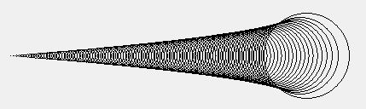

2.2-offense positioning :
the function that positions the offenders will be effected by the position of the opponent's Defenders and goalie . offenders are positioned in several ways explained below :
1- if there are only one defender it will position 2 offenders next to it in a line.
2- if there are 2 or more , 2 defenders will stand in the same line (Y) as the defenders of opponents (near the goal) . and one or more will stand farther (?)to the goal.

FIGURE 3
(offense positioning)

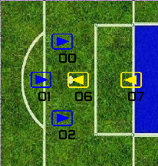

2.3. Dribble:

As you know moving with ball is one of the most important actions in football, even in simulating environment, so we had a good concentration on dribble action in our team.

We have pretended to these points in writing dribble:

2.3.1- routing:
We've needed a default route to move along of it.
2.3.2- changing the route when we face the opponent:
When you face the opponent you can't continue our movement, so we should change your route.
2.3.3- pretending to ball distance from us during a dribbling:
During dribbling you should be alert that ball won't be far from you after kicking.
2.3.4- pretending to kick power during a dribbling:

During dribbling you should be alert that your kick is not very strength. It may bring ball about keep out much more than usual!

2.3.5- valuing to each angle during changing the route:
When we want to the change our route we'll rotate out default route and we should value to each rotating angle to choose the best angle.
We have some criterion for valuing to each angle:

1- Having a desire to use the smallest angle. Because our original priority is the smallest route changing.
2- Pretending to the opponents in new route
3- Pretending to the teammates in new route

by the way it's important to use a weighted valuing during valuing .

FIGURE 4
(dribble route changing)
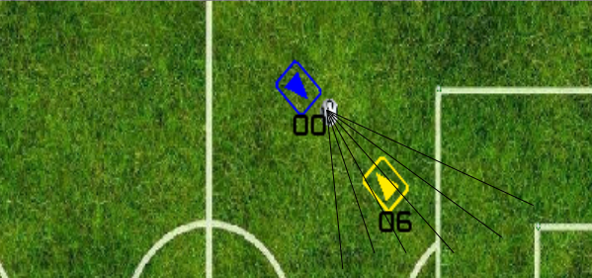

References :

1. BahiaMR team description paper
2. Stuart J. Russell and Peter Norvig . Artificial Intelligence : A Modern Approach .
ISBN : 0-13-103805-2 Library of Congress Cataloging-in-Publication Data
3. professor M.Ghahremani physic visualization in and multi agent intelligence cooperation
4. Obst, O., Rollmann, M.: SPARK: A generic simulator for physical multiagent
simulations. Computer Systems Science and Engineering 20(5) (September 2005)

