Trie:

A Trie is a tree-based data structure that organizes information in a hierarchy.

We use Trie’s tp save English Character in each node and it’s typically used to implement fast look ups and it’s very efficient for prefix matching in English Language.

## Trie Properties:

* It is typically used to store or search strings in a space and time efficient way.
* Any node in trie can store non repetitive multiple characters
* Every node stores link of the next character of the string
* ﻿﻿Every node keeps track of 'end of string'

This is a simple Trie and below that it’s strings that can be extracted from:

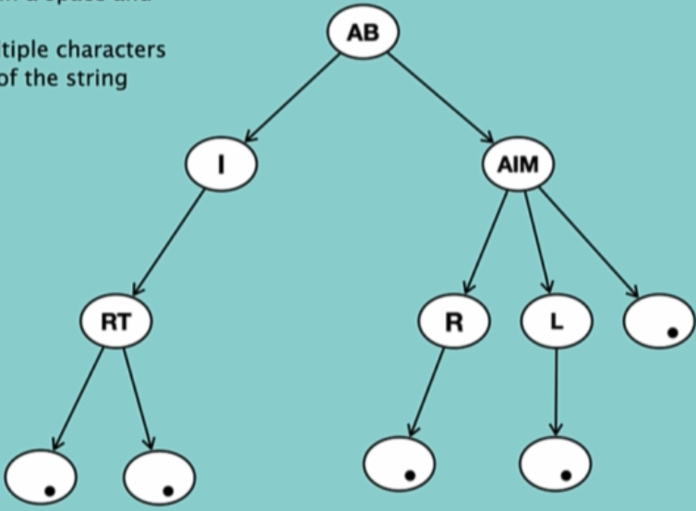

AIR,AIT,BAR,BIL,BM

Each time when we encounter a node with the value of dot “.” It means that the string ends here.

## Why we need Trie data structure?

In the world of data structure there are many problems that solve easily using trie data structure for instance:

* Spelling checker
* Auto completion

Each Node in the Trie data structure has a Map like this:

