Personas

Marcus, an undergraduate student for the main land university. She is planning to have a trip on somewhere on the summer vocation with her friends.

Ivy, 22 years old, a computer science student from the university of Hong Kong. She is always full of passion and curious about the new things.

Tasks:

Task1: Marcus want to have a trip on Hong Kong, but she hasn’t gone there before. He would like to look through the map and quickly know the locations of landmarks in Hong Kong, so she can use this knowledge to plan her trip.

Task2: Ivy have a homework to tell difference between machine learning and data mining. Although she is a CS student, but she knows less in this field. She wants to find a better way to compare them so that she can tell difference between them clearly. At the same time, one of her friends ask her to have dinner together, so she must do this work later.

Scene:

Scene1: Marcus used our app to search Hong Kong, after that, there are many colorful circles with represent different landmarks on Kong Hong, Marcus can zoom in or zoom out the sights by using gestures. For larger circle, it represents that place is more popular. If Marcus get interest in the place, she can stick the circle and our app will show Marcus the knowledge graph of the place.

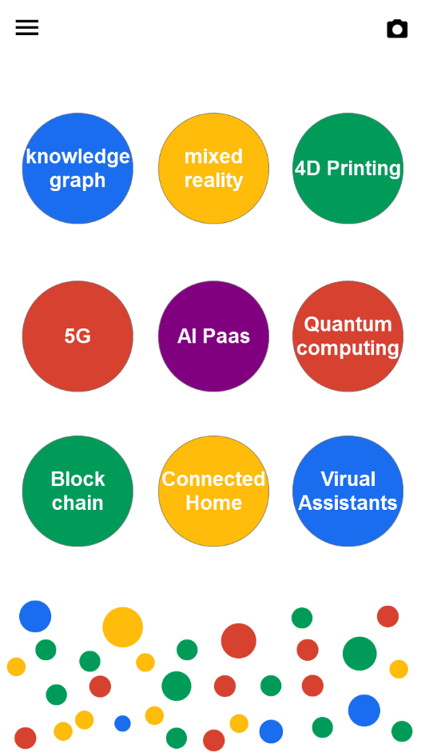

Scene2: Ivy tried to use our app to search the knowledge graph of machine learning as well as data mining and then marked them as collection. Then she had dinner with her friends. After that, she went home and then used collection file function of our app. For these two entities have been moved to collection file, Ivy can find them easily and compare each branch of them one by one.

