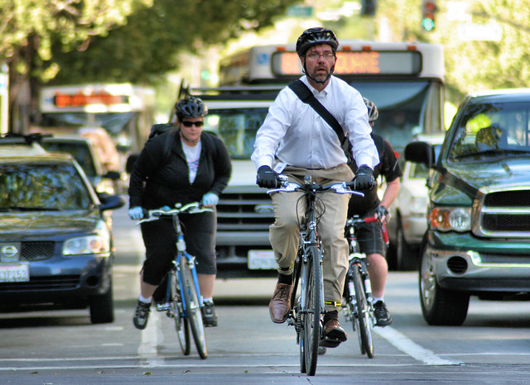

[This Photo](https://flickr.com/photos/bike/4605158343) by Unknown Author is licensed under [CC BY-SA](https://creativecommons.org/licenses/by-sa/3.0/)

GRID BIKE SHARE vs LIGHT RAIL

# commuting

## LIGHT RAIL

### What quarters do we see an increase of light rail riders? [bar graph or line chart]

### What is the cost comparison/benefits? (light rail one way $2/$4 all day) (Grid bike .12c per min/$7 deposit required{*First hr covered}

### What is the amount of rider difference eastbound vs westbound?

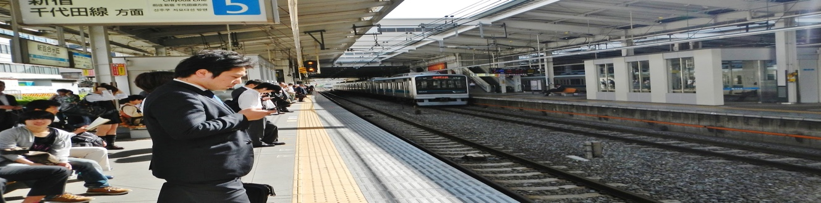

[This Photo](http://www.goneseoulsearching.com/2012/05/gone-seoul-searching-in-japan-embracing.html) by Unknown Author is licensed under [CC BY-ND](https://creativecommons.org/licenses/by-nd/3.0/)

# masstransit

## B. GRID BIKE SHARE

1. What are the busiest light rail locations annually? [list graph user data]
2. Show a user comparison of bike users vs light rail?
3. How many Grid Bike Share locations per city?

# 1: Which light rail stop has the most pedestrian traffic?

Calculate total riders by stop looking for all quarters and then years. We could have two

results here to show on a quarterly basis this stop has the most traffic and then etc. for year.

A bar graph may be a good visual representation but that will only work if we use something

like the top 5 stops so we do loose readability if there are too many values on display.

We could even break this down by the quarters per year in their own graphs to show a few

graphs and possibly identify any seasonal trends.

# 2: What are the busiest light rail locations annually?

Use total riders by year calculation here again.

Could reflect in a pie chart to show total of the overall rider population in our study.

**Something to note we may be trying to answer the same question twice in 1 & 2. Curios

what you guys think on Sat if I am being too general here.

# 1: How many bike stations are w/i a 1 mile radius of a transit station?

Convert lat/long into a list for both bike data and light rail data to determine stops locations.

Then compare lists using loops to determine what stops/transit centers have overlapping

locations within the set radius (1 mile). Maybe we extend this to look at 5 miles as an

additional step, even 10? 10 may be irrelevant but curious on teams’ feedback.

This would be a perfect use of a heat mat to show the relationships of bike stations w/i

proximity to one another.

# 2: During a high-volume period of light rail usage do we also see a correlation in bike

share usage?

From the above variables created for light rail rider peaks, break down by quarter and see if

seasonal changes exist in relation to the bike usage. Since we do not have biker share rider

numbers, we can use number of locations within a 5 mile radius of the highest volume light

rail stations to see if there is a high or low number of bike share stations.

If we find that the number of bike share stations are high in that 5-mile radius we could

assume light rail use is comparable to bike share use. If the number of stations is low in that

radius, we could conclude that bike share use is not correlated to high light rail usage times.

We could use the creation time of the bike station to compare to the quarterly rider numbers

to see the changes over time.

This could be a good use of a scatter plot I think. Map the different locations and then

maybe implement a heat signal(not exactly sure what those are called) map and show the

radius on