**Documentation**

Enrollment Form/Registration Form

**Group 1**

Leo C. Abarquez

Jasam Ardee D. Antero

Katrina Mae Apostol

John Mark M. Azur

Joseph Emanuel O. Bataller

Janlou P. Bernadas

December 2022

**Summary**

This documentation provides detailed information and includes the basic plan information necessary for initial establishment and operation of the group’s program. The group was formed for the fulfillment of project in the course Computer Programming 1 with the guidance of our instructor, Ms. Angelica Payne. All members of the group are all 1st year student, are resided at Trece Martires City, Cavite, and bonified student at Cavite State University – Trece Martires City Campus. All group members will work closely together, and share some common knowledge about computer programming especially about python programming language which is used to develop the project, the following information outlines all aspects of the group and documentation about the project only including pseudocode, flowchart, code, **clear concise narrative that describes the program**, techniques and methods for operationalizing the program, clarifications of the strategic guide or regulatory requirements, and communication to users of program for guidance information on actions that users are expected to complete.

The group was formed in October 2022 with its primary objective to develop a so called “Mini Project” before November 13 and have a much more complex project that will be deadline on January 2023.

**Program Description**

Enrollment Form is a program that asks the users for their information and for every information that the user enters, it will be recorded and saved in a .txt document. It is really helpful because the user’s input will be automatically recorded after pressing enter. The purpose of this program is to manage student's information in a more efficient way.

**How the Program Works**

* The program was designed to gather user inputs to gather their personal information. The user information fields include the following:
  + User Name
  + Age
  + Address
  + Date of Birth
  + Gender
  + Contact Information
  + E-mail Address
  + Year Level
  + Course
  + Number of units, they will take
* There are no restrictions on user input in the program. This means that the user is able to enter any datatype that they desire and no datatype is required for the user to input at any field. However, user information should be relevant and appropriate to the form's requirements.
* Once all fields have been filled, click "Enroll" button to save all user data and confirm that it has been saved by seeing the "Required Information Acquired" text and to see the user's name, course, and year level on the screen. Whereas a text stating "All Information Must Be Filled Up" shows if the user has not yet entered all the necessary information, your data will not be stored and all the information you enter must be complete.
* After pressing the enroll button, the program will immediately generate a.txt file containing all of the user's data. The user inputs will be stored in a.txt file that may be retrieved in the location where the file directory is located.

**Program Code**

The sole programming language used in this software is Python, and the functions that can be utilized in the program are created using the Tkinter GUI toolkit's standard Python interface. The code was written in visual studio code on a laptop. For the purpose of executing codes, programmers are diligently browsing the internet, notably on YouTube for reference and improvement of the code. A full day was needed to complete the initial code for the Mini Project, and progress was still ongoing on other codes for much more complex project.

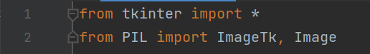

The basic import statement is executed by finding a module, loading and initializing it, if necessary, define a name or names in the local namespace for the scope where the import statement occurs.

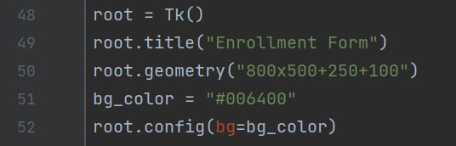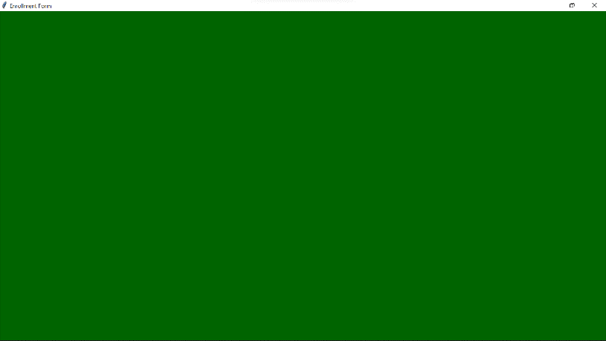

800

Window name, background color, width, and height.

500

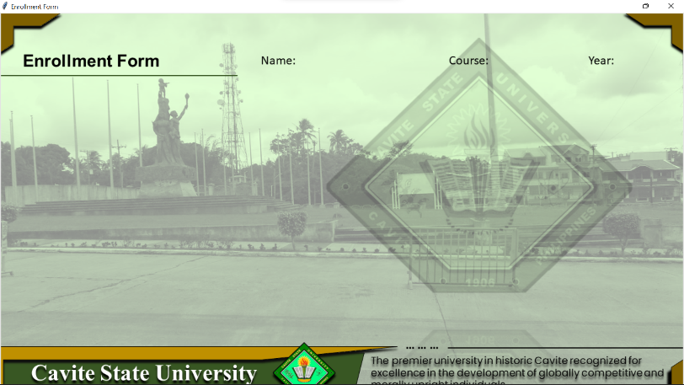

Window background picture.

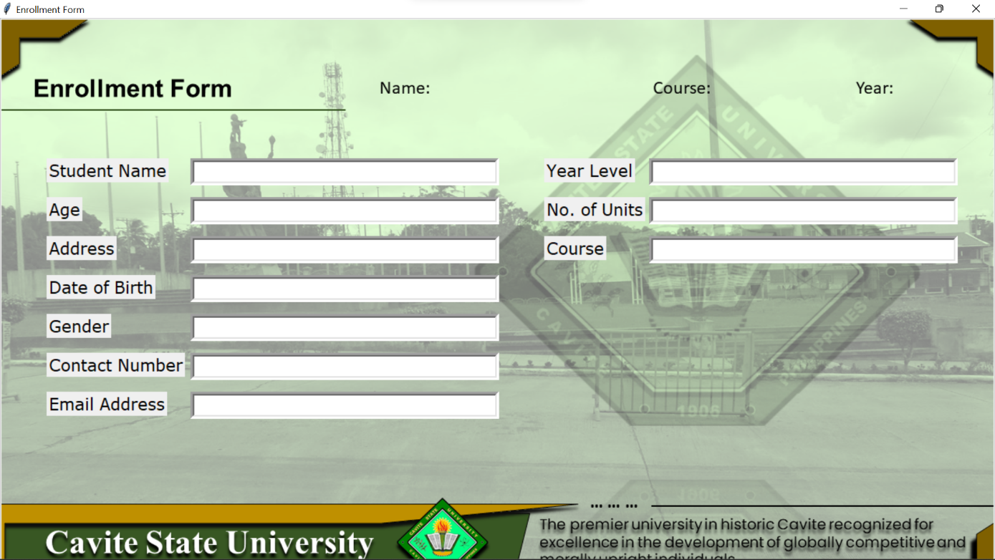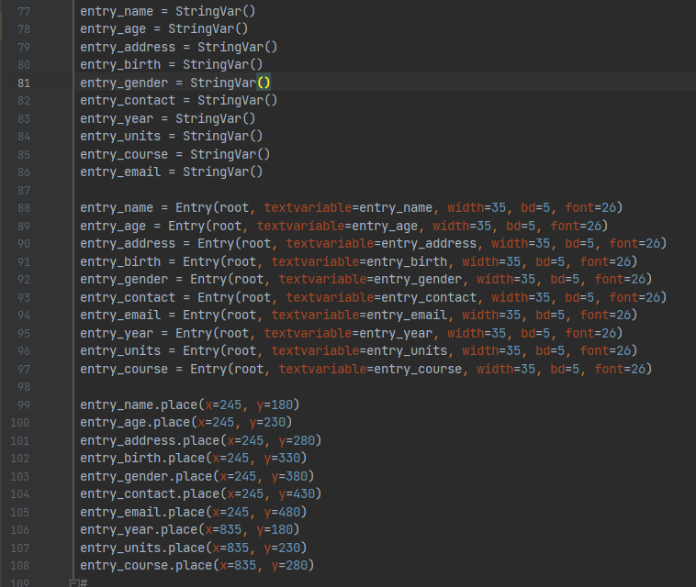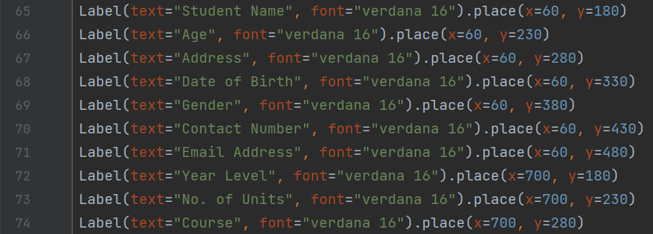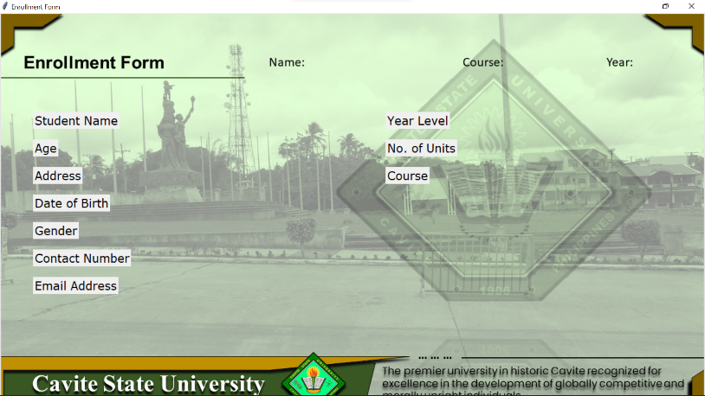 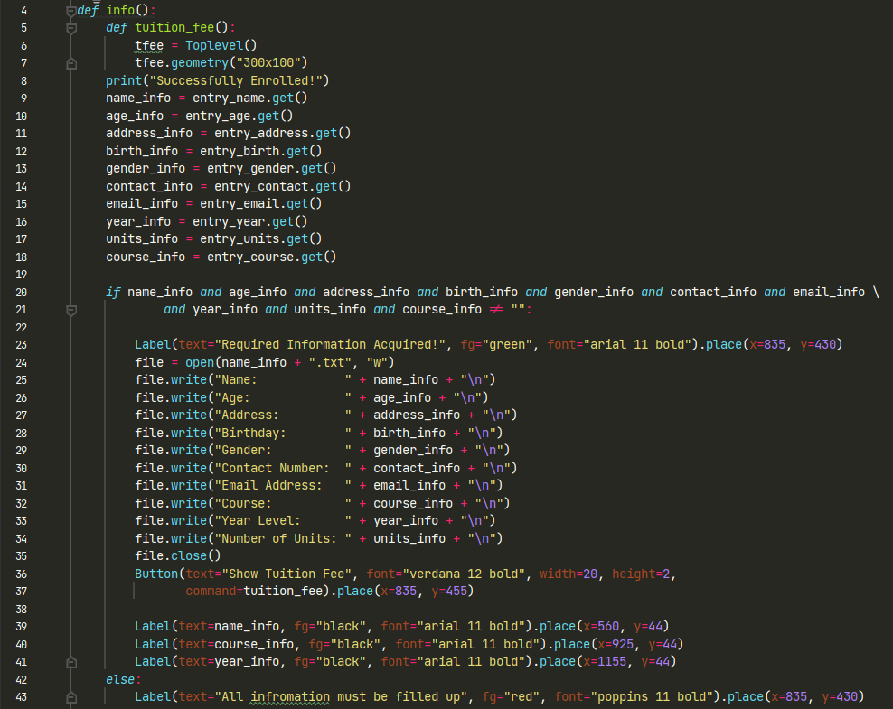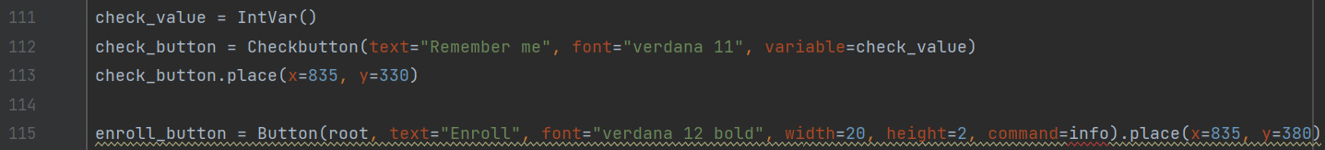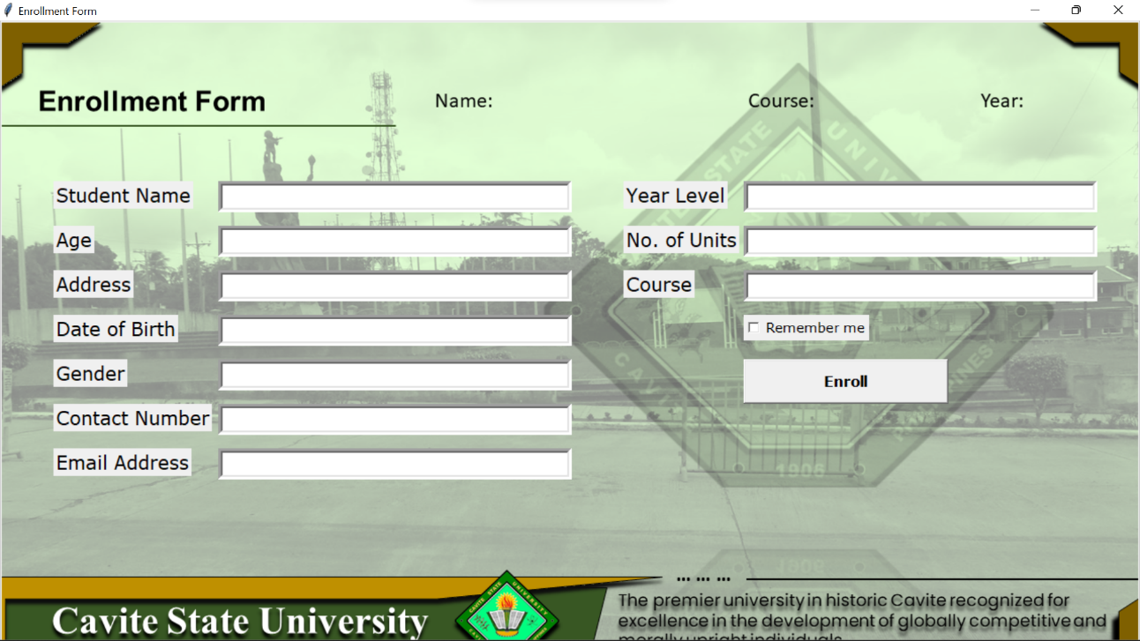

Field information entry and text box height, width, dimension and position

Field text, font, font size, and position.

Enroll Button command function:

* Getting the user entry on each field.
* Responsible for creating a txt file for saving user input.
* Window responsiveness.
* Form Validation.

Check button and Enroll Button

**Pseudocode**

start

open application

input student personal informations

input course, year level, and no. of units

check terms and conditions

select enroll button

accept student personal informations

accept course, year level, and no. of units

if student_information != ""

display "Required Information Acquired"

open ".txt" file

get student informations

display "Required Information Acquired"

display .get(student name)

display .get(course)

display .get(year)

save created ".txt" file

else:

display "All information must be filled up"

end

**Flowchart**

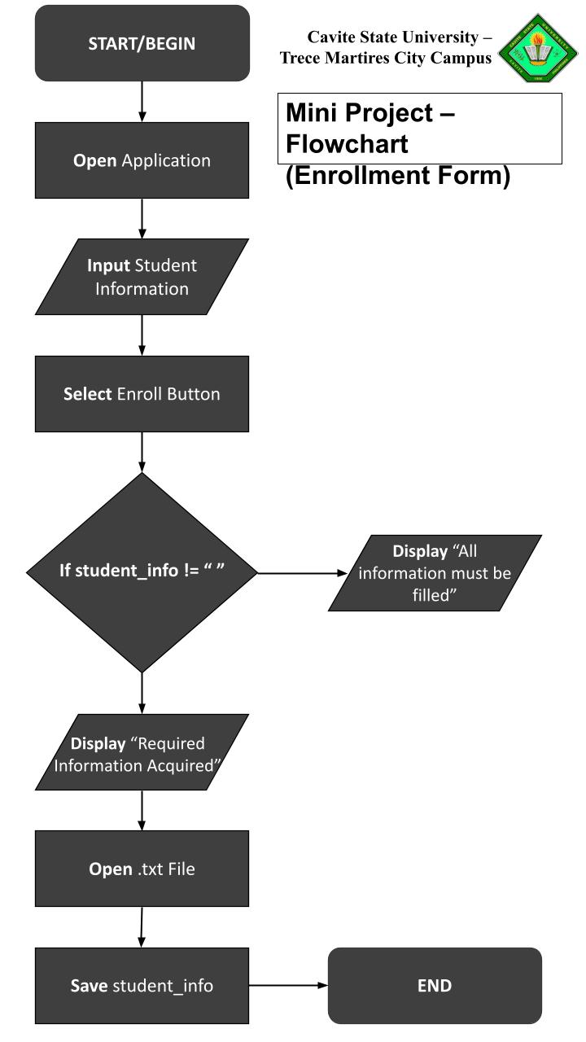

**Member’s Participation Summary**

**Leo C. Abarquez.** He is the Project Manager of the group and in charge on leading the group. He provides brief detailed orders and classify specific tasks and requirements that the group members should fulfil and accomplish. He also takes part on creating the PowerPoint presentation of the group.

**Janlou P. Bernadas** and **Katrina Apostol**. The group’s Business Analyst and System Analyst, who is in charge of **collecting data about the group’s operations,** creating the program's pseudocode, flowchart, and analyzes, implements information on instruction manual of the program.

**John Mark Azur** and **Joseph Bataller.** The programmers of the group, responsible in constructing the codes of the program, produces the desirable output results and perform debugging when necessary, and collaborates with business and system analyst to create the algorithm of the program. Also, they are in charge of making the group’s documentation report.

**Jazam Ardee Antero**. The Documentation Analyst of the group, responsible for**organizing, filing, and preserving important documents** of the group. He is the one who will submit the group’s output to our instructor. He is also in charge in creating the PowerPoint presentation of the group.

All group member participated, and accomplish their tasks properly and on time.