BATALLER. JOSEPH EMANUEL O. BSIT 4-1

**PART 1: UNDERSTANDING CURRENT SECURITY SETTINGS**

**TASK1.1 ACCESS LOCAL SECURITY POLICY**

**ALL CURRENT PASSWORD POLICY SETTING**

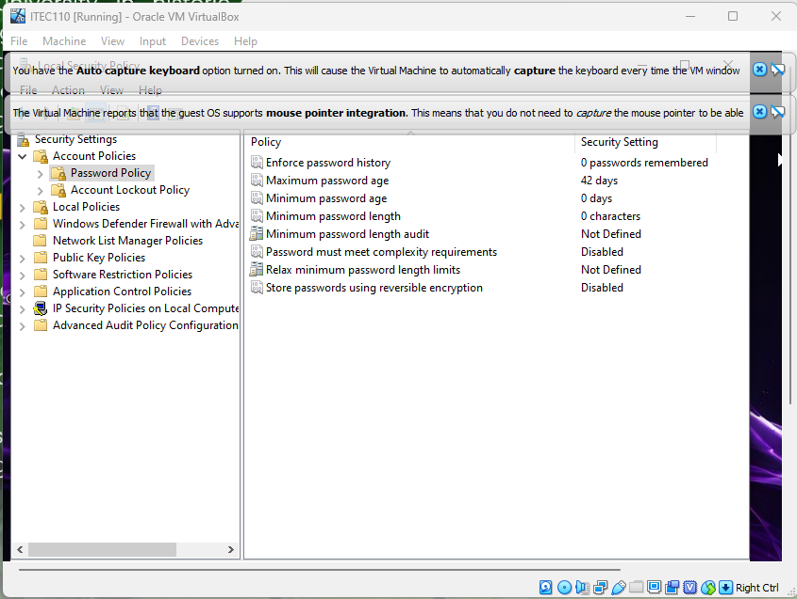

**ALL CURREENT LOCKOUT SETTINGS**

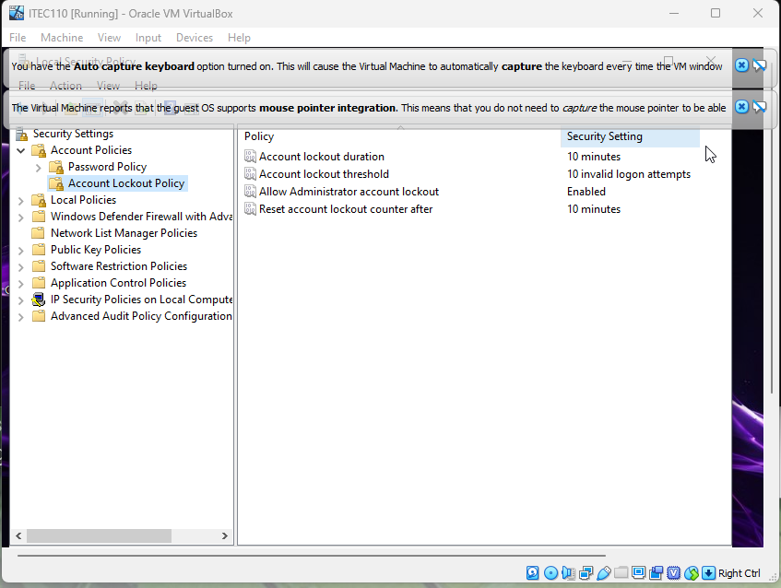

**TASK 1.2 CHECK CURRENT USER INTERFACE**

**NET USER OUTPUT**

­­­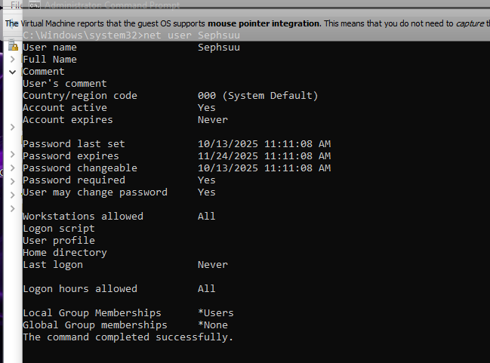

**LOCAL SECURITY POLICY**

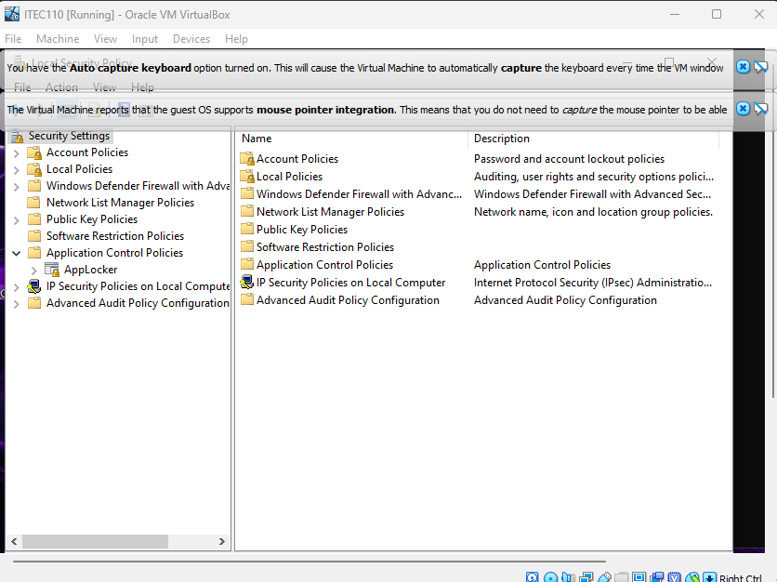

**PART 2:**

**CREATING 3 TEMP USER**

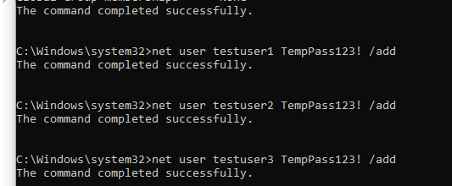

**SHOWING CREATED TEMP USER**

TESTUSER1 TESTUSER2

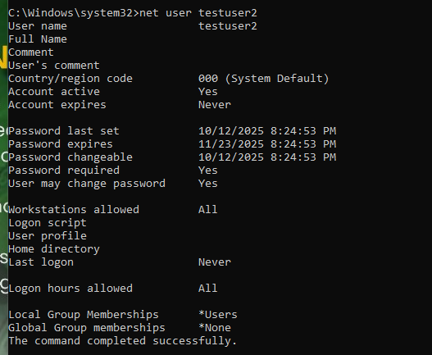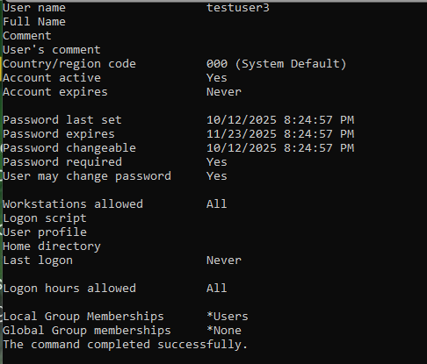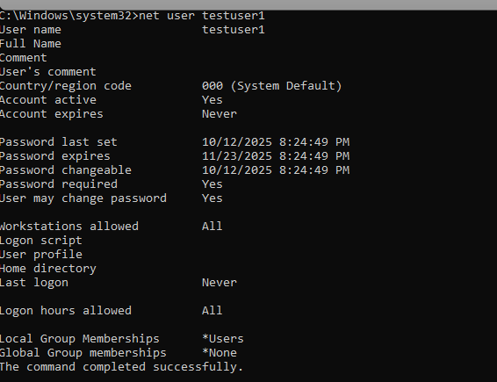

TESTUSER3

PART 3:

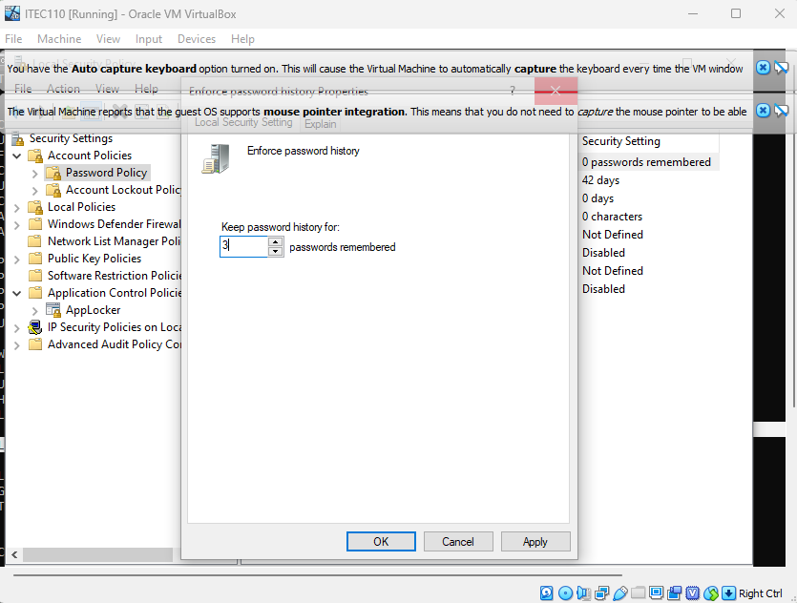

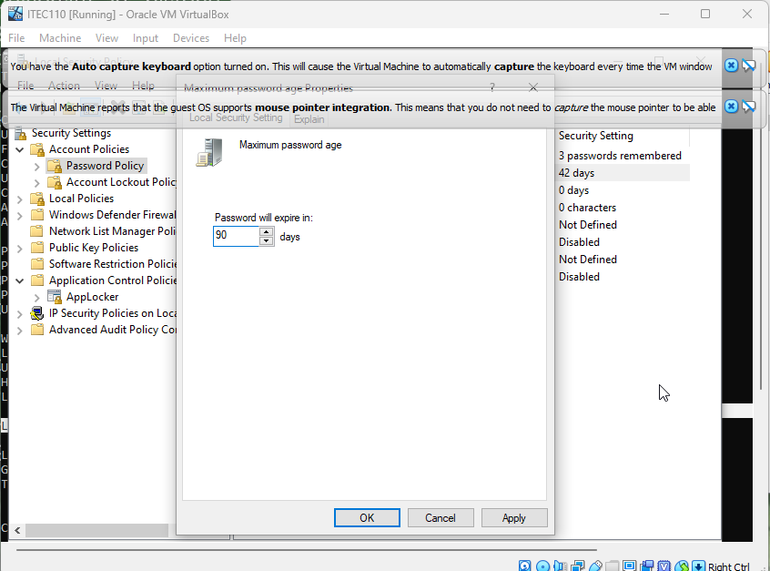

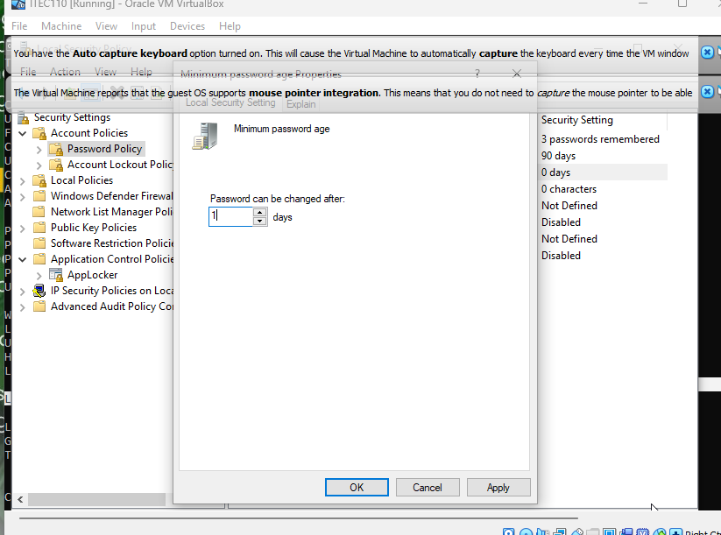

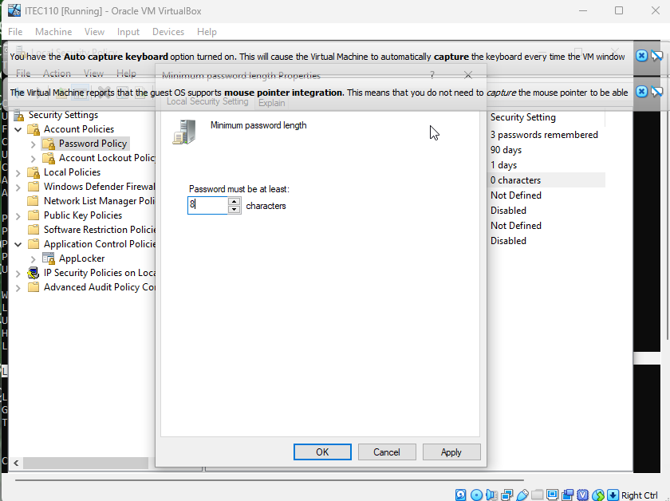

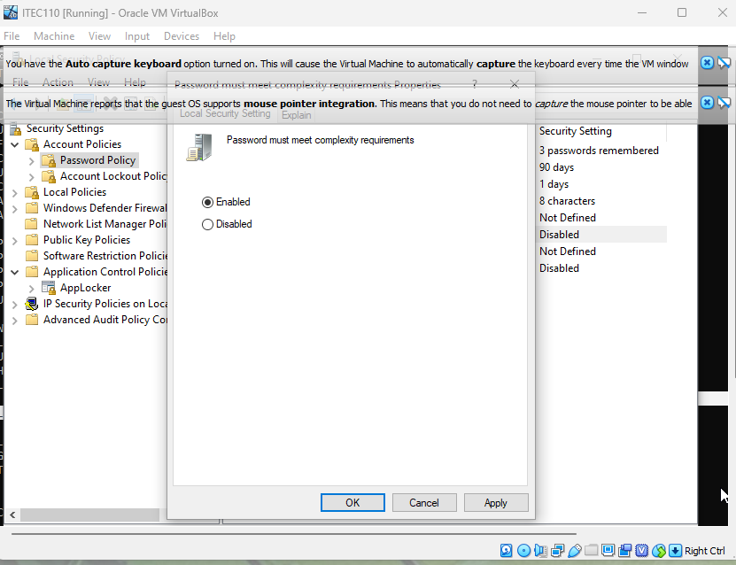

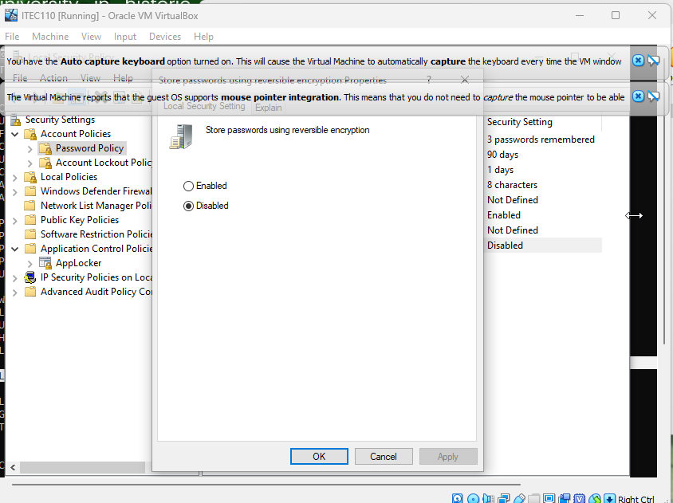

TEST 3.3:

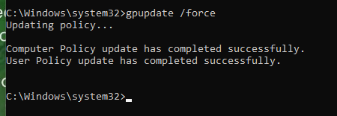

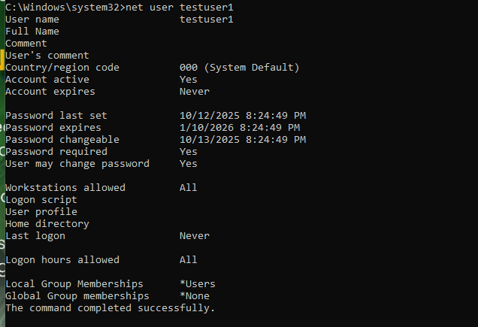

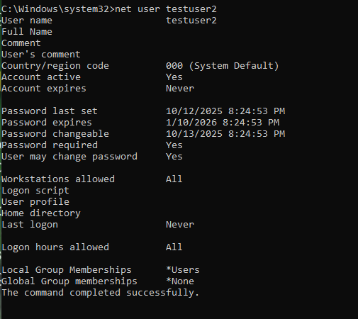

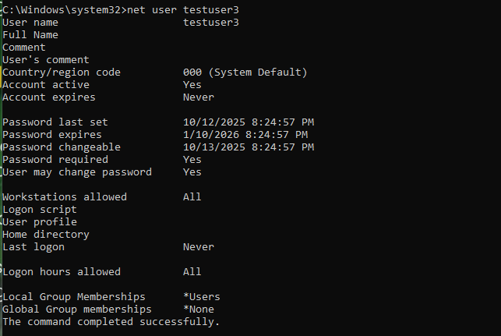

PART 4:

|  |  |  |  |
| --- | --- | --- | --- |
| PASSWORD ATTEMPT | EXPECTED RESULT | ACTUAL RESULT | REASON |
| Pass123 | FAILED |  | Length of characters is below 8 and password does not contain any special characters |
| password | FAILED |  | Password does not contain any special characters |
| PASSWORD123 | FAILED |  | Although the length is greater than 8, password has no variation of any special characters |
| P@ssword | PASSED |  | It contains both uppercase and lowercase alphabet and variation of numerical and symbol characters |
| MySecureP@ss123 | PASSED |  | It also contains variation of uppercase, lowercase, numerical, and symbol characters |
| testuser1 | FAILED |  | Password has no uppercase and symbol characters |

PART 4:

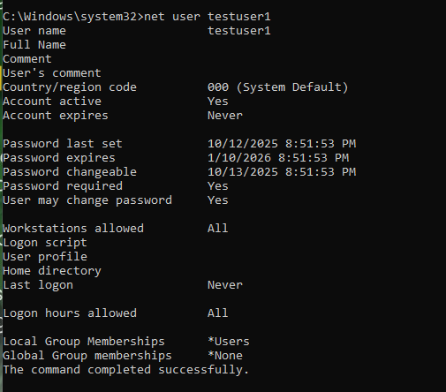

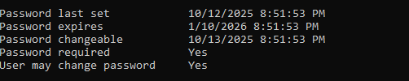

PART 5: CONFIGURING ACCOUNT LOCKOUT POLICY

TASK 5.1

