BATALLER. JOSEPH EMANUEL O. BSIT 4-1
PART 1: UNDERSTANDING CURRENT SECURITY SETTINGS
TASK1.1 ACCESS LOCAL SECURITY POLICY
ALL CURRENT PASSWORD POLICY SETTING
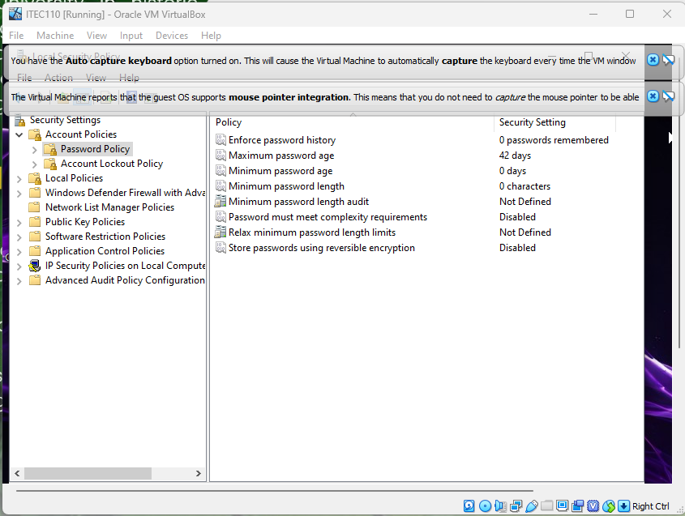
ALL CURREENT LOCKOUT SETTINGS
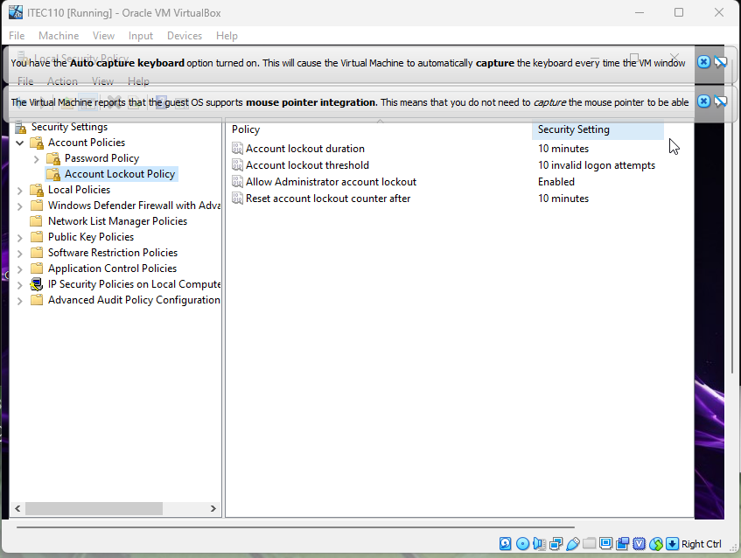

TASK 1.2 CHECK CURRENT USER INTERFACE
NET USER OUTPUT
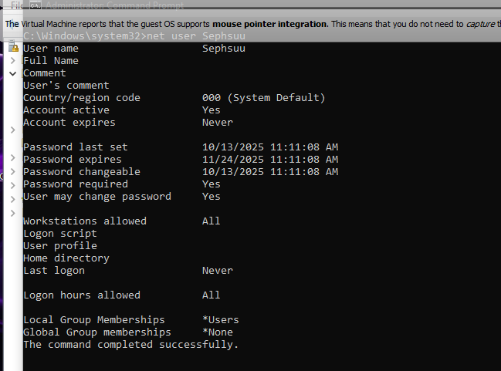
LOCAL SECURITY POLICY
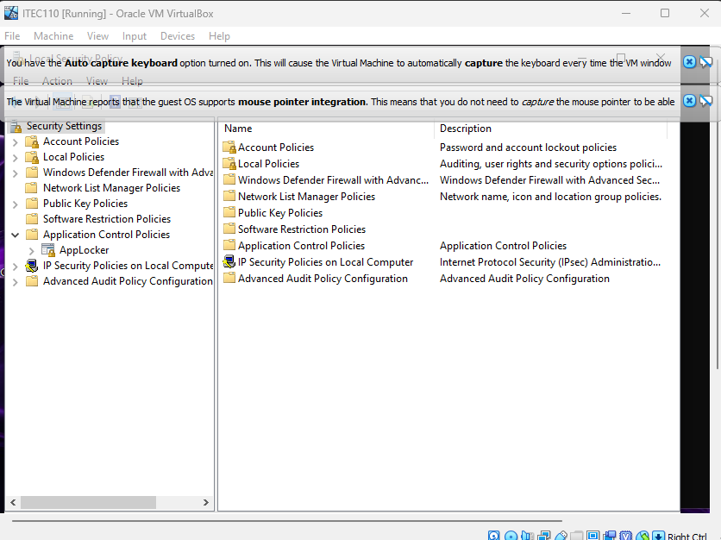

PART 2:
CREATING 3 TEMP USER
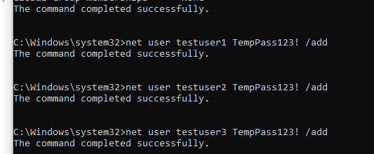
SHOWING CREATED TEMP USER
TESTUSER1 TESTUSER2
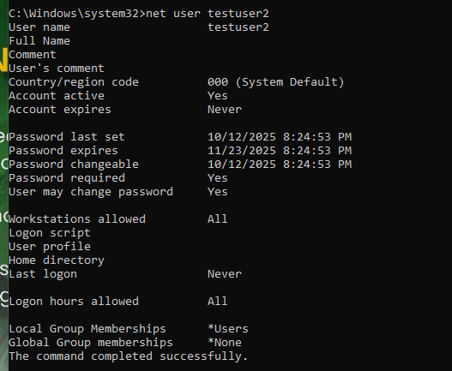
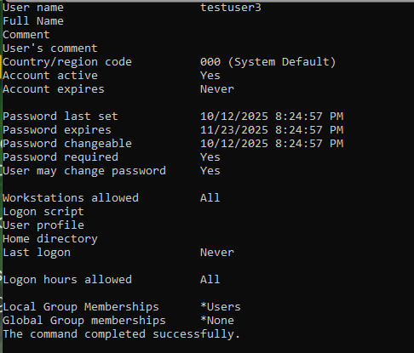
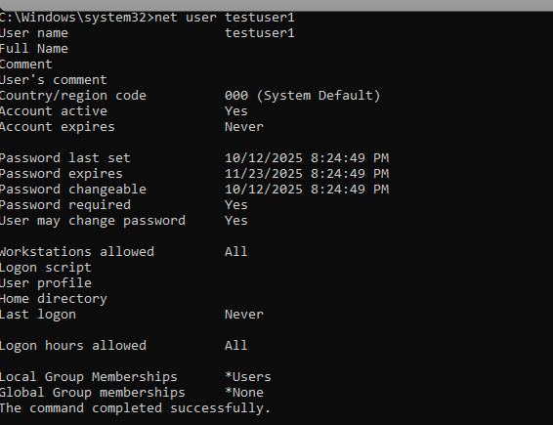
TESTUSER3

PART 3:
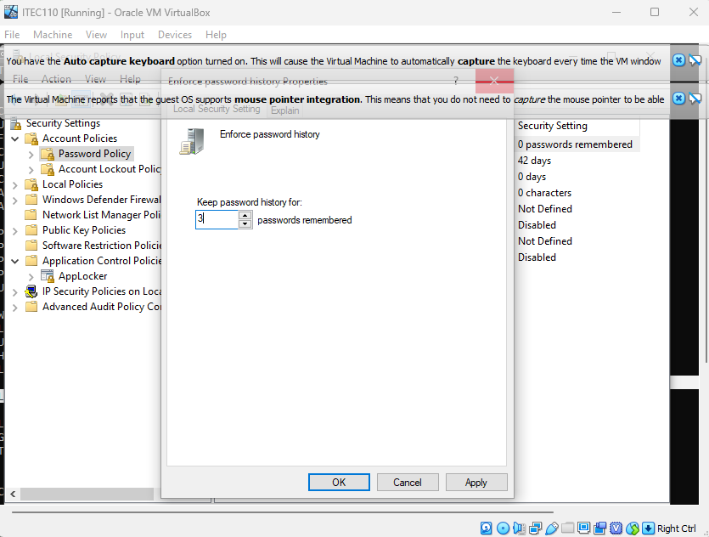
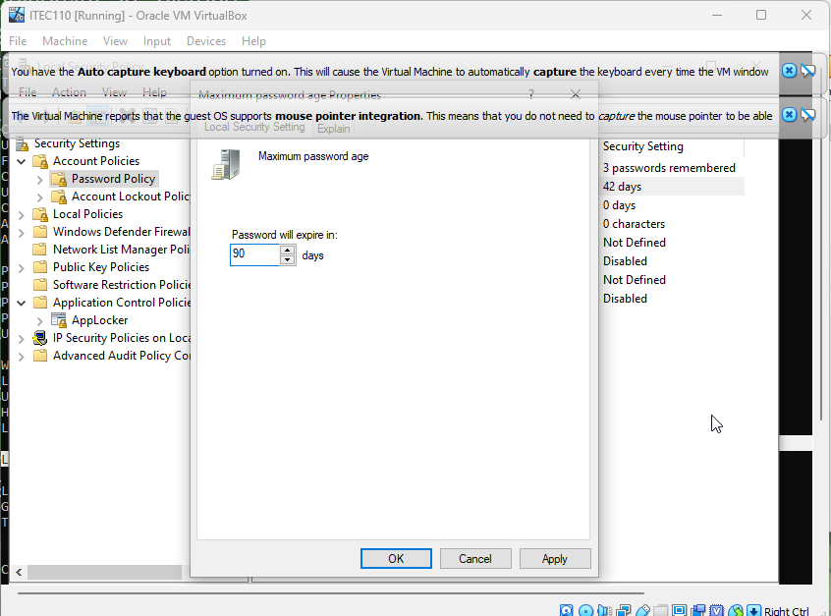

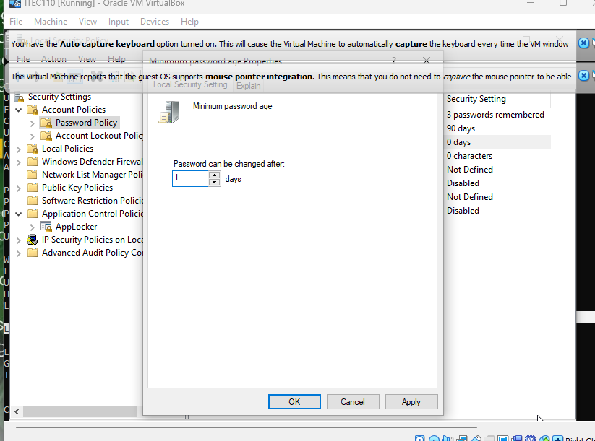

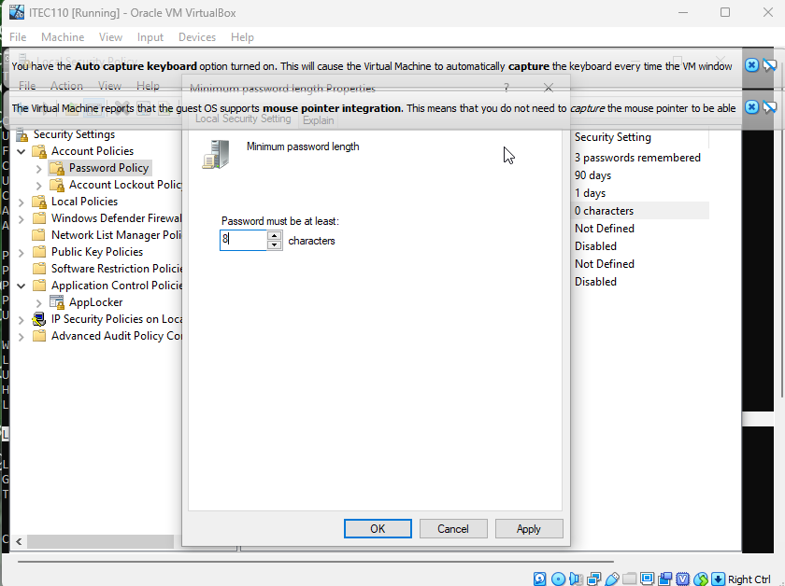
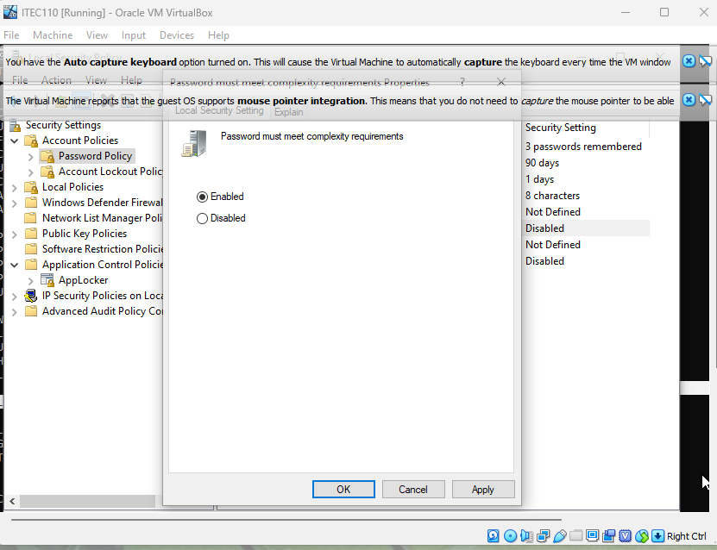
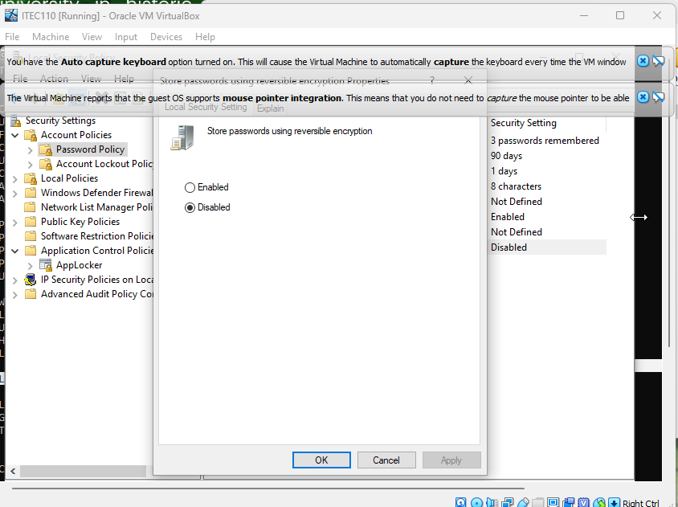

TEST 3.3:
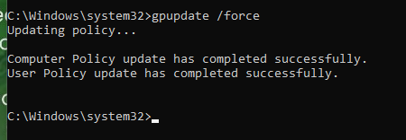
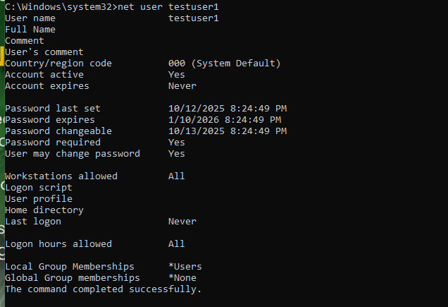

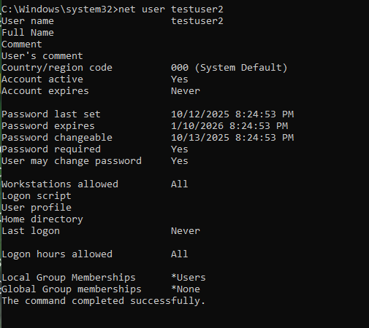
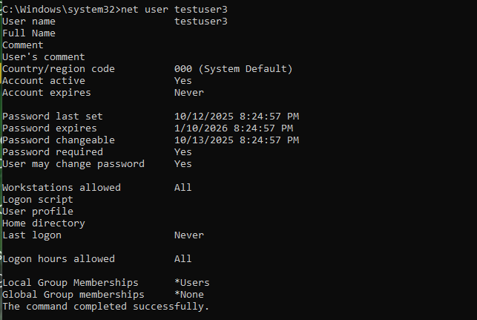

PART 4:
PASSWORD ATTEMPT | EXPECTED RESULT | ACTUAL RESULT | REASON
Pass123 | FAILED | 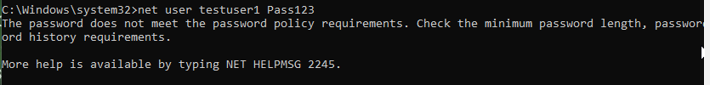 | Length of characters is below 8 and password does not contain any special characters
password | FAILED | 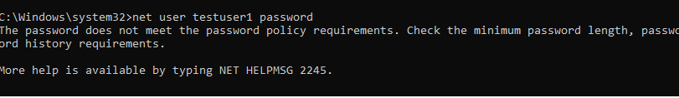 | Password does not contain any special characters
PASSWORD123 | FAILED | 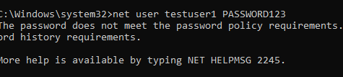 | Although the length is greater than 8, password has no variation of any special characters
P@ssword | PASSED | 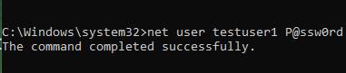 | It contains both uppercase and lowercase alphabet and variation of numerical and symbol characters
MySecureP@ss123 | PASSED | 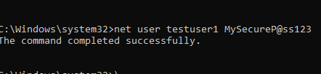 | It also contains variation of uppercase, lowercase, numerical, and symbol characters
testuser1 | FAILED | 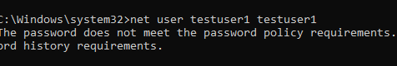 | Password has no uppercase and symbol characters

PART 4:
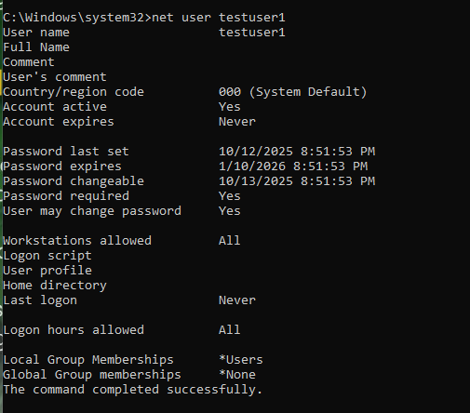

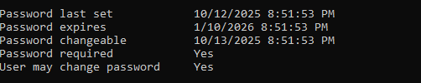

PART 5: CONFIGURING ACCOUNT LOCKOUT POLICY
TASK 5.1
