**Deliverable 3**

# Course: Fundamentals of Software Design and Development

**Project Title: WarGame Card Game**

**Group Name: Group 7**

**Members: Sepideh Pourshirazi, Nabia Mahmood,**

**Subh Kamran**

**Instructor: Sivagama Srinivasan**

**Date: April 7, 2025**

# Contents

1. Project Overview
2. Updated UML Class Diagram
3. Final Code Explanation
4. GitHub Repository Link

# 1. Project Overview

The "WarGame" project is a simple, text-based card game simulation implemented in Java. It was developed in three stages:

* Deliverable 1: Planning, class design, team contract
* Deliverable 2: Use case definitions, design justifications, partial implementation
* Deliverable 3: Final working version, UML diagram, and code analysis

The game allows two players to draw cards from a shuffled deck, compare their values, and track

scores over multiple rounds. The winner is the player with the most rounds won.

**2. Updated UML Class Diagram**

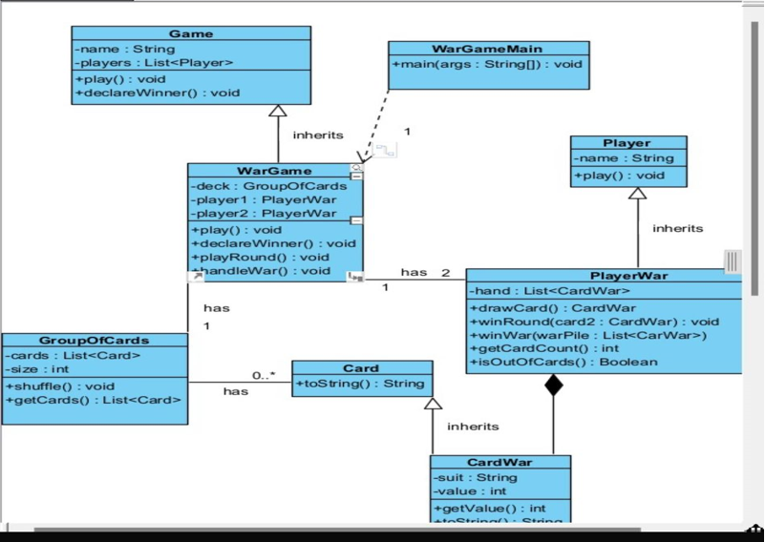

# 3. Final Code Explanation

The code was designed based on OOP principles:

* Encapsulation: Each class contains relevant data and behavior (e.g., Card, Player, Deck)
* Abstraction: Complex logic such as gameplay and card shuffling is abstracted in classes like Game and Deck
* Modularity: Each component (player, card, deck) is self-contained and easily testable - Reusability: The Card and Deck classes could be reused in other card games ***Highlights:***
* The Game class manages the core loop, round logic, and winner evaluation
* The Deck class shuffles and deals cards efficiently
* The Player class holds each player's name, score, and hand
* The game runs in the console and ends with a winner announcement

This implementation aligns with the original use case narrative and UML planning.

# 4. GitHub Repository Link

**https://github.com/SepidehPourshirazi/group-7-project/tree/main**

Output:-   
so the number of rounds when one player wins more he/she wins as shown in the output   
