Laboratory Data Quality Assessment & Exploratory Analysis Report
Analyst: Sepideh Ziaei Chamgordani
Date: September 6, 2026
Project Type: Exploratory Data Analysis (EDA) — Synthetic Patient Laboratory Data

Executive Summary
This report presents the findings of an exploratory data analysis (EDA) performed on a dataset of 500 synthetic patient-level laboratory records. The analysis focused on data quality assessment, descriptive statistics, and investigation of relationships between key laboratory measurements.
The dataset was successfully cleaned (3 duplicates removed, 5 sex variants standardized, 7 records with implausible values flagged), summarized, and visualized. Key findings include a strong Total Cholesterol–LDL correlation (r ≈ 0.92), a moderate positive BMI–Glucose association (r ≈ 0.40), and only small differences between males and females. Some patterns typical of real clinical data, such as a clear inverse triglyceride–HDL relationship, are weak or absent in this synthetic dataset. The dataset is suitable for downstream work pending expert review of flagged values.

1. Project Overview
1.1 Background
A private diagnostic laboratory requested an initial assessment of a historical dataset of routine laboratory measurements before using it for downstream statistical work and internal reporting.
1.2 Objectives
This analysis addresses three goals:
- Clean and validate the data — identify missing values, duplicates, and implausible readings
- Summarize key variables — describe central tendencies and spread of laboratory measurements
- Explore visually — reveal relationships between measurements (e.g., BMI vs. Glucose, Triglycerides vs. HDL) and differences between demographic groups.
1.3 Scope & Disclaimer
This is a strictly exploratory analysis. No predictive models are built, and no clinical diagnoses or causal claims are made from this data. The goal is to produce a clean dataset and a clear, reproducible summary that a non-technical stakeholder can understand.
2. Dataset Overview
2.1 Source & Structure
- Source: Synthetic patient-level laboratory records (AI-generated for portfolio purposes)
- Original size: 503 records × 13 variables
- Final size: 500 records (after removing 3 exact duplicates)
2.2 Variables
The dataset contains:
- Demographics: Age, Sex, BMI
- Laboratory measurements: Glucose, HbA1c, Total Cholesterol, LDL, HDL, Triglycerides, Systolic BP, Diastolic BP
- Target variable: Diabetes (binary: Yes/No)
2.3 Known Data Quality Issues
The dataset intentionally contains realistic data-quality issues:
- Missing values across 6 numeric variables
- Categorical inconsistencies in the Sex column
- Exact duplicate records
- Physiologically implausible values

3. Data Quality Assessment & Cleaning
3.1 Missing Values
Finding: 57 total missing values across 6 variables
Variable | Missing Count | Percentage
BMI | 12 | 2.39%
Triglycerides | 11 | 2.19%
Glucose | 10 | 1.99%
LDL | 9 | 1.79%
HbA1c | 8 | 1.59%
HDL | 7 | 1.39%
Decision: No single variable exceeds 2.5% missingness — a manageable level. Missing values were kept as missing (not imputed); each statistic uses the available values for that variable.
3.2 Categorical Consistency
- Finding: The Sex column contained 5 variants: Male, Female, M, F, female
- Action: Standardized to 2 clean categories: Male and Female
- Rationale: Without standardization, any sex-stratified analysis would silently split groups, producing misleading results.
3.3 Duplicate Records
- Finding: 3 exact duplicate rows identified (Patient_IDs: LAB-0058, LAB-0239, LAB-0412)
- Action: Removed duplicates, keeping the first occurrence
- Rationale: Exact duplicates provide no additional information and would artificially inflate the weight of certain records.
3.4 Physiologically Implausible Values
- Finding: 7 records flagged with values outside standard clinical reference ranges (Age = 7 years (likely data entry error), Total Cholesterol < 100 mg/dL (5 records), HDL = 4 mg/dL (extremely low)
- Action: Flagged in a new Implausible_Flag column but NOT deleted
- Rationale: These could be legitimate extreme values or data entry errors. Domain-expert review is required before final analysis.
3.5 Cleaning Log
All cleaning decisions have been documented in data_cleaning_log.csv for full transparency and reproducibility.
4. Descriptive Analysis
4.1 Overall Summary Statistics
Variable | Count | Mean | Std | Min | 25% | Median | 75% | Max
Age | 500 | 48.9 | 18.9 | 7 | 31.0 | 50.0 | 65.0 | 80
BMI | 488 | 27.0 | 4.8 | 17.0 | 23.5 | 26.8 | 30.2 | 61.5
Glucose | 490 | 102.3 | 19.2 | 55.0 | 89.4 | 102.0 | 115.0 | 155.9
HbA1c | 492 | 5.0 | 0.6 | 3.8 | 4.6 | 5.0 | 5.5 | 7.0
Total Cholesterol | 500 | 174.1 | 32.2 | 90.0 | 151.6 | 174.6 | 196.3 | 264.9
LDL | 491 | 83.1 | 30.4 | 45.0 | 55.6 | 79.3 | 104.8 | 184.4
HDL | 493 | 61.1 | 9.3 | 4.0 | 54.9 | 61.5 | 67.5 | 91.6
Triglycerides | 489 | 116.8 | 45.1 | 45.0 | 83.3 | 114.4 | 148.0 | 240.9
Systolic BP | 500 | 126.6 | 16.3 | 85.0 | 116.0 | 126.7 | 138.0 | 177.6
Diastolic BP | 500 | 73.2 | 9.2 | 50.0 | 66.7 | 73.3 | 78.9 | 103.0

4.2 Categorical Distributions
Sex Distribution:
Sex | Count | Percentage
Female | 252 | 50.4%
Male | 248 | 49.6%

Diabetes Distribution:
Diabetes | Count | Percentage
No | 426 | 85.2%
Yes | 74 | 14.8%
Key Observation: The cohort is balanced by sex (~50/50) and has a diabetes prevalence of ~15%, consistent with an adult outpatient population.
4.3 Laboratory Variables by Sex
Variable | Male Median | Female Median | Male IQR | Female IQR
Age | 49.0 | 50.0 | 32.0 | 35.0
BMI | 26.9 | 26.8 | 6.5 | 6.8
Glucose | 104.2 | 101.0 | 26.6 | 24.0
HbA1c | 5.1 | 5.0 | 0.9 | 0.8
Total Cholesterol | 177.8 | 171.2 | 43.5 | 46.9
LDL | 82.7 | 76.6 | 43.5 | 51.3
HDL | 61.0 | 61.7 | 13.0 | 11.6
Triglycerides | 117.3 | 112.1 | 71.5 | 58.3
Systolic BP | 127.8 | 125.2 | 23.4 | 21.6
Diastolic BP | 73.8 | 72.7 | 11.5 | 13.4
Key Observation: Differences between males and females are small. Males have slightly higher median triglycerides and systolic blood pressure, while median HDL is almost identical in both sexes.
5. Exploratory Visualization
5.1 Univariate Distributions
Distribution of Laboratory Variables by Diabetes Status
Most laboratory variables show approximately symmetric, unimodal distributions. BMI is the only clearly right-skewed variable (skewness ≈ 0.8). Diabetic patients are shifted toward higher glucose (median ≈ 110 vs. 101 mg/dL) and HbA1c, but the two groups overlap heavily on every variable, so no single measurement separates them on its own.
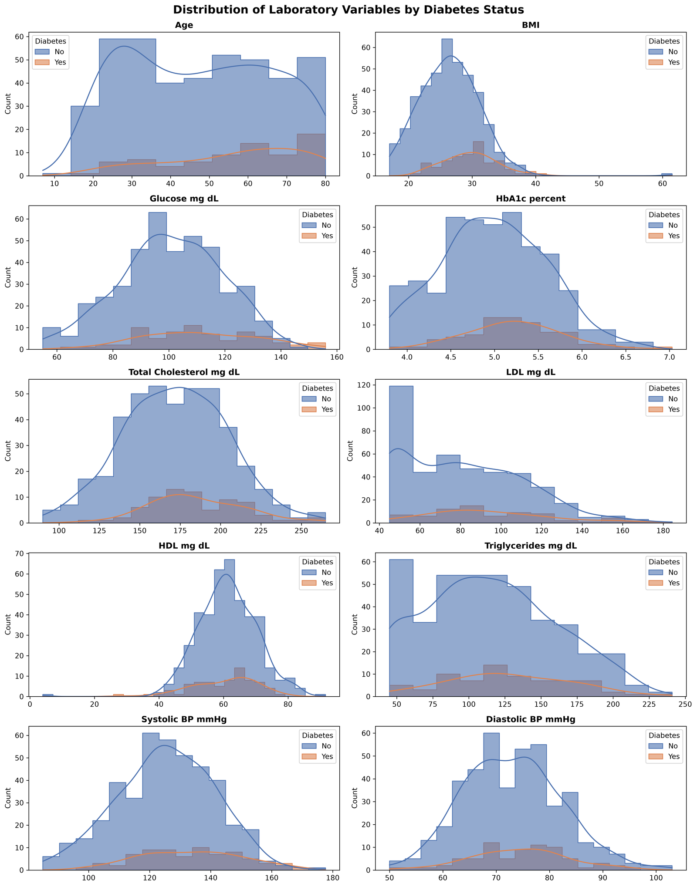
5.2 Sex-Based Comparisons
Boxplots: Laboratory Variables by Sex
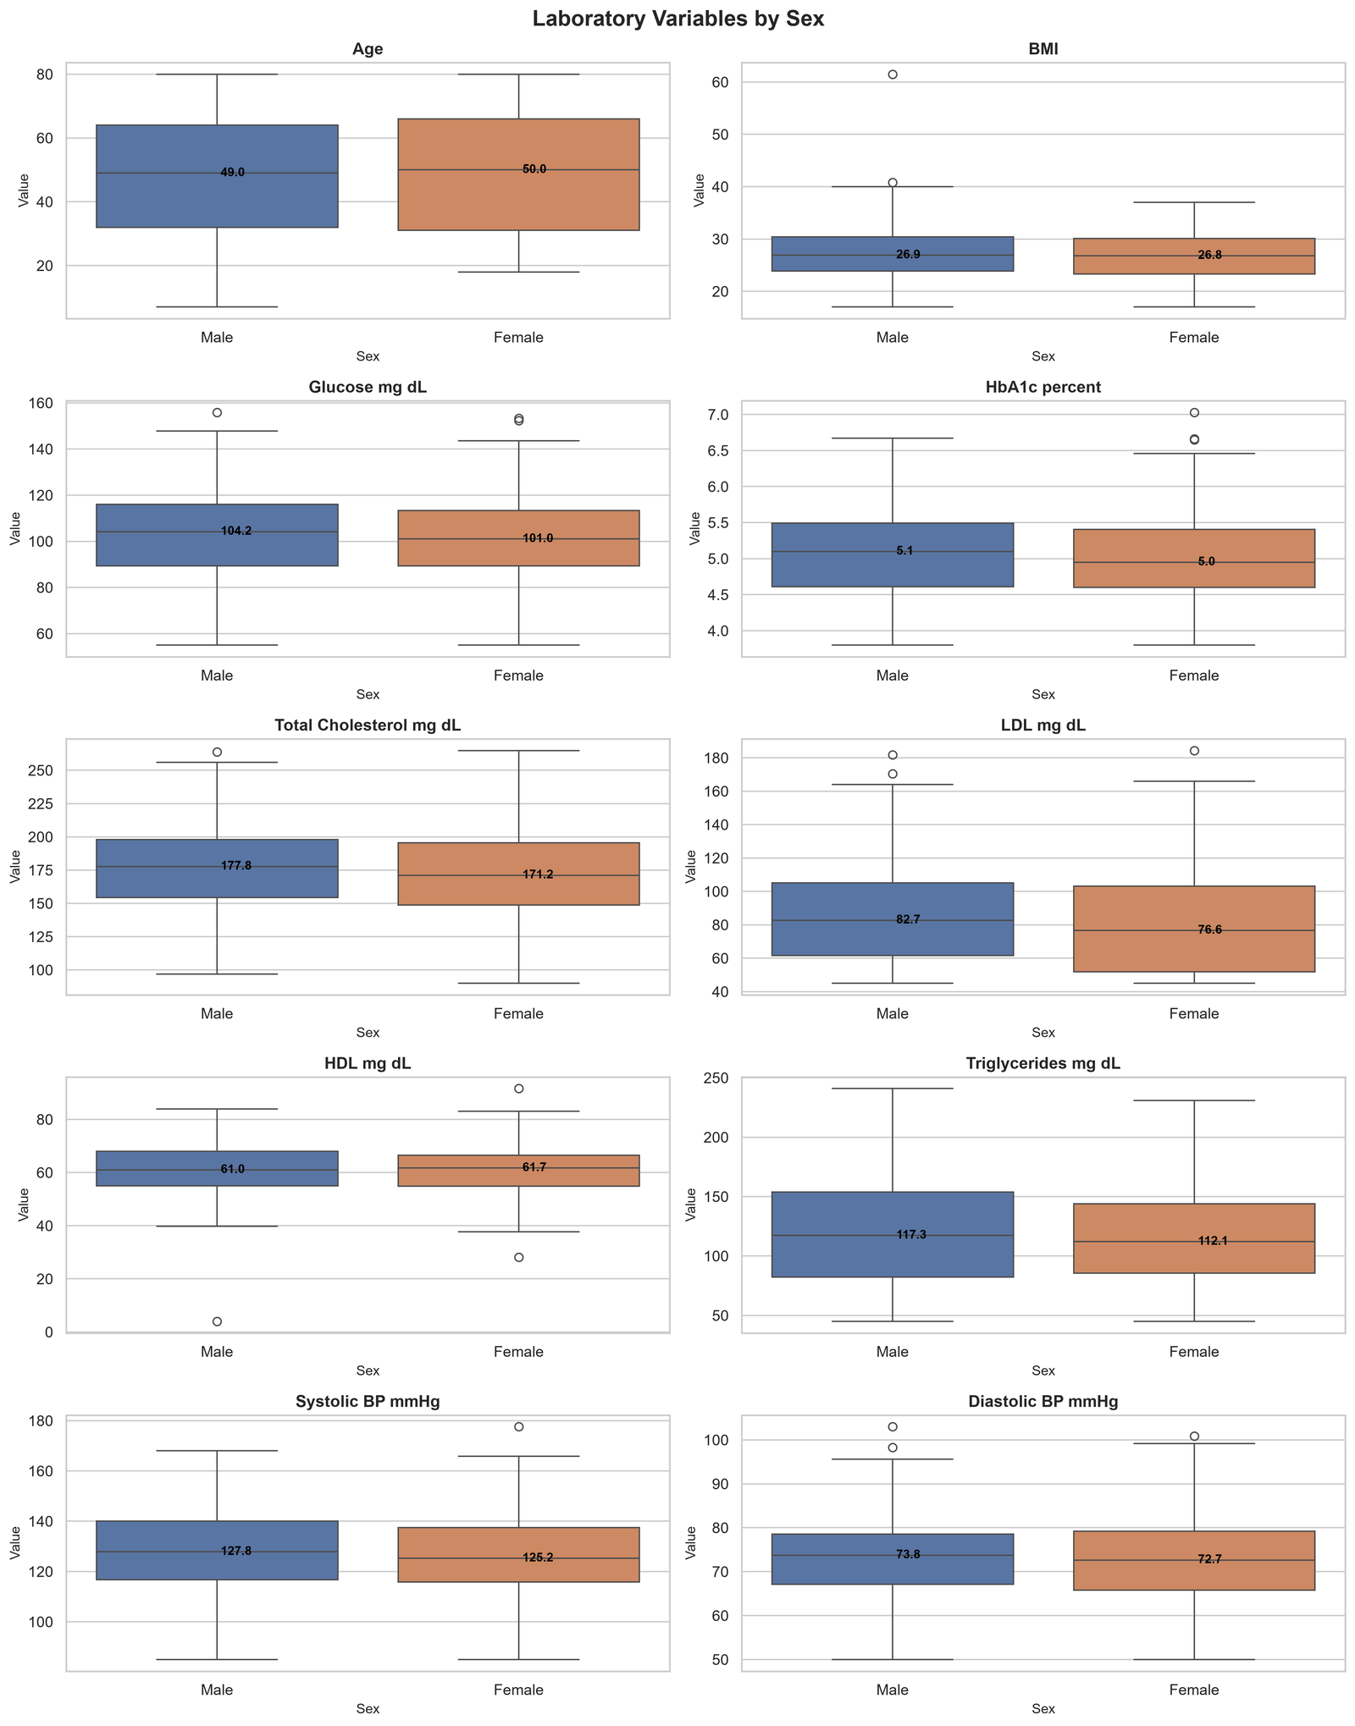
The boxplots show only small differences between sexes:
- HDL: Nearly identical medians (61.7 mg/dL in females vs. 61.0 mg/dL in males)
- Triglycerides: Males show higher median values (117.3 vs. 112.1 mg/dL)
- Systolic BP: Males show slightly higher median values (127.8 vs. 125.2 mmHg)
These differences are small. The clear sex difference in HDL usually reported in clinical literature is not visible in this synthetic dataset.
5.3 Bivariate Relationships
BMI vs. Glucose
BMI and glucose show a moderate positive association (r ≈ 0.40). The fitted slope is somewhat steeper among diabetic patients (≈ 2.0 vs. 1.4 mg/dL per BMI unit). This is consistent with the known link between adiposity and glucose metabolism, but it is an association only, not a causal effect.

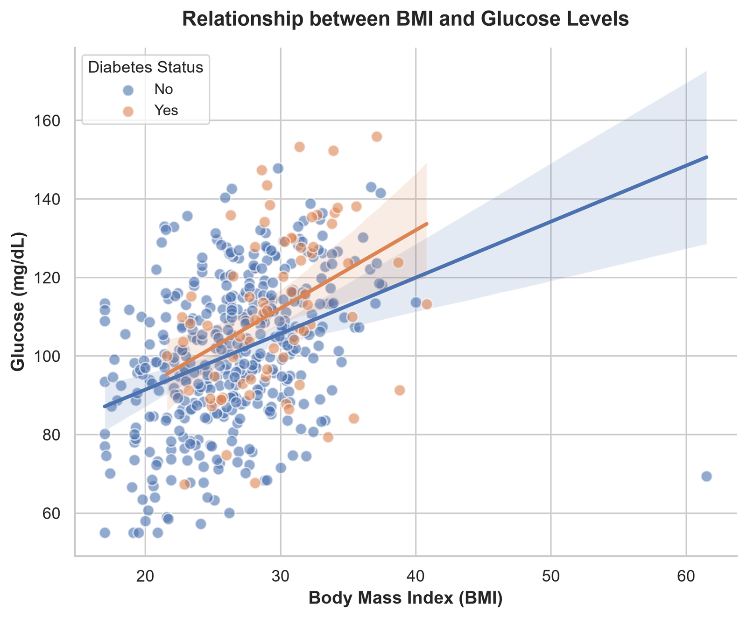
Triglycerides vs. HDL
The relationship between triglycerides and HDL is very weak (r ≈ −0.10), and diabetic patients do not cluster in the high-triglyceride / low-HDL region (their median HDL is in fact slightly higher). The strong inverse pattern typical of metabolic syndrome in real populations is not reproduced in this synthetic data — an important caveat before using it for further analysis.
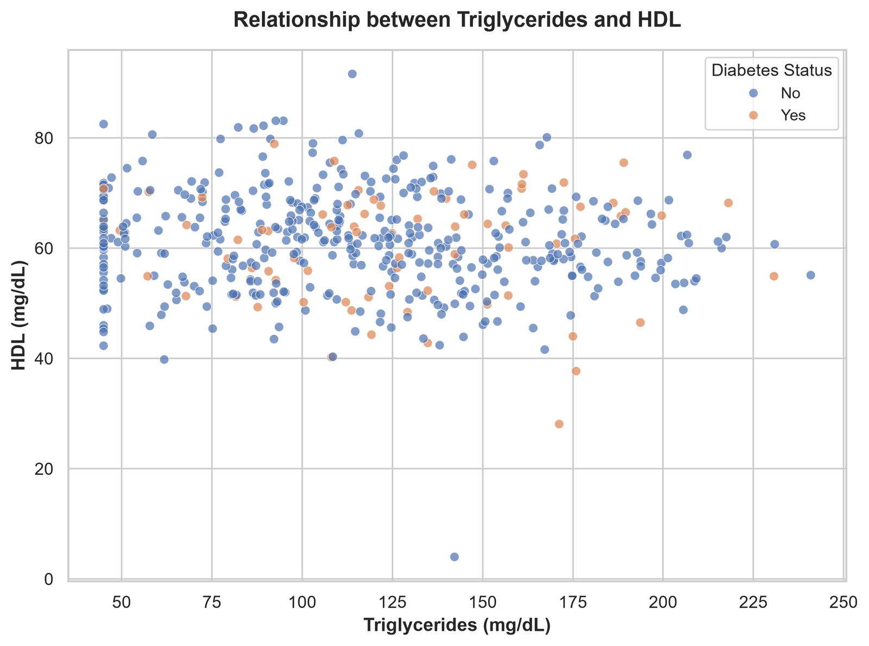
5.4 Correlation Analysis
Pairwise Correlation Heatmap
The heatmap reveals three key patterns:
- Biological validation: Total Cholesterol and LDL are extremely strongly correlated (r ≈ 0.92), which is expected since LDL is a major component of total cholesterol.
- Modeling warning: This same correlation means that any future regression model including both variables would suffer from multicollinearity. The client should drop one of them before predictive modeling.
- Otherwise weak correlations: No other pair of variables reaches |r| ≥ 0.5.
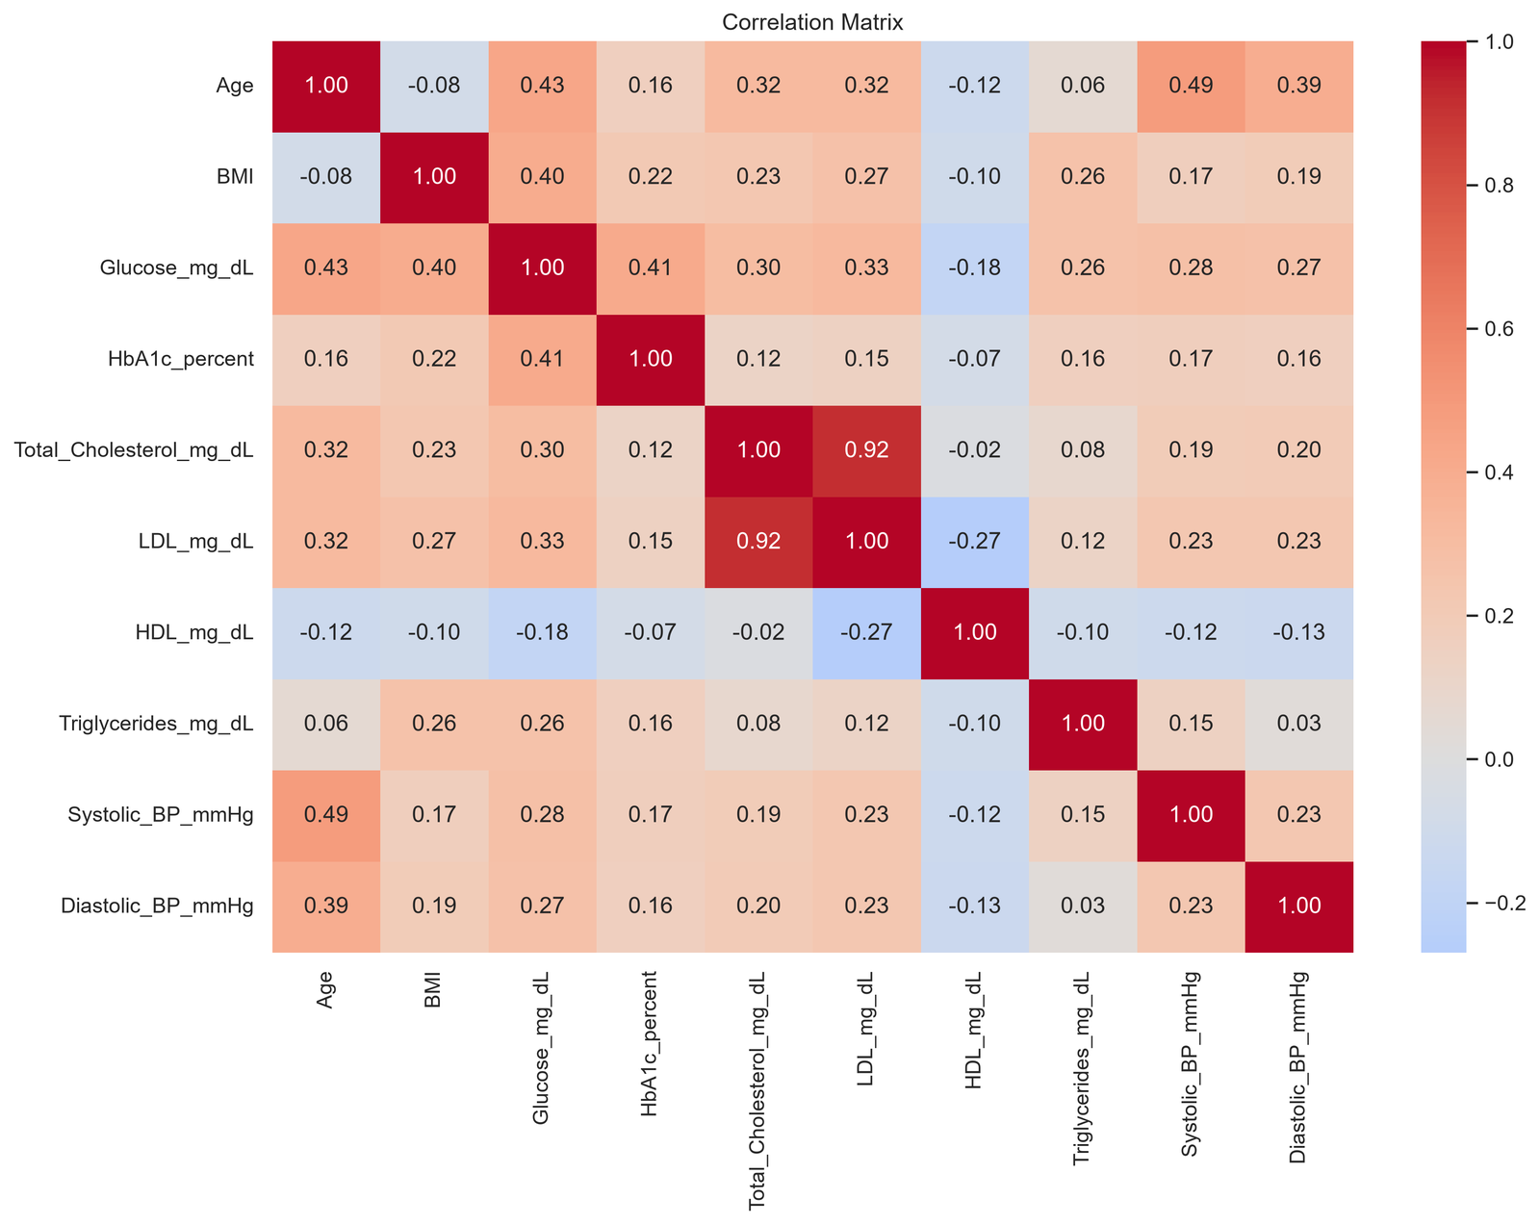
6. Findings & Conclusions
6.1 Data Quality Summary
- 503 → 500 records after removing 3 exact duplicates
- 57 missing values across 6 numeric variables; no single variable exceeds 2.5% missingness — a manageable level
- Categorical Sex column standardized from 5 variants to 2 (Male / Female)
- Implausible values flagged (e.g., Age = 7, HDL = 4 mg/dL, Total Cholesterol < 100 mg/dL) — these require domain-expert review before the dataset enters production pipelines
6.2 Key Descriptive Patterns
- The cohort is balanced by sex (~50/50) with a median age of ~50 years
- Diabetes prevalence is ~15%, consistent with an adult outpatient population
- Median BMI (~26.8) falls in the overweight range — a realistic population baseline
6.3 Notable Relationships
- Total Cholesterol ↔ LDL (r ≈ 0.92): extremely strong — expected, since LDL is a major component of total cholesterol. Consider dropping one in any downstream regression to avoid multicollinearity.
- BMI ↔ Glucose: moderate positive association (r ≈ 0.40), with a slightly steeper slope among diabetic patients
- Triglycerides ↔ HDL: only a very weak inverse relationship (r ≈ −0.10) — weaker than typically seen in real clinical data
- Sex differences: small overall — males show slightly higher median triglycerides and systolic BP, while median HDL is nearly identical between sexes
6.4 Recommendations for the Client
- Have a pathologist review the flagged implausible values before the dataset enters production pipelines
- Investigate the missingness mechanism — if missing BMI values are concentrated in a specific subgroup, choose an imputation strategy carefully, as simple imputation could introduce bias
- For any downstream modeling, drop either Total_Cholesterol or LDL to avoid multicollinearity
- Collect fasting status in future recordings — triglycerides and glucose are highly fasting-dependent
- Consider enriching the dataset with lifestyle variables (smoking, physical activity, medication use) to enable more nuanced analyses

7. Limitations
This analysis is informative but bounded by several important constraints:
- Synthetic data: The dataset is AI-generated for portfolio purposes. While it mimics realistic data-quality issues, it does not represent real patient outcomes.
- No causal claims: Correlations observed here (e.g., BMI ↔ Glucose) do not imply causation. Only controlled studies can establish causal relationships.
- Missing clinical context: Fasting status, medication use, family history, and lifestyle factors are absent — all of which materially affect lab interpretation.
- Unknown missingness mechanism: If data is not Missing Completely at Random (MCAR), descriptive statistics may carry subtle bias.
- Small sample size: With only 500 records and 74 diabetic cases, estimates for the diabetic subgroup have wider confidence intervals.
- No predictive modeling: Per the project brief, this analysis is strictly exploratory. Any future predictive work would require additional validation, feature engineering, and external test data.

8. Conclusion
The dataset is suitable for further statistical work after domain-expert review of the flagged implausible values. The expected Total Cholesterol–LDL and BMI–Glucose relationships are present, but some well-known clinical patterns (the inverse triglyceride–HDL relationship and the sex difference in HDL) are weak or absent, so results from this dataset should not be generalized to real populations.
The analysis successfully demonstrated:
- Rigorous data cleaning with full transparency
- Comprehensive descriptive statistics
- Publication-quality visualizations
- Critical comparison of the results with expected clinical patterns
All cleaning decisions, code, and outputs are documented in the accompanying Jupyter Notebook for full reproducibility.

Appendix: Full analysis code and cleaning log are available in the accompanying Jupyter Notebook (Patients-data-analysis-notebook.ipynb) and supporting files (data_cleaning_log.csv, laboratory_patient_data_cleaned.xlsx).

Report prepared by Sepideh Ziaei Chamgordani | September 7, 2026

