 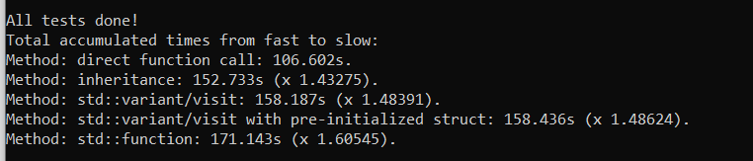

Improved inheritance (KerrMetricINHERITANCE const* m = new KerrMetricINHERITANCE{ thea }:

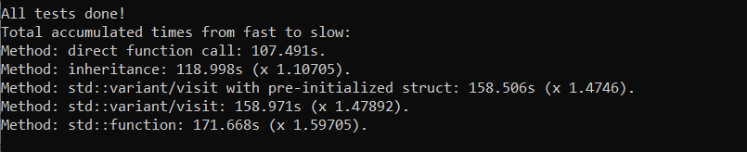

Improved inheritance (+final) and Kerr pointer:

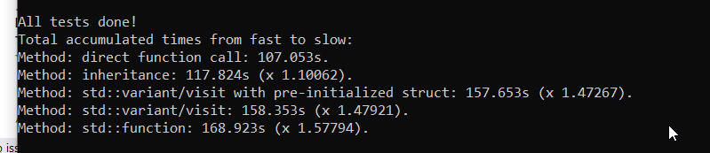

improved inheritance (no pointer) and +final:

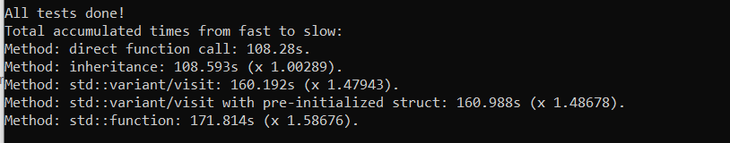

Improved inheritance (std::unique_ptr to Kerr and +final):

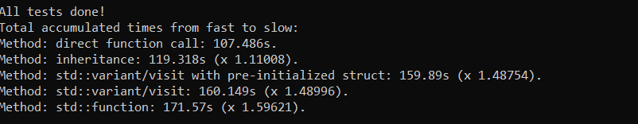

Normal inheritance with +final and std::unique_ptr:

