Mile Jabez Aclaro

Carlos Joaquin Macalolot

**The 9 Latest News on Nintendo**

1. **Sept 29, 2023:** PAW Patrol World - Launch Trailer - Nintendo Switch

Your favorite pups are emBARKing on an open world adventure! Explore the world of PAW Patrol like never before, from Adventure Bay to Barkingburg!



https://assets-prd.ignimgs.com/2023/09/26/paw-patrol-world-button-1695769339958.jpg?width=300&crop=1%3A1%2Csmart

1. **Sept 29, 2023:** COCOON - Launch Trailer - Nintendo Switch

From Jeppe Carlsen, the lead gameplay designer of LIMBO and INSIDE, COCOON takes you on an adventure across worlds within worlds. Master world-leaping mechanics, use unique orb abilities, and face monstrous guardians to unravel a cosmic mystery!

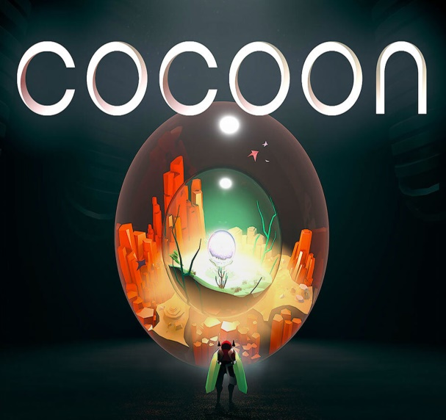 https://www.gamespot.com/a/uploads/scale_landscape/1574/15746725/4158924-33.jpg

1. **Sept 29, 2023:** Warm Snow - Announcement Trailer - Nintendo Switch

In this dark fantasy action roguelike inspired by Chinese mythology, a strange warm snow refuses to melt and plunges the world into chaos, turning people into uncontrollable monsters. Play as Bi An, a mysterious wandering warrior, and bring down the now corrupt Clans that used to protect the land.

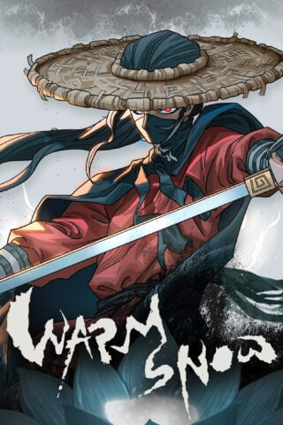

https://www.gematsu.com/wp-content/uploads/2023/09/Game-Page-Box-Art_Warm-Snow-320x480.jpg

1. **Sept 28, 2023:** Disney Speedstorm - Free-to-play launch and Season 4 Trailer "The Cave of Wonders" - Nintendo Switch

Disney Speedstorm makes three wishes come true during the Aladdin-inspired Season: The addition of new racers, the introduction of new villains, and a free-to-play experience.

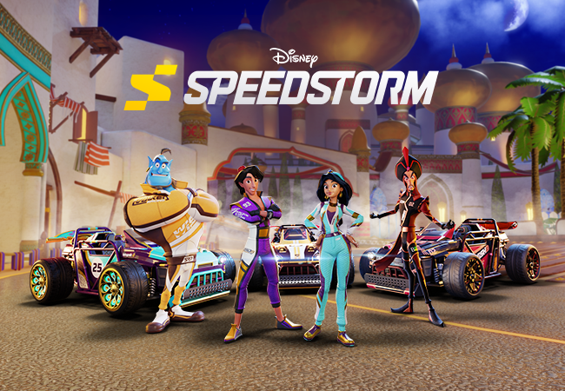 https://dst.assets.gameloft.com/assets/DS_23039_S_Season4_Key_Art_A_01_BLOG_LS_650x450_EN_f7ddbbd0b7.png

1. **Sept 27, 2023:** Fall Guys Fall Force - Update Trailer - Nintendo Switch

Go Fall Force in the latest Fall Guys update! This monstrous update is packed with tricks for Fall Guys Creative, treats for everyone in the Trick or Yeet Fame Pass, and more!

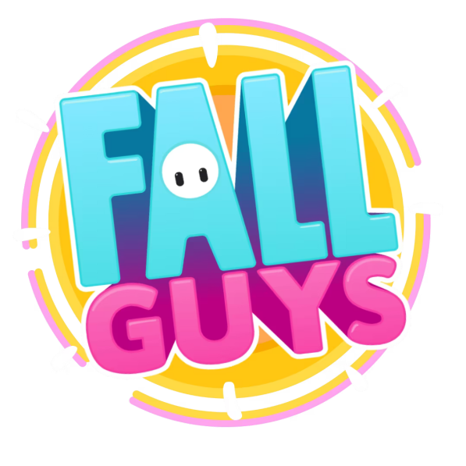 https://static.wikia.nocookie.net/fallguysultimateknockout_gamepedia_en/images/f/f2/FG_Fall_Force_Update_Logo.png/revision/latest/scale-to-width-down/1078?cb=20230928011346

1. **Sept 26, 2023:** The Legend of Nayuta: Boundless Trails - Launch Trailer - Nintendo Switch

Discovery awaits beyond the horizon in The Legend of Nayuta: Boundless Trails! Explore vivid locations, wield magic based on the seasons, and experience an adventure unlike any other!

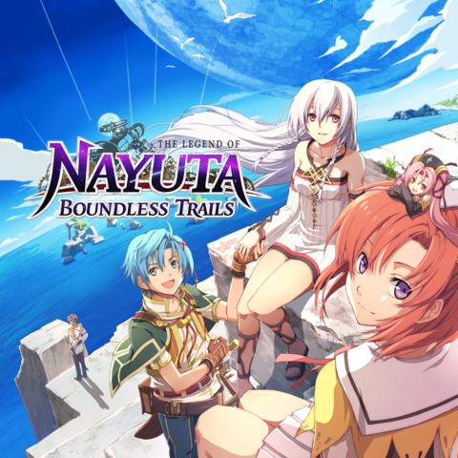 https://www.giantbomb.com/a/uploads/square_medium/33/338034/3300657-3451869545-EGS_TheLegendofNayutaBoundlessTrails_NihonFalcom_S2_1200x1600-bf5caaa98f3cc9e77dda449a76733d4f.jpg

1. **Sept 26, 2023:** Paleo Pines - Launch Trailer - Nintendo Switch

Set up your cozy dino sanctuary and embark on a lively adventure with your dino companion, Lucky! In Paleo Pines, you’ll meet quirky townsfolk, master the art of dino ranching, explore enchanting landscapes, and more!

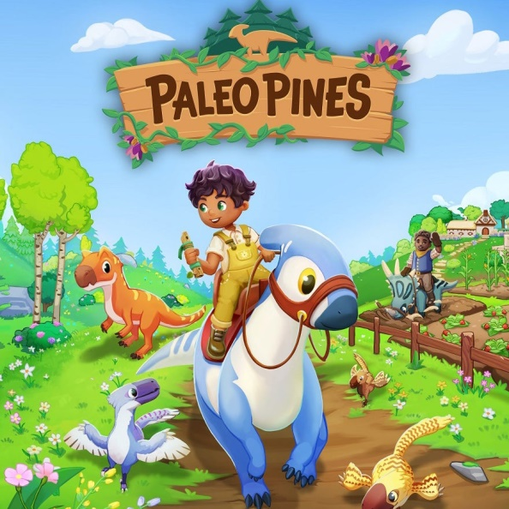

https://assets-prd.ignimgs.com/2023/04/26/paleo-pines-button-1682522362417.jpg

1. **Sept 26, 2023:** Mineko’s Night Market - Launch Trailer - Nintendo Switch

Join Mineko in Mount Fugu, a cozy Japanese inspired village with a great mystery to unfold! Make new friends, collect and craft whimsical items, revitalize the once thriving Night Market, and uncover the truth of the great sun cat, Nikko!

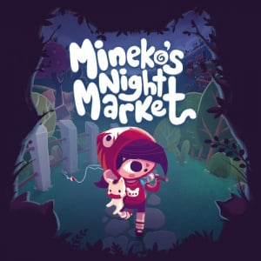 https://images.nintendolife.com/81473eb367745/minekos-night-market-cover.cover_300x.jpg

1. **Sept 25, 2023:** Tetris® 99 – 35th MAXIMUS CUP Gameplay Trailer - Nintendo Switch

The Tetris® 99 35th MAXIMUS CUP – Aionios Edition event runs from 12 a.m. PT on September 29 to 11:59 p.m. PT on October 2. To participate, you’ll need to be a Nintendo Switch Online member* and play the Tetris 99 online mode during the event period. You’ll earn event points based on your placement in each match. Once you’ve accumulated a total of 100 event points, a new theme will unlock, featuring art, music and Tetrimino designs!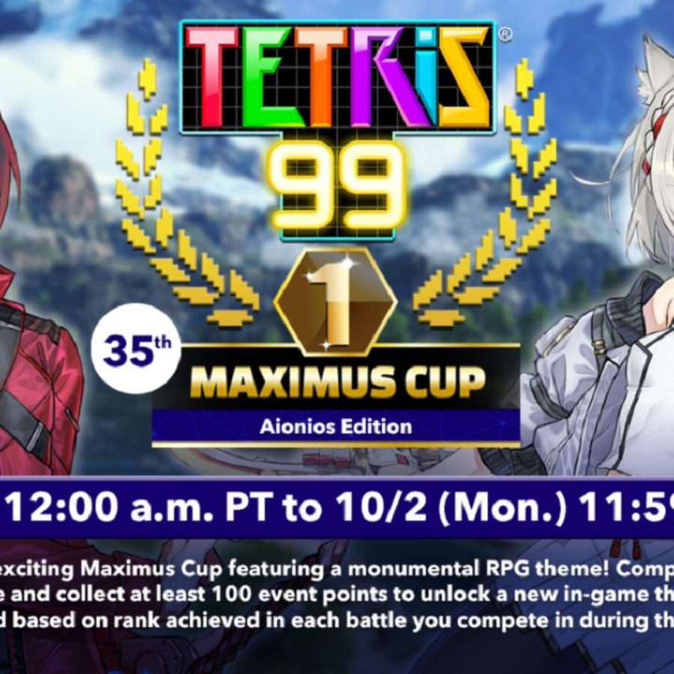

https://bleedingcool.com/wp-content/uploads/2023/09/Tetris-99-Xenoblade-Chronicles-3-900x900.jpg