**ROBOCUP ASIA-PACIFIC 2022**

**TEAM DESCRIPTION PAPER**

League Name : Cospace Rescue Challenge U19

Age Group : 19th

Team Name : E – RESQ

Participant Name :

1. Rohman Aditiya, [rohmxx@ce.student.pens.ac.id](mailto:rohmxx@ce.student.pens.ac.id)
2. Septian Bagus Jumantoro, [septian@ce.student.pens.ac.id](mailto:septian@ce.student.pens.ac.id)

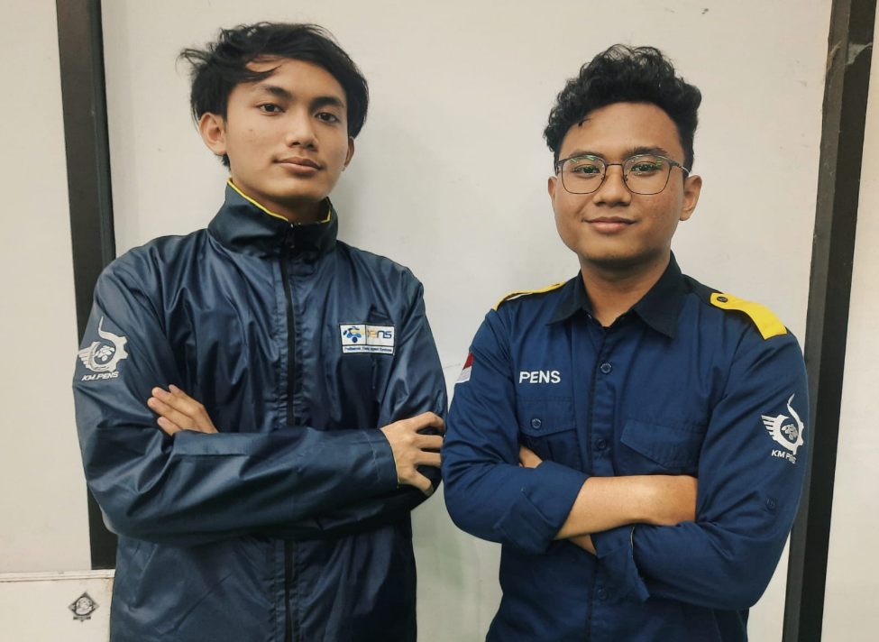Team Photo :

Mentor Name : Iwan Kurnianto Wibowo, [reiwan30@gmail.com](mailto:reiwan30@gmail.com)

Institution : Politeknik Elektronika Negeri Surabaya

Region : Indonesia

Contact Person : +62 813-5890-8998 (Rohman Aditiya, Leader)

Date : September 12, 2022

**ROBOCUP ASIA-PACIFIC 2022**

**TEAM DESCRIPTION PAPER**

Cospace Rescue Challenge U19

E - RESQ

Rohman Aditiya, Septian Bagus Jumantoro

Indonesia

1. **Abstract**

E - RESQ is one of the robotics teams from Politeknik Elektronika Negeri Surabaya, Indonesia. Our team will participate in Robocup Asia Pacific 2022 in the CoSpace Rescue Challenge U19 category for the first time. In this paper, we will explain the strategy we used to complete the mission in the event. We use Artificial Intelligence to program the robot and recognize RGB, ultrasonic and compass sensors.

To maximize the robot's mission, we use Zone Mapping so that the robot can recognize the Map and Autonomous Navigation to move according to a predetermined point automatically. For Artificial Intelligence, our robot is useful for reading RGB sensors, recognizing obstacles that are in front of us, and recognizing the direction of the robot's compass, so that the robot can be precise and fast to complete the mission.

1. **Introduction**

E - RESQ is one of the robotics teams from the Politeknik Elektronika Negeri Surabaya from Indonesia. The new E – RESQ team was formed in 2022, to participate in the 2022 Robocup Asia Pacific. Our team members come from the UAV Research Center for the 2022 Indonesian Flying Robot Contest. Our team was formed with the aim of winning competitions at the National and International levels, as well as to provide ideas and innovations in the field of technology that are useful for the future.

1. **System Overview**

The main mission of our robot is to get as many points as possible. To achieve this, our robots need to have high motion and accuracy. Therefore we created an Artificial Intelligence to process the commands that we set in the advance code that we made. To help streamline the program, we utilize the sensors that have been provided such as RGB sensors to detect color, ultrasonic sensors to measure the distance between the robot and obstacles, and a compass to determine the direction of the robot. The strategy we use is as follows:

1. Zone Mapping

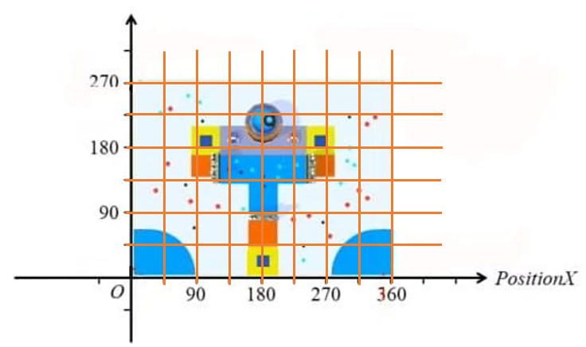To read the points on the map, we created a program called Zone Mapping. Zone Mapping is useful to help robots optimize movement when looking for targets and also recognize obstacles and places to Deposit faster.

Image: Zone Mapping

In the map there are also obstacles where, our robot will avoid it by optimizing the ultrasonic sensor and also the RGB sensor. If the robot is in the gray zone, the robot will increase its speed according to our command. If the robot has collected the target as desired, the robot will look for the fastest coordinates to immediately go to the deposit point.

1. Super Priority Object

We also use an advance code which we named Super Priority. Super Priority is a program that can increase the chances of getting Super Objects. Therefore, when the robot moves and passes a target, the robot will identify the color of the target and move again to look for the same color up to a maximum of 2 colors. If the number of colors is met, then the robot will look for the next target until the LoadedObject is full with 3 pairs of colors.

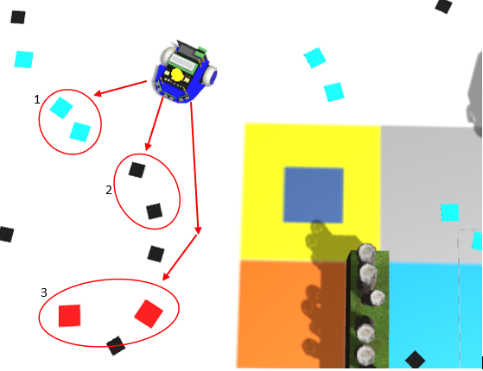

Image: Super Priority Object

If when moving the robot passes a target that has a different color, then the robot will store the coordinates of the target and pass it. When the robot has passed 6 different target colors, the robot will return to take the target that has been passed, based on the coordinates that have been stored and immediately go to the place of deposit.

With this method the robot can take a lot of points by utilizing super objects that can appear by picking up a pair of objects with the same color without having to lose time to look for the object. The following is a performance flowchart of the Super Priority Object system.

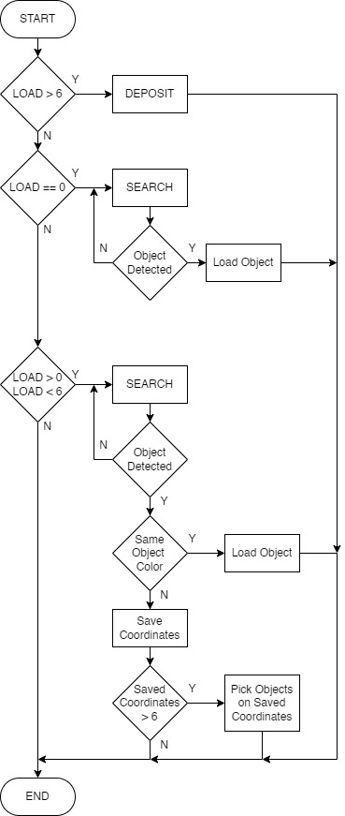

1. Super Object Autonomous Navigation

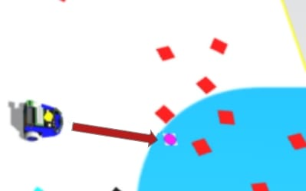When the committee gives the X and Y coordinates for the Super Object, the robot will go directly to the coordinate point to pick it up and go straight to the deposit point without having to take another target until the super object has been deposited. When the Super Object has been deposited, the robot will return to look for another target, when it is full it will proceed to the command to approach the deposit point.

Image: Super Object Autonomous Navigation

1. Obstacle and Limit Area Avoidance

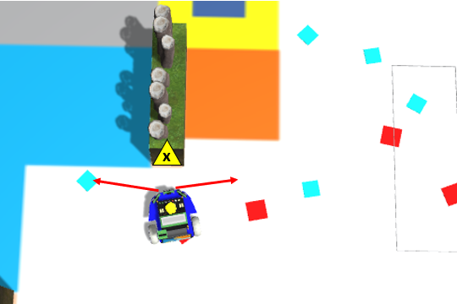This strategy is the most important key in helping to complete this mission. We added a program to the robot, so that the robot can avoid obstacles that are in front of it using ultrasonic sensors. Also our robot can scan the outer boundary of the field using the RGB sensor, so that our robot will not go out of the field. On the RGB sensor, we also use it to detect no pass areas.

Image: Obstacle Avoidance

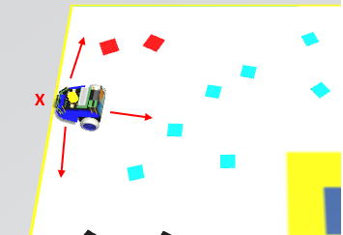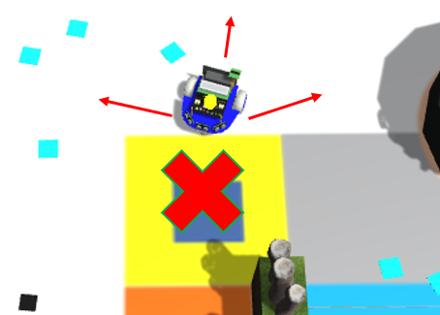Image: Limit Area Avoidance

1. **Conclusion**

From the competition, we gained a lot of insight and knowledge about technology and strategies related to robotics. We also gain knowledge about how the flow of the robot starts from the start, then the strategy used to process sensors that are used optimally and efficiently, until the mission is complete.

1. **Acknowledgement**

Thank you to the Politeknik Elektronika Negeri Surabaya (PENS) for the support, especially to the mentors who have guided us in this competition. Thanks also to RoboCup Asia Pacific 2022 for the guidance provided. This guide is very helpful for our team in learning the simulation.

1. **References**

Robocup Asia Pacific 2022 Academy Channel